**1.Abstract**

Wavelet analysis is an exciting new method for solving difficult problems in mathematics, physics, and engineering, with modern applications as diverse as wave propagation, data compression, signal processing, image processing, pattern recognition, computer graphics, the detection of aircraft and submarines and other medical image technologyWe propose a stationary and discrete wavelet based image de-noising scheme and an FFT based image de-noising scheme to remove noise and also compare different levels of thresholding in DWT. Wavelet transform of a function is the improved version of Fourier transform. Fourier transform is a powerful tool for analyzing the components of a stationary signal. But it is failed for analyzing the non stationary signal where as wavelet transform allows the components of a non-stationary signal to be analyzed. Wavelet transform enable us to represent signals with a high degree of sparsity this is the principle behind a non-linear wavelet based signal estimating technique known as wavelet de-noising. Denoising using wavelets attempts to remove the noise present in the signal while signal characteristics are preserved regardless of its frequency content it can be handled using three steps: a linear forward wavelet transform , non-linear thresholding steps and a linear inverse wavelet transform. Wavelet transform is quite different from smoothing, smoothing is used to remove the high frequencies and retains the lower frequencies.

The main goal of this project is to compare the results obtained by denoising of wavelet transform with other integral transforms.

**2. INTRODUCTION TO IMAGE PROCESSING**

Image processing is a method to perform some operations on an image, in order to get an enhanced image or to extract some useful information from it. It is a type of signal processing in which input is an image and output may be image or characteristics/features associated with that image. Nowadays, image processing is among rapidly growing technologies. It forms core research area within engineering and computer science disciplines too.

Image processing basically includes the following three steps:

* Importing the image via image acquisition tools;
* Analysing and manipulating the image;
* Output in which result can be altered image or report that is based on image analysis.

There are two types of methods used for image processing namely, analogue and digital image processing. Analogue image processing can be used for the hard copies like printouts and photographs. Image analysts use various fundamentals of interpretation while using these visual techniques. Digital image processing techniques help in manipulation of the digital images by using computers. The three general phases that all types of data have to undergo while using digital technique are pre-processing, enhancement, and display, information extraction.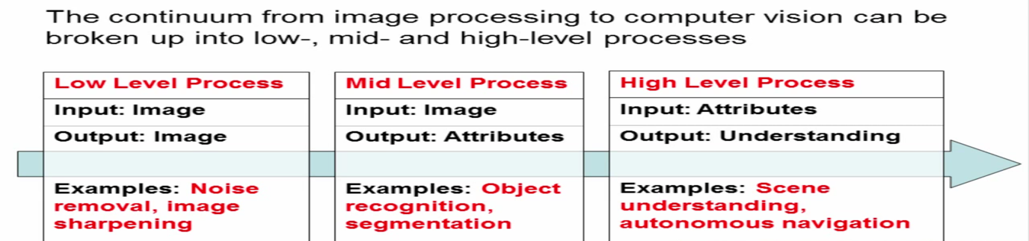

Image-digital image

An image is a 2-D function f(x,y), where x and y are the spatial (plane) co-ordinates and the amplitude of f at any pair of coordinates (x,y) is called intensity of image at that level .

If x,y and amplitude values of f are finite and discrete then ,we call it a digital image .A digital image is composed of finite number of elements called pixels , each of which has a particular location and value.

Source of digital Image

The pricinciple source for images is the electromagnetic (EM) energy select rum.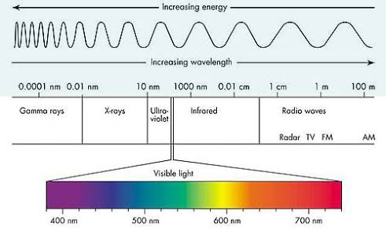

**3. INTEGRAL TRANSFORMS & IMAGE DENOISING**

Transformation is a function. A function that maps one set to another set after performing some operations.

Digital Image Processing system

We will develop a system that whose input would be an image and output would be an image too. And the system would perform some processing on the input image and gives its output as an processed image. It is shown below.

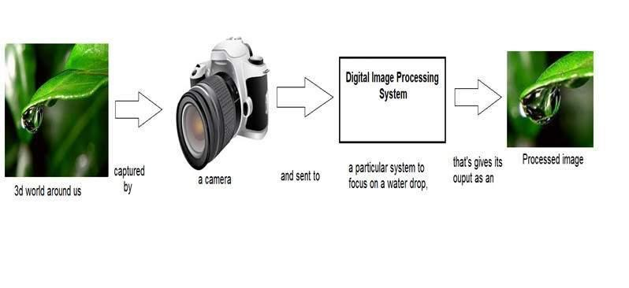

Now function applied inside this digital system that process an image and convert it into output can be called as transformation function.

As it shows transformation or relation, that how an image1 is converted to image2.

Image transformation

Consider this equation

**G(x,y) = T{ f(x,y) }**

In this equation,

**F(x,y)** = input image on which transformation function has to be applied.

**G(x,y)** = the output image or processed image.

T is the transformation function.

This relation between input image and the processed output image can also be represented as.

**s = T (r)**

where r is actually the pixel value or gray level intensity of f(x,y) at any point. And s is the pixel value or gray level intensity of g(x,y) at any point.

Examples

Consider this transformation function.

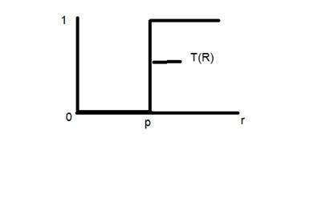

Lets take the point r to be 256, and the point p to be 127. Consider this image to be a one bpp image. That means we have only two levels of intensities that are 0 and 1. So in this case the transformation shown by the graph can be explained as.

All the pixel intensity values that are below 127 (point p) are 0, means black. And all the pixel intensity values that are greater then 127, are 1, that means white. But at the exact point of 127, there is a sudden change in transmission, so we cannot tell that at that exact point, the value would be 0 or 1.

Mathematically this transformation function can be denoted as:

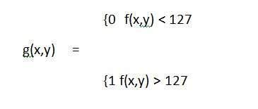

Consider another transformation like this

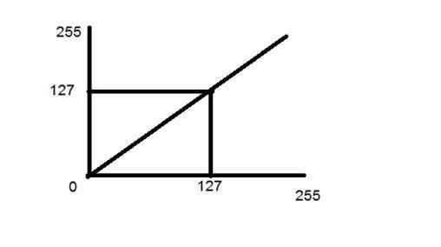

Now if you will look at this particular graph, you will see a straight transition line between input image and output image.

It shows that for each pixel or intensity value of input image, there is a same intensity value of output image. That means the output image is exact replica of the input image.

It can be mathematically represented as:

g(x,y) = f(x,y)

the input and output image would be in this case are shown below.

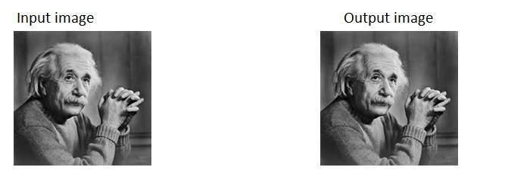

**Laplace transform:**

In mathematics, the Laplace transform is an integral transform. The Laplace transform converts integral and differential equations into algebraic equations. Although it is a different and beneficial alternative of variations of parameters and undetermined coefficients, the transform is most advantageous for input terms that placewise, periodic or pulsive.

Let f(t) be defined for t ≥ 0. The Laplace transform of f(t), denoted by F(s) or L{f(t)}, is an integral transform given by the Laplace integral.

**Basics of Laplace Transform 2**

L{f(t)}=F(s)

The most requirements for the image processing on a discrete grid and each sample or pixel is quantized using a finite number of bits.

For digitization, the given image is sampled on a discrete grid and each sample or pixel is quantized using a finite number of bits. After converting the image into bit information , processing is performed. This processing technique may be image enhancement,image reconstruction ,image compression

This can be obtained through various transformation. Laplace transformation is one of them.

**Application of laplacetransform :**

* Image sharpening /enhancement
* Edge detection
* Blob detection

Any feature with a sharp discontinuity (like noise) will be enhanced by a laplacian operator. Thus through laplacian operator we can restore fine detail to an image which has been smoothened to remove noise.

The result of a Laplacian filtering
is not an enhanced image
We have to do more work in order
to get our final image
Subtr...

This gives us a new filter which does the whole
job for us in one step
0 -1 0
-1 5 -1
0 -1 0
agestakenfromGonzalez&Woods,D...

**IMAGE DENOISING**

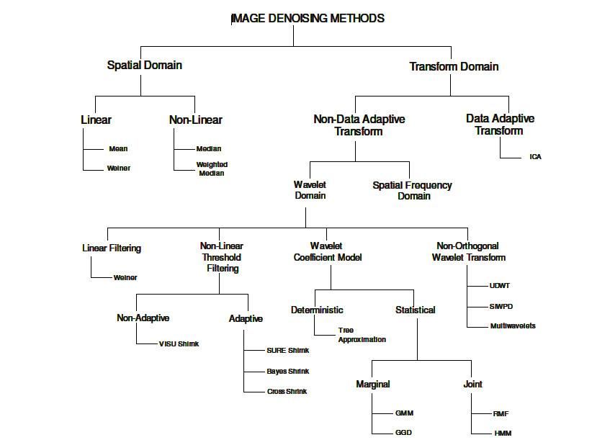

**What is Noise of a Image?**

**INTRODUCTION:**

Noise represents unwanted which deteriorates image quality. Noise is defined as a process(n) which affects the acquired image (f) and is not part of the scene (initial signal-s),and so the noise model can be written as:

**f(i,j)=s(i,j)+n(i,j).**



**Sources of Noise**

* If image scanned from photograph is made on film, the film grain is the source.
* Image sensor affected due to environmental conditions.
* If image is directly in digital format then mechanism for gathering data can cause noise.

**Types of Noise**

**SALT AND PEPPER:**

1.It is a impulse type of noise

2.It occurs due to sharp changes in image signal.

3.Noisy pixels can take only max or minimum.

4.For a 8-bit image

pepper:0 ,salt:255.(pixel values)

**Causes:**

>Malfunctioning of pixel sensor ,timing in digitization process.

**POSSION NOISE:**

1. It exists because of the phenomenon such that light and electric current consists of discrete packets.

2. Magnitude of noise increases , when average value of current or intensity of light.

**Causes:**

>occurs when number of photons sensed by sensor is not sufficient to provide statistical information of image.

**GAUSSIAN NOISE:**

1. Evenly distributed i.e. noisy image =true pixel + Gaussian distributed value.

2. Noise is independent of intensity of pixel value.

**Causes:**

>Arise during acquisition. For eg: poor illumination.

**SPECKAL NOISE:**

1. It is a multiplicative noise.

2**. P=I + n\*I**

P- speckel noise distribution image

I-input image ; n-uniform noise at mean 0 and variance v.

Commonly observed in radar sensing system. Reducing this noise permits both better discrimination of seen targets as well as easier image segmentation.

**Noise Reduction Techniques**

**INTRODUCTION:**

>Image de-noising is very important task in image processing.

>in modern world image de-noising is a well known problem and is concern problem.



**LINEAR & NON-LINEAR FILTERS ->**

**LINEAR FILTERS :**

These remove noise by combing original image with a mask that represents a low-pass filter or smoothing operation .these filters tend to blur the sharp edges ,destroy the lines and other fine details.

**Draw back :** These give output faster but the result given by them is not efficient because some of the image details are not preserved.

**NON LINEAR FILTERS:**

In this output is not linear function of inputs .Non linear filters preserve image details

they have many applications . Especially the one (NOISE)which are not additive.

**NON-LINEAR OVER LINEAR:**

They are considerable harder to use than linear filters .

**TYPES OF LINEAR & NON-LINEAR FILTERS**

**MEAN FILTER :**

It is simple spatial filter .In this for a pixel matrix the center value is replaced by the avg of all neighboring values . Similarly each value of pixel is replaced by the avg value.

Draw backs :edges of images are lost.;

**MEDIAN FILTER :**

It is a non linear filter .similar to mean filter only that avg is replaced by median value.

In this all neighboring values are arranged in increasing order.

**MAX AND MIN FILTER :**

Also known as erosion and dilation filter ,are morphological filters work by considering a neighbor ,from a group of neighbors max or minimum are found and stored. And hence the value is stored in original pixel value (i.e., original value is replaced).They can remove salt pepper noise effectively.

**MIDPOINT FILTER:**

It simply finds the mid value of max and minimum in area encompassed by the filter. ALPHA TRIMMED FILTER: It is windowed filter of non linear class . the basic idea is to remove most non typical element and calculate mean for rest of all .

**ADAPTIVE FILTER :**

It depends on two statistical measures mean and variance. More selective than mean filter as it retains edges too.

**WIENER FILTER :**

The main aim of this filter is to filter out corrupted signal (due to noise) . The wiener filter minimizes the mean square error b/n the estimated value by random process to that of desired process.

CHARACTERISTICS :  
Assumption : signal and noise are stationary linear with known spectral characteristics .

Requirement : filter must be physically realizable .

Performance criteria : minimum mean square error .

**4. FOURIER TRANSFORM (Brief Description)**

The Fourier Transform is an important image processing tool which is used to decompose an image into its sine and cosine components. The output of the transformation represents the image in the Fourier or frequency domain, while the input image is the spatial domainequivalent. In the Fourier domain image, each point represents a particular frequency contained in the spatial domain image. The Fourier Transform is used in a wide range of applications, such as image analysis, image filtering, image reconstruction and image compression.

**FFT BASED IMAGE Denoising**

First the fast Fourier transform is applied to the noise added image to transform the image from the spatial domain to frequency domain. A lowpass filter and a highpass filter are designed. Then the transformed image is filtered with lowpass filter and highpass filter. Now the inverse fast Fourier transform is employed to the lowpass filtered image and highpass filtered image. Soft thresholding is applied to the inverse of highpass image in order to enhance the sharpness of the image. The PWL filter or Lagrange or spline interpolated PWL filter is applied to the inverse of lowpass image, to enhance the smoothness of the image. Then the resulting two images are combined to retrieve the denoised image. The block diagram of FFT based image denoising scheme is shown in below figure

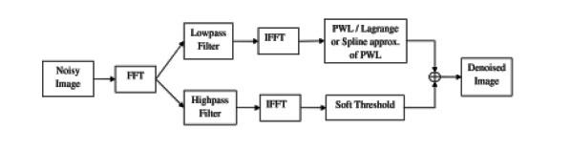

**Block diagram of FFT based image denoising scheme**

**Low pass Filter:**

The transformed image in the frequency domain near the center will have low frequency components. The lowpass filter [2] can be constructed using the following formula:

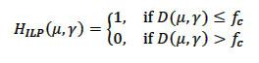

where DScreenshot (134) copy.png is the distance between the center of the frequency rectangle and a point Screenshot (134) copy.png in the frequency domain:

Screenshot (13422) copy.png

here *W* and *H* are the width and height of the image respectively. We have set the cutoff frequency, *fc* = 200, as we have used images of size 512 x 512.

**High pass Filter:**

In the transformed image, the region near the edge will have high frequency components than the

central region. Figure 4 shows the pictorial representation of these filters. The highpass filter can be constructed by using their corresponding lowpass filter:

ewrteer.JPG

 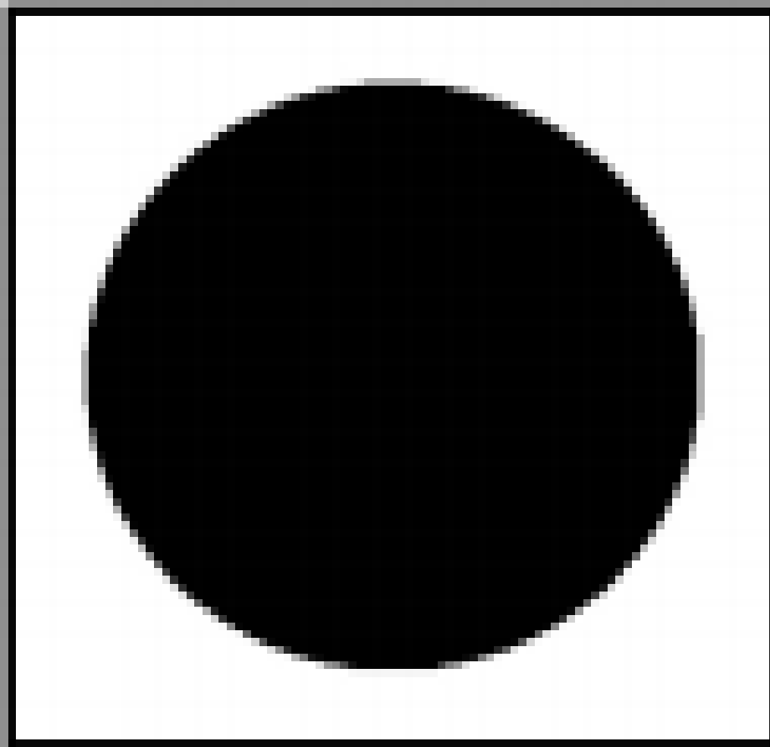

Low pass filter High pass filter

**Fourier transform overcome by wavelet transform**

Location information is stored in phases and difficult to extract. For example, consider The *discrete* Fourier transform transforms a sequence of N complex numbers werwg.JPG  into another sequence of complex numbers qwd.JPG is given by,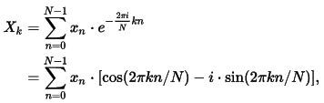 

We see that the Fourier coefficients all have the same magnitude, so the only way to tell from the Fourier transform that this function is concentrated at a single point in physical space, and to determine the location of that point, is to examine the phase of the coefficients.

Because of this, it can be very difficult, if not impossible, to determine whether a signal includes a particular frequency at a particular point in physical space (which may refer to space or time). This is especially difficult for a high frequency, in view of the sampling theorem, which states that a signal with n frequencies can be represented with complete accuracy using 2n samples per second. However, this sampling rate must be maintained for the entire duration of the signal, not just the interval of interest.

The Fourier transform is very sensitive to changes in the function. In view of the previous example, a change of O(ǫ) in one point of a discrete function can cause as much as O(ǫ) change in every Fourier coefficient. Similarly, a change in any one Fourier coefficient can cause a change of similar magnitude at every point in physical space.

Unfortunately, this transform is difficult to invert, due to its excessive redundancy, and it does not capture short “pulses” accurately, unless a very small window is used. But in that case, low-frequency content cannot be accurately captured. This is due to the Uncertainty Principle, which states that a function cannot be simultaneously concentrated in both physical space and Fourier space.

**5.WAVELET TRANSFORM & THRESHOLDING**

In conventional Fourier transform, we use sinusoids for basis functions. It can only provide the frequency information. Temporal information is lost in this transformation process. In some applications, we need to know the frequency and temporal information at the same time, such as a musical score, we want to know not only the notes (frequencies) we want to play but also when to play them. Unlike conventional Fourier transform, wavelet transforms are based on small waves, called wavelets. It can be shown that we can both have frequency and temporal information by this kind of transform using wavelets. Moreover, images are basically matrices. For this reason, image processing can be regarded as matrix processing. Due to the fact that human vision is much more sensitive to small variations in colour or brightness, that is, human vision is more sensitive to low frequency signals. Therefore, high frequency components in images can be compressed without distortion. Wavelet transform is one of a best tool for us to determine where the low frequency area and high frequency area is .

**Wavelet transform**

Definition-Wavelet transform ,in mathematics is means for performing signal processing and image processing .

The wavelet transform is similar to the Fourier transform with complete different merit function Generally, the wavelet transform can be expressed by the following equation

http://gwyddion.net/documentation/user-guide-en/eq-wavelet-transform-continuous.png

Wavelets capability to give spatial frequency information is the main reason for this investigation. This property promises the possibility for better discrimination between the noise and the data. Successful exploitation of wavelet transform might lessen the blurring effect or even overcome it completely. There are mainly two types of wavelet transform namely Continuous Wavelet Transform (CWT) and Discrete Wavelet Transform (DWT).

**Discrete Wavelet transform-**

DWT of image signals produces a non-redundant image representation, which provides better spatial and spectral localisation of image formation compared with other multi scale representation such as Gaussian and Laplacian pyramid. The DWT can be interpreted as signal decomposition in a set of independent spatially oriented frequency channels. The signal S is passed through two complementary filters and emerges a two signals, approximation and details. This is called decomposition or analysis.

The components can be associated back into the original signal without loss of information. This process is called reconstruction or synthesis. The mathematical manipulation, which implies analysis and synthesis, is called Discrete Wavelet Transform and Inverse DWT.

**Continuous Wavelet transform**-

CWT is an implementation of the wavelet transform using an arbitrary scales and almost arbitrary wavelets. Non-orthogonal wavelets are used for its development in the data obtained by this transform for highly correlated. CWT works by computing a convolution of the signal with the scaled wavelet and it is implemented in the CWT module that can be accessed with Data Process Integral Transforms CWT.

Types of wavelets

* Haar
* Daubechies
* Bi orthogonal
* Coieflets
* Symlets
* Morlet
* Mexican Hat
* Meyer
* Other Real Wavelets
* Complex Wavelets

Haar-

Haar is the first and simplest wavelet. The haar is discontinuous and represents a step function.

Daubechies -

Ingrid daubechies invented what are compactly supported orthonormal wavelets thus making DWT practicable.

The names of daubechies family are written as dbN where **N** is the order and **db** is surname. There are around 10 daubechies, db1 is similar to haar.

Bi orthogonal-

This family of wavelets exhibits the property of linear phase, which is needed for signal and image reconstruction.

Coiflets -It has 2N moments = 0 to 2N-1. It was also built by daubchies at request of R.Coifman.

Symlets-The symlets are nearly symmetrical wavelets proposed by daubechies as modifications to the dB family .The properties of two wavelet transform are similar.

Morlet- This wavelet has no scaling function but is explicit.

Mexican Hat-This wavelet has no scaling function and is derived from Gaussian probability density function.It is also known as the Ricker wavelet.

Meyer-

In Meyer Wavelet scaling function are defined in the frequency domain.

Other Real Wavelets

* Gaussian derivatives family
* FIR based approximation of the Meyer Wavelet.

Complex Wavelets

* Gaussian derivatives
* Morlet
* Frequency beta spline
* Shannon

Applications of wavelet transform-

There are wide range of applications of wavelet transform the following are some of them:

* Data and image compression
* Partial differential equation solving
* Transient detection
* Pattern reconization
* Texture analysis
* Noise reduction

**Wavelet based thresholding –**

Proposed algorithm- Digital image de-noising using Discrete Wavelet Transform (DWT) approach is being highlighted in the following steps:

1. Apply DWT on the noisy image to split it into four sub-bands (A, H, V, D) by using wavelet filter families
2. Choose one of the suitable threshold rule methods to compute a threshold value for each one of the detail bands H, V, D.
3. Compare pixels in the sub-bands (H, V, D) against the specific threshold value for that band. Set the pixel to zero if its value is less than the threshold of the band; otherwise, test the next pixel value. This step gets repeated for all the pixels of the selected sub- band.
4. Apply
5. Inverse DWT (IDWT) on the sub-bands to obtain the de-noisy (de-noised) image. 5. Apply median filter within WT alone before threshold or after threshold as needed by in each case. Median filter follow the moving window principle. A 3×3 filter mask of pixels is scanned over pixel matrix of the entire image, sorting all the values of the pixel from the surrounding neighbourhood in an ascending manner. Exchange the pixel with the middle pixel value
6. Compare the de-noised and the original image by computing the image quality of the de- noising technique. The result expressed as the values of the Mean Square Error (MSE) and the Peak Signal to Noise Ratio (PSNR). MSE and PSNR values are computed using the equations 2 and 3 respectively.

* Before knowing about thresholding we need to know about 2 processes

1. Decomposition process
2. Composition process.

* In between these two processes thresholding technique is used in order to remove noise from image.

**Decomposition process**:

* In this process first image is passed through low pass filter and high pass filter and high pass filter along the row which results in down sampling by two, These two sub signals corresponding to the row and high frequency components along rows of size N by N/2.
* Then each of these sub signals are further passed through high and low pass filters along column data.These again results in down sampling by two as a result 4 sub images of size N/2 by N/2 are formed.

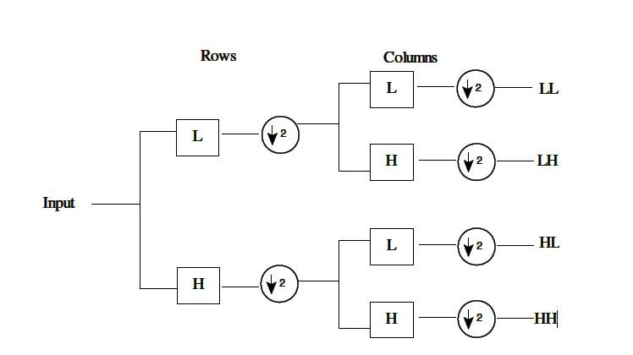

* The LL sub band is a result of low pass filtering in both column and row.It is also called approximate sub band .The HH sub band is result of high pass filtering in both column and row and contains high frequency components along the diagonal as well .
* The HL and LH are obtained as a result of high pass filtering in one direction and low along other direction .The HL represents horizontal detail from vertical edges and LH represents vertical detail from horizontal edges.
* HL,LH,HH are called detailed sub bands.

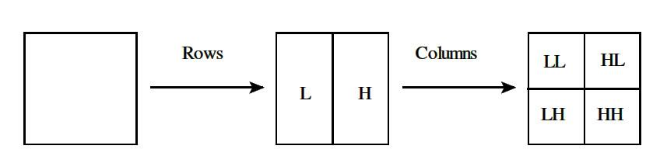

**Fig : One DWT Decomposition Step**

**Composition process:**

* The inverse of above process is known as composition process .The information from four sub images is up sampled and then filtered with the corresponding inverse filters along columns.
* The 2 sub images formed as a result of above processes are again up sampled and filtered with corresponding inverse filters along the rows.

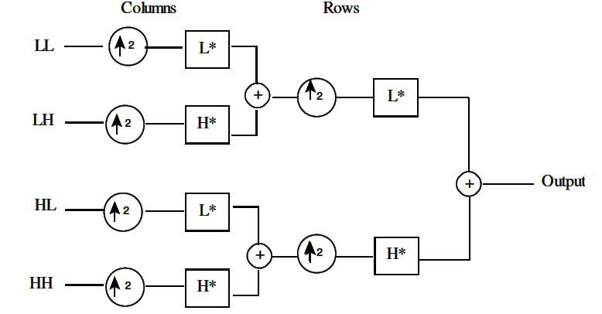

* In case of 2-D images N level decomposition can be performed resulting in 3N +1 different frequency bands namely LL,LH,HL,HH.The next level decomposition is applied to LL.
* The sub bands HH\*k,HL\*k,LH\*k are called the details where k is level ranging between 1 to j-1 where j is highest level ,The sub band LL\*j is the low resolution residual .The wavelet thresholding de-noising method filters each coefficient from the detail subband with a threshold function to obtain modified coefficients.The denoised coefficients can be estimated by inverse wavelet transform of the modified coefficient .Hence thresholding plays a major role in de noising.

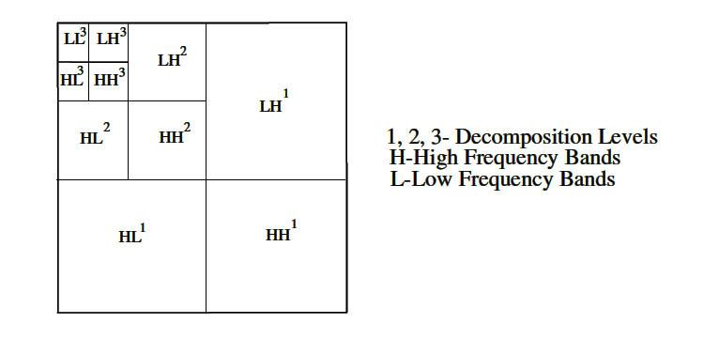

**Fig : Subbands of 2-D Discrete Wavelet Transform**

**Thresholding-**

In wavelet ,coefficients with small absolute value are dominated by noise,while coefficients with large absolute value carry more signal information than noise.

In thresholding the noisy coefficients whose value is less than certain threshold value is replaced by zero and inverse wavelet transform resulting in approximate image of less noise.

The idea of thresholding came into existence because of following assumptions :

* The décor relating property of a wavelet transform creates a spare signal most untouched coefficients are zero or close to zero .
* Noise is spread out equally along all coefficients
* The noisy values are not so high so that the signal wavelet coefficients

Can be distinguished from noisy ones.

Types of thresholding

* There are mainly two types:
* Soft thresholding
* Hard thresholding
* Soft thresholding is also called shrinkage function, takes the arguments and shrinks the coefficients to zero by the threshold U.Thresholding operator is given by,

Hard thresholding is given by,

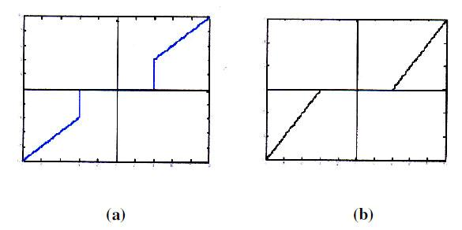

**Fig : represents (a) Hard Thresholding , (b) Soft Thresholding**

* Hard thresholding follows keep and kill rule whereas soft thresholding shrinks coefficients above the threshold in absolute value.
* Though hard thresholding seems to natural ,it doesn’t works efficiently as annoying blips appear in the output .Soft thresholding shrinks these false structure thresholding by making algorithm more attribute to mathematicians.
* The wavelet thresholding procedure removes noise by applying thresholding only the wavelet coefficients of detailed sub bands, while keeping the low resolution coefficients unaltered .soft thresholding yield visually more pleasing images than hard thresholding.

**Types of Thresholding Techniques:**

* Visu Shrink
* Sure Shrink
* Bayes Shrink
* Feature Adaptive Shrinkage etc.

As observed above, image denoising using fouier transform(FFT) is some way possible and the noise is not removed completely as expected. THUS, we have gone through **Discrete Wavelet Transform(DWT)** using **Adaptive Thresholding** **Technique,** we analysed different test images for 3 levels of thresholding technique .We observed that for level 1, the image is reconstructed(enhanced) most approximate to the original one. Whereas for levels 2, 3 the clarity of the image is slightly decreased consecutively. i.e., due to more loss of coefficient details.

Here we applied a Gaussian noise, which is evenly distributed i.e. noisy image =true pixel + Gaussian distributed value. Noise is independent of intensity of pixel value. It arise during acquisition. For eg: poor illumination.

Then the median filter is applied, which is a nonlinear digital filtering technique, often used to remove noise from an image or signal. Such noise reduction is a typical pre-processing step to improve the results of later processing (for example, edge detection on an image). Median filtering is very widely used in digital image processing because, under certain conditions, it preserves edges while removing noise (but see discussion below), also having applications in signal processing.

Wavelet Transform performs much better than other transforms like FFT and Laplace in image denoising due to it’s properties. Hence the below images are the results obtained by applying DWT, thresholding technique and IDWT are as follows:

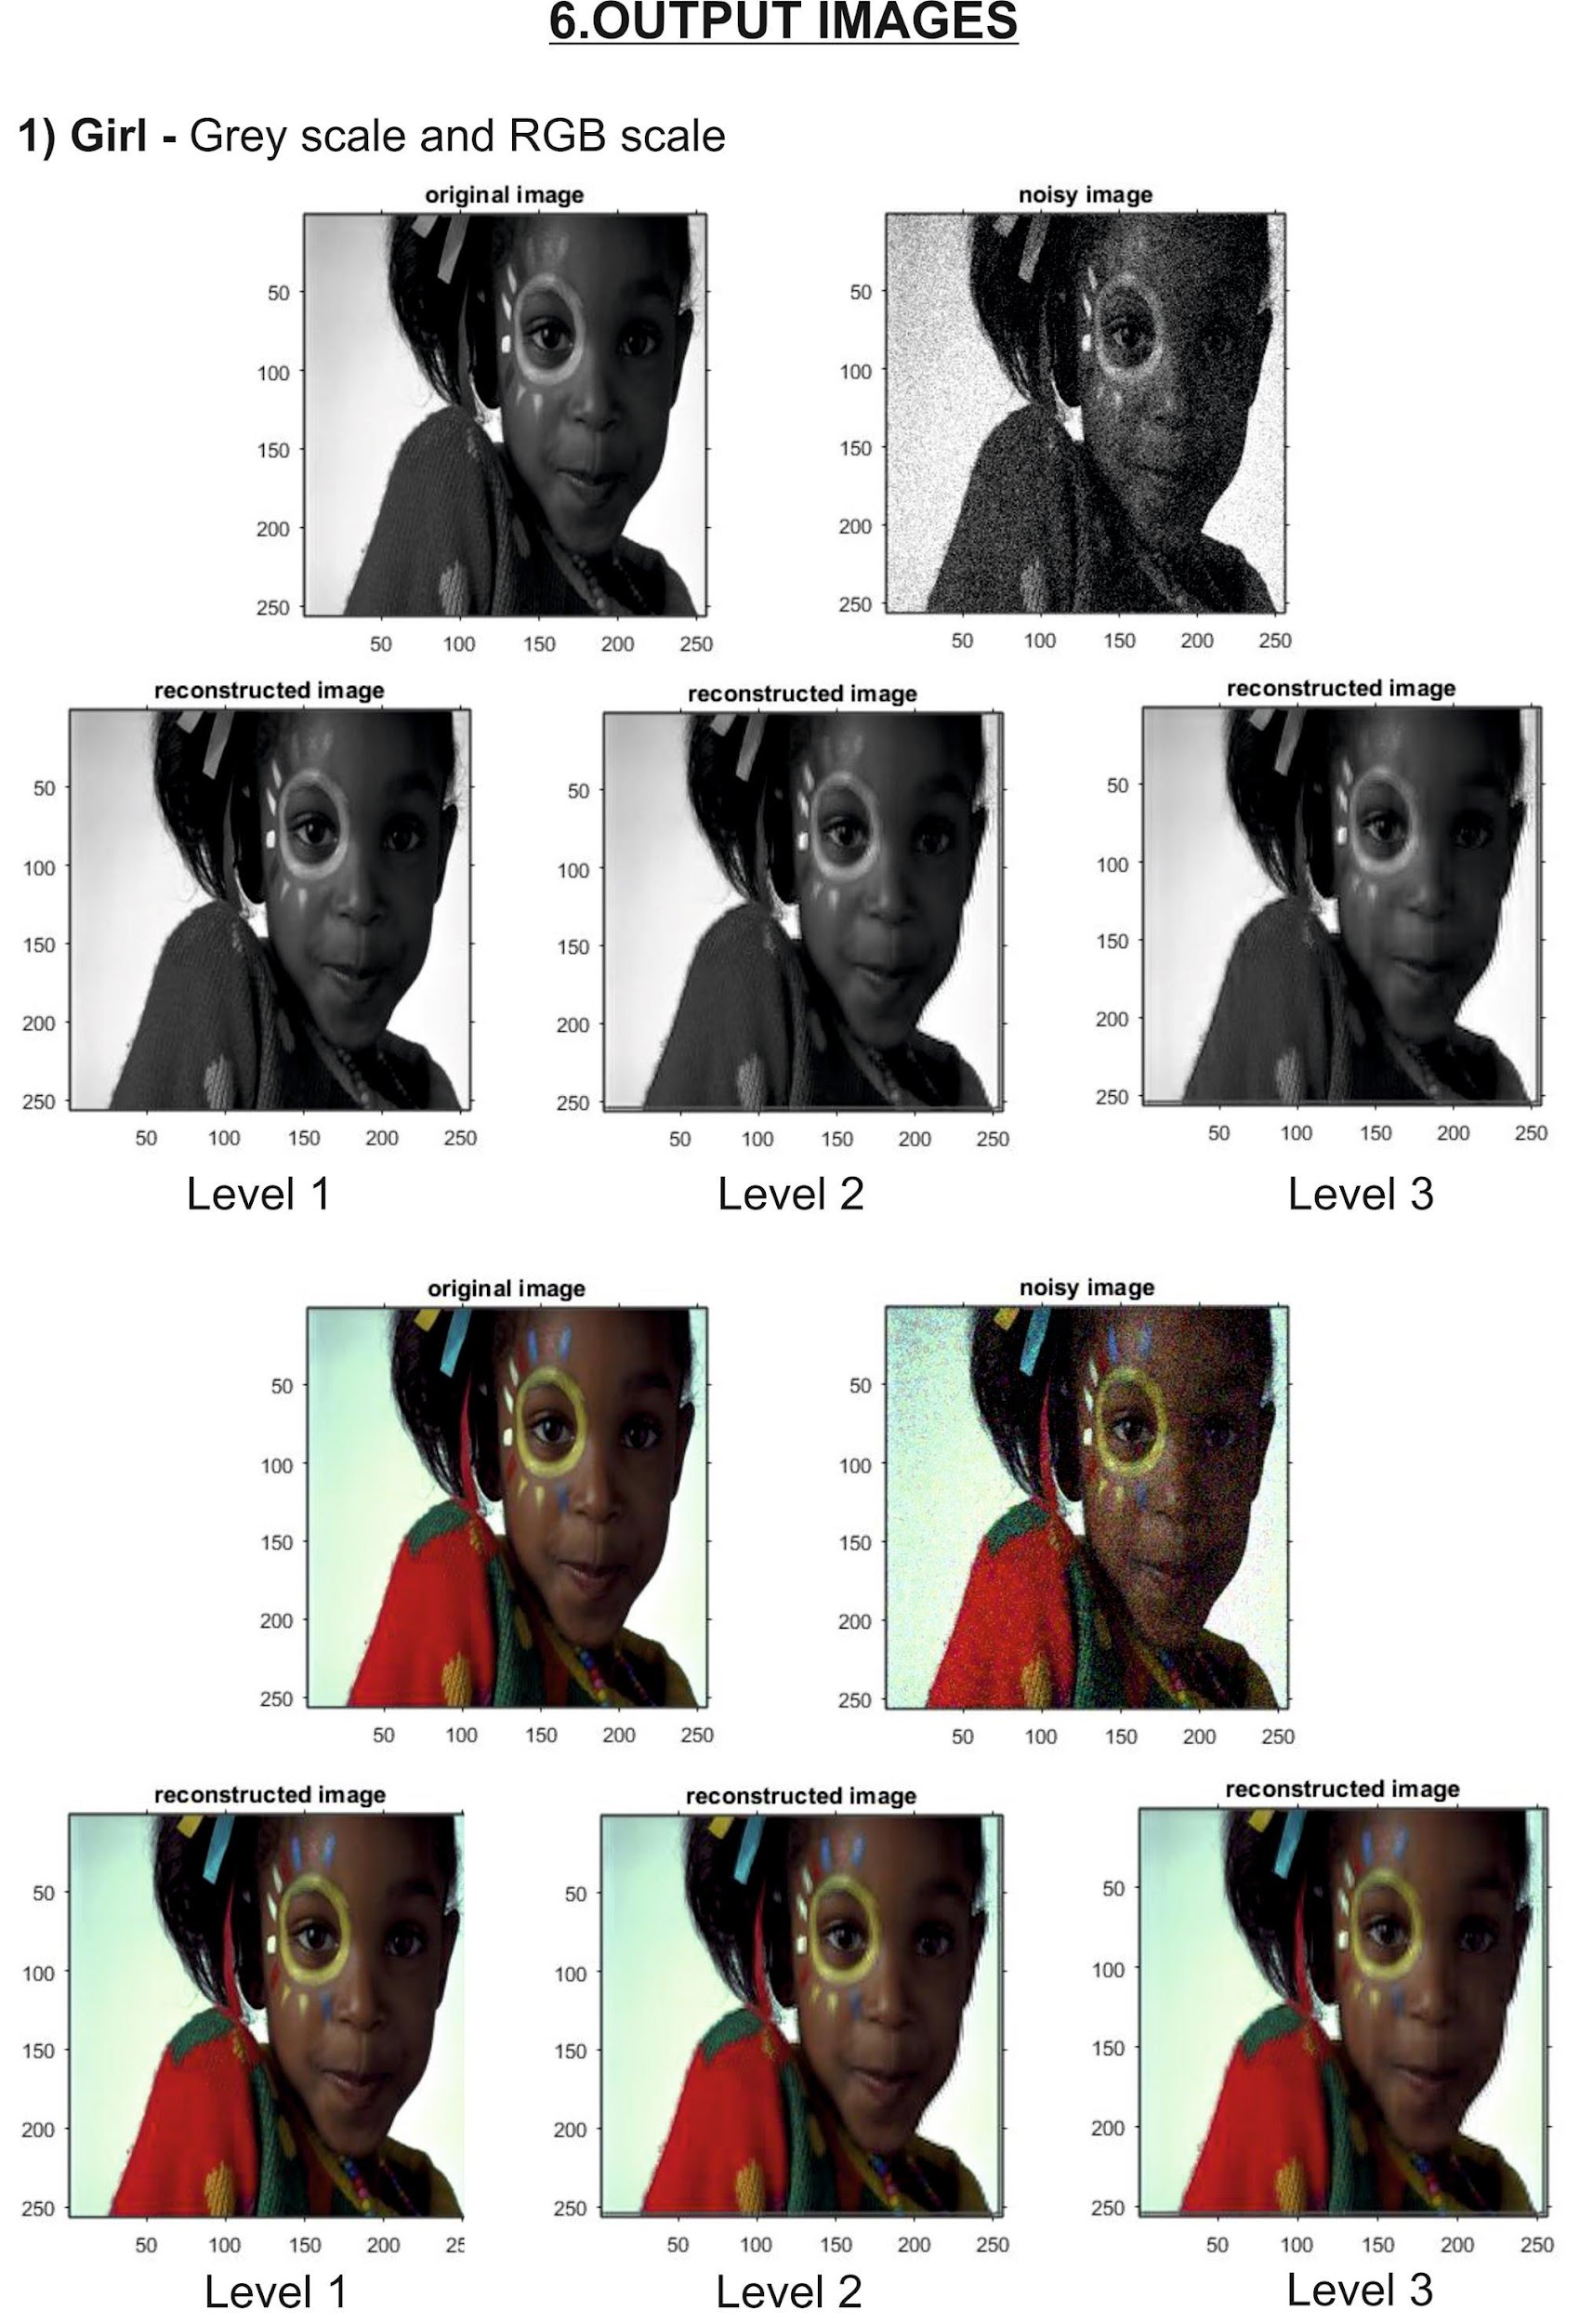

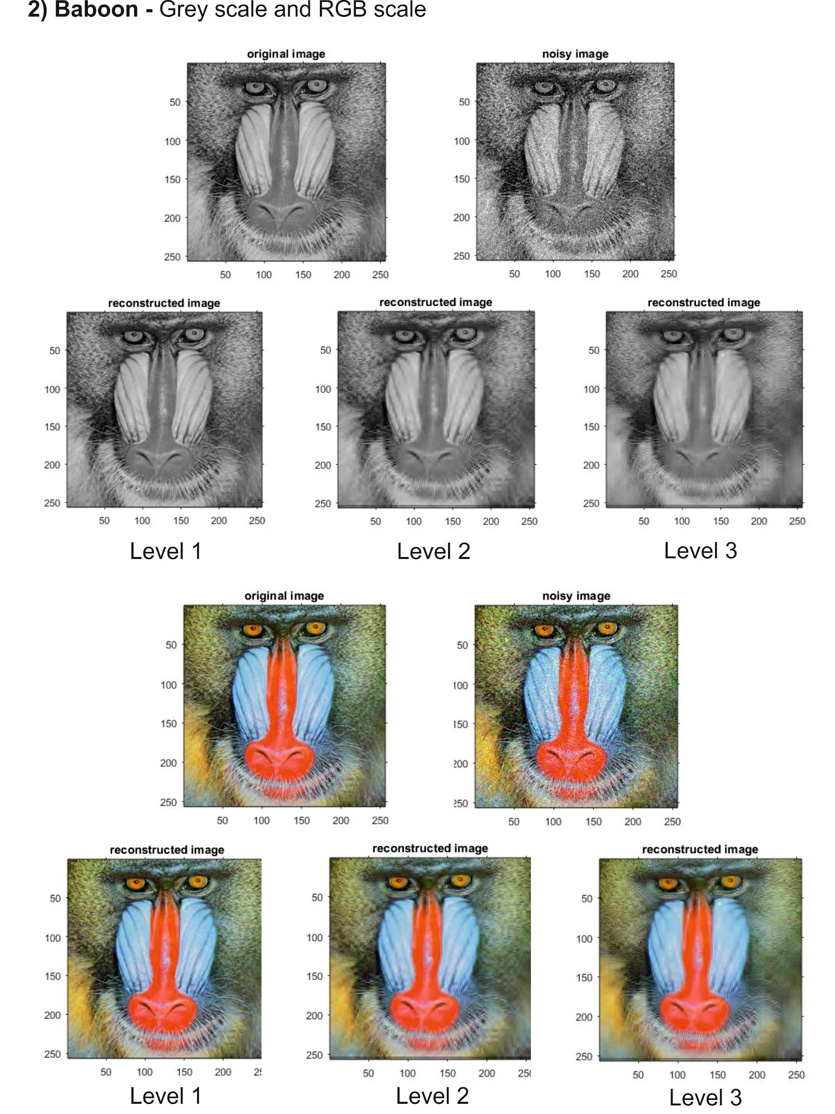

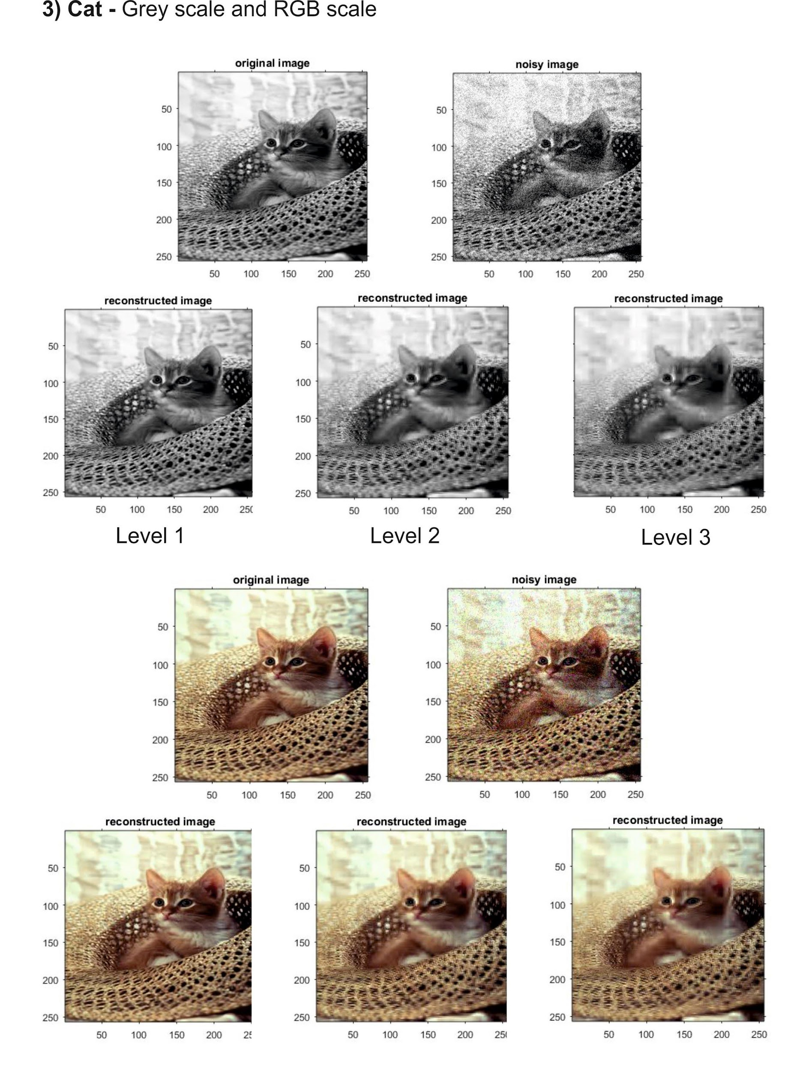

**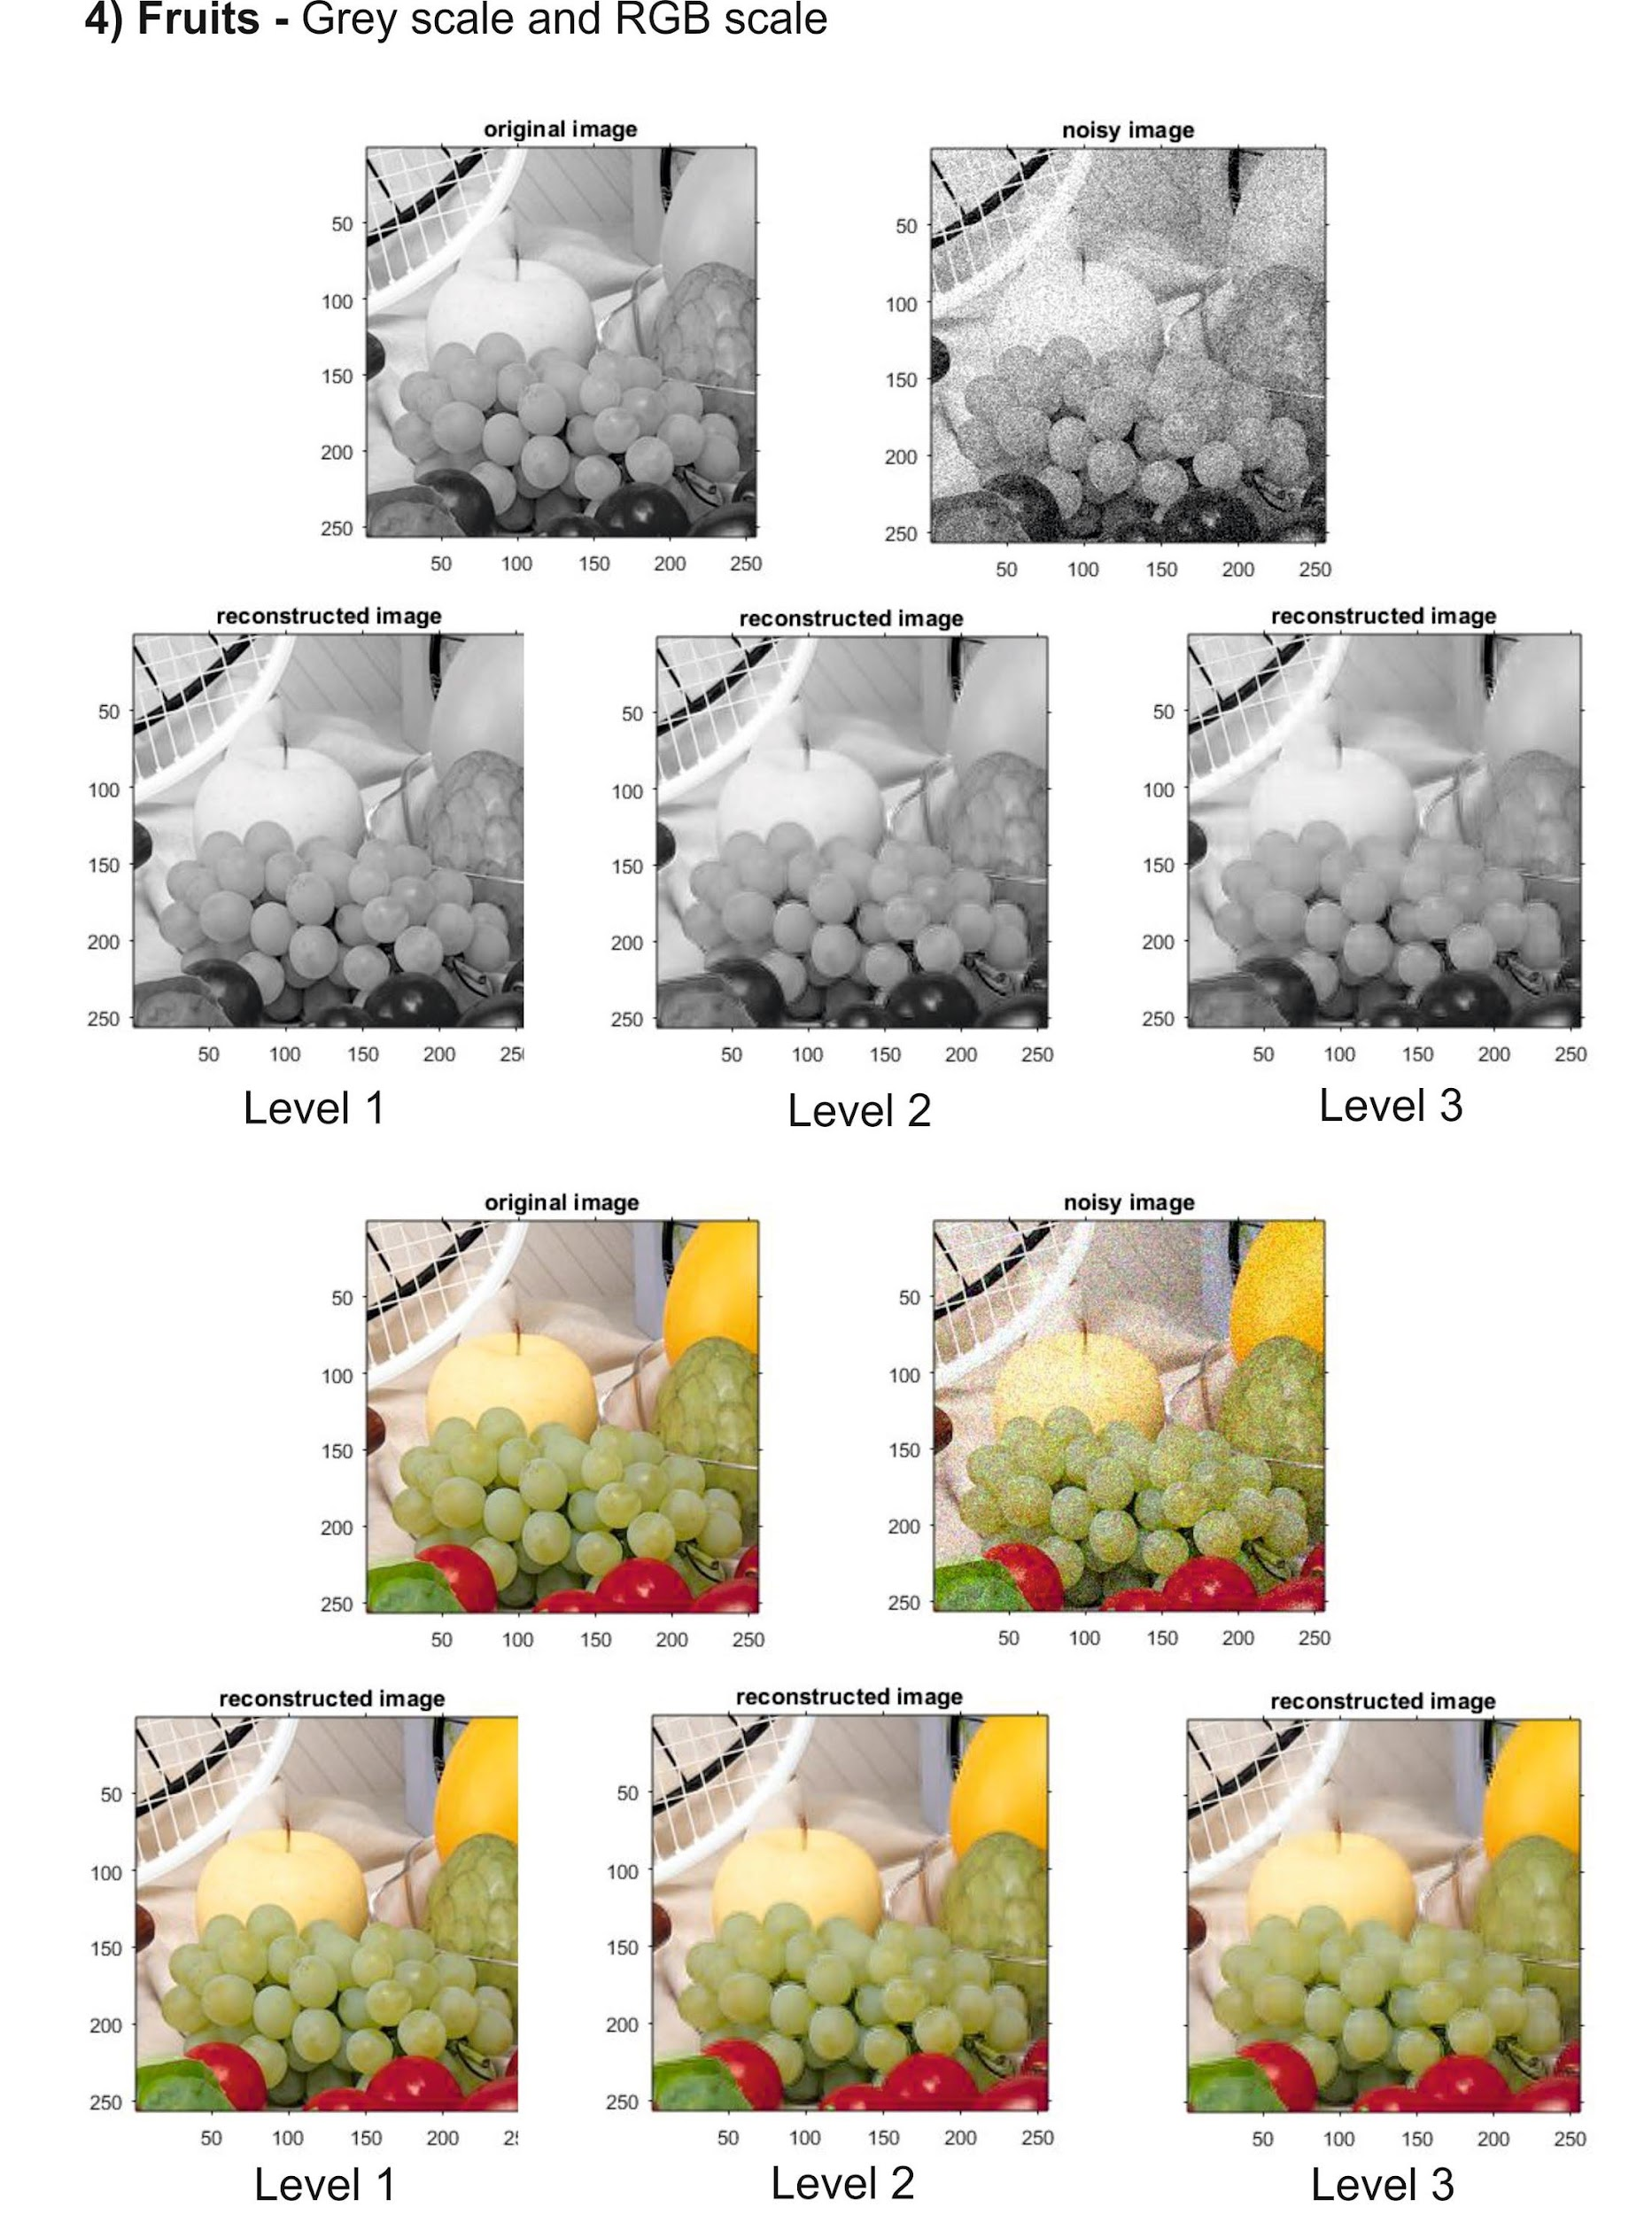**

**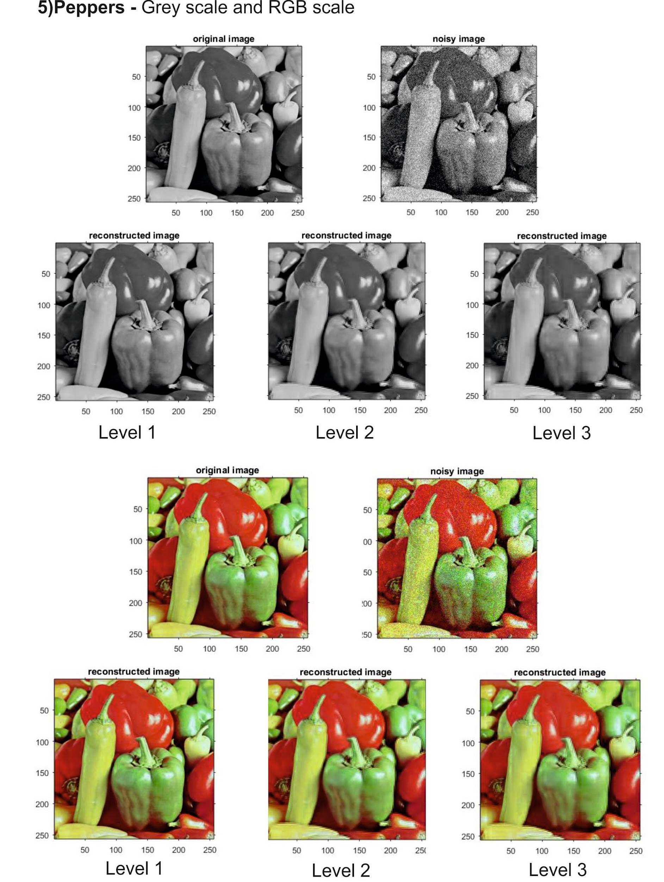**

**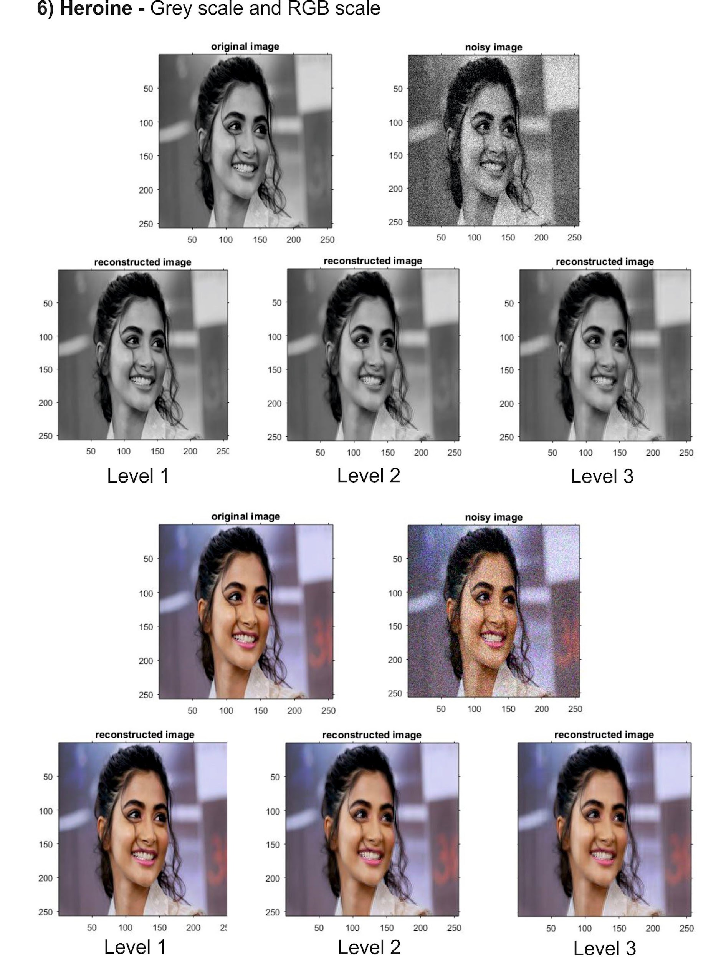**

**7.Peak Signal-To-Noise Ratio (PSNR) & GRAPHS:**

**Introduction**

The term **peak signal-to-noise ratio (PSNR)** is an expression for the ratio between the maximum possible value (power) of a signal and the power of distorting noise that affects the quality of its representation.  Because many signals have a very wide **dynamic range**, (ratio between the largest and smallest possible values of a changeable quantity) the **PSNR** is usually expressed in terms of the logarithmic decibel scale.

Image enhancement or improving the visual quality of a digital image can be subjective.  Saying that one method provides a better quality image could vary from person to person.   For this reason, it is necessary to establish quantitative/empirical measures to compare the effects of image enhancement algorithms on image quality.  
   
Using the same set of tests images, different image enhancement algorithms can be compared systematically to identify whether a particular algorithm produces better results.  The metric under investigation is the **peak-signal-to-noise ratio**.  If we can show that an algorithm or set of algorithms can enhance a degraded known image to more closely resemble the original, then we can more accurately conclude that it is a better algorithm.

**Mathematics**

For the following implementation, let us assume we are dealing with a standard 2D array of data or matrix.  The dimensions of the correct image matrix and the dimensions of the degraded image matrix must be identical. The mathematical representation of the **PSNR** is as follows:

/private/var/mobile/Containers/Data/Application/1C592000-9845-43F9-8C23-38EF7A8B0000/tmp/WebArchiveCopyPasteTempFiles/PSNR_MATH.png

**Figure 1 - Peak Signal-to-Noise Equation**

where the **MSE** (Mean Squared Error) is:

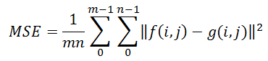

**Figure 2 - Mean Squared Error Equation**

This can also be represented in a text based format as:

MSE = (1/(m\*n))\*sum(sum((f-g).^2))

PSNR = 20\*log(max(max(f)))/((MSE)^0.5)

**Legend: f** represents the matrix data of our original image **g** represents the matrix data of our degraded image in question **m** represents the numbers of rows of pixels of the images and i represents the index of that row **n** represents the number of columns of pixels of the image and j represents the index of that column **MAXf**is the maximum signal value that exists in our original “known to be good” image

**Motivation for Use as an Image Quality Metric**

The mean squared error (MSE) for our practical purposes allows us to compare the “true” pixel values of our original image to our degraded image.   The MSE represents the average of the squares of the "errors" between our actual image and our noisy image. The error is the amount by which the values of the original image differ from the degraded image.

The proposal is that the higher the PSNR, the better degraded image has been reconstructed to match the original image and the better the reconstructive algorithm.  This would occur because we wish to minimise the MSE between images with respect the maximum signal value of the image

**Table : DWT (Adaptive Thresholding) Performance for Image Denoising in terms of PSNR**

**Operated on 6 test Grey Scale images at 3 thrsholding levels.**

| **S.NO** | **Images** | **level 1** | **level2** | **level 3** |
| --- | --- | --- | --- | --- |
| **1** | **Girl** | 47.4181 | 22.4806 | 22.4286 |
| **2** | **Baboon** | 32.9665 | 24.5876 | 24.3651 |
| **3** | **Cat** | 34.7032 | 19.2332 | 19.2435 |
| **4** | **Fruits** | 44.8468 | 26.6793 | 26.6053 |
| **5** | **Peppers** | 44.365 | 23.6689 | 23.552 |
| **6** | **Heroine** | 51.238 | 28.1815 | 28.1089 |

**Table : DWT (Adaptive Thresholding) Performance for Image Denoising in terms of PSNR**

**Operated on 6 test RGB Scale images at 3 thrsholding levels.**

| **S.NO** | **Images** | **level 1** | **level2** | **level 3** |
| --- | --- | --- | --- | --- |
| **1** | **Girl** | 47.1948 | 22.5253 | 22.4707 |
| **2** | **Baboon** | 32.4958 | 23.6472 | 23.4405 |
| **3** | **Cat** | 34.8649 | 19.559 | 19.5642 |
| **4** | **Fruits** | 43.9409 | 25.8936 | 25.7409 |
| **5** | **Peppers** | 43.5674 | 23.5587 | 23.4565 |
| **6** | **Heroine** | 49.7724 | 27.7333 | 27.6576 |

**GRAPHS : Plotted for above PSNR values obtained after applying source code on images.**



In both the graphs Indicates **Level 1**

Indicates Level 2

Indicates Level 3

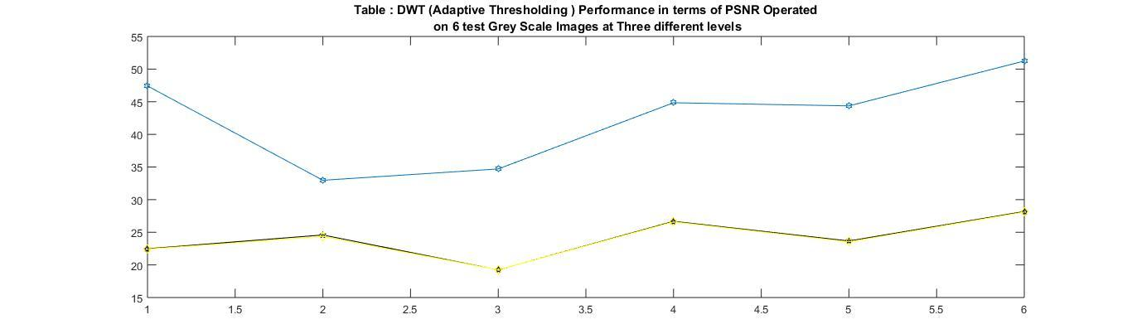

**Incase of Grey Scale Images**

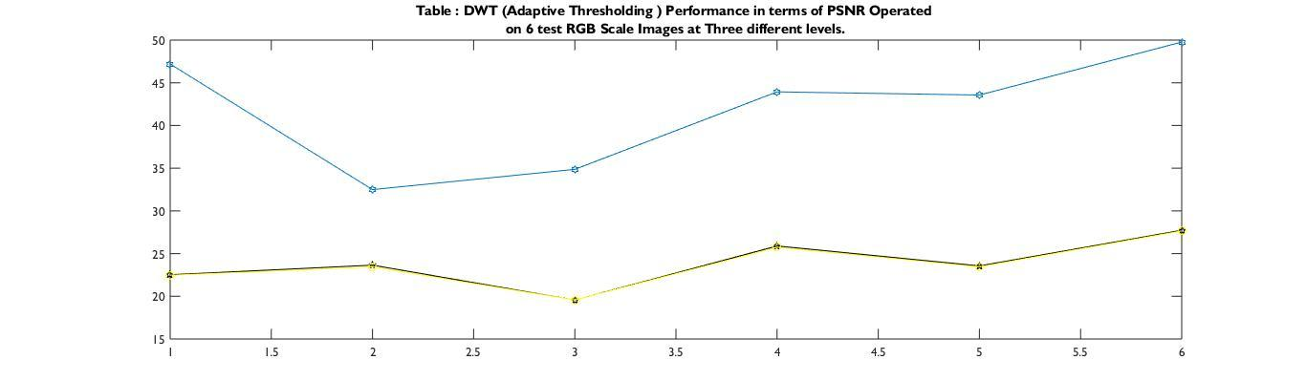

**Incase of RGB Scale Images**

**8. SCOPE OF FUTURE ENHANCEMENT:**

Till now we have gone through only one type of thresholding technique i.e; adaptive thresholding we can further use different types of thresholding techniques . Also we can further use different types of transformation techniques like Curvelet Transform, Counterlet Transform etc.

Also we have used this transformations only for image denoising but there are many different applications where these techniques can be used.

**9.CONCLUSION:**

As per the results its is clear that the denoising technique in wavelet domain is far better than denosing in FFT and other integral transforms also it is observed that as number of levels of thresholding is increased there is decrease in image enhacement ie;clarity of image is reduced . It is because of more difference in coefficient values.

**10.REFERENCES :**

1. “Image denoising using filtering and thresholding techniques in wavelet domain” by kalavathy.k ,department of computer science ,Dr.M.G.R educational and research institute ,university .
2. www. ni.com/white-paper “National instruments” .
3. [http://Sushu.ut.ee/imageprocessing/book/1](http://sushu.ut.ee/imageprocessing/book/1)
4. <http://www.tutorialspoint.com>
5. “Image De-noising by Various Filters for different noise” ,Internal journal of computer application.
6. [www.iro.umonteral.ca](http://www.iro.umonteral.ca)
7. “Image de-noising using wavelets” by Raghuram Rangarajan, Ramji Venkataraman ,Siddharth shah.
8. Suitability for image processing application by Priyanka Rathore It 3rd year IMSEC.