# 

October 14, 2022

Gopi Krishnan S

HIGH LEVEL DESIGN (HLD)

E-COMMERCE COMPANY

# Document Version Control

|  |  |  |  |
| --- | --- | --- | --- |
| Date Issued | Version | Description | Author |
|  | 1.0 | First version of Complete HLD | Gopi Krishnan S |
|  |  |  |  |
|  |  |  |  |
|  |  |  |  |
|  |  |  |  |

Contents

0

Document Version Control 1

Abstract 3

1. Introduction 4

1.1. Why this High-Level Design Document? 4

1.2. Scope 4

2. General Description 4

2.1. Product Perspective & Problem Statement 4

2.2. Tools Used 5

3. Design Details 5

3.1. Functional Architecture 5

4. KPIs 5

# Abstract

Designing a Dashboard for the analytics team of an Online E-Commerce Company to analyse the sales based on various product categories and features like user control for product category, so user can select a category and can see the trend month-wise and product - wise accordingly.

# Introduction

## Why this High-Level Design Document?

The purpose of this High-Level Design (HLD) Document is to add the necessary detail to the current project description to represent a suitable model for coding. This document is also intended to help detect contradictions prior to coding, and can be used as a reference manual for how the modules interact at a high level.

**The HLD will:**

• Present all of the design aspects and define them in detail

• Describe the user interface being implemented

• Describe the hardware and software interfaces

• Describe the performance requirements

• Include design features and the architecture of the project

## Scope

The HLD documentation presents the structure of the system, such as the database architecture, application architecture (layers), application flow (Navigation), and technology architecture. The HLD uses non-technical to mildly-technical terms which should be understandable to the administrators of the system.

# General Description

## Product Perspective & Problem Statement

The Company is looking to draw insights into their sales data to understand the profitability of various products and categories across different regions and age group.

The objective of the project is to create a dashboard with adequate visualizations and slicers to understand the data. This project applies features like Power pivot, Power query, pivot tables and charts in MS excel to get a visual understanding the data.

## Tools Used

MS Excel (Pivot table, Power query, Power pivot)

  

# Design Details

## Functional Architecture

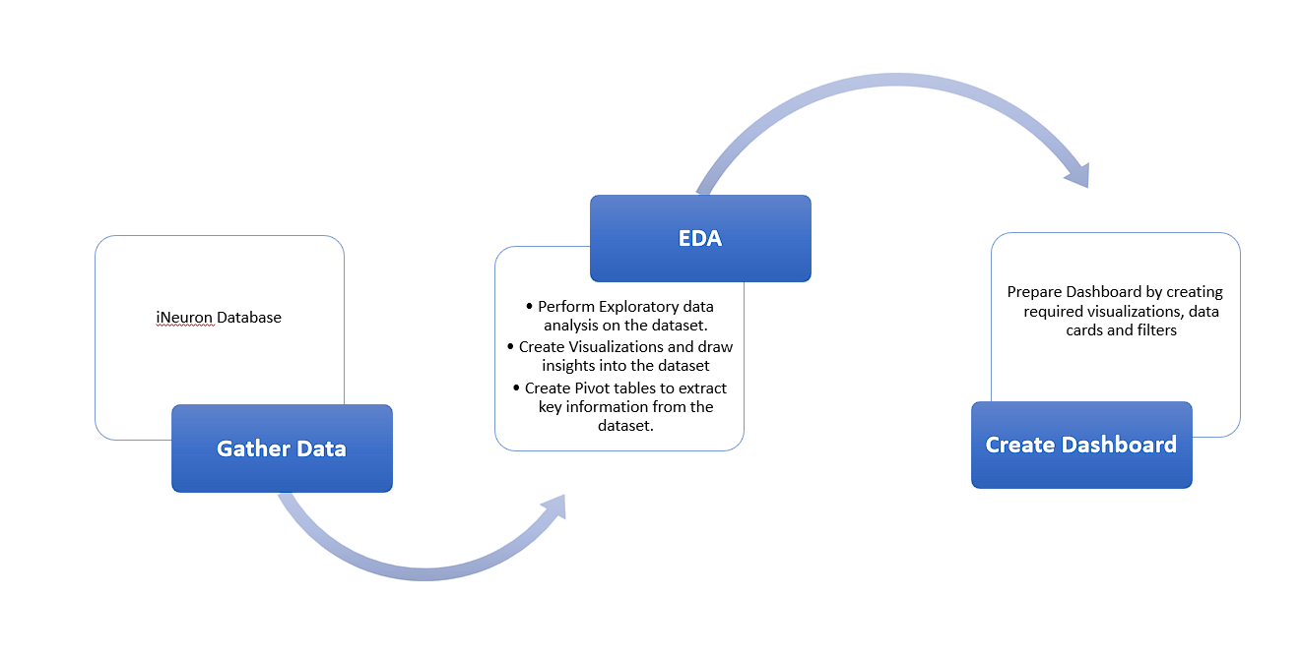

# KPIs

The Dashboard will display and indicate KPIs and relevant indicators for the sales.

Indicators displaying a summary of the Sales, Quantity and Profit for different product categories, and the sales across each month, region and age group.