ASSIGNMENT -1 - STATISTICS

Que 1) Plot a histogram,

10, 13, 18, 22, 27, 32, 38, 40, 45, 51, 56, 57, 88, 90, 92, 94, 99

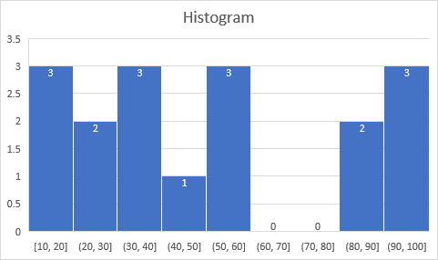

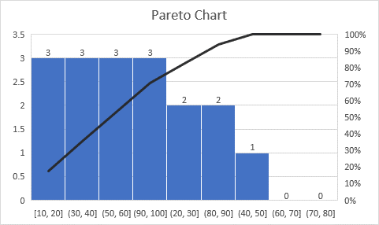

**Parameters:**

Bin Size = 10

Number of Bins = 9

Que 2) In a quant test of the CAT Exam, the population standard deviation is known to be 100. A sample of 25 tests taken has a mean of 520. Construct an 80% CI about the mean.

Standard deviation (σ) = 100

Sample size (n) = 25

Sample mean (x̄) = 520

Confidence interval (C.I) = 80% = 0.8

α = 0.2

The t-table is considered here as the sample size is less than 30 .

C.I = x̄ ± tα/2 × σ/√n

From t table,

t0.1 = 1.711

520 ± 1.711 x 100/(√25)

520 ± 34.22

**The intervals are 554.22 & 485.78**

Que 3) A car believes that the percentage of citizens in city ABC that owns a vehicle is 60% or less. A sales manager disagrees with this. He conducted a hypothesis testing surveying 250 residents & found that 170 residents responded yes to owning a vehicle.

1. State the null & alternate hypothesis.
2. At a 10% significance level, is there enough evidence to support the idea that vehicle owner in ABC city is 60% or less.

(a)

Null hypothesis is: H0 ≤60

Alternate hypothesis: Ha > 60

Since the Alternate hypothesis has to show only greater than 60, this is a **1 tail test**.

Significance value is = 0.10, **which** **represents the area.**

**Z – test :**

n = 250

P0 = 60 =0.6

P` = 0.68

q0 = 0.4

Z- Test value proportions = 2.6

Area representing H0  = 1 – 0.10 = 0.90

Using z table to find the z score ; closest one is 1.29 = 0.90147

Since 2.6 is greater than 1.29 , the **Null hypothesis is rejected. The sales manager`s disagreement is right.**

Que 4) What is the value of the 99 percentile?

2,2,3,4,5,5,5,6,7,8,8,8,8,8,9,9,10,11,11,12

n= 20

99th percentile = (99/100) x (n+1)

= (99/100) x 21 = 20.79

Since 20 is the highest count , the 99th percentile is taken as **12**.

Que 5) In left & right-skewed data, what is the relationship between mean, median & mode?

Draw the graph to represent the same.

**In Right Skewed distribution, the Mode < Median < Mean**

**In Left Skewed distribution, the Mean < Median < Mode**

