# Project 1 : WEB API Project

### Technology Stack

Used following stack of technologies:

* ASP.NET Core 3.1.0 as base platform;
* EF Core 5.0.6 as primary ORM;
* ASP.NET Core Identity 3.1.0 for authentication and authorization;
* JWTBearer 3.1.11 for OAuth authorization;
* Swashbuckle.AspNetCore.SwaggerGen for Swagger docs and UI;
* SQL Server 2012
* AutoMapper 10.1.1 for object to object mapping
* Aspnetcore.Mvc.versioning 5.0 for API Versioning
* Repository design Pattern.

Step 1: Update Connection String in appSetting.Json

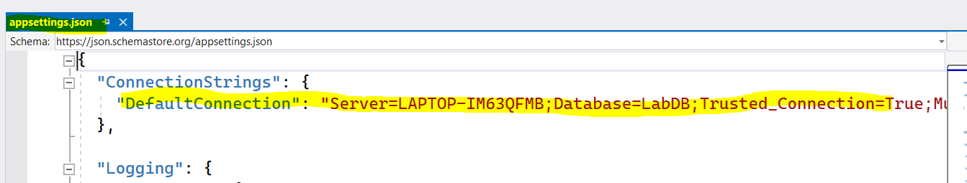

Step 2: From Package Manager Console, Run below command

* Add-Migration {MigrationName}
* Update-Database

Above step will create DB and Table Objects

Step 3: Build and Run Project