Visitor’s and staff member’s experience was prioritised while making this software.

Home page: This page is created for visitors with the focus to make it much informative as possible for them.
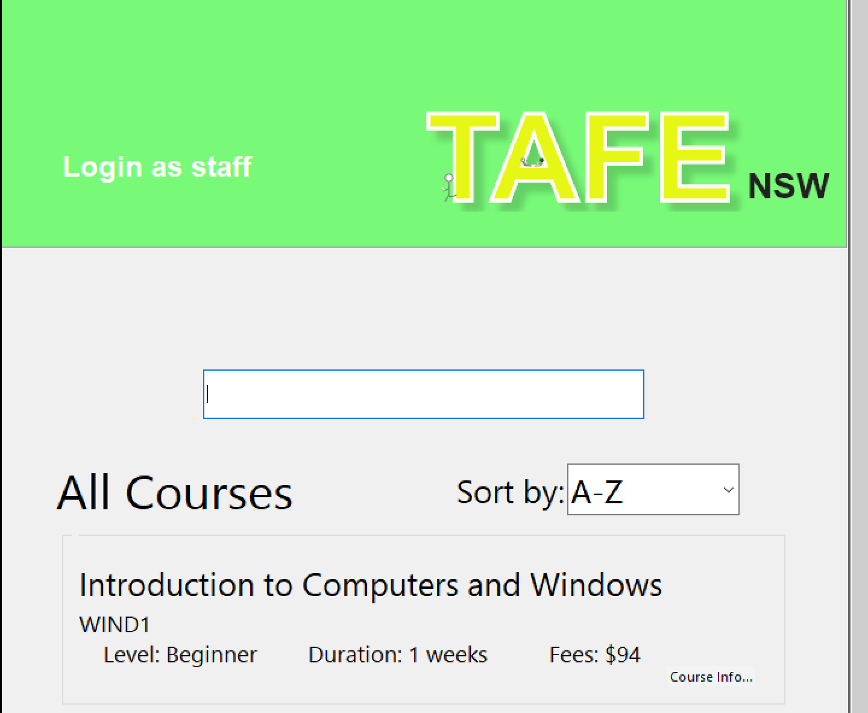
Login button - for staff members to identify themselves.
Search-bar – for users to search for courses. For every character user inputs, search-bar will search automatically.
Combo-box – Sort the courses with A-Z, duration, level, or fees.
Course Info button – to view more info on the course.

Login Page: Staff members can login with their special username and password. This will provide the staff members with special functionalities.
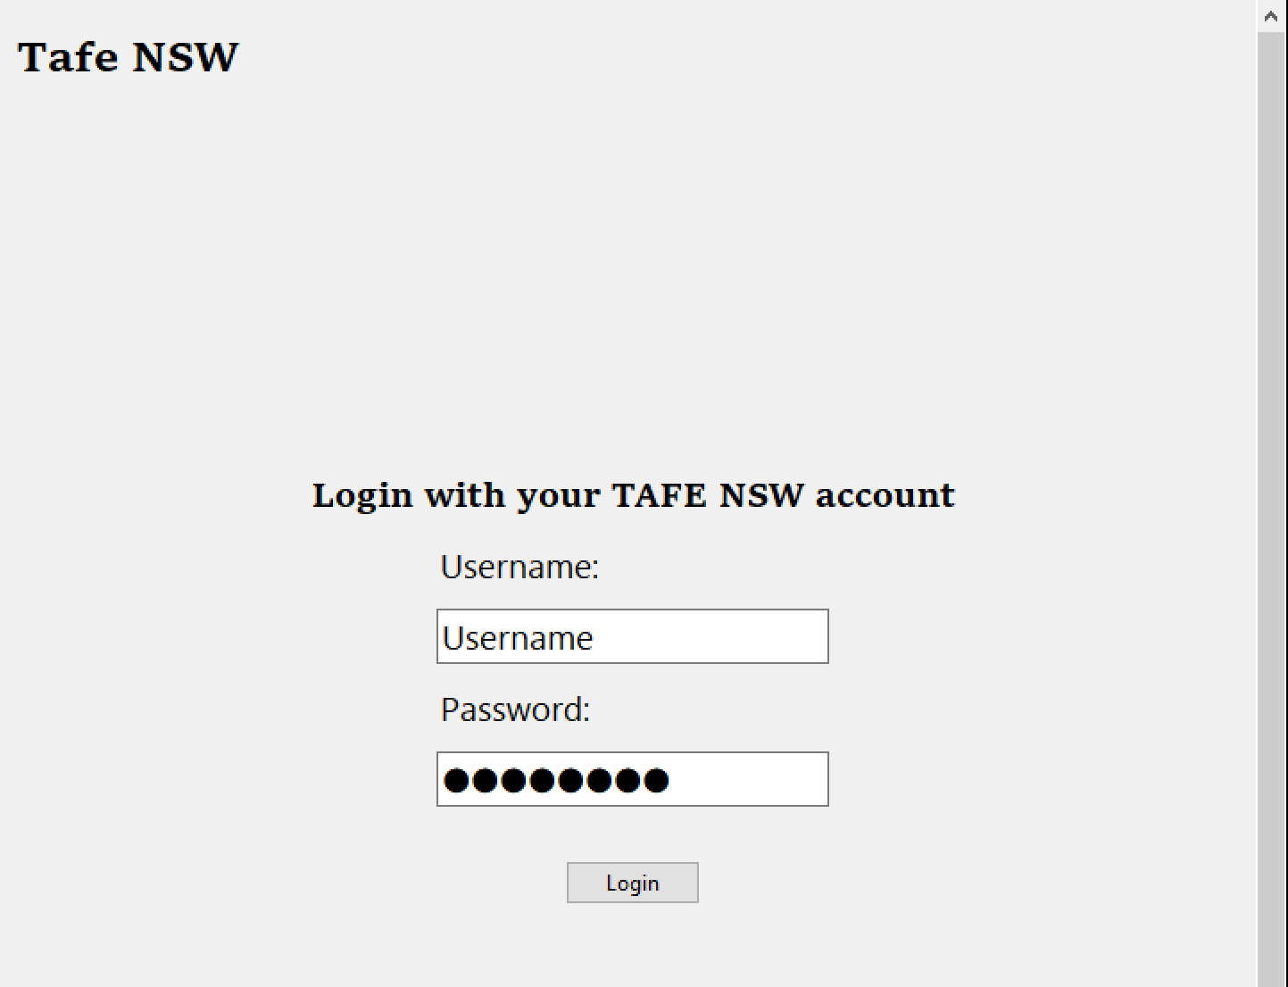
Back button – Tafe NSW works as a back button to go to a previous page.
Login Entry – User will have to provide their special username and password. Doesn’t work though.

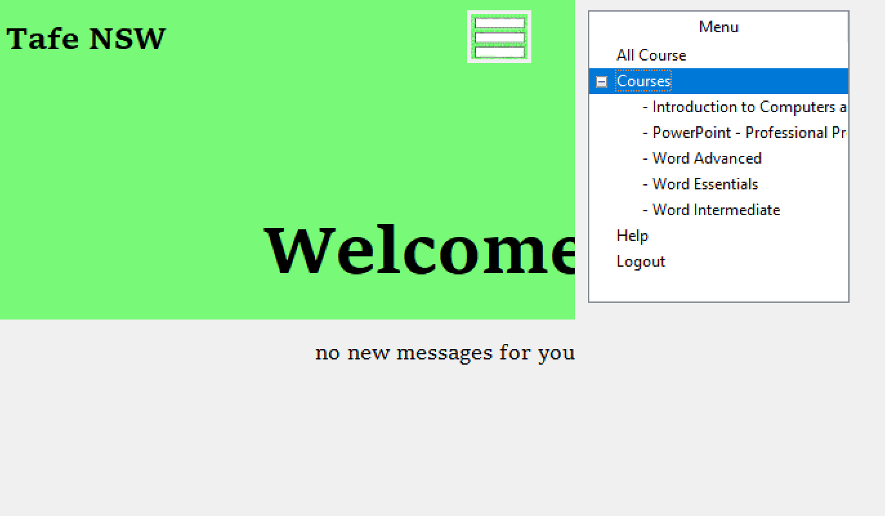
Welcome page – The purpose of this page is to be a root path to all pages. All pages can be accessed from here.
Hamburger button – will open and close the menu bar.
All course button – This button will take the staff members to all courses page.
Logout button – logs the staff member out and bring them to home page.

This is ‘all course page’ for staff members only. It is similar to the home page but there is more functionalities to this page.
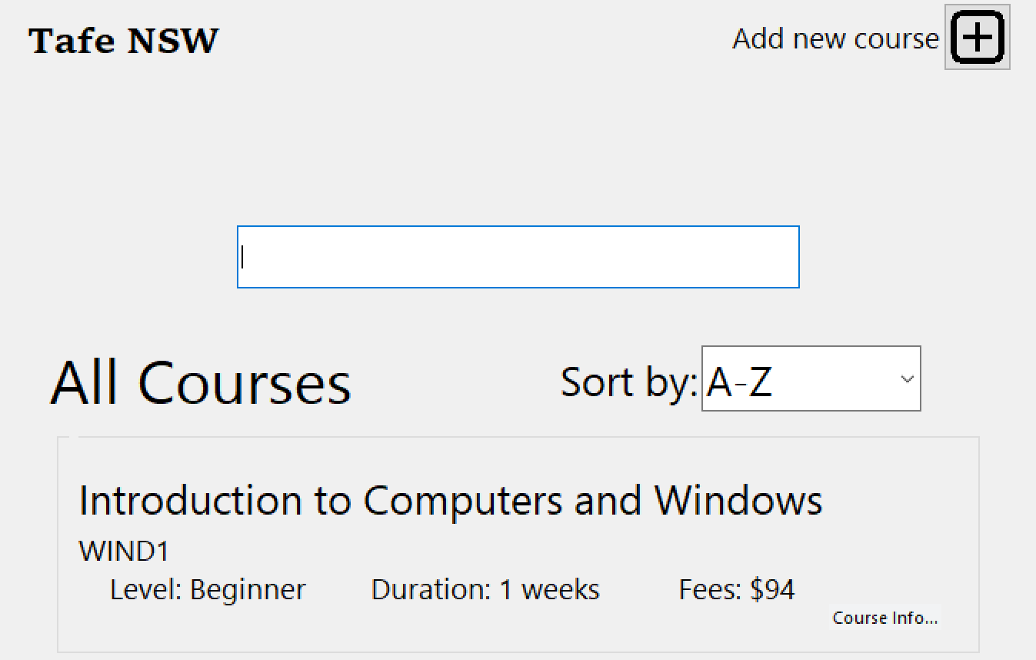
Add new Course button- will open a new Top-level window for staff to add the new course details.

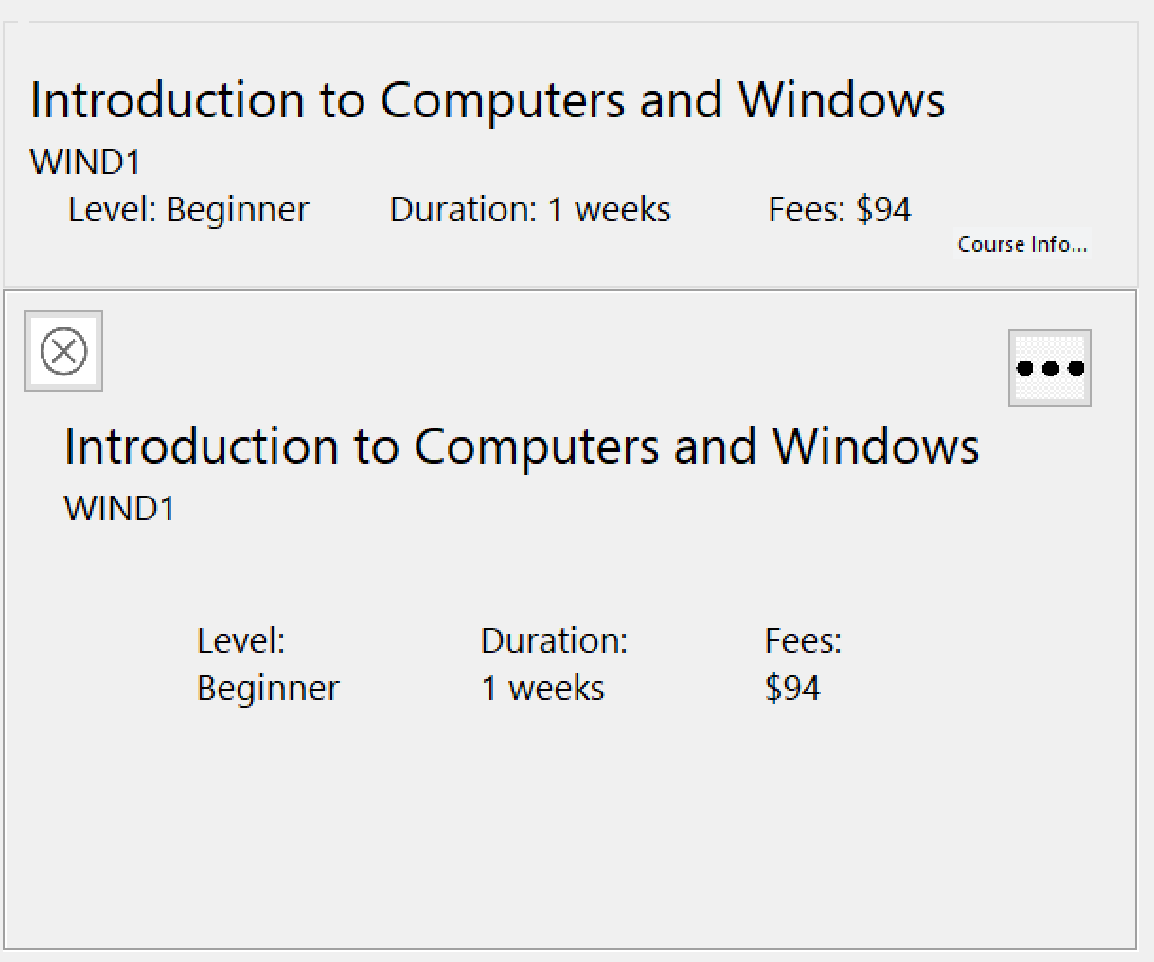
When clicked ‘Course Info’, a frame will appear beneath the course with more details of the course.
Meatball menu – this will open or close the menu.
The menu contains: edit and delete button


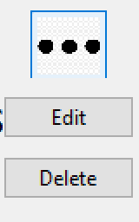

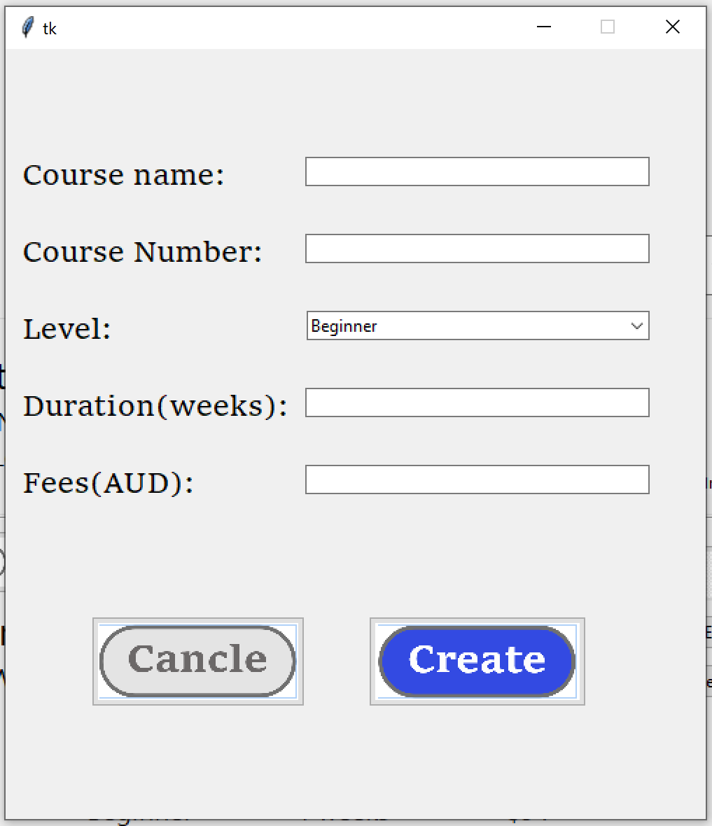
When creating and editing a course it is import to get the syntax right. There is different syntax rules for each detail entry. Let’s have a look at each syntax rule.
Fees – Entry must be either integer or floating point.
Duration – Entry must be numeric, meaning not 0 or -1.
Course number – All letters must be upper case.
Course name – Requires the entry to not be empty.

