Game Design Document

Fill up the Following document

1. Write the title of your project.

TEMPLE MARIO

1. What is the goal of the game?

TO SCORE HIGHEST AND HIGHEST

1. Write a brief story of your game?

A PLAYER HAS TO JUMP ALL THE OBSTACLE AND REACH

TO HIGHEST SCORE

1. Which are the playing characters of this game?

* Playing characters are the ones which respond to the user based on the input from the user
* Cars, monkeys, dinos, wizards etc, are the playing characters in the game.

|  |  |  |
| --- | --- | --- |
| Number | Character Name | What can this character do? |
| 1 | PLAYER | HAS TO JUMP ALL THE OBSTACLES COME IN THE PATH |
| 2 |  |  |
| 3 |  |  |
| 4 |  |  |
| 5 |  |  |
| 6 |  |  |
| 7 |  |  |
| 8 |  |  |

1. Which are the Non Playing Characters of this game?

* Non Playing characters are the ones which don't have an action or a behaviour when the user interacts with the game.
* Hurdles, stones, bananas, coins, etc are non playing characters in the game.

|  |  |  |
| --- | --- | --- |
| Number | Character Name | What can this character do? |
| 1 | STONE | HAS TO COME IN  PATH OF RUNNER |
| 2 |  |  |
| 3 |  |  |
| 4 |  |  |
| 5 |  |  |
| 6 |  |  |
| 7 |  |  |
| 8 |  |  |

Draw your imagination of this game. What does this game look like?

* Draw the game either on your computer or on paper,
* Add images of scenes of the game to show each of the playing and non-playing characters at least once.

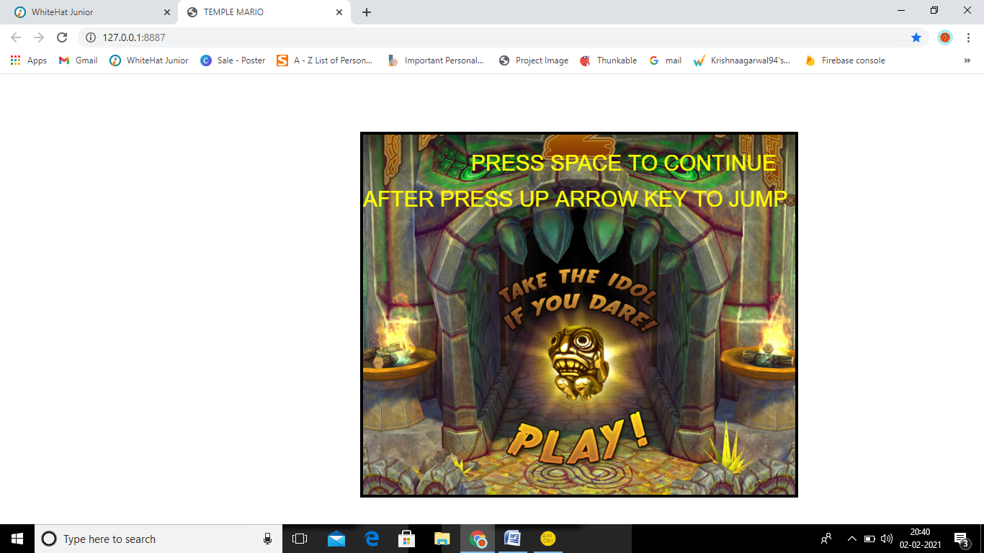

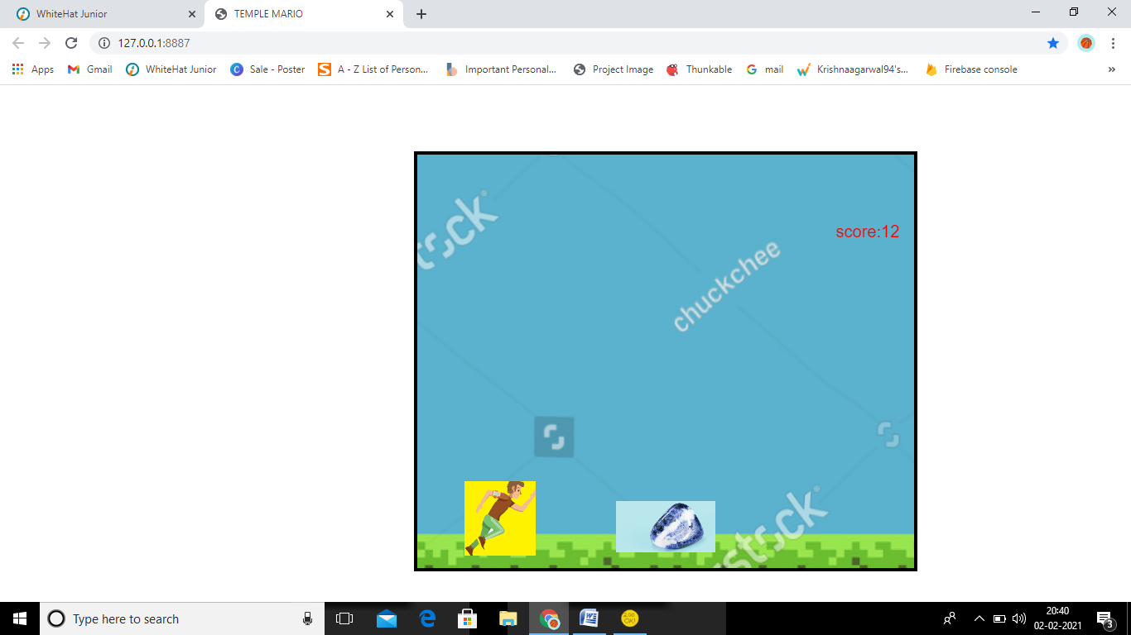

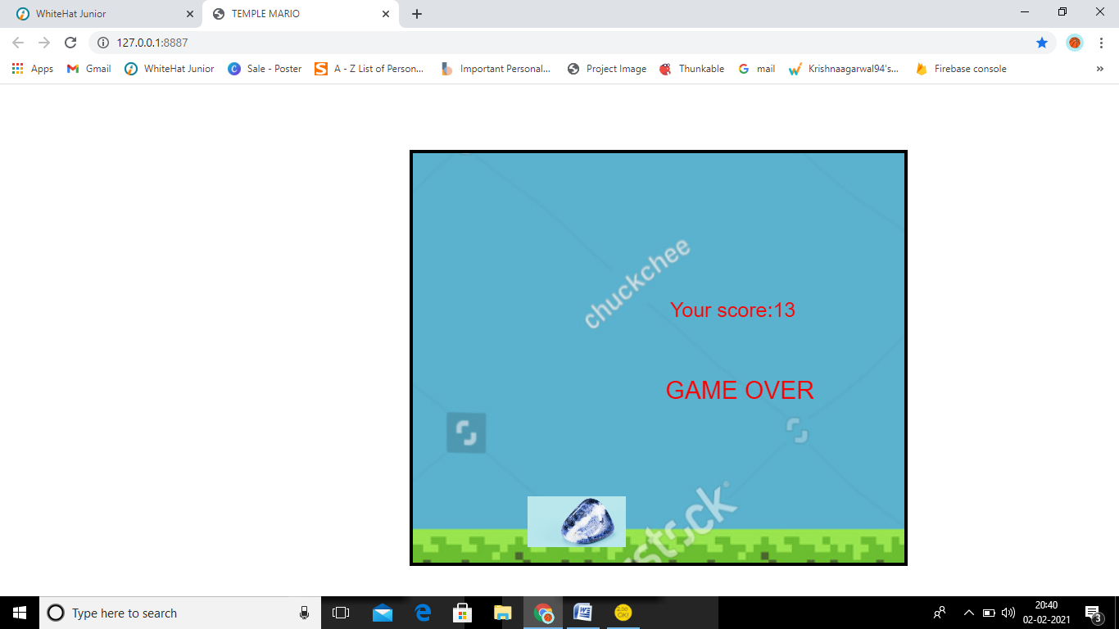

How do you plan to make your game engaging?

MAKE THE BACKGROUND MORE ATTRACTIVE AND IMAGES ALSO