NAMES: KEVADIYA RAJ ASHVINBHAI,

BHORANIYA KRISH

ROLL NUMBERS: 23BCE141,23BCE148

PROJECT TITLE: CAPITAL EXPENSE DISTRIBUTERS

**PROJECT DETAILS:**

**INTRODUCTION:**

Our Project is simply a website where the user can count his/her expenses. We have used programming languages like HTML, CSS and Javascript to create the website. This is only a front-end design where no data will be stored to any point.

**REFERENCES:**

For reference, we have used many Youtube videos and some Other already created webpages. The Pictures are taken from google websites and some font types are taken from free online sources.

The links are below:

<https://fonts.googleapis.com>

<https://fonts.gstatic.com>

<https://fonts.googleapis.com/css2?family=Capriola&display=swap>

<https://fonts.googleapis.com/css2?family=Ubuntu&display=swap>

"<https://use.fontawesome.com/releases/v5.8.1/css/all.css>

We have use JQuery also which we linked in our pages by:

|  |
| --- |
|  |
| <https://ajax.googleapis.com/ajax/libs/jquery/3.7.1/jquery.min.js>"></script> |
|  |

**OUTPUTS:**

**1.HOMEPAGE:**

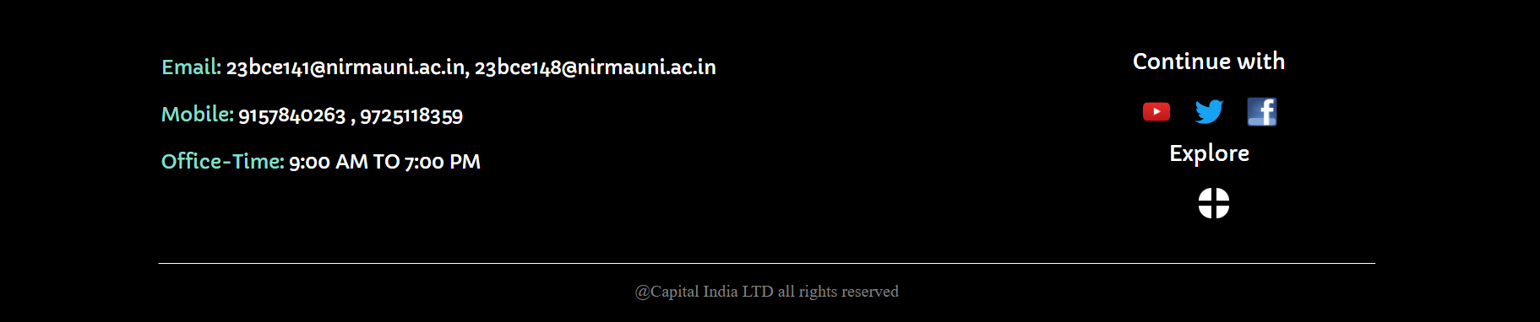

This is the image of the homepage of the website with its title. It contains a navigation bar with four tabs of HOME, LOGIN, SIGN UP and CONTACT. It also contains an image slider running in loop with three images of quotes and on its right there is a paragraph explaining the ethics of work in capital.

By scrolling down there is a footer containing the Emails and Mobile numbers of the members and Off-line working time and shortcuts to some apps like Facebook, Twitter and Facebook.

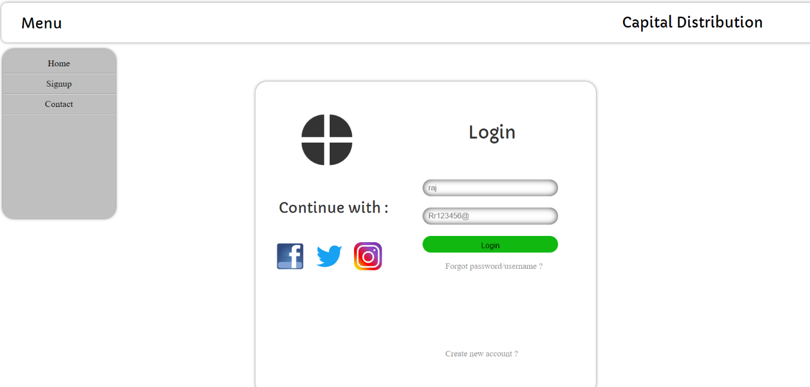 **2. LOGIN PAGE:**

This is an image of the Login-page of the website. It contains Menu-bar, Username input, Password input, password tracker, a path to Sign up page and a submit button.

**3. SIGN UP PAGE:**

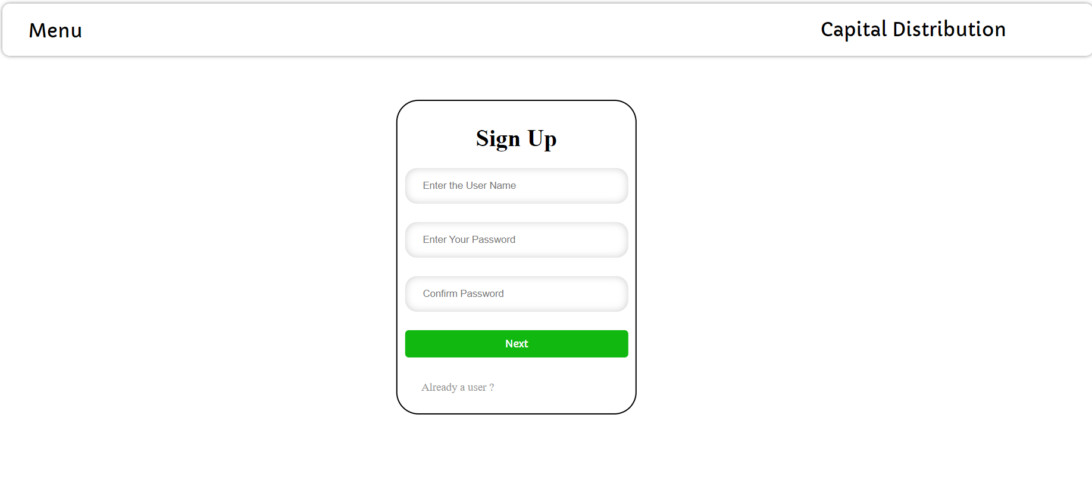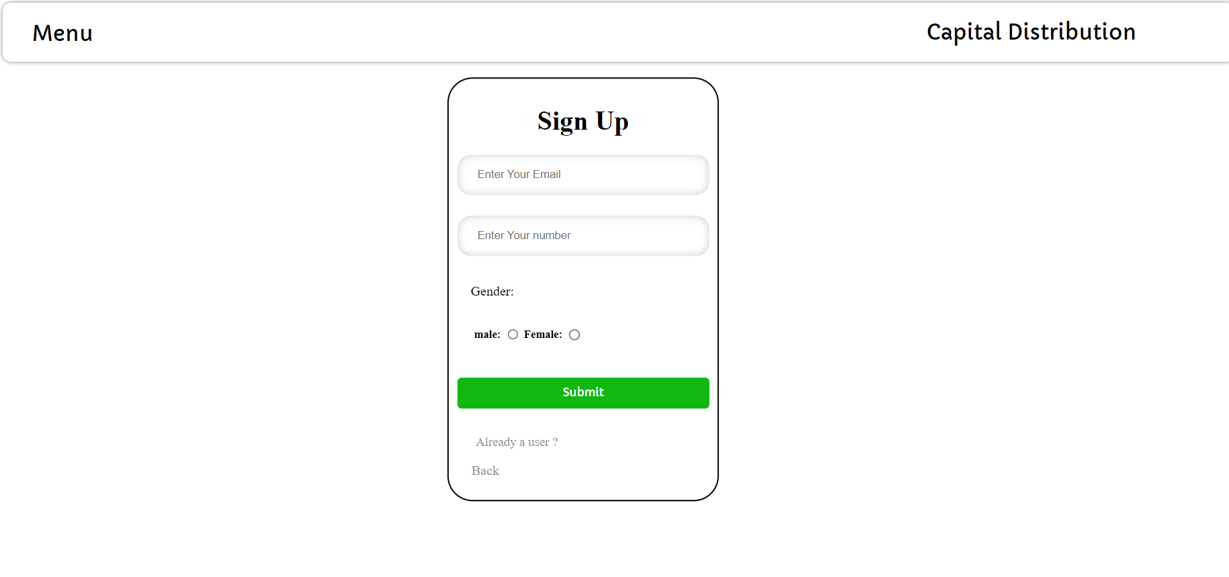

The Sign-Up page contains to divisions where the site asks for the Username, To create password, Email address, Mobile number and Gender of the User. It also contains the path to Login Page and Menubar.

**4. ACCOUNT TRACKER:**

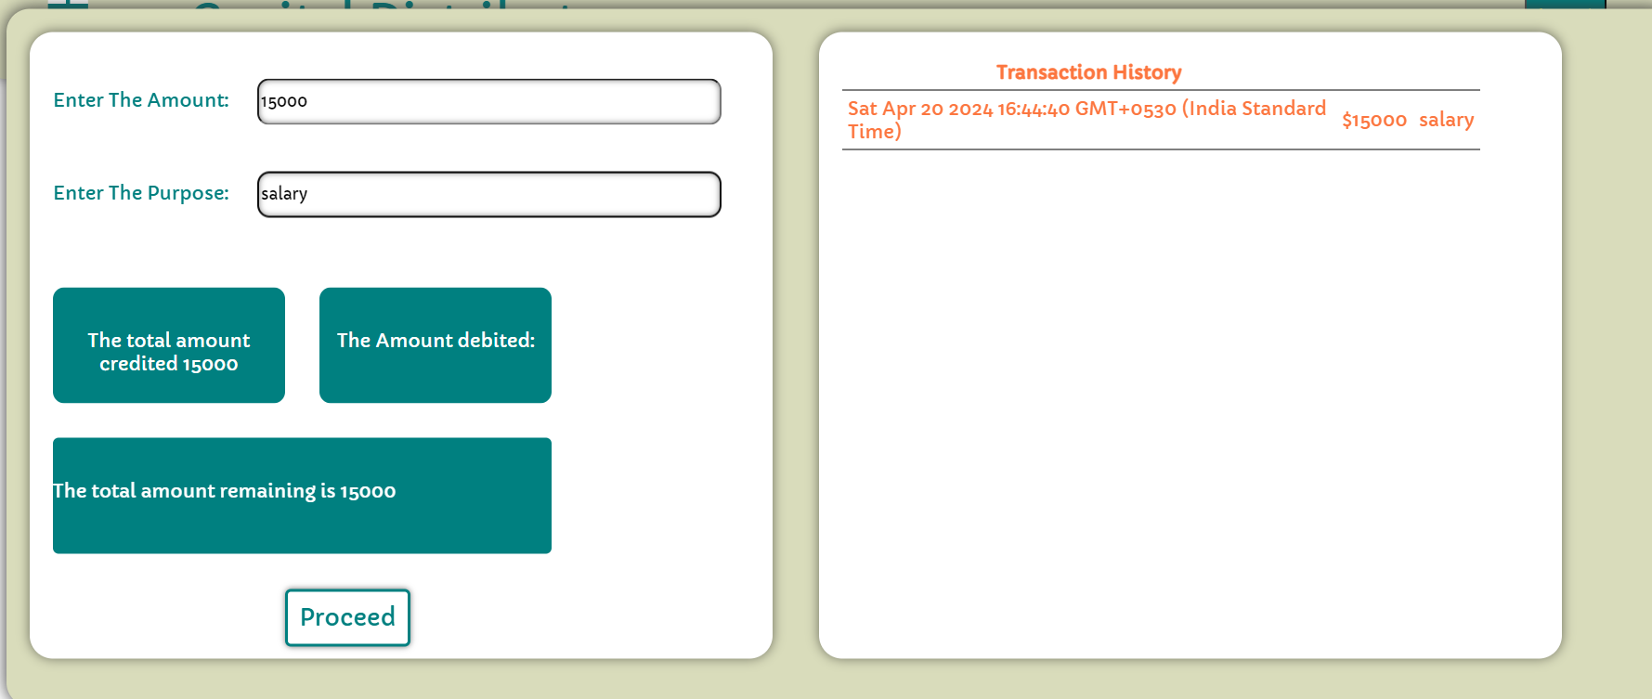

This page contains the account tracker which keeps the details of all the transactions and the purpose of the transaction. The history of the transaction is shown on the right automatically and the user has to enter the details on the left division.

**5. PASSWORD TRACKER:**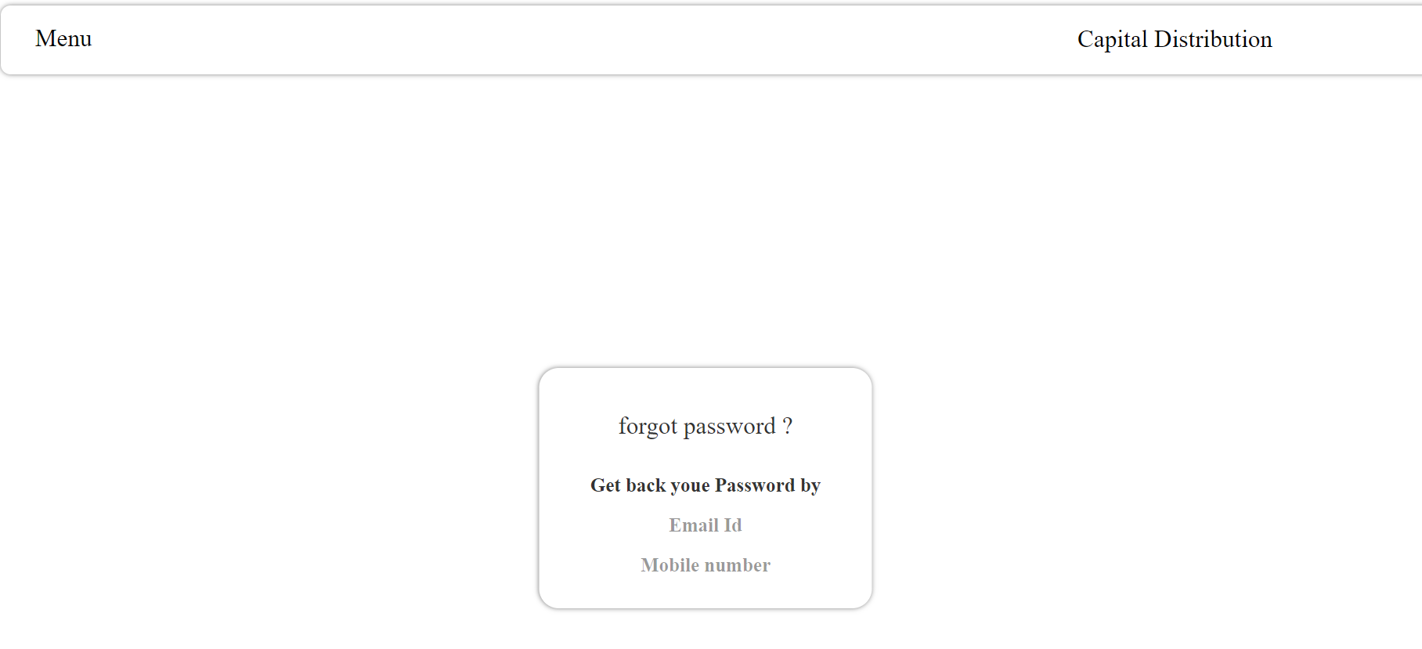

This is the page which contains the way to get back the password either by Email or Mobile Number.

**6. CONTACT PAGE:**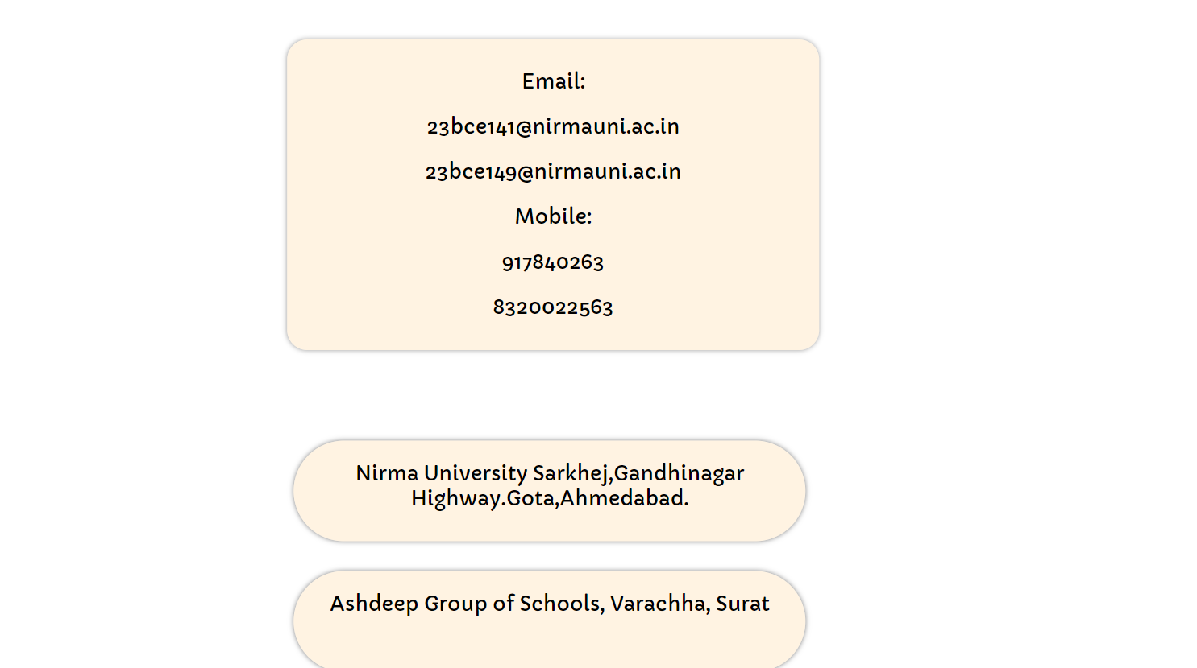

This page contains the emails and mobile numbers of the staff and addresses of the office branches.

**7. ABOUT US PAGE:**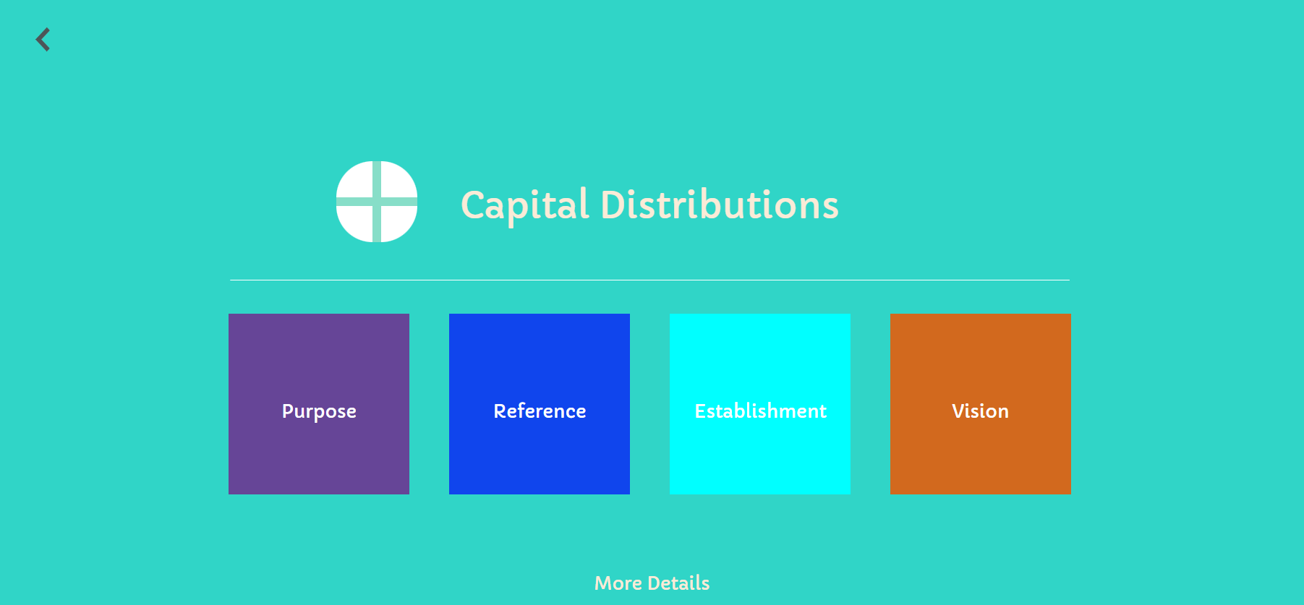

This page contains the details about the details about the objectives of the website and the information about the founder of the enterprise.

**CONCLUSION:**

The main objective of the website is to make the process of keeping records of their expenses and make them aware of their savings and expenses.