**Date:** 15/07/2020

**Enrollment No:** 19SE02CE047

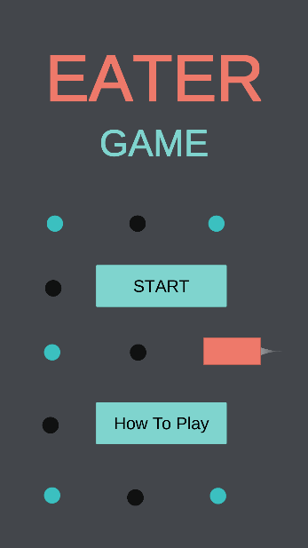 

Hello sir, my name is Krish Moradiya. I will make a small Snake game using Unity with C# script. My game name is Eater Game.

In this game main three characters : 1. Player(Snake) , 2. Food & 3. Poison. A snake is eat food & collect the point. But it touch poison our snake will be destroy and our game is over. If snake take all food, you are win in this game. These food and poison are generate random positions. I am also give a “How to play” button. This button is guide you to play this game. In this game I give three levels :

1. Easy level: In this level snake take 15 food in random position and no given any poison and boundary.
2. Medium level: In this level snake take 15 food in random position and no given any poison but boundary is given to you.
3. Hard level: In this level snake take 15 food in random position and given all poison and boundary.

In this game I’m not using any other’s graphics. I am make my own game objects and graphics. I am give sound effect also.