A Project Report

on

Deep Reinforcement Learning for Multi-Node Smart-Grid Power Balancing

carried out as part of the Project Based Learning-3 (DSE3170)
Submitted

by

Student 1: ____________________ (Reg. No. ______________)
Student 2: ____________________ (Reg. No. ______________)
Student 3: ____________________ (Reg. No. ______________)

in partial fulfilment for the award of the degree of

Bachelor of Technology

in

Computer Science and Engineering (Data Science)

Under the Guidance of
________________________



School of Computer Science and Engineering
Department of Data Science and Engineering

MANIPAL UNIVERSITY JAIPUR, JAIPUR
RAJASTHAN, INDIA
____________________
CERTIFICATE
This is to certify that the project-based learning, project titled “Deep Reinforcement Learning for Multi-Node Smart-Grid Power Balancing” is a record of the bonafide work done by ________________________ (________________________), ________________________ (________________________), ________________________ (________________________), submitted in partial fulfilment of the requirements for the award of the Degree of Bachelor of Technology in Computer Science and Engineering (Data Science) of Manipal University Jaipur, Jaipur during the academic year ________________________.

________________________
________________________
Project Guide, Department of Data Science and Engineering
Manipal University Jaipur, Jaipur

________________________
________________________
Class instructor, Department of Data Science and Engineering
Manipal University Jaipur, Jaipur
ABSTRACT
Electricity networks with a high share of intermittent renewable generation must be rebalanced continuously: generation and demand drift apart at every substation, and the resulting net imbalance has to be absorbed by routing power between nodes. Classical rule-based dispatch reacts to the present imbalance only, and the decision becomes harder as the number of controllable nodes grows. This project investigates whether deep reinforcement learning can learn a better routing policy, and compares the two architectures that dominate the literature — a single centralized controller with full observability, and a decentralized multi-agent system in which each substation controls one transmission line from local information only. A physically motivated hourly simulator of a three-node grid (city, suburb and industrial node) provides the data: diurnal load and generation cycles, a three-state Markov weather regime, AR(1) momentum noise and injected rare events (solar outages, demand spikes and brown-outs). An LSTM imbalance forecaster is pre-trained on this data and its feature-extraction layer is subsequently reused as a frozen backbone, giving a transfer-learning variant of the centralized controller.
Three controllers were trained and evaluated on identical unseen 240-hour windows against explicit baselines. The supervised forecaster achieves MAE 5.00 MW, RMSE 7.54 MW and R² 0.911, a 21.2 % RMSE reduction over a persistence baseline. The centralized Transformer-DQN reduces total grid imbalance by 23.52 % against a greedy-oracle ceiling of 24.39 %, recovering 96 % of the achievable control, and reaches a Cohen's kappa of 0.586 against oracle-labelled actions where an always-Hold policy scores 0.000. The transfer-learning agent reaches 22.04 %, slightly below the attention model. The decentralized PPO controller, by contrast, changes total imbalance by −14.93 %, which is worse than leaving the grid unmanaged and well below the 21.71 % achieved by a classical proportional rule; the diagnosis — saturated line shunts caused by local-only credit assignment and a delta bound smaller than the hourly imbalance swings — is reported as a measured negative result rather than tuned away. The gap identified by this work is that published comparisons of centralized and decentralized grid control rarely report trivial baselines or an attainable upper bound, which makes percentage improvements difficult to interpret; every number in this project is reported against both.
LIST OF TABLES

Table No | Table Title | Page No
1.1 | IPR status of the project | 2
3.1 | Datasets generated by the notebook | 6
3.2 | Descriptive statistics of the 30-day exploratory dataset (MW) | 6
3.3 | Discrete action space of FastEnv | 8
4.1 | Technology stack | 11
4.2 | Principal components of the implementation | 11
4.3 | Training configuration used for the reported run | 12
5.1 | Data audit results for every dataset used in the study | 14
5.2 | Design decisions settled by measurement | 16
6.1 | Statistical characterisation of the grid signal (30-day sample) | 18
6.2 | Held-out forecasting performance (chronological split) | 19
6.3 | Oracle label distribution over the 281 labelled test states | 20
6.4 | Action-selection metrics against the greedy oracle (281 test states) | 20
6.5 | Per-class report for the Transformer-DQN against oracle labels | 21
6.6 | Training progress of the two centralized agents (mean step reward) | 21
6.7 | Physical grid performance over 240 unseen hours (centralized paradigm) | 22
6.8 | Centralized routing telemetry over a 24-hour window (MW) | 23
6.9 | Physical grid performance over 240 unseen hours (decentralized paradigm) | 24
6.10 | Training progress of the decentralized PPO agents | 25
6.11 | Decentralized PPO transmission telemetry over a 24-hour window (MW) | 25
6.12 | Consolidated comparison of both control paradigms | 27
7.1 | Proposed manuscript structure and the evidence available for each section | 28
9.1 | Technical outcomes of the project | 31
A.1 | Project artefacts | 36
LIST OF FIGURES

Figure No | Figure Title | Page No
3.1 | End-to-end project workflow | 5
3.2 | System architecture of the notebook pipeline | 5
3.3 | Three-node transmission topology and the lines controlled under each paradigm | 9
3.4 | Information structure of the centralized and decentralized controllers | 10
6.1 | Exploratory analysis of the synthetic three-node grid | 19
6.2 | Autocorrelation and statistical analysis of the grid signal | 19
6.3 | Forecaster evaluation on the held-out window | 20
6.4 | Confusion matrices of the centralized controllers against oracle labels | 21
6.5 | Learning curves of the Transformer-DQN and the transfer-learning agent | 21
6.6 | Live routing telemetry of the Transformer-DQN policy over 24 hours | 23
6.7 | Decentralized PPO learning curves and the annealed penalty coefficient | 24
6.8 | Decentralized PPO transmission telemetry over 24 hours | 25

TABLE OF CONTENTS
Chapter / Section | Page No.
Certificate | ii
Abstract | iii
List of Tables | iv
List of Figures | v
Table of Contents | vi
1. INTRODUCTION | 1
1.1 Objectives of the Project | 1
1.2 Overview of Intellectual Property Rights (IPR) and Patenting | 2
2. LITERATURE SURVEY, RESEARCH GAP AND PROBLEM STATEMENT | 3
2.1 Background and Related Work | 3
2.2 Research Gap | 3
2.3 Problem Statement | 3
2.4 Motivation | 4
3. PROPOSED METHODOLOGY AND SYSTEM DESIGN | 5
3.1 The Grid Simulator and Data Source | 5
3.2 Data Quality and Preprocessing | 7
3.3 Statistical Characterisation of the Signal | 7
3.4 Supervised Pre-training: the LSTM Imbalance Forecaster | 7
3.5 Centralized Control Environment and Agents | 8
3.6 The Greedy Oracle | 8
3.7 Decentralized Control Environment and Agents | 9
3.8 Evaluation Design | 10
4. IMPLEMENTATION | 11
4.1 Technology Stack | 11
4.2 Module Structure | 11
4.3 Training Configuration | 12
4.4 Correctness Work Carried Out During Implementation | 13
5. TESTING AND VALIDATION | 14
5.1 Data Validation | 14
5.2 Environment and Oracle Consistency | 14
5.3 Validation of the Evaluation Harness | 15
5.4 Validation of the Train / Test Separation | 15
5.5 Reproducibility Validation | 16
5.6 Ablations and Design Decisions Measured | 16
5.7 Threats to Validity | 17
6. RESULTS AND DISCUSSION | 18
6.1 Characterisation of the Grid Signal | 18
6.2 Supervised Forecaster | 19
6.3 Centralized Control — Decision Quality | 20
6.4 Centralized Control — Physical Grid Performance | 22
6.5 Decentralized Control | 24
6.6 Paradigm Comparison | 26
7. PUBLICATION PREPARATION AND SUBMISSION | 28
7.1 Research Paper Structure and Formatting Guidelines | 28
7.2 Selection of Journals / Conferences | 28
7.3 Submission Process and Peer Review | 29
8. PROJECT SHOWCASE AND PRESENTATION | 30
8.1 Event Planning and Organization | 30
8.2 Audience Engagement and Feedback Collection | 30
8.3 Industry Interaction Opportunities | 30
8.4 Presentation Material Prepared | 30
9. OUTCOMES AND ACHIEVEMENTS | 31
9.1 Technical Outcomes | 31
9.2 Patents Filed | 31
9.3 Publications Accepted | 31
9.4 Awards and Recognitions | 31
10. CONCLUSION AND FUTURE SCOPE | 32
10.1 Conclusion | 32
10.2 Limitations | 32
10.3 Future Scope | 33
References | 34
Appendices | 36

CHAPTER 1
INTRODUCTION
Modern distribution grids are no longer passive networks that carry power from a few large generators to many consumers. Rooftop solar, wind and storage have turned individual substations into sources as well as sinks, so the net imbalance at a node — generation minus load — swings between surplus and deficit several times a day. Whenever that imbalance is non-zero the system operator must either curtail generation, shed load, or route power to a neighbouring node that is in the opposite condition. Routing is the cheapest of the three, but deciding how much to send and along which line is a sequential decision problem: the imbalance is autocorrelated, weather-dependent and subject to rare disturbances, so a decision that looks optimal for the current hour may not be optimal over a day.
This project treats that routing decision as a reinforcement learning problem on a three-node grid, and uses it to compare the two control architectures that the smart-grid literature most often sets against each other. A centralized controller sees the whole grid and issues one routing instruction per hour; a decentralized multi-agent controller places an independent learning agent at each substation, each of which observes only its own imbalance and what its neighbours broadcast. Centralization buys information; decentralization buys scalability and robustness to a single point of failure. The project measures what that trade costs on a concrete, fully reproducible task.
The entire study is implemented in a single Jupyter notebook (PBL.ipynb) that executes top-to-bottom from a fresh kernel. All randomness derives from one master seed (SEED = 42), every dataset is produced by a seeded generator, and every evaluation writes its numbers into a shared RESULTS dictionary from which the closing summary is printed, so the reported conclusions cannot drift away from the values a run actually produces.
1.1 Objectives of the Project
The project was carried out with the following objectives:
• To construct a physically motivated hourly simulator of a three-node power grid that exhibits the characteristics real grid signals have — diurnal periodicity, regime-switching weather, autocorrelated noise and rare disturbances — and to validate those characteristics statistically rather than assume them.
• To establish a data-quality and preprocessing stage (audit, imputation, physical clipping) through which every dataset used by every model must pass.
• To pre-train a supervised LSTM forecaster of next-hour net imbalance and to quantify its skill against a persistence baseline on a chronologically held-out split.
• To design a centralized control environment with a discrete routing action space and to train a Transformer-based Deep Q-Network on it.
• To evaluate transfer learning by reusing the frozen feature-extraction layer of the forecaster as the state encoder of a second, otherwise identical, Q-learning agent.
• To implement a decentralized multi-agent environment compliant with the PettingZoo ParallelEnv API, in which three PPO actor-critic agents exercise continuous delta-control over one transmission line each.
• To evaluate every controller on identical unseen data against explicit baselines — a greedy oracle (upper bound), an always-Hold policy, a uniform-random policy, a no-control policy and a classical rule-based proportional controller — so that each reported percentage is interpretable.
• To report the comparison between the centralized and decentralized paradigms honestly, including results that do not favour the learned controller.
1.2 Overview of Intellectual Property Rights (IPR) and Patenting
Intellectual Property Rights are the legal rights granted to the creators of original work. In the context of an engineering project the relevant categories are patents, which protect novel, non-obvious and industrially applicable inventions for a limited term; copyright, which protects the expression of a work such as source code, documentation and figures from the moment of creation; and trade secrets, which protect commercially valuable information that is kept confidential. In India, patents are governed by the Patents Act, 1970 and administered by the Office of the Controller General of Patents, Designs and Trade Marks, while copyright in software is governed by the Copyright Act, 1957.
For a project of this nature the position is as follows. The source code of the notebook and the figures generated from it are protected by copyright automatically on creation. A patent claim would have to rest on a technical contribution rather than on a mathematical method or a computer program as such, which are excluded from patentability under Section 3(k) of the Patents Act; a claim would therefore need to be framed around a concrete grid-control apparatus or process producing a demonstrable technical effect. No patent application, provisional specification or prior-art search has been prepared within this project, and the current state of the work — a simulation study on synthetic data with a measured negative result for one of the two paradigms — is better suited to academic publication than to patent filing. The IPR status of this project is therefore recorded as follows:
Table 1.1: IPR status of the project
Category | Status
Copyright in source code and figures | Subsists automatically in the authors on creation; no registration filed
Patent application | Not filed — no provisional or complete specification prepared within this project
Prior-art / patentability search | Not conducted within this project
Trade secret | Not applicable — the work is intended for academic disclosure
Intended route of dissemination | Conference / journal publication (see Chapter 7)

CHAPTER 2
LITERATURE SURVEY, RESEARCH GAP AND PROBLEM STATEMENT
2.1 Background and Related Work
Three strands of work converge on the problem addressed here. The first is short-term load and net-load forecasting, where recurrent architectures — and the LSTM in particular — became the standard neural baseline because the signal is strongly autocorrelated and has an explicit daily period. The second is reinforcement learning for economic dispatch and voltage control, in which the grid is modelled as a Markov decision process and a value-based or policy-gradient agent learns a dispatch policy; Deep Q-Networks with experience replay and a target network are the usual starting point for discrete action spaces, while Proximal Policy Optimization is the usual choice for continuous ones. The third is multi-agent reinforcement learning for distributed energy resources, where each substation or prosumer is modelled as an independent agent and the environment is expressed through a standard multi-agent API such as PettingZoo.
Two further techniques used in this project are drawn from the wider deep-learning literature rather than from power systems specifically. Self-attention, introduced for sequence modelling, allows a controller to weight the hours in its observation window according to relevance rather than recency, which suits a signal with both a short-lag and a 24-hour component. Transfer learning through a frozen pre-trained encoder is a standard way of injecting supervised knowledge into a reinforcement-learning agent whose reward signal is sparse or noisy; here the encoder is the forecaster's own feature layer, which has already learned to summarise a six-hour imbalance window.
This project does not claim a novel algorithm. Its contribution is methodological: it places a centralized attention-based DQN, a transfer-learning variant of the same agent, and a decentralized PPO multi-agent system on one common simulator and one common evaluation harness, and reports all three against trivial baselines and an attainable upper bound.
2.2 Research Gap
Reviewing how results are reported in this area exposes a recurring weakness rather than a missing algorithm:
• Percentage improvements are frequently reported without an attainable upper bound. A statement that a controller reduced imbalance by some percentage is uninterpretable unless the maximum achievable reduction for that action space is also stated.
• Trivial baselines are often omitted. On a control task where doing nothing is a legal action and the label distribution is dominated by it, raw accuracy flatters a policy that has learned nothing; chance-corrected agreement is rarely reported.
• Centralized and decentralized controllers are usually evaluated in separate studies on different simulators, so the cost of the information gap between the two paradigms is hard to isolate.
• Negative results in multi-agent grid control are under-reported, which makes it difficult for later work to know which configurations have already been found not to work.
2.3 Problem Statement
Given an hourly time series of load and generation at three interconnected grid nodes (A = city, B = suburb, C = industrial), the task is to choose, at every hour, how much power to route along the transmission lines so as to minimise the total absolute net imbalance |A| + |B| + |C| across the grid, subject to the transmission capacity and the cost of the transfers themselves. The problem is to be solved under two different information structures — one centralized controller with full observability of the grid, and three decentralized agents with local observability only — and the two solutions are to be compared on identical unseen data against explicit reference controllers.
2.4 Motivation
The practical motivation is that every megawatt-hour of imbalance that is not resolved by routing has to be resolved by curtailment, load shedding or reserve generation, all of which are more expensive and, in the last case, more carbon-intensive. The academic motivation is the comparison itself: decentralized control is widely advocated for future grids because it scales with the number of nodes and has no single point of failure, but the information each agent gives up is rarely quantified. A controlled comparison on one simulator, with the same evaluation harness and the same unseen hours, makes that cost measurable.

CHAPTER 3
PROPOSED METHODOLOGY AND SYSTEM DESIGN
The system is organised as a linear pipeline with two parallel control branches that share a common data layer, a common pre-trained encoder and a common evaluation harness. Figure 3.1 shows the end-to-end workflow and Figure 3.2 the software architecture.
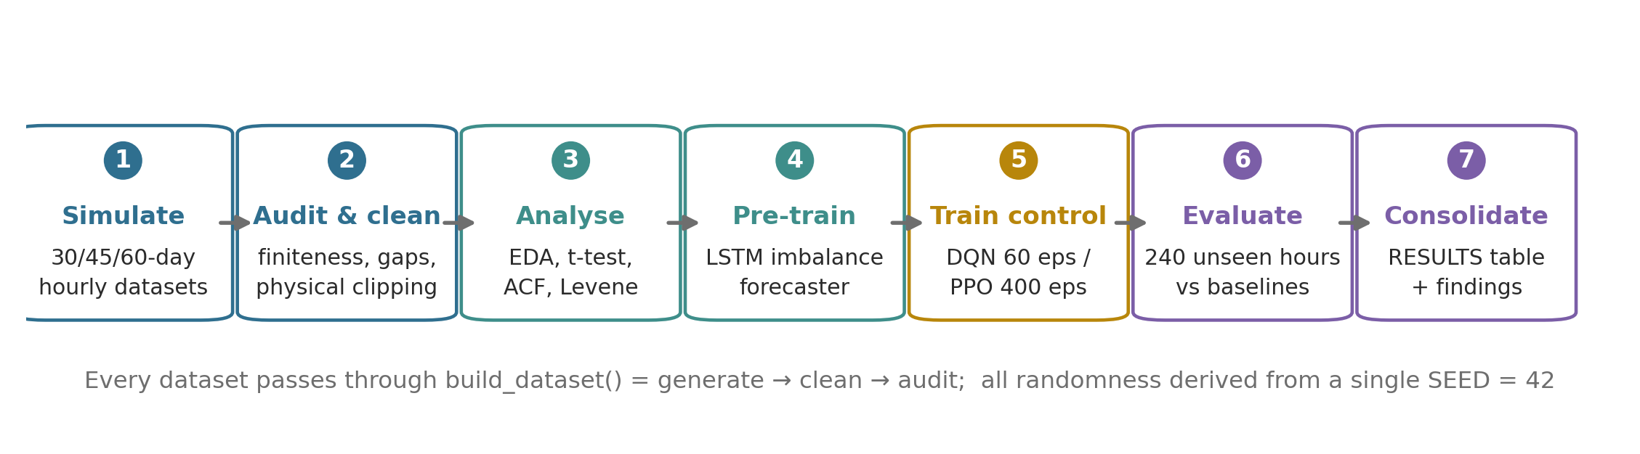
Fig. 3.1: End-to-end project workflow
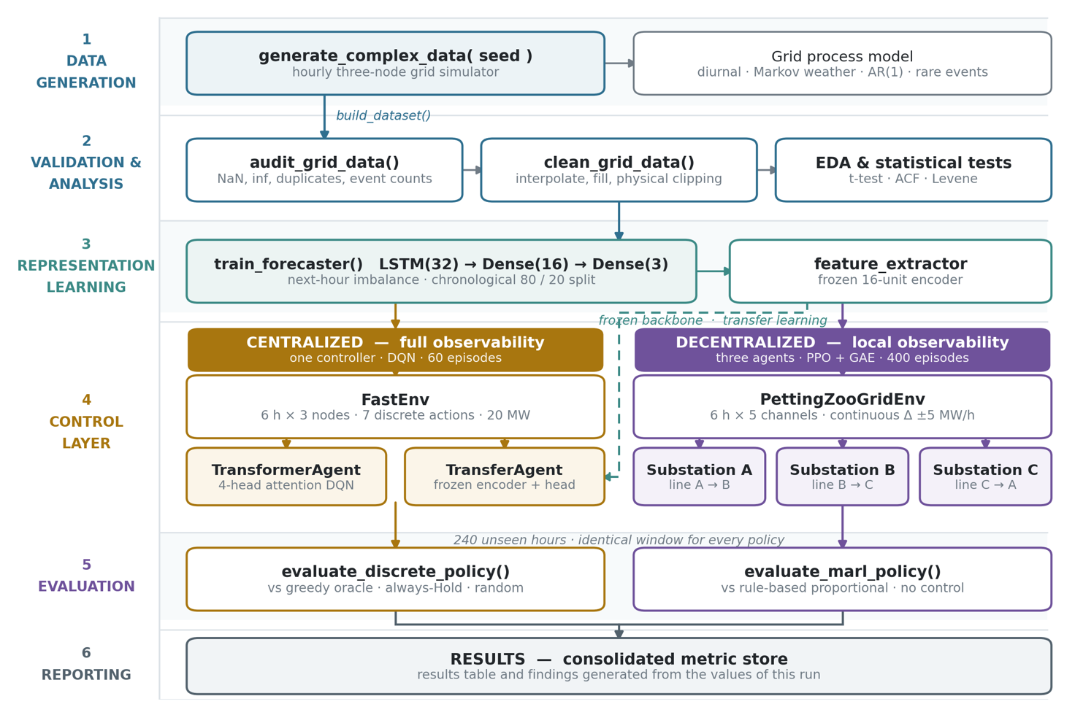
Fig. 3.2: System architecture of the notebook pipeline
3.1 The Grid Simulator and Data Source
The project uses no external dataset. Data is produced by generate_complex_data(), a seeded hourly simulator that returns, for each of the three nodes, a load series L_x and a generation series G_x together with a normalised hour-of-day feature. The quantity every controller acts on is the net imbalance G_x − L_x in MW, where a positive value denotes surplus and a negative value denotes deficit. The simulator combines four mechanisms:
• Diurnal cycles — sinusoidal load and generation with node-specific phase: node A is solar-peaked, node B is wind- and night-peaked, and node C follows a twelve-hour industrial load cycle.
• Markov weather regime — a three-state daily chain (normal, heatwave, storm) whose transition matrix scales load, solar output and wind output, producing regime-switching variance.
• Momentum noise — an AR(1) random walk with momentum 0.85 rather than white noise, so that residuals are autocorrelated in the way real forecast errors are.
• Rare events — industrial demand spikes at node C (p = 0.02), solar outages at node A (p = 0.005) and brown-outs at node B (p = 0.01).
Separate datasets are generated from separate derived seeds for exploratory analysis (30 days), forecaster pre-training (60 days), controller training (45 days) and evaluation (11–12 days), so no model is ever evaluated on hours it was trained on. Table 3.1 lists the datasets actually generated by the notebook.
Table 3.1: Datasets generated by the notebook
Purpose | Length | Seed | Audit result
Exploratory analysis | 720 h (30 days) | SEED | 0 missing, 0 infinite, 0 duplicate; 36 solar-outage hours at A, 1 demand spike at C
Forecaster pre-training | 1440 h (60 days) | SEED + 1 | 0 missing, 0 infinite, 0 duplicate; 65 solar-outage hours, 5 demand spikes
Centralized training | 1080 h (45 days) | derived | 0 missing, 0 infinite, 0 duplicate; 71 solar-outage hours, 5 demand spikes
Centralized test | 288 h (12 days) | derived | 0 missing, 0 infinite, 0 duplicate; 18 solar-outage hours, 0 demand spikes
MARL training | 1080 h (45 days) | derived | 0 missing, 0 infinite, 0 duplicate; 29 solar-outage hours, 3 demand spikes
MARL test | 264 h (11 days) | derived | 0 missing, 0 infinite, 0 duplicate; 17 solar-outage hours, 1 demand spike

Table 3.2 reports the descriptive statistics of the 30-day exploratory dataset. The generation series reach exactly zero at nodes A and B — the solar outage and the brown-out injections — while node C's load reaches 161.44 MW against a median of 48.77 MW, which is the industrial demand spike. The three NET columns are the quantities the controllers act on, and all three have a negative mean.
Table 3.2: Descriptive statistics of the 30-day exploratory dataset (MW)
Series | Count | Mean | Std | Min | 25 % | 50 % | 75 % | Max
L_A (load, city) | 720 | 53.19 | 17.82 | 23.67 | 38.78 | 51.41 | 64.85 | 100.51
G_A (generation, city) | 720 | 34.84 | 27.93 | 0.00 | 9.15 | 27.93 | 61.22 | 91.31
L_B (load, suburb) | 720 | 41.23 | 13.77 | 4.49 | 30.42 | 40.56 | 50.00 | 76.15
G_B (generation, suburb) | 720 | 31.50 | 21.20 | 0.00 | 15.91 | 27.80 | 42.82 | 97.21
L_C (load, industrial) | 720 | 50.22 | 26.14 | 8.01 | 26.70 | 48.77 | 69.63 | 161.44
G_C (generation, industrial) | 720 | 34.91 | 14.50 | 6.65 | 21.34 | 35.35 | 48.39 | 61.51
NET_A (G − L, city) | 720 | −18.35 | 35.29 | −92.02 | −48.43 | −25.06 | 15.19 | 47.51
NET_B (G − L, suburb) | 720 | −9.73 | 27.45 | −75.53 | −29.43 | −12.03 | 7.72 | 65.11
NET_C (G − L, industrial) | 720 | −15.31 | 16.79 | −106.42 | −21.91 | −12.20 | −3.57 | 13.30

3.2 Data Quality and Preprocessing
Two utilities enforce data quality. audit_grid_data() reports NaN and infinite counts, duplicated timestamps, negative generation or load, and how often the injected rare events actually fired, which converts “there are no missing values” from an assumption into a checked fact. clean_grid_data() coerces ±inf to NaN, repairs gaps by time interpolation followed by forward and backward fill, clips physically impossible negative generation and load to zero, and asserts that the frame is finite afterwards. Interpolation rather than row deletion is the correct imputation here because a power series is continuous and because dropping hours would break the fixed six-hour lookback windows every model uses. The wrapper build_dataset() chains generate → clean → audit and is used for every dataset in the project, so no model can receive unvalidated data.
3.3 Statistical Characterisation of the Signal
Before any model was fitted, the generated signal was characterised statistically on the 30-day exploratory dataset. The results, reported in full in Chapter 6, justify the two design choices that follow from them: a six-hour lookback window and an explicit hour-of-day feature. A one-sample t-test rejects the hypothesis of zero mean imbalance at all three nodes, establishing a structural deficit; the autocorrelation function shows a lag-1 coefficient of +0.949 at node A with a clear 24-hour echo at +0.872, so a short window carries most of the short-term predictive signal while the daily periodicity, which a six-hour window cannot see, is supplied by the hour feature; and a Levene test rejects equal variance across weather regimes, confirming that the Markov regime produces genuinely heteroscedastic behaviour.
3.4 Supervised Pre-training: the LSTM Imbalance Forecaster
The supervised stage learns the plain forecasting task “given the last six hours of net imbalance at all three nodes, predict the next hour”. The network is LSTM(32, tanh) → Dense(16, ReLU) named feature_extractor → Dense(3, linear), trained with Adam at a learning rate of 0.001 under mean squared error for up to 30 epochs with early stopping (patience 5, best weights restored) and a batch size of 32.
Two methodological points govern this stage. First, the hold-out split is chronological: the last 20 % of the sequences are held out without shuffling across the cut, because the sliding windows overlap and a random split would leak near-identical windows between training and validation and inflate the score. Of 1434 sequences, 1148 are used for training and 286 for validation. Second, the inputs are divided by IMB_SCALE = 100, the same normalisation the reinforcement-learning environments apply, so that the feature layer is trained on exactly the input distribution it will later be queried with as a frozen backbone.
3.5 Centralized Control Environment and Agents
FastEnv is the single-controller environment. Its observation is a (6, 3) window of net imbalance per node divided by IMB_SCALE. Its action space is the seven discrete routing actions listed in Table 3.2, each of which moves a fixed 20 MW along one directed pair of nodes; action 0 holds. The reward is differential — the sum of absolute imbalances before the action minus the sum after, divided by ten — which is the number of megawatts of grid stress the action actually removed. Because the pre-action sum is a constant of the state, this ranks the seven actions exactly as a greedy oracle would, which keeps agreement with the oracle a fair metric, while removing the large state-dependent offset that would otherwise dominate the Q-targets. A transmission penalty coefficient is available but defaults to zero for that reason.
Table 3.3: Discrete action space of FastEnv
Index | Action | Effect on (A, B, C)
0 | Hold | (0, 0, 0)
1 | A → B | (−20, +20, 0) MW
2 | B → C | (0, −20, +20) MW
3 | C → A | (+20, 0, −20) MW
4 | B → A | (+20, −20, 0) MW
5 | C → B | (0, +20, −20) MW
6 | A → C | (−20, 0, +20) MW

Two agents solve this identical task, which makes them directly comparable. TransformerAgent projects the three-channel window to 32 dimensions, adds a learned positional embedding, applies four-head self-attention followed by a feed-forward block with residual layer normalisation, pools over time and emits seven Q-values. It is trained as a Deep Q-Network with a replay buffer of 2000 transitions, a batch size of 64, γ = 0.95 and ε-greedy exploration decayed by a factor of 0.95 once per episode from 1.0 to a floor of 0.01, with an independently constructed target network. TransferAgent uses the identical Q-learning machinery but replaces the encoder with the frozen feature_extractor layer of the forecaster from Section 3.4, followed by a small trainable head of Dense(16, tanh) → Dense(7, linear).
3.6 The Greedy Oracle
To measure the discrete controller with familiar supervised metrics, every state is labelled with the action a greedy oracle would take — the one of the seven actions that minimises |A| + |B| + |C| after the transfer. This is a genuine upper bound for a single 20 MW transfer per hour, so agreement with the oracle answers the question “how often does the agent choose the myopically optimal routing?”. The oracle departs from Hold only when another action is strictly better, which makes Hold the most frequent label by a wide margin; accuracy alone would therefore flatter a trivial always-Hold policy, which is why the evaluation also reports macro-averaged precision, recall and F1, Cohen's kappa, and the always-Hold baseline itself.
3.7 Decentralized Control Environment and Agents
PettingZooGridEnv implements the PettingZoo ParallelEnv API and removes the central controller entirely. Each of the three substations owns one directed transmission line (A owns A→B, B owns B→C, C owns C→A) with a capacity of 25 MW, and acts by applying a continuous delta in [−1, 1] scaled by 5 MW to the accumulated, clipped shunt level on that line. The observation of each agent is a (6, 5) window whose channels are its own imbalance, the hour feature, the two neighbour imbalances broadcast to it, and the current loading of the line it controls. The reward is strictly local: the negative of its own absolute post-transfer imbalance plus a transmission penalty on its own line, divided by ten.
Each substation runs a LocalSubstationAgent, an actor-critic network that projects the observation to 32 dimensions, adds a learned positional embedding, applies two-head self-attention with residual layer normalisation, pools over time and emits three heads: an action mean (tanh), an action standard deviation (softplus) and a state value. Training uses clipped-surrogate PPO with generalised advantage estimation (γ = 0.94, λ = 0.95, clip ratio 0.2, four optimisation epochs per rollout, an entropy bonus of 0.01, a value-loss weight of 0.5, gradient-norm clipping at 0.5 and Adam at a learning rate of 5×10⁻⁵). A curriculum anneals the transmission-cost coefficient linearly from 0 to 0.05 between episodes 50 and 250 of 400, and the truncated 100-step episode bootstraps its value target from V(s_last) rather than from zero.
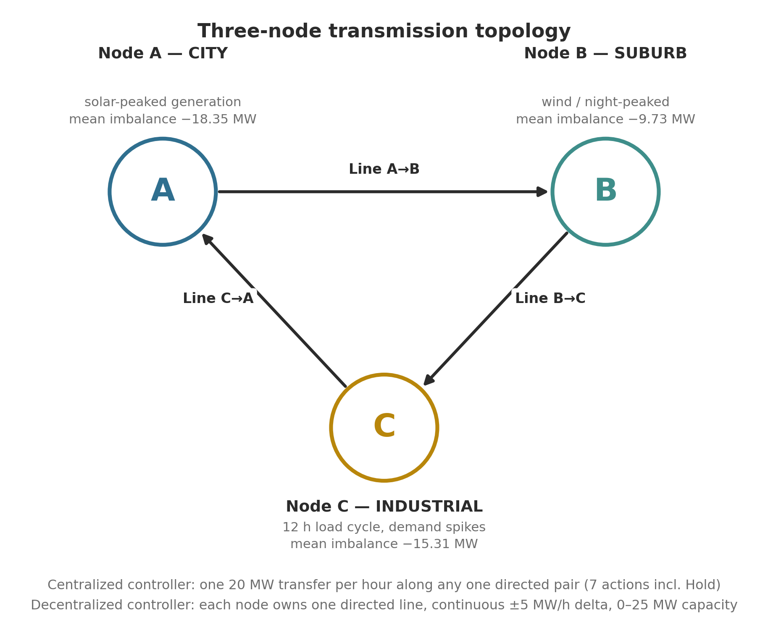
Fig. 3.3: Three-node transmission topology and the lines controlled under each paradigm
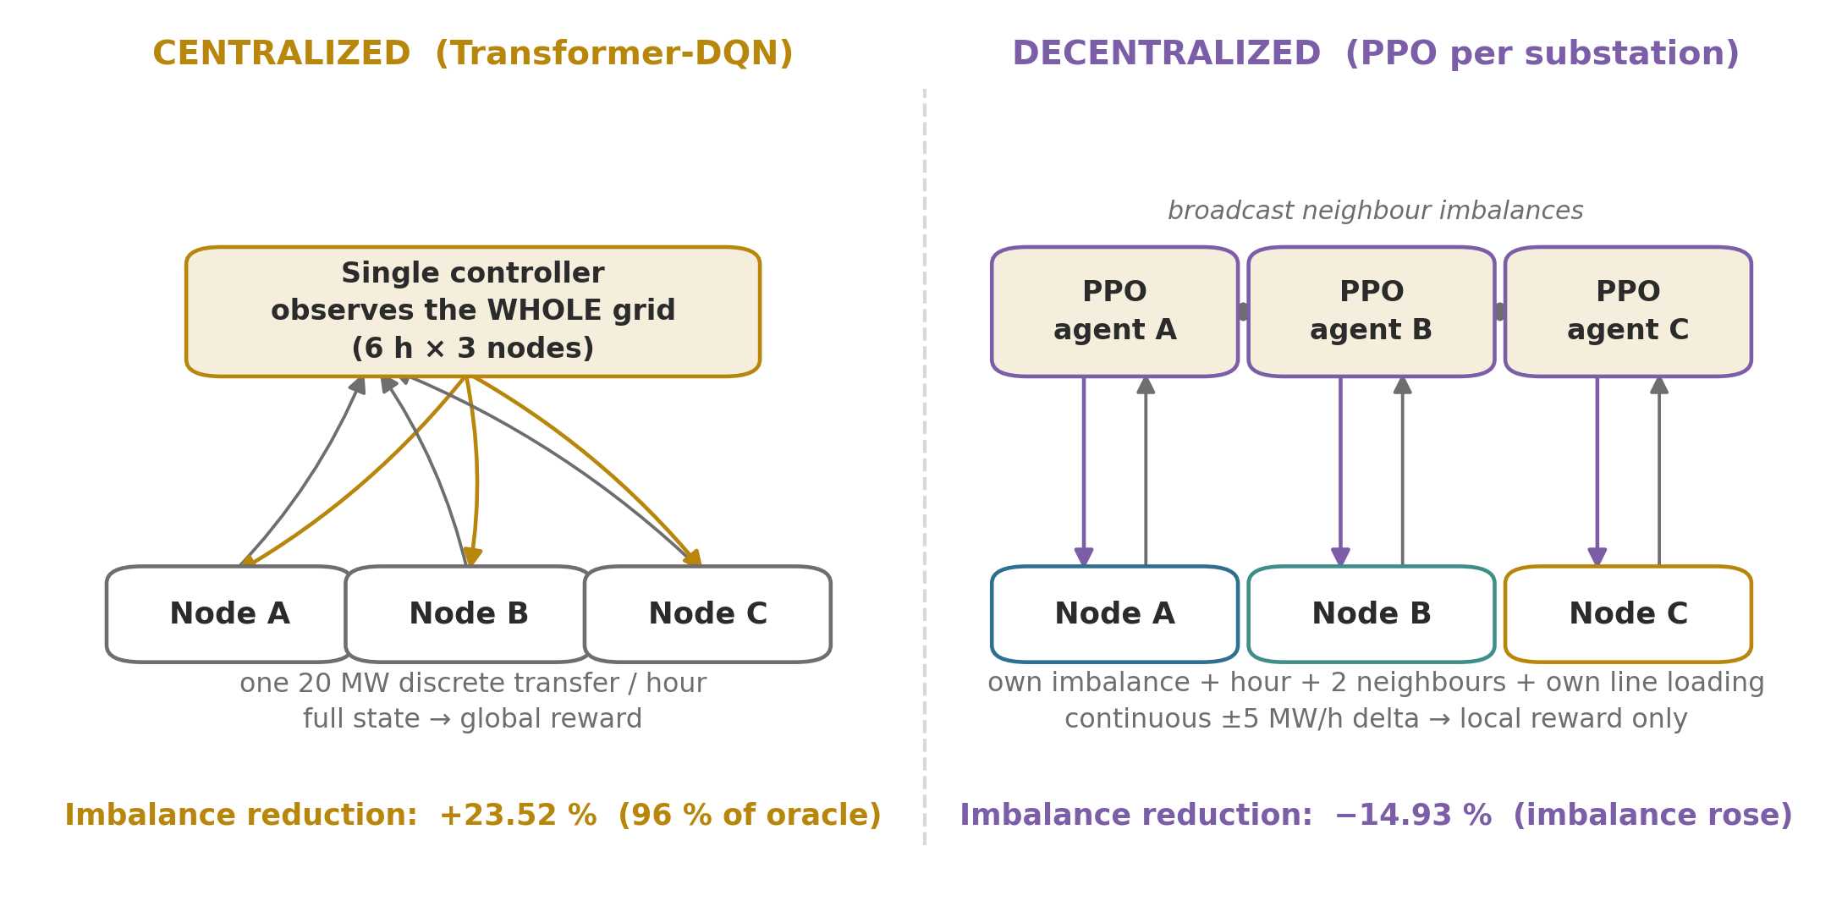
Fig. 3.4: Information structure of the centralized and decentralized controllers
3.8 Evaluation Design
Both paradigms are scored by a dedicated harness over 240 unseen hours — ten simulated days — drawn from a test dataset generated with its own seed and never touched during training. Because the same seed fixes the start index and the weather sequence, every policy within a paradigm is scored on exactly the same hours. The centralized harness evaluates the Transformer-DQN, the transfer agent, the greedy oracle, an always-Hold baseline and a uniform-random baseline; the decentralized harness evaluates the PPO controller, a rule-based proportional controller and a no-control policy. The no-control policy must return exactly 0.00 % reduction, which is the sanity check that proves the managed-imbalance figure measures the effect of the actions and nothing else. Evaluation is always greedy: the centralized agents act through act_greedy() and the PPO agents through their deterministic mean policy, so no residual exploration can leak into the reported metrics.

CHAPTER 4
IMPLEMENTATION
4.1 Technology Stack
The project is implemented entirely in Python within one Jupyter notebook. There is no separate frontend, backend, database or web API; the notebook is the complete deliverable and writes its trained model and figures to a pbl_artifacts directory beside itself. Table 4.1 lists the libraries and the role each plays.
Table 4.1: Technology stack
Component | Technology | Role in the project
Language / runtime | Python 3 | Entire implementation
Environment | Jupyter Notebook (PBL.ipynb) | Executable report; runs top-to-bottom in a fresh kernel
Deep learning | TensorFlow 2.21.0 / Keras 3.15.1 | LSTM forecaster, Transformer-DQN, PPO actor-critic networks
Multi-agent API | PettingZoo (ParallelEnv) | Decentralized environment interface
Action / observation spaces | Gymnasium (Box) | Space definitions for the ParallelEnv
Numerics | NumPy | Simulator, environment dynamics, advantage computation
Data handling | pandas | Dataset frames, descriptive statistics, result tables
Statistics | SciPy (stats) | t-test, Pearson/Spearman correlation, Levene test
Metrics | scikit-learn | Accuracy, precision, recall, F1, Cohen's kappa, confusion matrix, MAE/RMSE/R²
Visualisation | Matplotlib | All figures written to pbl_artifacts/
Persistence | Keras .keras format | grid_forecaster.keras (the transferable backbone)

4.2 Module Structure
The notebook is divided into twelve numbered sections, each of which depends only on the sections above it. Table 4.2 maps the principal components to their responsibilities.
Table 4.2: Principal components of the implementation
Component | Type | Responsibility
set_global_seeds() | Function | Seeds Python, NumPy and TensorFlow from one master seed
generate_complex_data() | Function | Seeded hourly three-node grid simulator
audit_grid_data() | Function | Reports NaN/inf, duplicates, negative values, rare-event counts
clean_grid_data() | Function | Interpolation, forward/backward fill, physical clipping, finiteness assertion
build_dataset() | Function | generate → clean → audit wrapper used for every dataset
train_forecaster() | Function | LSTM pre-training with chronological hold-out and early stopping
PositionalEmbedding1D | Keras layer | Learned absolute positional encoding, registered as serializable
FastEnv | Class | Centralized environment: 7 discrete actions, differential reward
TransformerAgent | Class | Attention-based DQN with replay buffer and independent target network
TransferAgent | Class | Same DQN machinery over the frozen forecaster backbone
greedy oracle | Function | Labels each state with the myopically optimal action
train_dqn_agent() | Function | Shared training loop so both centralized agents see one schedule
evaluate_discrete_policy() | Function | Physical-performance harness for the centralized paradigm
PettingZooGridEnv | Class | Decentralized ParallelEnv with continuous delta-control
LocalSubstationAgent | Class | Per-substation PPO actor-critic with local attention
evaluate_marl_policy() | Function | Physical-performance harness for the decentralized paradigm
RESULTS | Dictionary | Collects every metric; the final summary is printed from it

4.3 Training Configuration
All training budgets are exposed as constants in the configuration cell and can be overridden through environment variables for a fast smoke test without editing the notebook. Table 4.3 lists the values used for the run reported in this document.
Table 4.3: Training configuration used for the reported run
Parameter | Value
Master seed (SEED) | 42
Lookback window | 6 hours
Imbalance normalisation (IMB_SCALE) | 100.0
Forecaster epochs / batch size | 30 (early stopping, patience 5) / 32
Forecaster optimiser | Adam, learning rate 0.001, MSE loss
DQN episodes / steps per episode | 60 / 100
DQN discount γ / replay buffer / batch | 0.95 / 2000 / 64
DQN exploration | ε from 1.0 to 0.01, decay 0.95 per episode
DQN transfer size | 20 MW per action
MARL episodes / steps per episode | 400 / 100
PPO γ / λ / clip ratio / epochs | 0.94 / 0.95 / 0.2 / 4
PPO learning rate / gradient clip | 5×10⁻⁵ / global norm 0.5
Line capacity / maximum delta | 25 MW / ±5 MW per hour
Transmission penalty curriculum | 0 → 0.05, annealed over episodes 50–250
Evaluation horizon | 240 hours (10 simulated days)

4.4 Correctness Work Carried Out During Implementation
A substantial part of the implementation effort went into making the experiment valid rather than into adding features. The defects corrected during development are recorded here because several of them materially affect the numbers a run produces.
• The target network of both centralized agents was constructed from the same layer objects as the online network, making it an alias rather than a copy; the target update was therefore a no-op and the Q-learning bootstrapped off constantly moving targets. Each network is now built by its own constructor call.
• ε was decayed inside the replay step, which fired roughly fifty times per episode, so exploration collapsed to its floor within about three of the sixty episodes. Decay was moved to a per-episode call.
• The forecaster's training data was never split, so there was no way to tell whether the backbone had learned structure or memorised noise. A chronological hold-out was introduced.
• In the decentralized environment the agents could not observe the shunt level they control, although their actions are deltas on that level; the process was therefore not Markov. The agent's own line loading was added as a fifth observation channel.
• The PPO update took a single gradient step per rollout, which makes the importance ratio exactly one and the clipping mathematically inert. The update now performs four passes over each batch.
• The value target bootstrapped from zero at the 100-step truncation, teaching the critic that the episode genuinely ends there; truncated episodes now bootstrap from V(s_last).
• reset() did not satisfy the ParallelEnv contract (it returned observations only, ignored its seed argument, and the class defined no observation or action spaces). All three were corrected.
• PositionalEmbedding1D had no get_config(), so any saved model containing it could not be reloaded; it is now registered as a serializable Keras object.
One modelling change was tested and deliberately reverted. The directed-line clipping forbids reverse flow, so a node can never import over the line it owns. Allowing bidirectional flow was measured over 200 episodes on the same seed and moved the PPO controller from −14.9 % to −80.3 % and the rule-based reference from +21.7 % to +12.5 %, because all three nodes are usually in deficit simultaneously and the extra freedom mostly permits importing power that no neighbour has. The original directed model was therefore kept as the default, with bidirectional operation retained as an option.

CHAPTER 5
TESTING AND VALIDATION
The project is a simulation study rather than a deployed software system, and it contains no automated unit-test suite. Validation is therefore carried out in the way that is appropriate to an experimental pipeline: by asserting invariants that must hold if the code is correct, by scoring every controller against reference policies whose result is known in advance, and by running ablations that isolate the effect of individual design decisions. This chapter records those checks and their outcomes. All of them are executed as part of a normal top-to-bottom run of the notebook.
5.1 Data Validation
Every dataset is passed through build_dataset(), which chains generation, cleaning and auditing. The audit is not a formality: it reports the counts that the rest of the pipeline assumes to be zero, and it confirms that the injected rare events actually fired, which is the only way to know that the simulator is producing the regime-switching behaviour it was written to produce. Table 5.1 reports the audit outcome for all six datasets used in the study.
Table 5.1: Data audit results for every dataset used in the study
Dataset | Hours | Missing | Infinite | Duplicate | Negative G / L | Solar outages (A) | Demand spikes (C)
EDA sample | 720 | 0 | 0 | 0 | 0 / 0 | 36 | 1
Forecaster pre-training | 1440 | 0 | 0 | 0 | 0 / 0 | 65 | 5
Centralized train | 1080 | 0 | 0 | 0 | 0 / 0 | 71 | 5
Centralized test | 288 | 0 | 0 | 0 | 0 / 0 | 18 | 0
MARL train | 1080 | 0 | 0 | 0 | 0 / 0 | 29 | 3
MARL test | 264 | 0 | 0 | 0 | 0 / 0 | 17 | 1

The cleaning stage additionally asserts that the frame is finite after imputation, so a silent NaN cannot propagate into a model. Negative generation and load are clipped to zero because they are physically impossible; the audit confirms that no such value survives into any dataset.
5.2 Environment and Oracle Consistency
The greedy oracle is written as an explicit if/elif chain over the six transfer actions, whereas the environment applies the same physics through the ACTION_DELTAS matrix. These are two independent descriptions of one physical model, and if they ever drift apart the reported accuracy would be scoring the agent against a different grid from the one it was trained on. The oracle's action search is as follows:
for action_idx in range(1, 7):
temp_A, temp_B, temp_C = raw_A, raw_B, raw_C
if action_idx == 1: temp_A -= transfer; temp_B += transfer
elif action_idx == 2: temp_B -= transfer; temp_C += transfer
elif action_idx == 3: temp_C -= transfer; temp_A += transfer
elif action_idx == 4: temp_B -= transfer; temp_A += transfer
elif action_idx == 5: temp_C -= transfer; temp_B += transfer
elif action_idx == 6: temp_A -= transfer; temp_C += transfer
current_imbalance = abs(temp_A) + abs(temp_B) + abs(temp_C)
if current_imbalance < min_imbalance:
min_imbalance = current_imbalance
best_action = action_idx

A dedicated consistency check re-scores every labelled state through the environment's own apply_action() and verifies that the oracle's chosen label is in fact minimal:
def verify_oracle_consistency(env, states, labels):
agree = 0
for s, lab in zip(states, labels):
pre = s[-1] * env.scale
scores = [float(np.abs(env.apply_action(pre, a)).sum())
for a in range(env.N_ACTIONS)]
if np.isclose(scores[lab], min(scores)):
agree += 1
return agree / max(len(states), 1)

The measured agreement between the oracle and the environment physics is 100.0 %. This is a precondition for every metric reported in Section 6.3: without it, the accuracy and kappa figures would be meaningless.
5.3 Validation of the Evaluation Harness
Two policies in the evaluation have a result that is known before the experiment is run, and they are included precisely so that the harness can be checked against them.
• The always-Hold policy takes no action, so its managed imbalance must equal its unmanaged imbalance and its reduction must be exactly 0.00 %. It is.
• The no-control policy in the decentralized harness sets every action to zero, so its reduction must likewise be exactly 0.00 %. It is, and its managed total of 14 941.31 MW equals the unmanaged total to the last reported digit.
Together these confirm that the “managed imbalance” figure is measuring the effect of the actions and nothing else — that no part of the reduction is an artefact of how the window is selected or how the totals are accumulated. Had the harness been accumulating the unmanaged series by mistake, as an earlier version of the telemetry visualiser did, these two rows would not have come out at zero.
A third check concerns exploration leakage. The centralized agents are evaluated through act_greedy(), which ignores the current value of ε entirely, and the PPO agents are evaluated through their deterministic mean policy. A residual ε therefore cannot inflate or depress the reported figures, which is a real risk in a DQN whose ε is an instance attribute rather than a training-only parameter.
5.4 Validation of the Train / Test Separation
Three separate mechanisms keep training and evaluation apart, and each was verified.
• The forecaster's hold-out is chronological, not random. Because the sliding windows overlap by five of their six hours, a shuffled split would place near-identical windows on both sides of the cut; the reported R² of 0.911 is measured on 286 windows that follow the 1148 training windows in time and share no hour with them.
• The controllers are trained and evaluated on datasets generated from different seeds, so the test grid is a different realisation of the same process — the correct analogue of held-out data for a simulator. The test environment object is never stepped during training.
• Within a paradigm, every policy is scored on the identical window: the same seed fixes both the episode start index and the weather sequence, so the comparison between the learned agent, the oracle and the baselines is not confounded by window selection.
5.5 Reproducibility Validation
A single master seed (SEED = 42) is propagated to Python's random module, NumPy and TensorFlow through set_global_seeds(), and each dataset is generated from its own derived seed using a local np.random.Generator rather than the global state. The practical consequence is that a dataset's content depends only on its own seed and not on how many times the generator function has previously been called, so cells can be re-executed individually without changing the results of later cells. The artefact directory is an explicit absolute path rather than the implicit working directory, so a run started from a different folder writes its model and figures to the same place.
The training budgets are read from environment variables with the reported values as defaults, which allows the entire notebook to be smoke-tested at reduced length without editing any cell — a check that the pipeline runs end-to-end independently of the check that it produces good numbers.
5.6 Ablations and Design Decisions Measured
Several design decisions were settled by measurement rather than by argument. Table 5.2 records what was tested and what the measurement showed. The entries marked “reverted” are changes that appeared correct in principle but made the results worse, and were therefore not adopted.
Table 5.2: Design decisions settled by measurement
Decision tested | Measured effect | Outcome
Independent target network vs. a shared-layer “target” | The shared version made update_target_network() a no-op and bootstrapped off moving targets | Adopted — training is measurably more stable
ε decayed per episode vs. per replay call | Per-replay decay collapsed ε to its 0.01 floor within ~3 of 60 episodes | Adopted — the agent now actually explores
Differential reward vs. absolute imbalance reward | The absolute form carries a large state-dependent offset that dominates the Q-targets | Adopted — ranks actions identically to the oracle, with far less target noise
Own line loading as a 5th observation channel (MARL) | Without it the actions are deltas on a hidden state, so the process is not Markov | Adopted — include_shunt_state=True is the default
PPO with 4 optimisation epochs vs. 1 | With a single step the importance ratio is exactly 1.0 and the clipping is inert | Adopted — the clipped surrogate now has an effect
Bootstrap truncated episodes from V(s_last) vs. from 0 | Bootstrapping from 0 teaches the critic that the world ends every 100 hours | Adopted
Bidirectional transmission lines | PPO moved from −14.9 % to −80.3 %; the rule-based reference from +21.7 % to +12.5 % | Reverted — the original directed model is the default; available as an option
Rebalancing the PPO critic-loss weight | Did not correct the shunt saturation described in Section 6.5 | Reverted
Raising the PPO learning rate | Did not correct the shunt saturation either | Reverted

5.7 Threats to Validity
Three limitations of this validation effort should be stated explicitly, because they bound how far the reported numbers can be generalised.
• Each result is a single seeded run. The checks above establish that the pipeline is internally consistent and that the comparison is fair, but they do not establish that the difference between, for example, 23.52 % and 22.04 % would survive a change of seed. Quantifying that requires repeated runs, which is listed in the future scope.
• The oracle is a myopic upper bound. It is the best achievable single 20 MW transfer per hour, not the best achievable policy; an agent that sacrifices the current hour to position the grid better for the next could in principle exceed it, so “96 % of the ceiling” should be read as 96 % of the greedy ceiling.
• Validation is against the simulator, not against a real grid. Every invariant checked here is an invariant of the model; none of them tests whether the model resembles a physical network closely enough for the conclusions to transfer.

CHAPTER 6
RESULTS AND DISCUSSION
All results in this chapter are the output of a single seeded run of PBL.ipynb with the configuration of Table 4.3. Each controller is evaluated over 240 unseen hours, and within each paradigm every policy is scored on identical hours.
6.1 Characterisation of the Grid Signal
Across the 30-day exploratory dataset the mean absolute imbalance per node is 35.01 MW at A, 23.93 MW at B and 16.67 MW at C, and the mean total absolute imbalance across the grid is 75.61 MW — this last quantity is what every controller is asked to minimise. The nodes spend most of their time in deficit: 67.1 % of hours at A, 67.5 % at B and 84.0 % at C. Table 6.1 summarises the statistical tests.
Table 6.1: Statistical characterisation of the grid signal (30-day sample)
Test | Result | Interpretation
One-sample t-test, H₀: mean imbalance = 0 | A: mean −18.35 MW, t = −13.95, p = 2.4×10⁻³⁹; B: −9.73 MW, t = −9.51, p = 2.8×10⁻²⁰; C: −15.31 MW, t = −24.45, p = 1.4×10⁻⁹⁶ | H₀ rejected at every node — a structural generation deficit, not noise about zero
Pearson correlation between nodes | A–B: r = −0.294 (p = 7.9×10⁻¹⁶); B–C: r = +0.452 (p = 1.6×10⁻³⁷); A–C: r = +0.200 (p = 6.2×10⁻⁸) | A and B are partly complementary, so routing between them has genuine headroom; B and C move together
Autocorrelation (white-noise band ±0.073) | A: lag1 +0.949, lag12 −0.762, lag24 +0.872; B: lag1 +0.935, lag24 +0.750; C: lag1 +0.747, lag24 +0.630 | Strong short-lag persistence with a clear 24-hour echo; justifies a 6-hour window plus an explicit hour feature
Levene test across weather regimes | A: W = 118.28, p = 4.1×10⁻⁴⁵; B: W = 16.71, p = 8.0×10⁻⁸; C: W = 39.72, p = 4.4×10⁻¹⁷ | Variance differs by regime (A: 34.7 / 40.5 / 13.7 MW for normal / heatwave / storm) — genuinely heteroscedastic

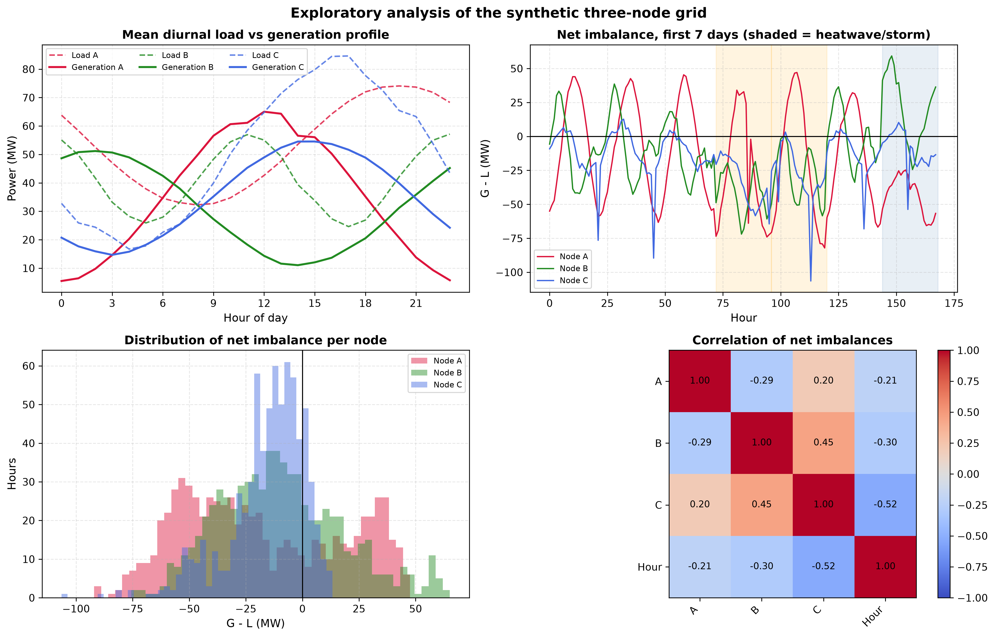
Fig. 6.1: Exploratory analysis of the synthetic three-node grid
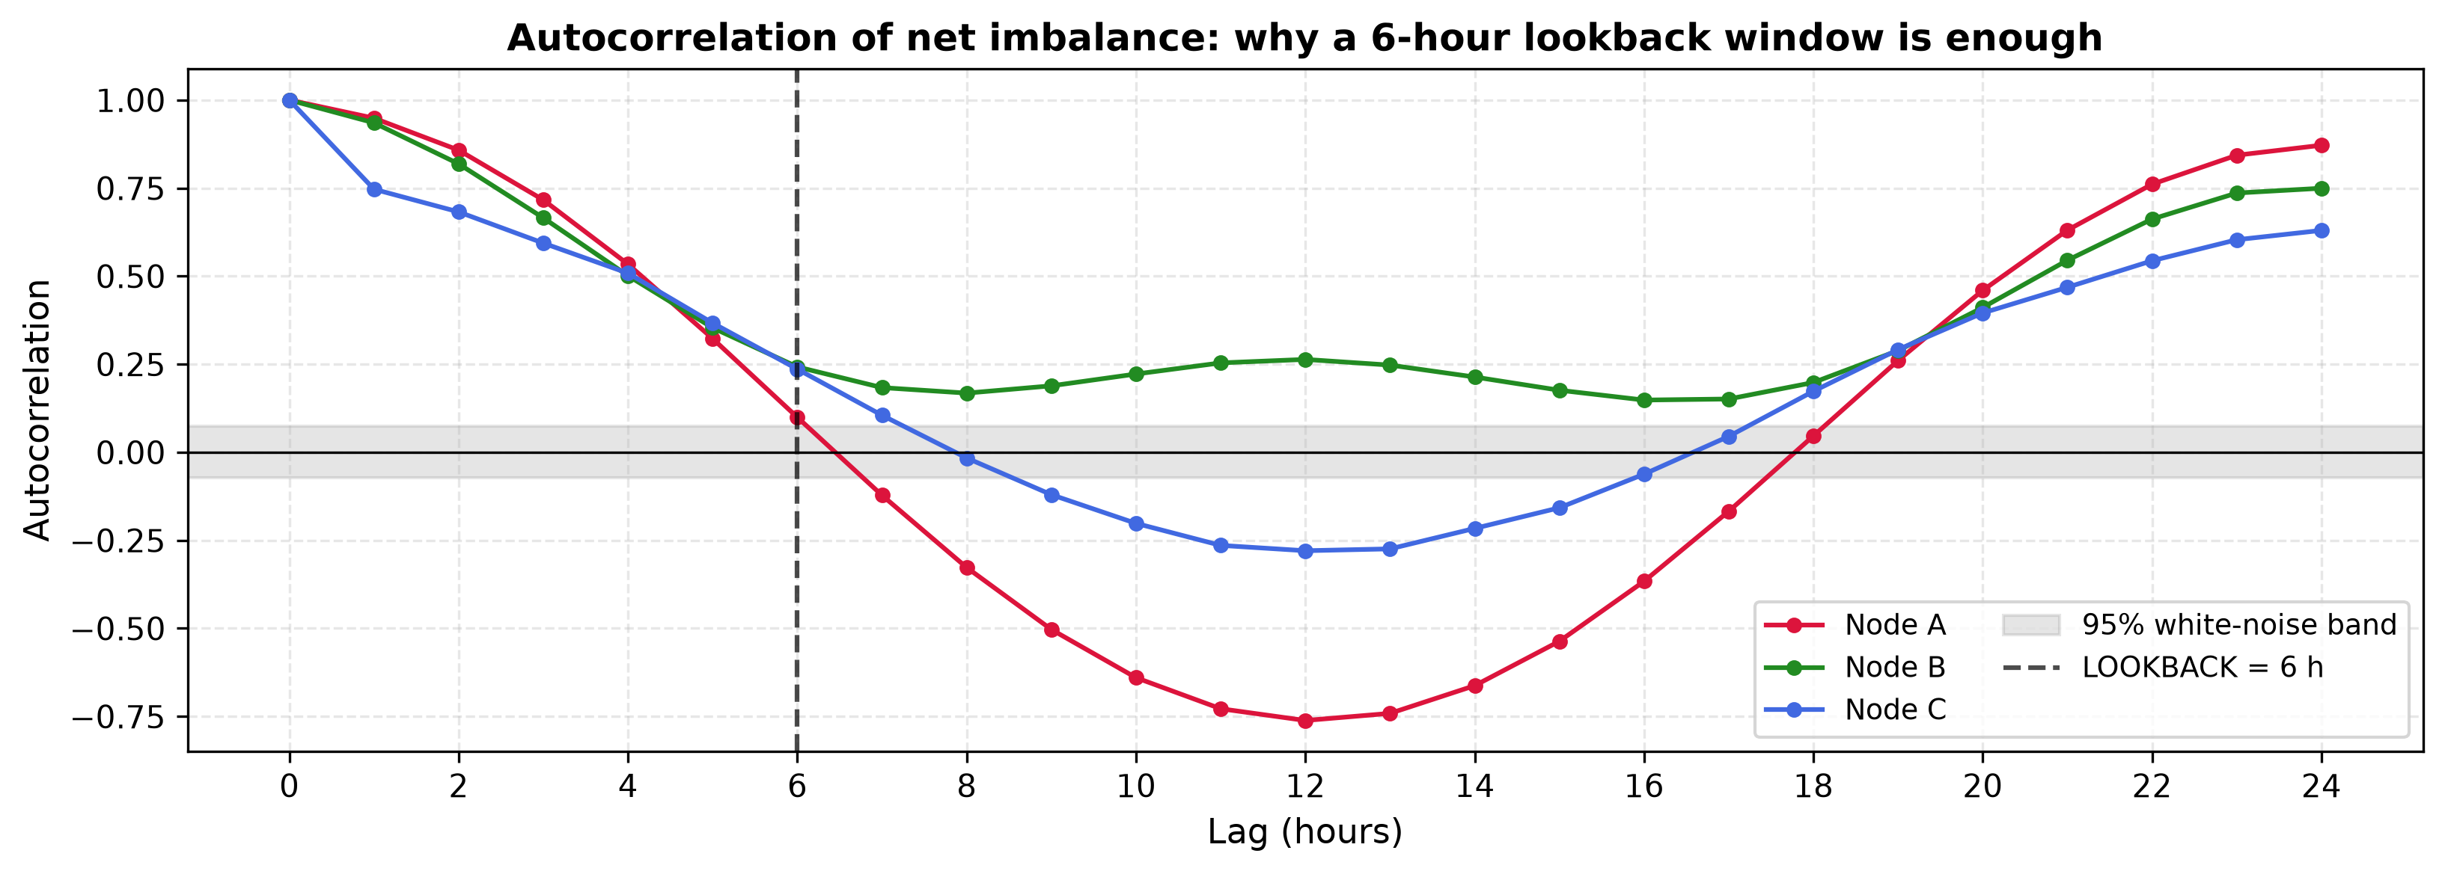
Fig. 6.2: Autocorrelation and statistical analysis of the grid signal
6.2 Supervised Forecaster
On the chronologically held-out 20 % of sequences the LSTM forecaster attains MAE 5.00 MW, RMSE 7.54 MW and R² 0.911, against 6.85 MW, 9.57 MW and 0.856 for a persistence baseline that simply repeats the last observed value. This is a 21.2 % reduction in RMSE, and it is the evidence that the frozen feature layer later reused by the transfer agent encodes something real rather than noise.
Table 6.2: Held-out forecasting performance (chronological split)
Model | MAE (MW) | RMSE (MW) | R²
LSTM forecaster | 4.995 | 7.54 | 0.911
Persistence baseline | 6.850 | 9.57 | 0.856

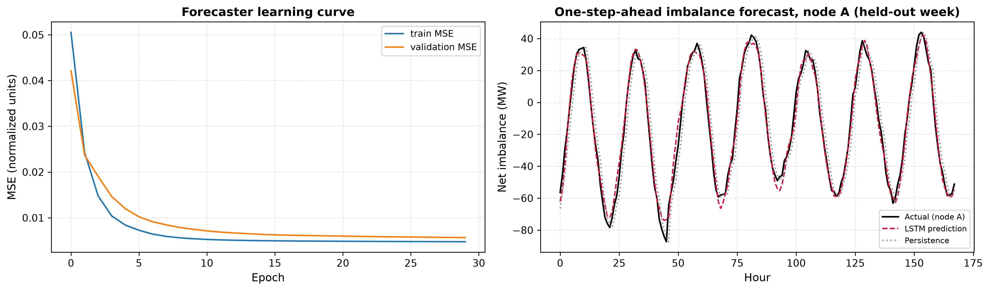
Fig. 6.3: Forecaster evaluation on the held-out window
6.3 Centralized Control — Decision Quality
Agreement with the greedy oracle is reported over 281 labelled test states. The oracle label distribution is dominated by Hold (36.3 %), followed by A→B (27.8 %) and B→A (24.2 %), so a majority-class policy would score 36.3 % accuracy while learning nothing; the oracle and the environment physics agree in 100 % of states, which confirms that the label and the dynamics cannot silently disagree. Table 6.4 therefore reports chance-corrected agreement alongside accuracy.
Table 6.3: Oracle label distribution over the 281 labelled test states
Index | Action | Count | Share
0 | Hold | 102 | 36.3 %
1 | A → B | 78 | 27.8 %
2 | B → C | 16 | 5.7 %
3 | C → A | 6 | 2.1 %
4 | B → A | 68 | 24.2 %
5 | C → B | 0 | 0.0 %
6 | A → C | 11 | 3.9 %

Table 6.4: Action-selection metrics against the greedy oracle (281 test states)
Model | Accuracy | Precision (w) | Recall (w) | F1 (w) | F1 (macro) | Cohen's κ
Transformer-DQN | 0.683 | 0.735 | 0.683 | 0.675 | 0.448 | 0.586
TransferAgent | 0.577 | 0.643 | 0.577 | 0.497 | 0.312 | 0.436
Baseline: always Hold | 0.363 | 0.132 | 0.363 | 0.193 | 0.089 | 0.000
Baseline: random | 0.114 | 0.228 | 0.114 | 0.147 | 0.090 | −0.026

The comparison with the baselines is what makes these numbers meaningful. The always-Hold policy reaches 0.363 accuracy purely from the label imbalance but a Cohen's kappa of exactly zero, which is the correct reading of a policy that contributes no information. The Transformer-DQN reaches kappa 0.586, substantial agreement on the usual interpretation, and clearly outperforms the transfer agent at 0.436. The per-class report shows where the remaining error lies: the agent is accurate on the two frequent transfer actions (F1 0.90 on A→B and 0.75 on B→A) but under-predicts Hold (recall 0.41) and fails entirely on the two rarest classes, C→A (6 support) and C→B (0 support). In physical terms the agent prefers to act when holding would have been marginally better, which costs transmission but little imbalance.
Table 6.5: Per-class report for the Transformer-DQN against oracle labels
Class | Precision | Recall | F1-score | Support
Hold | 0.82 | 0.41 | 0.55 | 102
A → B | 0.88 | 0.92 | 0.90 | 78
B → C | 0.36 | 0.50 | 0.42 | 16
C → A | 0.00 | 0.00 | 0.00 | 6
B → A | 0.65 | 0.88 | 0.75 | 68
C → B | 0.00 | 0.00 | 0.00 | 0
A → C | 0.36 | 0.91 | 0.51 | 11
Accuracy |  |  | 0.68 | 281
Macro average | 0.44 | 0.52 | 0.45 | 281
Weighted average | 0.74 | 0.68 | 0.67 | 281

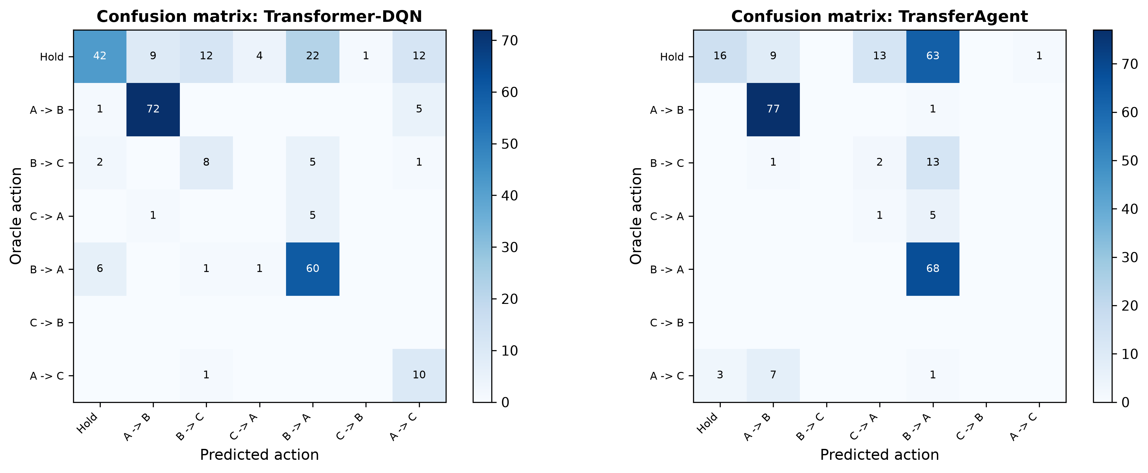
Fig. 6.4: Confusion matrices of the centralized controllers against oracle labels
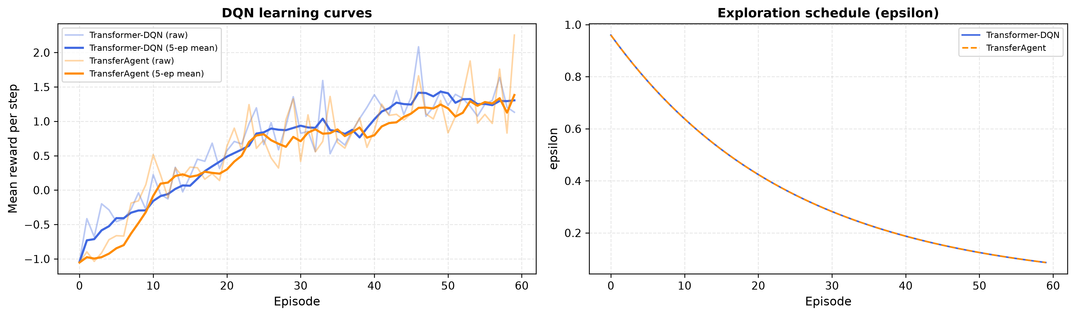
Fig. 6.5: Learning curves of the Transformer-DQN and the transfer-learning agent
Table 6.6 shows that both agents follow the same trajectory: the mean step reward is negative while exploration dominates, crosses zero between episodes 10 and 20, and settles above 1.2 MW of stress removed per step by episode 60. The two curves are close enough that the difference in final policy quality (Table 6.7) comes from what the encoders represent rather than from an unequal training schedule.
Table 6.6: Training progress of the two centralized agents (mean step reward)
Episode | Transformer-DQN | TransferAgent | ε | Elapsed (DQN)
10 / 60 | −0.410 | −0.621 | 0.665 | 7.2 s
20 / 60 | 0.241 | 0.234 | 0.442 | 15.7 s
30 / 60 | 0.863 | 0.784 | 0.294 | 25.1 s
40 / 60 | 0.887 | 0.795 | 0.195 | 34.9 s
50 / 60 | 1.342 | 1.155 | 0.130 | 45.0 s
60 / 60 | 1.278 | 1.305 | 0.086 | 55.4 s

6.4 Centralized Control — Physical Grid Performance
Decision quality is only a proxy; the quantity the project actually cares about is the total absolute imbalance over the evaluation window. Table 6.7 reports it for every policy over the same 240 unseen hours, with the unmanaged total of 16 303.73 MW as the common reference.
Table 6.7: Physical grid performance over 240 unseen hours (centralized paradigm)
Policy | Unmanaged (MW) | Managed (MW) | Reduction (%) | Transmission cost (MW) | Active hours (%)
Transformer-DQN | 16303.73 | 12469.37 | 23.52 | 201.0 | 83.75
TransferAgent | 16303.73 | 12710.78 | 22.04 | 223.0 | 92.92
Greedy oracle (upper bound) | 16303.73 | 12327.85 | 24.39 | 150.0 | 62.50
Baseline: always Hold | 16303.73 | 16303.73 | 0.00 | 0.0 | 0.00
Baseline: random | 16303.73 | 18734.01 | −14.91 | 202.0 | 84.17

The greedy oracle establishes that 24.39 % is the ceiling for a single 20 MW transfer per hour on this window. Against that ceiling the Transformer-DQN's 23.52 % recovers 96 % of the achievable control, and the transfer agent's 22.04 % recovers about 90 %. The always-Hold row is 0.00 % by construction and the random row is −14.91 %, which establishes that acting arbitrarily is considerably worse than not acting at all — the task is not one where any transfer helps. The transfer agent is also the least economical of the learned policies: it acts in 92.9 % of hours for 223 MW of transmission to achieve less reduction than the attention agent achieves in 83.8 % of hours for 201 MW, while the oracle needs only 62.5 % and 150 MW.
The transfer-learning result deserves comment because it is the opposite of the usual expectation. The frozen backbone was pre-trained to forecast the next hour, which is a different objective from ranking seven routing actions by their immediate effect on total imbalance; the features that best predict where the imbalance is going are not necessarily the features that best discriminate between actions. With the encoder frozen, the agent can only learn a small head on top of those features, and the measured cost of that constraint is 1.48 percentage points of imbalance reduction and 0.150 of kappa.
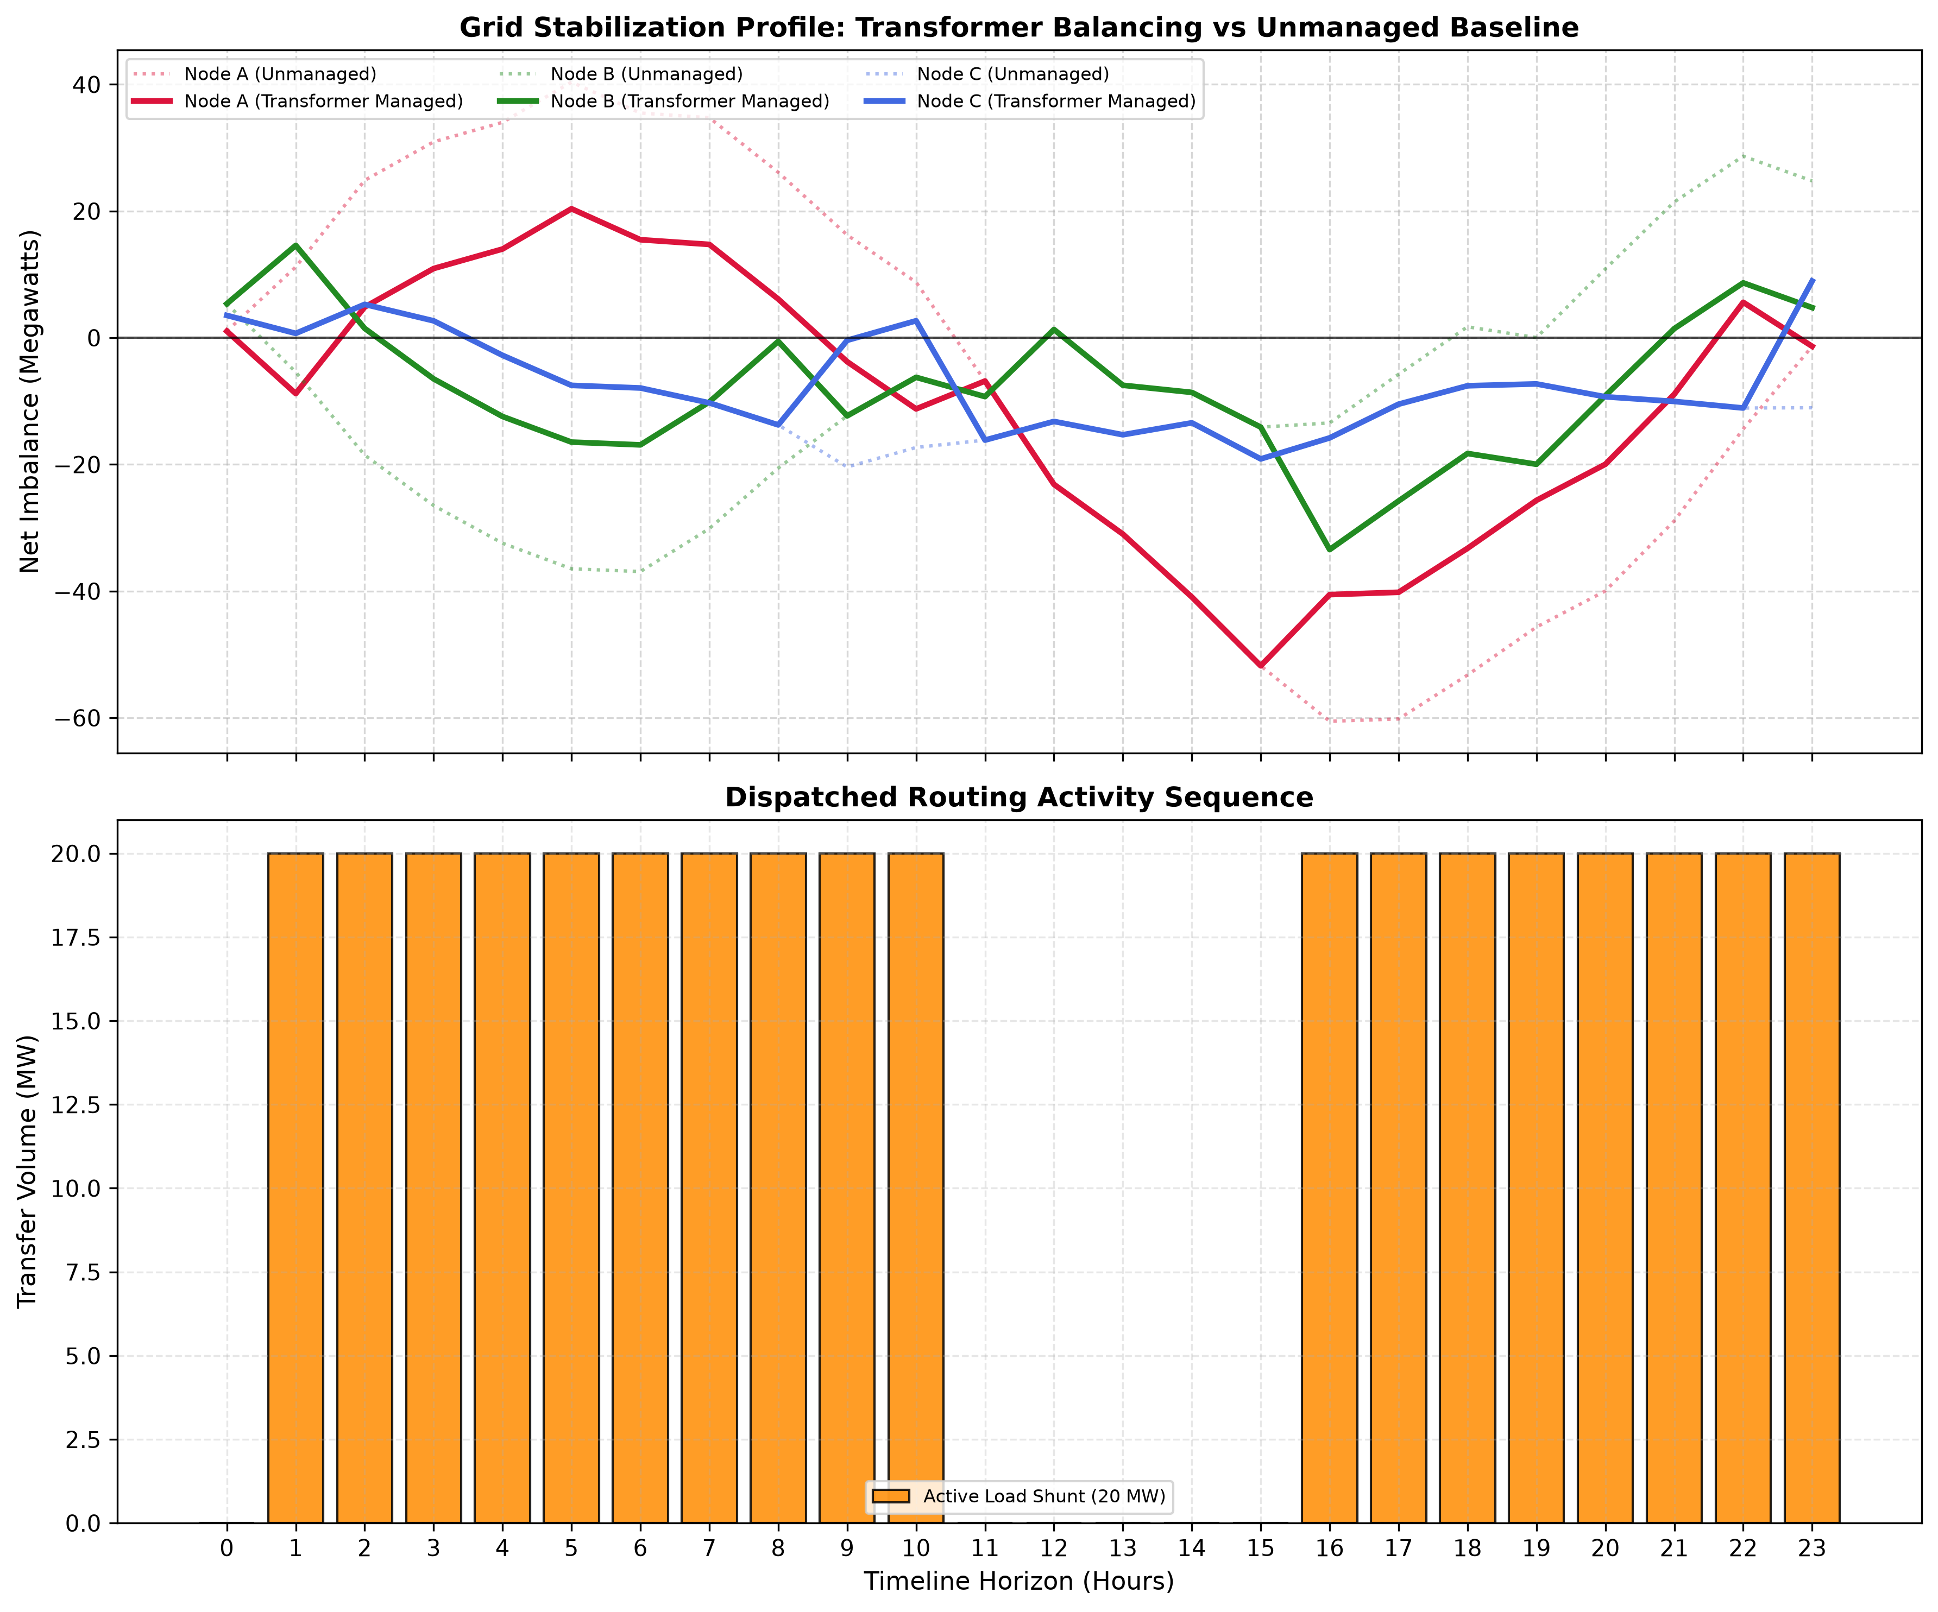
Fig. 6.6: Live routing telemetry of the Transformer-DQN policy over 24 hours
The 24-hour telemetry window illustrates the learned behaviour directly. In the early hours node A carries a surplus while node B is in deficit, and the agent routes A→B continuously; around midday all three nodes fall into deficit and the agent correctly holds, because no transfer can create power that the grid does not have; in the evening the pattern reverses as node B recovers and the agent switches to B→A. Over that window the unmanaged total of 1352.0 MW falls to 920.9 MW, a 31.9 % reduction, with transfers in 18 of the 24 hours.
Table 6.8: Centralized routing telemetry over a 24-hour window (MW)
Hour | Pre-A | Pre-B | Pre-C | Action selected | Post-A | Post-B | Post-C
00:00 | 1.0 | 5.4 | 3.5 | Hold | 1.0 | 5.4 | 3.5
01:00 | 11.2 | −5.4 | 0.7 | A → B | −8.8 | 14.6 | 0.7
02:00 | 24.9 | −18.5 | 5.3 | A → B | 4.9 | 1.5 | 5.3
03:00 | 30.9 | −26.5 | 2.7 | A → B | 10.9 | −6.5 | 2.7
04:00 | 34.0 | −32.4 | −2.8 | A → B | 14.0 | −12.4 | −2.8
05:00 | 40.4 | −36.5 | −7.5 | A → B | 20.4 | −16.5 | −7.5
06:00 | 35.5 | −36.9 | −7.9 | A → B | 15.5 | −16.9 | −7.9
07:00 | 34.7 | −30.1 | −10.3 | A → B | 14.7 | −10.1 | −10.3
08:00 | 26.1 | −20.6 | −13.8 | A → B | 6.1 | −0.6 | −13.8
09:00 | 16.2 | −12.3 | −20.4 | A → C | −3.8 | −12.3 | −0.4
10:00 | 8.8 | −6.2 | −17.3 | A → C | −11.2 | −6.2 | 2.7
11:00 | −6.8 | −9.3 | −16.2 | Hold | −6.8 | −9.3 | −16.2
12:00 | −23.1 | 1.3 | −13.2 | Hold | −23.1 | 1.3 | −13.2
13:00 | −31.0 | −7.5 | −15.3 | Hold | −31.0 | −7.5 | −15.3
14:00 | −40.9 | −8.6 | −13.4 | Hold | −40.9 | −8.6 | −13.4
15:00 | −51.8 | −14.1 | −19.1 | Hold | −51.8 | −14.1 | −19.1
16:00 | −60.5 | −13.4 | −15.8 | B → A | −40.5 | −33.4 | −15.8
17:00 | −60.2 | −5.8 | −10.5 | B → A | −40.2 | −25.8 | −10.5
18:00 | −53.2 | 1.7 | −7.6 | B → A | −33.2 | −18.3 | −7.6
19:00 | −45.7 | 0.0 | −7.3 | B → A | −25.7 | −20.0 | −7.3
20:00 | −40.0 | 10.9 | −9.3 | B → A | −20.0 | −9.1 | −9.3
21:00 | −28.9 | 21.5 | −10.0 | B → A | −8.9 | 1.5 | −10.0
22:00 | −14.4 | 28.7 | −11.1 | B → A | 5.6 | 8.7 | −11.1
23:00 | −1.3 | 24.8 | −11.0 | B → C | −1.3 | 4.8 | 9.0

6.5 Decentralized Control
The decentralized paradigm is evaluated on its own 240 unseen hours with an unmanaged total of 14 941.31 MW. Table 6.9 reports the PPO controller against the two reference controllers.
Table 6.9: Physical grid performance over 240 unseen hours (decentralized paradigm)
Policy | Managed (MW) | Reduction (%) | Transmission cost (MW) | Mean |imbalance| per hour (MW) | Worst-node peak (MW)
Decentralized PPO | 17171.44 | −14.93 | 297.49 | 71.55 | 99.48
Rule-based proportional | 11697.73 | 21.71 | 160.03 | 48.74 | 74.48
No control (sanity check) | 14941.31 | 0.00 | 0.00 | 62.26 | 74.48

The no-control row returns exactly 0.00 %, which is the sanity check that the managed figure measures the effect of the actions and nothing else. Against that reference the result is unambiguous and negative: the trained PPO controller increases total imbalance by 14.93 % while spending 297.49 MW of transmission, whereas the classical proportional rule reduces it by 21.71 % for 160.03 MW. The learned controller is worse than doing nothing, and worse still than the simplest sensible heuristic.
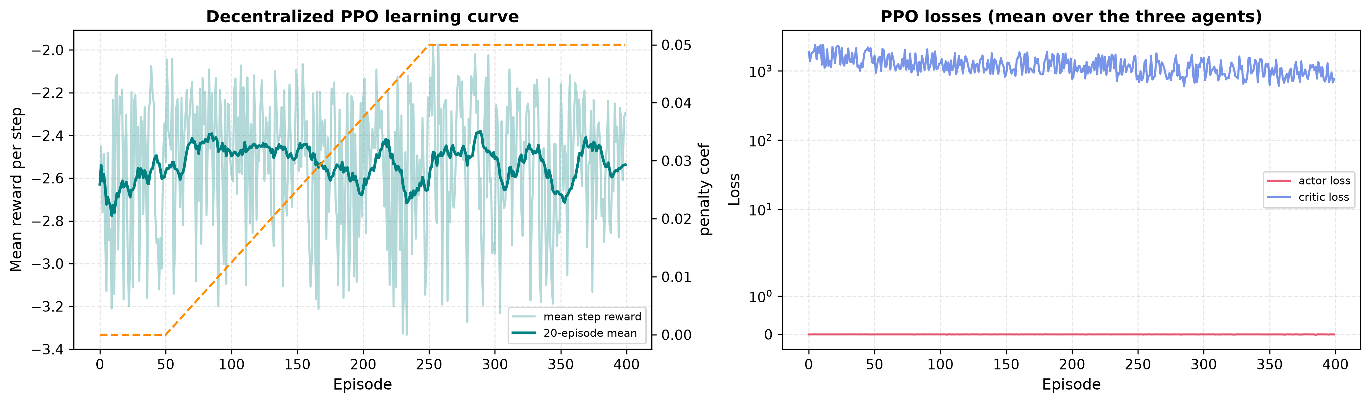
Fig. 6.7: Decentralized PPO learning curves and the annealed penalty coefficient
The training log in Table 6.10 shows why the curves are hard to read as progress. The mean step reward starts at −2.49 and ends at −2.30, a change far smaller than the episode-to-episode variation, and the dip between episodes 120 and 180 coincides with the transmission penalty being annealed in rather than with any change in control quality. Over the whole run the first ten episodes average −2.78 and the last ten −2.44.
Table 6.10: Training progress of the decentralized PPO agents
Episode | Mean step reward | Penalty coef. | Episode | Mean step reward | Penalty coef.
20 / 400 | −2.49 | 0.000 | 220 / 400 | −2.19 | 0.042
40 / 400 | −2.08 | 0.000 | 240 / 400 | −2.60 | 0.047
60 / 400 | −2.23 | 0.002 | 260 / 400 | −2.28 | 0.050
80 / 400 | −2.35 | 0.007 | 280 / 400 | −3.27 | 0.050
100 / 400 | −2.52 | 0.012 | 300 / 400 | −2.90 | 0.050
120 / 400 | −2.79 | 0.017 | 320 / 400 | −2.20 | 0.050
140 / 400 | −3.10 | 0.022 | 340 / 400 | −3.10 | 0.050
160 / 400 | −2.91 | 0.027 | 360 / 400 | −2.63 | 0.050
180 / 400 | −2.71 | 0.032 | 380 / 400 | −2.34 | 0.050
200 / 400 | −2.78 | 0.037 | 400 / 400 | −2.30 | 0.050

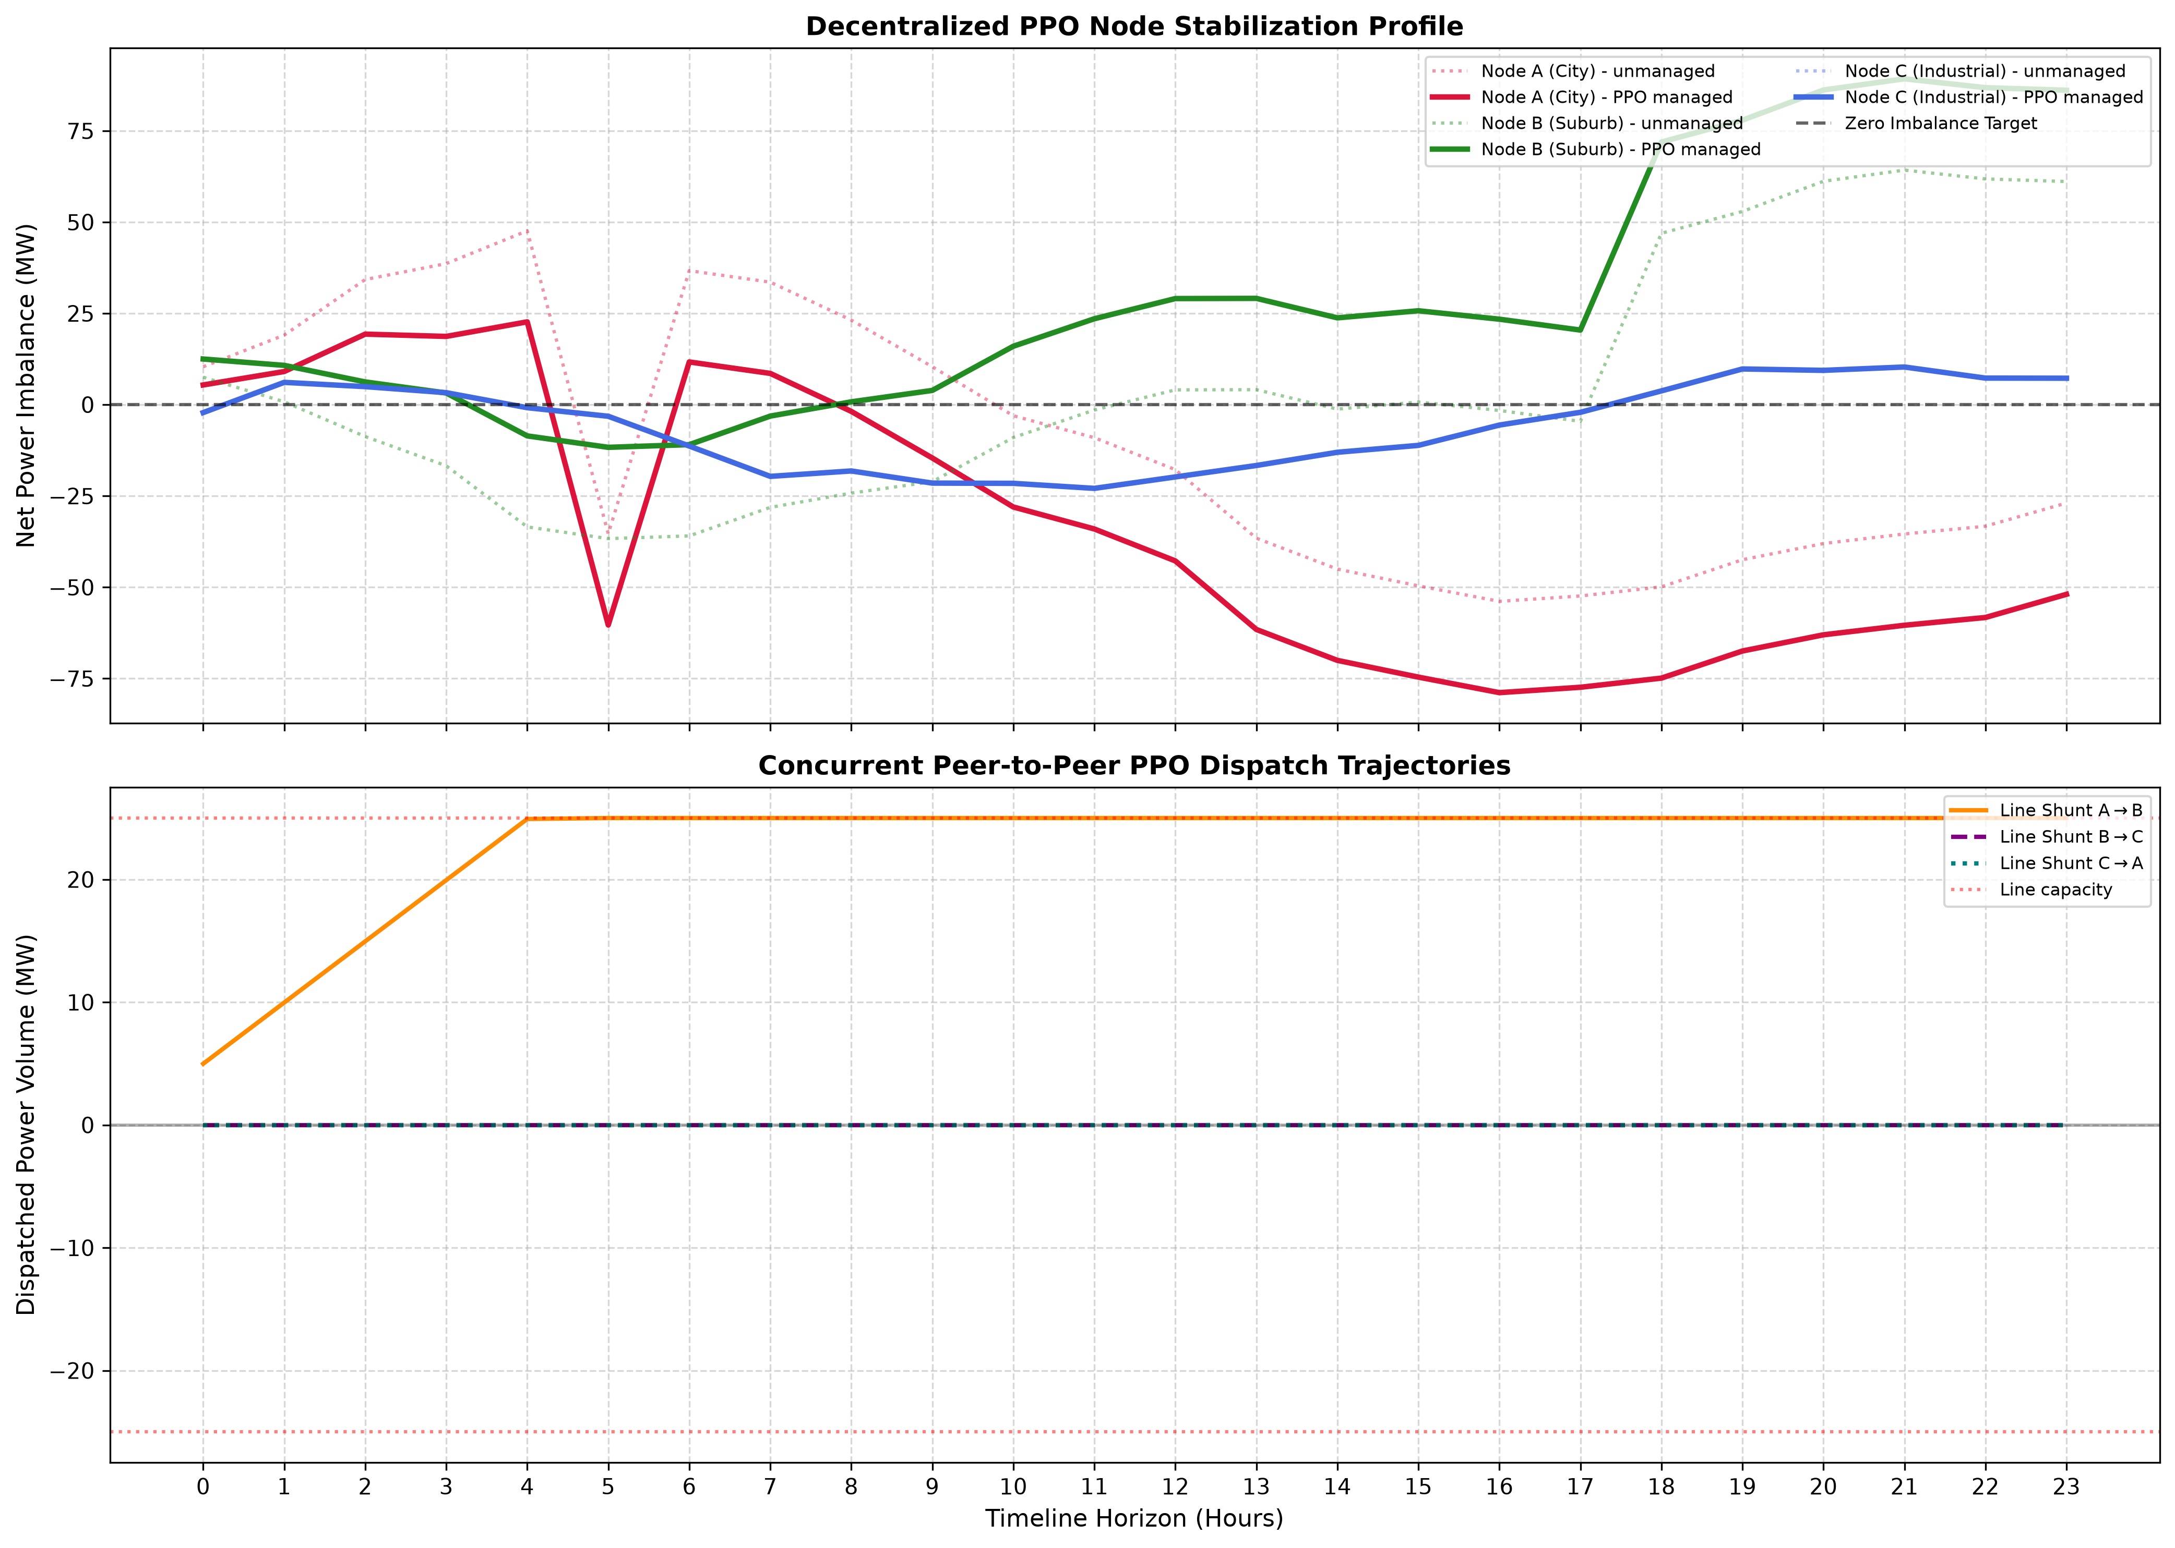
Fig. 6.8: Decentralized PPO transmission telemetry over 24 hours
Table 6.11: Decentralized PPO transmission telemetry over a 24-hour window (MW)
Hour | Net A | Net B | Net C | Shunt A→B | Shunt B→C | Shunt C→A
00:00 | 10.4 | 7.5 | −2.2 | 5.0 | 0.0 | 0.0
01:00 | 19.0 | 0.8 | 6.1 | 10.0 | 0.0 | 0.0
02:00 | 34.3 | −8.7 | 4.9 | 15.0 | 0.0 | 0.0
03:00 | 38.6 | −16.8 | 3.3 | 19.9 | 0.0 | 0.0
04:00 | 47.6 | −33.5 | −0.8 | 24.9 | 0.0 | 0.0
05:00 | −35.4 | −36.7 | −3.2 | 25.0 | 0.0 | 0.0
06:00 | 36.7 | −36.0 | −11.3 | 25.0 | 0.0 | 0.0
07:00 | 33.6 | −28.1 | −19.6 | 25.0 | 0.0 | 0.0
08:00 | 23.2 | −24.2 | −18.2 | 25.0 | 0.0 | 0.0
09:00 | 10.4 | −21.1 | −21.5 | 25.0 | 0.0 | 0.0
10:00 | −3.0 | −9.0 | −21.6 | 25.0 | 0.0 | 0.0
11:00 | −9.1 | −1.5 | −22.9 | 25.0 | 0.0 | 0.0
12:00 | −17.8 | 4.0 | −19.8 | 25.0 | 0.0 | 0.0
13:00 | −36.6 | 4.1 | −16.7 | 25.0 | 0.0 | 0.0
14:00 | −45.0 | −1.2 | −13.0 | 25.0 | 0.0 | 0.0
15:00 | −49.6 | 0.7 | −11.2 | 25.0 | 0.0 | 0.0
16:00 | −53.9 | −1.6 | −5.6 | 25.0 | 0.0 | 0.0
17:00 | −52.4 | −4.6 | −2.1 | 25.0 | 0.0 | 0.0
18:00 | −49.9 | 46.9 | 3.8 | 25.0 | 0.0 | 0.0
19:00 | −42.5 | 52.9 | 9.8 | 25.0 | 0.0 | 0.0
20:00 | −38.0 | 61.2 | 9.4 | 25.0 | 0.0 | 0.0
21:00 | −35.4 | 64.2 | 10.3 | 25.0 | 0.0 | 0.0
22:00 | −33.3 | 61.8 | 7.3 | 25.0 | 0.0 | 0.0
23:00 | −26.9 | 61.1 | 7.2 | 25.0 | 0.0 | 0.0

The mechanism is visible in the telemetry. Within the first five hours the learned mean policy drives line A→B to its 25 MW capacity and holds it there for the remaining nineteen hours, while lines B→C and C→A remain at zero throughout. The shunts therefore stop tracking the imbalance altogether, and a constant transfer applied to a signal that reverses sign during the day is actively harmful: at hour 05 node A is at −35.4 MW and still exporting 25 MW to node B. Three factors explain the saturation. Each agent is rewarded only for its own node while its imbalance also depends on the line its upstream neighbour controls, so the credit assignment is misaligned with the physical coupling. The delta bound of ±5 MW per hour cannot follow a signal whose hourly swings are several times larger, so even a correct policy would lag. And because the nodes are usually in deficit simultaneously, pushing a line to capacity is locally rational for the importing agent even when it is globally destructive. Rebalancing the critic loss and raising the learning rate were both measured and neither corrected the behaviour, so the result is reported as measured.
6.6 Paradigm Comparison
Table 6.12 consolidates the two paradigms. The percentages are not directly comparable in absolute terms because the two evaluations use different test windows and different action spaces, but the comparison against each paradigm's own references is meaningful.
Table 6.12: Consolidated comparison of both control paradigms
Paradigm | Controller | Reduction (%) | Reference points
Centralized | Transformer-DQN (attention) | 23.52 | Oracle ceiling 24.39 %; always-Hold 0.00 %; random −14.91 %
Centralized | TransferAgent (frozen backbone) | 22.04 | Same references
Decentralized | PPO multi-agent | −14.93 | Rule-based 21.71 %; no control 0.00 %
Decentralized | Rule-based proportional | 21.71 | No control 0.00 %

The centralized agent recovers nearly all of the control available to it; the decentralized agent does not learn a usable policy at all on this task under this configuration. The decentralized agents act on strictly less information — their own imbalance, the hour, two broadcast neighbour values and their own line loading — and receive credit only for their own node. On this problem that information gap plus the local credit assignment costs more than the scalability it buys, and a simple proportional rule remains the better decentralized controller. This is a result about this configuration on this simulator, not a general claim about multi-agent reinforcement learning; the diagnosis in Section 6.5 points to specific, testable causes.

CHAPTER 7
PUBLICATION PREPARATION AND SUBMISSION
The outcome of this project is a comparative simulation study with a clearly diagnosed negative result for one of the two paradigms. That profile suits academic publication rather than patent filing, and this chapter records the preparation carried out. No manuscript has been submitted and no venue has been selected; those items are left for the team to complete.
7.1 Research Paper Structure and Formatting Guidelines
A manuscript derived from this work would follow the standard IEEE conference structure. The mapping from the present report to that structure, together with the evidence available for each section, is given in Table 7.1.
Table 7.1: Proposed manuscript structure and the evidence available for each section
Manuscript section | Content drawn from this project
Title | Comparative evaluation of centralized and decentralized deep reinforcement learning for multi-node grid power balancing
Abstract | Report abstract, condensed to approximately 200 words
I. Introduction | Chapter 1: motivation, the routing decision as a sequential problem, the two paradigms
II. Related Work | Section 2.1: load forecasting, RL for dispatch, multi-agent RL for distributed resources
III. Problem Formulation | Section 2.3 and Sections 3.5 and 3.7: the MDP, the two information structures
IV. Simulator and Data | Sections 3.1–3.3 and Table 6.1: the generator and its statistical validation
V. Methods | Sections 3.4–3.7: the forecaster, the two centralized agents, the PPO multi-agent system
VI. Experimental Setup | Section 3.8 and Table 4.3: evaluation protocol, baselines, hyperparameters
VII. Results | Tables 6.1–6.12 and Figures 6.1–6.8
VIII. Discussion | Sections 6.4–6.6: the transfer-learning shortfall and the decentralized negative result
IX. Conclusion and Future Work | Chapter 10
References | Report reference list in IEEE format

The formatting requirements that would apply are the IEEE conference template: A4 or US Letter, two columns, Times New Roman 10 pt body text, numbered section headings in Roman numerals, figures and tables captioned and cited in order, and references in IEEE numeric style. The reproducible artefacts the manuscript would cite — the seeded notebook, the saved forecaster and the generated figures — already exist in the project.
7.2 Selection of Journals / Conferences
No venue has been selected. The following details are to be completed by the team in consultation with the project guide:
• Target conference / journal: ________________________
• Publisher and indexing: ________________________
• Submission deadline: ________________________
• Template and page limit: ________________________
• Author order and corresponding author: ________________________
7.3 Submission Process and Peer Review
No manuscript has been submitted within the duration of this project, so no peer-review correspondence exists. The record below is to be completed if and when a submission is made:
• Date of submission: ________________________
• Submission / paper ID: ________________________
• Review outcome: ________________________
• Date of acceptance or revision request: ________________________
• Reviewer comments and the response made: ________________________

CHAPTER 8
PROJECT SHOWCASE AND PRESENTATION
This chapter records the dissemination activities associated with the project. The project does not contain documentation of a showcase event, audience feedback or industry interaction, so these items are left for the team to complete.
8.1 Event Planning and Organization
• Name of the showcase / exhibition event: ________________________
• Date and venue: ________________________
• Organising department / committee: ________________________
• Mode of demonstration (poster, live notebook demonstration, recorded walkthrough): ________________________
8.2 Audience Engagement and Feedback Collection
• Evaluators / audience present: ________________________
• Feedback collected: ________________________
• Questions raised and responses given: ________________________
8.3 Industry Interaction Opportunities
• Industry participants or mentors interacted with: ________________________
• Outcome of the interaction: ________________________
8.4 Presentation Material Prepared
A presentation deck has been prepared from this report following the DSE3170 PBL-3 template, covering the abstract, introduction, literature survey, research gap, problem statement, motivation, objectives, proposed methodology, results and discussion, and references. The deck uses the figures generated by the project — the system architecture, the grid topology, the paradigm comparison, the exploratory analysis, the forecaster evaluation, the learning curves, the confusion matrices and both telemetry plots — so that every claim made verbally is supported by a visual produced from the actual run.

CHAPTER 9
OUTCOMES AND ACHIEVEMENTS
9.1 Technical Outcomes
The technical outcomes of the project, all of which are reproducible from the seeded notebook, are summarised in Table 9.1.
Table 9.1: Technical outcomes of the project
Outcome | Evidence
A seeded, auditable three-node grid simulator with validated statistical properties | Table 6.1; Figures 6.1 and 6.2
An LSTM imbalance forecaster with 21.2 % RMSE skill over persistence | Table 6.2; R² 0.911 on a chronological hold-out
A centralized attention-based DQN recovering 96 % of the attainable control | Table 6.7; 23.52 % against an oracle ceiling of 24.39 %
A quantified cost of transfer learning from a forecasting backbone | Table 6.7; 22.04 % versus 23.52 %, κ 0.436 versus 0.586
A PettingZoo-compliant decentralized environment and a trained PPO multi-agent system | Section 3.7; Figures 6.7 and 6.8
A diagnosed negative result for decentralized control on this task | Table 6.9 and Section 6.5; −14.93 % against 21.71 % for the rule-based reference
An evaluation harness reporting every policy against trivial baselines and an upper bound | Tables 6.4–6.12

9.2 Patents Filed
No patent application has been filed from this project. See Section 1.2 for the IPR position and the reasons.
• Patent title: ________________________
• Application number and date of filing: ________________________
• Status: ________________________
9.3 Publications Accepted
No publication has been submitted or accepted within the duration of this project. The preparation carried out is recorded in Chapter 7.
• Paper title: ________________________
• Venue and date of acceptance: ________________________
• DOI / proceedings reference: ________________________
9.4 Awards and Recognitions
• Award / recognition received: ________________________
• Awarding body and date: ________________________

CHAPTER 10
CONCLUSION AND FUTURE SCOPE
10.1 Conclusion
This project built a complete, reproducible pipeline for learning power-routing policies on a three-node grid and used it to compare centralized and decentralized deep reinforcement learning on one simulator with one evaluation harness. The supervised stage produced an LSTM forecaster with genuine skill — MAE 5.00 MW, RMSE 7.54 MW, R² 0.911 and a 21.2 % RMSE reduction over persistence — which established that the six-hour window carries real predictive structure and justified reusing its feature layer as a frozen backbone.
In the centralized paradigm the Transformer-based DQN learned a policy that reduces total grid imbalance by 23.52 % over 240 unseen hours against a greedy-oracle ceiling of 24.39 %, recovering 96 % of the control available to a single 20 MW transfer per hour, with a Cohen's kappa of 0.586 against oracle-labelled actions where an always-Hold policy scores zero. The transfer-learning variant reached 22.04 % and kappa 0.436, measurably below the attention agent, which shows that a frozen forecasting encoder is not automatically a good control encoder: the objective it was pre-trained on differs from the objective it is asked to serve.
In the decentralized paradigm the result was negative and is reported as measured. The three PPO substation agents increased total imbalance by 14.93 % while spending 297 MW of transmission, against a 21.71 % reduction for a classical proportional rule and 0.00 % for no control. The telemetry identifies the mechanism precisely: the learned mean policy saturates line A→B at its capacity within the first five hours and holds it there, so the shunts stop tracking the imbalance. Local-only credit assignment, a delta bound smaller than the hourly imbalance swings, and the fact that all three nodes are usually in deficit at the same time each contribute. Two remedies were measured and neither corrected it.
The broader conclusion the evidence supports is methodological. Every percentage reported here is accompanied by a trivial baseline and, where one exists, an attainable upper bound, and it is only against those references that the numbers mean anything: 23.52 % is excellent because the ceiling is 24.39 %, and −14.93 % is a failure because doing nothing scores 0.00 % and a one-line heuristic scores 21.71 %. Without those reference points neither statement could be made.
10.2 Limitations
• The grid is synthetic. The simulator is physically motivated but uses no real weather, demand or price data, so the results characterise the controllers on this process rather than on a real network.
• The transmission model is idealised: it has no line losses, no impedance, no voltage or frequency dynamics and no reactive power, and transfers take effect within the same hour.
• The centralized action space permits exactly one 20 MW transfer per hour, which bounds the attainable reduction at 24.39 % on the evaluation window.
• Each reported result is a single seeded run rather than a mean with a confidence interval over several seeds, so run-to-run variance is not quantified.
• The two paradigms are evaluated on different test windows and different action spaces, so their percentages are compared against their own references rather than head to head.
• The training budgets are modest — 60 episodes for the DQN and 400 for the PPO agents — so neither controller can be claimed to be at convergence.
10.3 Future Scope
• Replace the simulator with real data, for example measured substation load and generation together with observed weather, and retain the audit stage so that data-quality issues surface explicitly.
• Address the decentralized failure directly: give the agents a shared or mixed reward rather than a purely local one, widen the per-hour delta bound so the shunt can track the imbalance, and evaluate centralized-training-with-decentralized-execution methods such as MAPPO or QMIX against the same rule-based reference.
• Repeat every experiment over multiple seeds and report means with confidence intervals so that the differences between controllers can be tested rather than merely observed.
• Extend the physics: add line losses and impedance, introduce storage as a controllable element, and allow transfers to persist across hours.
• Scale the topology beyond three nodes, which is where the decentralized paradigm is expected to pay for itself and where the centralized action space grows quadratically.
• Fine-tune rather than freeze the forecasting backbone, and test whether an encoder pre-trained on an auxiliary control-relevant objective transfers better than one trained to forecast.
• Train the centralized agent for longer and with a tuned exploration schedule to establish whether the remaining 0.87 percentage points to the oracle ceiling can be recovered.

REFERENCES
[1] V. Mnih, K. Kavukcuoglu, D. Silver, A. A. Rusu, J. Veness, M. G. Bellemare, A. Graves, M. Riedmiller, A. K. Fidjeland, G. Ostrovski, S. Petersen, C. Beattie, A. Sadik, I. Antonoglou, H. King, D. Kumaran, D. Wierstra, S. Legg and D. Hassabis, “Human-level control through deep reinforcement learning,” Nature, vol. 518, no. 7540, pp. 529–533, 2015, doi: 10.1038/nature14236.
[2] J. Schulman, F. Wolski, P. Dhariwal, A. Radford and O. Klimov, “Proximal policy optimization algorithms,” arXiv preprint arXiv:1707.06347, 2017.
[3] J. Schulman, P. Moritz, S. Levine, M. I. Jordan and P. Abbeel, “High-dimensional continuous control using generalized advantage estimation,” in Proceedings of the International Conference on Learning Representations (ICLR), San Juan, Puerto Rico, 2016.
[4] A. Vaswani, N. Shazeer, N. Parmar, J. Uszkoreit, L. Jones, A. N. Gomez, L. Kaiser and I. Polosukhin, “Attention is all you need,” in Advances in Neural Information Processing Systems (NeurIPS), Long Beach, CA, USA, 2017, pp. 5998–6008.
[5] S. Hochreiter and J. Schmidhuber, “Long short-term memory,” Neural Computation, vol. 9, no. 8, pp. 1735–1780, 1997, doi: 10.1162/neco.1997.9.8.1735.
[6] J. Terry, B. Black, N. Grammel, M. Jayakumar, A. Hari, R. Sullivan, L. S. Santos, C. Dieffendahl, C. Horsch, R. Perez-Vicente, N. L. Williams, Y. Lokesh and P. Ravi, “PettingZoo: Gym for multi-agent reinforcement learning,” in Advances in Neural Information Processing Systems (NeurIPS), vol. 34, 2021, pp. 15032–15043.
[7] D. P. Kingma and J. Ba, “Adam: A method for stochastic optimization,” in Proceedings of the International Conference on Learning Representations (ICLR), San Diego, CA, USA, 2015.
[8] J. Cohen, “A coefficient of agreement for nominal scales,” Educational and Psychological Measurement, vol. 20, no. 1, pp. 37–46, 1960, doi: 10.1177/001316446002000104.
[9] R. S. Sutton and A. G. Barto, Reinforcement Learning: An Introduction, 2nd ed. Cambridge, MA, USA: MIT Press, 2018, ISBN 978-0262039246.
[10] M. Abadi, P. Barham, J. Chen, Z. Chen, A. Davis, J. Dean, M. Devin, S. Ghemawat, G. Irving, M. Isard, M. Kudlur, J. Levenberg, R. Monga, S. Moore, D. G. Murray, B. Steiner, P. Tucker, V. Vasudevan, P. Warden, M. Wicke, Y. Yu and X. Zheng, “TensorFlow: A system for large-scale machine learning,” in Proceedings of the 12th USENIX Symposium on Operating Systems Design and Implementation (OSDI), Savannah, GA, USA, 2016, pp. 265–283.
[11] F. Pedregosa, G. Varoquaux, A. Gramfort, V. Michel, B. Thirion, O. Grisel, M. Blondel, P. Prettenhofer, R. Weiss, V. Dubourg, J. Vanderplas, A. Passos, D. Cournapeau, M. Brucher, M. Perrot and É. Duchesnay, “Scikit-learn: Machine learning in Python,” Journal of Machine Learning Research, vol. 12, pp. 2825–2830, 2011.
[12] P. Virtanen, R. Gommers, T. E. Oliphant, M. Haberland, T. Reddy, D. Cournapeau, E. Burovski, P. Peterson, W. Weckesser, J. Bright, S. J. van der Walt, M. Brett, J. Wilson, K. J. Millman, N. Mayorov, A. R. J. Nelson, E. Jones, R. Kern, E. Larson, C. J. Carey, İ. Polat, Y. Feng, E. W. Moore, J. VanderPlas, D. Laxalde, J. Perktold, R. Cimrman, I. Henriksen, E. A. Quintero, C. R. Harris, A. M. Archibald, A. H. Ribeiro, F. Pedregosa and P. van Mulbregt, “SciPy 1.0: Fundamental algorithms for scientific computing in Python,” Nature Methods, vol. 17, pp. 261–272, 2020, doi: 10.1038/s41592-019-0686-2.
[13] H. Levene, “Robust tests for equality of variances,” in Contributions to Probability and Statistics: Essays in Honor of Harold Hotelling, I. Olkin, Ed. Stanford, CA, USA: Stanford University Press, 1960, pp. 278–292.
[14] G. E. P. Box, G. M. Jenkins, G. C. Reinsel and G. M. Ljung, Time Series Analysis: Forecasting and Control, 5th ed. Hoboken, NJ, USA: Wiley, 2015, ISBN 978-1118675021.
[15] The Patents Act, 1970 (Act No. 39 of 1970), Government of India, https://ipindia.gov.in/writereaddata/Portal/IPOAct/1_31_1_patent-act-1970-11march2015.pdf, Accessed on [date to be filled by team].

APPENDICES
Appendix A — Project Artefacts
The following files constitute the project as submitted. None of them was modified while preparing this report.
Table A.1: Project artefacts
File | Description
PBL.ipynb | The complete implementation: simulator, preprocessing, EDA, statistical tests, forecaster, both control paradigms, evaluation and consolidated results
pbl_artifacts/grid_forecaster.keras | The trained LSTM forecaster, including the feature_extractor layer reused as the frozen backbone
pbl_artifacts/eda_overview.png | Exploratory analysis of the three-node grid
pbl_artifacts/acf_analysis.png | Autocorrelation and statistical analysis
pbl_artifacts/forecaster_evaluation.png | Forecaster performance on the held-out window
pbl_artifacts/dqn_learning_curves.png | Learning curves of both centralized agents
pbl_artifacts/dqn_confusion_matrices.png | Confusion matrices against oracle labels
pbl_artifacts/grid_power_transfer_analysis.png | Centralized routing telemetry
pbl_artifacts/marl_learning_curves.png | Decentralized PPO learning curves
pbl_artifacts/marl_ppo_decentralized_balancing.png | Decentralized PPO transmission telemetry

Appendix B — Key Code Listings
The listings below are reproduced from PBL.ipynb. They are included because each one implements a decision discussed in the body of the report, and because the behaviour of the controllers cannot be checked against the text without them.
B.1 FastEnv.step() — the differential reward
def step(self, action):
if not 0 <= action < self.N_ACTIONS:
raise ValueError(f"action must be in [0, {self.N_ACTIONS - 1}], got {action}")

pre = self.current_imbalance_mw()
post = self.apply_action(pre, action)
transferred = 0.0 if action == 0 else self.transfer_mw

# DIFFERENTIAL reward: how much stress the action removed, rather than the
# absolute stress level. |pre| is a constant of the state, so this leaves the
# optimal policy identical to the greedy oracle's while removing the large
# state-dependent offset that otherwise drowns the action signal.
reward = (np.abs(pre).sum() - np.abs(post).sum()
- self.penalty_coef * transferred) / 10.0

self.last_pre_mw, self.last_post_mw = pre, post
self.last_transfer_mw = transferred

self.idx += 1
done = self.idx >= self.n_steps
next_state = (self._get_state() if not done
else np.zeros((self.lookback, 3), dtype=np.float32))
return next_state, float(reward), done

B.2 TransformerAgent._build_model() — the attention Q-network
def _build_model(self, lr):
inputs = Input(shape=(self.lookback, 3), name="grid_state_input")
projected_features = Dense(32, activation='linear')(inputs)
embedded_sequence = PositionalEmbedding1D(sequence_length=self.lookback,
embedding_dim=32)(projected_features)

attention_out = MultiHeadAttention(num_heads=4,
key_dim=32)(embedded_sequence, embedded_sequence)
x = LayerNormalization()(embedded_sequence + attention_out)

ffn_out = Dense(32, activation='gelu')(x)
x = LayerNormalization()(x + ffn_out)

pooled = GlobalAveragePooling1D()(x)
dense_bottleneck = Dense(32, activation='gelu')(pooled)
outputs = Dense(self.n_actions, activation='linear',
name="q_values_output")(dense_bottleneck)

model = Model(inputs=inputs, outputs=outputs)
model.compile(loss='mse', optimizer=Adam(learning_rate=lr))
return model

B.3 PettingZooGridEnv.step() — directed lines and local rewards
def step(self, actions_dict, penalty_coef=0.05):
c_A, c_B, c_C = (self.imb[self.idx] * self.scale).astype(np.float64)

low = -self.max_capacity if self.bidirectional else 0.0
for node, line in self.line_of.items():
self.current_shunts[line] = float(np.clip(
self.current_shunts[line] + float(actions_dict[node]) * self.max_delta,
low, self.max_capacity))

s_AB, s_BC, s_CA = (self.current_shunts["AB"],
self.current_shunts["BC"],
self.current_shunts["CA"])

c_A = c_A - s_AB + s_CA
c_B = c_B - s_BC + s_AB
c_C = c_C - s_CA + s_BC

# ISOLATED REWARD SHAPING: hold agents accountable for their local domains
reward_A = -(abs(c_A) + penalty_coef * abs(s_AB)) / 10.0
reward_B = -(abs(c_B) + penalty_coef * abs(s_BC)) / 10.0
reward_C = -(abs(c_C) + penalty_coef * abs(s_CA)) / 10.0

B.4 The PPO update with GAE and the clipped surrogate objective
last_val = 0.0 if episode_done else agents[idx].value(states_dict[idx])
v_batch_next = np.append(v_batch[1:], last_val)
deltas = r_batch + gamma * v_batch_next - v_batch
advantages = discount_cumsum(deltas, gamma * lam)
advantages = (advantages - np.mean(advantages)) / (np.std(advantages) + 1e-8)
returns = discount_cumsum(np.append(r_batch, last_val), gamma)[:-1]

advantages = np.ascontiguousarray(advantages, dtype=np.float32)
returns = np.ascontiguousarray(returns, dtype=np.float32)

for _ in range(PPO_EPOCHS):
with tf.GradientTape() as tape:
mean, std, val_preds = agents[idx].actor_critic(s_batch, training=True)
std, var = std + 1e-5, (std + 1e-5) ** 2
new_lps = (-((tf.squeeze(a_batch) - tf.squeeze(mean)) ** 2)
/ (2 * tf.squeeze(var))
- tf.math.log(tf.sqrt(2 * np.pi * tf.squeeze(var))))
ratios = tf.exp(new_lps - lp_batch)
surr1 = ratios * advantages
surr2 = tf.clip_by_value(ratios, 1.0 - clip_ratio,
1.0 + clip_ratio) * advantages
act_loss = -tf.reduce_mean(tf.minimum(surr1, surr2))
crit_loss = tf.reduce_mean(tf.square(returns - tf.squeeze(val_preds)))
entropy = tf.reduce_mean(0.5 * tf.math.log(2 * np.pi * np.e
* tf.squeeze(var)))
total_loss = act_loss + 0.5 * crit_loss - 0.01 * entropy

grads = tape.gradient(total_loss, agents[idx].actor_critic.trainable_variables)
clipped_grads, _ = tf.clip_by_global_norm(grads, 0.5)
agents[idx].optimizer.apply_gradients(
zip(clipped_grads, agents[idx].actor_critic.trainable_variables))

Appendix C — Reproduction Instructions
Open PBL.ipynb in a fresh Python 3 kernel and execute every cell from top to bottom. The first cell installs PettingZoo; every subsequent cell depends only on cells above it. All randomness derives from SEED = 42 and each dataset is generated from its own derived seed, so the results are reproducible regardless of execution order. The training budgets (forecaster epochs, DQN episodes, MARL episodes and evaluation horizon) are exposed as constants in the configuration cell and can be shortened through environment variables such as PBL_MARL_EPISODES for a fast smoke test without editing the notebook. On the machine used for the reported run the complete notebook executes in approximately twelve minutes, of which the 400-episode PPO training accounts for about ten.
Appendix D — Patent Draft Samples
Not applicable. No patent draft was prepared within this project; see Section 1.2.
Appendix E — Research Paper Manuscripts
No manuscript has been drafted within this project. The proposed structure and the evidence available for each section are given in Table 7.1.
Appendix F — Event Photographs and Reports
Not applicable. No showcase event documentation is contained in the project; see Chapter 8.

