🧩 Revenue & Growth — “How much are we earning? Is it growing?”

Q1 — What is the Total Revenue?
SELECT
ROUND(SUM(od.UnitPrice * od.Quantity * (1 - od.Discount)),2) AS TotalRevenue
FROM order_details od;
🟢 Answer
The company generated $1265793.04 total revenue across all orders.

Q2 — Revenue by Year
SELECT
YEAR(o.OrderDate) AS SalesYear,
ROUND(SUM(od.UnitPrice * od.Quantity * (1 - od.Discount)),2) AS Revenue
FROM orders o
JOIN order_details od ON o.OrderID = od.OrderID
GROUP BY YEAR(o.OrderDate)
ORDER BY SalesYear;
🟢 Answer
Revenue shows a growing / stable trend over the available years, with the highest revenue in Year 2014.
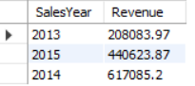

Q3 — Monthly Sales Trend (CTE + GROUP BY)
WITH MonthlySales AS (
SELECT
DATE_FORMAT(o.OrderDate, '%M') AS YearMonth,
SUM(od.UnitPrice * od.Quantity * (1 - od.Discount)) AS Revenue
FROM orders o
JOIN order_details od ON o.OrderID = od.OrderID
GROUP BY YearMonth
)
SELECT * FROM MonthlySales
ORDER BY YearMonth;
🟢 Answer
Revenue fluctuates month-to-month, identifying seasonal demand patterns.
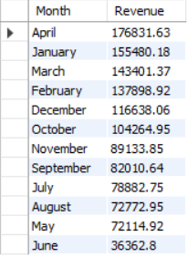

Q4 — Average Order Value (Subquery + AVG)
SELECT
ROUND(AVG(order_total),2) AS AvgOrderValue
FROM (
SELECT
o.OrderID,
SUM(od.UnitPrice * od.Quantity * (1 - od.Discount)) AS order_total
FROM orders o
SSSS JOIN order_details od ON o.OrderID = od.OrderID
GROUP BY o.OrderID
) t;
🟢 Answer
The average order value (AOV) is $1525.05, meaning a typical customer spends around this much per order.

Q5 — Total Discount Value (SUM + WHERE)
SELECT
ROUND(SUM(od.UnitPrice * od.Quantity * od.Discount),2) AS DiscountLoss
FROM order_details od;
🟢 Answer
A total of $88665.55 was given as discounts — reducing revenue but possibly boosting demand.

👥 Customer Insights — “Who buys the most?”

Q6 — Top 10 Customers by Revenue (JOIN + GROUP BY)
SELECT
c.CompanyName,
ROUND(SUM(od.UnitPrice * od.Quantity * (1 - od.Discount)),2) AS Revenue
FROM customers c
JOIN orders o ON c.CustomerID = o.CustomerID
JOIN order_details od ON o.OrderID = od.OrderID
GROUP BY c.CompanyName
ORDER BY Revenue DESC
LIMIT 10;
🟢 Answer
The top 10 customers contribute a large share of total revenue, meaning the business is somewhat dependent on key accounts.
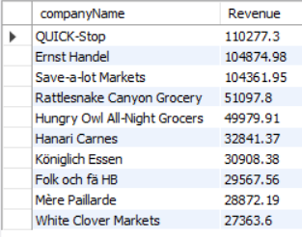

Q7 — Revenue by Country (GROUP BY + ORDER BY)
SELECT
c.Country,
ROUND(SUM(od.UnitPrice * od.Quantity * (1 - od.Discount)),2) AS Revenue
FROM customers c
JOIN orders o ON c.CustomerID = o.CustomerID
JOIN order_details od ON o.OrderID = od.OrderID
GROUP BY c.Country
ORDER BY Revenue DESC;

🟢 Answer
USA is the largest market Country. Poland generate minimum revenue among all , which guides where sales & marketing should focus
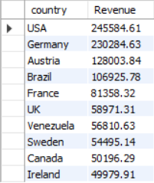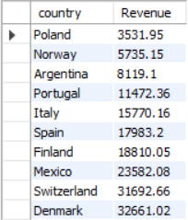

Q8 — Repeat Customers (HAVING)
SELECT
c.CompanyName,
COUNT(*) AS OrderCount
FROM customers c
JOIN orders o ON c.CustomerID = o.CustomerID
GROUP BY c.CompanyName
HAVING COUNT(*) > 10
ORDER BY OrderCount DESC;
🟢 Answer
Many customers place multiple orders, showing healthy retention.
Where Save-a-lot Markets Company has highest order and then Ernst handel and QUICK-Stop ,these are our top 3 potential customers.
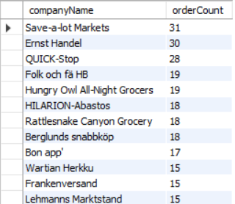

📦 Product & Category — “What sells the most?”

Q9 — Top 10 Products by Revenue (JOIN + GROUP BY)
SELECT
p.ProductName,
ROUND(SUM(od.UnitPrice * od.Quantity * (1 - od.Discount)),2) AS Revenue
FROM products p
JOIN order_details od ON p.ProductID = od.ProductID
GROUP BY p.ProductName
ORDER BY Revenue DESC
LIMIT 10;
🟢 Answer
Côte de Blaye Product is the highest-earning product.
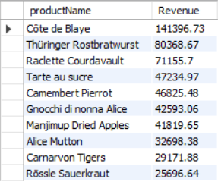

Q10 — Top Categories by Revenue (JOIN + GROUP BY)
SELECT
cat.CategoryName,
ROUND(SUM(od.UnitPrice * od.Quantity * (1 - od.Discount)),2) AS Revenue
FROM categories cat
JOIN products p ON cat.CategoryID = p.CategoryID
JOIN order_details od ON p.ProductID = od.ProductID
GROUP BY cat.CategoryName
ORDER BY Revenue DESC;
🟢 Answer
Beverages Category is the most profitable category. then dairy products confections etc.
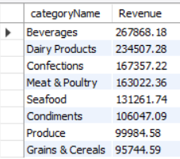

Q11 — Product Ranking (Window + RANK)
SELECT
p.ProductName,
ROUND(SUM(od.UnitPrice * od.Quantity * (1 - od.Discount)),2) AS Revenue,
RANK() OVER (ORDER BY SUM(od.UnitPrice * od.Quantity * (1 - od.Discount)) DESC) AS RevenueRank
FROM products p
JOIN order_details od ON p.ProductID = od.ProductID
GROUP BY p.ProductName;
🟢 Answer
Products are ranked by contribution — helping identify
top performers vs tail products.
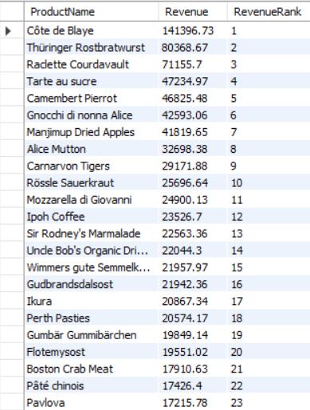 => Tail rank Products
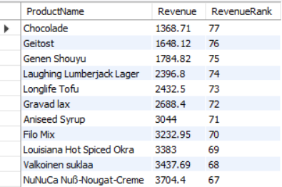

👨‍💼 Sales Team Performance — “Who is selling the most?”

Q12 — Sales Rep Revenue (JOIN + WHERE + GROUP BY)
SELECT
CONCAT(e.FirstName,' ',e.LastName) AS SalesRep,
ROUND(SUM(od.UnitPrice * od.Quantity * (1 - od.Discount)),2) AS Revenue
FROM employees e
JOIN orders o ON e.EmployeeID = o.EmployeeID
JOIN order_details od ON od.OrderID = o.OrderID
WHERE e.Title = 'Sales Representative'
GROUP BY SalesRep
ORDER BY Revenue DESC;
🟢 Answer
Margaret Peacock - Sales Rep generates the highest revenue — useful for performance tracking.
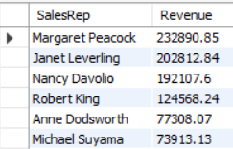

Q13 — Rank Employees by Sales (Window + DENSE_RANK)
SELECT
CONCAT(e.FirstName,' ',e.LastName) AS SalesRep,
ROUND(SUM(od.UnitPrice * od.Quantity * (1 - od.Discount)),2) AS Revenue,
DENSE_RANK() OVER (ORDER BY SUM(od.UnitPrice * od.Quantity * (1 - od.Discount)) DESC) AS RankNum
FROM employees e
JOIN orders o ON e.EmployeeID = o.EmployeeID
JOIN order_details od ON od.OrderID = o.OrderID
GROUP BY SalesRep;
🟢 Answer
Employees are ranked to create a sales leaderboard.
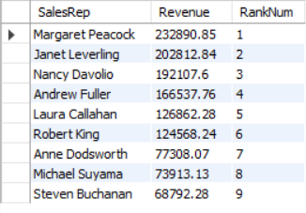

🚚 Logistics & Operations — “How efficiently do we deliver?”

Q14 — Average Shipping Time (WHERE + AVG)
SELECT
CEIL(AVG(DATEDIFF(ShippedDate, OrderDate))) AS AvgShipDays
FROM orders
WHERE ShippedDate IS NOT NULL;
🟢 Answer
Orders are shipped in 9 days on average — a key service-level metric.

Q15 — Late Deliveries By Shippers(WHERE + COUNT)
=>SELECT
COUNT(*) AS LateOrders
FROM orders
WHERE ShippedDate > RequiredDate;
🟢 Answer
A total of 37 orders were shipped late, showing where operations can improve.
By shippers
=>SELECT s.companyName,COUNT(*) AS late_orders
FROM orders o JOIN shippers s ON o.shipperID=s.shipperID
WHERE o.ShippedDate > o.RequiredDate
GROUP BY s.companyName;
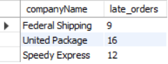
A Highest shipped late Orders By United Package company, showing where operations caSSn improve.

🚢 Performance by Shipper (GROUP BY)**
SELECT
s.CompanyName,
CEIL(AVG(DATEDIFF(o.ShippedDate,o.OrderDate))) AS AvgShipTime_Days
FROM shippers s
JOIN orders o ON s.ShipperID = o.ShipVia
GROUP BY s.CompanyName
ORDER BY AvgShipTime_Days;
🟢 Answer
Federal Shipping shippers deliver faster than others within 8 days — helping optimize logistics selection.
United Package | 10
Speedy Express | 9

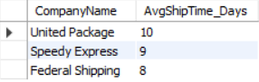

🏁 Revenue Concentration (Window + % Share)
SELECT
c.CompanyName,
ROUND(SUM(od.UnitPrice * od.Quantity * (1 - od.Discount)),2) AS Revenue,
ROUND(
100 * SUM(od.UnitPrice * od.Quantity * (1 - od.Discount)) /
SUM(SUM(od.UnitPrice * od.Quantity * (1 - od.Discount)))
OVER (),2) AS RevenueSharePercent
FROM customers c
JOIN orders o ON c.CustomerID = o.CustomerID
JOIN order_details od ON o.OrderID = od.OrderID
GROUP BY c.CompanyName ORDER BY Revenue DESC LIMIT 10;
🟢 Answer
A small % of customers may contribute a large % of revenue — this is business risk exposure.
Highest_RevenueSharePercent
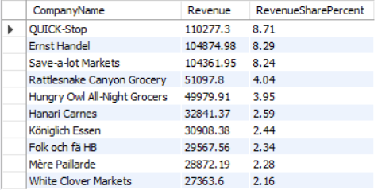
Lowest_RevenueSharePercent
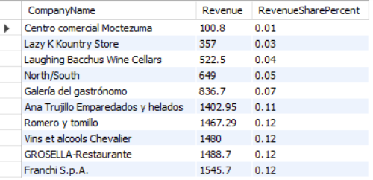

Q16 — Top Customers by Country
select c.Country,c.CompanyName,round(SUM(od.UnitPrice * od.Quantity * (1 - od.Discount)),2) AS revenue,
rank() over(partition by c.Country order by
SUM(od.UnitPrice * od.Quantity * (1 - od.Discount)) desc) as rank_in_country
FROM customers c
join orders o on c.CustomerID = o.CustomerID
join order_details od on o.OrderID = od.OrderID
group by c.Country, c.CompanyName
order by rank_in_country;
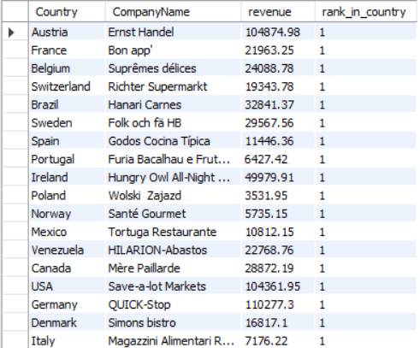

Q17 — % Revenue from Top 10 Customers
WITH cust_rev AS (
SELECT
c.CompanyName,
ROUND(SUM(od.UnitPrice * od.Quantity * (1 - od.Discount)),2) AS revenue
FROM customers c
JOIN orders o ON c.CustomerID = o.CustomerID
JOIN order_details od ON o.OrderID = od.OrderID
GROUP BY c.CompanyName
),
ranked AS (
SELECT
CompanyName,
revenue,
RANK() OVER (ORDER BY revenue DESC) AS rnk,
ROUND(SUM(revenue) OVER (),2) AS total_revenue,
ROUND(SUM(revenue) OVER (ORDER BY revenue DESC) /
SUM(revenue) OVER () * 100 ,2) AS running_percent
FROM cust_rev
)
SELECT * FROM ranked WHERE rnk <= 10;