
OSDAG Screening Task – Bridge Module Web-Based UI Development
- Introduction
Osdag is a cross-platform free/libre and open-source software for the design (and detailing) of steel structures. For the screening task, you will develop a web-based graphical user interface that handles user input, performs validation checks, manages field dependencies, and loads reference values from provided engineering data tables.
This screening task will assess your ability to:
- Design a clean and intuitive user interface layout
- Implement input validation and clear error feedback
- Use data from external tables (wind, seismic, temperature)
- Handle interactive UI elements and automatic field adjustments
- Write clear, maintainable, and well-structured code
You can set up the Osdag-web development environment using the following references:
- Automated Script for Windows Setup [SCRIPT] [VIDEO]
- Linux Installation Guide [LINK]
- Refer to this report for troubleshooting [LINK]
If you face any issues in the setting up of the development environment, you can reach out to us through the Osdag discord channel.

- Objective
Develop a web application titled Group Design that includes:
- A Basic Inputs tab where the user enters:
  - Type of Structure
  - Project Location
  - Geometric Inputs
  - Material Inputs
- An Additional Inputs tab (visible in the UI, but no functionality required in this task)
- A Bridge Cross-Section and Plan reference image is displayed beside the input panel
- A Modify Additional Geometry button within the basic Inputs tab, which opens a pop-up dialogue box where girder spacing, number of girders, and deck overhang width are interdependent

- Setup and Deployment
Set up and run Osdag-on-cloud. Ensure proper functionality on your local or preferred cloud environment.
- Module Development: Visual Flow
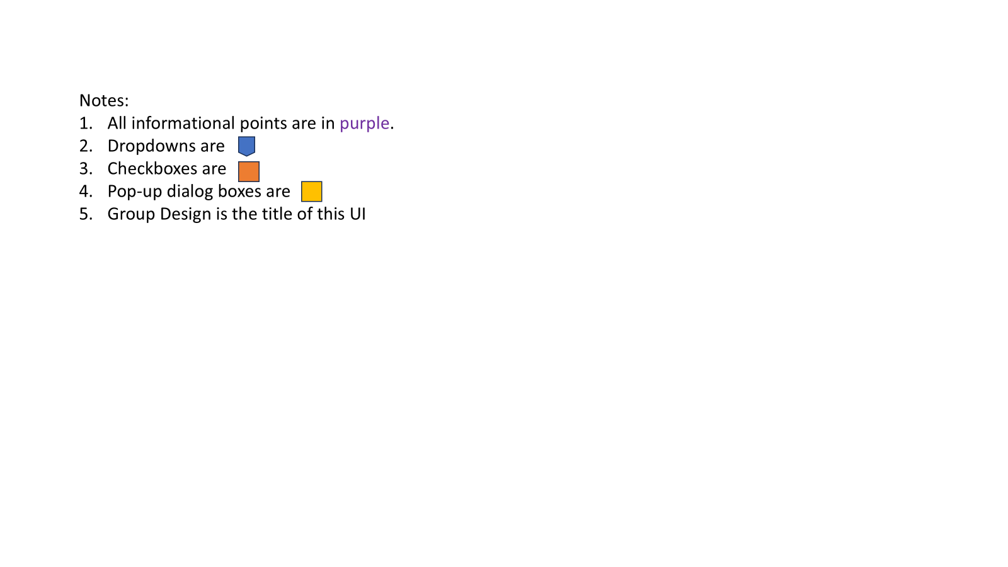
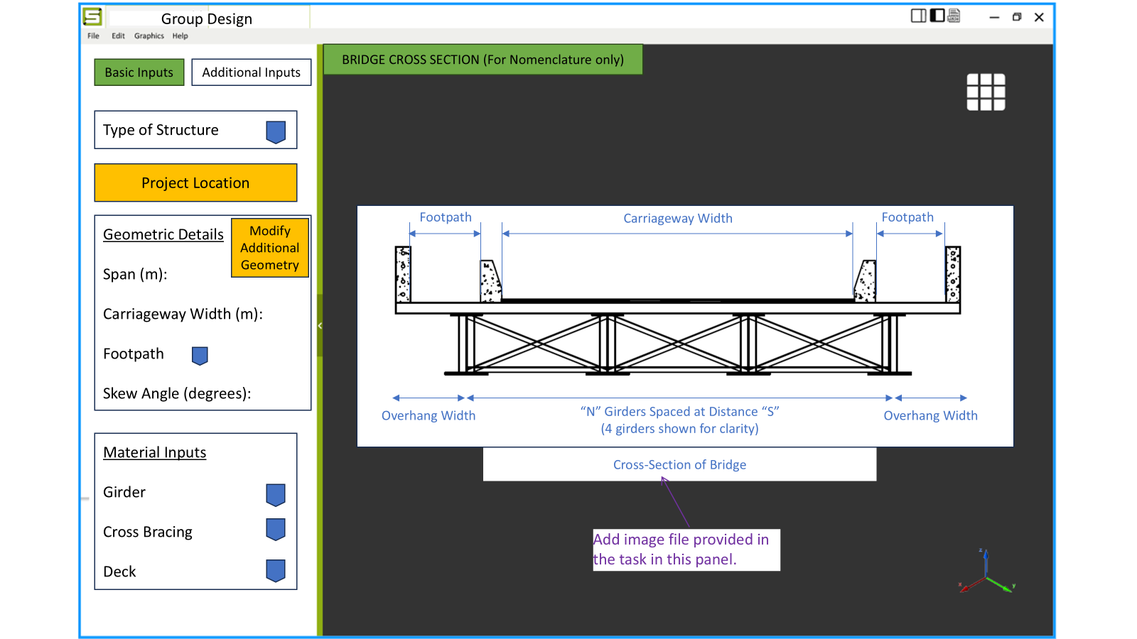
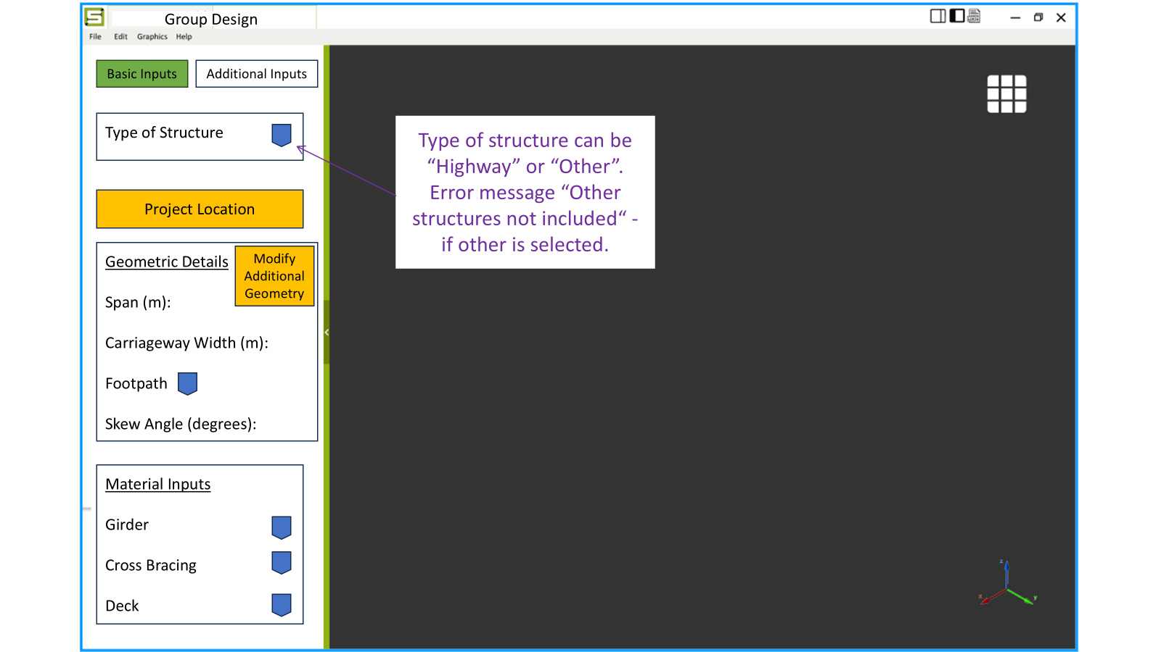
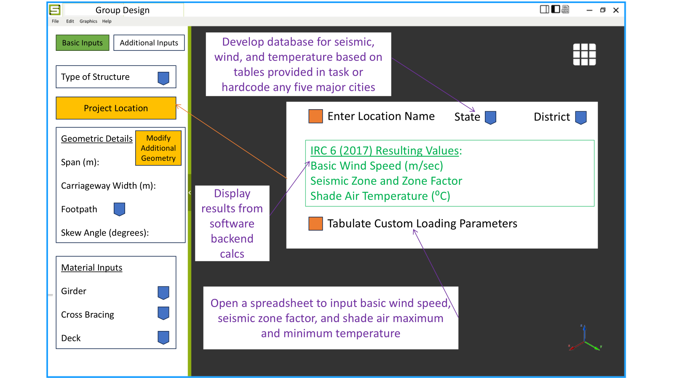
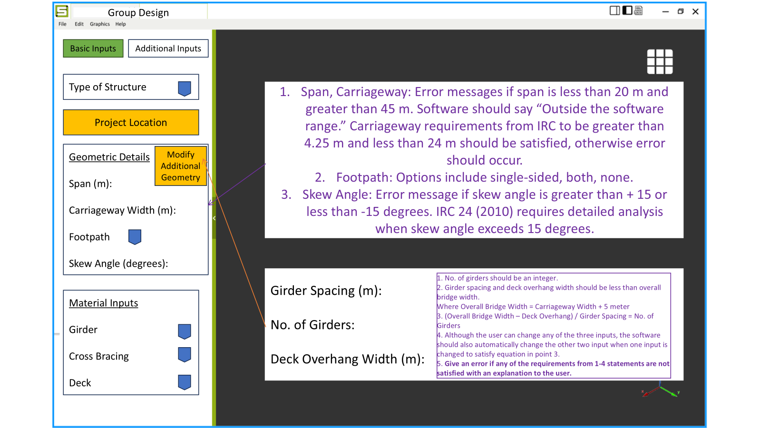
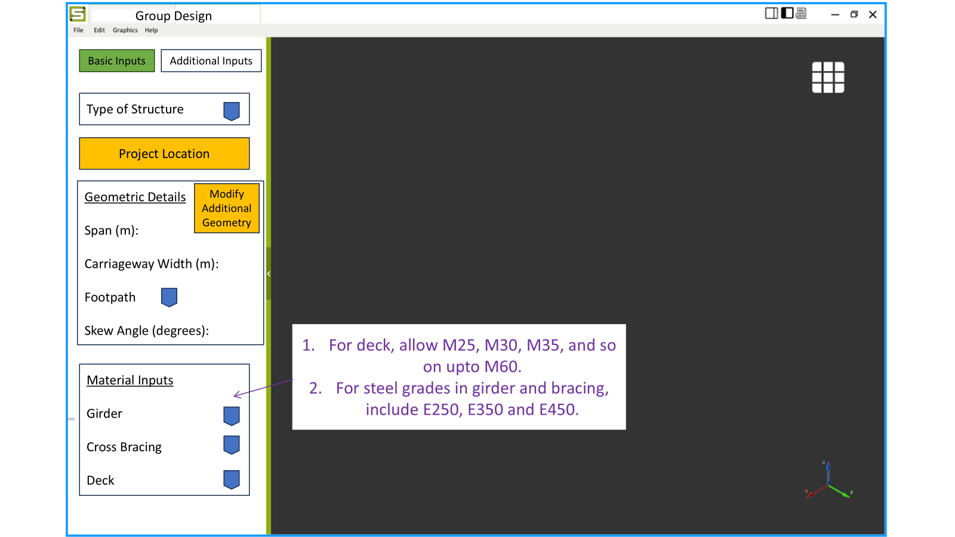

- Module Development: Flow Description
  - UI Title
Group Design
  - Layout
Left Panel (Inputs) | Right Panel (Reference Image)
Contains two tabs:  • Basic Inputs (implemented)  • Additional Inputs (placeholder only) | Must display the provided Bridge Cross-Section image. The image remains visible and is not interactive.
  - Tabs within Left Panel
Tab | Requirement
Basic Inputs | Implemented in this task
Additional Inputs | Only create the tab, content not required
    - Basic Inputs Tab
      - Type of Structure
- Choices: Highway or Other
- If Other is selected:
  - Display: “Other structures not included.”
  - Disable all remaining inputs
      - Project Location
Provide two mutually exclusive modes, i.e. only one option can be active at a time.
Mode No. | Mode | UI Behavior | Data Source | Resulting Values Shown
1. | Enter Location Name (checkbox) | Shows State and District dropdowns | Provided tables | Basic Wind Speed (m/s), Seismic Zone & Factor, Max/Min Shade Air Temperature (resulting from the reference tables) in the Project Location section
2. | Tabulate Custom Loading Parameters (checkbox + button) | Opens a spreadsheet-style pop-up | User manually enters values | Basic Wind Speed (m/s), Seismic Zone & Factor, Max/Min Shade Air Temperature from the user input in the spreadsheet will be visible in the Project Location section
For the first mode with “Enter Location Name,” you may choose either of the following approaches for the Project Location data:
- Option A (Extra Credit +20%)
Develop a database for temperature, seismic, and wind values using the tables provided in Section 5. This database should be used to populate the State and District dropdown menus within the Project Location section. When a location is selected, the corresponding Temperature (Max/Min), Basic Wind Speed (m/s), and Seismic Zone & Zone Factor should automatically appear. These values should be displayed in green, as shown in Section 3.

Correct implementation of this database earns 20% extra credit.

- Option B (Base Requirement)
If you choose to skip the optional database, then inside the code, hardcode temperature, wind, and seismic values for any 5 major cities (e.g.: Mumbai, Delhi, Chennai, Bangalore, Kolkata). These cities should appear in the Project Location dropdown and their corresponding values should be displayed in green.
      - Geometric Details
Field | Validation
Span (m) | If < 20 or > 45 → “Outside the software range.”
Carriageway Width (m) | Must be ≥ 4.25 m and <24 m
Footpath | Options: Single-sided / Both / None
Skew Angle (°) | If outside ±15° → “IRC 24 (2010) requires detailed analysis”
      - Material Inputs
Component | Allowed Grades
Girder Steel | E250, E350, E450
Cross Bracing Steel | E250, E350, E450
Deck Concrete | M25, M30, M35 and so on up to M60

      - Modify Additional Geometry (Pop-Up)
Placed within Geometric Details.
Field | Format
Girder Spacing (m) | Float, 1 decimal
No. of Girders | Integer
Deck Overhang Width (m) | Float, 1 decimal
Rules
- Overall Bridge Width = Carriageway Width + 5 meters
- Both spacing & overhang must be < overall width
- Must satisfy:
(Overall Width – Overhang) / Spacing = No. of Girders
- Changing any field must auto-update the other two
- Clear error messages required if constraints fail

- Frontend and Backend Stack
- Develop the UI for the selected module using React.
- Implement endpoints using Django and Django REST Framework.
- Provided Files
Link includes:
- Bridge Cross-Section Image
- Wind Table
- Seismic Table
- Temperature Table

- Deliverables
- Video Demonstration: Create a short video (1–3 minutes) demonstrating:
  - Navigation through the UI
  - Project Location selection using both modes
  - The Modify Additional Geometry pop-up and its auto-adjust behavior
  - Any implemented validations or error messages
If you completed the optional database, show selecting a location and automatic display of temperature, wind, and seismic data in green.
The video may be silent and does not need editing.
Upload it as Unlisted on YouTube, and provide the link in your submission.
- If the optional database was completed, include the processed database file (CSV/JSON/SQLite).
- Backend:
  - Endpoints implemented for the selected module in Django and Django REST Framework.
- Frontend:
  - A React-based UI for the selected module.
- Report:
  - Methodology: Describe the approach taken for development.
  - Challenges: Highlight issues faced while setting up and developing the project.
  - References: Include resources used for learning and development.

- Evaluation Criteria
- Backend Development
  - Reusable Code: Modular and efficient design.
  - Code Structure: Well-organized and adheres to Django conventions.
  - API Design: Adherence to RESTful API principles.
- Frontend Development
  - User Experience: Intuitive and responsive UI design.
  - Reusable Code: Modular and reusable React components.
  - Integration: Smooth integration of APIs with the frontend.

Optional Extra Credit (+20%)
Awarded if the candidate develops a database for temperature, wind, and seismic data from the provided tables, integrates it into the State → District dropdown selection, and displays the resulting values within the Project Location tab.

- Notes
- You may enhance the UI or code structure beyond the minimum required.
- The provided tables and image are reference inputs; you may refactor the data format for cleaner use.
- Ensure all dependencies are clearly listed and installable.
- Kindly join the Osdag Discord Server using the provided [LINK].
For any questions, please use the screening-task-helpdesk channel.

