Benefits of Vacuum-Assisted Excision Compared to Open Surgery in Breast Fibroadenoma
Discovering a lump in the breast can be worrying, even when it turns out to be harmless. Fibroadenoma is one of the common benign breast conditions, particularly among younger women. These lumps are usually non-cancerous and may simply be monitored when they are small, stable, and confirmed to be benign.
However, removal may be considered when a fibroadenoma becomes larger, causes discomfort, changes over time, or creates uncertainty about the diagnosis. Traditionally, removing such a lump involved open breast surgery. With advances in minimally invasive treatment, Vacuum-Assisted Excision (VAE) has emerged as an alternative for selected patients.
This technique allows the doctor to remove an appropriately selected breast lesion through a small access point, without making the larger incision typically associated with open surgery.

Understanding Vacuum-Assisted Excision
Vacuum-Assisted Excision is a minimally invasive technique used to remove certain benign breast lesions.
The procedure is generally performed under imaging guidance, most commonly using ultrasound. After numbing the treatment area with local anaesthesia, the doctor introduces a specialized vacuum-assisted device through a small opening in the skin.
The vacuum gently draws portions of the fibroadenoma into the device, allowing the abnormal tissue to be removed piece by piece. The process continues until the targeted lesion has been adequately removed.
The collected tissue can also be sent to a laboratory for histopathological examination, allowing specialists to confirm the diagnosis.
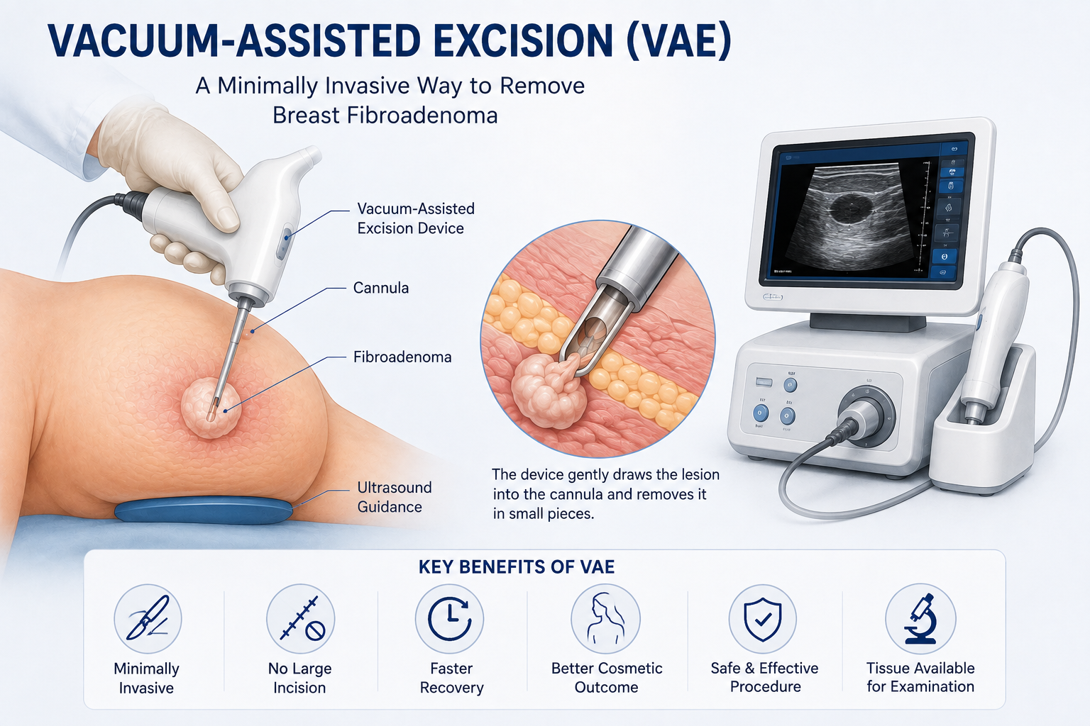

VAE vs Open Surgery: What Is the Difference?
In conventional open surgery, the surgeon makes an incision in the breast to directly reach and remove the fibroadenoma. The incision is then closed, usually with stitches.
VAE takes a different approach. Rather than creating a surgical opening large enough to expose the lump, the doctor reaches the lesion through a small entry point using imaging guidance.
For appropriately selected fibroadenomas, this minimally invasive approach may offer several advantages.

1. Minimal Scarring
One of the biggest concerns for many patients undergoing breast procedures is the appearance of a scar.
Open surgery requires an incision that is large enough for the surgeon to access the lesion. VAE, on the other hand, uses a much smaller skin entry point.
As a result, the resulting mark may be considerably less noticeable, which can be particularly important when cosmetic appearance is a concern.

2. Less Disruption to Breast Tissue
Open surgery involves cutting through the breast tissue to reach the fibroadenoma.
With VAE, the doctor uses image guidance to target the lesion directly and remove it through the specialized device. This minimally invasive approach can reduce unnecessary disturbance of the surrounding breast tissue.
Preserving the surrounding tissue can also be valuable when maintaining the natural appearance of the breast is an important consideration.

3. No Conventional Large Incision
Because the procedure is performed through a small access point, VAE does not usually involve the larger surgical wound associated with open excision.
This can simplify wound care and eliminates the need for a conventional surgical incision over the breast in many cases.

4. Recovery Can Be More Convenient
A smaller access point generally means there is less tissue healing involved compared with a traditional surgical incision.
Many appropriately selected patients can resume their usual activities relatively soon after the procedure. However, recovery varies from person to person and depends on factors such as the size and location of the fibroadenoma and the individual's overall health.
Your treating doctor will provide specific instructions about returning to work, exercise, and other activities.

5. Cosmetic Benefits
For many women, the appearance of their breast after treatment matters almost as much as treating the lump itself.
Because VAE requires only a small opening, it can provide a cosmetic advantage over conventional open excision. The final skin mark is often much smaller than a traditional surgical scar.
This can make VAE an appealing option for patients who are concerned about the cosmetic effects of breast surgery.

6. Often Performed Under Local Anaesthesia
VAE is commonly carried out using local anaesthesia, which numbs the treatment area while the patient remains awake.
This can make the procedure less demanding than some forms of conventional surgery. However, the type of anaesthesia used depends on the patient's circumstances, the lesion being treated, and the treating team's assessment.

7. Removed Tissue Can Be Examined
Another important aspect of fibroadenoma removal is knowing exactly what the tissue contains.
The tissue collected during VAE can be submitted for pathological examination. A pathologist examines the specimen under a microscope to verify that it is consistent with a benign lesion.
This provides an additional level of diagnostic confirmation when tissue analysis is clinically appropriate.

Is VAE Appropriate for Every Patient?
No. While Vacuum-Assisted Excision can be a useful option, it is not suitable for every breast lump or every patient.
Before recommending VAE, doctors consider factors such as the size and location of the lesion, ultrasound or mammography findings, previous biopsy results, symptoms, and whether the lesion has shown any changes.
If a lesion has suspicious features or is particularly large or complex, open surgery or another treatment may be more appropriate.
Therefore, the choice between VAE and surgery should always be individualized rather than based solely on the desire for a minimally invasive procedure.

What Happens After VAE?
It is normal to experience some temporary tenderness, bruising, swelling, or mild discomfort after the procedure. These symptoms generally settle as the treated area heals.
Patients should follow their doctor's instructions regarding wound care, physical activity, medications, and follow-up appointments.
Depending on the individual case, follow-up clinical assessment or breast imaging may also be recommended.

A Less Invasive Approach to Selected Fibroadenomas
A diagnosis of fibroadenoma does not automatically mean that the lump needs to be removed. In many cases, observation may be all that is required.
When removal is recommended, however, patients now have more options than traditional open surgery alone.
For appropriately selected benign breast lesions, Vacuum-Assisted Excision offers a minimally invasive approach with the potential benefits of a smaller skin opening, less visible scarring, limited tissue disruption, and a convenient recovery.
The most suitable treatment depends on an accurate diagnosis and individual assessment.
If you have a breast lump or have already been diagnosed with fibroadenoma, speak with a qualified breast specialist to understand whether monitoring, VAE, or surgical removal is appropriate for your situation.
Bankers Vascular Hospital focuses on minimally invasive, image-guided procedures designed around precision and patient comfort. Patients diagnosed with suitable benign breast lesions can discuss their treatment options with the medical team and determine whether Vacuum-Assisted Excision is appropriate for them.

