What Is a Breast Fibroadenoma? Causes, Symptoms, Diagnosis, and Treatment

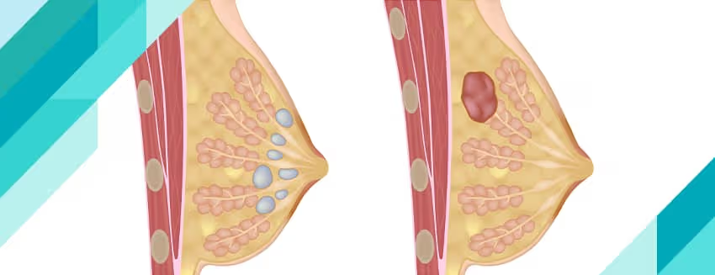
Discovering a lump in the breast can be a frightening experience, often leading to concerns about breast cancer. However, not all breast lumps are cancerous. One of the most common benign (non-cancerous) breast conditions is a breast fibroadenoma.
Fibroadenomas are particularly common among young women and are generally harmless. Although they do not increase the risk of breast cancer in most cases, they can cause anxiety and discomfort due to their presence. Understanding what a fibroadenoma is, why it develops, and how it is treated can help patients make informed decisions about their breast health.
In this article, we explore the causes, symptoms, diagnosis, and treatment options for breast fibroadenomas.

What Is a Breast Fibroadenoma?
A breast fibroadenoma is a benign breast tumor made up of both glandular breast tissue and connective tissue. It is one of the most frequently diagnosed non-cancerous breast lumps in women, especially those between the ages of 15 and 35.
Fibroadenomas are usually:
- Round or oval in shape
- Firm but rubbery in texture
- Smooth and well-defined
- Easily movable under the skin
- Painless in most cases
Because they can move slightly when touched, fibroadenomas are often referred to as "breast mice."
While fibroadenomas can occur at any age, they are most commonly found in younger women and may shrink naturally after menopause.

What Causes Breast Fibroadenomas?
The exact cause of fibroadenomas is not fully understood. However, hormonal influences—particularly estrogen—are believed to play a major role in their development.
Fibroadenomas often:
- Develop during reproductive years
- Increase in size during pregnancy
- Become more noticeable during hormone therapy
- Shrink after menopause
These patterns suggest a strong link between fibroadenomas and hormonal fluctuations.

Potential Contributing Factors
Although no definitive cause has been identified, several factors may contribute:
- Hormonal changes during puberty
- Pregnancy-related hormone increases
- Use of hormonal contraceptives
- Family history of benign breast conditions
- Increased sensitivity of breast tissue to estrogen

Types of Fibroadenomas
Not all fibroadenomas are the same. They can vary in size and structure.

Simple Fibroadenoma
This is the most common type.
Characteristics include:
- Uniform appearance under the microscope
- Low risk of complications
- Usually non-cancerous

Complex Fibroadenoma
These fibroadenomas contain additional tissue changes and may be larger.
Features may include:
- Cysts
- Calcifications
- Enlarged breast lobules
Although still benign, complex fibroadenomas may require closer monitoring.

Giant Fibroadenoma
These are larger fibroadenomas that exceed 5 centimeters in size.
They may:
- Cause visible breast asymmetry
- Grow rapidly
- Require surgical removal

Juvenile Fibroadenoma
Typically found in adolescents and young women.
These can grow quickly but remain benign.

Symptoms of Breast Fibroadenoma
Many fibroadenomas are discovered accidentally during self-examination or routine breast screening.

Common Symptoms

A Breast Lump
The most noticeable sign is a distinct lump within the breast.

Smooth Texture
The lump often feels smooth and well-defined.

Movable Lump
Unlike some malignant tumors, fibroadenomas can usually move slightly beneath the skin when touched.

Firm or Rubbery Feel
Most fibroadenomas feel firm but not hard.

Painless Mass
The majority do not cause pain.

Can Fibroadenomas Cause Pain?
Although fibroadenomas are typically painless, some women may experience:
- Breast tenderness
- Mild discomfort
- Increased sensitivity before menstruation
Pain is more likely if the fibroadenoma enlarges or if hormonal changes affect surrounding breast tissue.

How Are Fibroadenomas Diagnosed?
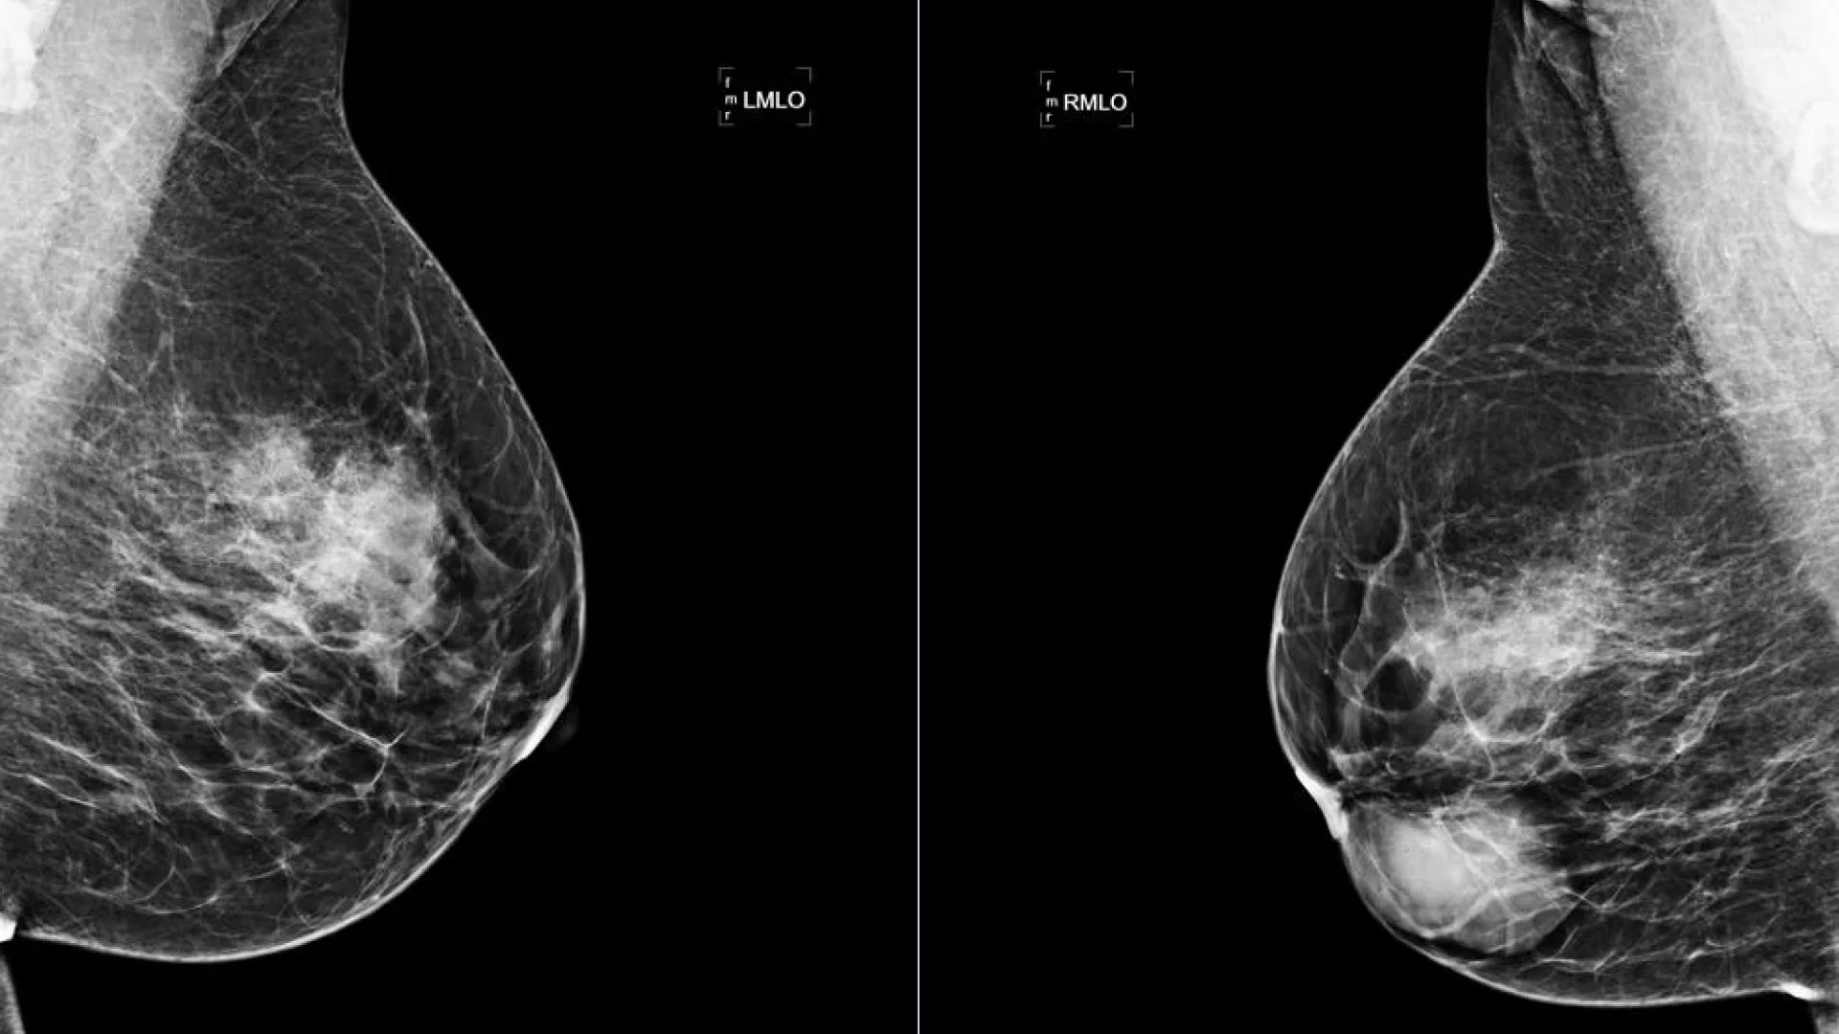
A breast lump should always be evaluated by a healthcare professional, even if it appears harmless.
Diagnosis usually involves several steps.

Clinical Breast Examination
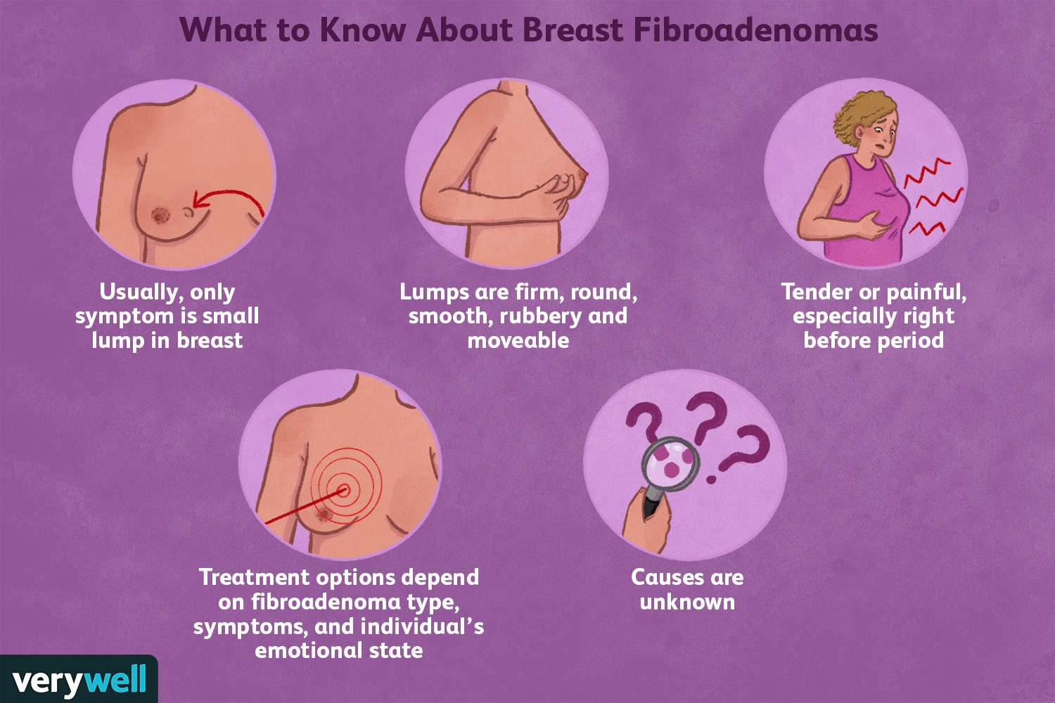
A doctor will examine the breast to assess:
- Size
- Shape
- Mobility
- Location of the lump

Breast Ultrasound
Ultrasound is often the preferred imaging test for younger women.
It helps determine whether the lump is:
- Solid
- Fluid-filled
- Suspicious for malignancy

Mammography
Mammograms may be recommended, particularly for older women.
These images provide detailed information about breast tissue structure.

MRI
Magnetic Resonance Imaging may be used in complex cases or when additional evaluation is needed.

Needle Biopsy
A core needle biopsy may be performed to confirm the diagnosis.
A small tissue sample is removed and examined under a microscope.
Biopsy provides the most accurate confirmation that the lump is benign.

Are Fibroadenomas Cancerous?
Fibroadenomas are benign tumors and are not considered breast cancer.
Most fibroadenomas:
- Do not become cancerous
- Do not spread to other parts of the body
- Do not significantly increase breast cancer risk
However, any new breast lump should be properly evaluated to rule out other conditions.

Do Fibroadenomas Need Treatment?
Not all fibroadenomas require treatment.
In many cases, observation is sufficient.

Watchful Waiting
Doctors may recommend monitoring if:
- The lump is small
- Imaging confirms a benign appearance
- Symptoms are absent
- Growth is stable
Regular follow-up examinations and imaging may be advised.

Treatment Options for Fibroadenoma
Treatment may be considered if the fibroadenoma grows, causes symptoms, or creates cosmetic concerns.

Surgical Removal (Lumpectomy)
A surgeon removes the fibroadenoma through a small incision.
This option may be recommended for:
- Large fibroadenomas
- Rapidly growing masses
- Uncertain diagnosis

Vacuum-Assisted Excision
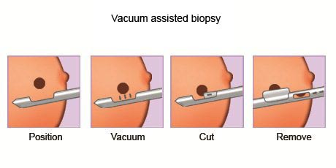
A minimally invasive procedure that removes the fibroadenoma through a small probe.
Benefits include:
- Minimal scarring
- Short recovery time
- Outpatient treatment

Can Fibroadenomas Come Back?
A fibroadenoma that has been completely removed usually does not return.
However:
- New fibroadenomas can develop in the same breast
- Additional fibroadenomas may appear in the opposite breast
Women with a history of fibroadenomas should continue routine breast monitoring.

When Should You See a Doctor?
Medical evaluation is recommended if you notice:
- A new breast lump
- Changes in breast shape
- Rapid enlargement of a lump
- Persistent breast pain
- Nipple discharge
- Skin changes over the breast
Early assessment helps ensure accurate diagnosis and peace of mind.

Tips for Maintaining Breast Health

Perform Regular Breast Self-Examinations
Become familiar with the normal feel of your breasts.

Attend Routine Screening
Follow age-appropriate screening recommendations.

Maintain a Healthy Lifestyle
Healthy habits support overall breast health.

Report Changes Promptly
Do not ignore new lumps or unusual symptoms.

Conclusion
A breast fibroadenoma is a common benign breast tumor that primarily affects young women. These lumps are typically smooth, movable, painless, and non-cancerous. While the exact cause is not fully understood, hormonal influences appear to play a significant role in their development.
Most fibroadenomas do not require treatment and can be safely monitored over time. However, larger, symptomatic, or rapidly growing fibroadenomas may benefit from minimally invasive procedures or surgical removal.
If you discover a breast lump, seeking professional medical evaluation is always important. Early diagnosis can provide reassurance, guide appropriate management, and help maintain long-term breast health.

