How Diabetes Affects Vein Health: The Connection You Should Know

When we talk about diabetes, blood sugar is usually the first thing that comes to mind. But diabetes can affect much more than glucose levels. Over time, uncontrolled or poorly controlled blood sugar can influence blood vessels, nerves, skin, and circulation throughout the body.
The veins in our legs play an important role in carrying blood back toward the heart. Because they have to work against gravity, they depend on healthy valves and proper circulation. Diabetes can make vascular health more complicated and may increase the risk of circulation-related problems.
Understanding this connection is important because some vascular problems develop gradually and may initially seem like ordinary leg fatigue or swelling.

How Does Diabetes Affect Blood Vessels?
When blood glucose remains elevated for long periods, it can gradually affect the inner lining and function of blood vessels. Chronic high blood sugar may contribute to inflammation and changes in the blood vessel walls.
Diabetes can affect both arteries and veins, although the problems they cause are different.
Arterial problems can reduce the amount of oxygen-rich blood reaching the legs and feet. Venous problems, meanwhile, can interfere with the return of blood from the legs to the heart.
When circulation is affected, symptoms such as swelling, heaviness, skin changes, discomfort, and delayed wound healing may appear.
This is one reason why diabetes management should include more than monitoring blood sugar alone. Vascular health also deserves attention.

Diabetes and Varicose Veins
Varicose veins develop when the valves inside the veins do not function properly. Normally, these valves help blood move upward toward the heart and prevent it from flowing backward.
If the valves become weak, blood can collect in the veins of the legs, increasing pressure and causing the veins to become enlarged and visible.
Diabetes does not directly cause every case of varicose veins. However, people with diabetes may have several factors that can contribute to circulation problems, including reduced physical activity, excess weight, and other vascular conditions.
When diabetes and venous disease occur together, symptoms may become more difficult to manage.
Some symptoms to watch for include:
- Swelling around the ankles or lower legs
- Aching or discomfort after standing for a long time
- A feeling of heaviness or tiredness in the legs
- Itching around affected areas
- Changes in the colour or texture of the skin
- Enlarged or prominent veins
If these symptoms occur regularly, they should not simply be considered a normal part of ageing or a busy lifestyle.

Why Swelling Deserves Attention
Leg swelling is a common complaint and does not always indicate a serious problem. Long periods of sitting, prolonged standing, hot weather, certain medications, and several medical conditions can cause temporary swelling.
However, persistent or recurring swelling—especially around the ankles—can sometimes indicate that the veins are struggling to move blood efficiently back toward the heart.
When venous circulation is impaired, pressure can build inside the veins. This increased pressure can encourage fluid to move into the surrounding tissues, resulting in swelling.
For a person with diabetes, ongoing swelling should be evaluated rather than repeatedly ignored or treated only as a temporary inconvenience.

Diabetes Can Slow Wound Healing
One of the most important reasons to pay attention to diabetes and vascular health is its effect on wound healing.
Our tissues require sufficient blood flow to receive oxygen and nutrients. Diabetes can affect circulation, while diabetic nerve damage can reduce the ability to feel pain, pressure, or injury.
This means a small cut, blister, pressure spot, or wound on the foot may go unnoticed.
A wound that would normally heal without difficulty can become more complicated when circulation is impaired or when infection develops.
For this reason, people with diabetes should regularly examine their feet and legs, even when they feel completely normal.

Skin Changes Can Be a Warning Sign
The skin of the lower legs can sometimes reveal that there is an underlying circulation problem.
Long-standing venous problems may be associated with:
- Darkening or discoloration of the skin
- Dryness or persistent itching
- Thickened or hardened skin
- Changes around the ankle area
- Recurrent sores
- Ulcers that take a long time to heal
These changes should not be considered purely cosmetic. They may indicate that blood is not circulating normally through the veins.
When diabetes is also present, proper assessment becomes particularly important because impaired circulation and reduced healing capacity can occur together.

The Role of Nerves
Diabetes can also affect the nerves, particularly those supplying the feet and lower legs. This is commonly known as diabetic neuropathy.
A person may experience numbness, tingling, burning sensations, or reduced sensitivity.
The problem is not only the discomfort caused by these symptoms. Reduced sensation can make it difficult to notice an injury.
For example, a small blister caused by footwear may continue to worsen because the person does not feel enough pain to notice it.
This is why foot care is an essential part of diabetes management.

An Important Connection Between Veins, Nerves and Wounds
Diabetes can create a combination of problems that deserve particular attention.
A person may have reduced sensation because of nerve damage, while circulation problems may slow the healing process. If a small injury is not noticed quickly, it may remain untreated for longer than it should.
This does not mean every person with diabetes will develop serious vascular complications. It simply highlights why early attention and regular monitoring are so valuable.

What Can You Do to Protect Your Vein Health?
Managing diabetes effectively is one of the most important steps toward protecting long-term vascular health.

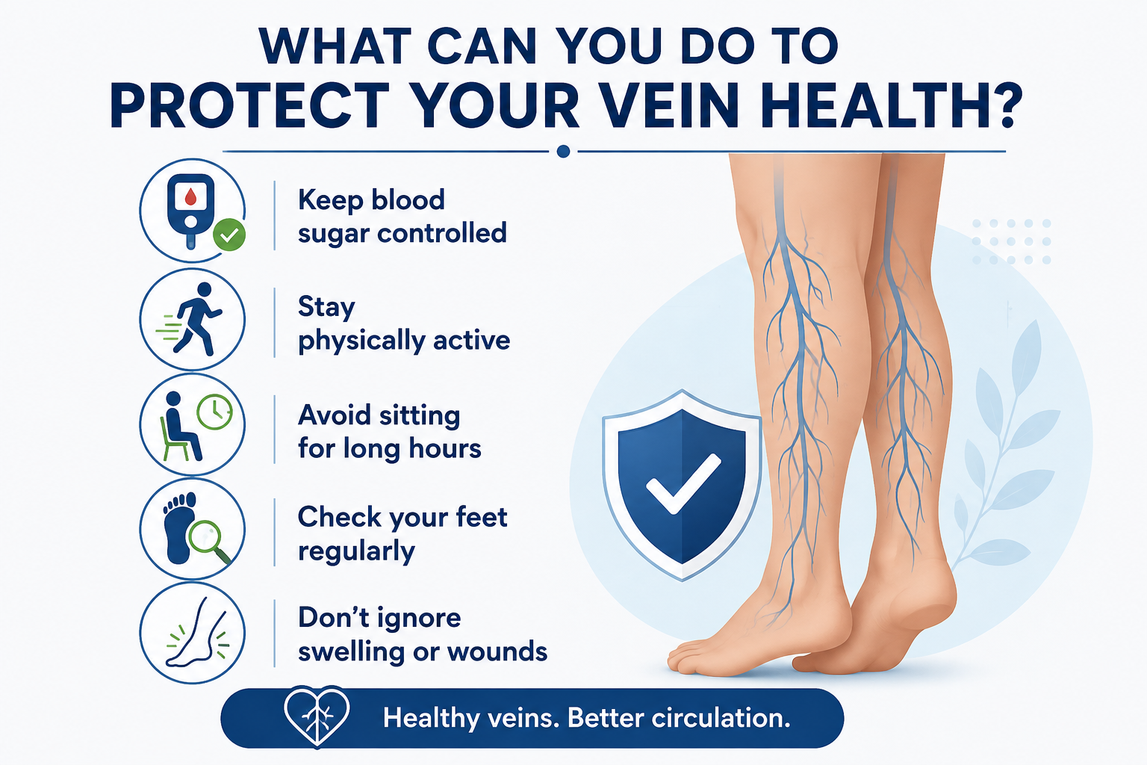

1. Keep blood sugar under control
Follow your healthcare professional's recommendations regarding medication, diet, exercise, and glucose monitoring. Consistent diabetes management can help reduce the risk of long-term complications.

2. Stay physically active
Regular movement can support healthy circulation. Walking is a simple activity that can help keep the leg muscles active and encourage blood movement, provided it is suitable for your individual health condition.

3. Avoid staying in one position for too long
If you sit for extended periods, take regular breaks to move your legs. Similarly, if your work involves prolonged standing, changing positions and moving periodically may help reduce discomfort.

4. Check your feet regularly
Look for cuts, blisters, redness, swelling, cracks, changes in skin colour, or wounds. This is particularly important if you have reduced sensation in your feet.

5. Maintain a healthy weight
Maintaining a healthy body weight can support overall cardiovascular health and reduce additional stress on the lower limbs.

6. Take care of your footwear
Comfortable, properly fitting footwear can help reduce pressure points and the risk of blisters or injuries. People with reduced foot sensation should be particularly careful when choosing shoes.

7. Do not ignore persistent symptoms
Repeated swelling, skin changes, unexplained discomfort, or a wound that does not appear to be healing normally should be evaluated by a healthcare professional.

When Should You See a Vascular Specialist?
Not every leg symptom experienced by someone with diabetes is necessarily caused by a vein problem. Similar symptoms can occur due to arterial disease, nerve problems, medication effects, or other medical conditions.
A vascular specialist can help identify the underlying cause.
You should consider seeking medical evaluation if you notice:
- Persistent or increasing leg swelling
- Recurrent heaviness or aching
- Significant varicose veins accompanied by symptoms
- Changes in skin colour or texture
- Repeated ulcers or sores
- A wound that is slow to heal
- New numbness or changes in sensation
- Unusual changes in the feet or lower legs
Depending on the symptoms, your doctor may recommend a physical examination and vascular investigations such as a Doppler ultrasound to understand how blood is moving through the vessels.

The Bigger Picture
Diabetes is more than a condition involving blood sugar. Over the long term, it can influence the blood vessels, nerves, skin, and body's ability to heal.
Taking care of your veins therefore means looking beyond visible varicose veins. Persistent swelling, skin discoloration, leg heaviness, changes in sensation, and slow-healing wounds can all provide useful clues about your vascular health.
The important point is not to become worried about every minor change. Instead, learn to recognize persistent or unusual symptoms and seek appropriate medical advice when needed.
Early evaluation can help identify circulation problems before they become more difficult to manage.

A Small Step Today Can Protect Your Legs Tomorrow
If you have diabetes, make your feet and legs part of your regular health check routine. A few minutes spent checking for swelling, skin changes, injuries, or wounds can help you notice problems earlier.
Along with good blood sugar control, regular physical activity, healthy lifestyle choices, and appropriate medical follow-up, paying attention to vascular health can play an important role in protecting your legs in the long term.
At Bankers Vascular Hospital, we believe that vascular care starts with awareness, early evaluation, accurate diagnosis, and appropriate treatment. Our team provides comprehensive assessment and minimally invasive treatment options for a wide range of vascular conditions, helping patients take better care of their circulation and overall vascular health.

