Jam Genome — data report
Generated from analysis/report.py. Covers everything collected to 09 September 2026.

What this dataset is
Segment speeds from the TomTom Traffic Flow Segment Data API, polled every 30 minutes across Mumbai. Each reading gives a road segment's currentSpeed and its freeFlowSpeed; the working measure throughout is
speed ratio = current speed ÷ free-flow speed, and a point counts as
congested when that ratio is below 0.5.
93,839 usable readings over 51 days. Mumbai has no open traffic dataset — Uber Movement shut down in 2023 — so this was collected from scratch.

Two eras, not one dataset
The monitoring points changed part-way through, so the two periods are reported separately and only compared where honest:
era | dates | points | days | readings
A | 10 Jul 2026 – 10 Aug 2026 | 36 | 32 | 50,453
B | 22 Aug 2026 – 09 Sep 2026 | 50 | 19 | 43,386

Era A used hand-picked junctions. Era B used points re-sited onto short segments after a citywide survey, for the reason set out next.

Headline result: most of the original points were blind
In era A, only 19 of 36 points ever recorded congestion. The other 17 sat at free-flow for a month — including Kalanagar, Amar Mahal and King's Circle, three of Mumbai's most notorious junctions.
They were not uncongested. Every TomTom reading describes a whole road segment, and Mumbai's expressways are modelled as single segments 13–20 km long. A jam at one junction is averaged away across the whole stretch. Segment length, not sampling rate, is the real resolution limit.
A 260 m-grid survey of Greater Mumbai (6,327 probes, sweep/) enumerated 870 distinct segments, of which 692 are short enough (0.1–3 km) to measure a single junction. The points were re-sited onto those.
It worked: in era B, 42 of 50 points record congestion — 84% versus 53% before.

Worst points

Era B (19 days, 50 points)
point | congested h/day | mean ratio | 5th pct
sk_bole_road_dadar | 8.63 | 0.67 | 0.23
dadar_chowpatty | 5.76 | 0.74 | 0.30
weh_kherwadi | 2.74 | 0.83 | 0.37
opera_house | 2.37 | 0.79 | 0.42
eeh_sion | 1.92 | 0.80 | 0.46
hindmata_junction | 1.87 | 0.77 | 0.46
eeh_vikhroli | 1.18 | 0.89 | 0.49
eeh_teen_hath | 1.16 | 0.79 | 0.48
sion_circle | 1.03 | 0.87 | 0.51
atal_setu | 0.84 | 0.95 | 0.66
chintamani_chinchpokli | 0.71 | 0.77 | 0.50
bandra_bandstand | 0.68 | 0.87 | 0.53

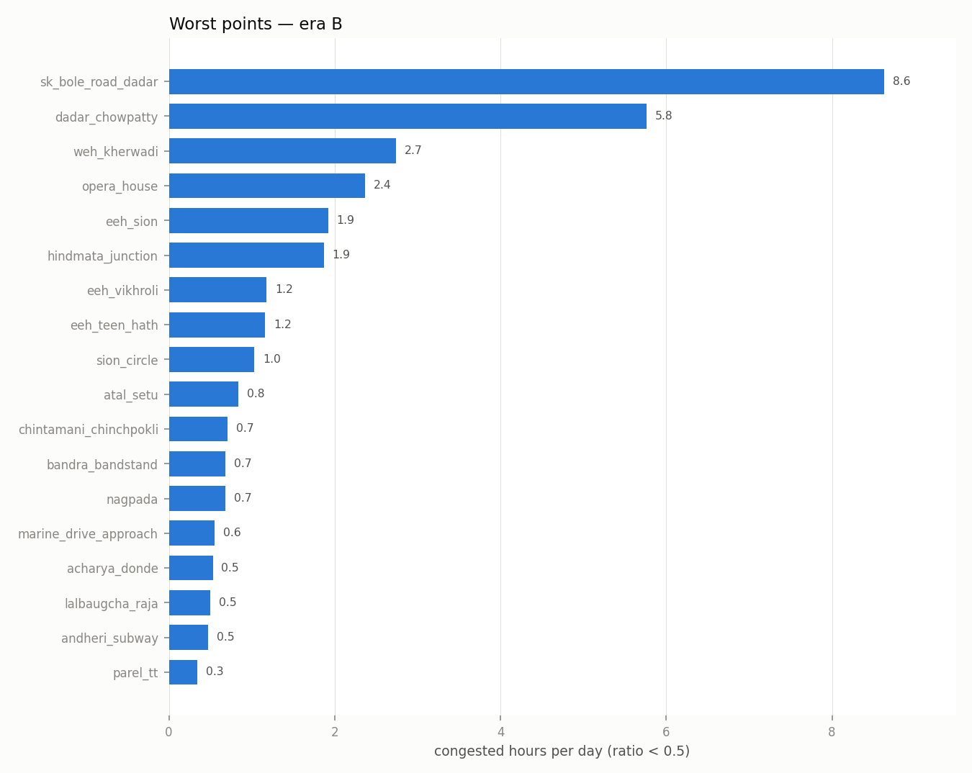

Era A (32 days, 36 points)
point | congested h/day | mean ratio | 5th pct
weh_kherwadi | 2.66 | 0.81 | 0.39
eeh_sion | 2.08 | 0.79 | 0.46
eeh_vikhroli | 1.73 | 0.88 | 0.44
eeh_teen_hath | 1.22 | 0.79 | 0.47
jvlr_powai | 0.48 | 0.88 | 0.56
sion_circle | 0.47 | 0.89 | 0.57
eeh_bhandup | 0.25 | 0.90 | 0.63
lbs_kurla | 0.22 | 0.92 | 0.62
linking_road | 0.22 | 0.82 | 0.55
hindmata | 0.09 | 0.93 | 0.67

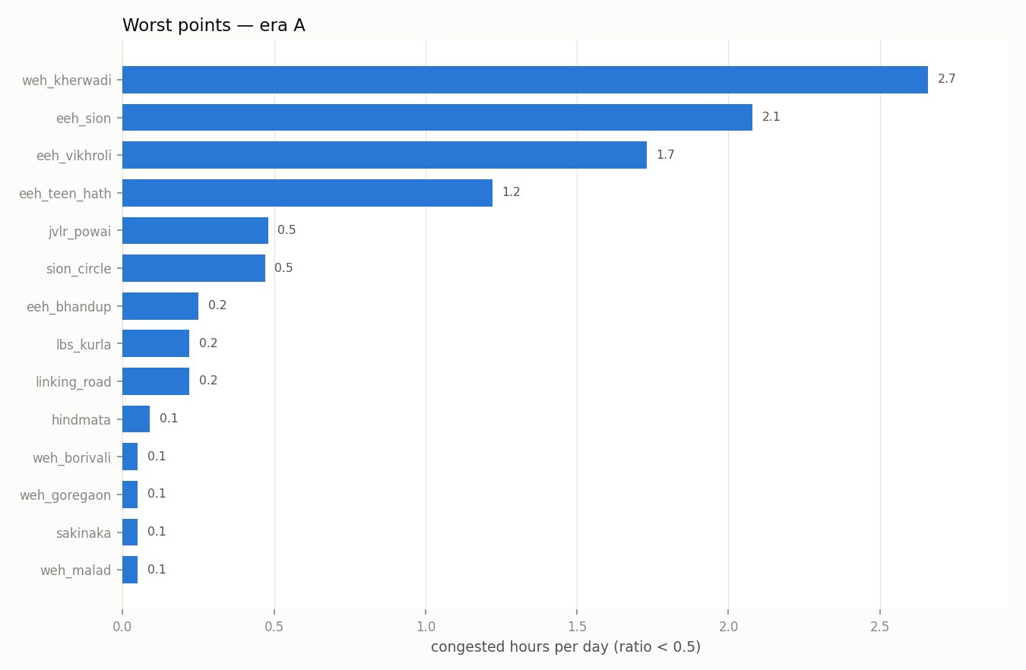

When Mumbai jams
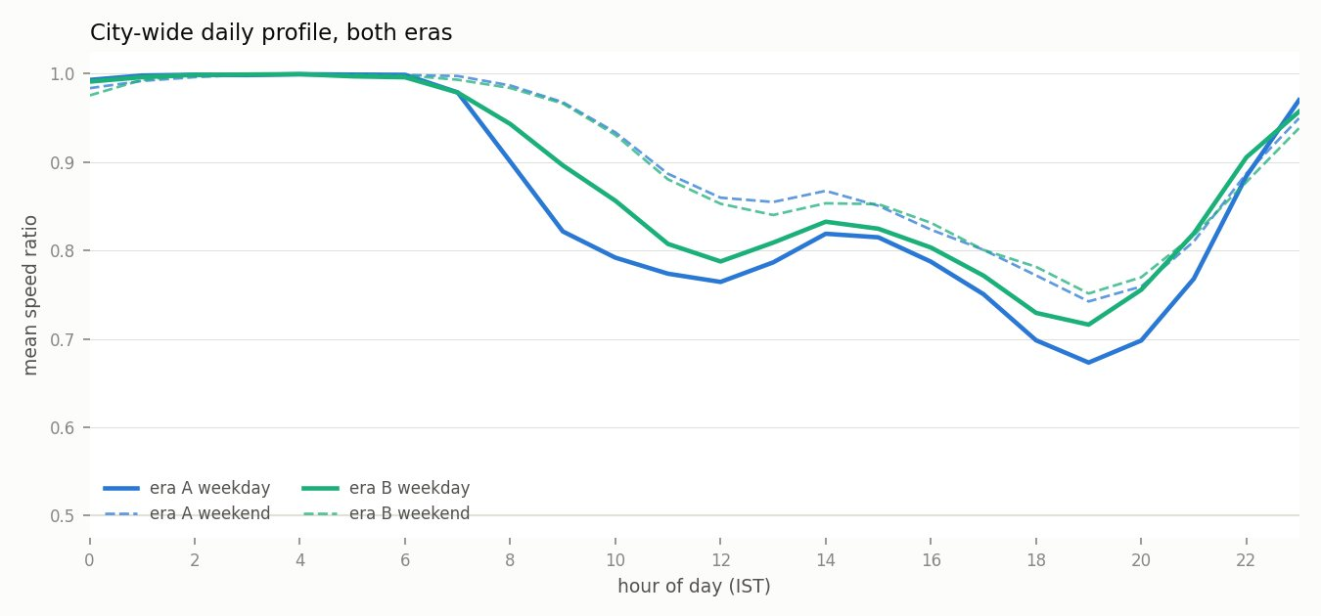
The city shows a double hump — a late-morning dip and a deeper evening trough around 18:00–20:00 — with free-flow from roughly midnight to 07:00. Weekends are not uniformly better: in central Mumbai the weekend afternoon is frequently worse than the weekday commute.
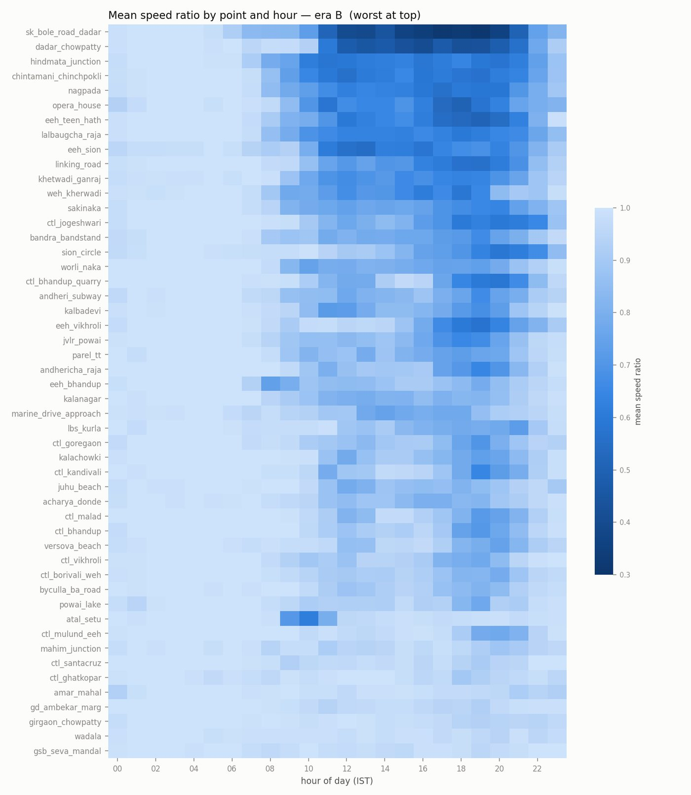

Congestion episodes
An episode is two or more consecutive 30-minute slots below the threshold.
- era A: 134 episodes
- era B: 215 episodes over a shorter window
Longest single episodes in era B:
point | start (IST) | duration | worst ratio
sk_bole_road_dadar | 22 Aug 12:00 | 12.0 h | 0.15
sk_bole_road_dadar | 25 Aug 11:00 | 11.0 h | 0.26
sk_bole_road_dadar | 01 Sep 11:00 | 11.0 h | 0.15
sk_bole_road_dadar | 29 Aug 12:00 | 10.5 h | 0.15
sk_bole_road_dadar | 06 Sep 12:00 | 10.0 h | 0.09
sk_bole_road_dadar | 02 Sep 13:00 | 9.0 h | 0.11
acharya_donde | 29 Aug 10:30 | 9.0 h | 0.05
sk_bole_road_dadar | 03 Sep 10:30 | 9.0 h | 0.15

Threshold sensitivity
The 0.50 cut-off is a choice, so here is the whole curve rather than one number:
threshold | episodes | points affected | total hours
0.40 | 101 | 18 | 216
0.45 | 153 | 23 | 340
0.50 | 215 | 30 | 476
0.55 | 389 | 36 | 812
0.60 | 590 | 43 | 1322
0.65 | 850 | 45 | 2087
0.70 | 1042 | 47 | 2935

0.50 is selective enough to be meaningful and loose enough to leave signal; 0.40 is too sparse and 0.65+ flags nearly every point.

Deeper statistics (era B)

How long a jam lasts
Of the 215 jams in era B: the median lasts 1.5 hours, the average 2.2, and the longest ran 12 hours. 41% are over within an hour, but 15% drag on past three.
So most jams are short, but a meaningful tail runs for hours — and the worst single episode filled most of a working day.

Morning peak or evening peak?
48 of 50 points are worse in the evening than the morning. The most evening-skewed roads:
point | morning ratio | evening ratio
dadar_chowpatty | 0.87 | 0.48
sk_bole_road_dadar | 0.73 | 0.36
sion_circle | 0.97 | 0.66
eeh_vikhroli | 0.96 | 0.65
ctl_jogeshwari | 0.93 | 0.63

Only 2 points suffer more in the morning, and they are unusual cases: atal_setu is the harbour bridge, which carries an outbound morning flow, and eeh_bhandup sits on a long expressway segment.

Which roads are commuter roads?
Comparing daytime (08:00–21:00) weekdays against weekends:
point | weekday | weekend | weekend is better by
eeh_vikhroli | 0.78 | 0.93 | +0.15
weh_kherwadi | 0.68 | 0.82 | +0.15
jvlr_powai | 0.77 | 0.91 | +0.14
marine_drive_approach | 0.82 | 0.94 | +0.12
opera_house | 0.63 | 0.74 | +0.11

13 of 50 points are actually worse at the weekend. Central Mumbai's shopping and leisure traffic outweighs the weekday commute on those roads — a genuine finding, and the opposite of the usual assumption.

The single worst hour of the week
day | hour | mean ratio
Tuesday | 19:00 | 0.701
Friday | 19:00 | 0.707
Monday | 19:00 | 0.720
Wednesday | 18:00 | 0.720
Tuesday | 18:00 | 0.721

Every one of the ten worst hours falls between 18:00 and 19:00. Tuesday evening is the worst hour in Mumbai's week.

Which points jam together
Correlation of congestion between every pair of points. This shows association, not causation — with 30-minute sampling it cannot say which jam came first, which is the analysis the project never got the data density to complete.
correlation | point A | point B
+0.61 | dadar_chowpatty | sk_bole_road_dadar
+0.39 | sk_bole_road_dadar | weh_kherwadi
+0.30 | opera_house | sk_bole_road_dadar
+0.29 | eeh_vikhroli | opera_house
+0.29 | eeh_vikhroli | sk_bole_road_dadar
+0.29 | dadar_chowpatty | eeh_teen_hath

The strongest pair by a wide margin is dadar_chowpatty and sk_bole_road_dadar at +0.61 — two roads about a kilometre apart in Dadar. That is the closest thing to propagation evidence in this dataset.

Did rain or events explain any of this?
Mumbai's monsoon ran through the whole collection window, and news reports for the period describe repeated disruption: over 400 mm in the first four days of July, a 205 mm day, a road cave-in on LBS Marg, and standstills on the Western Express Highway near Vile Parle on 18 August. The Sion road-over-bridge was also shut for reconstruction throughout (closed Aug 2024, due to reopen 30 Sept 2026), and the Sant Rohidas Marg subway opened mid-collection on 14 July 2026.
Rainfall was backfilled from the Open-Meteo ERA5 archive rather than the collector's own rain log, which is unusable (see Limitations). Testing at hourly resolution and matching wet hours against dry hours of the same hour-of-day — because rain and traffic both follow daily cycles — gives:
era | hours tested | wet hours | wet minus dry
A | 716 | 307 | −0.10 pp
B | 436 | 65 | −0.43 pp

No measurable increase in congestion on wet hours. If anything the sign is negative, and a naive pooled figure of −0.70 pp turned out to be mostly an artefact of mixing the two eras. Daily correlations are similarly flat (era A r = −0.03 over 29 days).
Three reasons not to read this as "rain doesn't cause jams":
- Mumbai's heaviest rain days coincide with school and office closures, so
demand falls at the same time capacity does. 2. ERA5 is a ~9 km grid and smooths the local cloudbursts that actually flood individual junctions. 3. Many points sit on long segments that average away a flooded stretch.
The honest statement is that at this measurement resolution, rain has no detectable net effect on speed ratios. Reproduce with python analysis/rain_check.py.

Limitations
- The two eras are not directly comparable. Different point sets, and
many era-A points measured segments too long to be informative. 2. The rain log is unusable. collector/weather.py sampled a 15-minute window every 30 minutes, so it missed roughly half of all rainfall. Any rain analysis must backfill from the Open-Meteo archive instead. 3. No festival data. The collection was designed around Ganeshotsav (14–25 Sept 2026), but TomTom began enforcing a 20,000 requests/month free-tier limit and the September quota was exhausted on 8 September. The festival window was not captured. 4. Expressway propagation cannot be measured. WEH and EEH are single segments, so every point on one returns the same value. Propagation analysis is only possible on the arterial and junction network. 5. Ratios depend on TomTom's free-flow baseline, which is their modelled figure, not a measured overnight speed.

Reproducing
python analysis/report.py # this report and its figures
python analysis/eda.py # league table, heatmaps, profiles
python analysis/episodes.py # episode extraction + threshold sweep
python analysis/data_quality.py # coverage and dead-point checks
Background and constraints are in [FINDINGS.md](FINDINGS.md); the build plan is in [PLAN.md](PLAN.md).

