# NSABBS0001

| Min. | 1st Qu. | Median | Mean | 3rd Qu. | Max. |
| --- | --- | --- | --- | --- | --- |
| 22.35206 | 43.17948 | 49.9376 | 49.24158 | 54.90303 | 71.8722 |

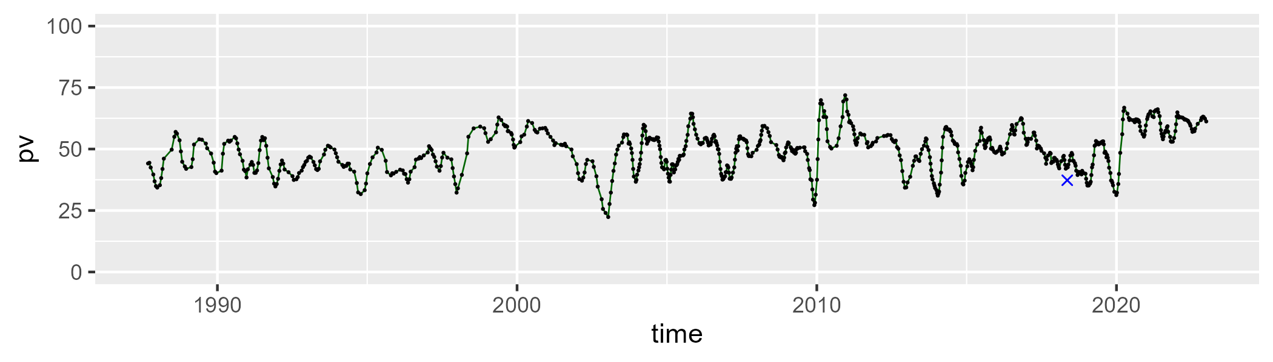

| Min. | 1st Qu. | Median | Mean | 3rd Qu. | Max. |
| --- | --- | --- | --- | --- | --- |
| 24.4035 | 37.73847 | 42.02654 | 41.74025 | 45.89721 | 60.27897 |

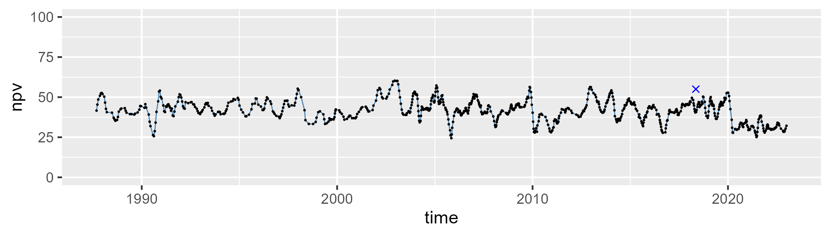

| Min. | 1st Qu. | Median | Mean | 3rd Qu. | Max. |
| --- | --- | --- | --- | --- | --- |
| 0 | 4.68828 | 6.921352 | 7.764458 | 10.44237 | 22.37433 |

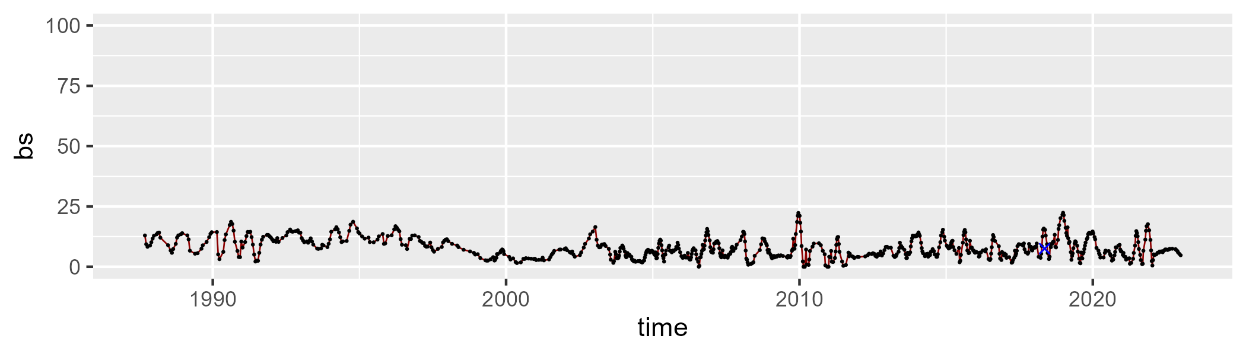

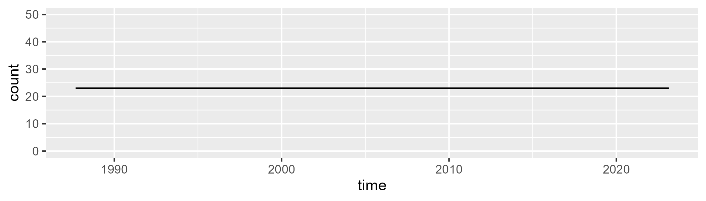

Min. :23 1st Qu.:23 Median :23 Mean :23 3rd Qu.:23 Max. :23

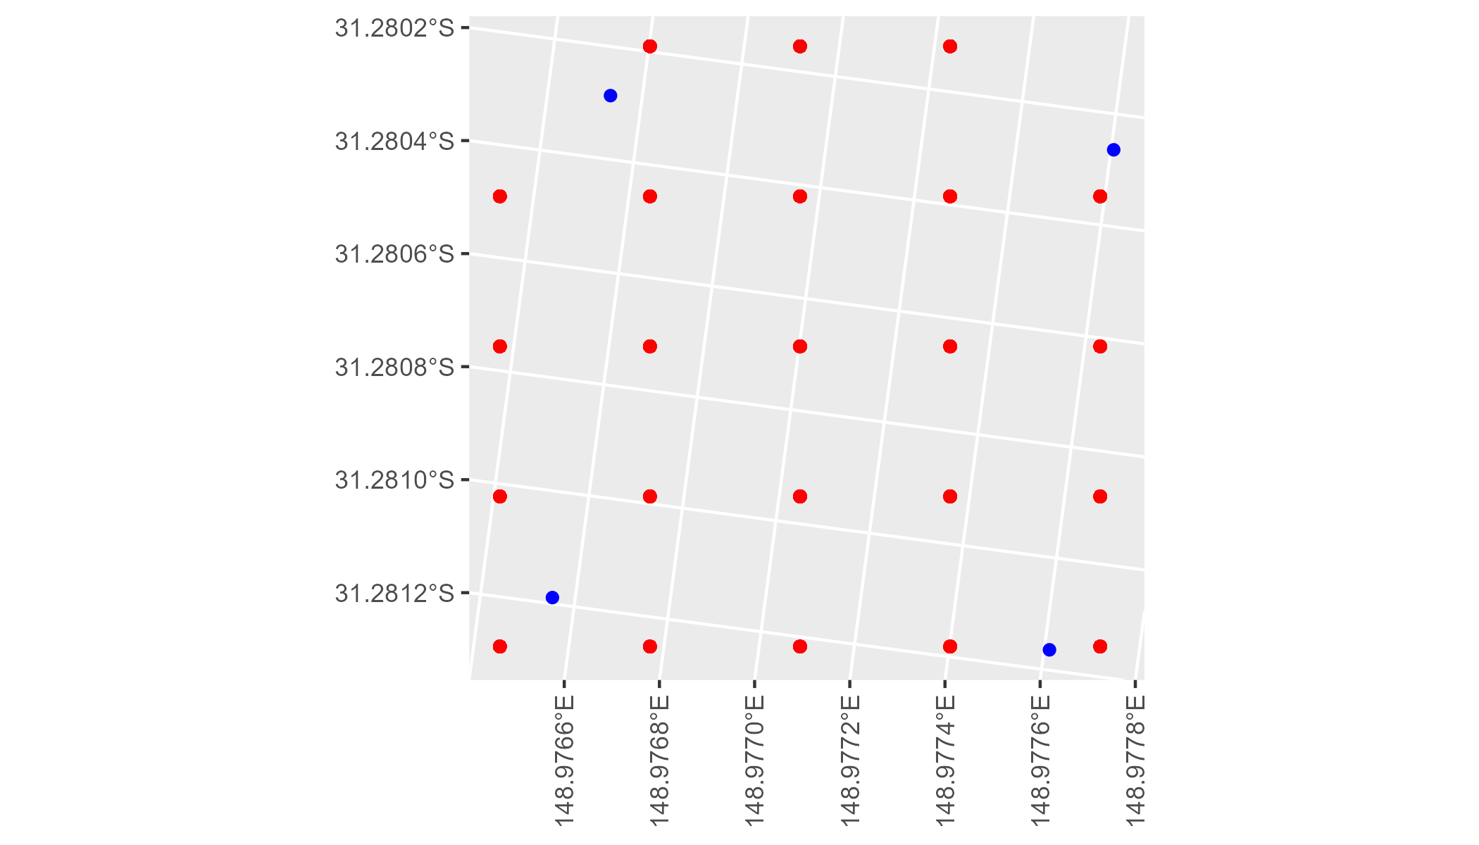

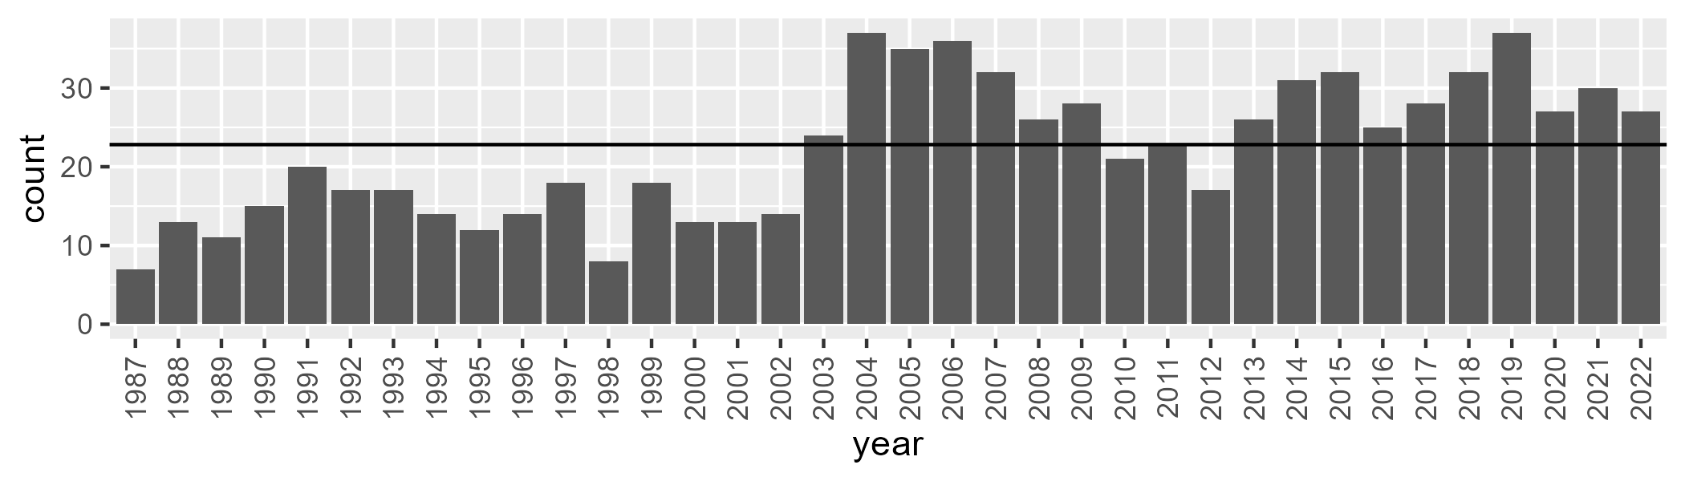

Number of samples: 798