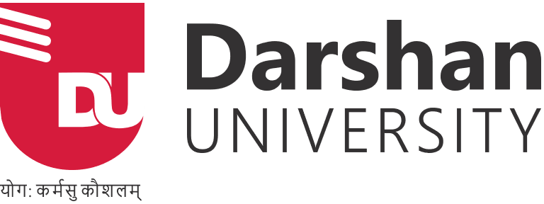

**Rajkot - Morbi Highway, Contact no: 97277 47310  
Gujarat-363650, INDIA 97277 47311**

**About Darshan University**

**About Darshan University**

Darshan University (DU), is a prominent organization offering a broad slate of academic programs and professional courses for undergraduate, graduate and postgraduate programs in Engineering, Science & Technology. The University is located in peaceful and sylvan surroundings with distinctive collegiate structure, about 19 km from Rajkot, Gujarat, India. It was established as an Engineering Institute in the year 2009, by Shree G. N. Patel Education & Charitable Trust with the objective to impart quality education and training in various fields of Engineering and Technology. It has now been transformed to the DARSHAN UNIVERSITY through an Act by the Government of Gujarat under Gujarat State Private Universities (Amendment) Act, 2021 (Act no. 15).

**About Shree G. N. Patel Education and Charitable Trust**

Shree G. N. Patel Education and Charitable Trust have an enthusiastic desire to start varied institutes in the name of Darshan University which offers a broad slate of academic programs and professional courses due course of time like Degree Engineering, Diploma Engineering & Master of Engineering. The institute had acquired recognition in the region of Saurashtra as the hub of providing excellent education in the field of professional courses like Engineering and Technology.

**IQAC**

Quality enhancement is a continuous process and sustaining the momentum of quality cognizance is crucial for an Institution. Internal Quality Assurance Cell (IQAC) is conceived as a mechanism to build and ensure a quality culture at the institutional level.

**Schools**

### **School of Engineering**

The learning environment at the University nurtures the spirit of enquiry, creativity, problem-solving, entrepreneurship and innovation, promote hands-on & cross-disciplinary learning, and inculcate an array of values, job & life skills. The University provides a perfect environment to pursue cutting-edge cross-disciplinary research in engineering sciences and technology by taking advantage of the facilities and expertise available with the well-established schools of study at the University, particularly Civil Engineering, Electrical Engineering and Mechanical Engineering. This ensures that students of the School of Engineering at Darshan University are transformed into well-rounded, industry-ready individuals who are equipped to take on leadership responsibilities from the day they graduate from the University.

### **School of Diploma Engineering**

The school of Diploma Engineering progresses when its mainstay, the student community prospers. So to ensure the all-round development of the students, Darshan University organizes various student-centric activities which provide eclectic learning opportunities to them and also a platform to showcase their talents.

### **School of Management**

Darshan University, School of Management started functioning from the academic year 2021 - 22, offering BBA, B Com & MBA programs. Department is rich in terms of experienced faculty members, library resources, and IT infrastructure. SoM provides an excellent atmosphere to its UG and PG students to develop educationally, physically, emotionally and intellectually through a robust teaching-learning system. Faculty members of School of Management are in continuous touch with industry experts of various fields which helps the department to strengthen their curriculum as per industry requirements.

**Life At Campus**

## Frolic – Techfest

Frolic is National Level Technical Symposium where talent meets opportunity. Technical fests should be an essential part of course curriculum as it gives a platform to young brains to showcase their innovative ideas and compete with their peers.

These technical fests are an amalgamation of fun and learning where spectacular ideas are displayed, and students learn and feel inspired. These events guide engineers, computer experts, researchers to dream bigger and achieve them. Frolic hosts technical competitions and events covering all areas of engineering are organized every year in the first week of September, where students participate enthusiastically to make the Tech-Fest a success.

## Udaan - Cultural Festival

Udaan is an annual cultural festival. It usually takes place in the second week of April. This consists of literary and debating events/competitions like singing, dance, play, mimicry, garba, etc. Students put in their best efforts to make college fests entertaining and exciting. These multiple cultural events, technical fests, celebrity performances, competitions, partying with friends make you confident and job-ready.

These amazing college fests play a significant role in shaping the career of a student, read on to know-how. Students who volunteer and organize college fests display their self-starter attitude. Students also develop four essential skills from organizing fests – planning, teamwork, leadership, and multi-tasking. They also learn how to balance personal and professional life which helps in differentiating between doers and dreamers.