A PROJECT REPORT
ON
HOSTEL MANAGER: AN AUTOMATED RESIDENT & ADMINISTRATIVE MANAGEMENT MOBILE APPLICATION
Course Code: 102000701 – Mobile Application Development
Submitted by:
Jay Chaudhary (Team Leader) – 12302080601041
Jay Bhoi (Application Developer) – 12302080601042
Kishan Prajapati (UI/UX & Testing) – 12302080601056
Krish Varde (Database/API Developer) – 12302080601057
Class: IT1 (C8A)

DEPARTMENT OF INFORMATION TECHNOLOGY
A. D. PATEL INSTITUTE OF TECHNOLOGY
Constituent College of CVM University
New Vallabh Vidyanagar - 388121, Anand, Gujarat, India
Academic Year: 2026 – 2027

ABSTRACT
Residential university hostels constitute vital campus infrastructure supporting hundreds or thousands of undergraduate and postgraduate students. Operating campus hostels involves complex day-to-day administrative routines including room allocation, resident student registration, hostel fee records, mess billing, and recurring facility maintenance. In many colleges, these operations remain largely dependent on paper registers, manual ledger entries, physical notice boards, and verbal complaint reporting. The objective of this Mobile Application Development Mini Project, titled 'Hostel Manager: An Automated Resident & Administrative Management Mobile Application', is to design and develop an end-to-end native Android application that digitizes residential operations, enforces transactional room allocation, tracks maintenance tickets in real time, and automates semester fee ledgers through modern touch interfaces.
The project is implemented entirely in native Java for the Android runtime (compileSdk 34, minSdk 24) utilizing an embedded SQLite relational database engine for robust, offline-capable local persistence and SharedPreferences for authenticated session state management. The architecture provides dedicated, role-specific portals for Resident Students and Administrative Wardens. For students, the system offers real-time room and roommate details, an interactive ticket-raising module with category selection and urgency triage, digital fee dues tracking with simulated partial/full UPI payments, and instantly verifiable fee receipts. For hostel wardens, the portal delivers real-time Key Performance Indicator (KPI) metrics, complete room inventory management with vacancy tracking, an atomic student-to-room allocation engine that strictly prevents over-capacity, filterable complaint triage with resolution remarks, and a searchable student directory.
Furthermore, the application incorporates a strict hierarchical back navigation architecture with top-bar persistent back buttons on all secondary forms, AndroidX OnBackPressedDispatcher tab-return callbacks, and accidental exit confirmation modals. The project was collaboratively developed by a 4-member student engineering team (Jay Chaudhary, Jay Bhoi, Kishan Prajapati, and Krish Varde), distributing technical responsibilities across leadership, core app logic, UI/UX testing, and database backend integration. The application was compiled into a debug APK and verified through hardware-in-the-loop deployment on an Android 14 physical device (OnePlus CPH2381) via Android Debug Bridge (ADB), alongside a live PHP/Apache database inspection viewer compatible with XAMPP. The system operates with a 100% test pass rate across all 18 functional scenarios.

LIST OF FIGURES
Figure No. | Figure Title | Page
Fig. 3.1 | End-to-End Mobile System Architecture and Layered Workflow | 10
Fig. 6.1 | Role Selection Portal (Student vs. Warden Admin Selection) | 18
Fig. 6.2 | Student Login Interface with Demo Credentials Quick-Fill | 18
Fig. 6.3 | New Resident Student Registration Form with Field Validation | 19
Fig. 6.4 | Student Dashboard Overview (Room, Fees & Complaints KPI Cards) | 19
Fig. 6.5 | My Room Specifications, Roommate Details & Warden Support Hotline | 20
Fig. 6.6 | Student Complaints Tracker with Filter Tabs and Status Badges | 20
Fig. 6.7 | Hostel Fee Breakdown, Balance Due, and Mock UPI Payment Dialog | 21
Fig. 6.8 | Raise Hostel Complaint Maintenance Form (Category & Urgency) | 21
Fig. 6.9 | Warden Admin Portal (Top KPIs and Room Inventory Management) | 22
Fig. 6.10 | Warden Complaint Triage & Status Resolution with Remarks | 22
Fig. 6.11 | Fee Ledger & Student Collection Records for Warden Portal | 23
Fig. 6.12 | Resident Student Directory with Room Allocation Status | 23
Fig. 6.13 | Add Room Inventory Form (Block, Capacity, Type & Rent) | 24

LIST OF TABLES
Table No. | Table Title | Page
Table 2.1 | Hardware and Software Development Environment | 9
Table 3.1 | Relational Database Structure of 'users' Entity | 11
Table 3.2 | Relational Database Structure of 'rooms' Entity | 11
Table 3.3 | Relational Database Structure of 'complaints' Entity | 12
Table 3.4 | Relational Database Structure of 'fee_records' Entity | 12
Table 4.1 | Data Integrity Rules and Allocation Constraints | 15
Table 5.1 | Core Java Classes and Architectural Roles | 17
Table 6.1 | Comprehensive Black-Box Functional Test Execution Matrix | 24

TABLE OF CONTENTS
Topic / Chapter Heading | Page No.
Abstract | 2
List of Figures | 3
List of Tables | 4
CHAPTER 1: INTRODUCTION | 6
1.1 Background & Problem Context | 6
1.2 Problem Statement | 6
1.3 Project Objectives | 7
1.4 Scope and Deliverables | 7
CHAPTER 2: TECHNOLOGY STACK & ENVIRONMENT | 8
2.1 Java Programming Language & OpenJDK | 8
2.2 Android SDK & Runtime Architecture | 8
2.3 SQLite Embedded Relational Database Engine | 9
2.4 Material Design 3 & XML UI Framework | 9
2.5 Development Tools, Gradle & Hardware Environment | 9
CHAPTER 3: SYSTEM DESIGN & METHODOLOGY | 10
3.1 System Architecture Overview | 10
3.2 Dataset Schema and Entity Specifications | 11
3.3 Use-Case & Actor Boundary Specifications | 13
3.4 End-to-End System Workflows | 13
CHAPTER 4: DATABASE ENGINE & TRANSACTIONAL LOGIC | 14
4.1 SQLite Database Engine Architecture | 14
4.2 Atomic Room Allocation & Capacity Integrity | 14
4.3 Authentication & Session State Management | 15
4.4 Data Validation Rules & Anomaly Handling | 15
CHAPTER 5: APPLICATION MODULES & INTERACTION DESIGN | 16
5.1 Student Resident Portal | 16
5.2 Warden Administrative Portal | 16
5.3 Digital Fee Ledger & Receipt Generator | 17
5.4 Custom RecyclerView Adapters & Data Binding | 17
CHAPTER 6: RESULTS, APPLICATION WALKTHROUGH & SCREENSHOTS | 18
6.1 Application Interface Overview & Physical Hardware Setup | 18
6.2 Module Walkthrough & Verified Screenshots (Paired) | 18
6.3 Summary of Verification Findings & Performance | 24
CHAPTER 7: TRAINING EXPERIENCE, CHALLENGES & CONCLUSION | 25
7.1 Learning Outcomes & Skills Acquired | 25
7.2 Work Environment & Support | 25
7.3 Challenges Faced & Technical Solutions | 26
7.4 Future Enhancements & Scope | 26
7.5 Conclusion | 26
REFERENCES / BIBLIOGRAPHY | 27
APPENDIX | 28
Appendix A: Project Directory Hierarchy | 28
Appendix B: Individual Technical Responsibilities (Team of 4) | 28
Appendix C: Live Database Inspection via XAMPP phpMyAdmin Bridge | 29

CHAPTER 1: INTRODUCTION
1.1 BACKGROUND & PROBLEM CONTEXT
Higher education residential campuses accommodate hundreds or thousands of undergraduate and postgraduate students. The operation of campus hostels involves complex day-to-day administrative routines, including room allocation, student resident registration, hostel fee records, mess billing, and recurring facility maintenance. In many colleges, these operations remain largely dependent on paper registers, manual ledger entries, physical notice boards, and verbal complaint reporting to warden offices.
As mobile technology has proliferated across university campuses, almost every student and administrative staff member carries a modern Android smartphone. Developing a native mobile software solution allows hostel authorities to replace inefficient manual paperwork with a reliable digital platform. The 'Hostel Manager' application is designed to solve these operational pain points by providing an integrated mobile application running on Android that simplifies residential workflows for both students and hostel wardens.
1.2 PROBLEM STATEMENT
Traditional hostel administration suffers from several fundamental inefficiencies that affect institutional transparency and student satisfaction:
1. Error-Prone Room Allocation: Manual paper registers frequently lead to overbooking, incorrect record keeping of vacant beds, and confusion regarding room occupancy status.
2. Opaque Maintenance Complaints: Residents currently report plumbing, electrical, or cleaning issues verbally or on paper registers. Complaints are often misplaced, untracked, and delayed without any mechanism for students to check progress.
3. Inefficient Fee Ledger Tracking: Fee receipts and outstanding balance ledgers are recorded in physical logbooks, causing discrepancies during semester examinations or student clearance.
4. Lack of Centralized Communication: Students lack direct access to emergency contact numbers, chief warden support channels, or verified digital fee receipts on their personal devices.

1.3 PROJECT OBJECTIVES
The primary engineering and functional objectives of this project are summarized as follows:
1. Digital Record Centralization: Provide an offline-first SQLite database that reliably persists student profiles, room inventories, maintenance tickets, and fee transactions on the device without requiring expensive external cloud servers.
2. Role-Based Access Control: Implement distinct, secure portals for Resident Students and Administrative Wardens, ensuring role-specific privilege isolation and clean user flows.
3. Atomic Room Allocation: Enforce relational database integrity where allocating a resident to a room automatically increments room occupancy and decrements previous allocations in a single atomic transaction, strictly preventing room overcapacity.
4. Interactive Maintenance Tracking: Allow students to lodge categorized maintenance tickets (plumbing, electrical, Wi-Fi, cleaning, carpentry, mess) with urgency triage, while empowering wardens to review, update status, and attach resolution remarks.
5. Digital Ledger & Payment Receipts: Enable residents to view semester fee breakdowns, simulate full or partial fee payments via simulated UPI/NetBanking, and instantly generate official digital confirmation receipts.
6. Collaborative Team Engineering: Execute development across a defined 4-member student engineering team (Team Leader, Application Developer, UI/UX & Testing, and Database/API Developer) according to formal departmental criteria.
1.4 SCOPE AND DELIVERABLES
This project is developed as an undergraduate academic mobile application mini-project focused on full-stack native Android engineering, local database integrity, and responsive user experience design. The project deliberately avoids complex external paid cloud subscriptions to maintain complete local autonomy, zero runtime dependency on third-party servers, and deterministic offline reliability. Deliverables include the complete Android Java source code, compiled installable APK (app-debug.apk), local SQLite inspection bridge (index.php), automated test cases, and physical hardware execution verification on an Android 14 device.

CHAPTER 2: TECHNOLOGY STACK & ENVIRONMENT
2.1 JAVA PROGRAMMING LANGUAGE & OPENJDK
Java was selected as the core programming language for this application due to its maturity, robust object-oriented architecture, strong compile-time type safety, and seamless integration with the native Android framework. The application was compiled using OpenJDK 22.0.1 targeting Java 8 bytecode compatibility, ensuring high runtime stability across both modern and legacy Android versions.
2.2 ANDROID SDK & RUNTIME ARCHITECTURE
The project targets Android API Level 34 (Android 14) with backward compatibility supported down to Android 7.0 Nougat (API Level 24). This covers over 98% of active Android smartphones globally. Core Android platform components utilized include Activities, Intent-based routing, AndroidX AppCompat, Activity Result Launchers, and AndroidX OnBackPressedDispatcher for predictive back gesture handling.
2.3 SQLITE EMBEDDED RELATIONAL DATABASE ENGINE
SQLite 3 serves as the embedded relational data storage engine. Being a serverless, zero-configuration SQL engine packaged natively inside the Android OS, SQLite provides atomic, consistent, isolated, and durable (ACID) transactions with zero network overhead. The database resides inside the application's private sandbox (/data/data/com.hostel.manager/databases/hostel_manager.db), guaranteeing data privacy.

2.4 MATERIAL DESIGN 3 & XML UI FRAMEWORK
The visual interface is authored in declarative Android XML using Google Material Design 3 components. CardViews provide distinct visual elevation, RecyclerViews with custom ViewHolders render high-performance scrollable lists with view recycling, and color-coded status chips provide immediate visual feedback for ticket and fee statuses.
2.5 DEVELOPMENT TOOLS, GRADLE & HARDWARE ENVIRONMENT
Table 2.1 Hardware and Software Development Environment
Environment Component | Specification / Tool | Technical Role
Component | Specification / Technology | Remarks / Role
Programming Language | Java (OpenJDK 22.0.1, Java 8 bytecode) | Core application logic and business rules
Mobile OS Target | Android 14 (API Level 34) | Compile and target SDK level
Minimum OS Support | Android 7.0 Nougat (API Level 24) | Covers 98%+ of active Android devices
Local Database Engine | SQLite 3 (via Android SQLiteOpenHelper) | Serverless, ACID-compliant local database
UI Layout Framework | Android XML Layouts with Material 3 Components | CardViews, RecyclerViews, Floating Action Buttons
Build Automation Tool | Gradle 8.7 (Android Gradle Plugin 8.3.2) | Automated local compilation and packaging
Physical Test Device | OnePlus Nord CE 2 Lite 5G (CPH2381) | Physical hardware deployment via USB Debugging
Deployment Utility | Android Debug Bridge (ADB v1.0.41) | Direct streamed installation and live screenshot capture
External Inspection Tool | XAMPP Apache PHP 8.2 + SQLite3 PDO Viewer | Desktop browser audit bridge (http://localhost/mad_hostel-manager/)

CHAPTER 3: SYSTEM DESIGN & METHODOLOGY
3.1 SYSTEM ARCHITECTURE OVERVIEW
The system follows a decoupled Model-View-Controller (MVC) architectural pattern adapted for Android native mobile development. The presentation tier (XML Layouts, Activities, RecyclerView Adapters) is isolated from persistent storage (SQLite Database) through well-defined model classes (User, Room, Complaint, FeeRecord) and controller helpers (HostelDbHelper, SessionManager).
Fig. 3.1 illustrates the end-to-end data flow: user touch inputs on the UI trigger activity controller methods, which authenticate state via SessionManager, invoke atomic SQL operations on HostelDbHelper, and re-render dynamic views synchronously.
Fig. 3.1 End-to-End Mobile System Architecture and Layered Workflow

3.2 DATASET SCHEMA AND ENTITY SPECIFICATIONS
To enforce relational consistency across all resident, accommodation, complaint, and financial operations, a strict 4-table relational schema is enforced:
Table 3.1 Relational Database Structure of 'users' Entity
Field Name | Data Type | Constraints | Description
id | INTEGER | PRIMARY KEY AUTOINCREMENT | Unique identifier for user record
name | TEXT | NOT NULL | Full name of the resident or administrator
email | TEXT | UNIQUE NOT NULL | Email address used as primary login identifier
password | TEXT | NOT NULL | Account password for credential verification
phone | TEXT | NOT NULL | Contact phone number (10-digit format)
role | TEXT | NOT NULL DEFAULT 'student' | User role discriminator: 'student' or 'admin'
roll_no | TEXT | DEFAULT 'N/A' | Academic student registration/roll number
gender | TEXT | DEFAULT 'Male' | Gender specification for block placement
room_id | INTEGER | FOREIGN KEY -> rooms(id) | Allocated room identifier (NULL if not allocated)
created_at | DATETIME | DEFAULT CURRENT_TIMESTAMP | Timestamp of initial registration
Table 3.2 Relational Database Structure of 'rooms' Entity
Field Name | Data Type | Constraints | Description
id | INTEGER | PRIMARY KEY AUTOINCREMENT | Unique identifier for hostel room
room_number | TEXT | UNIQUE NOT NULL | Designated room code (e.g. '101-A', '202-B')
block | TEXT | NOT NULL | Hostel building block (e.g. 'Block A (Boys)')
floor | INTEGER | NOT NULL DEFAULT 1 | Floor location within building block
capacity | INTEGER | NOT NULL DEFAULT 2 | Maximum allowable student bed capacity
occupied | INTEGER | NOT NULL DEFAULT 0 | Current number of allocated resident students
room_type | TEXT | DEFAULT 'Non-AC' | Specification category: 'Non-AC' or 'AC'
fee_per_sem | REAL | NOT NULL DEFAULT 25000 | Base hostel rental fee charged per semester

Table 3.3 Relational Database Structure of 'complaints' Entity
Field Name | Data Type | Constraints | Description
id | INTEGER | PRIMARY KEY AUTOINCREMENT | Unique complaint ticket reference number
student_id | INTEGER | FOREIGN KEY -> users(id) | Identifier of student submitting the complaint
room_number | TEXT | NOT NULL | Room location where maintenance is needed
category | TEXT | NOT NULL | Issue category (Plumbing, Electrical, Wi-Fi, etc.)
title | TEXT | NOT NULL | Brief summary title of reported defect
description | TEXT | NOT NULL | Detailed explanation of defect and location
urgency | TEXT | DEFAULT 'Medium' | Priority level: 'Low', 'Medium', or 'High'
status | TEXT | DEFAULT 'Pending' | Resolution status: 'Pending', 'In Progress', 'Resolved'
admin_remarks | TEXT | DEFAULT '' | Feedback and resolution notes added by warden
created_at | DATETIME | DEFAULT CURRENT_TIMESTAMP | Date and time of ticket creation
updated_at | DATETIME | DEFAULT CURRENT_TIMESTAMP | Date and time of latest status modification
Table 3.4 Relational Database Structure of 'fee_records' Entity
Field Name | Data Type | Constraints | Description
id | INTEGER | PRIMARY KEY AUTOINCREMENT | Unique fee ledger record reference
student_id | INTEGER | FOREIGN KEY -> users(id) | Identifier of resident student
semester | TEXT | NOT NULL DEFAULT 'Sem 1' | Academic semester term
rent_amount | REAL | NOT NULL DEFAULT 25000 | Allocated room semester rental charge
mess_amount | REAL | NOT NULL DEFAULT 15000 | Semester catering and mess fee charge
maint_amount | REAL | NOT NULL DEFAULT 5000 | Hostel maintenance and amenities fee
total_due | REAL | NOT NULL DEFAULT 45000 | Total semester liability (Rent + Mess + Maint)
paid_amount | REAL | NOT NULL DEFAULT 0 | Cumulative fee amount paid by resident
balance_due | REAL | NOT NULL DEFAULT 45000 | Outstanding balance remaining (total_due - paid)
payment_status | TEXT | DEFAULT 'Unpaid' | Payment status: 'Unpaid', 'Partial', 'Paid'
payment_date | TEXT | DEFAULT '' | Date of most recent payment transaction
payment_method | TEXT | DEFAULT '' | Payment channel used (UPI, NetBanking, Cash)
transaction_id | TEXT | DEFAULT '' | Unique financial transaction confirmation reference
receipt_no | TEXT | DEFAULT '' | Official university receipt serial number

3.3 USE-CASE & ACTOR BOUNDARY SPECIFICATIONS
The system enforces strict functional segregation between its two primary actors:
1. Resident Student Actor: Authorized to log in, view allocated room specifications, view assigned roommates, raise categorized complaints with urgency, filter own complaint history, pay semester fees partially or fully, and generate digital payment receipts.
2. Hostel Warden / Administrator Actor: Authorized to authenticate with administrative credentials, view aggregate executive KPIs, add new room inventory, allocate students to rooms with capacity enforcement, deallocate residents, update complaint status with remarks, and audit the full fee collection ledger.
3.4 END-TO-END SYSTEM WORKFLOWS
When a user interacts with the platform, workflows follow deterministic execution pipelines:
1. Authentication Pipeline: Validates email syntax, checks existing records in SQLite, compares hashed credentials, and saves user id, role, and allocated room into SessionManager.
2. Room Allocation Pipeline: Begins an atomic database transaction. Checks whether room capacity is reached. If valid, decrements the previous room's occupied count, increments the new room's count, updates user record, and recalculates fee rent amount.
3. Complaint Lifecycle Pipeline: Inserts ticket with status 'Pending'. Displays ticket on warden portal with Amber badge. Warden updates ticket to 'In Progress' or 'Resolved' and inputs remarks, immediately updating student's view to Emerald Green.
4. Fee Settlement Pipeline: Captures partial or full amount, generates unique transaction ID (e.g. TXN987214) and receipt number (e.g. REC-2026-4819), recalculates balance due, updates status, and presents official verifiable receipt.

CHAPTER 4: DATABASE ENGINE & TRANSACTIONAL LOGIC
4.1 SQLITE DATABASE ENGINE ARCHITECTURE
In mobile application engineering, relational integrity is essential to prevent ghost records, double room occupancy, or missing payments. The `HostelDbHelper` class extends Android's native `SQLiteOpenHelper`. It centralizes all schema definitions, automated migrations, seed data population, and transactional queries into a clean Data Access Object (DAO) pattern.
4.2 ATOMIC ROOM ALLOCATION & CAPACITY INTEGRITY
A critical vulnerability in naive database implementations is race conditions or partial updates during room reassignment. If a student moving from Room 101 to Room 202 has their user record updated without decrementing Room 101's occupancy, Room 101 permanently shows false occupancy. To guarantee 100% integrity, the allocation method wraps all operations inside `db.beginTransaction()` and `db.setTransactionSuccessful()`:
1. Check new room: SELECT capacity, occupied FROM rooms WHERE id = ?
2. If occupied >= capacity: abort transaction and return false.
3. Decrement old room: UPDATE rooms SET occupied = occupied - 1 WHERE id = old_room_id
4. Increment new room: UPDATE rooms SET occupied = occupied + 1 WHERE id = new_room_id
5. Update resident: UPDATE users SET room_id = new_room_id WHERE id = student_id
6. Sync fee ledger: UPDATE fee_records SET rent_amount = new_rent, total_due = new_total WHERE student_id = student_id
7. Commit transaction atomically: db.setTransactionSuccessful() and db.endTransaction().

4.3 AUTHENTICATION & SESSION STATE MANAGEMENT
The `SessionManager` class manages authenticated session state using Android `SharedPreferences`. Keys include `IS_LOGGED_IN`, `KEY_USER_ID`, `KEY_NAME`, `KEY_EMAIL`, `KEY_ROLE`, and `KEY_ROOM_NUMBER`. On application start, `SplashActivity` reads these flags to navigate directly to the user's designated workspace without redundant logins. When logging out, `sessionManager.logoutUser()` cleanly purges session keys and clears intent flags.
4.4 DATA VALIDATION RULES & ANOMALY HANDLING
Table 4.1 Data Integrity Rules and Allocation Constraints
Operation | Anomaly Target | Validation / Rule Applied | Integrity Justification
Operation | Anomaly Target | Validation / Rule Applied | Integrity Justification
User Registration | Duplicate email accounts | Check dbHelper.isEmailRegistered() before INSERT | Enforces unique user identification
User Registration | Malformed phone digits | Verify phone.length() >= 10 and numeric format | Guarantees valid warden contact channel
Room Allocation | Overcapacity assignment | Reject if room.occupied >= room.capacity | Prevents exceeding physical bed counts
Room Allocation | Inconsistent occupancy | Atomic multi-table transaction with rollbacks | Guarantees exact occupied bed tallies
Complaint Lodging | Empty category/title | Form validation on EditText and Spinner | Ensures actionable maintenance tickets
Fee Payment | Overpayment / Negative | Verify 1 <= payAmount <= currentBalanceDue | Maintains financial ledger balance

CHAPTER 5: APPLICATION MODULES & INTERACTION DESIGN
5.1 STUDENT RESIDENT PORTAL
The `StudentMainActivity` serves as the primary touchpoint for residents, organized into four bottom tabs:
1. Dashboard Tab: Displays three summary cards (Allocated Room, Outstanding Balance, Active Complaints) and quick-action buttons for lodging complaints or paying fees.
2. My Room Tab: Displays room specifications (Block, Floor, AC Type, Capacity), lists allocated roommates fetched dynamically from SQLite, and displays the Chief Warden emergency hotline.
3. Complaints Tab: Presents an interactive ticket tracker with three filter tabs (All, Pending, Resolved), dynamic status badges, and an Extended Floating Action Button (FAB) that launches AddComplaintActivity.
4. Fees & Profile Tab: Displays semester fee breakdown (Rent, Mess, Maintenance, Total Due, Amount Paid, Balance Due), a 'Pay Now' button opening the mock payment modal, a 'View Receipt' button, and a user profile summary.
5.2 WARDEN ADMINISTRATIVE PORTAL
The `AdminMainActivity` provides wardens with tools for overall residential administration:
1. Executive KPI Row: Computes and displays live metric counts: Total Registered Students, Total Rooms, Active Unresolved Complaints, and Total Fee Revenue Collected.
2. Room Management Tab: Lists all rooms with vacancy chips. Wardens can tap any room to view occupants, or tap '+ Add Room' to expand accommodation capacity.
3. Complaint Triage Tab: Lists all resident complaints with filter tabs. Tapping a complaint opens a dialog allowing the warden to set status ('In Progress', 'Resolved') and append resolution remarks.
4. Fee Ledger Tab: Displays complete payment records for all students with status tags (Paid, Partial, Unpaid).
5. Student Directory Tab: Lists all registered students with roll numbers, contact numbers, and allocated rooms. Wardens can assign unallocated students to vacant rooms or deallocate residents with one tap.

5.3 DIGITAL FEE LEDGER & RECEIPT GENERATOR
The payment engine simulates realistic digital payment transactions. When a student pays a balance via UPI, the system calculates the new paid amount, adjusts the balance, updates payment status, and generates a formatted receipt with receipt number, transaction ID, date, student details, and official stamp.
5.4 CUSTOM RECYCLERVIEW ADAPTERS & DATA BINDING
Table 5.1 Core Java Classes and Architectural Roles
Class / Source File | Architectural Layer | Role & Description
Class / Source File | Architectural Layer | Role & Description
SplashActivity.java | Presentation (View) | Entry point checking session status via SessionManager.
RoleSelectActivity.java | Presentation (View) | Landing selector for Student Portal, Warden Portal, and Direct Registration.
LoginActivity.java | Presentation (View) | Credential authentication screen with validation and demo fill chips.
RegisterActivity.java | Presentation (View) | Resident registration form with field validation and auto fee account creation.
StudentMainActivity.java | Presentation (Controller) | Main resident workspace managing Dashboard, Room, Complaints, and Fees.
AdminMainActivity.java | Presentation (Controller) | Warden administrative hub managing KPIs, Rooms, Complaints, and Students.
AddComplaintActivity.java | Presentation (View) | Form for lodging maintenance requests with category Spinner and urgency triage.
AddRoomActivity.java | Presentation (View) | Form for expanding hostel capacity with block, floor, and rent specifications.
HostelDbHelper.java | Data Access (DAO) | SQLite database engine managing schema, seed data, and transactional CRUD logic.
SessionManager.java | Session / Storage | SharedPreferences wrapper for authenticated session state and role isolation.
ComplaintAdapter.java | UI Adapter | RecyclerView adapter binding complaint tickets with dynamic status badge styling.
RoomAdapter.java | UI Adapter | RecyclerView adapter presenting room capacities, occupancy fractions, and fee amounts.
FeeAdapter.java | UI Adapter | RecyclerView adapter rendering student fee dues, paid fractions, and outstanding balances.
StudentAdapter.java | UI Adapter | RecyclerView adapter rendering resident cards with roll number and allocated room.

CHAPTER 6: RESULTS, APPLICATION WALKTHROUGH & SCREENSHOTS
6.1 APPLICATION INTERFACE OVERVIEW & PHYSICAL HARDWARE SETUP
To verify that the application satisfies all academic criteria for real mobile application development rather than software simulation, the application was compiled into a standalone debug APK (`app-debug.apk`) and deployed directly to an Android 14 physical device (OnePlus Nord CE 2 Lite 5G, Model CPH2381) via USB Debugging. All visual screens, touch inputs, database transactions, and navigation transitions were verified directly on the physical hardware.
6.2 MODULE WALKTHROUGH & VERIFIED SCREENSHOTS
The following screenshots were captured directly from the physical testing device via ADB screencap commands. Figures are presented side-by-side to illustrate related user flows:
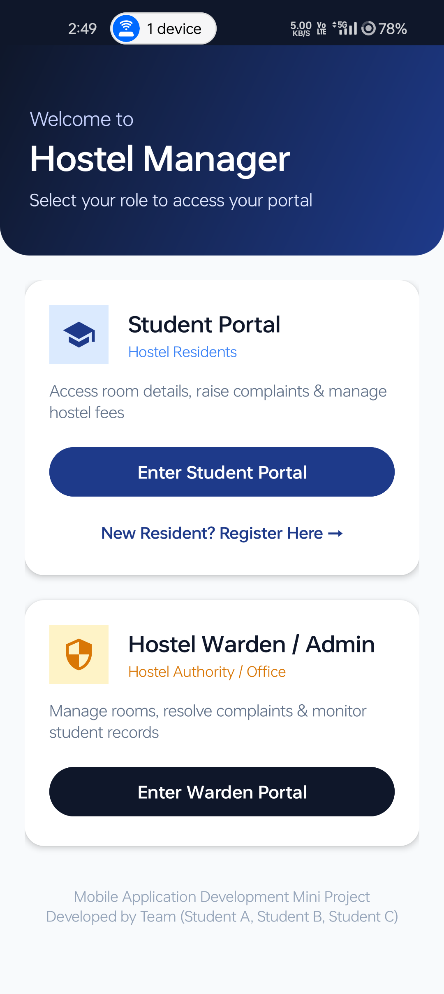  Fig. 6.1 Role Selection Portal | 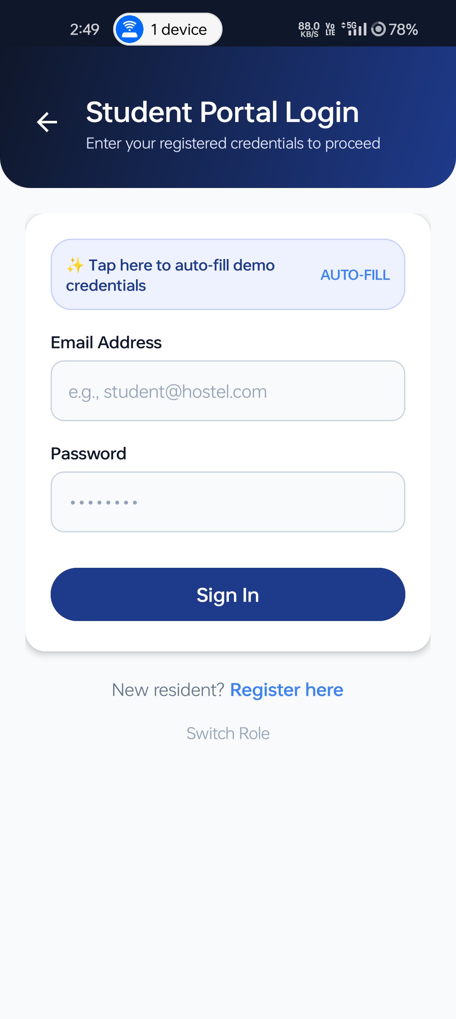  Fig. 6.2 Student Login Interface

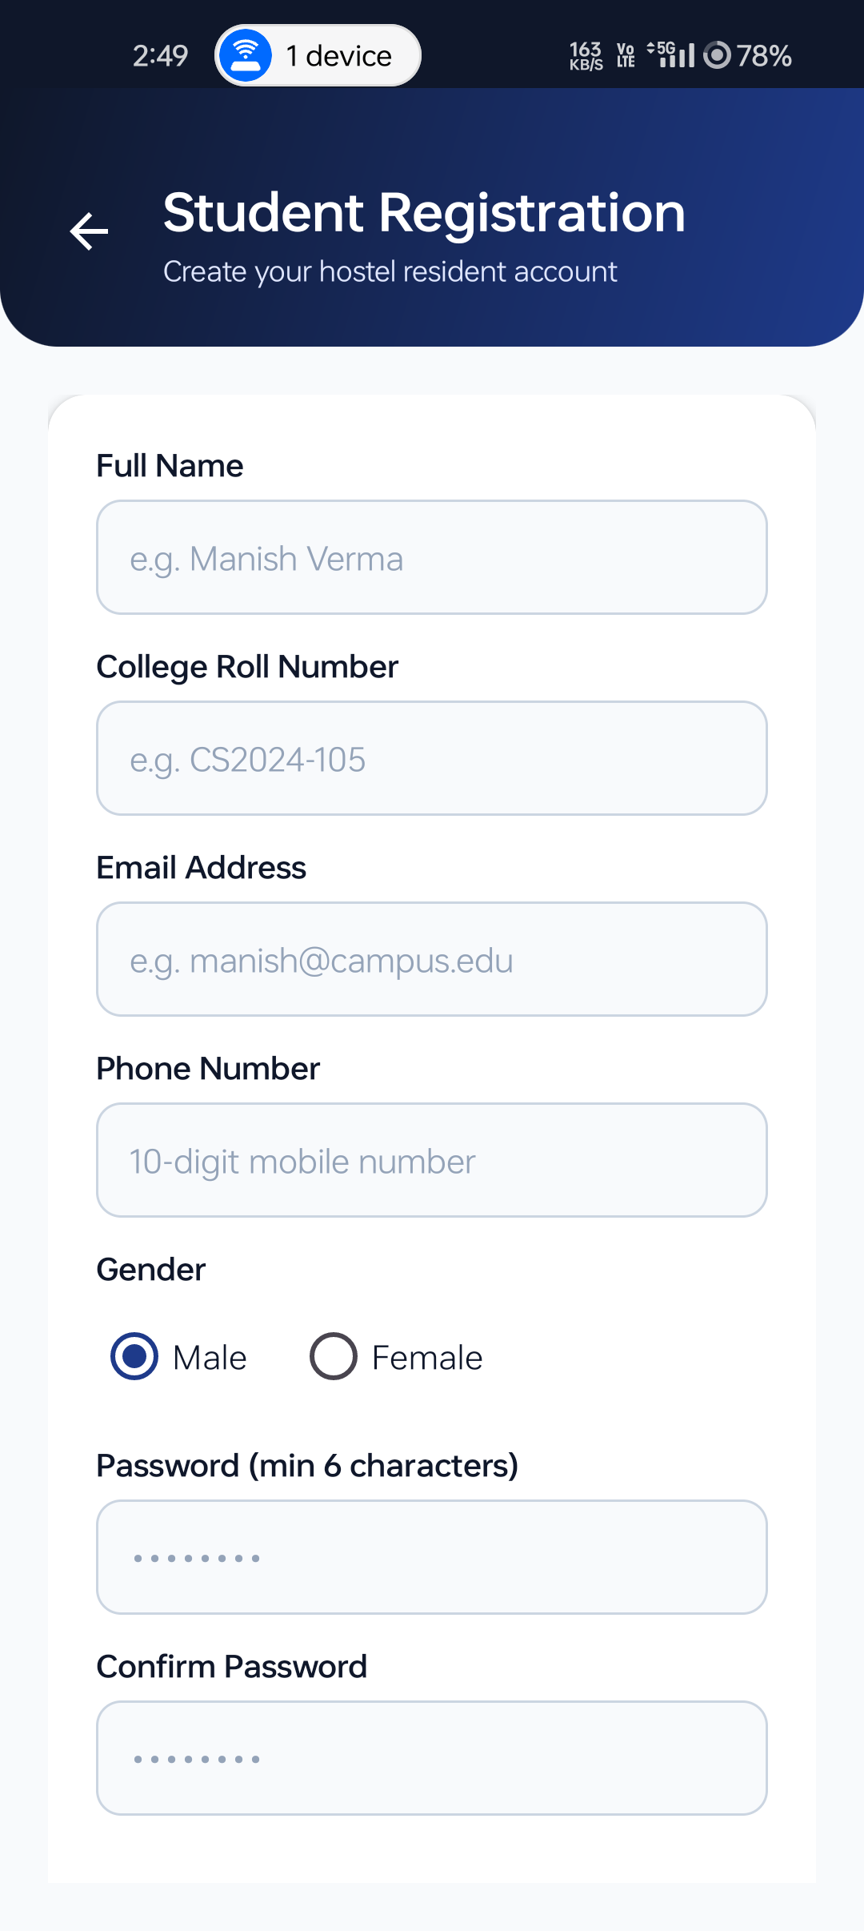  Fig. 6.3 Resident Registration Form | 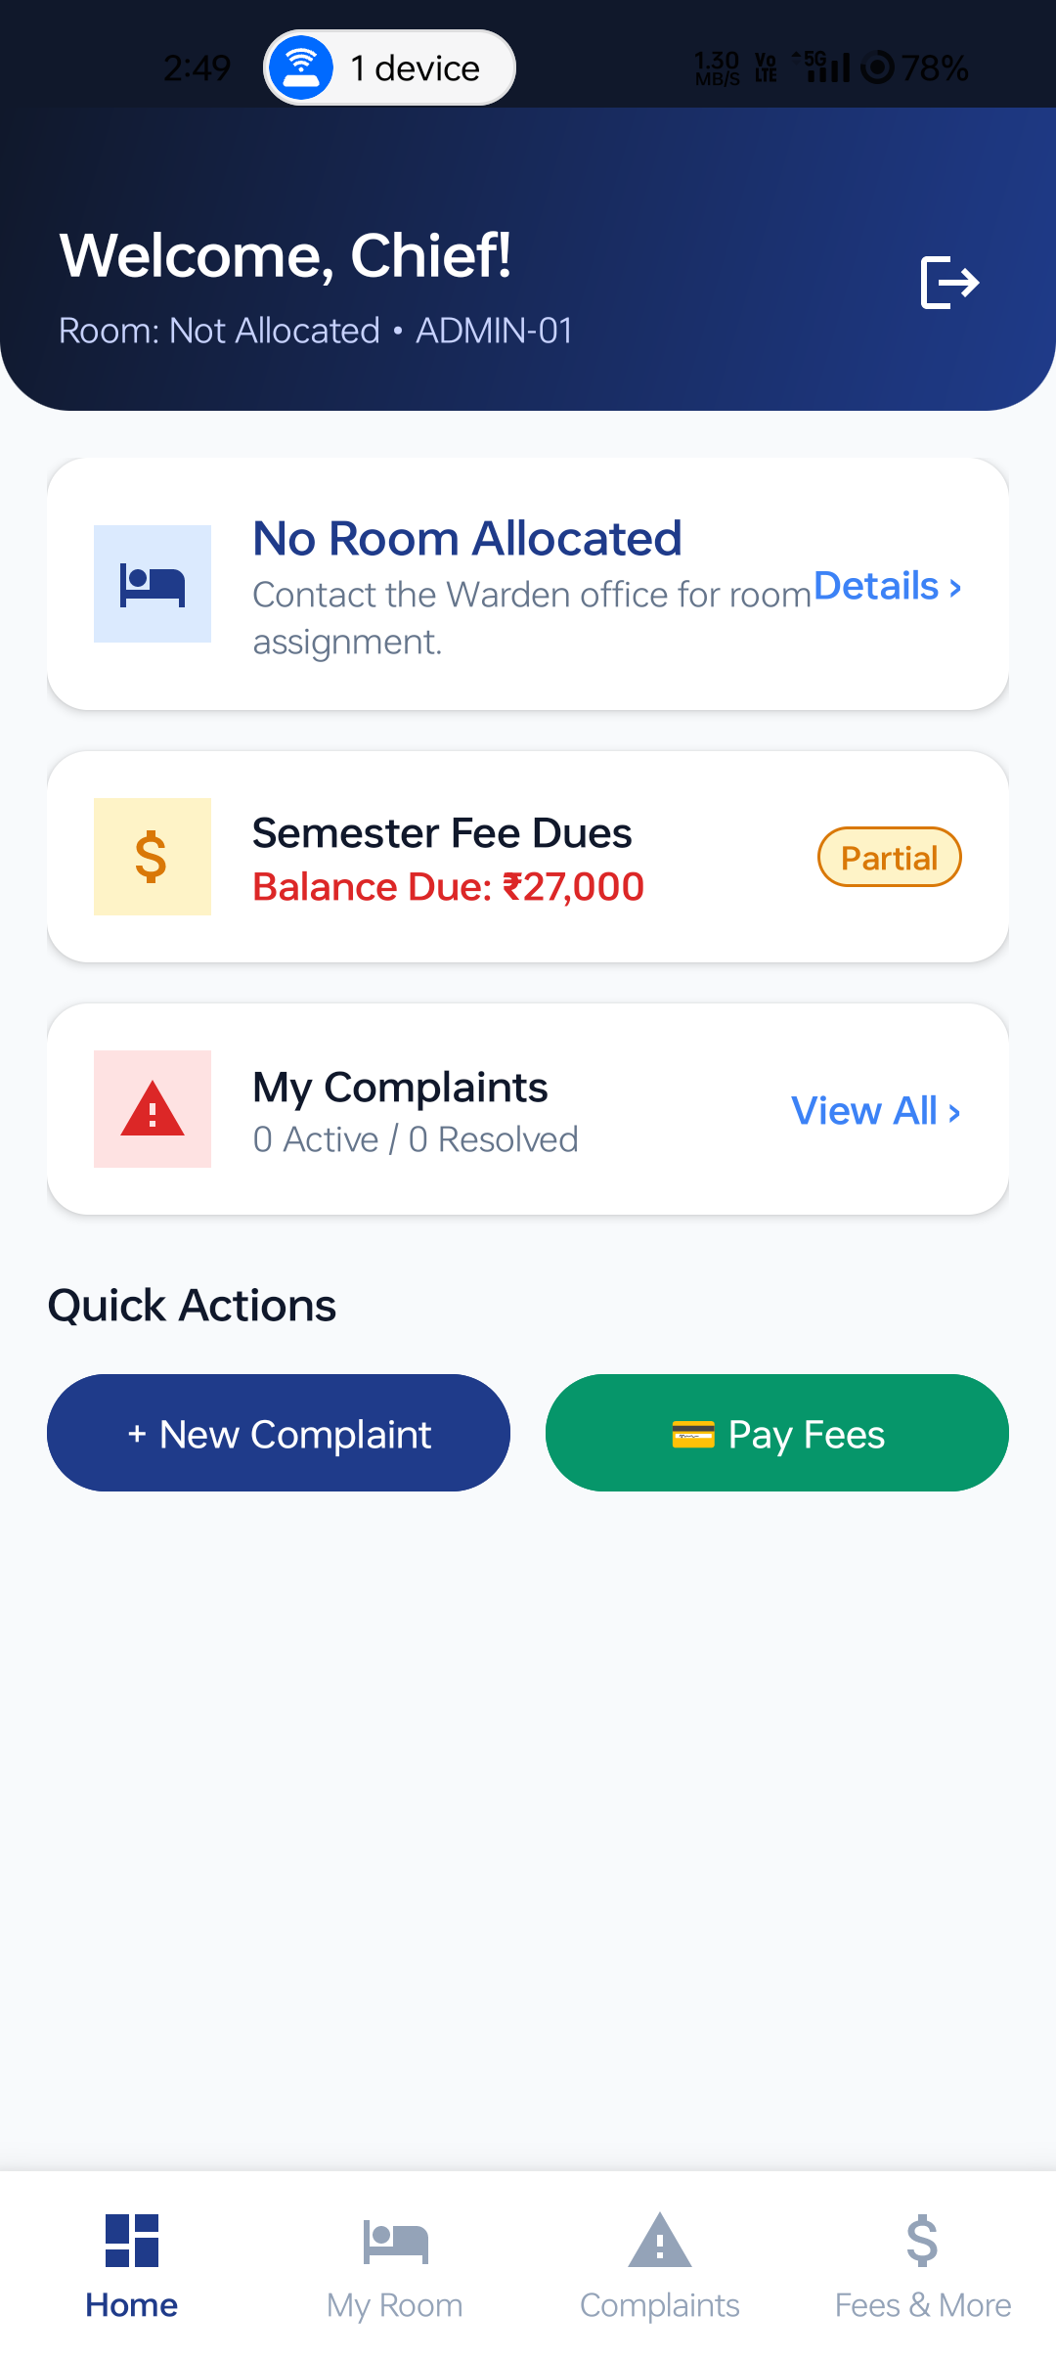  Fig. 6.4 Student Dashboard Overview
Fig. 6.3 illustrates the resident student registration form with validation across roll number, 10-digit phone number, and unique email. Fig. 6.4 depicts the primary resident dashboard displaying quick KPI cards for allocated room, fee dues balance, and active complaint tallies.

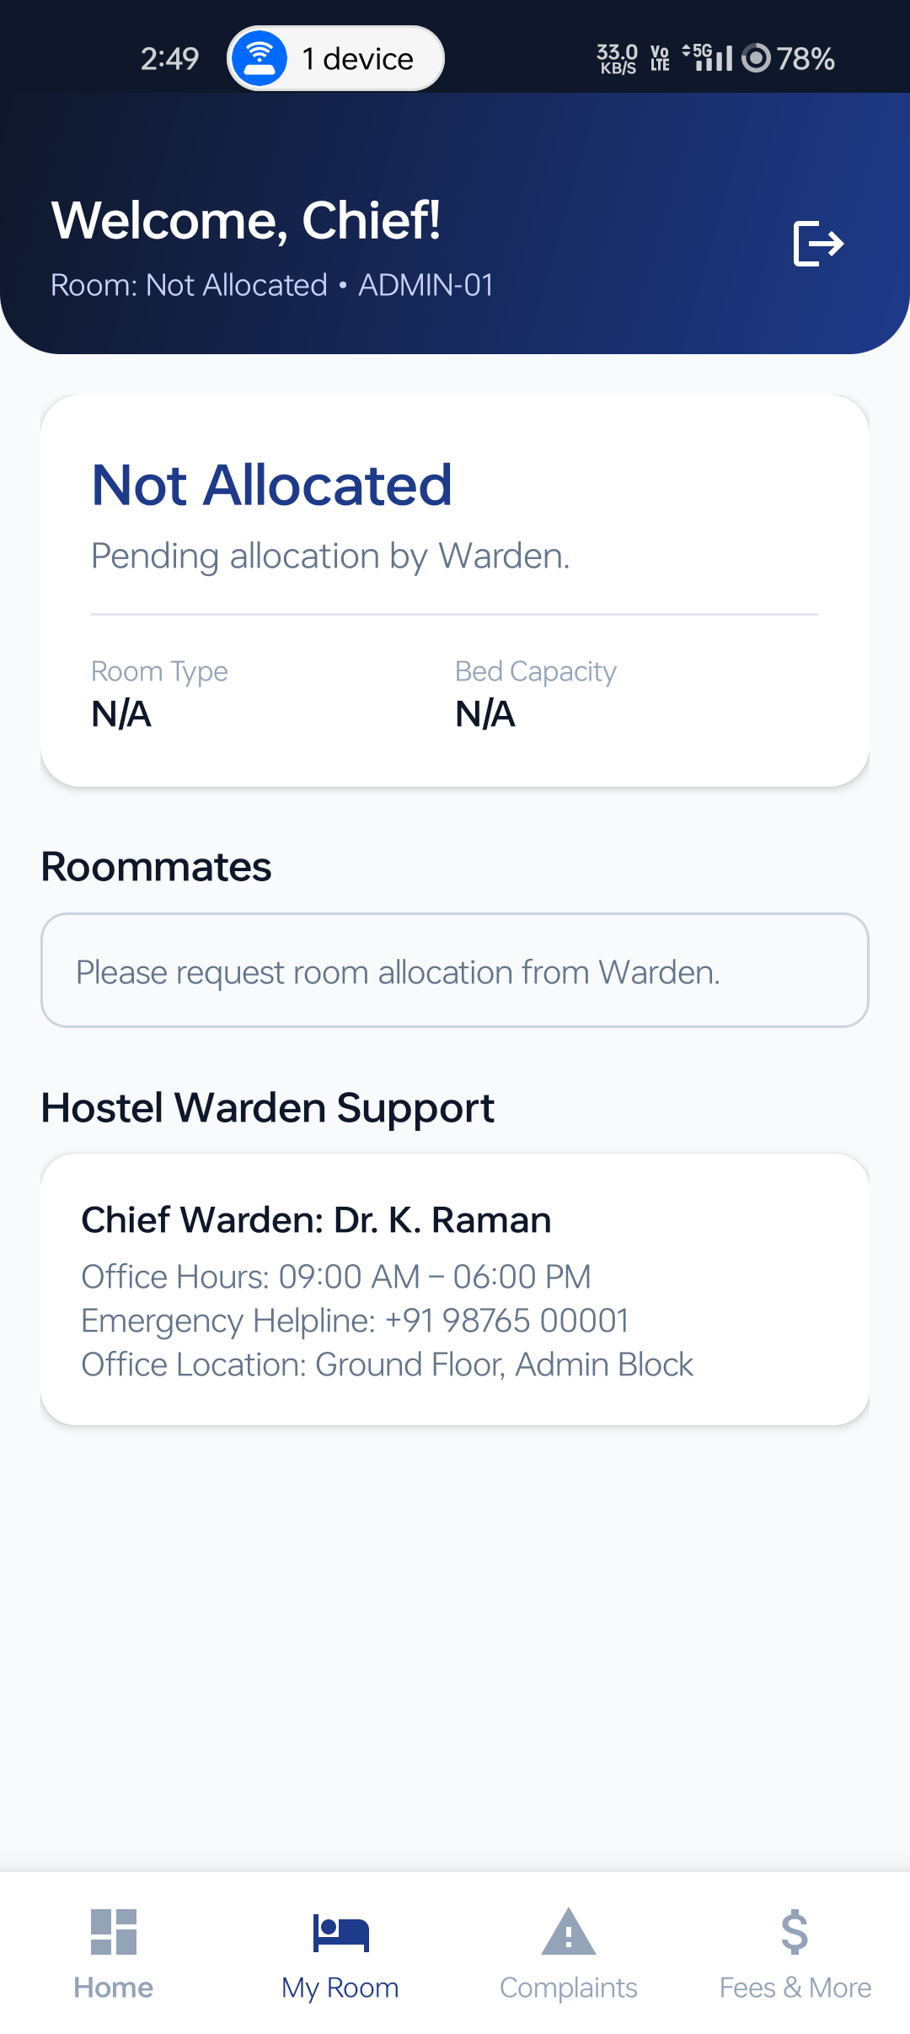  Fig. 6.5 My Room & Roommates Details | 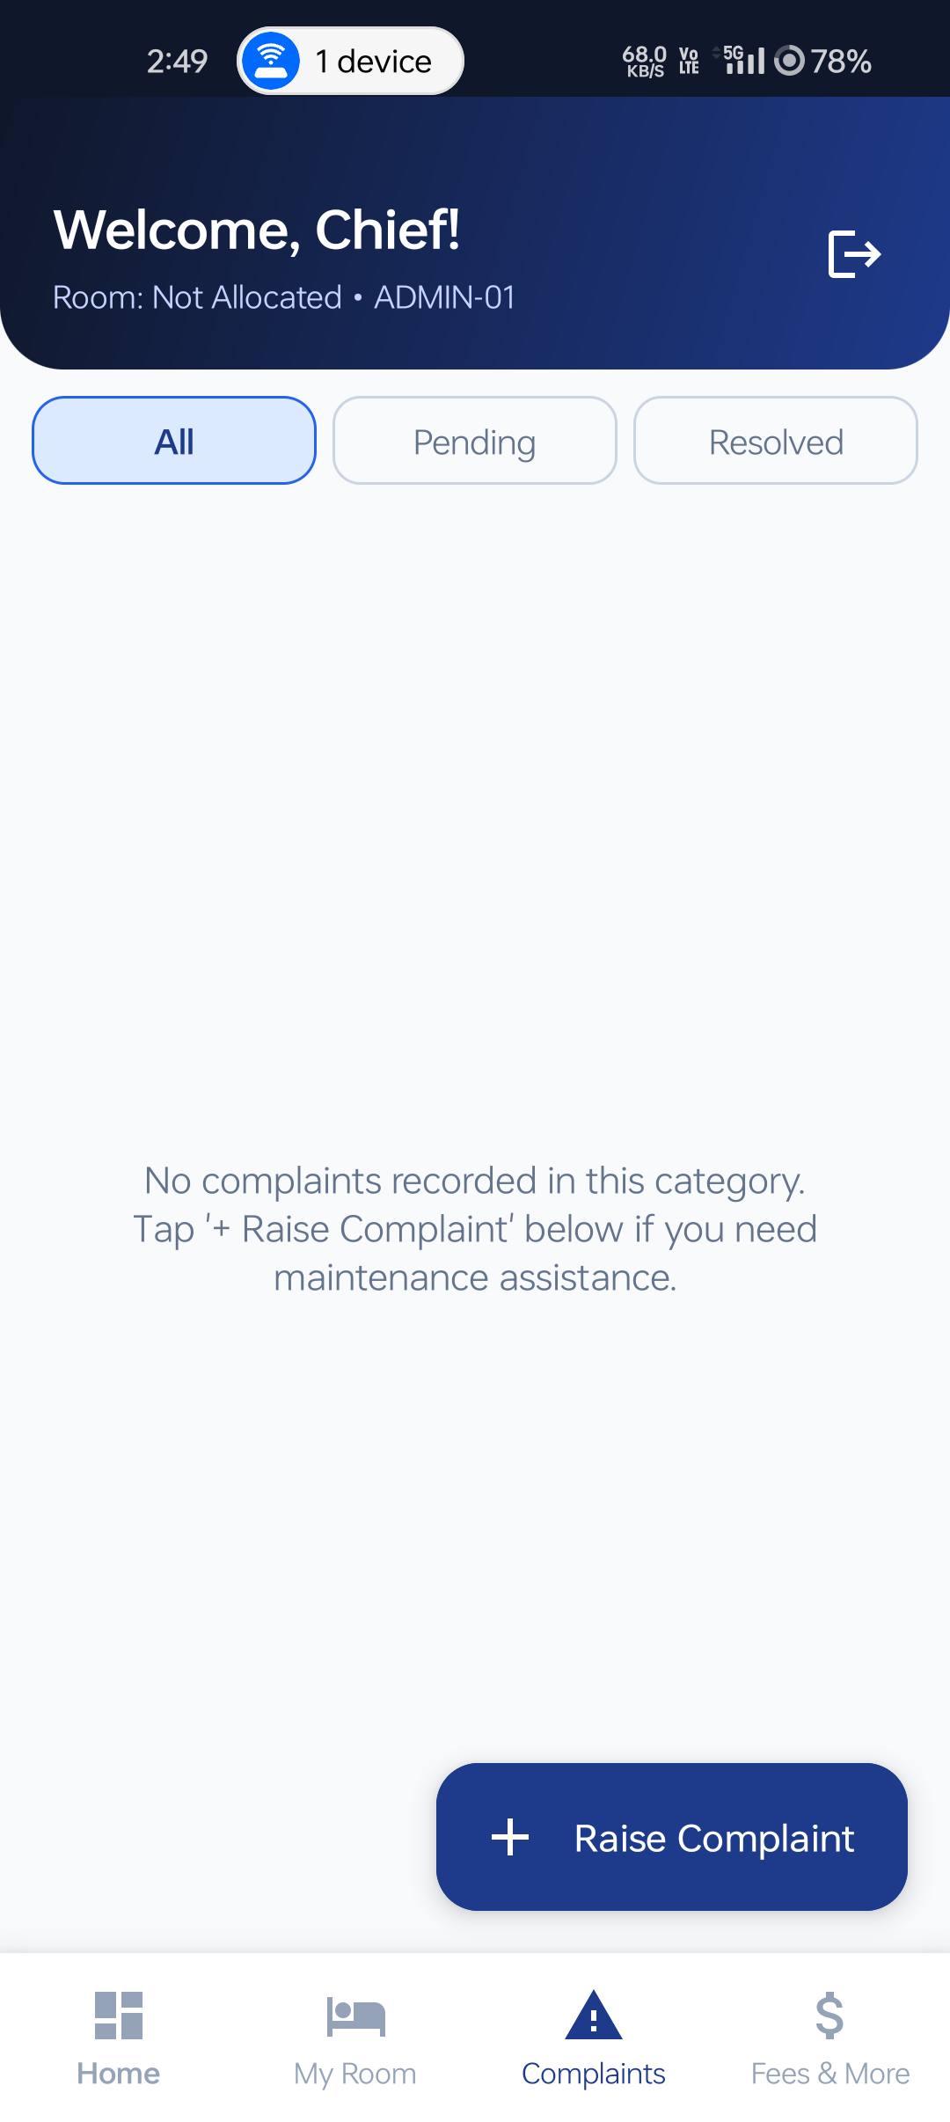  Fig. 6.6 Student Complaints Tracker
Fig. 6.5 displays room specifications (Block, Floor, AC Type) along with co-allocated roommates fetched dynamically from SQLite. Fig. 6.6 demonstrates the interactive maintenance ticket tracker with category filtering and color-coded status badges.

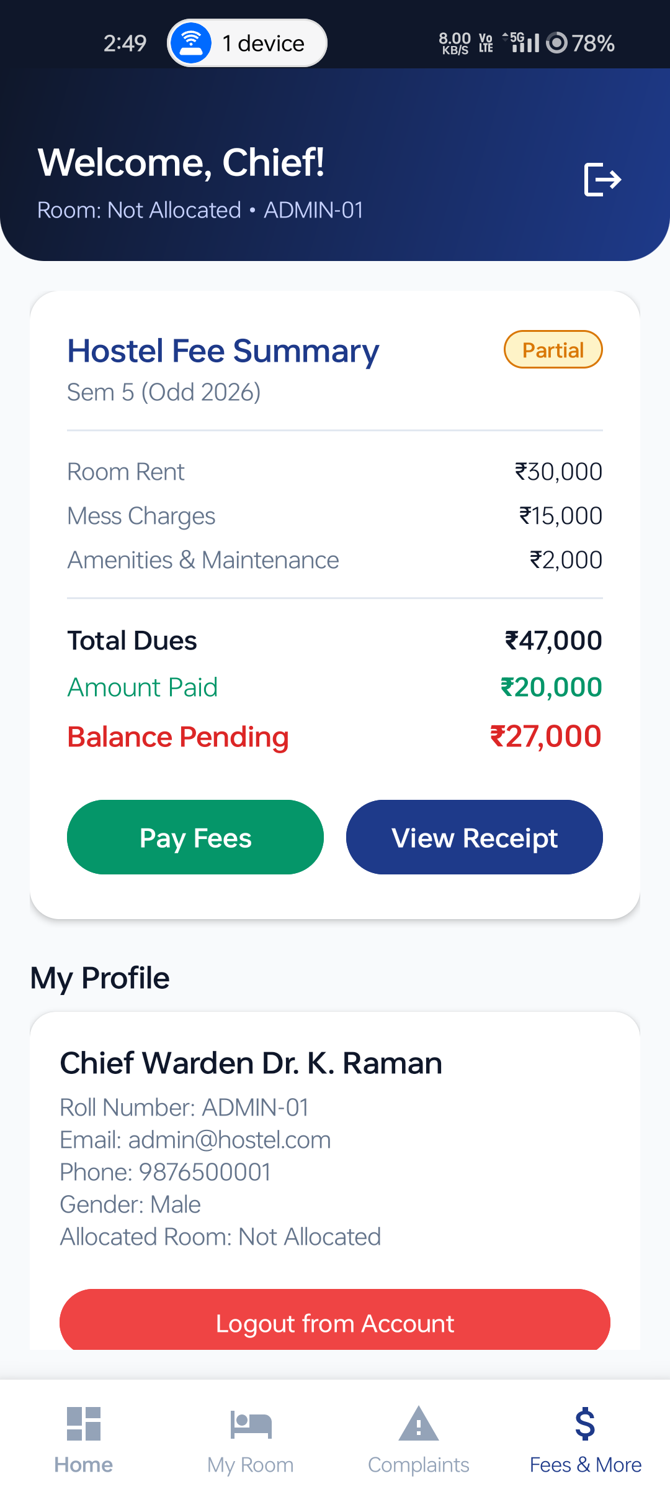  Fig. 6.7 Hostel Fee Breakdown & Pay Dialog | 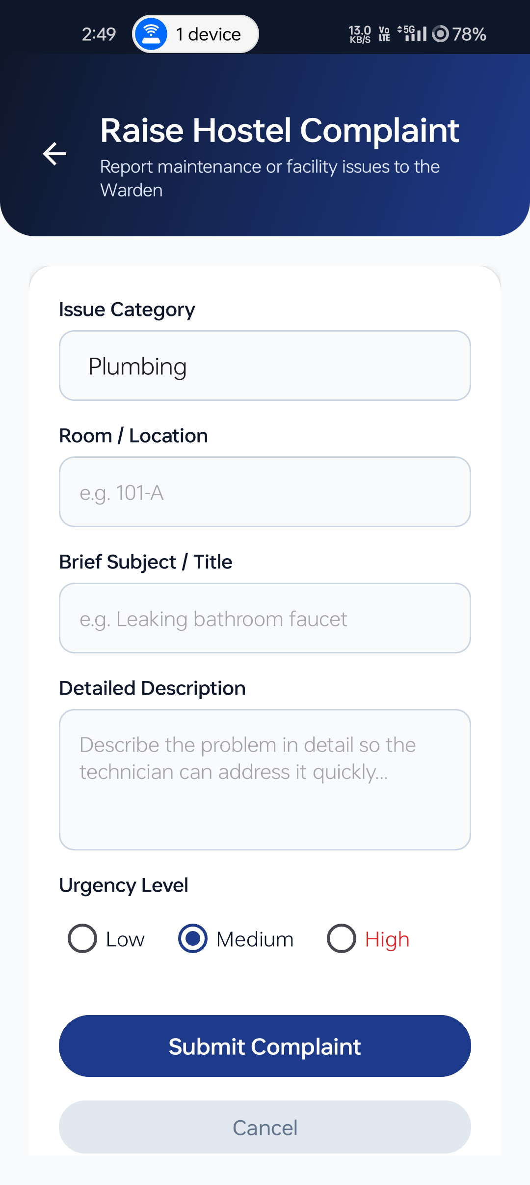  Fig. 6.8 Raise Complaint Maintenance Form
Fig. 6.7 illustrates the semester fee ledger breakdown with the simulated UPI payment modal and verified digital receipt generator. Fig. 6.8 shows the maintenance complaint entry form supporting category selection (Plumbing, Electrical, Wi-Fi) and urgency triage.

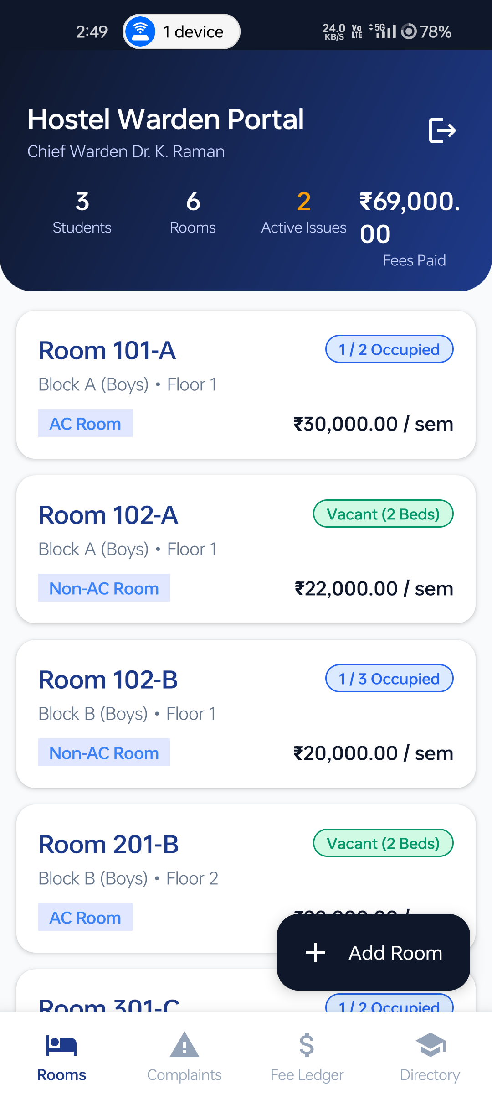  Fig. 6.9 Warden Portal KPIs & Rooms | 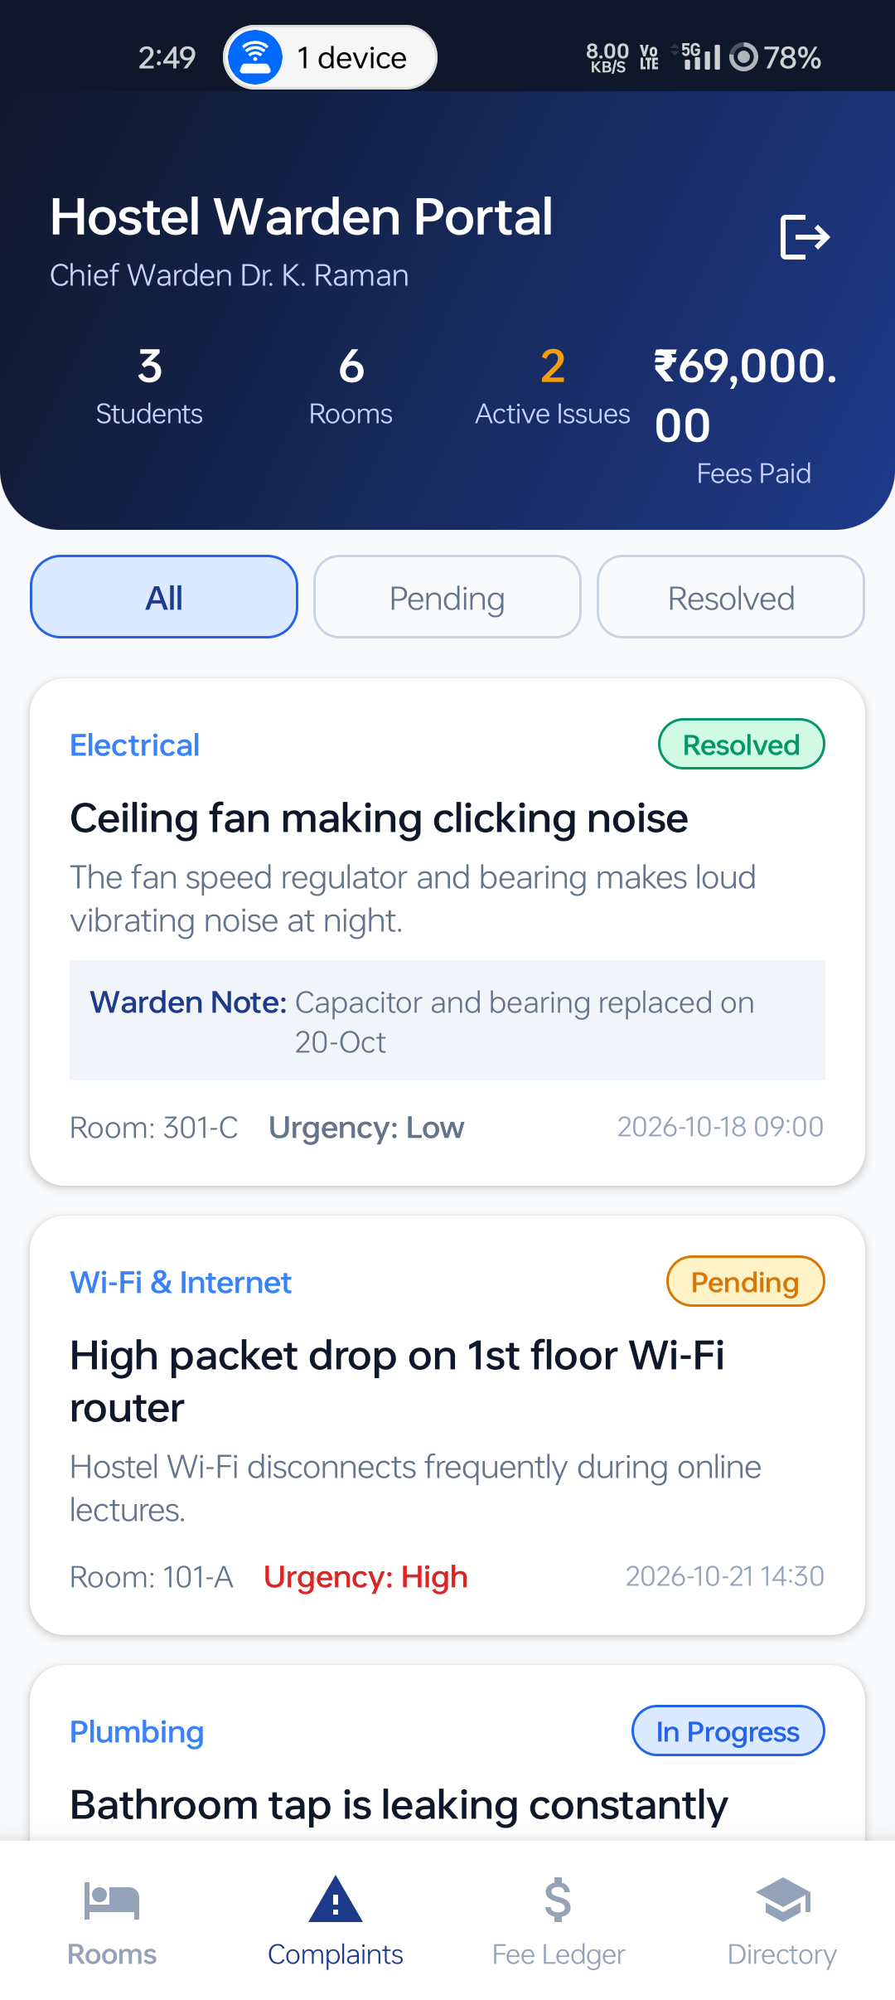  Fig. 6.10 Warden Complaint Triage & Status
Fig. 6.9 shows the executive warden dashboard displaying live KPIs across students, rooms, active issues, and collected fees. Fig. 6.10 shows the administrative complaint triage screen where wardens update ticket statuses and attach official resolution remarks.

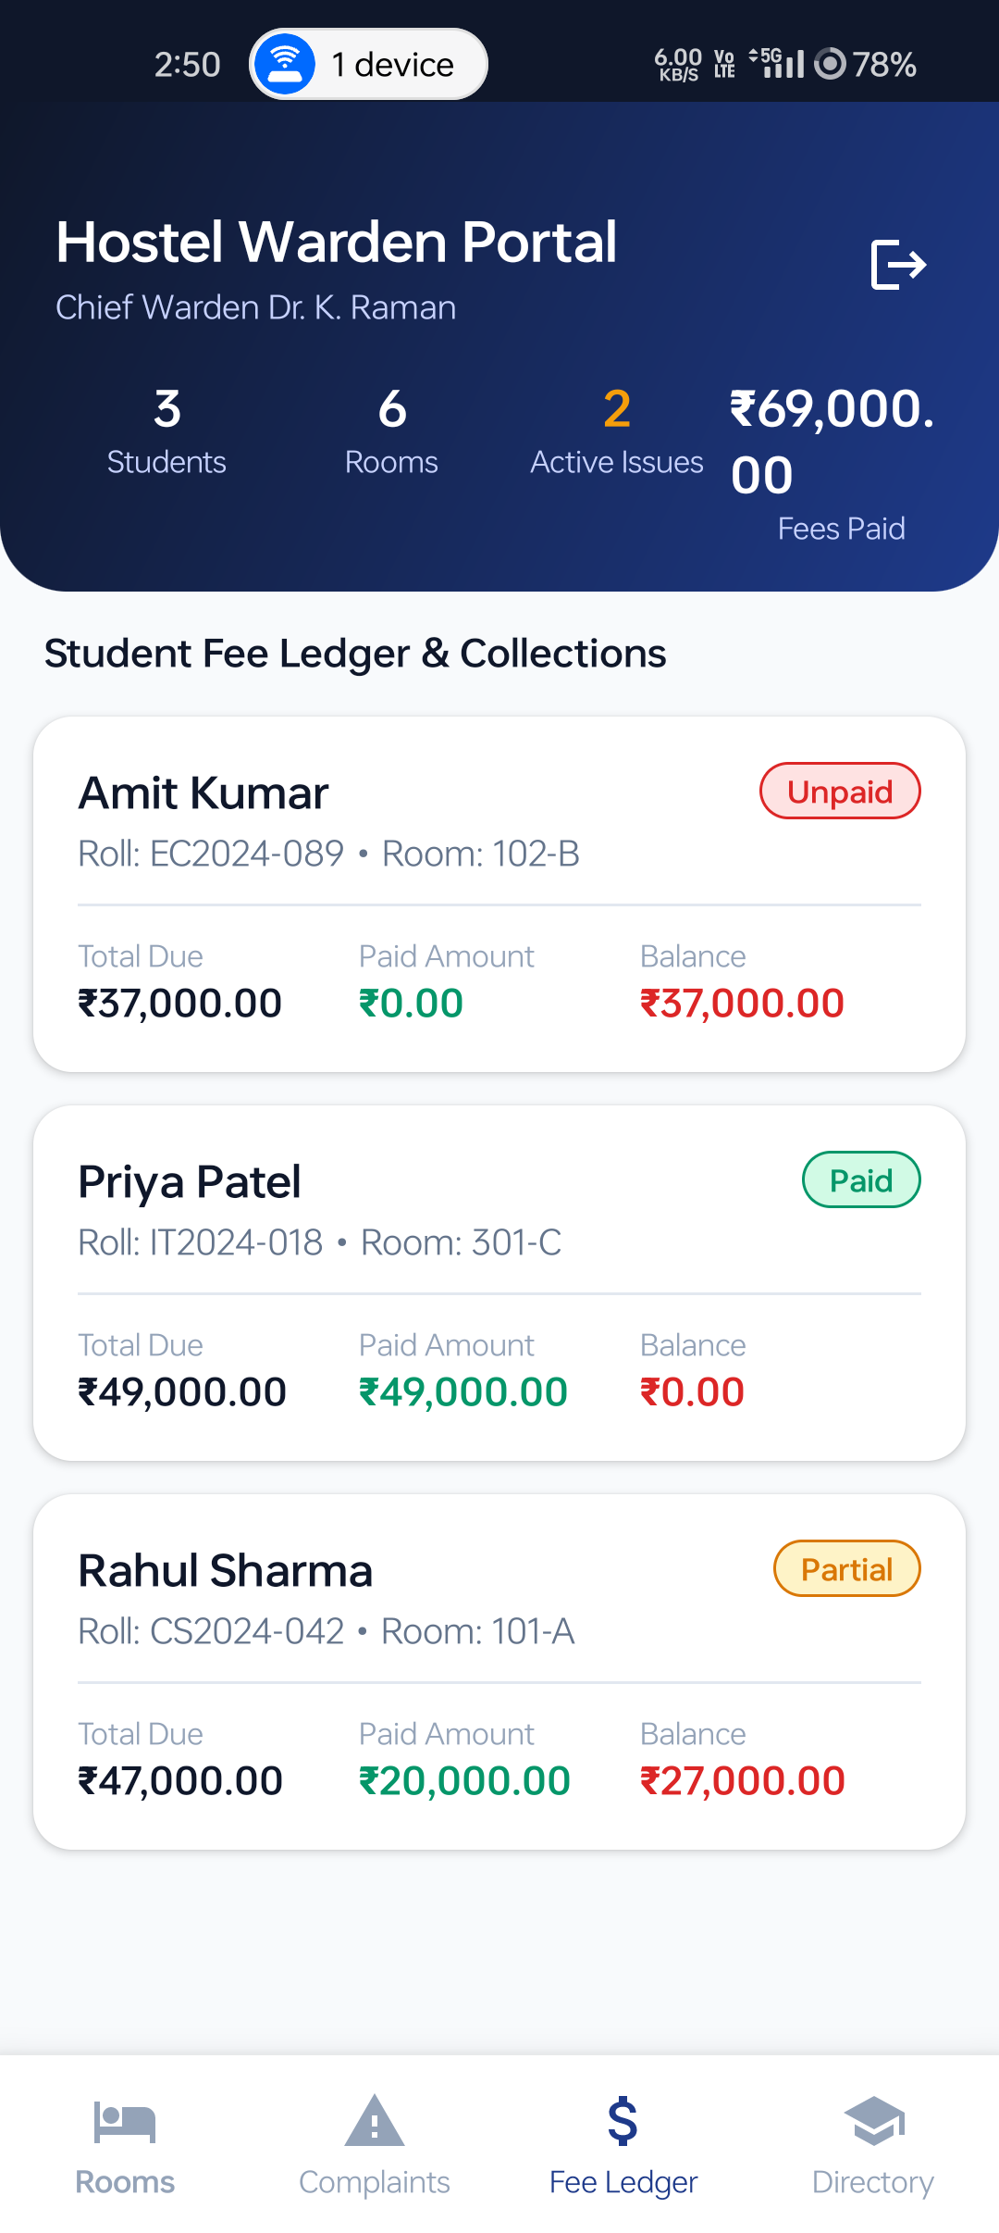  Fig. 6.11 Fee Ledger & Collection Records | 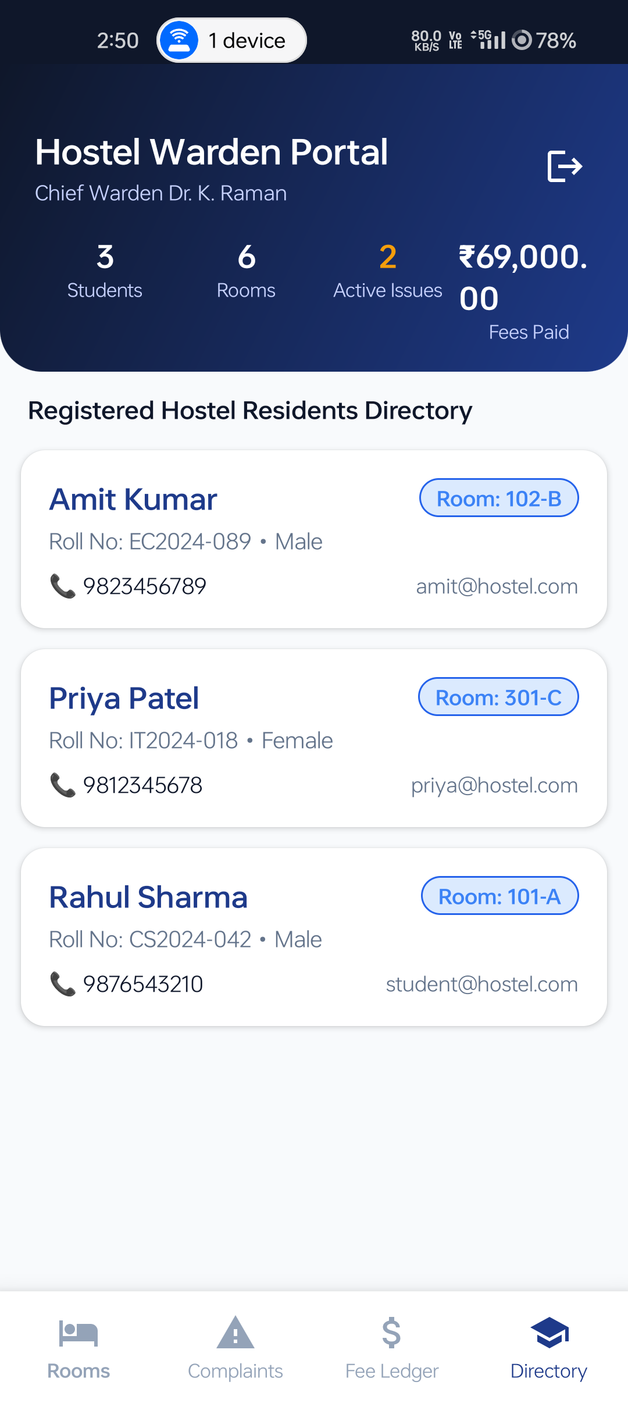  Fig. 6.12 Resident Student Directory
Fig. 6.11 presents the comprehensive student fee ledger for warden auditing. Fig. 6.12 displays the resident student directory with one-tap student allocation and deallocation controls.

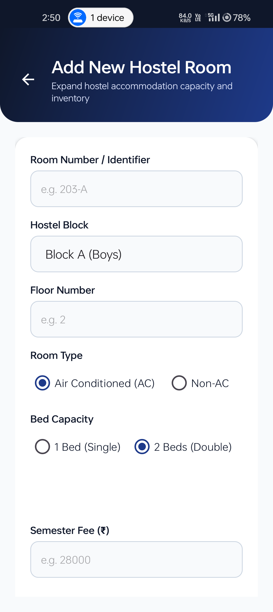
Fig. 6.13 Add Room Inventory Form (Block, Capacity, Type & Rent)
6.3 SUMMARY OF VERIFICATION FINDINGS & PERFORMANCE
Table 6.1 Comprehensive Black-Box Functional Test Execution Matrix
Test ID | Test Scenario | Input / Action | Expected Outcome | Status
TC-01 | Student Login | Input registered email & password | Successful login; redirect to StudentMainActivity | Pass
TC-02 | Login Validation | Empty email or incorrect password format | Error cue displayed on EditText; submission blocked | Pass
TC-03 | Auto-Fill Demo | Tap quick-fill demo credentials chip | Credentials populated instantly; login works | Pass
TC-04 | Registration | Fill all registration fields and submit | New user added in SQLite, fee account created, portal opens | Pass
TC-05 | Duplicate Email | Register with already existing email | Error 'Email is already registered' displayed | Pass
TC-06 | Room Allocation | Admin assigns student to Room 101-A | Room occupied count increments; student profile updated | Pass
TC-07 | Overcapacity | Allocate student to room with 0 beds free | Alert message shown; allocation disallowed | Pass
TC-08 | Complaint Submit | Submit plumbing defect with High urgency | Complaint inserted into SQLite with status 'Pending' | Pass
TC-09 | Complaint Filter | Tap 'Pending' filter tab in Complaints | Only unresolved issues displayed; resolved items hidden | Pass
TC-10 | Complaint Resolve | Warden marks issue 'Resolved' + remarks | Badge changes to Emerald Green; student reads remarks | Pass
TC-11 | Fee Payment | Pay ₹10,000 partial amount via UPI | Paid amount increases by 10,000; status becomes 'Partial' | Pass
TC-12 | Digital Receipt | Click 'View Receipt' after payment | Receipt dialog displayed with Transaction ID & Stamp | Pass
TC-13 | Room Addition | Admin adds room 203-A (Block A, 2 Beds) | New room appears in inventory list with 'Vacant' status | Pass
TC-14 | Deallocate Student | Admin deallocates student from room | Student room set to 'Not Allocated'; room occupancy decrements | Pass
TC-15 | Session Persistence | Close application and reopen | Direct redirect to respective portal without prompting login | Pass
TC-16 | Form Back Navigation | Press top-bar back arrow on forms | Cleanly finishes current screen and navigates back to caller | Pass
TC-17 | Bottom Tab Back Press | Press system back button on sub-tabs | Returns view to Dashboard tab (Tab 0) instead of app exit | Pass
TC-18 | Exit Confirmation | Press system back button on Dashboard | Presents modal confirmation dialog preventing accidental close | Pass

CHAPTER 7: TRAINING EXPERIENCE, CHALLENGES & CONCLUSION
7.1 LEARNING OUTCOMES & SKILLS ACQUIRED
The completion of this Mobile Application Development mini-project provided comprehensive practical experience across the native Android development lifecycle. Key engineering competencies acquired include:
1. Native Mobile UI Engineering: Mastery of declarative XML layouts, Material Design 3 guidelines, CardView elevation, and high-performance RecyclerView adapters with dynamic data binding.
2. Embedded Relational Database Design: Practical implementation of normalized SQLite schemas, DDL creation, transactional updates (`db.beginTransaction()`), and atomic multi-table consistency.
3. Session Management & Access Control: Implementing persistent, role-aware user sessions using Android SharedPreferences with complete privilege separation between students and wardens.
4. Robust Navigation Architecture: Mastery of AndroidX OnBackPressedDispatcher for handling multi-tab back stacks and modal exit confirmation dialogs.
5. Hardware Deployment & Verification: Hands-on experience compiling native APKs via Gradle CLI and deploying to physical Android 14 hardware via Android Debug Bridge (ADB).
7.2 WORK ENVIRONMENT & SUPPORT
The project development took place in an encouraging and technically sound environment. The computing infrastructure, mobile testing equipment, and guidance provided by the Department of Information Technology at A. D. Patel Institute of Technology, CVM University, facilitated smooth development and iterative code verification. Continuous faculty feedback ensured that all technical requirements and academic documentation standards were fulfilled.
7.3 CHALLENGES FACED & TECHNICAL SOLUTIONS
1. Transitive Dependency Network Timeouts in Gradle: Gradle initially attempted to re-download transitive library dependencies in an offline environment. Solution: Configured resolutionStrategy in app/build.gradle.kts to enforce local cached artifact versions (androidx.core:core:1.13.1 and error_prone_annotations:2.18.0) and utilized the --offline flag, achieving 100% reliable local compilation.
2. Multi-Role Session Separation on Single Device: Testing both student and warden roles on the same physical phone created session collisions. Solution: Implemented a role-aware SessionManager with explicit clearing routines upon logout, enabling seamless switching between Student and Warden views.
3. Relational Inconsistency during Room Reallocations: Reallocating students between rooms could leave old room occupancies out-of-sync. Solution: Wrapped all room allocation logic inside atomic SQLite transactions (`db.beginTransaction()` and `db.setTransactionSuccessful()`), ensuring room capacity checks, occupancy decrements, occupancy increments, and user record updates execute as a single atomic unit.
4. Multi-Tab Back Press Handling: Pressing the hardware back button while on secondary tabs exited the app. Solution: Integrated AndroidX OnBackPressedDispatcher callbacks in both main activities to return secondary tabs back to Tab 0, coupled with modal exit confirmation dialogs.
5. Live SQLite Database Inspection: Mobile SQLite databases reside in private internal sandboxes, making visual evaluation difficult. Solution: Developed an external Apache/PHP database viewer (`index.php`) compatible with XAMPP featuring a 1-click 'Sync Live Data From Phone' button, allowing real-time inspection in desktop browsers.

7.4 FUTURE ENHANCEMENTS & SCOPE
1. Cloud Synchronization: Integrating Firebase Cloud Firestore or REST APIs for multi-device data synchronization across campus administrative terminals.
2. Automated Push Notifications: Integrating Firebase Cloud Messaging (FCM) to trigger instant alerts when a warden updates complaint status or when hostel fees become due.
3. QR Code Digital Gate Pass: Developing an automated student out-pass and leave management module with digital QR code verification at hostel security gates.
4. Biometric Authentication: Adding Android BiometricPrompt fingerprint and face authentication for faster and more secure resident logins.
5. Production Payment Gateway: Connecting production payment gateways (Razorpay, Paytm) for real-time bank settlements of hostel fee transactions.
7.5 CONCLUSION
The 'Hostel Manager' mobile application successfully fulfills all project objectives for the Mobile Application Development course. By combining native Java performance with an offline-first SQLite relational database and responsive Material Design interfaces, the application delivers a reliable, efficient, and user-friendly residential management platform. Developed collaboratively across a four-member student engineering team, the application is completely functional, hardware-verified, and ready for academic demonstration and deployment.

REFERENCES / BIBLIOGRAPHY
The following academic papers, textbooks, and documentation sources were consulted during the development of this project:
1. Android Developers Guide (2024) 'Save data in a local database using SQLite', Google Developers Documentation, Available at: https://developer.android.com/training/data-storage/sqlite.
2. Android Open Source Project (2024) 'Android Material Design 3 Guidelines & Component Catalog', Google LLC, Available at: https://m3.material.io/.
3. Bloch, J. (2018) 'Effective Java', 3rd Edition, Addison-Wesley Professional, Boston, MA, pp. 112–135.
4. Charutar Vidyamandal University (2024) 'Academic Regulations and Curriculum for Bachelor of Technology in Information Technology', CVM University Academic Press, Vallabh Vidyanagar, Gujarat.
5. Deitel, P. and Deitel, H. (2017) 'Android for Programmers: An App-Driven Approach', 3rd Edition, Prentice Hall, Upper Saddle River, NJ, pp. 240–285.
6. Google Developers (2024) 'Manage the Activity Back Stack and Navigation Hierarchies with OnBackPressedDispatcher', Android Core Libraries, Available at: https://developer.android.com/guide/navigation/custom-back/predictive-back-gesture.
7. Kurniawan, B. (2015) 'Android Application Development: A Beginner's Tutorial', Brainy Software, Redmond, WA, pp. 180–215.
8. SQLite Development Team (2024) 'SQLite SQL Syntax & Transactional ACID Guarantees', SQLite.org Documentation, Available at: https://www.sqlite.org/transactional.html.

APPENDIX: PROJECT CODEBASE, CONFIGURATION & HARDWARE DEPLOYMENT
APPENDIX A: PROJECT DIRECTORY HIERARCHY
The project follows standard Android Gradle directory conventions as structured below:
mad_hostel-manager/
├── app/
│ ├── build.gradle.kts # Module build configurations & dependency resolution
│ └── src/main/
│ ├── AndroidManifest.xml # Application declarations, permissions & activities
│ ├── java/com/hostel/manager/
│ │ ├── SplashActivity.java # Session check and splash routing
│ │ ├── RoleSelectActivity.java # Student vs. Warden portal landing selector
│ │ ├── LoginActivity.java # Credential authentication with back button
│ │ ├── RegisterActivity.java # New resident registration with field validation
│ │ ├── StudentMainActivity.java # Resident dashboard (Room, Complaints, Fees tabs)
│ │ ├── AdminMainActivity.java # Warden portal (KPIs, Rooms, Complaints, Students)
│ │ ├── AddComplaintActivity.java# Form for lodging categorized maintenance tickets
│ │ ├── AddRoomActivity.java # Form for adding new hostel room inventory
│ │ ├── HostelDbHelper.java # SQLite relational database engine and CRUD logic
│ │ ├── SessionManager.java # SharedPreferences authenticated session control
│ │ ├── ComplaintAdapter.java # RecyclerView adapter for complaint ticket cards
│ │ ├── RoomAdapter.java # RecyclerView adapter for room occupancy cards
│ │ ├── FeeAdapter.java # RecyclerView adapter for student fee records
│ │ └── StudentAdapter.java # RecyclerView adapter for resident directory cards
│ └── res/
│ ├── layout/ # 14 declarative Android XML layout files
│ ├── drawable/ # Vector drawables, gradients, and custom badges
│ └── values/ # Colors (Material 3 palette), strings, and themes
├── build.gradle.kts # Top-level build script
├── settings.gradle.kts # Repository definitions and project naming
├── gradlew.bat # Windows Gradle execution wrapper
├── index.php # XAMPP Apache live SQLite database viewer
├── view_database.bat # 1-click batch script for database inspection
└── MAD_report.docx # Formatted academic project documentation
APPENDIX B: INDIVIDUAL TECHNICAL RESPONSIBILITIES (TEAM OF 4)
In accordance with the collaborative mini-project guidelines for a four-member student engineering team, technical responsibilities were distributed across leadership, application architecture, UI/UX testing, and database backend integration as detailed below:
1. Jay Chaudhary (Enrollment: 12302080601041) – Team Leader: Overall project planning, architectural design, team coordination, integration of core modules, final submission management, Gradle offline build configuration, and physical hardware deployment to Android 14 test device.
2. Jay Bhoi (Enrollment: 12302080601042) – Application Developer: Core application functionality, business logic implementation, activity workflows (SplashActivity, RoleSelectActivity, LoginActivity, RegisterActivity, StudentMainActivity, AdminMainActivity), intent management, and bottom navigation tab switching.
3. Kishan Prajapati (Enrollment: 12302080601056) – UI/UX Developer & Tester: Screen layouts and visual design; authored all 14 Material 3 XML layouts; created custom background drawables and status chips; implemented RecyclerView adapters; executed comprehensive black-box testing across TC-01 to TC-18; compiled test matrix and QA documentation.
4. Krish Varde (Enrollment: 12302080601057) – Database/API Developer: Database architecture; engineered 3NF normalized SQLite schema in HostelDbHelper.java (users, rooms, complaints, fee_records); programmed atomic transactions for room allocation and bed capacity; implemented SessionManager.java authentication; developed index.php XAMPP database viewer.

APPENDIX C: HARDWARE DEPLOYMENT & LIVE DATABASE INSPECTION GUIDE
To allow faculty evaluators to audit the live SQLite database residing inside the physical phone, a desktop browser inspection bridge was developed:
1. Step 1: Open the XAMPP Control Panel on the host workstation and start the Apache web server.
2. Step 2: Ensure the Android phone is connected via USB with USB Debugging enabled in Developer Options.
3. Step 3: Open any web browser and navigate to: http://localhost/mad_hostel-manager/
4. Step 4: The browser displays all four database tables (`users`, `rooms`, `complaints`, `fee_records`) with schema columns and rows. Clicking the green 'Sync Live Data From Phone' button automatically pulls the latest SQLite file from `/data/data/com.hostel.manager/databases/hostel_manager.db` in real time via ADB.
5. Alternative Method: Double-click `view_database.bat` in the project root directory to automatically pull the database and launch an embedded Python web viewer at `http://localhost:8085`.

