Software Requirements Specification (SRS) Template
Project: MF Software (Mini Flipkart)
Version: 1.0
Authors: Anand MS, Nahush P Shetty, Machiraju Karthikeya, Gururaj Rao, Krishna Venkatesh
Date: 03-09-25
Status: Draft

Revision History
Version | Date | Author | Change Summary | Approval
1.0 | 03-09-25 | Anand M S | Initial SRS for MF System

Approvals
Role | Name | Signature / Email | Date
Course Coordinator | Prof Rajesh Banginwar

Table of Contents
- Introduction
- Overall Description
- External Interface Requirements
- System Features (Detailed)
- Non-functional Requirements (Detailed)
- Quality Attributes & Acceptance Tests
- UML Use-Case Diagram
- Requirements Traceability Matrix (RTM)

1. Introduction

1.1 Purpose
This document is a Software Requirements Specification (SRS) for an MF Software System (Mini Flipkart). It defines the functional and non-functional requirements, interfaces, and criteria for testing an online marketplace platform. The platform allows customers to browse and purchase products, and enables sellers to manage their inventory.

1.2 Scope

The system covers customer interactions including registration, product browsing, cart management, order placement, payment processing, and order tracking. It also includes seller functionalities for product management, inventory control, and order fulfillment. The system will connect with payment gateways, shipping providers, and notification services. Exclusions include internal operations of third-party logistics and implementations of external banking systems.

1.3 Audience
Software Engineers, Quality Assurance Engineers, System Architects, Product Managers, Business Analysts, and Academic Evaluators.

1.4 Definitions
- SKU: Stock Keeping Unit - unique identifier for products
- API: Application Programming Interface
- PCI-DSS: Payment Card Industry Data Security Standard
- SSL/TLS: Secure Sockets Layer/Transport Layer Security
- MFA: Multi-Factor Authentication
- UPI: Unified Payments Interface
- OTP: One-Time Password
- CDN: Content Delivery Network

2. Overall Description

2.1 Product Perspective

The MF system is a web-based marketplace platform that provides an online shopping experience similar to Flipkart. It includes customer-facing web and mobile applications, a seller dashboard, an admin panel, and backend services that manage order processing, payment, and inventory.

2.2 Major Product Functions (Detailed)
- User Management: Registration, authentication, profile management
- Product Catalog: Browse products, categories, search, filtering
- Shopping Experience: Cart management, wishlist, product reviews
- Order Processing: Checkout, payment integration, order tracking
- Seller Operations: Product listing, inventory management, order fulfillment
- Administrative Functions: User management, system monitoring, analytics
- Notification System: Email/SMS notifications for orders and updates
- Security: Authentication, authorization, data protection
- Analytics: Sales reports, user behavior tracking, inventory reports

2.3 User Roles and Characteristics (Expanded)
- Customer: General consumers with basic internet knowledge, expecting fast loading times and intuitive navigation
- Seller/Vendor: Business users managing product listings and orders, requiring efficient management tools
- Administrator: System operators with technical knowledge for platform management and monitoring
- Guest User: Unregistered visitors with limited browsing capabilities

2.4 Operating Environment
- Frontend: Web browsers (Chrome, Firefox, Safari, Edge), Mobile apps (iOS, Android)
- Backend: Cloud-based servers (AWS/Azure/GCP), Load balancers, CDN
- Database: MySQL/PostgreSQL for transactions, MongoDB for product catalogs
- Infrastructure: HTTPS encryption, Redis caching, Elasticsearch for search

2.5 Constraints
- PCI-DSS compliance for payment processing
- GDPR/Privacy law compliance for user data
- Mobile-responsive design mandatory
- Integration with Indian payment gateways (UPI, Razorpay, PayU)
- Scalability to handle 10,000+ concurrent users

3. External Interface Requirements

3.1 User Interfaces
- Primary UI: A responsive web interface with simple navigation, product grid/list views, and a search bar with autocomplete.
- Mobile UI: A touch-optimized interface with gesture support and mobile-specific features.
- Admin Interface: A dashboard with analytics, user management, and system monitoring features.
- Accessibility: The system must comply with WCAG 2.1 AA, including support for screen readers and keyboard navigation.

3.2 Hardware Interfaces
- Client Devices: The system will work with desktop computers, laptops, smartphones, and tablets.
- Server Infrastructure: The hardware includes cloud servers, load balancers, and storage systems.
- Network Equipment: CDN nodes, firewalls, and routers are part of the network infrastructure.

3.3 Software Interfaces
- Payment Gateway APIs: Razorpay, PayU, Stripe for payment processing
- Shipping APIs: Integration with logistics providers (Delhivery, Blue Dart, India Post)
- Email/SMS Services: SMTP servers, SMS gateway APIs for notifications
- Analytics Services: Google Analytics, internal analytics systems
- Search Engine: Elasticsearch for product search and recommendations

3.4 Communications
- Protocol: HTTPS for all client-server communication
- API Format: RESTful APIs with JSON data format
- Real-time: WebSocket connections for order status updates
- Security: TLS 1.3 encryption, API rate limiting, authentication tokens

4. System Features

4.1 User Authentication and Registration
Description: Secure user registration and authentication system supporting multiple verification methods.
Req ID | Requirement | Type | Priority | Source/Stakeholder | Acceptance Criteria / Test Case Ref | Comments
MF-F-001 | The system shall allow users to register using email or phone number with OTP verification | Functional | High | Security/UX | Valid email/phone with OTP leads to account creation. Test: TC-Auth-01 | Integration with OTP service required
MF-F-002 | The system shall authenticate users via email/password or social login (Google, Facebook) | Functional | High | User Experience | Successful login redirects to dashboard. Test: TC-Auth-02 | OAuth integration needed
MF-F-003 | The system shall implement session management with automatic timeout after 30 minutes of inactivity | Functional | High | Security | Session expires after timeout, user redirected to login. Test: TC-Auth-03 | Security requirement

4.2 Product Catalog Management
Description: Comprehensive product catalog with categories, search, and filtering capabilities.
Req ID | Requirement | Type | Priority | Source/Stakeholder | Acceptance Criteria / Test Case Ref | Comments
MF-F-004 | The system shall display products in hierarchical categories and subcategories | Functional | High | Business | Products organized in logical category tree. Test: TC-Cat-01 | Database design critical
MF-F-005 | The system shall provide advanced search with filters for price, brand, rating, availability | Functional | High | User Experience | Search returns relevant results with applied filters. Test: TC-Search-01 | Elasticsearch integration
MF-F-006 | The system shall display product details including images, specifications, price, and reviews | Functional | High | Business | Complete product information displayed. Test: TC-Product-01 | Image optimization needed

4.3 Shopping Cart and Wishlist
Description: Shopping cart management and wishlist functionality for enhanced user experience.
Req ID | Requirement | Type | Priority | Source/Stakeholder | Acceptance Criteria / Test Case Ref | Comments
MF-F-007 | The system shall allow users to add/remove/update quantities of products in shopping cart | Functional | High | User Experience | Cart operations reflect immediately. Test: TC-Cart-01 | Session persistence required
MF-F-008 | The system shall persist cart items for registered users across sessions | Functional | Medium | User Experience | Cart items available after re-login. Test: TC-Cart-02 | Database storage needed
MF-F-009 | The system shall provide wishlist functionality to save products for later | Functional | Medium | User Experience | Users can save/remove wishlist items. Test: TC-Wish-01 | User-specific storage

4.4 Order Management and Payment
Description: Secure order processing with multiple payment options and order tracking.
Req ID | Requirement | Type | Priority | Source/Stakeholder | Acceptance Criteria / Test Case Ref | Comments
MF-F-010 | The system shall support multiple payment methods (Credit/Debit cards, UPI, Wallets, COD) | Functional | High | Business | All payment methods process successfully. Test: TC-Pay-01 | Payment gateway integration
MF-F-011 | The system shall generate unique order IDs and send confirmation emails | Functional | High | Business | Order confirmation with tracking ID sent. Test: TC-Order-01 | Email service integration
MF-F-012 | The system shall provide real-time order tracking with status updates | Functional | High | User Experience | Order status visible to customers. Test: TC-Track-01 | Logistics integration

4.5 Seller and Admin Management
Description: Multi-vendor support with seller dashboards and administrative controls.
Req ID | Requirement | Type | Priority | Source/Stakeholder | Acceptance Criteria / Test Case Ref | Comments
MF-F-013 | The system shall provide seller registration and verification process | Functional | Medium | Business | Sellers can register and get verified. Test: TC-Seller-01 | Document verification needed
MF-F-014 | The system shall provide seller dashboard for product and inventory management | Functional | High | Business Operations | Sellers can manage their products. Test: TC-Seller-02 | Role-based access control
MF-F-015 | The system shall provide admin panel for user management and system monitoring | Functional | High | Administration | Admins can manage users and monitor system. Test: TC-Admin-01 | Administrative privileges

5. Non-functional Requirements (Detailed)
Req ID | Requirement | Category | Priority | Acceptance Criteria / Measurement
MF-NF-001 | System shall respond to user requests within 3 seconds for 95% of transactions under normal load | Performance | High | 95th percentile ≤ 3s in load testing. Test: TC-Perf-01
MF-NF-002 | System shall maintain 99.9% availability monthly excluding scheduled maintenance | Reliability | High | Uptime monitoring reports ≥99.9% monthly. Test: TC-Rel-01
MF-NF-003 | System shall support up to 10,000 concurrent users during peak shopping periods | Scalability | High | Load testing with 10K concurrent users. Test: TC-Scale-01
MF-NF-004 | System shall be mobile-responsive and comply with WCAG 2.1 AA accessibility standards | Usability | Medium | Accessibility audit and mobile testing pass. Test: TC-UX-01
MF-NF-005 | System shall implement PCI-DSS compliant payment processing with SSL/TLS encryption | Security/Compliance | High | PCI-DSS audit checklist and SSL verification. Test: TC-Sec-01

5.1 Security

5.1.1 Security Objectives
Objective 1: Data Protection
Ensure all customer personal information, payment data, and business-sensitive information are protected through encryption, access controls, and secure communication protocols.
Objective 2: System Integrity
Maintain the integrity of the MF platform by preventing unauthorized modifications to product data, orders, and user accounts while ensuring audit trails for all critical operations.

5.1.2 Security Requirements
Req ID | Requirement | Type | Priority | STRIDE Category | Acceptance Criteria
MF-SR-001 | System shall implement multi-factor authentication for admin accounts | Security | High | Spoofing | MFA setup required for admin access. Test: TC-Sec-Auth-01
MF-SR-002 | System shall encrypt all sensitive data in transit and at rest using AES-256 | Security | High | Information Disclosure | Encryption verification in database and network traffic. Test: TC-Sec-Enc-01
MF-SR-003 | System shall maintain comprehensive audit logs for all user actions | Security | High | Repudiation | All actions logged with timestamp and user ID. Test: TC-Sec-Log-01
MF-SR-004 | System shall validate and sanitize all user inputs to prevent injection attacks | Security | High | Tampering | Input validation blocks malicious inputs. Test: TC-Sec-Input-01
MF-SR-005 | System shall implement role-based access control with principle of least privilege | Security | High | Elevation of Privilege | Users access only authorized resources. Test: TC-Sec-RBAC-01

6. Quality Attributes & Acceptance Tests
Exit Criteria for Acceptance: - All high-priority functional requirements implemented and verified - No critical security vulnerabilities identified - Performance benchmarks met under load testing - 99.9% uptime achieved in pre-production testing - PCI-DSS compliance verification completed - All test cases in RTM marked as passed
Acceptance Test Suites: - Authentication and Authorization Tests - Product Catalog and Search Tests
- Shopping Cart and Checkout Tests - Payment Processing Tests - Order Management Tests - Performance and Load Tests - Security and Penetration Tests - Mobile Responsiveness Tests - Accessibility Compliance Tests

7. System Models and Diagrams

7.1 UML Use-Case Diagrams
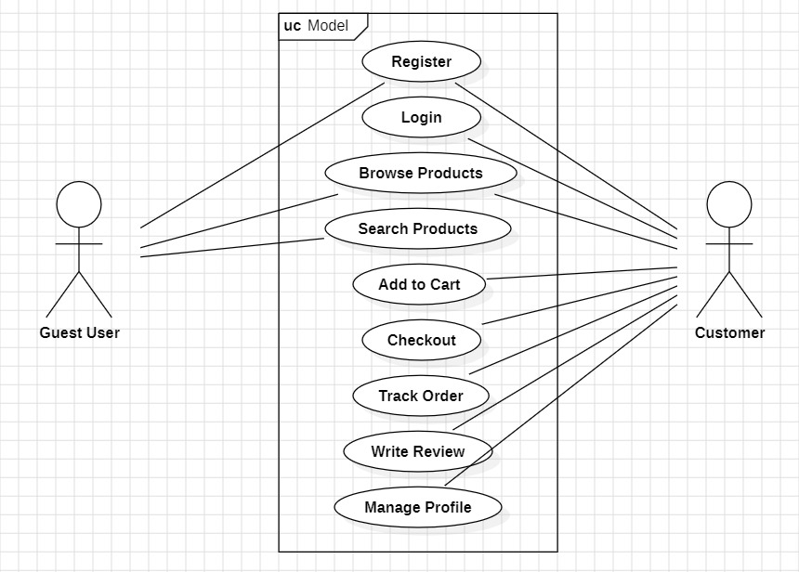
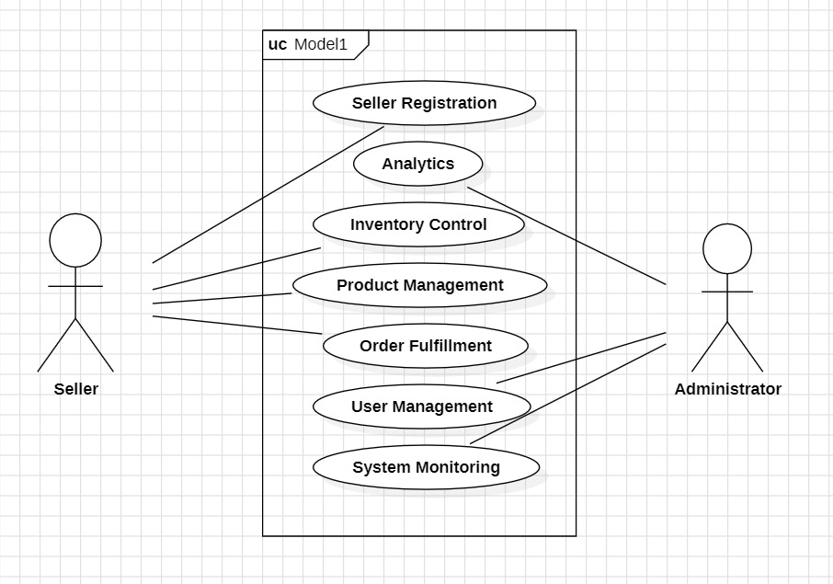

8. Requirements Traceability Matrix (RTM)
Req ID | Requirement Short | Section Ref | Module | Test Case(s) | Status (N/P/A)
MF-3 | User Onboarding and Login UX | 4.1 | UserModule | TC-Auth-01 | A
MF-4 | Catalog browsing and filters | 4.2 | CatalogModule | TC-Cat-01 | A
MF-5 | Product detail page enhancements | 4.3 | ProductModule | TC-Cart-01 | A
MF-6 | Personalized recommendation | 4.4 | RecModule | TC-Pay-01 | A
MF-7 | Checkout flow refinements | 5 | All Modules | TC-Perf-01 | A
MF-8 | Order placement orchestration | 5.1.2 | OrderModule | TC-Sec-Auth-01 | A
MF-9 | Inventory sync and alerts | 5.2 | InventoryModule | TC-inv-01 | A
MF-10 | Payment validation and fraud checks | 5.3 | PaymentModule | TC-Pay-Auth-02 | A
MF-11 | Shipment tracking and notifications | 5.4 | ShippingModule | TC-Ship-01 | A
MF-12 | Audit logging and complaints | 5.5 | AuditModule | TC-SEC-log-01 | A

Technology Stack Recommendations
Component | Technology | Justification
Frontend Framework | React.js/Angular | Modern, responsive UI with component-based architecture
Backend Framework | Node.js/Django/Spring Boot | Scalable server-side development with API support
Database | MySQL/PostgreSQL + MongoDB | Relational DB for transactions, NoSQL for product catalogs
Payment Gateway | Razorpay/PayU/Stripe | Multiple payment options with Indian payment methods
Cloud Platform | AWS/Google Cloud/Azure | Scalable cloud infrastructure with global CDN
Web Server | Nginx | High-performance web server with load balancing
Caching | Redis | Fast data retrieval and session management
Search Engine | Elasticsearch | Advanced search capabilities with filters and suggestions

Implementation Guidelines

Phase 1: Core Development (Weeks 1-4)
- User authentication and registration
- Basic product catalog
- Shopping cart functionality
- Database design and setup

Phase 2: Advanced Features (Weeks 5-8)
- Payment gateway integration
- Order management system
- Search and filtering
- Admin and seller dashboards

Phase 3: Enhancement and Testing (Weeks 9-12)
- Performance optimization
- Security implementation
- Mobile responsiveness
- Testing and bug fixes

Phase 4: Deployment and Monitoring (Weeks 13-14)
- Production deployment
- Monitoring setup
- Documentation completion
- User acceptance testing

