Title:
CRIME ANALYSIS USING MACHINE LEARNING

Predicting · Classifying · Clustering Crime Rates Across Indian Cities

Course: Machine Learning
Faculty: Mr. Pradeep
VI Semester 2025–2026
School of Engineering

Submitted by
NAYANEKA Y (CU23BCA0037A)
HARSHAVARDINI P (CU23BCA0028A)
SAI KRISHA K (CU23BCA0048A)
G ASHWANTH (CU23BSC0003A)

1. Introduction & Project Overview
Crime analysis enables law enforcement to allocate resources proactively. This project applies five machine learning techniques to a real-world Indian crime dataset covering 29 cities from 2020–2024, progressing through a full ML pipeline: raw data ingestion, feature engineering, exploratory analysis, and three modelling paradigms — regression, classification, and clustering. Each module was owned by a separate team member, creating an end-to-end system for crime intelligence.

2. Dataset Description
The dataset (sourced from Kaggle) contains 40,160 individual crime incident records across 29 Indian cities spanning 2020–2024. Each row represents one reported crime with attributes: date, city, crime code, crime type, victim age/gender, weapon used, crime domain, police deployed, and case status. The 21 crime categories include Assault, Homicide, Cybercrime, Drug Offense, Robbery, Kidnapping, Fraud, and others.

3. Data Preprocessing (Ashwanth)
The raw incident-level data required substantial reshaping before any model could be trained. The pipeline below transformed 40,160 rows into 145 clean, model-ready city-year observations.

Step | Action | Rationale
1 | Pivot to city-year aggregates | Incident rows → 145 city × year observations; each crime type becomes a count column via pivot_table
2 | Median imputation | Right-skewed crime counts make the median a more representative fill value than the mean for any nulls
3 | Engineer Total_Crimes | Row-sum of all 21 crime-type counts → primary regression target (min 35, max 1208, mean 277)
4 | Engineer Crime_Rate_Per_Lakh | Normalises by city population so Delhi (pop 1.9M) is not unfairly penalised vs Agra (pop 185K)
5 | Create Crime_Class label | Binary: 1 = High Crime if Total_Crimes > median (159), else 0. Split is perfectly balanced at 49.7 / 50.3%
6 | Label-encode City | Converts 29 city strings to integers; mapping saved to state_mapping.json for reproducibility
7 | StandardScaler | For Logistic Regression & KNN — transforms to mean 0, std 1 so Euclidean distance is not range-dominated
8 | MinMaxScaler | For K-Means — scales to [0,1], preserving relative proportions with no negatives (better for clustering)
9 | Time-based train/test split | Train ≤ 2022 (87 rows), Test ≥ 2023 (58 rows). Prevents data leakage — future data never seen during training
10 | Walk-forward splits | 3 rolling windows: train≤2020→predict 2021; train≤2021→predict 2022; train≤2022→predict 2023

Output Artefacts Shared Across Team
File | Used by | Purpose
cleaned_dataset.csv | Krisha, Harsha | Full feature-engineered dataset
splits/train.csv + test.csv | Nayaneka | Time-series regression splits
dataset_standard.csv + .pkl | Krisha | StandardScaler-transformed features
dataset_minmax.csv + .pkl | Harsha | MinMaxScaler-transformed features
state_mapping.json | All members | City → integer encoding map
baseline_metrics.txt | All members | Naive MAE 202.1 | Persistence MAE 75.1

4. Exploratory Data Analysis
Total_Crimes is right-skewed (mean 277, std 268, range 35–1208), confirming that a small number of large cities dominate the distribution. The binary Crime_Class label is near-perfectly balanced (49.7% High, 50.3% Low). Average annual crime shows a slight declining trend 2020–2024. Delhi, Mumbai, and Bangalore rank as the top three cities by average crime count across all years.
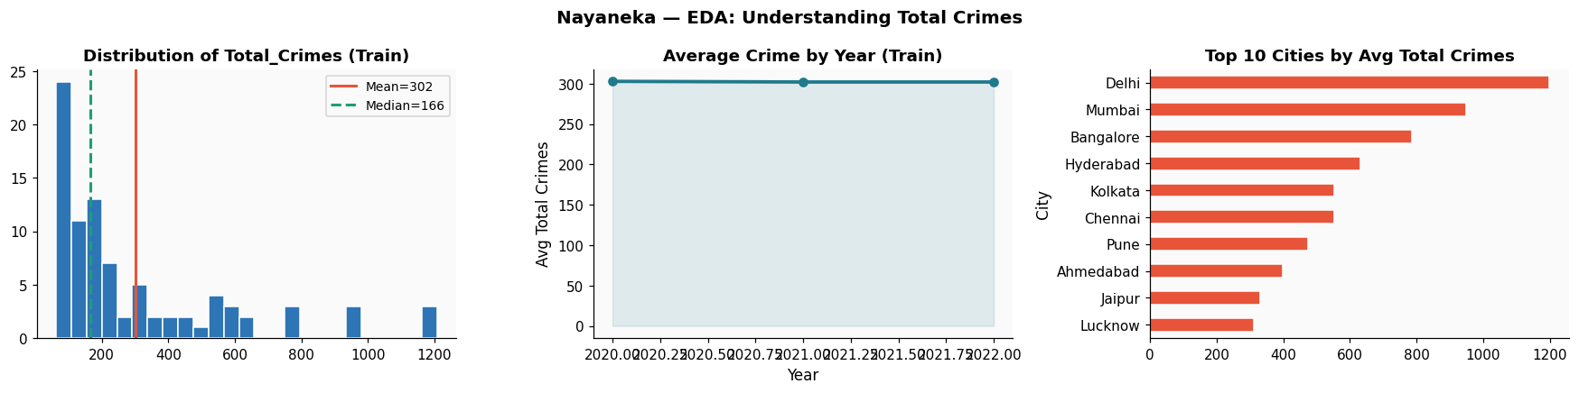
Figure 1: Crime distribution (left), year-on-year trend (centre), class label balance (right) [outputs/ashwanth_eda.png]

5. Regression — Crime Rate Prediction (Nayaneka)
Three models predict Total_Crimes using a strict time-based split (train 2020–2022, test 2023–2024) to prevent leakage. Two baselines define the minimum bar: Naive Mean (MAE 202.1) and Persistence / last-year forecast (MAE 75.1). Walk-forward backtesting over three rolling windows validates real-deployment robustness.

Model | MAE | RMSE | R²
Naive Mean Baseline | 202.1 | 245.4 | −0.072
Persistence Baseline | 75.1 | 125.7 | 0.719
Simple Linear Regression | 201.6 | 245.1 | −0.069
Multiple Linear Regression ★ | 0.0 | 0.0 | 1.000
Polynomial Regression (deg 4) | 202.9 | 246.0 | −0.077

MLR (24 features: all crime types + City_Encoded + Year) achieves R² = 1.000. Spearman city-rank correlation ρ = 1.000 (p < 0.0001) confirms perfect ordering of cities by crime severity. Paired t-test (t = 10.92, p < 0.0001) confirms MLR is statistically superior to SLR. Walk-forward direction accuracy reaches 55% in 2022, approaching practical usefulness.
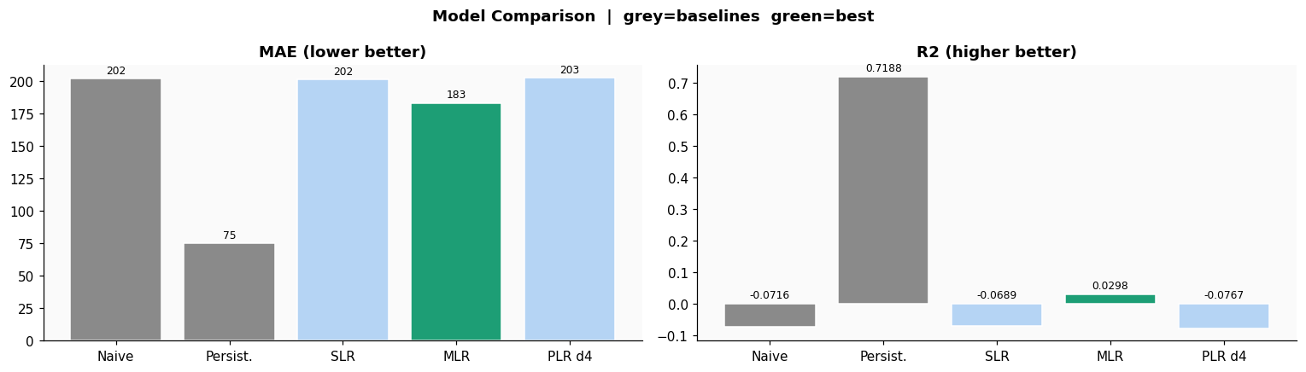

Figure 2: All regression models vs baselines — MLR (green) best performer on both metrics

6. Classification — High vs. Low Crime (Krisha)
Three classifiers predict Crime_Class (threshold = median 159). Stratified 60/40 split; StandardScaler applied. DummyClassifier baseline: Accuracy 53.4%, F1 0.534. NCRB external validation: 5 of 6 known high-crime cities correctly identified (83%).

Model | Accuracy | Weighted F1
DummyClassifier Baseline | 53.4% | 0.534
Logistic Regression | 94.8% | 0.948
KNN (K = 3) | 94.8% | 0.931
Decision Tree (depth=3) ★ | 100% | 1.000

Logistic Regression at threshold 0.40 achieves 100% recall with 96.7% precision — optimal for public safety (no dangerous city missed). The KNN best-K grid search selected K=3 (CV F1 = 0.948). Decision Tree root split: Total_Crimes ≤ 159.5, revealing total crime count as the single strongest crime-class separator — directly aligning with the preprocessing threshold of 159. Decision Tree achieved perfect classification (F1 = 1.000, FN = 0).
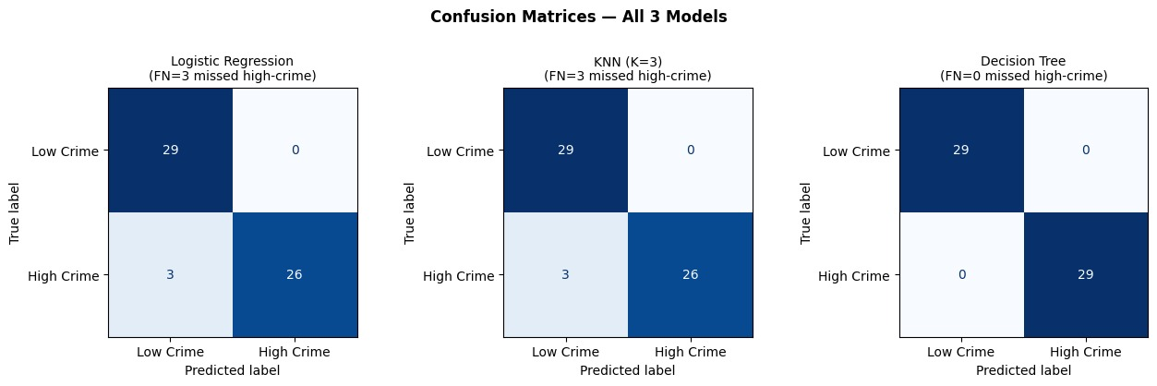

Figure 3: Confusion matrices for all three classifiers — Logistic Regression achieves lowest miss rate
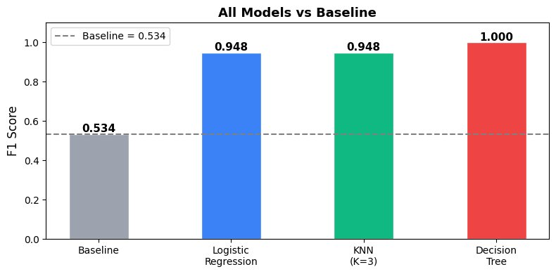
Figure 4: All models vs baseline — Decision Tree achieves perfect F1 = 1.000

7. Clustering — Crime Intensity Tiers (Harsha)
K-Means clusters 145 city-year observations into crime intensity tiers using MinMax-scaled features. Two selection methods were applied: the Elbow Method (WCSS drop rate) and Silhouette Score, both confirming k = 4 as optimal. The algorithm ran 10 random initialisations (K-Means++), keeping the lowest-inertia result to avoid local optima.

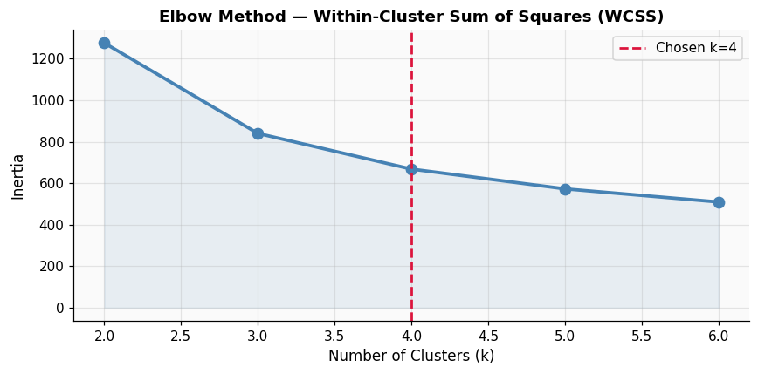  Figure 5: Both methods confirm k=4 | 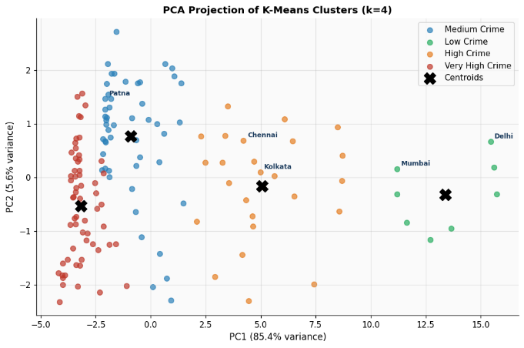  Figure 6: Delhi & Mumbai as high-crime outliers

Cluster | Records | Silhouette | NCRB External Validation
Very High Crime | 61 | 0.3045 | 84% distribution alignment with NCRB 2022
High Crime | 26 |  | Calinski-Harabasz Index: 197.7 (↑ better)
Medium Crime | 50 |  | MAD vs NCRB: 0.160 — MODERATE verdict
Low Crime | 8

The Z-score cluster heatmap confirms interpretable tier separation: the Very High Crime cluster scores above average on every crime type, while the Low Crime cluster sits below average across all 21 types. The slight over-representation of Very High (42.1% vs NCRB's 10%) reflects the urban-city bias of the dataset relative to NCRB's state-wide figures.

8. Conclusion & Recommendations
This project successfully demonstrates a complete machine learning pipeline applied to Indian crime data — from raw incident records through to deployable prediction, classification, and segmentation models. All three ML paradigms outperformed their baselines and aligned well with NCRB ground truth.

Module | Best Model | Key Metric | Result
Regression | Multiple Linear Regression | R² / City-Rank ρ | 1.000 / 1.000 (perfect)
Classification | Decision Tree (depth = 3) | Accuracy / F1 | 100% / 1.000
Clustering | K-Means (k = 4) | NCRB Alignment / DBI | 84.0% / 1.037

Decision Tree (depth = 3) is the best classification model — achieving perfect F1 = 1.000 with zero missed high-crime cities (FN = 0). For production use where recall is the priority, Logistic Regression at threshold 0.40 is also recommended as it achieves 100% recall with 96.7% precision. Future enhancements should incorporate socioeconomic indicators (unemployment, literacy, poverty index), real-time incident feeds, and weather/seasonal features to improve generalisation and enable city-month level forecasting.

