WS & SOA (IT644)
Software Requirements Specification (SRS) / Business Requirements Document (BRD)
PrepNova
RAG-based Adaptive Mock Interview Platform
GitHub Repository: github.com/Krisha4801/PrepNova

Project Team
Student ID | Name | Technical Role
202512001 | Shruti Makwana | Frontend – Interview Interface & Interview Flow
202512015 | Jaimin Trivedi | AI & Backend – AI Service, Prompt Orchestration & Backend Integration
202512023 | Kush Dani | Backend – Interview, Evaluation, Report APIs & Database
202512064 | Krisha Shah | AI – Resume Processing, Embeddings & RAG Pipeline
202512065 | Dev Patel | AI & Frontend – Question Generation & AI Interview Experience
202512067 | Varunee Agrawal | Backend – Authentication, User Management & Resume/JD APIs
202512085 | Hardi Dhadhal | Frontend – Authentication, Dashboard & General UI
202512097 | Garv Modi | AI – Retrieval, Answer Evaluation, Adaptive Scoring & Vector Database

Table of Contents
1 Introduction 3
1.1 Purpose 3
1.2 Document Scope 3
1.3 Intended Audience 3
1.4 Definitions, Acronyms and Abbreviations 3
1.5 References 4
1.6 Overview 4
2 Overall Description 5
2.1 Product Perspective 5
2.2 Product Functions (Summary) 5
2.3 User Classes and Characteristics 6
2.4 Operating Environment 6
2.5 Design and Implementation Constraints 6
2.6 Assumptions and Dependencies 7
3 System Features and Functional Requirements (FR-1 – FR-18) 8
4 Non-Functional Requirements (NFR-1 – NFR-8) 12
5 User Stories and Use Case Diagram 14
5.1 Use Case Diagram 14
5.2 Use Case Summary Table 14
5.3 Detailed User Stories (US-1 – US-12) 15
6 External Interface Requirements 17
6.1 User Interfaces 17
6.2 Software Interfaces 17
6.3 Communication Interfaces 17
6.4 Hardware Interfaces 18
7 Wireframes and UI/UX Mockups (Initial Draft) 19
7.1 Login / Register Page 19
7.2 Resume Upload / Role Selection Page 20
7.3 Difficulty Selection Page 21
7.4 Interview Session Page 22
7.5 Report / Score Page 23
7.6 Dashboard / Interview History Page 24
8 Acceptance Criteria 24
Appendix — Core Database Collections (MongoDB) 26
Appendix — Document Control & Traceability 26

1 Introduction

1.1 Purpose
This Requirements Specification Document (RSD) defines the functional requirements, non-functional requirements, user stories, use case diagrams, interface requirements, initial-draft wireframes, and acceptance criteria for PrepNova — an AI-powered, RAG-based adaptive mock interview platform. It translates the approved PrepNova Project Proposal and PrepNova Project Plan into a single, detailed, verifiable specification that the development team can build against and that can be used for review and sign-off.

1.2 Document Scope
This document defines the scope of PrepNova, an AI-powered web application for personalized interview preparation. The system includes user authentication, resume upload, role-based interview configuration, RAG-powered text-based mock interviews, AI-generated evaluation, interview history, dashboard, and estimated ATS compatibility analysis.
The project follows a 14-week development roadmap covering requirement analysis, design, implementation, testing, and deployment. Future Scope features—including voice-based AI interviews, online coding interviews, company-specific interview preparation, Google Meet integration, calendar scheduling, and a full ATS audit—are excluded from the current version of the system.

1.3 Intended Audience
This document is intended for the stakeholders involved in the planning, development, review, and approval of the PrepNova project. The primary audience includes:
- Course Instructor / Project Guide – To review and approve the business requirements.
- Project Development Team – To implement the system according to the specified requirements.
- UI/UX Designers – To design user interfaces based on the defined requirements and wireframes.
- QA/Testers – To validate the system against the functional requirements and acceptance criteria.
- Project Team Members – To maintain a common understanding of the project's scope, features, and deliverables.

1.4 Definitions, Acronyms and Abbreviations
Term | Definition
RAG | Retrieval-Augmented Generation — combines vector retrieval of relevant context with LLM-based generation
LLM | Large Language Model — the AI model used for question generation and answer evaluation
JD | Job Description — an optional text input describing a target job opening
JWT | JSON Web Token — used for stateless authentication
ATS | Applicant Tracking System — PrepNova implements a lite, keyword-match-only version
FAISS | Facebook AI Similarity Search — the vector store used for the development prototype
CRUD | Create, Read, Update, Delete — basic persistence operations
CI/CD | Continuous Integration / Continuous Deployment
E2E | End-to-End (testing)
MVP | Minimum Viable Product — the Week 1–8 core platform build
FR / NFR | Functional Requirement / Non-Functional Requirement
STAR | Situation, Task, Action, Result — behavioral-answer structure

1.5 References
- PrepNova — Project Proposal (WS & SOA, IT644), PrepNova Team
- PrepNova — Project Plan (14-Week Plan), WS & SOA, IT644, PrepNova Team
- PrepNova Bi-Weekly Status Report, Weeks 1–2 (submitted 30-Aug-2026)
- GitHub Repository — github.com/Krisha4801/PrepNova

1.6 Overview
Section 2 gives an overall description of the product. Section 3 lists functional requirements by module. Section 4 lists non-functional requirements. Section 5 presents the use case diagram and detailed user stories. Section 6 defines external interface requirements. Section 7 presents initial-draft wireframes for all frontend pages. Section 8 defines module-level acceptance criteria. Appendices contain the data model and REST API reference reused from the Project Proposal.

2 Overall Description

2.1 Product Perspective
PrepNova is a new, standalone browser-based web application; it is not a modification of an existing system. It follows a client-server architecture composed of four layers: a React.js frontend, a Node.js/Express.js backend (with JWT authentication and MongoDB), a Python AI/RAG service (FastAPI) that performs parsing, chunking, embedding, retrieval, question generation and answer evaluation, and a vector store used for semantic retrieval over resumes, job descriptions, and curated role knowledge. The AI service returns structured results to the Node backend, which exposes them to the frontend through REST APIs.
PrepNova supports two interview modes, each of which can optionally be combined with a Job Description (JD):
- Mode 1 — Resume-Based Interview: the user uploads a resume, which is parsed, chunked, embedded, and stored in the vector store; questions are grounded in the resume content.
- Mode 2 — Role-Based Interview: if no resume is provided, the user selects a target role and the system retrieves context from the curated role knowledge base instead.
The following table defines which context PrepNova uses to generate questions, based on what the user provides:
Resume | Role | JD | Interview Context Used
Provided | Optional | Not provided | Resume
Not provided | Selected | Not provided | Role Knowledge Base
Provided | Optional | Provided | Resume + JD
Not provided | Selected | Provided | Role + JD
Not provided | Not selected | Not provided | Not enough information — interview cannot start

2.2 Product Functions (Summary)
- Secure user registration and login (JWT-based)
- Resume upload with PDF/DOCX parsing and text extraction
- Optional Job Description (JD) input, combinable with resume or role
- Manual job-role selection when no resume is uploaded
- RAG pipeline: chunking → embedding → vector-store retrieval → context-grounded question generation
- Curated role-based question bank fallback for the no-resume path
- Selectable interview difficulty (Easy / Medium / Hard)
- Dynamic technical and HR/behavioral mock-interview question generation
- Post-interview AI-based evaluation and scoring (out of 10) with strengths/weaknesses/suggestions
- Interview history and score-over-time progress tracking
- Automatic job-role detection from resume with lite ATS keyword-match scoring (Week 9 scope)
- Real-time adaptive difficulty within a session (Week 10 scope)
- CI/CD pipeline, security hardening, automated E2E and performance/load testing, accessibility pass (Weeks 11–13 scope)

2.3 User Classes and Characteristics
PrepNova's target users are: college students, fresh graduates, working professionals, internship applicants, and job seekers. All users interact with the system through a single authenticated user role — there is no separate administrator role defined in the source documents. Users are expected to have basic web-browser literacy and, optionally, a resume file (PDF or DOCX) and/or a job description to paste.

2.4 Operating Environment
Layer | Technology
Frontend | React.js, Tailwind CSS, JavaScript
Backend | Node.js, Express.js, REST APIs
AI / RAG Layer | Python (FastAPI service) — RAG pipeline, embeddings, model integration
Database | MongoDB
Vector Store | ChromaDB evaluated as an on-disk persistence fallback; Pinecone as an optional production upgrade
Authentication | JWT Authentication
AI Model | Open-source LLM — Qwen2.5-7B-Instruct or an equivalent open-weight instruct model
Embedding Model | sentence-transformers/all-MiniLM-L6-v2 (384-dim), locally run; hosted embedding API as fallback
Resume Processing | pdfplumber / python-docx (parsing), recursive chunking, sentence-transformers embeddings
Testing Tools | Jest + Supertest (Node/API), React Testing Library (UI), Pytest (AI/RAG service), Cypress (E2E), Locust/k6 (load testing)
CI/CD | GitHub Actions (automated test runs on PRs, staging deployment on merge)
Version Control | Git & GitHub

2.5 Design and Implementation Constraints
- The technology stack (React, Node/Express, Python/FastAPI, MongoDB, JWT) is fixed as defined in the Project Proposal and Project Plan; the specific open-source LLM and vector store are to be finalized during Week 3 based on Week 2 provisioning tests, from the shortlisted candidates already named (Qwen2.5-7B-Instruct; FAISS/ChromaDB/Pinecone).
- The 14-week schedule constrains delivery: Weeks 1–8 deliver the MVP (fixed-difficulty core platform); Weeks 9–14 deliver extended features (auto role detection, ATS-lite scoring, adaptive difficulty, CI/CD, security hardening, automated E2E/load testing, accessibility, and final deployment).
- Each of the 8 team members is budgeted approximately 200 person-hours across the project; effort is tracked per phase (Section 12 of the Project Plan).
- MVP question generation produces a fixed set of 5 technical + 2 HR questions per session at the user-selected difficulty; real-time adaptive difficulty is introduced only from Week 10 onward.

2.6 Assumptions and Dependencies
- Users have access to a modern web browser and, optionally, a resume file in PDF or DOCX format.
- The chosen open-source LLM and embedding model are available to run locally or via a hosted API within the team's infrastructure budget.
- Question-generation and evaluation modules (Weeks 5–6) depend on a stable embedding pipeline being in place from Week 3–4.
- The final LLM and vector-store choice (Pinecone / FAISS / ChromaDB) is a tracked project risk (R-01) to be locked in by the end of Week 3.

3 System Features and Functional Requirements
Functional requirements are grouped by module. Each requirement is uniquely identified (FR-xx) and traces directly to a feature described in the Project Proposal's "Scope and High-Level Features" section and/or the Project Plan's weekly breakdown.

3.1 FR-1 — User Registration & Login
- The system shall allow a new user to register with name, email, and password.
- The system shall hash passwords using bcrypt before storing them in MongoDB.
- The system shall allow a registered user to log in with email and password and receive a short-expiry JWT access token on success.
- The system shall reject registration with an email that already exists, with a clear error message.

3.2 FR-2 — Session Authentication & Authorization
- The system shall require a valid Bearer JWT on all protected API routes.
- The system shall reject requests with a missing, expired, or invalid JWT with a 401 Unauthorized response, via middleware that runs before any controller logic.
- The system shall enforce per-user data isolation, returning 403 Forbidden if a user attempts to access another user's interview session or report.

3.3 FR-3 — Resume Upload & Parsing
- The system shall allow a user to upload a resume file in PDF or DOCX format.
- The system shall validate the uploaded file on both size and MIME type before sending it to the parsing service, returning a specific (non-generic) error for invalid files.
- The system shall extract resume text (PDF text extraction, with an OCR fallback for scanned/image-only PDFs) and clean it by normalizing whitespace and stripping repeated headers/footers.
- If extracted text falls below a minimum length threshold (e.g., a scanned resume with no extractable text), the system shall prompt the user to select a role instead, falling back to the curated question-bank path.

3.4 FR-4 — Job Description (JD) Input
- The system shall allow the user to optionally provide a Job Description as text, in addition to a resume or a selected role.
- The system shall reject an empty JD submission with a clear message, while accepting a very short JD with a note that personalization will be limited.
- The system shall chunk a very large JD and retrieve only the relevant portions rather than processing it in full.
- The system shall detect a duplicate JD via hash comparison and reuse the already-processed JD rather than reprocessing it.

3.5 FR-5 — Job Role Selection
- The system shall provide a dropdown of predefined job roles for the user to select when a resume is not uploaded.
- The system shall prevent an interview from starting if neither a resume nor a role/subject has been provided.

3.6 FR-6 — Resume/JD Chunking & Embedding (RAG Ingestion)
- The system shall split cleaned resume/JD text into chunks of approximately 300 tokens with 50-token overlap using a recursive character/token splitter.
- The system shall tag each chunk by resume section (Education, Experience, Projects, Skills).
- The system shall convert each chunk into a vector embedding and store it in the vector store, namespaced per user_id/session_id so retrieval never crosses users.

3.7 FR-7 — RAG Context Retrieval
- The system shall build a query embedding from the target role/skill and difficulty level.
- The system shall retrieve the top-k (k = 3–5) most similar chunks via cosine similarity, restricted to the requesting user's namespace, to ground question generation and answer evaluation.

3.8 FR-8 — Curated Role-Based Knowledge Base Fallback
- When no resume is uploaded, the system shall skip the RAG retrieval step entirely and pull questions from a pre-tagged question bank in MongoDB, filtered by role and difficulty.
- The system shall optionally pass fallback questions through the LLM once for light rephrasing so repeat users do not see identical wording.
- Behavioral/HR questions shall always be drawn from the curated question bank rather than RAG, since they are role-generic rather than resume-specific.

3.9 FR-9 — Interview Difficulty Selection
- The system shall allow the user to select one of three difficulty levels — Easy, Medium, or Hard — before starting an interview.
- The system shall enforce difficulty through explicit rubric language in the generation prompt: Easy = definition/recall, Medium = applied scenario, Hard = trade-off/design-judgment.

3.10 FR-10 — Interview Session Management
- The system shall initiate a personalized mock interview session after the user uploads a resume or selects a target job role and chooses a difficulty level (Easy, Medium, or Hard).
- The system shall dynamically generate technical and HR interview questions using the RAG pipeline based on the user's resume, selected role, optional Job Description (JD), and interview context.
- The system shall maintain the interview session state, including the current question, user responses, progress, selected difficulty, and remaining questions.
- The system shall support interview lifecycle states including In Progress, Completed, and Abandoned, while preserving partial responses if the session is interrupted.

3.11 FR-11 — Dynamic Question Generation
- The system shall generate questions across the defined content categories (resume-based, JD-based, role-based, technical concept, project-based, skill-based, scenario-based, problem-solving, system design, debugging, behavioral/HR, situational, skill-gap, resume+JD combined, follow-up/cross-question, experience-based, real-world application, communication/explanation, leadership & teamwork) and structural formats (MCQ, short answer, scenario/subjective, coding/debugging, behavioral/STAR, resume/JD deep-dive), each tagged with a difficulty level.
- The system shall insert retrieved chunks into a fixed prompt template with explicit instructions (target role/skill, question type, difficulty) and parse the LLM response to keep only the question text before storage.
- The system shall detect a duplicate generated question via a similarity check and regenerate a different question when a duplicate is found.

3.12 FR-12 — Answer Submission
- The system shall accept the candidate's free-text answer for the current question.
- The system shall reject an empty answer submission or record it as a no-response, per input validation rules.
- The system shall store each answer together with the full grounding context used to generate its question.

3.13 FR-13 — AI-Based Answer Evaluation & Scoring
- The system shall evaluate each answer using a format-specific scoring method: exact-match auto-grading for MCQ; embedding cosine similarity plus keyword check for short answer; LLM-as-judge against a 5-part rubric (Relevance, Correctness, Completeness, Clarity, Depth) for scenario/subjective questions; test-case execution (where feasible) or LLM code-review for coding/debugging; STAR-structure completeness and clarity checks for behavioral questions; and re-grounded LLM-as-judge for resume/JD deep-dive questions.
- The system shall instruct the LLM to return a fixed JSON structure ({ score, relevance, correctness, completeness, clarity, strengths[], weaknesses[], suggestions[] }) so the backend can parse it reliably.
- If evaluation-response parsing fails, the system shall store a default fallback response instead of allowing the session to crash.

3.14 FR-14 — Performance Report Generation
- The system shall aggregate per-question scores into a Technical Score, Problem-Solving Score, Communication Score, and Resume/JD Alignment Score.
- The system shall surface recurring weakness themes (appearing across 2+ questions) ahead of one-off comments on the report page.
- The system shall, from Week 9 onward, display an ATS-Lite Score alongside the interview report.
- If report generation fails, the system shall preserve the stored answers and allow the report to be retried rather than lost.

3.15 FR-15 — Interview History & Progress Tracking
- The system shall persist every completed session with its full question set, answers, per-question scores, and overall score.
- The system shall allow the dashboard to query a user's past sessions by userId and render a score-over-time view (session date on the x-axis, score out of 10 on the y-axis).

3.16 FR-16 — Automatic Role Detection & ATS-Lite Scoring (Week 9 Scope)
- When the user has not manually selected a role, the system shall extract keywords/skills from the parsed resume text to auto-suggest a likely target role, reusing the same parsing pipeline built for RAG.
- The system shall compute an ATS-lite score by comparing the resume's extracted keywords against the expected skill list for the selected/detected role, returning a weighted match score shown alongside the interview report. This is a directional keyword-match signal only, not a full formatting/structure ATS audit.

3.17 FR-17 — Real-Time Adaptive Difficulty (Week 10 Scope)
- From Week 10 onward, the system shall adjust the next question's difficulty based on the score of the previous answer: a score of 8 or above increases difficulty, a score of 4 or below decreases it.
- The system shall update the interview-session API to support dynamic difficulty progression per question and reflect the difficulty change in the UI with a visible per-question difficulty indicator.

3.18 FR-18 — Error Handling & Edge Cases
- Unsupported resume file type: reject with a clear error.
- Corrupted PDF: show an error and request re-upload.
- Empty resume (no meaningful extracted text): reject / request another file.
- Scanned resume (insufficient extractable text): fall back to OCR.
- Empty JD: reject with a message. Very short JD: accept with limited personalization. Very large JD: chunk and retrieve relevant portions. Duplicate JD: reuse already-processed JD.
- No resume and no role selected: do not allow the interview to start.
- Missing JD skill during skill matching: ask a foundational/knowledge-check question instead.
- Embedding failure: retry with backoff. Vector-store unavailable: retry, then fail gracefully. LLM unavailable/timeout: retry, then show a clear error.
- Duplicate question generated: regenerate a different question.
- Empty answer submitted: reject or record as no-response.
- Invalid or expired JWT: 401 Unauthorized, redirect to login. Unauthorized interview access: 403 Forbidden.
- Interview abandoned mid-session: mark as abandoned, preserve partial answers.
- Report generation failure: preserve stored answers, retry generation.

4 Non-Functional Requirements
Non-functional requirements below are derived directly from the security, performance/load-testing, reliability, CI/CD, accessibility, and testing-strategy content already defined in the Project Proposal and Project Plan.

4.1 NFR-1 — Performance
- REST APIs, RAG retrieval, and behavior under concurrent load shall be evaluated using Locust/k6 (Week 12) against the interview-session, evaluation, and retrieval endpoints, with latency/throughput bottlenecks documented.
- Authentication endpoints shall be load-tested to verify that rate limiting continues to hold under load (Week 12).

4.2 NFR-2 — Security
- Passwords shall be hashed with bcrypt before storage; JWT access tokens (short expiry) shall be required as a Bearer token on all protected routes, verified by middleware before any controller logic runs.
- Rate limiting (express-rate-limit) shall be applied to authentication and resume-upload endpoints; input sanitization shall be audited across all POST endpoints.
- Vector-store embeddings shall be namespaced per user_id/session_id so that retrieval can never cross users.
- The RAG prompt-construction path shall be reviewed for prompt-injection risk, and resume text shall be sanitized before being inserted into prompts.

4.3 NFR-3 — Reliability & Availability
- Embedding failures shall be retried with backoff; vector-store connection errors shall be retried and then fail gracefully; LLM timeouts shall be retried and then surface a clear error to the user.
- Evaluation and report-generation failures shall preserve stored answers and allow the operation to be retried rather than losing session data.
- Sessions abandoned mid-interview shall be marked as abandoned with partial answers preserved.

4.4 NFR-4 — Scalability
- Vector-store embeddings shall be namespaced per user/session to isolate and scale retrieval independently per user.
- The AI/RAG layer shall be isolated as its own FastAPI service, separate from the Node backend, allowing the two to scale independently.
- The curated question bank shall be structured to support expansion (Week 10) without requiring a redesign.

4.5 NFR-5 — Usability
- A manual accessibility pass (alt text, colour contrast, keyboard navigation) shall be performed across all pages (Week 13).
- The system shall surface specific, actionable error messages (e.g., a distinct message for a corrupt/unparseable file) instead of generic failure responses.
- AI-driven UI states — loading, streaming, and error handling for timeout/invalid response/network failure — shall be implemented for all AI-powered interactions.

4.6 NFR-6 — Maintainability
- Backend code shall be documented with JSDoc and the AI/RAG service with docstrings; a maintained API reference (Postman collection / OpenAPI spec) shall be kept up to date.
- Project documentation shall be consolidated into the repository's /docs folder.
- A GitHub Actions CI pipeline shall run the Jest/Supertest and Pytest suites automatically on every pull request.

4.7 NFR-7 — Portability & Compatibility
- PrepNova shall be a browser-based web application requiring no client installation.
- Cross-browser and responsive layout behavior shall be verified across all pages (Week 11).

4.8 NFR-8 — Testability
- The system shall be validated across the 15 testing types defined in the Project Plan's Testing Strategy: unit, integration, system/E2E, functional, API, database, AI/RAG, AI-evaluation, security, performance, UI, usability, regression, error/negative, and acceptance testing.
- Cypress E2E automation shall cover both the resume-based and role-based flows end-to-end, including the dashboard/history navigation (Week 12).

5 User Stories and Use Case Diagram

5.1 Use Case Diagram
The diagram below shows the single external actor — the User (Candidate) — and the primary use cases supported by PrepNova, as defined in the Project Proposal's Use Cases list.
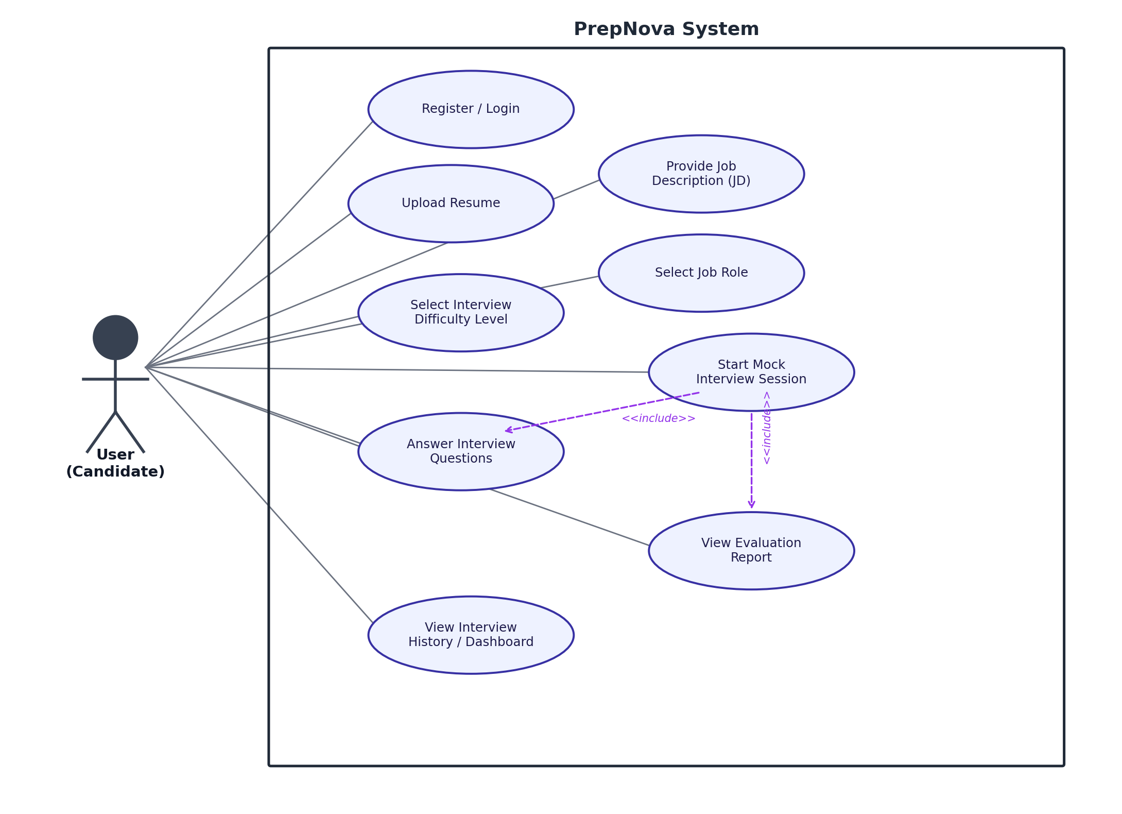
Figure 5.1 — PrepNova Use Case Diagram

5.2 Use Case Summary Table
ID | Use Case | Description
UC-1 | Register / Login | User creates an account or authenticates to access the platform
UC-2 | Upload Resume | User uploads a resume for parsing and RAG-based question generation
UC-3 | Provide Job Description (JD) | User optionally pastes a JD to narrow resume- or role-based questions
UC-4 | Select Job Role | User selects a target role when no resume is uploaded
UC-5 | Select Interview Difficulty Level | User chooses Easy, Medium, or Hard before starting
UC-6 | Start Mock Interview Session | User begins an AI-generated technical and HR mock interview
UC-7 | Answer Interview Questions | User submits free-text answers to each generated question
UC-8 | View Evaluation Report | User views the post-interview score, strengths, and weaknesses
UC-9 | View Interview History / Dashboard | User reviews past sessions and score trend over time

5.3 Detailed User Stories
US-1: As a job seeker, I want to register and log in securely, so that my interview data and history stay private to me.
  - Given valid registration details, when I submit the form, then my account is created with a securely hashed password.
  - Given valid login credentials, when I submit them, then I receive a JWT and land on the dashboard.
  - Given an already-registered email, when I try to register again, then I see a clear duplicate-account error.
US-2: As a candidate, I want to upload my resume, so that PrepNova can generate questions grounded in my actual experience.
  - Given a valid PDF/DOCX resume, when I upload it, then it is parsed, chunked, and embedded successfully.
  - Given a corrupt or unsupported file, when I upload it, then I see a specific error rather than a generic failure.
  - Given a scanned resume with no extractable text, when parsing runs, then OCR fallback is attempted or I am prompted to select a role instead.
US-3: As a candidate preparing for a specific opening, I want to paste a job description, so that questions target what that job actually expects.
  - Given a resume and a JD, when I start an interview, then questions reflect Resume + JD context, including skill-gap questions.
  - Given an empty JD field is submitted, then I see a rejection message rather than a silent failure.
  - Given a duplicate JD I've submitted before, when I submit it again, then the system reuses the already-processed version.
US-4: As a candidate without a specific resume ready, I want to select a target role, so that I can still get a relevant mock interview.
  - Given no resume uploaded, when I select a role from the dropdown, then questions are drawn from the curated role knowledge base.
  - Given neither a resume nor a role is provided, when I try to start an interview, then the system blocks the start with a clear message.
US-5: As a candidate, I want to choose a difficulty level, so that the interview matches my current preparation level.
  - Given I select Easy, Medium, or Hard, when the interview starts, then generated questions follow the corresponding rubric (recall / applied / trade-off).
US-6: As a candidate, I want to take a mock interview with technical and HR questions, so that I can practice a realistic session end-to-end.
  - Given a session has started, when each question loads, then I see the question, my progress (e.g., Question 3 of 7), and the current difficulty.
  - Given I answer a question, when I submit it, then the next question is generated without duplicating a prior question in the same session.
US-7: As a candidate, I want to submit my answers to each question, so that they can be evaluated afterward.
  - Given a non-empty answer, when I submit it, then it is stored with the full grounding context of its question.
  - Given an empty submission, when I try to submit, then it is rejected or recorded as a no-response per validation rules.
US-8: As a candidate, I want each answer evaluated with clear scoring, so that I understand exactly how I performed.
  - Given a submitted answer, when it is evaluated, then I receive a structured result with a score, strengths, and weaknesses.
  - Given the AI evaluation response fails to parse, when this happens, then a default fallback result is stored instead of the session failing.
US-9: As a candidate, I want a post-interview report, so that I can see my overall score and where to improve.
  - Given a completed session, when I open the report, then I see an overall score, category-wise scores, strengths, and weaknesses, with recurring weakness themes surfaced first.
  - Given report generation fails, when I retry, then my stored answers are preserved and the report can be regenerated.
US-10: As a returning candidate, I want to view my interview history, so that I can track whether I'm improving over time.
  - Given I have completed sessions, when I open the dashboard, then I see a score-over-time chart and a list of past sessions.
US-11: As a candidate who hasn't picked a role, I want PrepNova to suggest one from my resume, so that I don't have to guess which role fits me.
  - Given a resume is uploaded and no role is manually selected, when parsing completes, then a likely target role is auto-suggested.
  - Given a detected/selected role, when my report is generated, then an ATS-Lite keyword-match score is shown alongside it.
US-12: As a candidate, I want the interview to get harder or easier based on how I'm doing, so that the session stays appropriately challenging.
  - Given my previous answer scored 8 or above, when the next question is generated, then its difficulty increases.
  - Given my previous answer scored 4 or below, when the next question is generated, then its difficulty decreases, and the UI shows the difficulty change.

6 External Interface Requirements

6.1 User Interfaces
PrepNova's frontend consists of six pages, listed below with their key interface elements. Initial-draft wireframes for each page appear in Section 7.
Page | Key Interface Elements
Login / Register page | Email/password entry, tab or link toggle between login and registration, inline validation and error messaging.
Resume Upload / Role Selection page | Resume drag-and-drop/browse upload (PDF/DOCX), an alternate job-role dropdown, and an optional JD paste field.
Difficulty Selection page | Three selectable cards — Easy, Medium, Hard — each with a short description of the question style at that level.
Interview Session page | Question display, free-text answer input, submit control, and a progress indicator (current question number, difficulty).
Report / Score page | Per-session overall score, category-wise scores, strengths, weaknesses, and (from Week 9) ATS-Lite score.
Dashboard / Interview History page | List of past sessions and a score-trend-over-time view, plus entry point to start a new interview.

6.2 Software Interfaces
The Node.js/Express backend exposes REST APIs (JSON over HTTP) to the React frontend. Internally, the backend calls the Python AI/RAG service (FastAPI) over its own REST interface; the RAG service endpoints are not exposed directly to the frontend.
Module | Representative Endpoints
Auth | POST /api/auth/register, POST /api/auth/login, GET /api/auth/me
Resume & Role | POST /api/resume/upload, POST /api/role/select
Interview Session | POST /api/interview/start, GET /api/interview/:id/next-question, POST /api/interview/:id/answer
Evaluation & Reports | GET /api/interview/:id/report, GET /api/history
RAG Service (internal) | POST /rag/parse, POST /rag/embed, POST /rag/retrieve, POST /rag/generate-question — called by the Node backend only, not exposed directly to the frontend

6.3 Communication Interfaces
- Frontend ↔ Backend: RESTful HTTP(S) API calls with JSON request/response bodies.
- Authentication: JWT passed as a Bearer token in the Authorization header on all protected routes.
- Backend ↔ AI/RAG Service: internal HTTP calls from Node.js/Express to the Python FastAPI service.
- Backend ↔ Database: MongoDB driver connection for all persistent application data.

6.4 Hardware Interfaces
Not applicable. PrepNova is a browser-based web application; the only client-side requirement is a device capable of running a modern web browser. No specialized hardware interface is defined in the Project Proposal or Project Plan.

7 Wireframes — UI/UX Mockups (Initial Draft)
The following low-fidelity wireframes represent the initial draft layout for each of PrepNova's six frontend pages, as scoped in the Project Proposal's Frontend Pages list. These are structural drafts (page layout, key elements, and their placement) intended to guide implementation and will be refined into high-fidelity mockups by Frontend 1 and Frontend 2 during Week 1 UI/UX design work.

7.1 Login / Register Page
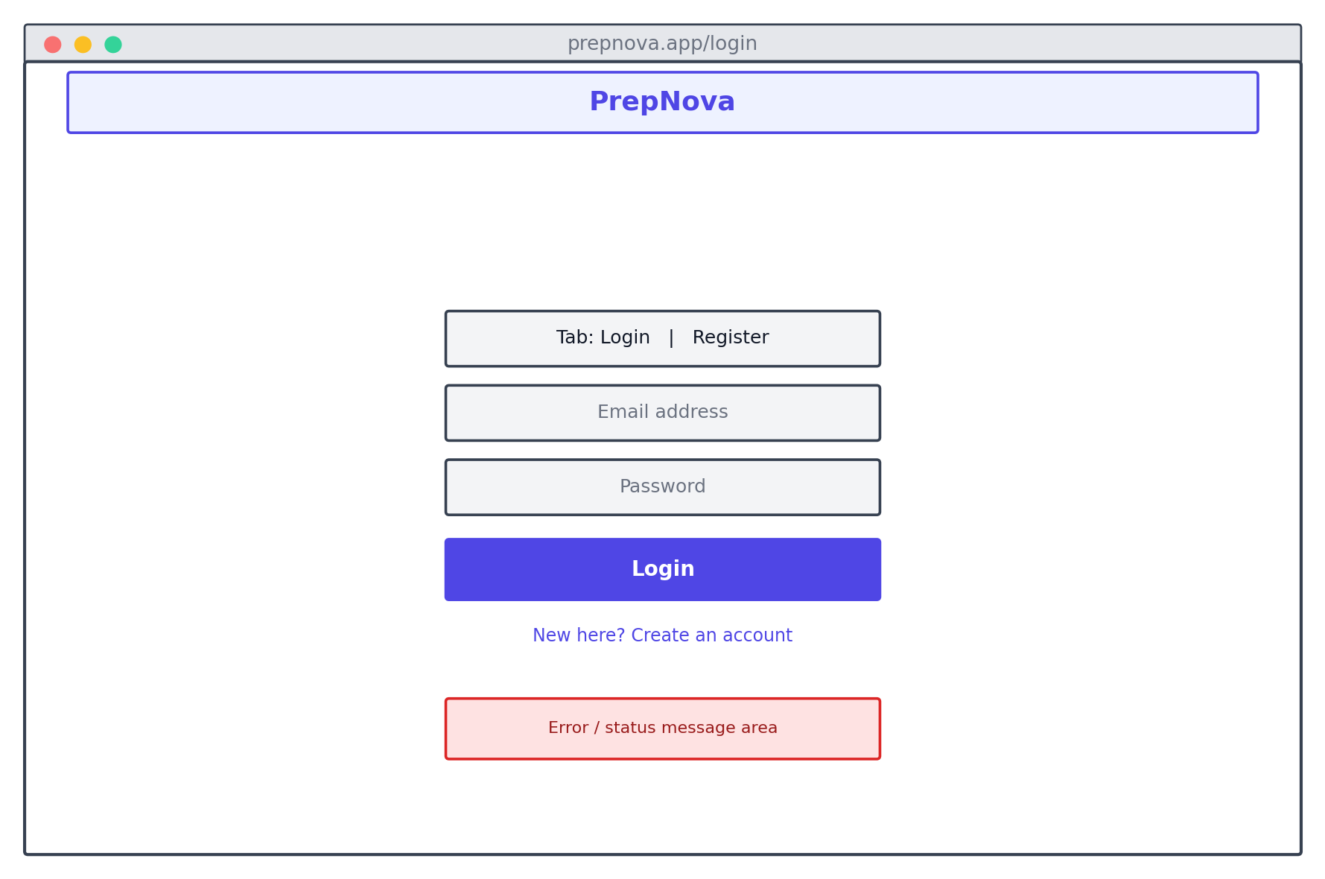
Figure — Initial-draft wireframe (low-fidelity)

7.2 Resume Upload / Role Selection Page
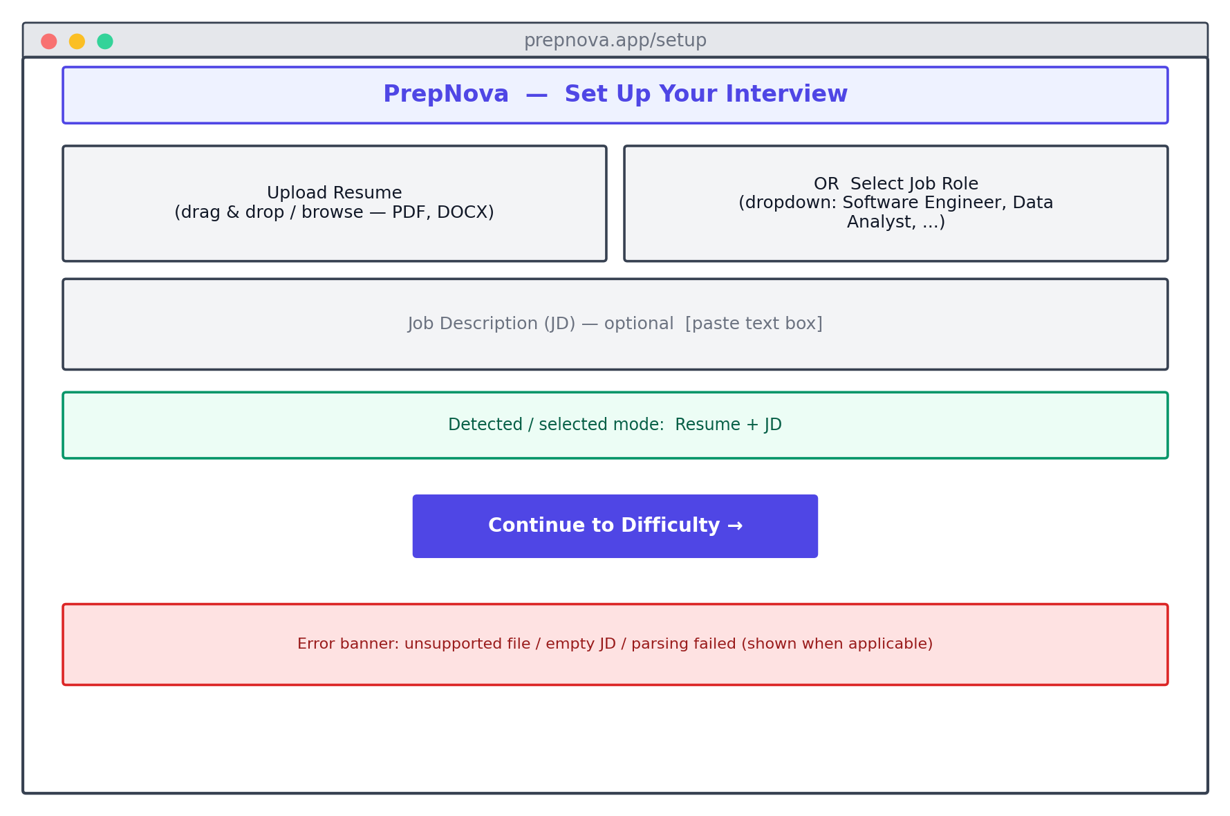
Figure — Initial-draft wireframe (low-fidelity)

7.3 Difficulty Selection Page
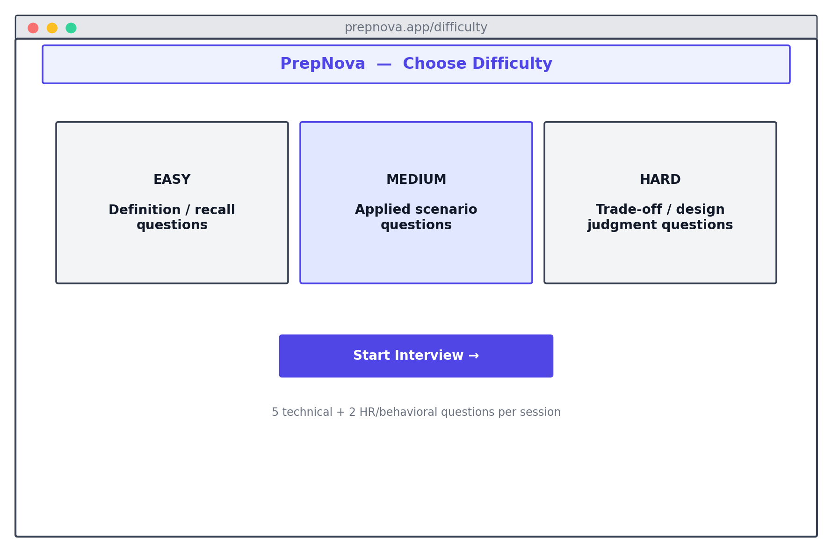
Figure — Initial-draft wireframe (low-fidelity)

7.4 Interview Session Page
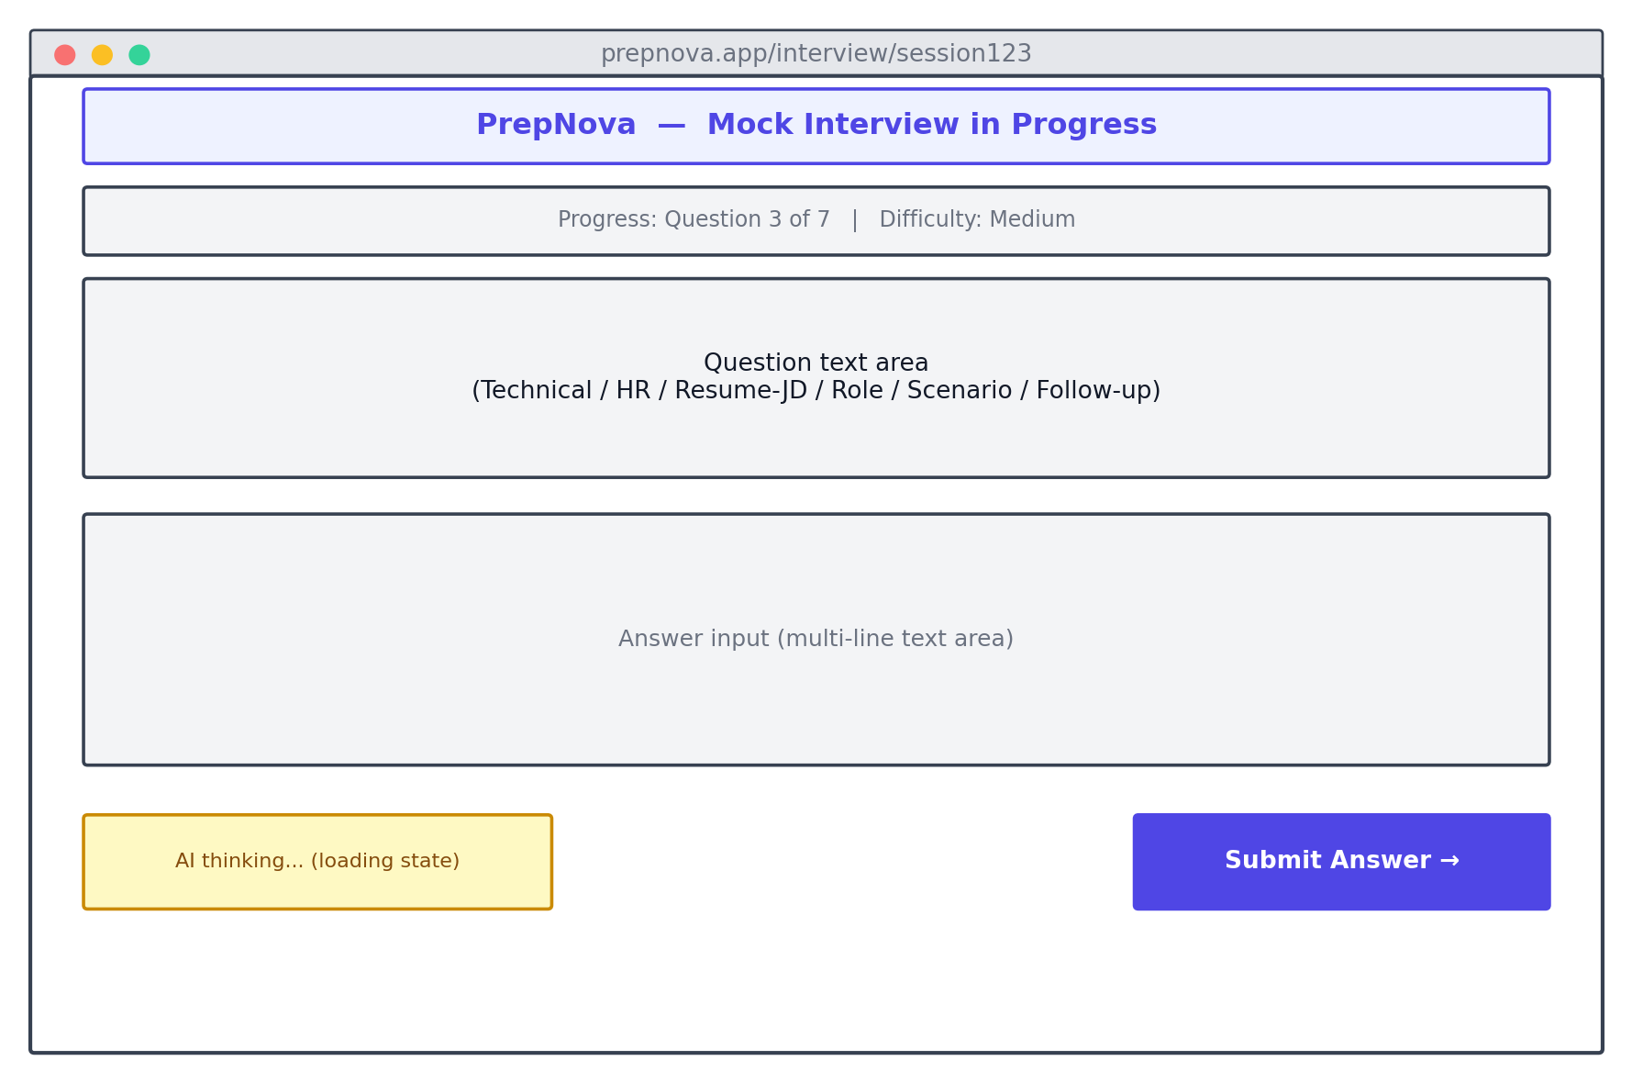
Figure — Initial-draft wireframe (low-fidelity)

7.5 Report / Score Page
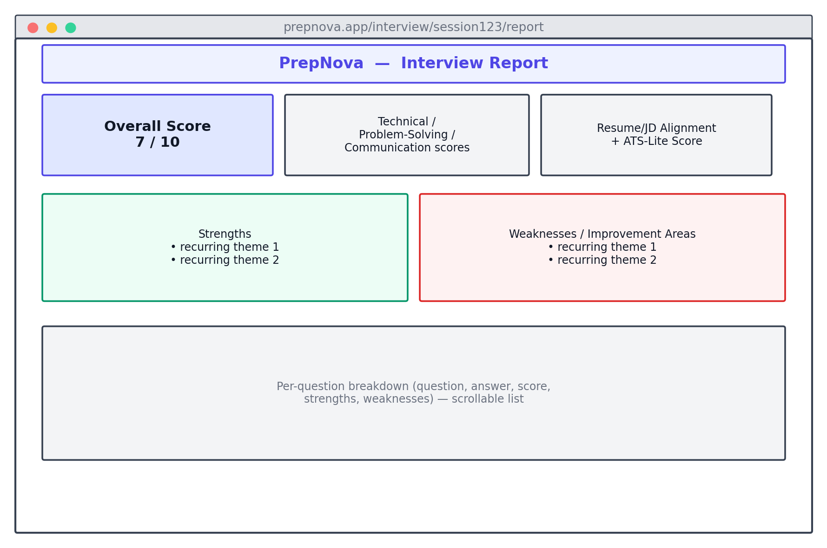
Figure — Initial-draft wireframe (low-fidelity)

7.6 Dashboard / Interview History Page
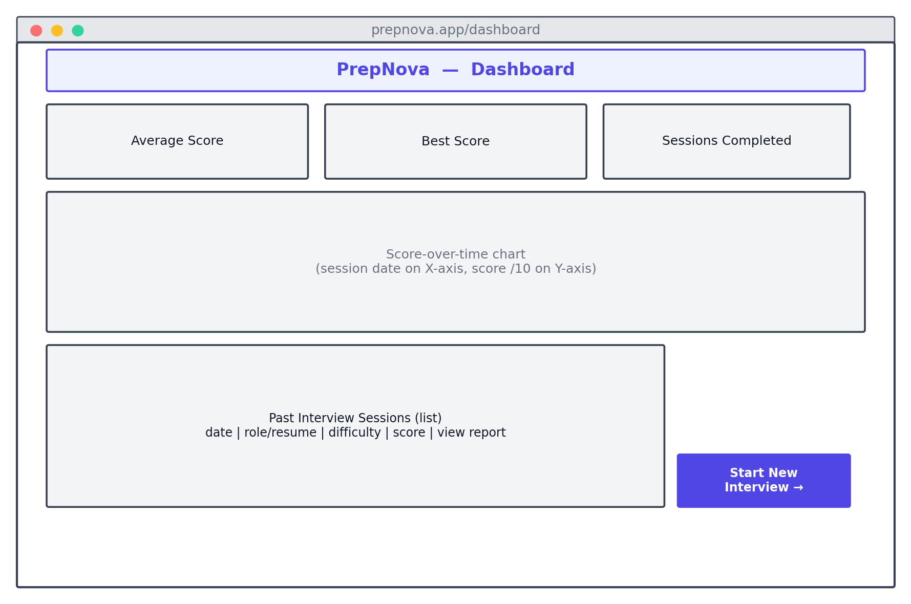
Figure — Initial-draft wireframe (low-fidelity)

8 Acceptance Criteria
The criteria below define module-level sign-off conditions used to confirm that a feature is complete and demo-ready; they complement (and do not repeat) the story-level Given/When/Then criteria in Section 5.3.
Module / Feature | Acceptance Criteria
Authentication & Session Security | - Registration rejects duplicate emails and stores only bcrypt-hashed passwords.  - Login returns a valid JWT; protected routes reject missing/expired/invalid tokens with 401.  - A user cannot access another user's interview session or report (403 on mismatch).
Resume / JD Ingestion & RAG Pipeline | - Valid PDF/DOCX resumes are parsed, chunked (~300 tokens, 50-token overlap), and embedded successfully.  - Invalid files (wrong type, corrupt, oversized) are rejected with a specific error, not a generic 500.  - Retrieval returns only chunks from the requesting user's namespace (verified via isolation testing).
Role-Based Fallback & JD Handling | - When no resume is uploaded, questions are pulled from the curated question bank filtered by role and difficulty.  - Empty JD is rejected; very large JD is chunked before retrieval; duplicate JD (by hash) is reused, not reprocessed.
Difficulty Selection & Interview Session | - The selected difficulty (Easy/Medium/Hard) visibly governs the rubric used for question generation.  - A session generates 5 technical + 2 HR questions at MVP baseline, with no duplicate questions within a session.  - An abandoned session is marked abandoned and its partial answers are preserved.
Answer Evaluation & Scoring | - Each answer format (MCQ, short answer, scenario, coding, behavioral, resume/JD deep-dive) is scored via its defined method.  - Evaluation output always includes score, strengths, weaknesses, and suggestions in the fixed JSON structure.  - A malformed LLM evaluation response triggers the fallback response rather than a session crash.
Report & History | - The report shows an overall score plus Technical, Problem-Solving, Communication, and Resume/JD Alignment scores.  - Recurring weakness themes (2+ occurrences) are surfaced ahead of one-off comments.  - The dashboard shows a score-over-time chart populated from the user's completed sessions only.
Auto Role Detection & ATS-Lite Scoring (Week 9) | - A likely role is auto-suggested when the user has not manually selected one.  - The ATS-Lite score is a weighted keyword-match value shown alongside the report, not a full formatting audit.
Adaptive Difficulty (Week 10) | - A score ≥8 increases the next question's difficulty; a score ≤4 decreases it; the UI reflects the change.  - Boundary-case scores (exactly the threshold values) are covered by unit tests.
Security, CI/CD & Testing | - Rate limiting is active on auth and resume-upload endpoints and holds under load testing (Week 12).  - GitHub Actions runs Jest/Supertest and Pytest suites on every pull request before merge.  - Cypress E2E passes for both the resume-based and role-based end-to-end flows.  - A manual accessibility pass (alt text, contrast, keyboard navigation) is completed across all pages.

Appendix - Core Database Collections (MongoDB)
Reproduced from the Project Proposal for reference; no fields have been added or altered.
Collection | Key Fields
users | _id, name, email, passwordHash, createdAt
resumes | _id, userId, rawText, chunks[] (text, sectionLabel, embeddingId), uploadedAt
interviewSessions | _id, userId, role, difficulty, questions[] (questionId, text, type, difficulty, source), startedAt, completedAt
answers | _id, sessionId, questionId, answerText, score, strengths[], weaknesses[], submittedAt
questionBank | _id, role, difficulty, type, questionText — curated fallback questions used when no resume is uploaded

Appendix - Document Control & Traceability
Every functional requirement, user story, and acceptance-criterion in this document traces back to the PrepNova Project Proposal and/or the PrepNova Project Plan; no functionality outside those two source documents has been introduced. Items listed under "Future Scope" in the Project Proposal remain explicitly out of scope.
Version | Date | Description | Status
1.0 | 20-Aug-2026 | Initial Requirements Specification, derived from the approved Project Proposal and Project Plan | Final

