NAME:S.H.KRISHAANT

SECTION:H1

REG NO.:125003153

2)

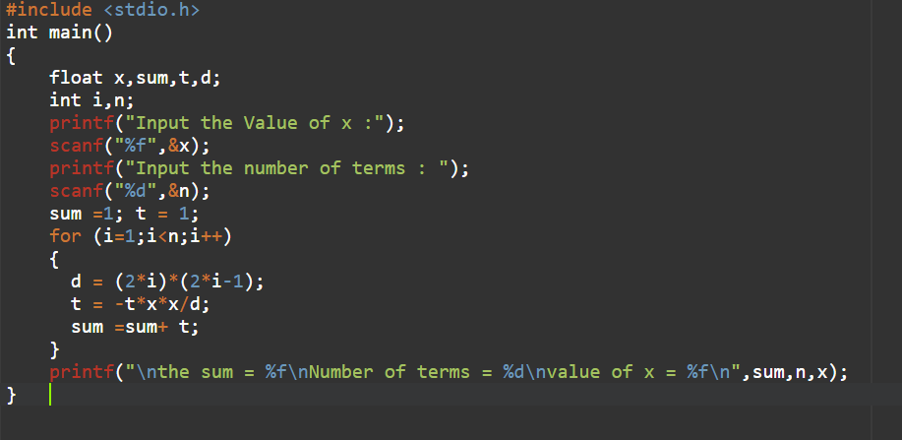

OUTPUT:

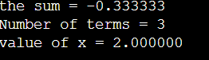

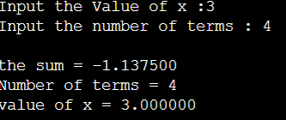

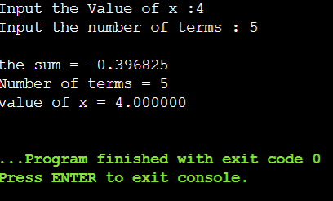

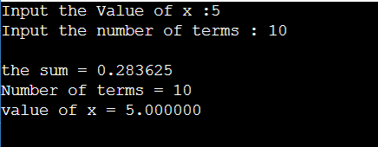

1) #include<stdio.h>

int main()

{

int num,i,fact,r,sum=0,temp;

printf("Please enter a number to find strong number");

scanf("%d",&num);

temp=num;

while(num)

{

i=1,fact=1;

r=num%10;

while(i<=r)

{

fact=fact\*i;

i++;

}

sum=sum+fact;

num=num/10;

}

if(sum==temp)

printf("\nThe number %d is a strong number",temp);

else

printf("\nThe number %d is not a strong number",temp);

return 0;

}

Output:

