**Q1. Section-1 (**Answers to question**)**

1. As given, ‘T’ denotes the lifetime of the satellite, then

P(T > 15) = 1 – P(T ≤ 15) = 1 - F(15) -------- (i)

where F(t) denotes the cdf of T. As given, f(t) denotes the probability density function:

Now, F(t) = $\int_{0}^{t}{f\left(t\right)dt}$ = [-2 $e^{-0.1t}+ e^{-0.2t}$] – [ -2 + 1] = 1 - 2 $e^{-0.1t}$ + $e^{-0.2t}$

So, F(15) = 1 - 2 $e^{-1.5}$ + $e^{-3}$ = 0.604

Therefore, P(T > 15) = 1 – 0.604 = 0.396 (From (i) )

1. Given that both XA and XBare independent and have exponential distributions, so they can be simulated from standard exponential function in ‘R’, i.e. rexp(1, λ = 0.1).

(Here, given mean = 10 years, so λ = 1/mean = 0.1)

XA <- rexp(1, 0.1) ------> simulates one draw of XA

[1] 3.864123

XB <- rexp(1, 0.1) ------> simulates one draw of XB

[1] 13.09933

Now, the satellite will work until any of the components XA or XB fails. Therefore lifetime of the satellite can be simulated using max(XA, XB).

T <- max(XA,XB)

[1] 13.09933

1. We can use the replicate function as below to repeat step (i) 10,000 times:

T.10k <- replicate(10000, max( rexp(1, 0.1), rexp(1, 0.1) ))

1. Histogram can be drawn using ‘hist’ function in R, i.e. hist(T.10k, probability = TRUE)

Also, the density curve can be superimposed using ‘curve’ function. We have to use the density function as a function of ‘x’ while mentioning it as an argument to ‘curve’.

f <- function(t) (0.2*exp(-0.1*t) - 0.2*exp(-0.2*t))

curve(f(x), add = TRUE, xlab = "t", ylab = "density")

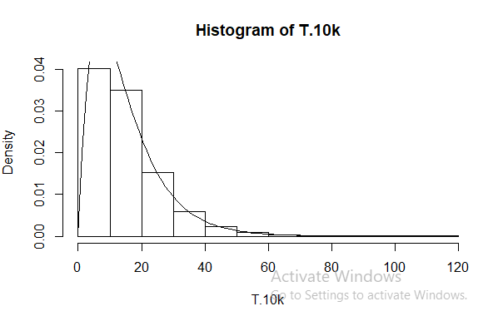

1. The expected value of T, E(T) can be estimated by calculating the mean of 10,000 draws we saved.

E(T.10k) = mean(T.10k) = 14.91116

The exact answer given was E(T) = 15 years.

1. Now we can estimate the probability P(T > 15) by using Monte-Carlo estimation for T.10k

In R, we can use the function ‘mean(abs(T.10k) > 15)’ for the above said Monte-Carlo estimation.

We get below answer:

> mean(abs(T.10k) > 15)

[1] 0.3932

Part (a) answer was 0.396 which is quite close to this result.

1. Now, repeating the steps ii), iv) and v) four times:

Four values of E(T) are:

> replicate(4, mean(replicate(10000, max( rexp(1, 0.1), rexp(1, 0.1) ))))

[1] 15.18020 14.85462 15.02440 14.87166

Four probabilities, P(T > 15) are:

> replicate(4, abs(mean(replicate(10000, max( rexp(1, 0.1), rexp(1, 0.1)) > 15))))

[1] 0.4085 0.4015 0.3886 0.3977

We see that,

1. USING 1000 REPLICATIONS

E(T) =

>replicate(5,mean(replicate(1000, max( rexp(1, 0.1), rexp(1, 0.1)) )))

[1] 14.92907 15.83393 15.38075 14.91199 15.20010

P(T > 15) =

>replicate(5,abs(mean(replicate(1000, max( rexp(1, 0.1), rexp(1, 0.1))) > 15 )))

[1] 0.407 0.405 0.386 0.391 0.420

USING 10000 REPLICATIONS

E(T) =

>replicate(5,mean(replicate(10000, max( rexp(1, 0.1), rexp(1, 0.1)) )))

[1] 14.97077 14.95754 14.80169 15.23752 15.07932

P(T > 15)=

> replicate(5,abs(mean(replicate(10000, max( rexp(1, 0.1), rexp(1, 0.1))) > 15 )))

[1] 0.4026 0.3969 0.4042 0.3925 0.4059

**Q2.** Let us assume a square with coordinates(0,0), (0,1), (1,0), (1,1). Now if we inscribe a circle inside it, it will have the center at (0.5,0.5) and radius = 0.5. Now lets us see the relationship between areas of the squares and the circle.

Area(circle)/Area(square) = π/4

So, π = 4*[ Area(circle)/Area(square)]

Now the expression [ Area(circle)/Area(square)] is equivalent to the probability that a point selected at random inside the square falls inside the circle. Let this probability be P.

Therefore, π = 4*P ----- eq (i)

Suppose x and y be the random coordinates selected from the interval [0,1] to estimate the probability described above. Then for P to be true, (x-0.5)^2 + (y-0.5)^2 <= (0.5)^2 ;(Using (x-0.5)^2 + (y-0.5)^2 <= radius^2).

So, we can take the 10,000 samples of x,y and calculate the corresponding probability. Then using eq (i) ,value of pi can be estimated.

R code can be written as below for estimating a value of π:

>4*mean(abs(replicate(10000,(((runif(1,0,1)-0.5)^2 + (runif(1,0,1)-0.5)^2)))) <= 0.25)