***Case Study of Kick Starter***

1. What are three conclusions we can make about Kickstarter campaigns given the provided data?

Theater is the most successful category of Kickstarter campaigns is theater followed by music, technology, film & video; only theater, music, film & video have chance to success in overall categories.

Journalism is less popular and profitable than other categories, chance of failure of Journalism is greater. Needs to think how to make it profitable or don’t promote this category.

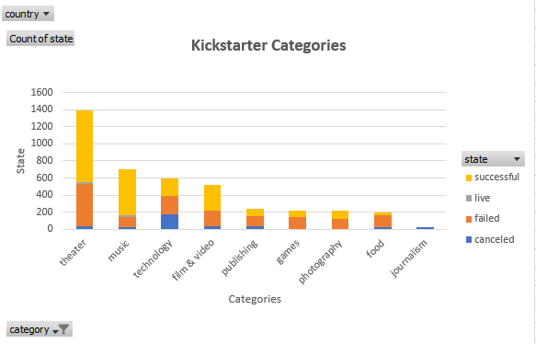

Classical music, documentary, electronic music, hardware, metal, nonfiction, pop, radio & podcasts, rock, shorts, tabletop games and television have 100% chance of successful crowdfunding in Kickstarter campaigns

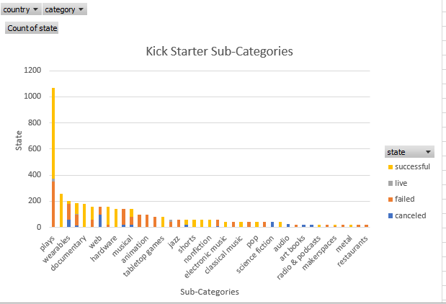.

The chances of failing projects rapidly decrease from January to February and remain low from February to April, the chances of success increase smoothly from January to February and decrease smoothly from February to March; the chances of failing projects and the chances of success have a same trend from April to November.

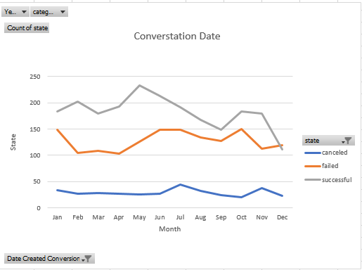

1. What are some of the limitations of this dataset?

There are a lot of crowdfunding firms on the market; this dataset only indicates the situation that Kickstarter faces, the study of the trend of the crowdfunding market should be extended.

There are not enough independent variables in the dataset to support sophisticated data analysis ~~like trendline.~~

1. What are some other possible tables/graphs that we could create?

A table can be created with subcategories based on relationship with categories and show that which program has highest chance of success.

We can create a time series plot of a specific category.