1. Aim: Design Turing Machine using simulator over the set {a,b} to accept the input string anbn.

Diagram:

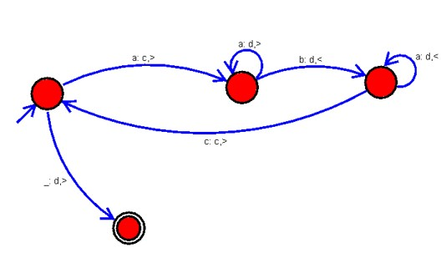

Result: successfully executed Turing Machine using simulator over the set {a,b} to accept the input string anbn.