Create a simple application in android to fetch data from one application's database into another's using content provider

Main XML Code:-

<?xml version="1.0" encoding="utf-8"?>

<androidx.constraintlayout.widget.ConstraintLayout xmlns:android="http://schemas.android.com/apk/res/android"

xmlns:app="http://schemas.android.com/apk/res-auto"

xmlns:tools="http://schemas.android.com/tools"

android:layout_width="match_parent"

android:layout_height="match_parent"

tools:context=".MainActivity">

<Button

android:id="@+id/btn"

android:layout_width="wrap_content"

android:layout_height="wrap_content"

android:layout_marginTop="298dp"

android:text="Get Contacts"

android:onClick="Contacts"

app:layout_constraintEnd_toEndOf="parent"

app:layout_constraintStart_toStartOf="parent"

app:layout_constraintTop_toTopOf="parent" />

</androidx.constraintlayout.widget.ConstraintLayout>

# Manifest Xml Code:-

<?xml version="1.0" encoding="utf-8"?>

<manifest xmlns:android="http://schemas.android.com/apk/res/android"

package="com.example.content">

<uses-permission android:name="android.permission.READ_CONTACTS"></uses-permission>

<uses-permission android:name="android.permission.WRITE_CONTACTS"></uses-permission>

<application

android:allowBackup="true"

android:icon="@mipmap/ic_launcher"

android:label="@string/app_name"

android:roundIcon="@mipmap/ic_launcher_round"

android:supportsRtl="true"

android:theme="@style/Theme.Content">

<activity

android:name=".MainActivity"

android:exported="true">

<intent-filter>

<action android:name="android.intent.action.MAIN" />

<category android:name="android.intent.category.LAUNCHER" />

</intent-filter>

</activity>

</application>

</manifest>

Java Code:-

package com.example.content;

import androidx.annotation.RequiresApi;

import androidx.appcompat.app.AppCompatActivity;

import androidx.core.app.ActivityCompat;

import androidx.core.content.ContextCompat;

import android.Manifest;

import android.content.ContentResolver;

import android.content.pm.PackageManager;

import android.database.Cursor;

import android.database.CursorIndexOutOfBoundsException;

import android.net.Uri;

import android.os.Build;

import android.os.Bundle;

import android.provider.ContactsContract;

import android.util.Log;

import android.view.View;

public class MainActivity extends AppCompatActivity {

@Override

protected void onCreate(Bundle savedInstanceState) {

super.onCreate(savedInstanceState);

setContentView(R.layout.activity_main);

}

public void Contacts(View v){

getContacts();

}

@RequiresApi(api = Build.VERSION_CODES.O)

private void getContacts() {

if(ContextCompat.checkSelfPermission(this, Manifest.permission.READ_CONTACTS) != PackageManager.PERMISSION_GRANTED){

ActivityCompat.requestPermissions(this,new String[]{Manifest.permission.READ_CONTACTS },0);

}

ContentResolver contactsResolver = getContentResolver();

Uri uri = ContactsContract.CommonDataKinds.Phone.CONTENT_URI;

Cursor cursor = contactsResolver.query(uri,null,null,null);

Log.i("Contacts","Total # of Contacts" + Integer.toString(cursor.getCount()));

if(cursor.getCount()>0){

while(cursor.moveToNext()){

String contactName = cursor.getString(cursor.getColumnIndex(ContactsContract.CommonDataKinds.Phone.DISPLAY_NAME));

String contactNumber = cursor.getString(cursor.getColumnIndex(ContactsContract.CommonDataKinds.Phone.NUMBER));

Log.i("Contacts","Contact Name:::::"+contactName+"PH NUM:::"+contactNumber);

}

}

}

}

O/P:-

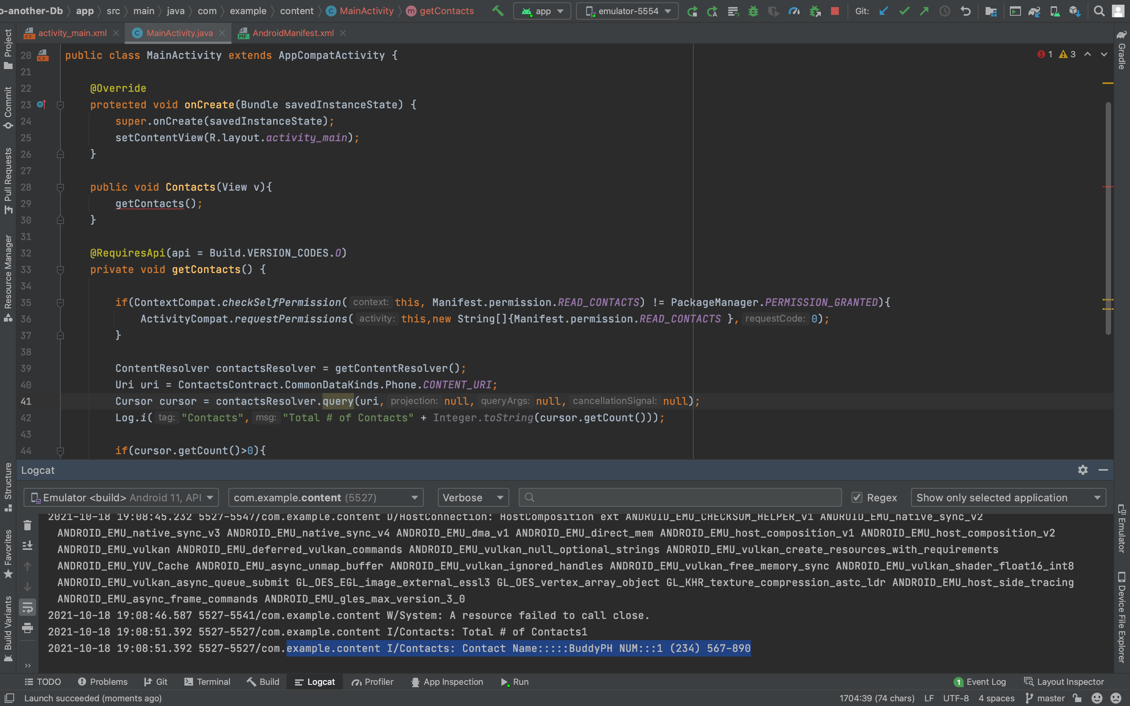

Caption