**Question 1 - Create a basic Hello World program.**

**Solution –**

**activity_main.xml**

<?xml version="1.0" encoding="utf-8"?>

<androidx.constraintlayout.widget.ConstraintLayout xmlns:android="http://schemas.android.com/apk/res/android"

xmlns:app="http://schemas.android.com/apk/res-auto"

xmlns:tools="http://schemas.android.com/tools"

android:layout_width="match_parent"

android:layout_height="match_parent"

tools:context=".MainActivity">

<TextView

android:layout_width="209dp"

android:layout_height="86dp"

android:text="Hello World!"

android:textAlignment="center"

android:textSize="34sp"

android:textStyle="bold"

android:gravity="center"

android:textColor="@color/black"

app:layout_constraintBottom_toBottomOf="parent"

app:layout_constraintLeft_toLeftOf="parent"

app:layout_constraintRight_toRightOf="parent"

app:layout_constraintTop_toTopOf="parent" />

</androidx.constraintlayout.widget.ConstraintLayout>

**MainActivity.java**

package com.example.myapplication;

import androidx.appcompat.app.AppCompatActivity;

public class MainActivity extends AppCompatActivity {

@Override

protected void onCreate(Bundle savedInstanceState) {

super.onCreate(savedInstanceState);

setContentView(R.layout.activity_main);

}

}

**Output –**

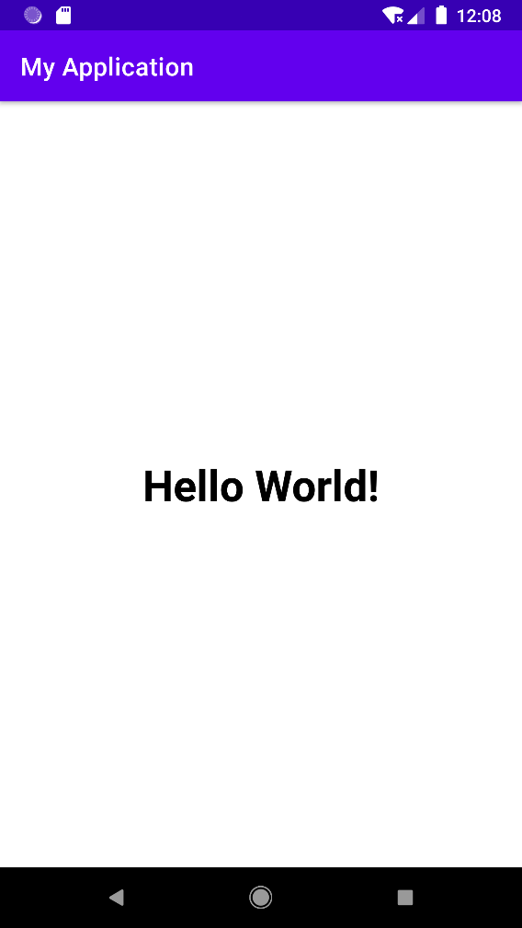

**Question 2 - Create a simple application to change Color of background of any textbox with the click of a button.**

**Solution –**

**activity _main.xml**

<?xml version="1.0" encoding="utf-8"?>

<androidx.constraintlayout.widget.ConstraintLayout xmlns:android="http://schemas.android.com/apk/res/android"

xmlns:app="http://schemas.android.com/apk/res-auto"

xmlns:tools="http://schemas.android.com/tools"

android:layout_width="match_parent"

android:layout_height="match_parent"

tools:context=".MainActivity">

<TextView

android:id="@+id/TextView1"

android:layout_width="wrap_content"

android:layout_height="wrap_content"

android:background="#FFFFFFFF"

android:text="Hello World!"

android:textColor="#FF03DAC5"

android:textSize="50sp"

android:textStyle="bold"

app:layout_constraintBottom_toBottomOf="parent"

app:layout_constraintLeft_toLeftOf="parent"

app:layout_constraintRight_toRightOf="parent"

app:layout_constraintTop_toTopOf="parent"

app:layout_constraintVertical_bias="0.314" />

<Button

android:id="@+id/Button1"

android:layout_width="wrap_content"

android:layout_height="wrap_content"

android:text="Red"

app:layout_constraintBottom_toBottomOf="parent"

app:layout_constraintHorizontal_bias="0.90"

app:layout_constraintLeft_toLeftOf="@id/Button2"

app:layout_constraintRight_toRightOf="parent"

app:layout_constraintTop_toTopOf="@id/TextView1" />

<Button

android:id="@+id/Button2"

android:layout_width="wrap_content"

android:layout_height="wrap_content"

android:text="Yellow"

app:layout_constraintBottom_toBottomOf="parent"

app:layout_constraintHorizontal_bias="0.10"

app:layout_constraintLeft_toLeftOf="parent"

app:layout_constraintRight_toRightOf="@id/Button1"

app:layout_constraintTop_toTopOf="@id/TextView1" />

<Button

android:id="@+id/Button3"

android:layout_width="wrap_content"

android:layout_height="wrap_content"

android:text="Reset"

app:layout_constraintBottom_toBottomOf="parent"

app:layout_constraintHorizontal_bias="0.498"

app:layout_constraintLeft_toLeftOf="@id/Button2"

app:layout_constraintRight_toRightOf="@id/Button1"

app:layout_constraintTop_toTopOf="@id/TextView1" />

</androidx.constraintlayout.widget.ConstraintLayout>

**MainActivity.java**

package com.example.myapplication;

import androidx.appcompat.app.AppCompatActivity;

import android.graphics.Color;

import android.os.Bundle;

import android.view.View;

import android.widget.Button;

import android.widget.TextView;

public class MainActivity extends AppCompatActivity {

@Override

protected void onCreate(Bundle savedInstanceState) {

super.onCreate(savedInstanceState);

setContentView(R.layout.activity_main);

TextView textview;

Button button1, button2, button3;

textview=findViewById(R.id.TextView1);

button1=findViewById(R.id.Button1);

button2=findViewById(R.id.Button2);

button3=findViewById(R.id.Button3);

button1.setOnClickListener(new View.OnClickListener() {

@Override

public void onClick(View view) {

textview.setBackgroundColor(Color.RED);

}

});

button2.setOnClickListener(new View.OnClickListener() {

@Override

public void onClick(View v) {

textview.setBackgroundColor(Color.YELLOW);

}

});

button3.setOnClickListener(new View.OnClickListener() {

@Override

public void onClick(View v) {

textview.setBackgroundColor(Color.WHITE);

}

});

}

}

**Output –**

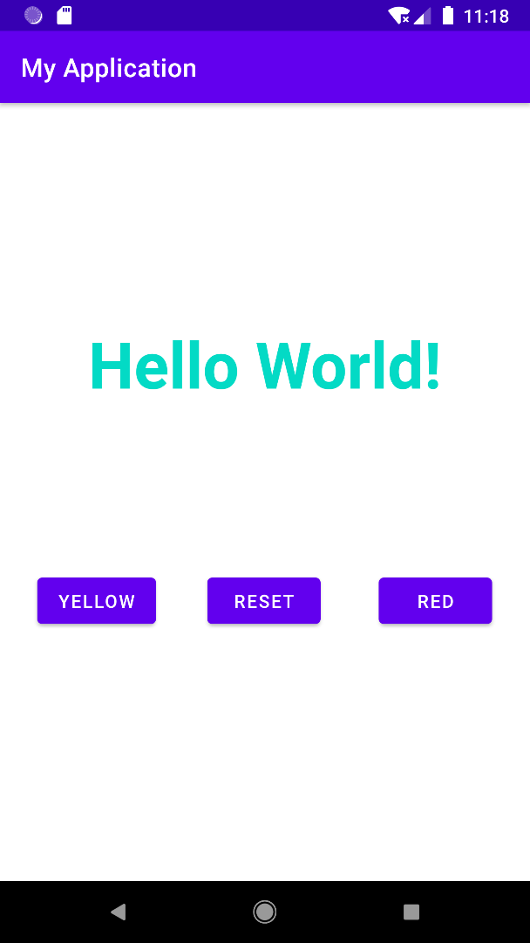 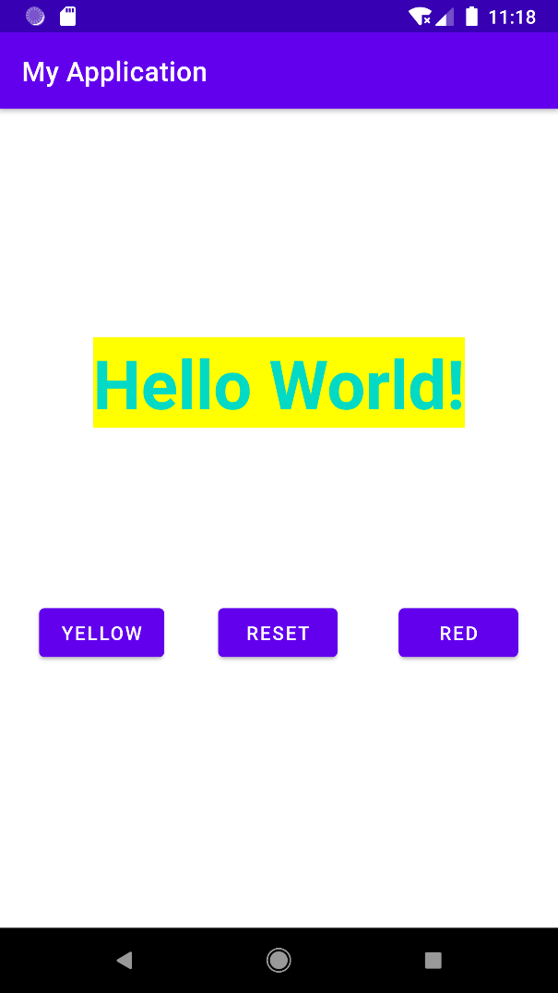

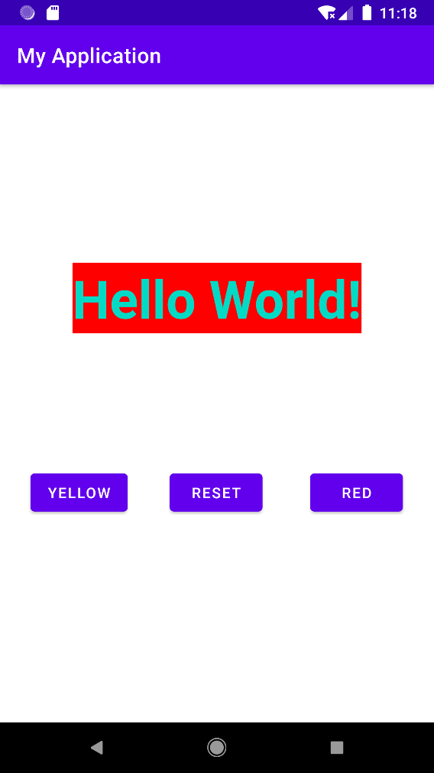 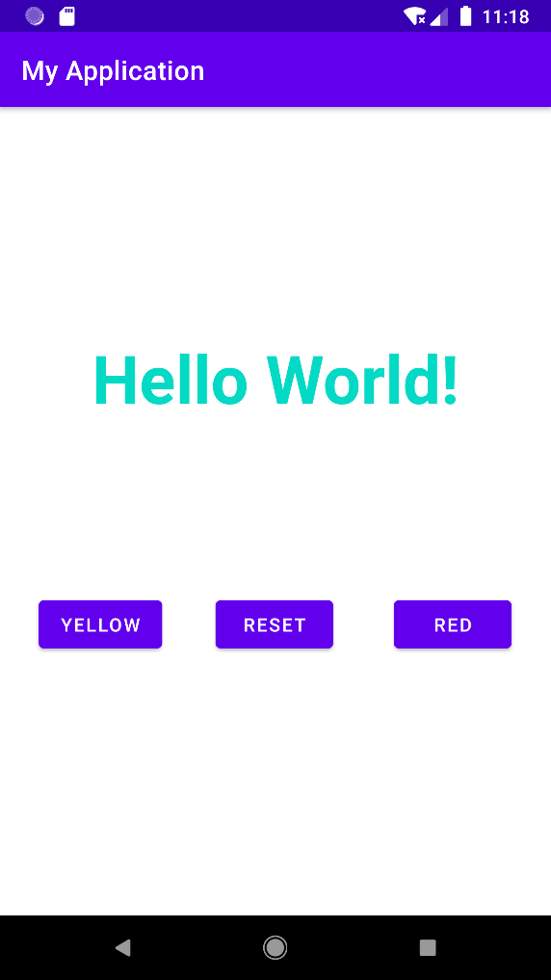

**Question 3 - Create a simple app to change background colour on button click.**

**Solution –**

**activity_main.xml**

<?xml version="1.0" encoding="utf-8"?>

<RelativeLayout xmlns:android="http://schemas.android.com/apk/res/android"

xmlns:app="http://schemas.android.com/apk/res-auto"

xmlns:tools="http://schemas.android.com/tools"

android:layout_width="match_parent"

android:layout_height="match_parent"

android:id="@+id/R"

tools:context=".MainActivity">

<Button

android:id="@+id/Button1"

android:layout_width="wrap_content"

android:layout_height="wrap_content"

android:layout_alignParentTop="true"

android:layout_centerHorizontal="true"

android:layout_marginTop="100dp"

android:text="Red" />

<Button

android:id="@+id/Button2"

android:layout_width="wrap_content"

android:layout_height="wrap_content"

android:layout_below="@+id/Button1"

android:layout_centerHorizontal="true"

android:layout_marginTop="52dp"

android:text="Blue" />

<Button

android:id="@+id/Button3"

android:layout_width="wrap_content"

android:layout_height="wrap_content"

android:layout_below="@+id/Button2"

android:layout_alignParentBottom="true"

android:layout_centerHorizontal="true"

android:layout_marginTop="53dp"

android:layout_marginBottom="383dp"

android:text="Reset" />

</RelativeLayout>

**Output –**

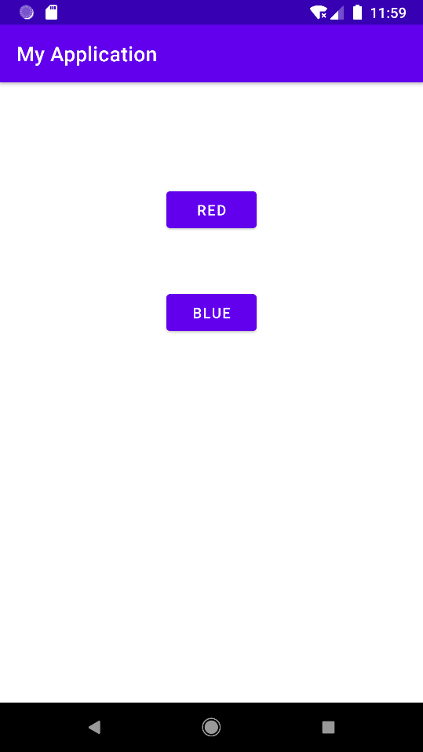 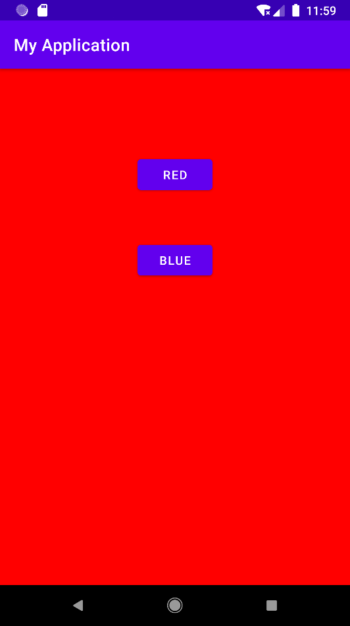

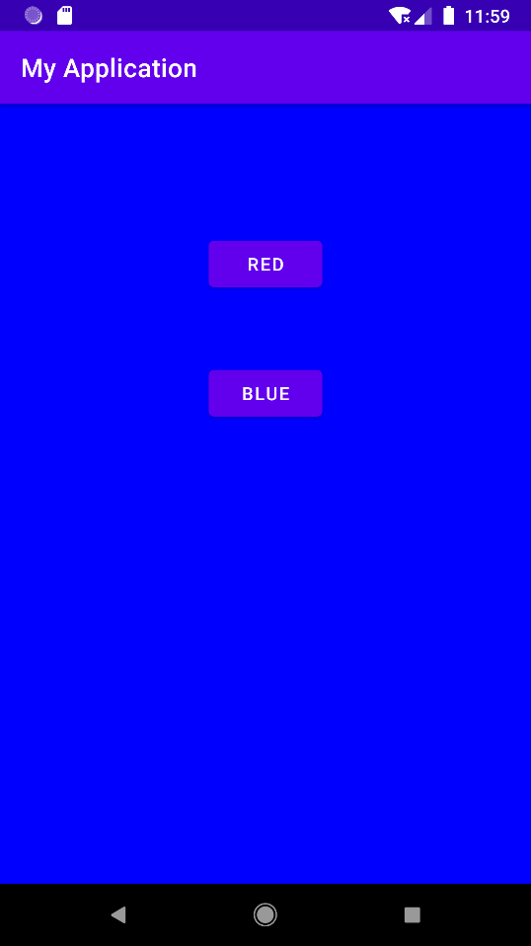

**Question 4 - Create a simple app to add two numbers.**

**Solution –**

**activity_main.xml**

<?xml version="1.0" encoding="utf-8"?>

<androidx.constraintlayout.widget.ConstraintLayout xmlns:android="http://schemas.android.com/apk/res/android"

xmlns:app="http://schemas.android.com/apk/res-auto"

xmlns:tools="http://schemas.android.com/tools"

android:layout_width="match_parent"

android:layout_height="match_parent"

tools:context=".MainActivity">

<TextView

android:id="@+id/tv1"

android:layout_width="wrap_content"

android:layout_height="wrap_content"

android:textSize="34sp"

android:textStyle="bold"

app:layout_constraintBottom_toTopOf="@+id/b1"

app:layout_constraintEnd_toEndOf="parent"

app:layout_constraintLeft_toLeftOf="parent"

app:layout_constraintRight_toRightOf="parent"

app:layout_constraintStart_toStartOf="parent"

app:layout_constraintTop_toBottomOf="@+id/et2" />

<EditText

android:id="@+id/et1"

android:layout_width="250dp"

android:layout_height="40dp"

android:layout_marginTop="56dp"

android:inputType="number"

app:layout_constraintEnd_toEndOf="parent"

app:layout_constraintStart_toStartOf="parent"

app:layout_constraintTop_toTopOf="parent" />

<EditText

android:id="@+id/et2"

android:layout_width="250dp"

android:layout_height="40dp"

android:layout_marginTop="52dp"

android:inputType="number"

app:layout_constraintEnd_toEndOf="parent"

app:layout_constraintStart_toStartOf="parent"

app:layout_constraintTop_toBottomOf="@+id/et1" />

<Button

android:id="@+id/b1"

android:layout_width="100dp"

android:layout_height="48dp"

android:layout_marginBottom="304dp"

android:text="add"

app:layout_constraintBottom_toBottomOf="parent"

app:layout_constraintEnd_toEndOf="parent"

app:layout_constraintHorizontal_bias="0.498"

app:layout_constraintStart_toStartOf="parent" />

</androidx.constraintlayout.widget.ConstraintLayout>

**MainActivity.java**

package com.example.myapplication;

import androidx.appcompat.app.AppCompatActivity;

import android.os.Bundle;

import android.view.View;

import android.widget.Button;

import android.widget.EditText;

import android.widget.TextView;

public class MainActivity extends AppCompatActivity {

@Override

protected void onCreate(Bundle savedInstanceState) {

super.onCreate(savedInstanceState);

setContentView(R.layout.activity_main);

EditText value1, value2;

TextView result;

Button b;

value1=findViewById(R.id.et1);

value2=findViewById(R.id.et2);

result=findViewById(R.id.tv1);

b=findViewById(R.id.b1);

b.setOnClickListener(new View.OnClickListener() {

@Override

public void onClick(View view) {

int sum=Integer.parseInt(value1.getText().toString()) + Integer.parseInt(value2.getText().toString());

result.setText(String.valueOf(sum));

}

});

}

}

**Output –**

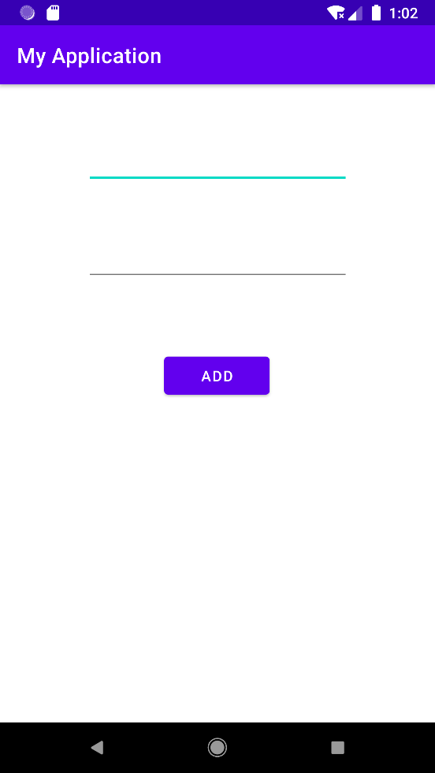 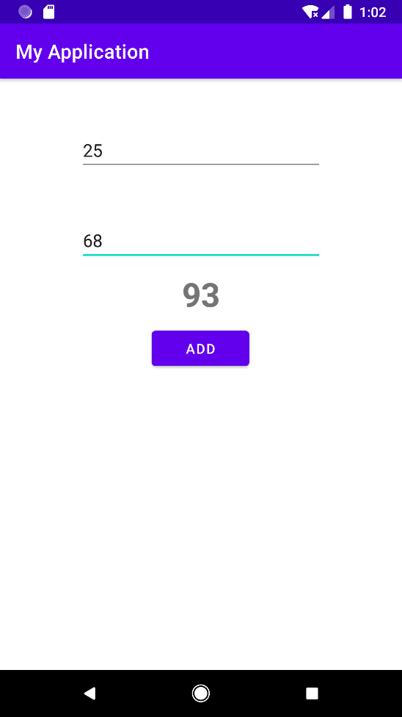

**Question 5 - Create a simple app to create a simple Calculator in android.**

**Solution –**

**activity_main.xml**

<?xml version="1.0" encoding="utf-8"?>

<androidx.constraintlayout.widget.ConstraintLayout xmlns:android="http://schemas.android.com/apk/res/android"

xmlns:app="http://schemas.android.com/apk/res-auto"

xmlns:tools="http://schemas.android.com/tools"

android:layout_width="match_parent"

android:layout_height="match_parent"

tools:context=".MainActivity">

<TextView

android:id="@+id/tv1"

android:layout_width="wrap_content"

android:layout_height="wrap_content"

android:textSize="34sp"

android:textStyle="bold"

app:layout_constraintBottom_toTopOf="@+id/b1"

app:layout_constraintEnd_toEndOf="parent"

app:layout_constraintLeft_toLeftOf="parent"

app:layout_constraintRight_toRightOf="parent"

app:layout_constraintStart_toStartOf="parent"

app:layout_constraintTop_toBottomOf="@+id/et2" />

<EditText

android:id="@+id/et1"

android:layout_width="250dp"

android:layout_height="40dp"

android:layout_marginTop="56dp"

android:inputType="number"

android:hint="Enter First value"

app:layout_constraintEnd_toEndOf="parent"

app:layout_constraintStart_toStartOf="parent"

app:layout_constraintTop_toTopOf="parent" />

<EditText

android:id="@+id/et2"

android:layout_width="250dp"

android:layout_height="40dp"

android:layout_marginTop="52dp"

android:inputType="number"

android:hint="Enter Second value"

app:layout_constraintEnd_toEndOf="parent"

app:layout_constraintStart_toStartOf="parent"

app:layout_constraintTop_toBottomOf="@+id/et1" />

<Button

android:id="@+id/b1"

android:layout_width="100dp"

android:layout_height="48dp"

android:layout_marginBottom="308dp"

android:text="add"

app:layout_constraintBottom_toBottomOf="parent"

app:layout_constraintEnd_toStartOf="@+id/b2"

app:layout_constraintHorizontal_bias="0.267"

app:layout_constraintStart_toStartOf="parent" />

<Button

android:id="@+id/b2"

android:layout_width="120dp"

android:layout_height="48dp"

android:layout_marginBottom="308dp"

android:text="Subtract"

app:layout_constraintBottom_toBottomOf="parent"

app:layout_constraintEnd_toStartOf="@+id/b3"

app:layout_constraintHorizontal_bias="0.858"

app:layout_constraintStart_toStartOf="parent" />

<Button

android:id="@+id/b3"

android:layout_width="120dp"

android:layout_height="48dp"

android:layout_marginBottom="308dp"

android:text="multiply"

app:layout_constraintBottom_toBottomOf="parent"

app:layout_constraintEnd_toEndOf="parent"

app:layout_constraintHorizontal_bias="0.945"

app:layout_constraintStart_toStartOf="parent" />

<Button

android:id="@+id/b4"

android:layout_width="120dp"

android:layout_height="48dp"

android:text="divide"

app:layout_constraintBottom_toBottomOf="parent"

app:layout_constraintEnd_toEndOf="parent"

app:layout_constraintHorizontal_bias="0.457"

app:layout_constraintStart_toStartOf="parent"

app:layout_constraintTop_toBottomOf="@+id/b2"

app:layout_constraintVertical_bias="0.084" />

</androidx.constraintlayout.widget.ConstraintLayout>

**MainActivity.java**

package com.example.myapplication;

import androidx.appcompat.app.AppCompatActivity;

import android.os.Bundle;

import android.view.View;

import android.widget.Button;

import android.widget.EditText;

import android.widget.TextView;

public class MainActivity extends AppCompatActivity {

@Override

protected void onCreate(Bundle savedInstanceState) {

super.onCreate(savedInstanceState);

setContentView(R.layout.activity_main);

EditText value1, value2;

TextView result;

Button b1,b2,b3,b4;

value1=findViewById(R.id.et1);

value2=findViewById(R.id.et2);

result=findViewById(R.id.tv1);

b1=findViewById(R.id.b1);

b2=findViewById(R.id.b2);

b3=findViewById(R.id.b3);

b4=findViewById(R.id.b4);

b1.setOnClickListener(new View.OnClickListener() {

@Override

public void onClick(View view) {

int sum=Integer.parseInt(value1.getText().toString()) + Integer.parseInt(value2.getText().toString());

result.setText(String.valueOf(sum));

}

});

b2.setOnClickListener(new View.OnClickListener() {

@Override

public void onClick(View view) {

int sub=Integer.parseInt(value1.getText().toString()) - Integer.parseInt(value2.getText().toString());

result.setText(String.valueOf(sub));

}

});

b3.setOnClickListener(new View.OnClickListener() {

@Override

public void onClick(View view) {

int mul=Integer.parseInt(value1.getText().toString()) * Integer.parseInt(value2.getText().toString());

result.setText(String.valueOf(mul));

}

});

b4.setOnClickListener(new View.OnClickListener() {

@Override

public void onClick(View view) {

int div=Integer.parseInt(value1.getText().toString()) / Integer.parseInt(value2.getText().toString());

result.setText(String.valueOf(div));

}

});

}

}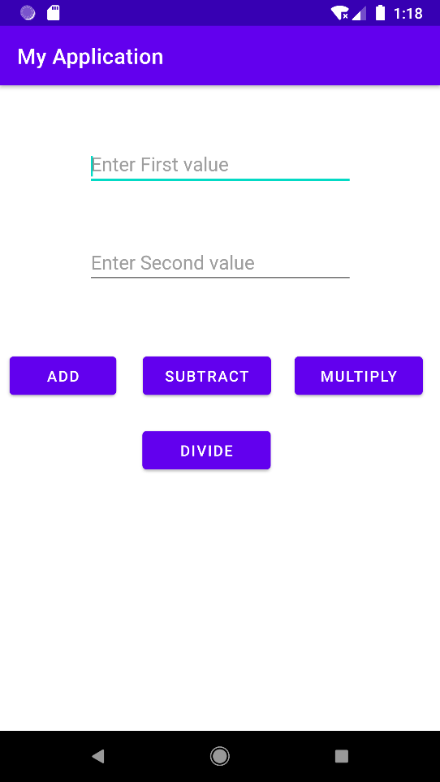 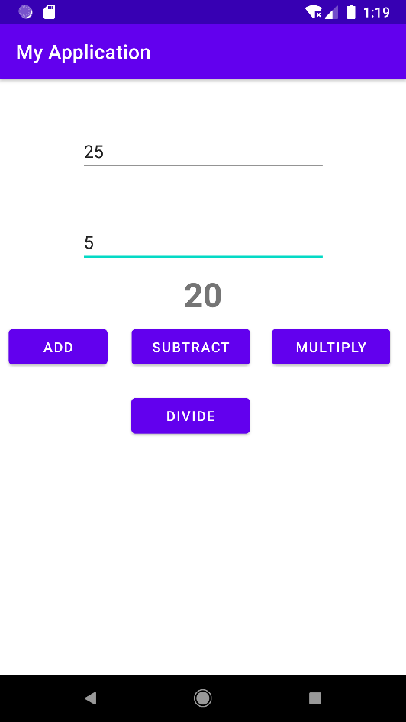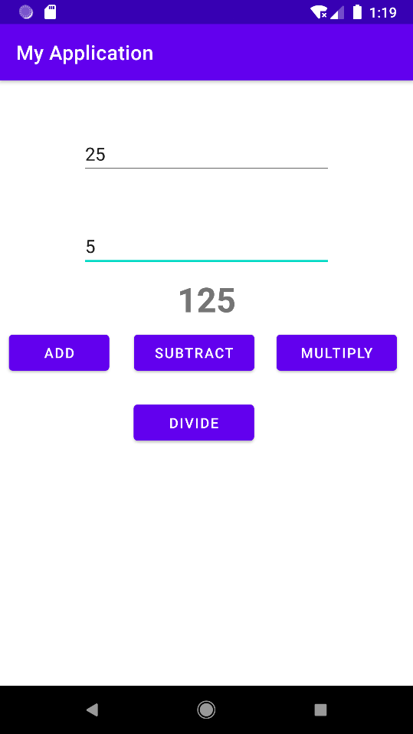 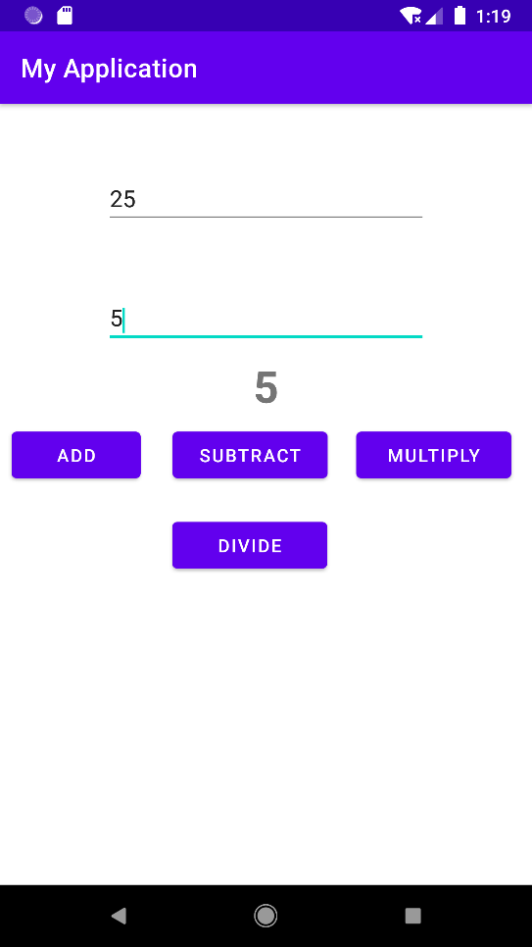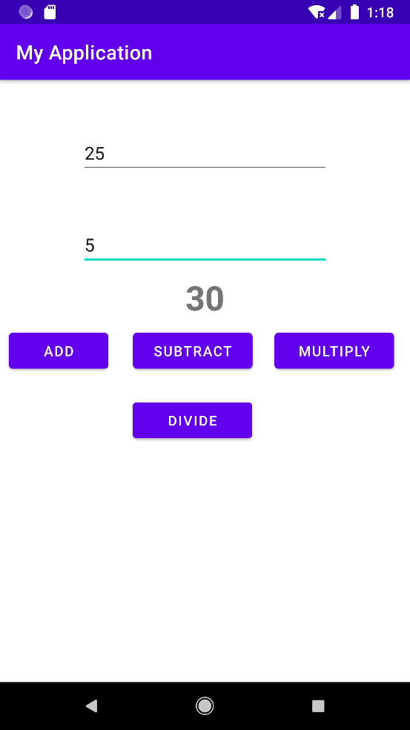

**Question 6 - Create an app to set image on Image view.**

**Solution –**

**activity_main.xml**

<?xml version="1.0" encoding="utf-8"?>

<androidx.constraintlayout.widget.ConstraintLayout xmlns:android="http://schemas.android.com/apk/res/android"

xmlns:app="http://schemas.android.com/apk/res-auto"

xmlns:tools="http://schemas.android.com/tools"

android:layout_width="match_parent"

android:layout_height="match_parent"

tools:context=".MainActivity">

<ImageView

android:id="@+id/imageView2"

android:layout_width="wrap_content"

android:layout_height="wrap_content"

app:layout_constraintBottom_toBottomOf="parent"

app:layout_constraintEnd_toEndOf="parent"

app:layout_constraintStart_toStartOf="parent"

app:layout_constraintTop_toTopOf="parent"

app:srcCompat="@drawable/paintedstyle" />

</androidx.constraintlayout.widget.ConstraintLayout>

**MainActivity.java**

package com.example.myapplication;

import androidx.appcompat.app.AppCompatActivity;

import android.content.Intent;

import android.net.Uri;

import android.os.Bundle;

import android.util.Log;

import android.view.View;

import android.widget.Button;

import android.widget.EditText;

public class MainActivity extends AppCompatActivity {

@Override

protected void onCreate(Bundle savedInstanceState) {

super.onCreate(savedInstanceState);

setContentView(R.layout.activity_main);

}

}

**Output –**

**Question 7 - Create a program to change image on button click.**

**Solution –**

**activity_ main.java**

<?xml version="1.0" encoding="utf-8"?>

<androidx.constraintlayout.widget.ConstraintLayout xmlns:android="http://schemas.android.com/apk/res/android"

xmlns:app="http://schemas.android.com/apk/res-auto"

xmlns:tools="http://schemas.android.com/tools"

android:layout_width="match_parent"

android:layout_height="match_parent"

tools:context=".MainActivity">

<ImageView

android:id="@+id/iv1"

android:layout_width="410dp"

android:layout_height="485dp"

app:layout_constraintEnd_toEndOf="parent"

app:layout_constraintStart_toStartOf="parent"

app:layout_constraintTop_toTopOf="parent" />

<Button

android:id="@+id/bt1"

android:layout_width="wrap_content"

android:layout_height="wrap_content"

android:layout_marginStart="70dp"

android:text="Previous"

android:backgroundTint="@color/black"

app:layout_constraintBottom_toBottomOf="parent"

app:layout_constraintStart_toStartOf="parent"

app:layout_constraintTop_toBottomOf="@+id/iv1"

app:layout_constraintVertical_bias="0.498" />

<Button

android:id="@+id/bt2"

android:layout_width="wrap_content"

android:layout_height="wrap_content"

android:layout_marginEnd="70dp"

android:text="Next"

android:backgroundTint="@color/black"

app:layout_constraintBottom_toBottomOf="parent"

app:layout_constraintEnd_toEndOf="parent"

app:layout_constraintTop_toBottomOf="@+id/iv1"

app:layout_constraintVertical_bias="0.498" />

</androidx.constraintlayout.widget.ConstraintLayout>

**MainActivity.java**

package com.example.imageview;

import androidx.appcompat.app.AppCompatActivity;

import android.media.Image;

import android.os.Bundle;

import android.view.View;

import android.widget.Button;

import android.widget.ImageView;

public class MainActivity extends AppCompatActivity {

Button bt1,bt2;

ImageView iv1;

@Override

protected void onCreate(Bundle savedInstanceState) {

super.onCreate(savedInstanceState);

setContentView(R.layout.activity_main);

iv1=findViewById(R.id.iv1);

bt1=findViewById(R.id.bt1);

bt2=findViewById(R.id.bt2);

bt1.setOnClickListener(new View.OnClickListener() {

@Override

public void onClick(View view) {

iv1.setImageResource(R.drawable.bone);

}

});

bt2.setOnClickListener(new View.OnClickListener() {

@Override

public void onClick(View view) {

iv1.setImageResource(R.drawable.iiustration);

}

});

}

}

**Output –**

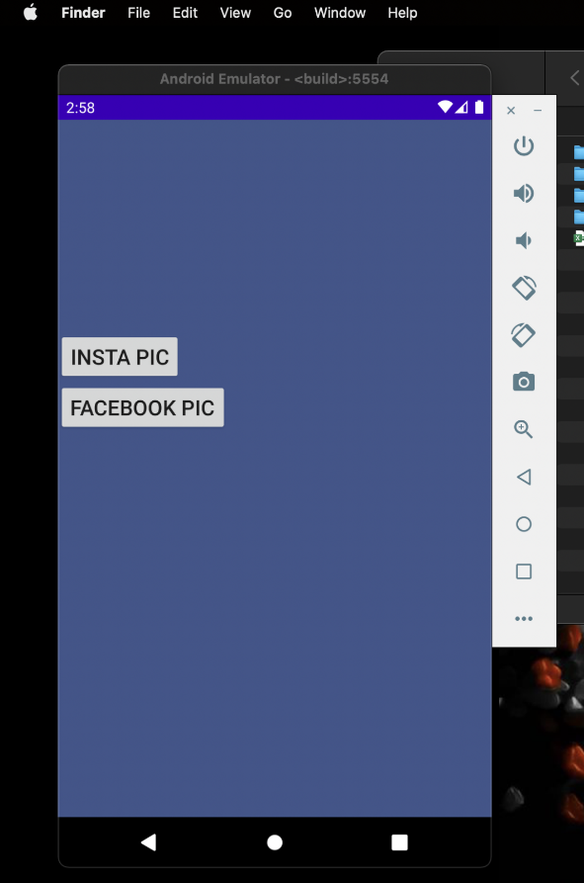 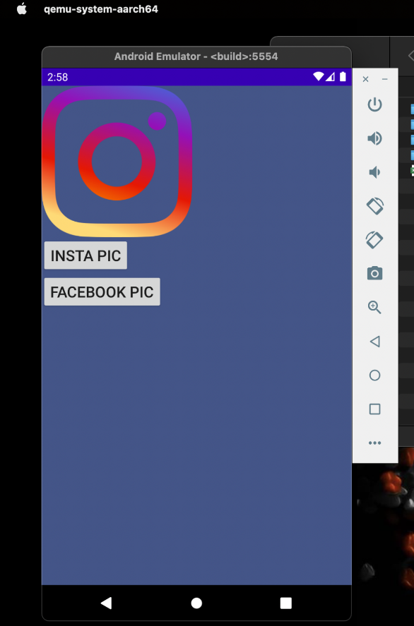

**Question 8 - Create a program to depict activity lifecycle.**

**Solution –**

**activity_main.xml**

<?xml version="1.0" encoding="utf-8"?>

<androidx.constraintlayout.widget.ConstraintLayout xmlns:android="http://schemas.android.com/apk/res/android"

xmlns:app="http://schemas.android.com/apk/res-auto"

xmlns:tools="http://schemas.android.com/tools"

android:layout_width="match_parent"

android:layout_height="match_parent"

tools:context=".MainActivity">

<TextView

android:id="@+id/textView4"

android:layout_width="wrap_content"

android:layout_height="wrap_content"

android:text="TextView"

android:textSize="20sp"

android:textStyle="bold"

app:layout_constraintBottom_toBottomOf="parent"

app:layout_constraintEnd_toEndOf="parent"

app:layout_constraintStart_toStartOf="parent"

app:layout_constraintTop_toTopOf="parent" />

</androidx.constraintlayout.widget.ConstraintLayout>

**MainActivity.java**

package com.example.myapplication;

import androidx.appcompat.app.AppCompatActivity;

import android.os.Bundle;

import android.util.Log;

public class MainActivity extends AppCompatActivity {

public static final String status=MainActivity.class.getSimpleName();

@Override

protected void onCreate(Bundle savedInstanceState) {

super.onCreate(savedInstanceState);

setContentView(R.layout.activity_main);

Log.i(status,"In method onCreate");

}

@Override

protected void onStart() {

super.onStart();

Log.i(status,"In method onStart");

}

@Override

protected void onResume() {

super.onResume();

Log.i(status,"In method onResume");

}

@Override

protected void onPause() {

super.onPause();

Log.i(status,"In method onPause");

}

@Override

protected void onStop() {

super.onStop();

Log.i(status,"In method onStop");

}

@Override

protected void onDestroy() {

super.onDestroy();

Log.i(status,"In method onDestroy");

}

}

**Output -**

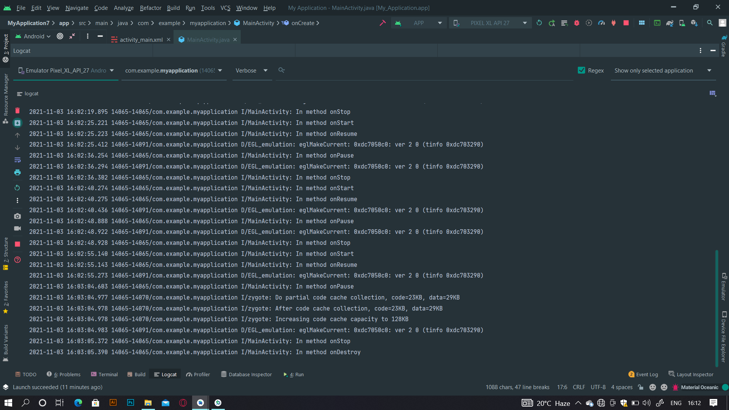

**Question 9 - Create a program to show implicit intent.**

**Solution –**

**activity_main.xml**

<?xml version="1.0" encoding="utf-8"?>

<androidx.constraintlayout.widget.ConstraintLayout xmlns:android="http://schemas.android.com/apk/res/android"

xmlns:app="http://schemas.android.com/apk/res-auto"

xmlns:tools="http://schemas.android.com/tools"

android:layout_width="match_parent"

android:layout_height="match_parent"

tools:context=".MainActivity">

<EditText

android:id="@+id/et1"

android:layout_width="365dp"

android:layout_height="45dp"

android:hint="Url"

app:layout_constraintBottom_toTopOf="@+id/bt1"

app:layout_constraintEnd_toEndOf="parent"

app:layout_constraintStart_toStartOf="parent"

app:layout_constraintTop_toTopOf="parent"

app:layout_constraintVertical_bias="0.691" />

<Button

android:id="@+id/bt1"

android:layout_width="348dp"

android:layout_height="52dp"

android:text="Search"

app:layout_constraintBottom_toBottomOf="parent"

app:layout_constraintEnd_toEndOf="parent"

app:layout_constraintStart_toStartOf="parent"

app:layout_constraintTop_toTopOf="parent" />

</androidx.constraintlayout.widget.ConstraintLayout>

**MainActivity.java**

package com.example.myapplication;

import androidx.appcompat.app.AppCompatActivity;

import android.content.Intent;

import android.net.Uri;

import android.os.Bundle;

import android.util.Log;

import android.view.View;

import android.widget.Button;

import android.widget.EditText;

public class MainActivity extends AppCompatActivity {

EditText et1;

Button bt1;

@Override

protected void onCreate(Bundle savedInstanceState) {

super.onCreate(savedInstanceState);

setContentView(R.layout.activity_main);

et1=findViewById(R.id.et1);

bt1=findViewById(R.id.bt1);

bt1.setOnClickListener(new View.OnClickListener() {

@Override

public void onClick(View view) {

String url=et1.getText().toString();

Intent i=new Intent(Intent.ACTION_VIEW, Uri.parse(url));

startActivity(i);

}

});

}

}

**Output –**

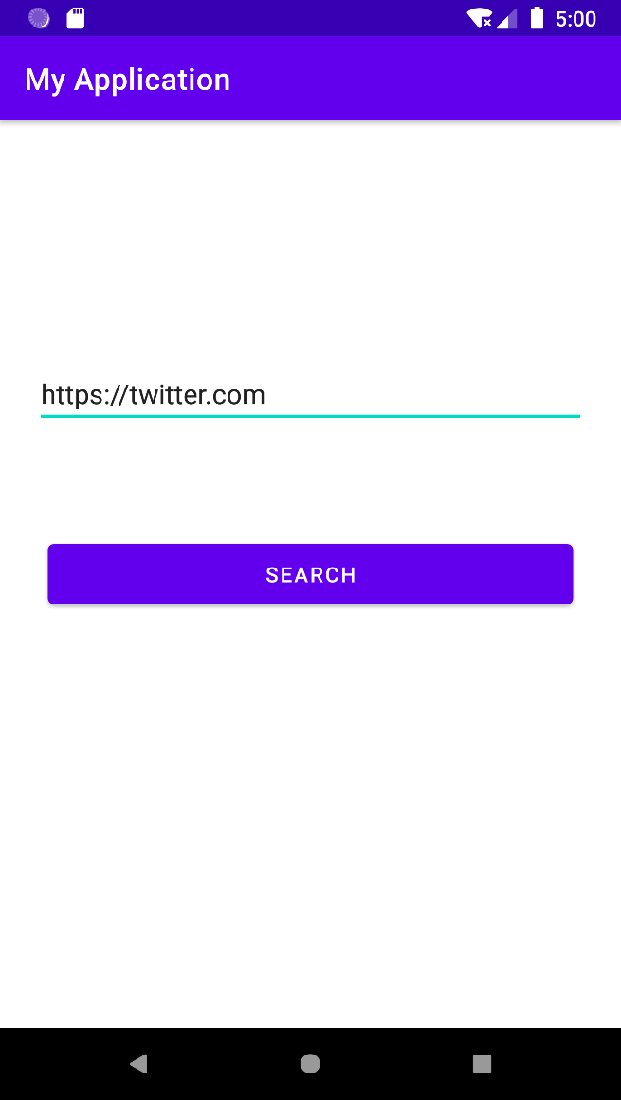 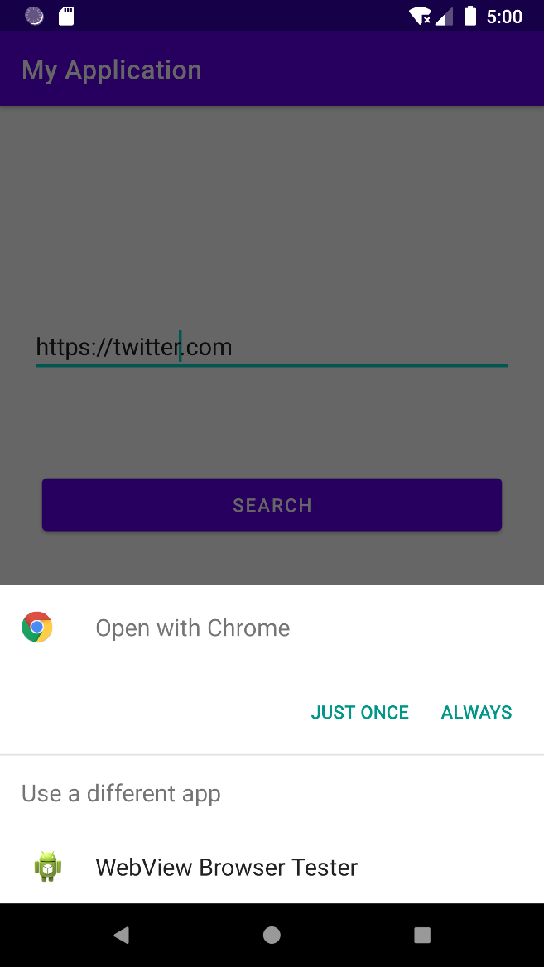

**Question 10 - Create a program to show explicit intent.**

**Solution –**

**activity_main.xml**

**Activity1**

activity_main.xml

<?xml version="1.0" encoding="utf-8"?>

<androidx.constraintlayout.widget.ConstraintLayout xmlns:android="http://schemas.android.com/apk/res/android"

xmlns:app="http://schemas.android.com/apk/res-auto"

xmlns:tools="http://schemas.android.com/tools"

android:layout_width="match_parent"

android:layout_height="match_parent"

tools:context=".MainActivity">

<Button

android:id="@+id/bt1"

android:layout_width="348dp"

android:layout_height="52dp"

android:text="Next Activity"

app:layout_constraintBottom_toBottomOf="parent"

app:layout_constraintEnd_toEndOf="parent"

app:layout_constraintStart_toStartOf="parent"

app:layout_constraintTop_toTopOf="parent" />

</androidx.constraintlayout.widget.ConstraintLayout>

**MainActivity.java**

package com.example.myapplication;

import androidx.appcompat.app.AppCompatActivity;

import android.content.Intent;

import android.net.Uri;

import android.os.Bundle;

import android.util.Log;

import android.view.View;

import android.widget.Button;

import android.widget.EditText;

public class MainActivity extends AppCompatActivity {

EditText et1;

Button bt1;

@Override

protected void onCreate(Bundle savedInstanceState) {

super.onCreate(savedInstanceState);

setContentView(R.layout.activity_main);

bt1=findViewById(R.id.bt1);

bt1.setOnClickListener(new View.OnClickListener() {

@Override

public void onClick(View view) {

Intent i=new Intent(getApplicationContext(), Activity2.class);

startActivity(i);

}

});

}

}

**Activity2**

**activity_main.xml**

<?xml version="1.0" encoding="utf-8"?>

<androidx.constraintlayout.widget.ConstraintLayout xmlns:android="http://schemas.android.com/apk/res/android"

xmlns:app="http://schemas.android.com/apk/res-auto"

xmlns:tools="http://schemas.android.com/tools"

android:layout_width="match_parent"

android:layout_height="match_parent"

tools:context=".Activity2">

<TextView

android:id="@+id/textView"

android:layout_width="wrap_content"

android:layout_height="wrap_content"

android:text="Second Activity"

android:textColor="#157FDC"

android:textSize="34sp"

android:textStyle="bold"

app:layout_constraintBottom_toBottomOf="parent"

app:layout_constraintEnd_toEndOf="parent"

app:layout_constraintHorizontal_bias="0.497"

app:layout_constraintStart_toStartOf="parent"

app:layout_constraintTop_toTopOf="parent"

app:layout_constraintVertical_bias="0.332" />

</androidx.constraintlayout.widget.ConstraintLayout>

**MainActivity.java**

package com.example.myapplication;

import androidx.appcompat.app.AppCompatActivity;

import android.os.Bundle;

public class Activity2 extends AppCompatActivity {

@Override

protected void onCreate(Bundle savedInstanceState) {

super.onCreate(savedInstanceState);

setContentView(R.layout.activity_2);

}

}

**Output –**

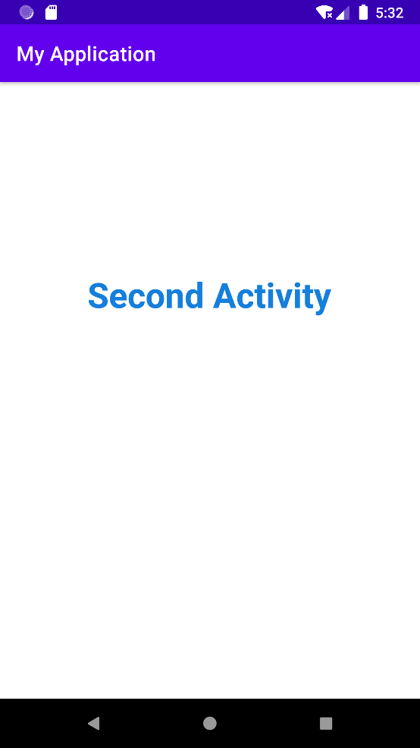

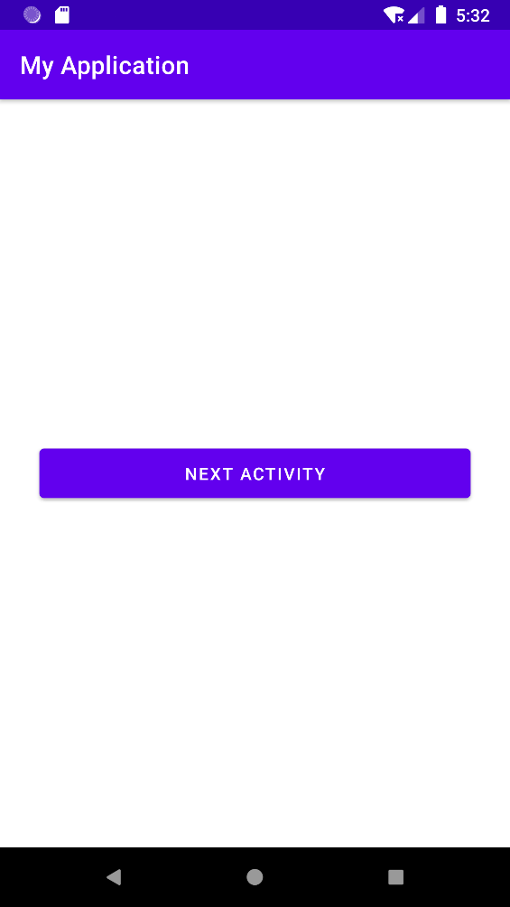

**Question 11 - Create a program to show text view and its attributes.**

**Solution –**

**activity_main.xml**

<?xml version="1.0" encoding="utf-8"?>

<androidx.constraintlayout.widget.ConstraintLayout xmlns:android="http://schemas.android.com/apk/res/android"

xmlns:app="http://schemas.android.com/apk/res-auto"

xmlns:tools="http://schemas.android.com/tools"

android:layout_width="match_parent"

android:layout_height="match_parent"

tools:context=".MainActivity">

<TextView

android:layout_width="209dp"

android:layout_height="86dp"

android:fontFamily="sans-serif-medium"

android:gravity="center"

android:text="Hello World!"

android:textAlignment="center"

android:textColor="@color/black"

android:textSize="34sp"

android:textStyle="italic"

android:typeface="monospace"

app:layout_constraintBottom_toBottomOf="parent"

app:layout_constraintLeft_toLeftOf="parent"

app:layout_constraintRight_toRightOf="parent"

app:layout_constraintTop_toTopOf="parent" />

</androidx.constraintlayout.widget.ConstraintLayout>

**MainActivity.java**

package com.example.myapplication;

import androidx.appcompat.app.AppCompatActivity;

import android.os.Bundle;

public class Activity2 extends AppCompatActivity {

@Override

protected void onCreate(Bundle savedInstanceState) {

super.onCreate(savedInstanceState);

setContentView(R.layout.activity_2);

}

}

**Output –**

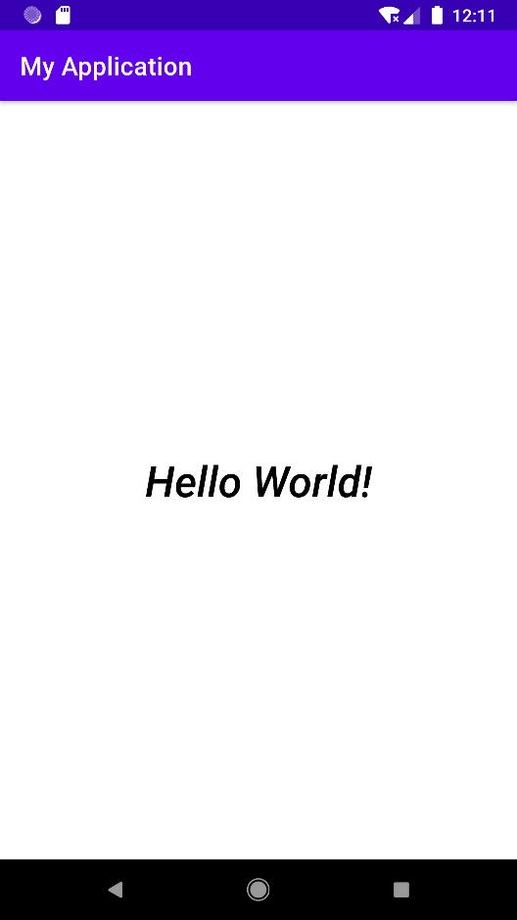

**Question 12 - Create a program to depict fragment.**

**Solution –**

**activity_main.xml**

<?xml version="1.0" encoding="utf-8"?>

<LinearLayout xmlns:android="http://schemas.android.com/apk/res/android"

xmlns:app="http://schemas.android.com/apk/res-auto"

xmlns:tools="http://schemas.android.com/tools"

android:layout_width="match_parent"

android:layout_height="match_parent"

tools:context=".MainActivity">

<fragment

android:layout_width="0dp"

android:layout_height="match_parent"

android:id="@+id/f1"

android:layout_weight="1"

android:name="com.example.myapplication.FirstFragment"/>

<fragment

android:layout_width="0dp"

android:layout_height="match_parent"

android:id="@+id/f2"

android:layout_weight="1"

android:name="com.example.myapplication.SecondFragment"/>

</LinearLayout>

**MainActivity.java**

package com.example.myapplication;

import androidx.appcompat.app.AppCompatActivity;

public class MainActivity extends AppCompatActivity {

@Override

protected void onCreate(Bundle savedInstanceState) {

super.onCreate(savedInstanceState);

setContentView(R.layout.activity_main);

}

}

**fragment_first.xml**

<?xml version="1.0" encoding="utf-8"?>

<FrameLayout xmlns:android="http://schemas.android.com/apk/res/android"

xmlns:tools="http://schemas.android.com/tools"

android:layout_width="match_parent"

android:layout_height="match_parent"

android:background="#FF03DAC5"

tools:context=".FirstFragment">

<TextView

android:layout_width="match_parent"

android:layout_height="match_parent"

android:text="First Fragment"

android:gravity="center"

android:textSize="36sp"

android:textStyle="bold"

android:textColor="@color/white"/>

</FrameLayout>

**FisrtFragment.java**

package com.example.myapplication;

import android.os.Bundle;

import androidx.fragment.app.Fragment;

import android.view.LayoutInflater;

import android.view.View;

import android.view.ViewGroup;

public class FirstFragment extends Fragment {

private static final String ARG_PARAM1 = "param1";

private static final String ARG_PARAM2 = "param2";

private String mParam1;

private String mParam2;

public FirstFragment() {

}

public static FirstFragment newInstance(String param1, String param2) {

FirstFragment fragment = new FirstFragment();

Bundle args = new Bundle();

args.putString(ARG_PARAM1, param1);

args.putString(ARG_PARAM2, param2);

fragment.setArguments(args);

return fragment;

}

@Override

public void onCreate(Bundle savedInstanceState) {

super.onCreate(savedInstanceState);

if (getArguments() != null) {

mParam1 = getArguments().getString(ARG_PARAM1);

mParam2 = getArguments().getString(ARG_PARAM2);

}

}

@Override

public View onCreateView(LayoutInflater inflater, ViewGroup container,

Bundle savedInstanceState) {

return inflater.inflate(R.layout.fragment_first, container, false);

}

}

**fragment_second.xml**

<?xml version="1.0" encoding="utf-8"?>

<FrameLayout xmlns:android="http://schemas.android.com/apk/res/android"

xmlns:tools="http://schemas.android.com/tools"

android:layout_width="match_parent"

android:layout_height="match_parent"

android:background="#FF03DAC5"

tools:context=".SecondFragment">

<TextView

android:layout_width="match_parent"

android:layout_height="match_parent"

android:text="Second Fragment"

android:gravity="center"

android:textSize="36sp"

android:textStyle="bold"

android:textColor="@color/black"/>

</FrameLayout>

**SecondFragment.java**

package com.example.myapplication;

import android.os.Bundle;

import androidx.fragment.app.Fragment;

import android.view.LayoutInflater;

import android.view.View;

import android.view.ViewGroup;

public class FirstFragment extends Fragment {

private static final String ARG_PARAM1 = "param1";

private static final String ARG_PARAM2 = "param2";

private String mParam1;

private String mParam2;

public FirstFragment() {

}

public static FirstFragment newInstance(String param1, String param2) {

FirstFragment fragment = new FirstFragment();

Bundle args = new Bundle();

args.putString(ARG_PARAM1, param1);

args.putString(ARG_PARAM2, param2);

fragment.setArguments(args);

return fragment;

}

@Override

public void onCreate(Bundle savedInstanceState) {

super.onCreate(savedInstanceState);

if (getArguments() != null) {

mParam1 = getArguments().getString(ARG_PARAM1);

mParam2 = getArguments().getString(ARG_PARAM2);

}

}

**Output -**

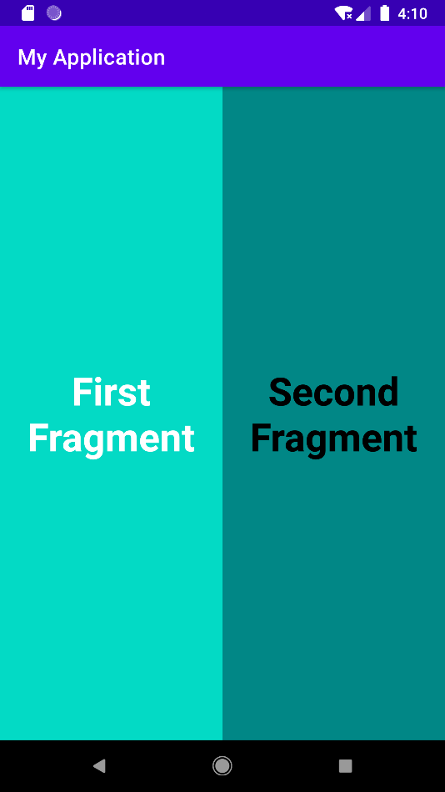

**Question 13 - Create a program in android to show the use of array adapter.**

**Solution –**

**activtity_main.xml**

<?xml version="1.0" encoding="utf-8"?>  
<LinearLayout xmlns:android="http://schemas.android.com/apk/res/android"  
 xmlns:app="http://schemas.android.com/apk/res-auto"  
 xmlns:tools="http://schemas.android.com/tools"  
 android:layout_width="match_parent"  
 android:layout_height="match_parent"  
 tools:context=".MainActivity">  
  
 <ListView  
 android:id="@+id/list1"  
 android:layout_width="match_parent"  
 android:layout_height="wrap_content"/>  
  
</LinearLayout>

**Item_view.xml Code:-**

<?xml version="1.0" encoding="utf-8"?>  
<LinearLayout xmlns:android="http://schemas.android.com/apk/res/android"  
 android:layout_width="match_parent"  
 android:layout_height="match_parent">  
 <TextView  
 android:layout_width="match_parent"  
 android:layout_height="match_parent"  
 android:id="@+id/text1"  
 android:layout_gravity="center"/>  
</LinearLayout>

**MainActivity.java**

package com.example.array_adapter;  
import androidx.appcompat.app.AppCompatActivity;  
import android.content.Context;  
import android.os.Bundle;  
import android.widget.ArrayAdapter;  
import android.widget.ListView;  
  
public class MainActivity extends AppCompatActivity {  
 ListView obj1;  
  
 @Override  
 protected void onCreate(Bundle savedInstanceState) {  
 super.onCreate(savedInstanceState);  
 setContentView(R.layout.activity_main);  
  
 obj1 = findViewById(R.id.list1);  
  
 String progList[] = {"Html" , "Java" , "Css" , "Javascript" ,"React Js" };  
  
 ArrayAdapter<String> obj_ad = new ArrayAdapter<String>(this,R.layout.item_view,R.id.text1,progList);  
 obj1.setAdapter(obj_ad);  
 }  
}

**Output -**

**Question 14 – Create a program to show a Toast.**

**Solution –**

**activity_main.xml**

<?xml version="1.0" encoding="utf-8"?>

<androidx.constraintlayout.widget.ConstraintLayout xmlns:android="http://schemas.android.com/apk/res/android"

xmlns:app="http://schemas.android.com/apk/res-auto"

xmlns:tools="http://schemas.android.com/tools"

android:layout_width="match_parent"

android:layout_height="match_parent"

tools:context=".MainActivity">

<Button

android:id="@+id/b1"

android:layout_width="wrap_content"

android:layout_height="wrap_content"

android:backgroundTint="#020101"

android:text="Click for Toast"

app:layout_constraintBottom_toBottomOf="parent"

app:layout_constraintLeft_toLeftOf="parent"

app:layout_constraintRight_toRightOf="parent"

app:layout_constraintTop_toTopOf="parent" />

</androidx.constraintlayout.widget.ConstraintLayout>

**MainActivity.java**

package com.example.arrayadapter;

import androidx.appcompat.app.AppCompatActivity;

import android.os.Bundle;

import android.view.View;

import android.widget.Button;

import android.widget.Toast;

public class MainActivity extends AppCompatActivity {

Button b1;

@Override

protected void onCreate(Bundle savedInstanceState) {

super.onCreate(savedInstanceState);

setContentView(R.layout.activity_main);

b1=findViewById(R.id.b1);

b1.setOnClickListener(new View.OnClickListener() {

@Override

public void onClick(View view) {

Toast.makeText(MainActivity.this, "Here is your Toast", Toast.LENGTH_LONG).show();

}});}}

**Output –**

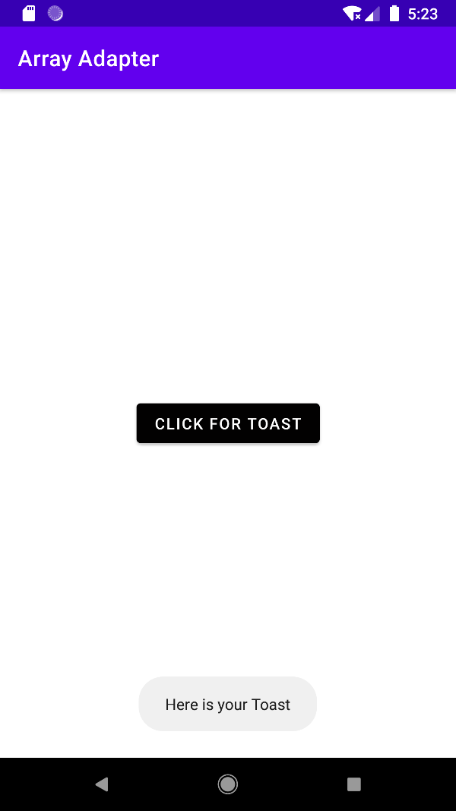

**Question 15 - Implement the following designs using Tabular Layout in android.**

**Solution –**

**1.: Table.xml**

<?xml version="1.0" encoding="utf-8"?>  
<TableLayout xmlns:android="http://schemas.android.com/apk/res/android"  
 android:layout_width="match_parent"  
 android:layout_height="match_parent">  
  
 <TableRow  
 android:layout_height="wrap_content"  
 android:layout_width="wrap_content">  
 <TextView  
 android:layout_height="wrap_content"  
 android:layout_width="wrap_content"  
 android:text="Cell 1"  
 android:layout_marginRight="10sp"  
 android:layout_marginBottom="5sp"  
 android:padding="5sp"  
 android:background="@color/teal_200"/>  
 <TextView  
 android:layout_height="wrap_content"  
 android:layout_width="wrap_content"  
 android:text="Cell 2"  
 android:layout_marginRight="10sp"  
 android:padding="5sp"  
 android:background="@color/teal_700"/>  
 <TextView  
 android:layout_height="wrap_content"  
 android:layout_width="wrap_content"  
 android:text="Cell 3"  
 android:layout_marginRight="10sp"  
 android:padding="5sp"  
 android:background="@color/purple_200"/>  
 </TableRow>  
  
 <TableRow  
 android:layout_height="wrap_content"  
 android:layout_width="wrap_content">  
 <TextView  
 android:layout_height="wrap_content"  
 android:layout_width="wrap_content"  
 android:text="Cell 4"  
 android:layout_marginRight="10sp"  
 android:padding="5sp"  
 android:background="@color/teal_200"/>  
 <TextView  
 android:layout_height="wrap_content"  
 android:layout_width="wrap_content"  
 android:text="Cell 5"  
 android:layout_marginRight="10sp"  
 android:padding="5sp"  
 android:background="@color/teal_700"/>  
 <TextView  
 android:layout_height="wrap_content"  
 android:layout_width="wrap_content"  
 android:text="Cell 5"  
 android:layout_marginRight="10sp"  
 android:padding="5sp"  
 android:background="@color/purple_200"/>  
 </TableRow>  
  
 <RatingBar  
 android:layout_height="wrap_content"  
 android:layout_width="wrap_content"  
 android:padding="10dp"  
 android:background="@color/purple_500" />  
</TableLayout>

**Output -**

**Question 16 - Create a program in android to demonstrate Event Handlers and Event Listeners.**

**Solution –**

**activity_main.xml**

<androidx.constraintlayout.widget.ConstraintLayout xmlns:android="http://schemas.android.com/apk/res/android"

xmlns:app="http://schemas.android.com/apk/res-auto"

xmlns:tools="http://schemas.android.com/tools"

android:layout_width="match_parent"

android:layout_height="match_parent"

tools:context=".MainActivity">

<Button

android:id="@+id/bt1"

android:layout_width="wrap_content"

android:layout_height="wrap_content"

android:layout_marginTop="92dp"

android:backgroundTint="@color/black"

android:padding="20dp"

android:text="Button"

android:textSize="24sp"

app:layout_constraintEnd_toEndOf="parent"

app:layout_constraintStart_toStartOf="parent"

app:layout_constraintTop_toTopOf="parent" />

<Button

android:id="@+id/bt2"

android:layout_width="wrap_content"

android:layout_height="wrap_content"

android:layout_marginTop="72dp"

android:backgroundTint="@color/black"

android:padding="20dp"

android:text="Button"

android:textSize="24sp"

app:layout_constraintEnd_toEndOf="parent"

app:layout_constraintStart_toStartOf="parent"

app:layout_constraintTop_toBottomOf="@+id/bt1" />

</androidx.constraintlayout.widget.ConstraintLayout>

**MainActivity.java**

package com.example.eventhandler;

import androidx.appcompat.app.AppCompatActivity;

import android.graphics.Color;

import android.os.Bundle;

import android.view.View;

import android.widget.Button;

import android.widget.Toast;

public class MainActivity extends AppCompatActivity {

Button bt1;

Button bt2;

@Override

protected void onCreate(Bundle savedInstanceState) {

super.onCreate(savedInstanceState);

setContentView(R.layout.activity_main);

bt1=findViewById(R.id.bt1);

bt2=findViewById(R.id.bt2);

bt1.setOnLongClickListener(new View.OnLongClickListener() {

@Override

public boolean onLongClick(View view) {

bt1.setBackgroundColor(Color.parseColor("#FF03DAC5"));

Toast.makeText(getApplicationContext(),"Button pressed for longer duration.",Toast.LENGTH_LONG).show();

return false;

}

});

bt2.setOnClickListener(new View.OnClickListener() {

@Override

public void onClick(View view) {

bt2.setBackgroundColor(Color.parseColor("#FF03DAC5"));

Toast.makeText(getApplicationContext(),"Button pressed for short duration.", Toast.LENGTH_LONG).show(); }}); }}

**Output –**

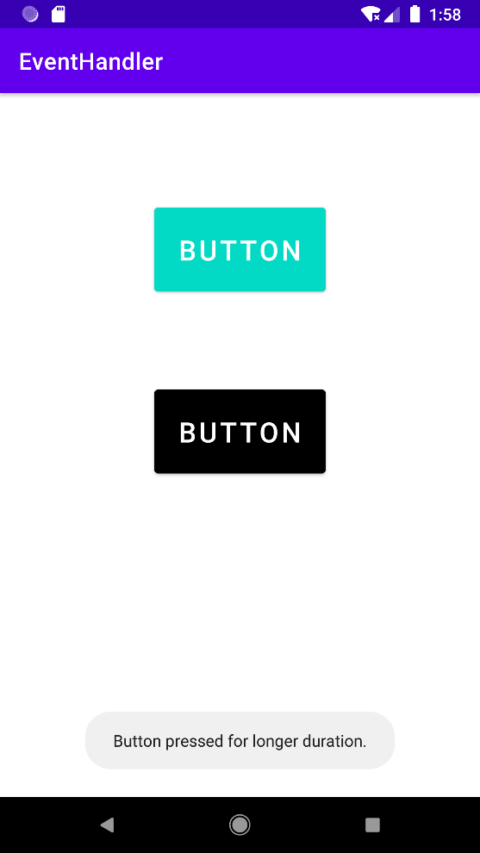 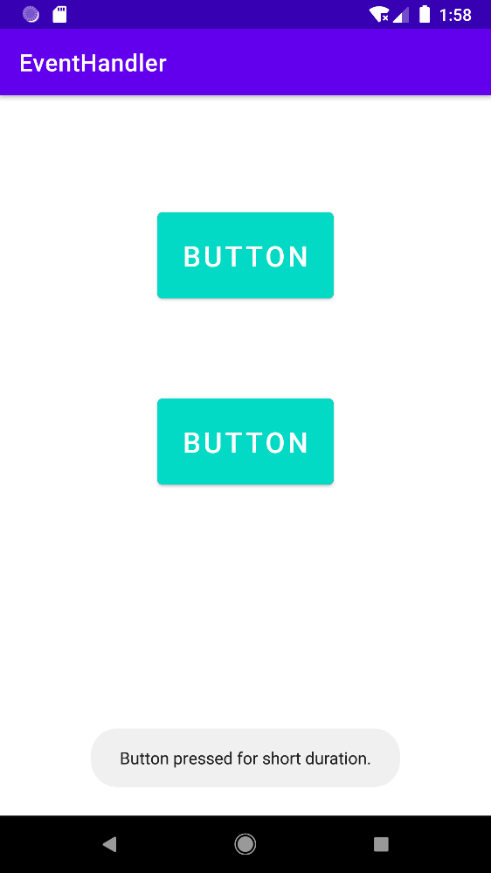

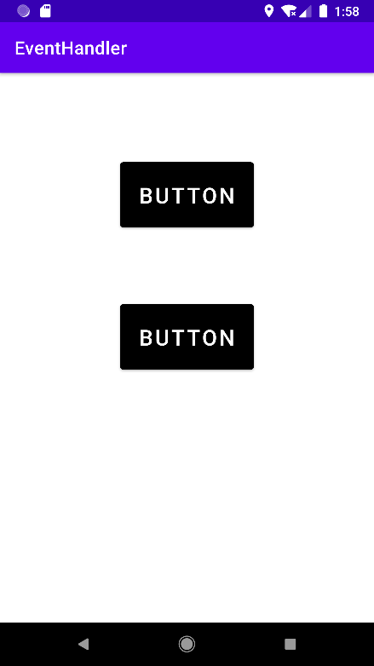

**Question 17 - Create an android application to insert an audio and play it using Media Player Class.**

**Solution –**

**activity_main.xml**

<androidx.constraintlayout.widget.ConstraintLayout xmlns:android="http://schemas.android.com/apk/res/android"

xmlns:app="http://schemas.android.com/apk/res-auto"

xmlns:tools="http://schemas.android.com/tools"

android:layout_width="match_parent"

android:layout_height="match_parent"

tools:context=".MainActivity">

<LinearLayout

android:layout_width="match_parent"

android:layout_height="600dp"

android:gravity="center"

android:orientation="horizontal"

app:layout_constraintBottom_toBottomOf="parent"

app:layout_constraintTop_toTopOf="parent">

<ImageView

android:id="@+id/imageView"

android:layout_width="50dp"

android:layout_height="50dp"

android:background="#4A4A4A"

android:onClick="pause"

app:srcCompat="@android:drawable/ic_media_pause"

tools:layout_editor_absoluteX="47dp"

tools:layout_editor_absoluteY="498dp" />

<ImageView

android:id="@+id/imageView2"

android:layout_width="50dp"

android:layout_height="50dp"

android:layout_marginStart="20dp"

android:layout_marginEnd="20dp"

android:background="#3E3D3D"

android:onClick="play"

app:srcCompat="@android:drawable/ic_media_play"

tools:layout_editor_absoluteX="162dp"

tools:layout_editor_absoluteY="498dp" />

<ImageView

android:id="@+id/imageView3"

android:layout_width="50dp"

android:layout_height="50dp"

android:onClick="stop"

app:srcCompat="@android:drawable/btn_dialog"

tools:layout_editor_absoluteX="287dp"

tools:layout_editor_absoluteY="498dp" />

</LinearLayout>

</androidx.constraintlayout.widget.ConstraintLayout>

**MainActivity.java**

package com.example.eventhandler;

import androidx.appcompat.app.AppCompatActivity;

import android.media.MediaPlayer;

import android.os.Bundle;

import android.view.View;

import android.widget.Toast;

public class MainActivity extends AppCompatActivity {

MediaPlayer player;

@Override

protected void onCreate(Bundle savedInstanceState) {

super.onCreate(savedInstanceState);

setContentView(R.layout.activity_main);

}

public void play(View view)

{

if(player==null)

{

player=MediaPlayer.create(this,R.raw.teejiseat);

}

player.start();

}

public void pause(View view)

{

if(player!=null)

{

player.pause();

} }

public void stop(View view)

{

StopPlayer(); }

public void StopPlayer(){

if(player!=null)

{

player.release();

player=null;

Toast.makeText(this, "Media Player is released",Toast.LENGTH_LONG).show();

}

}}

**Output –**

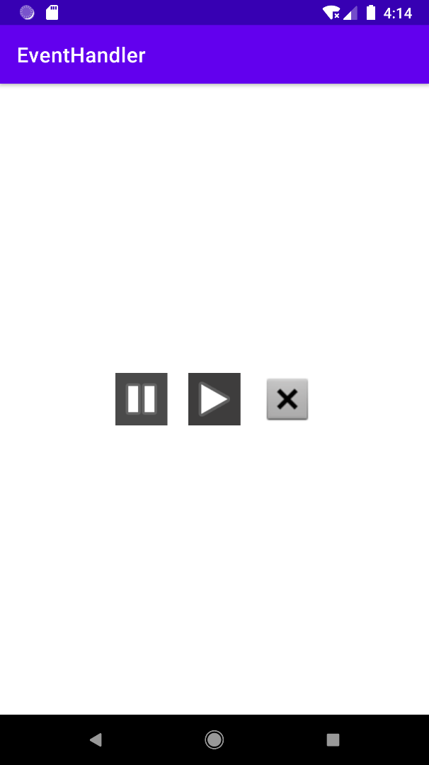

**Question 18 - Create an application in android to play a video and add some video controls using Media Controller class.**

**Solution –**

**activity_main.xml**

<?xml version="1.0" encoding="utf-8"?>  
<androidx.constraintlayout.widget.ConstraintLayout xmlns:android="http://schemas.android.com/apk/res/android"  
 xmlns:app="http://schemas.android.com/apk/res-auto"  
 xmlns:tools="http://schemas.android.com/tools"  
 android:layout_width="match_parent"  
 android:layout_height="match_parent"  
 tools:context=".MainActivity">  
  
 <VideoView  
 android:id="@+id/v1"  
 android:layout_width="match_parent"  
 android:layout_height="wrap_content"  
 app:layout_constraintBottom_toBottomOf="parent"  
 app:layout_constraintLeft_toLeftOf="parent"  
 app:layout_constraintRight_toRightOf="parent"  
 app:layout_constraintTop_toTopOf="parent"  
 />  
  
</androidx.constraintlayout.widget.ConstraintLayout>

**MainActivity.java**

package com.example.videoplayer;  
  
import androidx.appcompat.app.AppCompatActivity;  
  
import android.net.Uri;  
import android.os.Bundle;  
import android.widget.MediaController;  
import android.widget.VideoView;  
  
import java.net.URI;  
public class MainActivity extends AppCompatActivity {  
 VideoView vv1;  
 @Override  
 protected void onCreate(Bundle savedInstanceState) {  
 super.onCreate(savedInstanceState);  
 setContentView(R.layout.activity_main);

vv1 = findViewById(R.id.v1);  
 String path = "android.resource://"+getPackageName()+"/"+R.raw.worst;  
 Uri url = Uri.parse(path);  
 vv1.setVideoURI(url);  
  
 MediaController m = new MediaController(this);  
 vv1.setMediaController(m);  
 m.setAnchorView(vv1);  
 }  
}

**Output-**

**Question 19 - Create a program in android to display all the built-in sensors of emulator/machine.**

**Solution –**

**activity_main.xml**

<androidx.constraintlayout.widget.ConstraintLayout xmlns:android="http://schemas.android.com/apk/res/android"

xmlns:app="http://schemas.android.com/apk/res-auto"

xmlns:tools="http://schemas.android.com/tools"

android:layout_width="match_parent"

android:layout_height="match_parent"

tools:context=".MainActivity">

<ScrollView

android:layout_width="match_parent"

android:layout_height="match_parent"

app:layout_constraintBottom_toBottomOf="parent"

app:layout_constraintLeft_toLeftOf="parent"

app:layout_constraintRight_toRightOf="parent"

app:layout_constraintTop_toTopOf="parent">

<TextView

android:layout_width="wrap_content"

android:layout_height="wrap_content"

android:id="@+id/tv1"

android:text=""

android:lineSpacingExtra="20dp"

android:textSize="24sp"

android:textColor="@color/black"

android:textAlignment="center"

app:layout_constraintBottom_toBottomOf="parent"

app:layout_constraintLeft_toLeftOf="parent"

app:layout_constraintRight_toRightOf="parent"

app:layout_constraintTop_toTopOf="parent" />

</ScrollView>

</androidx.constraintlayout.widget.ConstraintLayout>

**MainActivity.java**

package com.example.sensors;

import androidx.appcompat.app.AppCompatActivity;

import android.hardware.Sensor;

import android.hardware.SensorManager;

import android.os.Bundle;

import android.widget.TextView;

import java.util.List;

public class MainActivity extends AppCompatActivity {

TextView tv1;

SensorManager sm;

int i;

@Override

protected void onCreate(Bundle savedInstanceState) {

super.onCreate(savedInstanceState);

setContentView(R.layout.activity_main);

tv1=findViewById(R.id.tv1);

sm=(SensorManager)getSystemService(SENSOR_SERVICE);

List<Sensor> mList=sm.getSensorList(Sensor.TYPE_ALL);

for (i = 1; i<mList.size(); i++)

{

tv1.append("\n"+mList.get(i).getName());

}

}

}

**Output –**

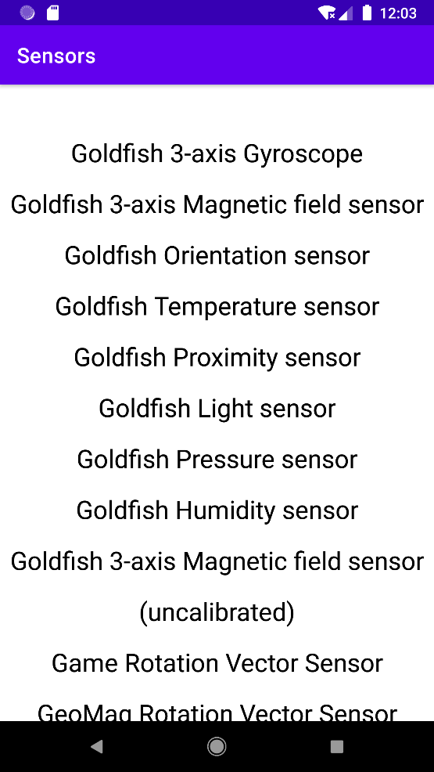

**Question 20 - Create an application in android to fetch data from one application's database into another's using content provider.**

**Solution –**

**activity_main.xml**

<androidx.constraintlayout.widget.ConstraintLayout xmlns:android="http://schemas.android.com/apk/res/android"

xmlns:app="http://schemas.android.com/apk/res-auto"

xmlns:tools="http://schemas.android.com/tools"

android:layout_width="match_parent"

android:layout_height="match_parent"

tools:context=".MainActivity">

<ScrollView

android:layout_width="match_parent"

android:layout_height="match_parent"

app:layout_constraintBottom_toBottomOf="parent"

app:layout_constraintHorizontal_bias="1.0"

app:layout_constraintLeft_toLeftOf="parent"

app:layout_constraintRight_toRightOf="parent"

app:layout_constraintTop_toTopOf="parent"

app:layout_constraintVertical_bias="1.0">

<Button

android:layout_width="wrap_content"

android:layout_height="wrap_content"

android:text="View Contacts"

android:layout_gravity="center"

android:onClick="Contacts"

android:backgroundTint="@color/black"/>

</ScrollView>

</androidx.constraintlayout.widget.ConstraintLayout>

**MainActivity.java**

package com.example.sensors;

public class MainActivity extends AppCompatActivity {

@Override

protected void onCreate(Bundle savedInstanceState) {

super.onCreate(savedInstanceState);

setContentView(R.layout.activity_main);

}

public void Contacts(View view)

{

getContacts();

}

public void getContacts()

{

if (ContextCompat.checkSelfPermission(this, Manifest.permission.READ_CONTACTS)!= PackageManager.PERMISSION_GRANTED)

{

ActivityCompat.requestPermissions(this,new String[]{Manifest.permission.READ_CONTACTS},0);

}

ContentResolver contentResolver=getContentResolver();

Uri uri= ContactsContract.CommonDataKinds.Phone.CONTENT_URI;

Cursor cursor=contentResolver.query(uri,null,null,null,null);

Log.i("Contacts","Total # of contacts:::"+Integer.toString(cursor.getCount()));

if (cursor.getCount()>0)

{

while (cursor.moveToNext()){

String contactName=cursor.getString(cursor.getColumnIndex(ContactsContract.CommonDataKinds.Phone.DISPLAY_NAME));

String contactNum=cursor.getString(cursor.getColumnIndex(ContactsContract.CommonDataKinds.Phone.NUMBER));

Log.i("Contacts","Contact Name::::"+contactName+"PH NUM::"+contactNum); }

} } }

**AndroidManifest.xml**

<?xml version="1.0" encoding="utf-8"?>

<manifest xmlns:android="http://schemas.android.com/apk/res/android"

package="com.example.sensors">

<uses-permission android:name="android.permission.READ_CONTACTS"/>

<uses-permission android:name="android.permission.WRITE_CONTACTS"/>

<application

android:allowBackup="true"

android:icon="@mipmap/ic_launcher"

android:label="@string/app_name"

android:roundIcon="@mipmap/ic_launcher_round"

android:supportsRtl="true"

android:theme="@style/Theme.Sensors">

<activity android:name=".MainActivity">

<intent-filter>

<action android:name="android.intent.action.MAIN" />

<category android:name="android.intent.category.LAUNCHER" />

</intent-filter>

</activity>

</application>

</manifest>

**Output –**

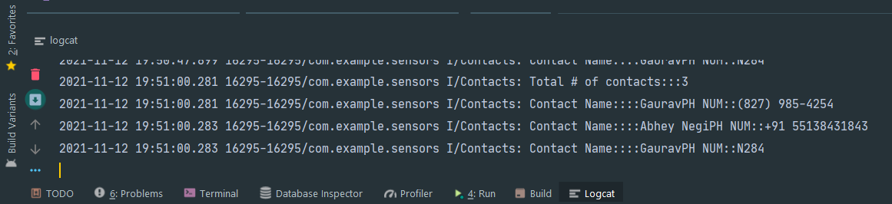

**Question 21 - Create an android application to show Internal storage.**

**Solution –**

**activity_main.xml**

<androidx.constraintlayout.widget.ConstraintLayout xmlns:android="http://schemas.android.com/apk/res/android"

xmlns:app="http://schemas.android.com/apk/res-auto"

xmlns:tools="http://schemas.android.com/tools"

android:layout_width="match_parent"

android:layout_height="match_parent"

android:backgroundTint="@color/white"

tools:context=".MainActivity">

<TextView

android:id="@+id/tv1"

android:layout_width="wrap_content"

android:layout_height="wrap_content"

android:layout_marginTop="24dp"

android:text="Internal Storage"

android:textColor="#673AB7"

android:textSize="24sp"

android:textStyle="bold"

app:layout_constraintEnd_toEndOf="parent"

app:layout_constraintStart_toStartOf="parent"

app:layout_constraintTop_toTopOf="parent" />

<EditText

android:id="@+id/et1"

android:layout_width="350dp"

android:layout_height="wrap_content"

android:layout_marginTop="96dp"

android:textColor="@color/black"

app:layout_constraintEnd_toEndOf="parent"

app:layout_constraintHorizontal_bias="0.491"

app:layout_constraintStart_toStartOf="parent"

app:layout_constraintTop_toBottomOf="@+id/tv1" />

<Button

android:id="@+id/bt1"

android:layout_width="wrap_content"

android:layout_height="wrap_content"

android:layout_marginStart="76dp"

android:layout_marginBottom="140dp"

android:backgroundTint="#090909"

android:text="Save"

android:textSize="18sp"

app:layout_constraintBottom_toBottomOf="parent"

app:layout_constraintStart_toStartOf="parent"

app:layout_constraintTop_toBottomOf="@+id/et1"

app:layout_constraintVertical_bias="0.323" />

<Button

android:id="@+id/bt2"

android:layout_width="wrap_content"

android:layout_height="wrap_content"

android:layout_marginEnd="76dp"

android:layout_marginBottom="140dp"

android:backgroundTint="#090909"

android:text="Load"

android:textSize="18sp"

app:layout_constraintBottom_toBottomOf="parent"

app:layout_constraintEnd_toEndOf="parent"

app:layout_constraintTop_toBottomOf="@+id/et1"

app:layout_constraintVertical_bias="0.323" />

</androidx.constraintlayout.widget.ConstraintLayout>

**MainActivity.java**

public class MainActivity extends AppCompatActivity {

EditText et1;

TextView tv1;

Button bt1, bt2;

String data;

private String file="My Data";

@Override

protected void onCreate(Bundle savedInstanceState) {

super.onCreate(savedInstanceState);

setContentView(R.layout.activity_main);

et1=findViewById(R.id.et1);

tv1=findViewById(R.id.tv1);

bt1=findViewById(R.id.bt1);

bt2=findViewById(R.id.bt2);

bt1.setOnClickListener(new View.OnClickListener() {

@Override

public void onClick(View view) {

data=et1.getText().toString();

try {

FileOutputStream fout=openFileOutput(file, Context.MODE_PRIVATE);

fout.write(data.getBytes());

Toast.makeText(getBaseContext(),"Save",Toast.LENGTH_SHORT).show();

}

catch (Exception e){

e.printStackTrace();

}

}

});

bt2.setOnClickListener(new View.OnClickListener() {

@Override

public void onClick(View view) {

try {

FileInputStream fin = openFileInput(file);

int c;

String temp = "";

while ((c = fin.read()) != -1) {

temp = temp + Character.toString((char) c);

}

tv1.setText(temp);

Toast.makeText(getBaseContext(), "Loaded", Toast.LENGTH_SHORT).show();

}

catch (Exception e){

e.printStackTrace();

}}});}}

**Output –**

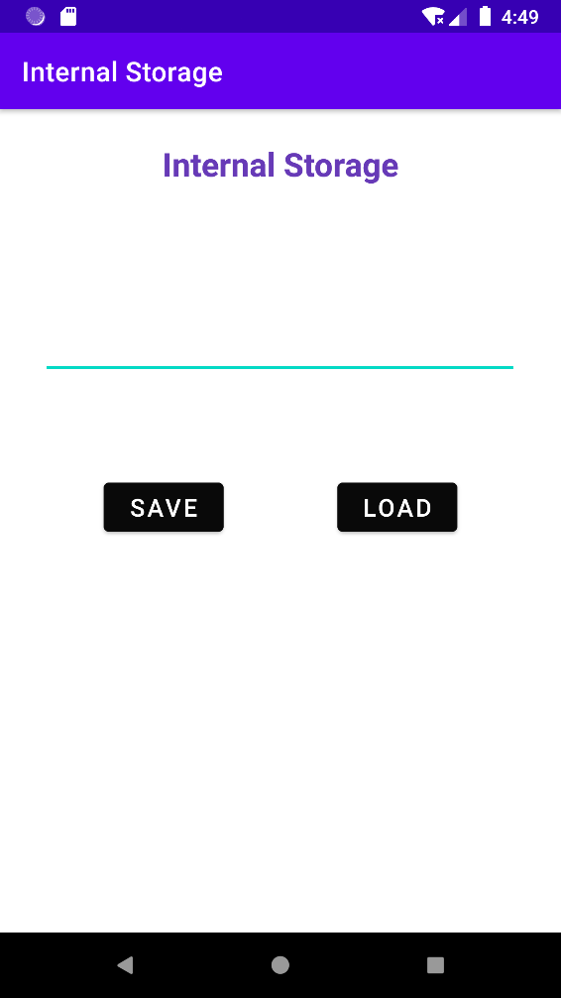

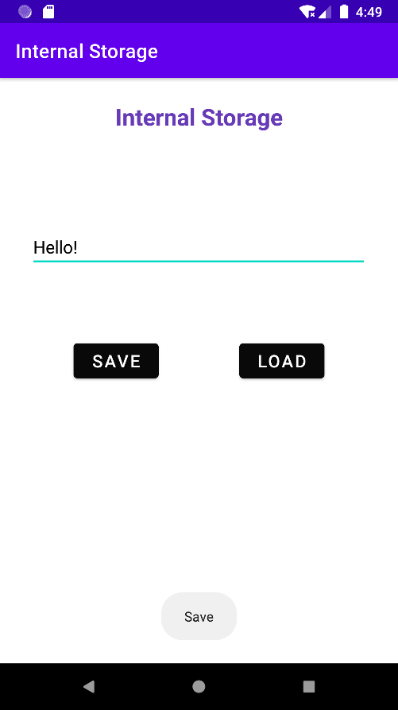 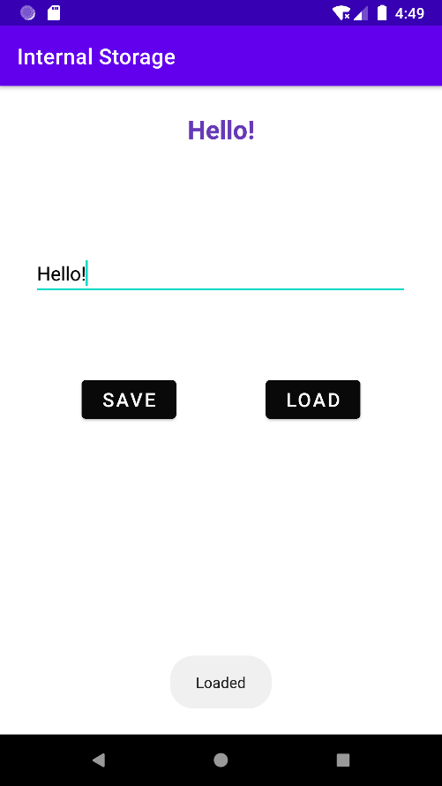

**Question 22 - Create an application to show shared preferences.**

**Solution –**

**activity_main.xml**

<androidx.constraintlayout.widget.ConstraintLayout xmlns:android="http://schemas.android.com/apk/res/android"

xmlns:app="http://schemas.android.com/apk/res-auto"

xmlns:tools="http://schemas.android.com/tools"

android:layout_width="match_parent"

android:layout_height="match_parent"

tools:context=".MainActivity">

<EditText

android:id="@+id/et1"

android:layout_width="350dp"

android:layout_height="wrap_content"

android:layout_marginTop="60dp"

android:text=""

android:hint="Name"

android:textColor="@color/black"

app:layout_constraintLeft_toLeftOf="parent"

app:layout_constraintRight_toRightOf="parent"

app:layout_constraintTop_toTopOf="parent" />

<EditText

android:id="@+id/et2"

android:layout_width="350dp"

android:layout_height="wrap_content"

android:layout_marginTop="65dp"

android:text=""

android:hint="Phone Number"

android:textColor="@color/black"

app:layout_constraintHorizontal_bias="0.491"

app:layout_constraintLeft_toLeftOf="parent"

app:layout_constraintRight_toRightOf="parent"

app:layout_constraintTop_toTopOf="@+id/et1" />

<EditText

android:id="@+id/et3"

android:layout_width="350dp"

android:layout_height="wrap_content"

android:layout_marginTop="65dp"

android:hint="Email"

android:text=""

android:textColor="@color/black"

app:layout_constraintBottom_toBottomOf="parent"

app:layout_constraintHorizontal_bias="0.508"

app:layout_constraintLeft_toLeftOf="parent"

app:layout_constraintRight_toRightOf="parent"

app:layout_constraintTop_toTopOf="@+id/et2"

app:layout_constraintVertical_bias="0.008" />

</androidx.constraintlayout.widget.ConstraintLayout>

**MainActivity.java**

package com.example.sharedpreferences;

import androidx.appcompat.app.AppCompatActivity;

public class MainActivity extends AppCompatActivity {

EditText et1,et2,et3;

SharedPreferences sharedPreferences;

@Override

protected void onCreate(Bundle savedInstanceState) {

super.onCreate(savedInstanceState);

setContentView(R.layout.activity_main);

et1=findViewById(R.id.et1);

et2=findViewById(R.id.et2);

et3=findViewById(R.id.et3);

}

@Override

protected void onResume(){

super.onResume();

SharedPreferences sharedPreferences=getSharedPreferences("MyPREFERENCES",MODE_PRIVATE);

String n=sharedPreferences.getString("et1","");

String pn=sharedPreferences.getString("et2","");

String e=sharedPreferences.getString("et3","");

et1.setText(n);

et2.setText(pn);

et3.setText(e);

}

@Override

protected void onPause(){

super.onPause();

SharedPreferences sharedPreferences=getSharedPreferences("MyPREFERENCES",MODE_PRIVATE);

SharedPreferences.Editor editor=sharedPreferences.edit();

editor.putString("et1",et1.getText().toString());

editor.putString("et2",et2.getText().toString());

editor.putString("et3",et3.getText().toString());

editor.apply();

Toast.makeText(MainActivity.this, "Data is Saved", Toast.LENGTH_SHORT).show();

}

}

**Output –**

**Question 23 - Create a program in android to show CRUD operations using SQLite Databases and cursor.**

**Solution –**

**activity_main.xml**

<RelativeLayout xmlns:android="http://schemas.android.com/apk/res/android"

xmlns:tools="http://schemas.android.com/tools"

android:layout_width="match_parent"

android:layout_height="match_parent"

android:layout_gravity="center"

android:gravity="center"

android:orientation="vertical"

tools:context=".MainActivity">

<EditText

android:layout_width="match_parent"

android:layout_height="wrap_content"

android:id="@+id/ed1"

android:hint="Enter Data"/>

<LinearLayout

android:layout_width="match_parent"

android:layout_height="wrap_content"

android:orientation="horizontal"

android:layout_gravity="center"

android:gravity="center">

<Button

android:layout_width="wrap_content"

android:layout_height="wrap_content"

android:text="Insert"

android:onClick="insert"

android:layout_margin="10dp"/>

<Button

android:layout_width="wrap_content"

android:layout_height="wrap_content"

android:text="Read"

android:onClick="read"

android:layout_margin="10dp"/>

<Button

android:layout_width="wrap_content"

android:layout_height="wrap_content"

android:text="Delete"

android:onClick="delete"

android:layout_margin="10dp"/>

</LinearLayout>

<TextView

android:layout_width="match_parent"

android:layout_height="wrap_content"

android:text="Click on read to load data."

android:gravity="center"

android:id="@+id/display"/>

</RelativeLayout>

**MainActivity.java**

import androidx.appcompat.app.AppCompatActivity;

import android.database.Cursor;

import android.database.sqlite.SQLiteDatabase;

import android.icu.text.UnicodeSetSpanner;

import android.os.Bundle;

import android.view.View;

import android.widget.Button;

import android.widget.EditText;

import android.widget.TextView;

import android.widget.Toast;

public class MainActivity extends AppCompatActivity {

SQLiteDatabase db;

Cursor c;

TextView display;

@Override

protected void onCreate(Bundle savedInstanceState) {

super.onCreate(savedInstanceState);

setContentView(R.layout.activity_main);

db= openOrCreateDatabase("mydb",MODE_PRIVATE,null);

db.execSQL("create table if not exists stud(name varchar2(200) not null)");

}

public void insert(View view){

String name="";

EditText ed = (EditText) findViewById(R.id.ed1);

name = ed.getText().toString();

db.execSQL("insert into stud(name) values(\""+name+"\")");

}

public void read(View view){

String sql = "Select * from stud";

display = findViewById(R.id.display);

try{

c = db.rawQuery(sql,null);

if(c.getCount()==0){

display.setText("No data");

}

else{

c.moveToFirst();

String name = c.getString(0);

display.setText(name);

}

}

catch(Exception e){

e.printStackTrace();

}

}

public void delete(View view){

try {

String sql = "delete from stud";

db.execSQL(sql);

}

catch(Exception e){

e.printStackTrace();

}

}

}

**Output –**

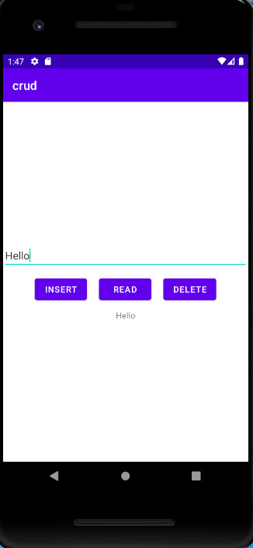

**Question 24- Create a program to depict Bluetooth Adapter class.**

**Solution –**

**activity_main.xml**

<RelativeLayout  
 xmlns:android="http://schemas.android.com/apk/res/android"  
 xmlns:tools="http://schemas.android.com/tools"  
 android:layout_width="match_parent"  
 android:layout_height="match_parent"  
 tools:context=".MainActivity"  
 android:transitionGroup="true">  
 <Button  
 android:id="@+id/button"  
 android:layout_width="wrap_content"  
 android:layout_height="wrap_content"  
 android:layout_alignParentStart="true"  
 android:layout_alignParentTop="true"  
 android:layout_marginStart="2dp"  
 android:layout_marginTop="2dp"  
 android:layout_marginEnd="103dp"  
 android:layout_marginRight="103dp"  
 android:clickable="true"  
 android:onClick="on"  
 android:text="Turn On" />  
 <Button  
 android:id="@+id/button2"  
 android:layout_width="wrap_content"  
 android:layout_height="wrap_content"  
 android:layout_alignBottom="@+id/button"  
 android:layout_alignParentTop="true"  
 android:layout_alignParentEnd="true"  
 android:layout_centerHorizontal="true"  
 android:layout_marginTop="2dp"  
 android:layout_marginEnd="160dp"  
 android:layout_marginBottom="1dp"  
 android:onClick="visible"  
 android:text="Get visible" />  
 <Button  
 android:id="@+id/button3"  
 android:layout_width="124dp"  
 android:layout_height="38dp"  
 android:layout_alignParentTop="true"  
 android:layout_alignParentEnd="true"  
 android:layout_marginStart="74dp"  
 android:layout_marginLeft="74dp"  
 android:layout_marginTop="4dp"  
 android:layout_marginEnd="15dp"

android:onClick="list"  
 android:text="List devices" />  
 <Button  
 android:id="@+id/button4"  
 android:layout_width="wrap_content"  
 android:layout_height="37dp"  
 android:layout_below="@+id/button"  
 android:layout_alignParentStart="true"  
 android:layout_alignParentLeft="true"  
 android:onClick="off"  
 android:text="turn off" />  
 <ListView  
 android:layout_width="wrap_content"  
 android:layout_height="wrap_content"  
 android:id="@+id/listView"  
 android:layout_alignParentBottom="true"  
 android:layout_alignLeft="@+id/button"  
 android:layout_alignStart="@+id/button"  
 android:layout_below="@+id/textView2" />  
 <TextView  
 android:layout_width="wrap_content"  
 android:layout_height="wrap_content"  
 android:text="Paired devices:"  
 android:id="@+id/textView2"  
 android:textColor="#ff34ff06"  
 android:textSize="25dp"  
 android:layout_below="@+id/button4"  
 android:layout_alignLeft="@+id/listView"  
 android:layout_alignStart="@+id/listView" />  
</RelativeLayout>

**MainActivity.java**

package com.example.bluetooth;  
import androidx.appcompat.app.AppCompatActivity;  
import android.bluetooth.BluetoothAdapter;  
import android.bluetooth.BluetoothDevice;  
import android.content.Intent;  
import android.os.Bundle;  
import android.view.View;  
import android.widget.ArrayAdapter;  
import android.widget.Button;  
import android.widget.ListView;  
import android.widget.Toast;  
import java.util.ArrayList;  
import java.util.Set;  
public class MainActivity extends AppCompatActivity {

Button b1,b2,b3,b4;

private BluetoothAdapter BA;  
 private Set<BluetoothDevice> pairedDevices;  
 ListView lv;  
 @Override  
 protected void onCreate(Bundle savedInstanceState) {  
 super.onCreate(savedInstanceState);  
 setContentView(R.layout.*activity_main*);  
 b1 = (Button) findViewById(R.id.*button*);  
 b2=(Button)findViewById(R.id.*button2*);  
 b3=(Button)findViewById(R.id.*button3*);  
 b4=(Button)findViewById(R.id.*button4*);  
 BA = BluetoothAdapter.*getDefaultAdapter*();  
 lv = findViewById(R.id.*listView*);  
 }  
 public void on(View v){  
 if (!BA.isEnabled()) {  
 Intent turnOn = new Intent(BluetoothAdapter.*ACTION_REQUEST_ENABLE*);  
 onActivityResult(0,0,turnOn);  
 Toast.*makeText*(getApplicationContext(), "Turned on",Toast.*LENGTH_LONG*).show();  
 } else {  
 Toast.*makeText*(getApplicationContext(), "Already on", Toast.*LENGTH_LONG*).show();  
 }  
 }  
 public void off(View v){  
 BA.disable();  
 Toast.*makeText*(getApplicationContext(), "Turned off" ,Toast.*LENGTH_LONG*).show();  
 }  
  
 public void visible(View v){  
 Intent getVisible = new Intent(BluetoothAdapter.*ACTION_REQUEST_DISCOVERABLE*);  
 onActivityResult(0,0,getVisible);  
 }  
  
 public void list(View v){  
 pairedDevices = BA.getBondedDevices();  
 ArrayList list = new ArrayList();  
 for(BluetoothDevice bt : pairedDevices) list.add(bt.getName());  
 Toast.*makeText*(getApplicationContext(), "Showing Paired Devices",Toast.*LENGTH_SHORT*).show();  
  
 final ArrayAdapter adapter = new ArrayAdapter(this,android.R.layout.*simple_list_item_1*, list);  
 lv.setAdapter(adapter);  
 }  
}

**Output –**

**Question 25 - Create a Google Maps application using android.**

**Solution –**

**MainActivity.java**

package com.example.googlemap;

import androidx.fragment.app.FragmentActivity;

import android.os.Bundle;

import com.google.android.gms.maps.CameraUpdateFactory;

import com.google.android.gms.maps.GoogleMap;

import com.google.android.gms.maps.OnMapReadyCallback;

import com.google.android.gms.maps.SupportMapFragment;

import com.google.android.gms.maps.model.LatLng;

import com.google.android.gms.maps.model.MarkerOptions;

import com.example.googlemap.databinding.ActivityMapsBinding;

public class MapsActivity extends FragmentActivity implements OnMapReadyCallback {

private GoogleMap mMap;

private ActivityMapsBinding binding;

@Override

protected void onCreate(Bundle savedInstanceState) {

super.onCreate(savedInstanceState);

binding = ActivityMapsBinding.inflate(getLayoutInflater());

setContentView(binding.getRoot());

// Obtain the SupportMapFragment and get notified when the map is ready to be used.

SupportMapFragment mapFragment = (SupportMapFragment) getSupportFragmentManager()

.findFragmentById(R.id.map);

mapFragment.getMapAsync(this);

}

@Override

public void onMapReady(GoogleMap googleMap) {

mMap = googleMap;

mMap.setMapType(GoogleMap.MAP_TYPE_HYBRID);

LatLng India = new LatLng(30.183472, 78.174234);

mMap.addMarker(new MarkerOptions().position(India).title("Marker in Sydney"));

mMap.moveCamera(CameraUpdateFactory.newLatLng(India));

}

}

**AndroidManifest.xml**

<?xml version="1.0" encoding="utf-8"?>

<manifest xmlns:android="http://schemas.android.com/apk/res/android"

package="com.example.googlemap">

<uses-permission android:name="android.permission.ACCESS_FINE_LOCATION" />

<uses-permission android:name="android.permission.INTERNET"/>

<uses-permission android:name="android.permission.ACCESS_COARSE_LOCATION"/>

<uses-permission android:name="android.permission.REQUEST_INSTALL_PACKAGES"/>

<application

android:allowBackup="true"

android:icon="@mipmap/ic_launcher"

android:label="@string/app_name"

android:roundIcon="@mipmap/ic_launcher_round"

android:supportsRtl="true"

android:theme="@style/Theme.GoogleMap">

<meta-data

android:name="com.google.android.geo.API_KEY"

android:value="@string/google_maps_key" />

<activity

android:name=".MapsActivity"

android:label="@string/title_activity_maps">

<intent-filter>

<action android:name="android.intent.action.MAIN" />

<category android:name="android.intent.category.LAUNCHER" />

</intent-filter>

</activity>

</application>

</manifest>

**Output -**

