CSS Float

The **CSS float property** is *a positioning property*. It is used *to push an element to the left or right*, allowing other element to wrap around it. It is generally used with images and layouts.

To understand its purpose and origin, let's take a look to its print display. In the print display, image is set into the page such that text wraps around it as needed.

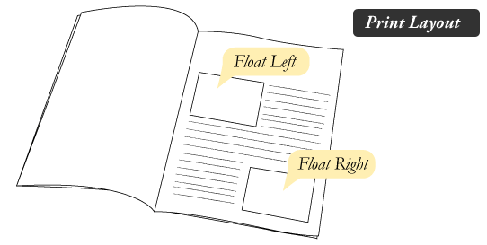

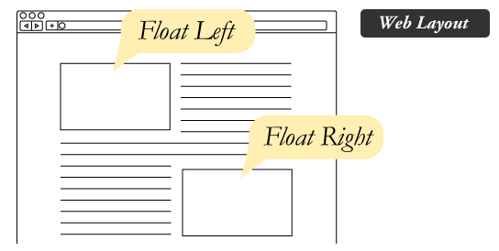

## How it works

Elements are floated only horizontally. So it is possible only to float elements left or right, not up or down.

1. A floated element may be moved as far to the left or the right as possible. Simply, it means that a floated element can display at extreme left or extreme right.
2. The elements after the floating element will flow around it.
3. The elements before the floating element will not be affected.
4. If the image floated to the right, the texts flow around it, to the left and if the image floated to the left, the text flows around it, to the right.

## CSS Float Properties

|  |  |  |
| --- | --- | --- |
| **Property** | **Description** | **Values** |
| clear | The clear property is used to avoid elements after the floating elements which flow around it. | left, right, both, none, inherit |
| float | It specifies whether the box should float or not. | left, right, none, inherit |

## CSS Float Property Values

|  |  |
| --- | --- |
| **Value** | **Description** |
| none | It specifies that the element is not floated, and will be displayed just where it occurs in the text. this is a default value. |
| left | It is used to float the element to the left. |
| right | It is used to float the element to the right. |
| initial | It sets the property to its initial value. |

# CSS Font

CSS Font property is used to control the look of texts. By the use of CSS font property you can change the text size, color, style and more. You have already studied how to make text bold or underlined. Here, you will also know how to resize your font using percentage.

These are some important font attributes:

1. **CSS Font color**: This property is used to change the color of the text. (standalone attribute)
2. **CSS Font family**: This property is used to change the face of the font.
3. **CSS Font size**: This property is used to increase or decrease the size of the font.
4. **CSS Font style**: This property is used to make the font bold, italic or oblique.
5. **CSS Font variant**: This property creates a small-caps effect.
6. **CSS Font weight**: This property is used to increase or decrease the boldness and lightness of the font.

## 1) CSS Font Color

CSS font color is a standalone attribute in [CSS](https://www.javatpoint.com/css-tutorial) although it seems that it is a part of CSS fonts. It is used to change the color of the text.

## 2) CSS Font Family

CSS font family can be divided in two types:

* Generic family: It includes Serif, Sans-serif, and Monospace.
* Font family: It specifies the font family name like Arial, New Times Roman etc.

**Serif**: Serif fonts include small lines at the end of characters. Example of serif: Times new roman, Georgia etc.

**Sans-serif**: A sans-serif font doesn't include the small lines at the end of characters. Example of Sans-serif: Arial, Verdana etc.

## 3) CSS Font Size

CSS font size property is used to change the size of the font.

These are the possible values that can be used to set the font size:

|  |  |
| --- | --- |
| **Font Size Value** | **Description** |
| xx-small | used to display the extremely small text size. |
| x-small | used to display the extra small text size. |
| small | used to display small text size. |
| medium | used to display medium text size. |
| large | used to display large text size. |
| x-large | used to display extra large text size. |
| xx-large | used to display extremely large text size. |
| smaller | used to display comparatively smaller text size. |
| larger | used to display comparatively larger text size. |
| size in pixels or % | used to set value in percentage or in pixels. |

1. **html>**
2. **<head>**
3. **<title>**Practice CSS font-size property**</title>**
4. **</head>**
5. **<body>**
6. **<p** style="font-size:xx-small;"**>**  This font size is extremely small.**</p>**
7. **<p** style="font-size:x-small;"**>**  This font size is extra small**</p>**
8. **<p** style="font-size:small;"**>**  This font size is small**</p>**
9. **<p** style="font-size:medium;"**>**  This font size is medium. **</p>**
10. **<p** style="font-size:large;"**>**  This font size is large. **</p>**
11. **<p** style="font-size:x-large;"**>**  This font size is extra large. **</p>**
12. **<p** style="font-size:xx-large;"**>**  This font size is extremely large. **</p>**
13. **<p** style="font-size:smaller;"**>**  This font size is smaller. **</p>**
14. **<p** style="font-size:larger;"**>**  This font size is larger. **</p>**
15. **<p** style="font-size:200%;"**>**  This font size is set on 200%. **</p>**
16. **<p** style="font-size:20px;"**>**  This font size is 20 pixels.  **</p>**
17. **</body>**
18. **</html>**

## 4) CSS Font Style

CSS Font style property defines what type of font you want to display. It may be [italic](https://www.javatpoint.com/html-em-tag), oblique, or normal.

1. body {
2. font-size: 100%;
3. }
4. h2 { font-style: italic; }
5. h3 { font-style: oblique; }
6. h4 { font-style: normal; }
7. }

## 5) CSS Font Variant

CSS font variant property specifies how to set font variant of an element. It may be normal and small-caps.

1. <!DOCTYPE html**>**
2. **<html>**
3. **<head>**
4. **<style>**
5. p { font-variant: small-caps; }
6. h3 { font-variant: normal; }
7. **</style>**
8. **</head>**
9. **<body>**
10. **<h3>**This heading is shown in normal font.**</h3>**
11. **<p>**This paragraph is shown in small font.**</p>**
12. **</body>**
13. **</html>**

## 6) CSS Font Weight

CSS font weight property defines the weight of the font and specify that how bold a font is. The possible values of font weight may be normal, bold, bolder, lighter or number (100, 200..... upto 900).

1. <!DOCTYPE html**>**
2. **<html>**
3. **<body>**
4. **<p** style="font-weight:bold;"**>**This font is bold.**</p>**
5. **<p** style="font-weight:bolder;"**>**This font is bolder.**</p>**
6. **<p** style="font-weight:lighter;"**>**This font is lighter.**</p>**
7. **<p** style="font-weight:100;"**>**This font is 100 weight.**</p>**
8. **<p** style="font-weight:200;"**>**This font is 200 weight.**</p>**
9. **<p** style="font-weight:300;"**>**This font is 300 weight.**</p>**
10. **<p** style="font-weight:400;"**>**This font is 400 weight.**</p>**
11. **<p** style="font-weight:500;"**>**This font is 500 weight.**</p>**
12. **<p** style="font-weight:600;"**>**This font is 600 weight.**</p>**
13. **<p** style="font-weight:700;"**>**This font is 700 weight.**</p>**
14. **<p** style="font-weight:800;"**>**This font is 800 weight.**</p>**
15. **<p** style="font-weight:900;"**>**This font is 900 weight.**</p>**
16. **</body>**

# CSS Margin

CSS Margin property is used to define the space around elements. It is completely transparent and doesn't have any background color. It clears an area around the element.

Top, bottom, left and right margin can be changed independently using separate properties. You can also change all properties at once by using shorthand margin property.

There are following [CSS](https://www.javatpoint.com/css-tutorial) margin properties:

## CSS Margin Properties

|  |  |
| --- | --- |
| **Property** | **Description** |
| margin | This property is used to set all the properties in one declaration. |
| margin-left | it is used to set left margin of an element. |
| margin-right | It is used to set right margin of an element. |
| margin-top | It is used to set top margin of an element. |
| margin-bottom | It is used to set bottom margin of an element. |

## CSS Margin Values

These are some possible values for margin property.

|  |  |
| --- | --- |
| **Value** | **Description** |
| auto | This is used to let the browser calculate a margin. |
| length | It is used to specify a margin pt, px, cm, etc. its default value is 0px. |
| % | It is used to define a margin in percent of the width of containing element. |

1. p.ex {
2. margin-top: 50px;
3. margin-bottom: 50px;
4. margin-right: 100px;
5. margin-left: 100px;
6. }