**Procedure-**

Given-

* + Starting coordinates = (X0, Y0)
  + Ending coordinates = (Xn, Yn)
  + The points generation using DDA Algorithm involves the following steps-

**Step-01:**

* Calculate ΔX, ΔY and M from the given input.
* These parameters are calculated as-
* ΔX = Xn – X0 ΔY =Yn – Y0
* M = ΔY / ΔX

**Step-02:**

* Find the number of steps or points in between the starting and ending coordinates.
* if (absolute (ΔX) > absolute (ΔY))

Steps = absolute (ΔX);

else

Steps = absolute (ΔY);

**Step-03:**

* **Suppose the current point is (Xp, Yp) and the next point is (Xp+1, Yp+1).**
* **Find the next point by following the below three cases-**

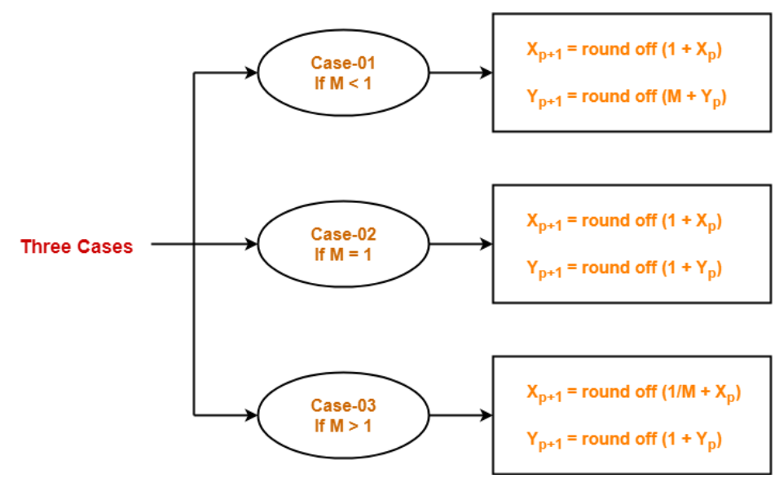

**Step-04**

* Keep repeating Step-03 until the end point is reached or the number of generated new points (including the starting and ending points) equals to the steps count.