# e-Voting

## A Project Report

Seminar Report submitted in partial fulfillment of the requirements for the award of the degree of BCA

**by**

**Malyaj Nailwal**

Regd. No. : 1921091

### Under the Guidance of

**Dr. Chandrakala Arya**

### (Assistant Professor)



# DEPARTMENT OF SOC

## GEHU

**06- 2022**

## CERTIFICATE

This is to certify that the Seminar entitled e-Voting presented by Malyaj Nailwal

bearing **Registration No. 1921091** of **GEHU, Dehradun** has been completed successfully.

This is in partial fulfillment of the requirements of Bachelor’s Degree in **GEHU, Dehradun**.

I wish her/ him success in all future endeavors.

(Asst./Asso./Prof., SOC)

## Acknowledgements

I would like to express my deep and sincere gratitude to my guide(s), Asst. Prof Dr. Chandrakala Arya, of GEHU, Dehradun for his/her/their unflagging support and continuous encouragement throughout the seminar/project work. Without his/her/their guidance and persistent help this report would not have been possible.

I must acknowledge the faculties and staffs of GEHU Dehradun.

It’s my great pleasure to acknowledge my colleagues for providing an opportunity, I am

especially grateful to my teacher.

**Name: Malyaj Nailwal**

**SOC**

**GEHU Dehradun**

**Regd. No. - 1921091**

# 

Table of Contents

Abstract 4

Chapter 1 5

Introduction 5

Chapter 2 6

Literature Review 6

Chapter 3 7

Proposed Work 7

Hardware and Software Requirements 8

Software Requirements 8

Hardware Requirements 10

Chapter 4 12

Result & Discussion 12

Chapter 5 30

Conclusion 30

Chapter 6 32

References 32

# 

# Abstract

Elections and voting are an essential part of democracy. With the development of Information and Communication Technology, an online voting system has appeared and is being actively developed. E-voting is the latest and most convenient approach to voting in elections. In general, the electronic voting process includes: End-user as a voting terminal. Implementation of ballot website and web server as electronic station, ballot processing and result counting. Internet as a means of communication and ballot delivery between users and districts. Despite the potential for security vulnerabilities, many different countries have already attempted to implement and use an online voting system. e- Voting technology intends to speed up the counting of ballots, reduce the cost of paying staff to count votes manually and can provide improved accessibility for disabled voters and who are not present in their constituency. Also in the long term, expenses are expected to decrease. Results can be reported and published faster. e-Voting is fast and easy service than traditional system. The online voting system provides a less time consuming poll. It reduces paper work and makes the work less tedious for the electoral commission. By this, voting percentage has increased drastically. There is convenience in this system, since every eligible person can cast his/her vote at his convenience and comfort.

There are two modules in the Project. Admin Module and Voter Module. In Admin Module the admin has the power to registered a candidate who is electing. Also admin can checks the voting status and at final the voter’s tally is projected through Admin panel. Before resulting the final result the Admin has to input a password which will be unique and different from Admin Login credentials. The voter module has the power to registered themselves in e-Voting before casting vote. Afterwards the voter login using it’s username and password. The voter afterwards cast his vote. Vote can be cast only once. And logout than successfully. The major functionalities of e-Voting system is : mobility, the voter should not be restricted to cast his ballot at a single poll-site at his nearby precinct. He shall be able to vote from any poll-site within the nation. Convenience, the system shall allow the voters to cast their votes quickly, in one session, and should not require many special skills or intimidate the voter (to ensure Equality of Access to Voters). Accuracy, the system shall record and count all the votes and shall do so correctly. Voter Confirmation, the voter shall be able to confirm clearly how his vote is being cast, and shall be given a chance to modify his vote before he commits it.Voter Anonymity, ensure that votes must not be associated with voter identity. Data Integrity, ensure that each vote is recorded as intended and cannot be tampered with in any manner, once recorded (i.e., votes should not be modified, forged or deleted without detection).

**Signature of the Student**

**Name : Malyaj Nailwal**

**Regn. No : 1921091**

**Semester : 6th**

**Branch : -**

**Section : A**

**Date : 01-06-2022**

# Chapter 1

## Introduction

India is a constitutional democracy with a parliamentary government, at the heart of which is the obligation to hold regular, free and fair elections. These elections determine the composition of the government, the two chambers of parliament, the legislatures of the states and territories, and the composition of the president and vice president. Elections are held in accordance with the provisions of the Constitution supplemented by the law passed by Parliament. The purpose of the project is to create and manage voting and election details. This is a system that allows all citizens to vote online. The main goal of this project is to increase the national voting share. Citizens need to visit the booth to vote for the current system across the country. Because the system is online, people who live outside their hometown can also vote. The system maintains a database of all eligible citizens.  
  
The online voting system has gained its own importance since the NRI Voting Rights Act was passed by Congress on February 11, 2011. .. The new law allows Indians residing abroad to register and exercise their voting rights even if they have lived in India for more than 6 months for employment, education or other reasons. In this case, the person must attend the election day and exercise his right to vote in the constituency. Electronic voting (“awakening”) is the possibility of participating in referendums and elections by electronic means. There are various systems such as B. Direct Recording Electronic Voting Machine (DRE). Record your vote directly without sending it over the internet or other networks. For example, the interface of the DRE machine can be a touch screen or the voter can fill it out. Put it on the ballot and scan it into the system. Most commonly, electronic voting refers to voting on the Internet using a personal computer (PC) connected to the Internet.   
  
It makes sense to distinguish between the two voting concepts of "polling place electronic voting" and "remote electronic voting". "Voting at a polling place" refers to a system in which voters vote at a polling place or a similar facility managed by polling place staff. "Remote voting" is used to describe a system in which voters vote anywhere outside the polling place. Both may be relevant to the purpose of this topic. There are various ways to facilitate external voting using electronic means. The most difficult thing is to give foreign voters the opportunity to send electronic votes. For example, voting on a PC and voting on an electronic ballot box over the Internet. Voting can also be conducted in a supervised environment of diplomatic or consular missions. However, in the course of this research, we did not find any cases where the latter solution was considered. Only remote voting seems to be an option for external voting  
  
Therefore, our project, e-Voting, aims to improve the opportunity for outside voters who are not present in their constituency and increase the voting percentage for the growth and future aspects of the country.

# Chapter 2

## Literature Review

Electronic voting refers to the use of computers or computerized voting equipment to cast ballots in an election. Sometimes, this term is used more specifically to refer to voting that takes place over the Internet. It makes sense to distinguish between the two voting concepts of "polling place electronic voting" and "remote electronic voting". "Voting at a polling place" refers to a system in which voters vote at a polling place or a similar facility managed by polling place staff. "Remote voting" is used to describe a system in which voters vote anywhere outside the polling place. Although the number of countries that have adopted e-voting has decreased lately, the number of academic publications on e-voting adoption has increased in the last two years. To date, there is no coherent narrative in the existing literature that explains the progress of the research on e-voting adoption.[I] The evolution of blockchain-based systems has enabled researchers to develop next-generation e-voting systems. However, the classical consensus method of blockchain, that is, Proof-of-Work, as implemented in Bitcoin, has a significant impact on energy consumption and compromises the scalability, efficiency, and latency of the system. In this paper, we propose a hybrid consensus model (PSC-Bchain) composed of Proof of Credibility and Proof of Stake that work mutually to address the aforementioned problems to secure e-voting systems.[II] In recent years, many works have focused on improving traditional voting mechanisms and, as a result, a wide range of electronic voting (e-Voting) systems have been proposed. Even though some approaches have achieved a proper level of usability, the main challenges of e-Voting are essentially still open: protect the privacy of participants, guarantee secrecy, anonymity, integrity, uniqueness, and authenticity of votes, while making e-Voting as trustful as voting.

In order to address this issue, we present SecureBallot, a secure open-source e-Voting system that completely decouples the voter identification and voting phases by means of proven cryptographic technologies.[III]Attackers legally receive customer passwords and use secret passwords to major sites. Consider a corporate voting system based on the web, electing a president or secretary or key managers of the organization once a year. This survey presents a secure verifiable online voting system, which allows voters to vote secretly in the public system to benefit from early voting and it will very useful in pandemic like Covid-19. The proposed system is intended to universally support the election process by using the unique identification and biometric features of the elector. A digital witness is provided to a voter by the system to check if the voting is recorded as it intends and to check whether all the registered votes are recorded.[IV] Under the well-known elliptic curve of the Daffie – Hellman hypotheses, the privacy of the proposed system is achieved. In the current system, every elector must collect and cast his or her vote at one point on election day. We will use an alternative system called cryptography in this method. Here we split the unique image into two, four, placed in separate databases.

# Chapter 3

## Proposed Work

The new implemented voting protocol has two main players: The voter and administrator sections. The voter(which can be found at home, in a working station, in a special polling station or any other device have the fuction of performing the Authentication and voting).The administrator performs the function of voter and candidate registration, authorization and validation of voter, database and counting and the result.

The main advantages of the new protocol are the following:

1) Public transparency by the administrator (publication of Voter ID key, etc.).

2) Inured to technical troubles like interruption of access, etc, uncomplicated recovery.

3)Possibility of configuration for different voting models by policies and Greater performance.

Furthermore it is assumed that a trustworthy Administrator is available. Apart from that, the accessibility to the public in the voting procedure plays a special role, which means that the voting result can be monitored, although casting of the votes has to be secret as a matter of course.

Accessibility to the public is necessary for all voting stages and is performed by the electoral committee, but also by any member of the public.

## Proposed Approach

# e-Voting is a challenging approach for increasing e-Participation. However, lack of citizens' trust seems to be a main obstacle that hinders its successful realization. In this paper we propose a trust-centered engineering approach for building e-Voting systems that people can trust, based on transparent design and implementation phases. The approach is based on three components: the decomposition of e-Voting systems into "layers of trust" for reducing the complexity of managing trust issues in smaller manageable layers, the application of a risk analysis methodology able to identify and document security critical aspects of the e-Voting system, and a cryptographically secure e-Voting protocol. Our approach is pragmatic rather than theoretical in the sense that it sidesteps the controversy that besets the nature of trust in information systems and starts with a working definition of trust as people's positive attitude towards a system that performs its operations transparently.

## **Hardware and Software Requirements**

### Software Requirements

Languages:

HTML

Hypertext Markup Language (HTML) is the standard markup language for documents designed to be viewed in a web browser. It can be supported by technologies such as cascading style sheets (CSS) and scripting languages ​​such as JavaScript. The web browser receives the HTML document from the web server or local storage and renders the document into a multimedia web page. HTML semantically describes the structure of a website and originally contains information about the appearance of the document. The  
HTML element is a component of an HTML page. You can use the HTML structure to embed other objects such as images and interactive forms in the rendered page. HTML provides a way to create structured documents by displaying the structural semantics of text such as headings, paragraphs, lists, links, citations, and other elements. HTML elements are separated by tags enclosed in angle brackets. HTML can embed programs written in scripting languages ​​such as JavaScript and affect the behavior and content of web pages. Including CSS defines the appearance and layout of your content. The World Wide Web Consortium (W3C), the former maintainer of HTML and the current maintainer of the CSS standard, has been promoting the use of CSS over explicit presentation HTML since 1997.

CSS

Cascading Style Sheets (CSS) is a style sheet language used for describing the presentation of a document written in a markup language such as HTML. CSS is a cornerstone technology of the World Wide Web, alongside HTML and JavaScript. CSS is designed to enable the separation of presentation and content, including layout, colors, and fonts. This separation can improve content accessibility; provide more flexibility and control in the specification of presentation characteristics; enable multiple web pages to share formatting by specifying the relevant CSS in a separate .css file, which reduces complexity and repetition in the structural content; and enable the .css file to be cached to improve the page load speed between the pages that share the file and its formatting. Separation of formatting and content also makes it feasible to present the same markup page in different styles for different rendering methods, such as onscreen, in print, by voice (via speech based browser or screen reader), and on Braille based tactile devices. CSS also has rules for alternate formatting if the content is accessed on a mobile device. The name cascading comes from the specified priority scheme to determine which style rule applies if more than one rule matches a particular element. This cascading priority scheme is predictable. The CSS specifications are maintained by the World Wide Web Consortium (W3C).

JavaScript

JavaScript often abbreviated JS, is a programming language that is one of the core technologies of the World Wide Web, alongside HTML and CSS. Over 97% of websites use JavaScript on the client side for web page behavior, often incorporating third party libraries. All major web browsers have a dedicated JavaScript engine to execute the code on users' devices. JavaScript is a high level, often just in time compiled language that conforms to the ECMA Script standard. It has dynamic typing, prototype based object orientation, and first class functions. It is multi paradigm, supporting event driven, functional, and imperative programming styles. It has application programming interfaces (APIs) for working with text, dates, regular expressions, standard data structures, and the Document Object Model (DOM).The ECMA Script standard does not include any input/output (I/O), such as networking, storage, or graphics facilities. In practice, the web browser or other runtime system provides JavaScript APIs for I/O. JavaScript engines were originally used only in web browsers, but are now core components of some servers and a variety of applications. The most popular runtime system for this usage is Node.js. Although Java and JavaScript are similar in name, syntax, and respective standard libraries, the two languages are distinct and differ greatly in design.

PHP

PHP is a [general-purpose](https://en.wikipedia.org/wiki/General-purpose_programming_language) [scripting language](https://en.wikipedia.org/wiki/Scripting_language) geared toward [web development](https://en.wikipedia.org/wiki/Web_development). It was originally created by Danish-Canadian [programmer](https://en.wikipedia.org/wiki/Programmer) [Rasmus Lerdorf](https://en.wikipedia.org/wiki/Rasmus_Lerdorf) in 1994. The PHP [reference implementation](https://en.wikipedia.org/wiki/Reference_implementation) is now produced by The PHP Group. PHP originally stood for Personal Home Page, but it now stands for the [recursive initialism](https://en.wikipedia.org/wiki/Recursive_initialism) PHP: Hypertext Pre processor. PHP code is usually processed on a [web server](https://en.wikipedia.org/wiki/Web_server) by a PHP [interpreter](https://en.wikipedia.org/wiki/Interpreter_(computing)) implemented as a [module](https://en.wikipedia.org/wiki/Plugin_(computing)), a [daemon](https://en.wikipedia.org/wiki/Daemon_(computing)) or as a [Common Gateway Interface](https://en.wikipedia.org/wiki/Common_Gateway_Interface) (CGI) executable. On a web server, the result of the [interpreted](https://en.wikipedia.org/wiki/Interpreter_(computing)) and executed PHP code – which may be any type of data, such as generated [HTML](https://en.wikipedia.org/wiki/HTML) or [binary](https://en.wikipedia.org/wiki/Binary_number) image data – would form the whole or part of an [HTTP](https://en.wikipedia.org/wiki/Hypertext_Transfer_Protocol) response. Various [web template systems](https://en.wikipedia.org/wiki/Web_template_system), web [content management systems](https://en.wikipedia.org/wiki/Content_management_system), and [web frameworks](https://en.wikipedia.org/wiki/Web_framework) exist which can be employed to orchestrate or facilitate the generation of that response. Additionally, PHP can be used for many programming tasks outside the web context, such as standalone [graphical applications](https://en.wikipedia.org/wiki/Graphical_user_interface) and [robotic](https://en.wikipedia.org/wiki/Robotics) [drone](https://en.wikipedia.org/wiki/Unmanned_aerial_vehicle) control. PHP code can also be directly executed from the [command line](https://en.wikipedia.org/wiki/Command-line_interface).The standard PHP interpreter, powered by the [Zend Engine](https://en.wikipedia.org/wiki/Zend_Engine), is [free software](https://en.wikipedia.org/wiki/Free_software) released under the [PHP License](https://en.wikipedia.org/wiki/PHP_License). PHP has been widely ported and can be deployed on most web servers on a variety of [operating systems](https://en.wikipedia.org/wiki/Operating_system) and [platforms](https://en.wikipedia.org/wiki/Computing_platform). The PHP language evolved without a written [formal specification](https://en.wikipedia.org/wiki/Formal_specification) or standard until 2014, with the original implementation acting as the [de facto](https://en.wikipedia.org/wiki/De_facto) standard which other implementations aimed to follow. Since 2014, work has gone on to create a formal PHP specification. W3Techs reports that, as of January 2022, "PHP is used by 78.1% of all the websites whose server-side programming language we know." PHP version 7.4 is the most used version. Support for version 7.3 was dropped on 6 December 2021.

MySQL

MySQL provides our small, medium and large enterprise customers with affordable, open access to their web data warehouses. MySQL allows us to offer our System Administrator low cost, low maintenance database solution for applications without sacrificing power, performance or scalability.

Benefits of MySQL are as follows:

* Easy to maintain & upgrade, does not have a slew of administrative tasks to put up.
* Its table format does not vary between releases
* It has cleanly separated table handler modules and can mix access to different type of tables.
* It seems to be developed iteratively, and the features are very stable when they ship them.

It is a relational database. Over the past several years, this relational database management systems have become the most widely accepted way to manage data.

It offers benefits such as:

* Easy to access data
* Flexibility in data modeling
* Reduced data storage and redundancy
* Independence of physical storage and logical data design

A high level data manipulation language

Software/Tools:

Visual Studio Code

Visual Studio Code is a source-code editor that can be used with a variety of programming languages, including [Java](https://en.wikipedia.org/wiki/Java_(programming_language)), [JavaScript](https://en.wikipedia.org/wiki/JavaScript), [Go](https://en.wikipedia.org/wiki/Go_(programming_language)), [Node.js](https://en.wikipedia.org/wiki/Node.js), [Python](https://en.wikipedia.org/wiki/Python_(programming_language)), [C++](https://en.wikipedia.org/wiki/C%2B%2B) and [Fortran](https://en.wikipedia.org/wiki/Fortran). It is based on the [Electron](https://en.wikipedia.org/wiki/Electron_(software_framework)) framework which is used to develop [Node.js](https://en.wikipedia.org/wiki/Node.js) [Web applications](https://en.wikipedia.org/wiki/Web_application) that run on the [Blink layout engine](https://en.wikipedia.org/wiki/Blink_layout_engine). Visual Studio Code employs the same editor component (codenamed "Monaco") used in [Azure Dev Ops](https://en.wikipedia.org/wiki/Azure_DevOps_Server) (formerly called Visual Studio Online and Visual Studio Team Services). Out of the box, Visual Studio Code includes basic support for most common programming languages. This basic support includes [syntax highlighting](https://en.wikipedia.org/wiki/Syntax_highlighting), [bracket matching](https://en.wikipedia.org/wiki/Bracket_matching), [code folding](https://en.wikipedia.org/wiki/Code_folding), and configurable snippets. Visual Studio Code also ships with [IntelliSense](https://en.wikipedia.org/wiki/Intelligent_code_completion) for JavaScript, Type Script, [JSON](https://en.wikipedia.org/wiki/JSON), [CSS](https://en.wikipedia.org/wiki/CSS), and [HTML](https://en.wikipedia.org/wiki/HTML), as well as debugging support for Node.js. Support for additional languages can be provided by freely available extensions on the VS Code Marketplace. Instead of a project system, it allows users to open one or more directories, which can then be saved in workspaces for future reuse. This allows it to operate as a [language-agnostic](https://en.wikipedia.org/wiki/Language-agnostic) code editor for any language. It supports many programming languages and a set of features that differs per language. Unwanted files and folders can be excluded from the project tree via the settings. Many Visual Studio Code features are not exposed through menus or the user interface but can be accessed via the command palette. Visual Studio Code can be extended via [extensions](https://en.wikipedia.org/wiki/Plug-in_(computing)),[]](https://en.wikipedia.org/wiki/Visual_Studio_Code#cite_note-extensions-24) available through a central repository. This includes additions to the editor and language support. A notable feature is the ability to create extensions that add support for new [languages](https://en.wikipedia.org/wiki/Programming_language), [themes](https://en.wikipedia.org/wiki/Theme_(computing)), and [debuggers](https://en.wikipedia.org/wiki/Debugger), perform [static code analysis](https://en.wikipedia.org/wiki/Static_code_analysis), and add [code linters](https://en.wikipedia.org/wiki/Lint_(software)) using the [Language Server Protocol](https://en.wikipedia.org/wiki/Language_Server_Protocol).

### Hardware Requirements

In order to implement a new system the choice of processor with maximum possible speed is made. There should be sufficient memory to store data and software tools for efficient processing.

|  |
| --- |
| System : IBM-Compatible PC |
| Processor : Pentium IV |
| Speed : 2.0 GHz |
| Memory : 256 MB RAM |
| Hard Disk Drive : 40 GB |
| Bandwidth :15Mbps |
| Disk space of server : 200GB |

# 

# Chapter 4

## Result & Discussion

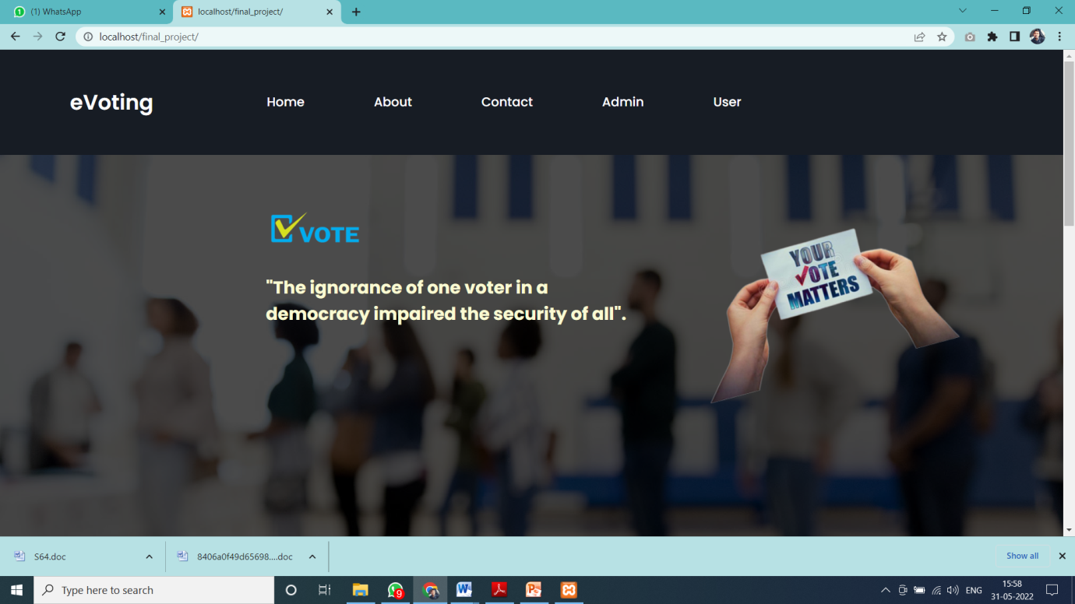

Homepage of e-Voting

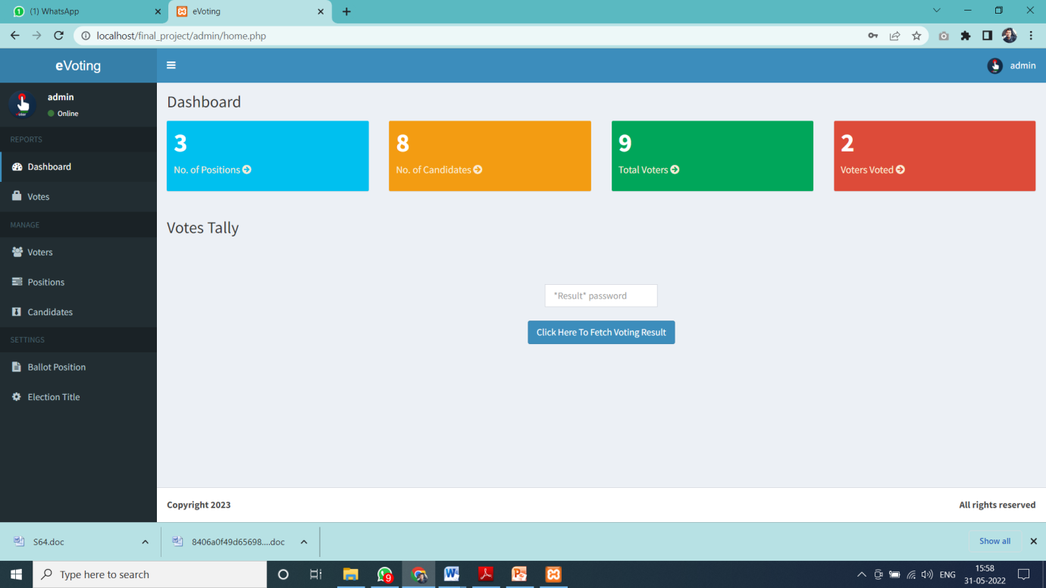

Admin panel of e-Voting

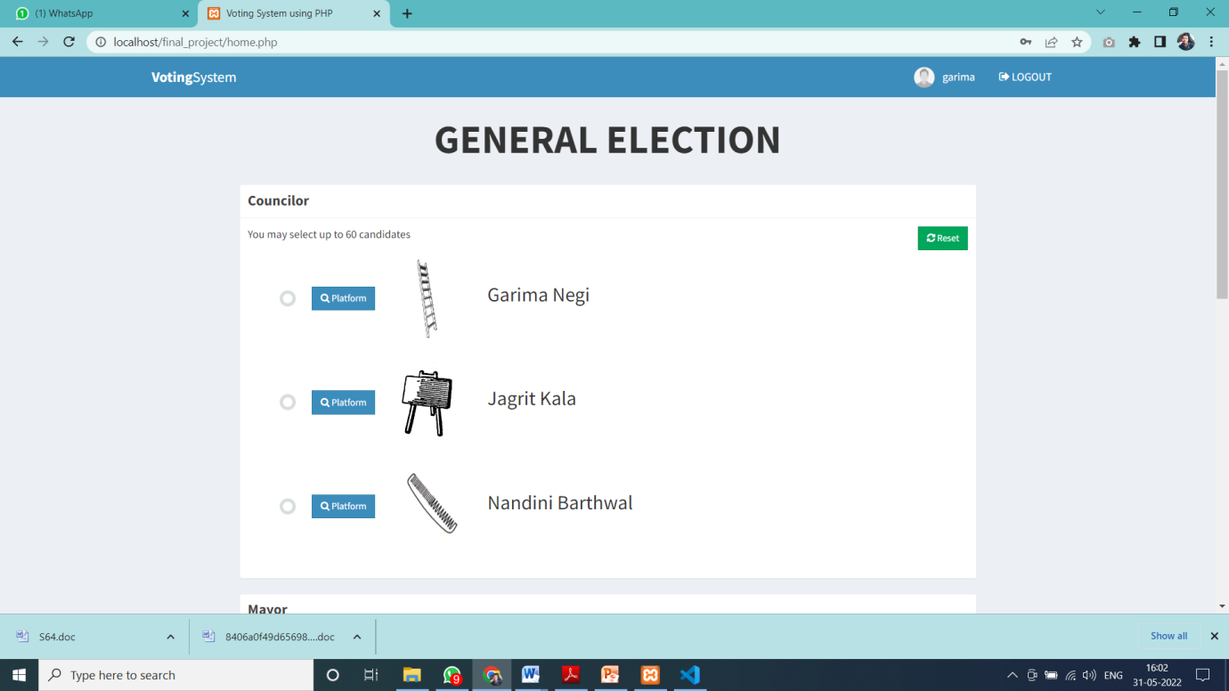

User-panel for e-Voting

index.php

<!DOCTYPE html>

<html lang="en">

<head>

<meta charset="UTF-8">

<meta name="viewport" content="width=device-width, initial-scale=1.0">

<meta http-equiv="X-UA-Compatible" content="ie=edge">

<link rel="stylesheet" href="navstyle.css">

<link rel="stylesheet" href="styleweb2.css">

<link rel="stylesheet" href="https://cdnjs.cloudflare.com/ajax/libs/font-awesome/5.15.3/css/all.min.css"/>

</head>

<body>

<div class="wrapper">

<nav>

<input type="checkbox" id="show-menu">

<label for="show-menu" class="menu-icon"><i class="fas fa-bars"></i></label>

<div class="content">

<div class="logo"><a href="index.php">eVoting</a></div>

<ul class="links">

<li><a href="index.php">Home</a></li>

<li><a href="#about">About</a></li>

<li><a href="#contact">Contact</a></li>

<li><a href="admin/index.php">Admin</a></li>

<li><a href="index1.php">User</a></li>

</ul>

</div>

</nav>

</div>

<section class="background firstsection">

<div class="boxmain">

<div class="firsthalf">

<img src="vote.png" width="140px">

<p class="smalltext" ><font face="Lucida Calligraphy" color="#fafad2"><br>"The ignorance of one voter in a democracy impaired the security of all".</font> </p>

</div>

<div class="secondhalf">

<img src="votingsystem1.png" height="400px">

<a id="about"></a>

</section>

<div class="paras">

<p class="sectiontag"><br><br><img src="about.jpg" width="200"><br><br></p>

<p class="sectionsubtag">

India is a Socialist, Secular, Democratic Republic and the largest democracy in the World. The modern Indian nation state came into existence on 15th of August 1947. Since then free and fair elections have been held at regular intervals as per the principles enshrined in the Constitution, Electoral Laws and System. The Constitution of India has vested in the Election Commission of India the superintendence, direction and control of the entire process for conduct of elections to Parliament and Legislature of every State and to the offices of President and Vice-President of India. Election Commission of India is a permanent Constitutional Body. The Election Commission was established in accordance with the Constitution on 25th January 1950. The Commission celebrated its Golden Jubilee in 2001. Originally the commission had only a Chief Election Commissioner. It currently consists of Chief Election Commissioner and two Election Commissioners. For the first time two additional Commissioners were appointed on 16th October 1989 but they had a very short tenure till 1st January 1990. Later, on 1st October 1993 two additional Election Commissioners were appointed. The concept of multi-member Commission has been in operation since then, with decision making power by majority vote. The Commission has a separate Secretariat at New Delhi, consisting of about 300 officials, in a hierarchical set up. India is the largest democracy of the world and the elections of India are the largest election exercise. The people of India directly elect the Prime Minister by participating in the General/ Lok Sabha elections every five years.

The election commission of India is the apex and powerful body that administers elections. It employs Electronic Voting Machines (EVMs) for the election process. The elections for 17th Lok Sabha were scheduled between 11 April to 19 May 2019. BJP emerged as a single largest party winning 303 seats and Narendra Modi once again became the Prime Minister after 2014.

eVote is an election system that facilitates voters to record their secure and secret ballot electronically. It has a friendly user interface and enables voters to cast their votes in few simple steps. We ensures the authenticity of the voters and the votes cast by them along with non-traceability of the casted vote. eVote's robust architecture has persistently manifested to be one of the most reliable, comprehensible and economical electronic voting solution. It renders Simple and Accessible voter experience that eventually increases voter engagement and turnout. Auditable, Easy To Use, Secure and Reliable is what sets eVote apart from its competitors. eVote has facilitated several organizations, across a wide range of industries to conduct hassle-free electronic <a id="contact"></a> voting with utmost security and integrity. Some of our fortes include outstanding and prompt customer support, highly secure and trustworthy elections and last but not the least; our potential to be able to tabulate expeditious and accurate results. We’d welcome the opportunity to work with you to provide exceptional and unparalleled service and add you to our ever-growing list of satisfied clients.

<a id="contact"></a>

</div>

<div class="contact-section">

<h1><br>Contact Us</h1>

<div class="border"></div>

<form class="contact-form" action="contact.php" method="post" enctype = "multipart/form-data">

<input type="text" name="name" class="contact-form-text" placeholder="Your name">

<input type="email" name="email" class="contact-form-text" placeholder="Your email">

<input type="text" name="phone" class="contact-form-text" placeholder="Your phone">

<textarea class="contact-form-text" name="message" placeholder="Your message"></textarea>

<input type="submit" class="contact-form-btn" value="Send">

</form>

</div>

<footer class="footer">

<p class="text-footer">

Copyright &copy: 2023 - All rights reserved

</p>

</footer>

</body>

</html>

Database connectivity:

<?php

$conn = new mysqli('localhost', 'root', '', 'votesystem');

if ($conn->connect_error) {

die("Connection failed: " . $conn->connect_error);

}

?>

Admin (home.php)

<?php include 'includes/session.php'; ?>

<?php include 'includes/slugify.php'; ?>

<?php include 'includes/header.php'; ?>

<style>

a:link

{

color:antiquewhite;

}

a:hover

{

color:violet;

}

a:visited

{

color:antiquewhite;

}

</style>

<body class="hold-transition skin-blue sidebar-mini">

<div class="wrapper">

<?php include 'includes/navbar.php'; ?>

<?php include 'includes/menubar.php'; ?>

<!-- Content Wrapper. Contains page content -->

<div class="content-wrapper">

<!-- Content Header (Page header) -->

<section class="content-header">

<h1>

Dashboard

</h1>

</section>

<!-- Main content -->

<section class="content">

<?php

if(isset($_SESSION['error'])){

echo "

<div class='alert alert-danger alert-dismissible'>

<button type='button' class='close' data-dismiss='alert' aria-hidden='true'>&times;</button>

<h4><i class='icon fa fa-warning'></i> Error!</h4>

".$_SESSION['error']."

</div>

";

unset($_SESSION['error']);

}

if(isset($_SESSION['success'])){

echo "

<div class='alert alert-success alert-dismissible'>

<button type='button' class='close' data-dismiss='alert' aria-hidden='true'>&times;</button>

<h4><i class='icon fa fa-check'></i> Success!</h4>

".$_SESSION['success']."

</div>

";

unset($_SESSION['success']);

}

?>

<!-- Small boxes (Stat box) -->

<div class="row">

<div class="col-lg-3 col-xs-6">

<!-- small box -->

<div class="small-box bg-aqua">

<div class="inner">

<?php

$sql = "SELECT * FROM positions";

$query = $conn->query($sql);

echo "<h3>".$query->num_rows."</h3>";

?>

<p><a href="positions.php" class="small-box-footer">No. of Positions <i class="fa fa-arrow-circle-right"></i></a></p>

</div>

<!-- ./col -->

<div class="col-lg-3 col-xs-6">

<!-- small box -->

<div class="small-box bg-yellow">

<div class="inner">

<?php

$sql = "SELECT * FROM candidates";

$query = $conn->query($sql);

echo "<h3>".$query->num_rows."</h3>";

?>

<p><a href="candidates.php" class="small-box-footer">No. of Candidates <i class="fa fa-arrow-circle-right"></i></a></p>

</div>

</div>

</div>

<!-- ./col -->

<div class="col-lg-3 col-xs-6">

<!-- small box -->

<div class="small-box bg-green">

<div class="inner">

<?php

$sql = "SELECT * FROM voters";

$query = $conn->query($sql);

echo "<h3>".$query->num_rows."</h3>";

?>

<p> <a href="voters.php" class="small-box-footer">Total Voters <i class="fa fa-arrow-circle-right"></i></a></p>

</div>

</div>

</div>

<!-- ./col -->

<div class="col-lg-3 col-xs-6">

<!-- small box -->

<div class="small-box bg-red">

<div class="inner">

<?php

$sql = "SELECT * FROM votes GROUP BY voters_id";

$query = $conn->query($sql);

echo "<h3>".$query->num_rows."</h3>";

?>

<p><a href="votes.php" class="small-box-footer">Voters Voted <i class="fa fa-arrow-circle-right"></i></a></p>

</div>

</div>

</div>

<!-- ./col -->

</div>

<div class="row">

<div class="col-xs-12">

<h3>Votes Tally</h3>

<br><br><br>

<center>

<form method="post" action="checkpass.php" >

<div style="width: 13%;"><input type="password" name="resultpass" class="form-control" placeholder="*Result* password" required></div><br>

<div style="width: 35%;"><input type="submit" value="Click Here To Fetch Voting Result" class="btn btn-primary" class="form-control" ></div>

</form>

</center>

</div>

</div>

</section>

<!-- right col -->

</div>

<?php include 'includes/footer.php'; ?>

<?php include 'includes/scripts.php'; ?>

</div>

<!-- ./wrapper -->

</body>

</html>

User: (home.php)

<?php include 'includes/session.php'; ?>

<?php include 'includes/header.php'; ?>

<?php include 'includes/conn.php'; ?>

<body class="hold-transition skin-blue layout-top-nav">

<div class="wrapper">

<?php include 'includes/navbar.php'; ?

<div class="content-wrapper">

<div id="response"></div>

<script type="text/javascript">

setInterval(function()

{

var xmlhttp=new XMLHttpRequest();

xmlhttp.open("GET","response.php".false);

xmlhttp.send(null);

document.getElementById("response").innerHTML=xmlhttp.responseText;

},1000);

</script>

<div class="container">

<!-- Main content -->

<section class="content">

<?php

$parse = parse_ini_file('admin/config.ini', FALSE, INI_SCANNER_RAW);

$title = $parse['election_title'];

?>

<h1 class="page-header text-center title"><b><?php echo strtoupper($title); ?></b></h1>

<div class="row">

<div class="col-sm-10 col-sm-offset-1">

<?php

if(isset($_SESSION['success'])){

echo "

<div class='alert alert-success alert-dismissible'>

<button type='button' class='close' data-dismiss='alert' aria-hidden='true'>&times;</button>

<h4><i class='icon fa fa-check'></i> Success!</h4>

".$_SESSION['success']."

</div>

";

unset($_SESSION['success']);

}

?>

<div class="alert alert-danger alert-dismissible" id="alert" style="display:none;">

<button type="button" class="close" data-dismiss="alert" aria-hidden="true">&times;</button>

<span class="message"></span>

</div>

<?php

$sql = "SELECT * FROM votes WHERE voters_id = '".$voter['id']."'";

$vquery = $conn->query($sql);

if($vquery->num_rows > 0){

?>

<div class="text-center">

<h3>You have already voted for this election.</h3>

<a href="#view" data-toggle="modal" class="btn btn-flat btn-primary btn-lg">View Ballot</a>

</div>

<?php

}

else{

?>

<!-- Voting Ballot -->

<form method="POST" id="ballotForm" action="submit_ballot.php">

<?php

include 'includes/slugify.php';

$candidate = '';

$sql = "SELECT * FROM positions ORDER BY priority ASC";

$query = $conn->query($sql);

while($row = $query->fetch_assoc()){

$sql = "SELECT * FROM candidates WHERE position_id='".$row['id']."'";

$cquery = $conn->query($sql);

while($crow = $cquery->fetch_assoc()){

$slug = slugify($row['description']);

$checked = '';

if(isset($_SESSION['post'][$slug])){

$value = $_SESSION['post'][$slug];

if(is_array($value)){

foreach($value as $val){

if($val == $crow['id']){

$checked = 'checked';

}

} }

else{

if($value == $crow['id']){

$checked = 'checked';

}

}

$input = ($row['max_vote'] > 1) ? '<input type="radio" class="flat-red '.$slug.'" name="'.$slug."[]".'" value="'.$crow['id'].'" '.$checked.'>' : '<input type="radio" class="flat-red '.$slug.'" name="'.slugify($row['description']).'" value="'.$crow['id'].'" '.$checked.'>';

$image = (!empty($crow['photo'])) ? 'images/'.$crow['photo'] : 'images/profile.jpg';

$candidate .= '<li>

'.$input.'<button type="button" class="btn btn-primary btn-sm btn-flat clist platform" data-platform="'.$crow['platform'].'" data-fullname="'.$crow['firstname'].' '.$crow['lastname'].'"><i class="fa fa-search"></i> Platform</button><img src="'.$image.'" height="100px" width="100px" class="clist"><span class="cname clist">'.$crow['firstname'].' '.$crow['lastname'].'</span>

</li>'; }

$instruct = ($row['max_vote'] > 1) ? 'You may select up to '.$row['max_vote'].' candidates' : 'Select only one candidate';

echo '

<div class="row">

<div class="col-xs-12"><div class="box box-solid" id="'.$row['id'].'">

<div class="box-header with-border">

<h3 class="box-title"><b>'.$row['description'].'</b></h3>

</div>

<div class="box-body">

<p>'.$instruct.'

<span class="pull-right">

<button type="button" class="btn btn-success btn-sm btn-flat reset" data-desc="'.slugify($row['description']).'"><i class="fa fa-refresh"></i> Reset</button>

</span> </p> <div id="candidate_list"> <ul> '.$candidate.' </ul> </div> </div> </div> </div>

</div>

';

$candidate = '';

}

?>

<div class="text-center">

<button type="button" class="btn btn-success btn-flat" id="preview"><i class="fa fa-file-text"></i> Preview</button>

<button type="submit" class="btn btn-primary btn-flat" name="vote"><i class="fa fa-check-square-o"></i> Submit</button>

</div>

</form>

<?php

}

?>

</div>

</div>

</section>

</div>

</div>

<?php include 'includes/ballot_modal.php'; ?>

</div>

<?php include 'includes/scripts.php'; ?>

<script>

$(function(){

$('.content').iCheck({

checkboxClass: 'icheckbox_flat-green',

radioClass: 'iradio_flat-green'

});

$(document).on('click', '.reset', function(e){

e.preventDefault();

var desc = $(this).data('desc');

$('.'+desc).iCheck('uncheck');

});

$(document).on('click', '.platform', function(e){

e.preventDefault();

$('#platform').modal('show');

var platform = $(this).data('platform');

var fullname = $(this).data('fullname');

$('.candidate').html(fullname);

$('#plat_view').html(platform);

});

$('#preview').click(function(e){

e.preventDefault();

var form = $('#ballotForm').serialize();

if(form == ''){

$('.message').html('You must vote atleast one candidate');

$('#alert').show();

}

else{

$.ajax({

type: 'POST',

url: 'preview.php',

data: form,

dataType: 'json',

success: function(response){

if(response.error){

var errmsg = '';

var messages = response.message;

for (i in messages) {

errmsg += messages[i];

}

$('.message').html(errmsg);

$('#alert').show();

}

else{

$('#preview_modal').modal('show');

$('#preview_body').html(response.list);

}

}

});

}

});

});

</script>

</body>

</html>

The primary advantage of an electronic voting machine is its speed. With traditional paper methods, ballots must be collected and counted from polling stations. This process is time-consuming and delays the final result. Another major plus of electronic voting is voter engagement. Many people fail to take advantage of their right to elect their officials, even when Google begs them to vote. Advocates for e-voting argue that by offering an option to vote from home or work, more people would cast their votes. Electronic voting also allows for greater accessibility to people with disabilities. Currently, someone unable to mark paper ballots requires an assistant to vote for them. This process compromises the person’s right to cast an anonymous ballot. By bringing voting into the digital space, people who are unable to visit or use a polling booth can vote from home. This maintains anonymity and encourages the disabled and elderly to make their voices heard. Electronic ballot-counting machines can cut the cost of human counters, while internet voting can also cut out polling location employees. The infrastructure can be re-used every election, so it would be a one-time purchase. e-voting is a long-term decrease in expenses. Paper votes require assistants that count and transport votes, which can add up as stations around the country tally up the results. These expenses could put a major strain on an entity like a small, underfunded local government.

# 

# Chapter 5

## Conclusion

In several countries the foundations for online voting are being put in place, experiments have been carried out or policies are being drafted. On the other hand, critical analyses that warn against fundamental problems of Internet voting have been presented, suggesting that Internet voting is not really a viable option for serious democracies. A number of countries otherwise deeply committed to democratic practices hesitate to pursue online democracy. What can be made of these seemingly contradictory trends? Is there a future for Internet voting? Are the critics right in their claim that online election is a dead-end street? Or should we trust the proponents' belief that technical and social problems will be overcome, and go for the advantages promised by electronic channels of voting? Interesting as these issues of the feasibility and desirability of online elections may be, we wish to develop a somewhat different line of reasoning by asking why some countries decide to move faster along the path of Internet elections than others. In our opinion, it is impossible to make definite claims about the appropriate stance to be taken, irrespective of the particular context in which voting takes place. In this chapter we will argue that variations in social and political context influence the adoption of Internet voting. Countries, populations, electoral systems, public attitudes, political and administrative arrangements differ widely, and all these factors play a role with regard to how Internet voting may be adopted. This means that in different countries with different circumstances the decisions on whether or not to introduce a particular kind of Internet voting may, and indeed do, differ.

Electronic voting, or e-Voting, is the use of modern technologies in the process of marking or casting a vote during elections. This definition encompasses political elections, referendums and plebiscites. A distinction must be made to differentiate e-Voting from electronic counting (e-Counting), which is the use of Information and Communication Technologies (ICTs) during the counting, not marking a ballot or casting a vote in an election. E-Counting usually involves the use of optical mark recognition (OMR) scanning machines.

Bassically e-Voting systems have 2 aspects-

Direct recording electronic (DRE) voting machines, which are used to electronically mark and cast votes. Ballot marking devices (BMD), also known as electronic ballot markers (EBM), which electronically mark and print a paper ballot.

Some key Points of E voting:-

Faster counting and delivering of election results.

Increased trust in elections as human error is avoided.

Increased voter turnout, especially when internet voting is involved.

Cost reduction when applying e-Voting on multiple electoral events.

Reduced ballot waste.

Improved convenience for voters

Easier vote marking and casting as the voting experience helps to avoid errors, in particular when over-voting, under-voting or making incorrect selections. Ballots available in multiple languages. Vote remotely from home or other locations using internet voting.

Improved Accessibility People with disabilities are able to vote thanks to features like sip-and-puff voting, paddle voting, high-contrast viewing screens and audio voting.

Online voting allows people who are unable to reach the polling places to vote.

Fraud Prevention e-Voting reduces the chances of accidental or intentional variations in vote counts by reducing poll worker direct interaction with ballots or counts.

e-Voting and online voting reduce voter errors and the chances of voter fraud, increasing electoral integrity.

Electors abroad are clearly a focus group that is of particular interest for those countries that are considering the introduction of e-voting in a general manner. At the same time, they are a target group that can be difficult to include in e-voting for practical reasons. Other countries see a need to introduce e-voting for their external electors but do not see the same urgency for introducing e-voting for the internal electors. However, there is no definite trend towards the introduction of remote e-voting, not even in the countries where the first steps towards it have been taken.

# Chapter 6

## References

1. Darmawan, I. (2021). E-voting adoption in many countries: A literature review. Asian Journal of Comparative Politics, 6(4), 482-504.
2. Abuidris, Y., Kumar, R., Yang, T., & Onginjo, J. (2021). Secure large‐scale E‐voting system based on blockchain contract using a hybrid consensus model combined with sharding. Etri Journal, 43(2), 357-370.
3. Agate, V., De Paola, A., Ferraro, P., Re, G. L., & Morana, M. (2021). SecureBallot: A secure open source e-Voting system. Journal of Network and Computer Applications, 191, 103165.
4. Risnanto, S., Abd Rahim, Y., Mohd, O., Effendi, A., & Perdana, R. S. (2021, November). E-Voting: Security, Threats and Prevention. In 2021 15th International Conference on Telecommunication Systems, Services, and Applications (TSSA) (pp. 1-8). IEEE.