Practical 3 (R)

#1.

course<-c('BCA','MCA','BScIT','BTech','Mech','BCom','MCom','BBA','MBA','MTech')

lang<-c('Hindi','English','French','Russian','Spanish','Mandrin','Arabic','Afriki','Bangla','Kannad')

job<-c('Asssociate','Analyst','SDE','Engineer','CCE','HR','Manager','Assistant','Trainer','CEO')

print(course)

print(lang)

print(job)



#2. Matrix

mat1<-matrix(c(course,lang,job),byrow=TRUE,nrow=3,ncol=10)

print(mat1)



#3. Barplot

sdata<-c(6,4,9,2,6,3,8,5,1,7)

barplot(sdata,main="information of students",col='grey')

png(file="bar1_r3.png")

dev.off()

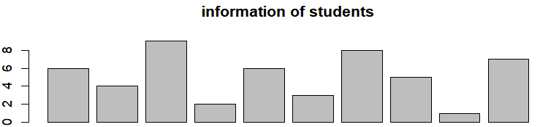

#4.barplot with names.arg

sdata<-c(6,4,9,2,6,3,8,5,1,7)

barplot(sdata,main="information of students",col='grey',names.arg=course)

png(file="bar2_r3.png")

dev.off()

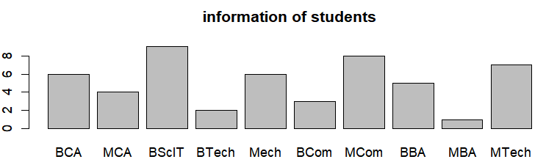

#5. 3D pie chart

library(plotrix)

p<-c(5,7,2,4,8)

lbl<-c("A","B","C","D","E")

pie3D(p,labels=lbl,col=rainbow(length(p)),explode=0.1)

png("pie3D.jpg")

dev.off()

