**Write a PHP program to check whether a given positive integer is a power of three.**

<html>

<head>

<title>power of 3 </title>

</head>

<body>

<form method="post" >

Enter the number:<br>

<input type="text" name="num1"><br>

<input type="submit" name="submit">

</form>

</body>

</html>

<?php

if(isset($_POST["submit"]))

{

$n=$_POST["num1"];

$x = $n;

while ($x % 3 == 0) {

$x = $x/3;

}

if($x == 1)

{

echo "$n is power of 3";

}

else

{

echo "$n is not power of 3";

}

}

?>

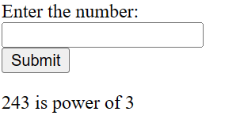

**Write a PHP program to find maximum of three numbers.**

<html>

<head>

<title>Largest Number</title>

</head>

<body>

<form method="post" >

Enter the first number:<br>

<input type="text" name="num1"><br>

Enter the second number:<br>

<input type="text" name="num2"><br>

Enter the third number:<br>

<input type="text" name="num3">

<br>

<input type="submit" name="submit">

</form>

</body>

</html>

<?php

if(isset($_POST["submit"])){

$num1=$_POST["num1"];

$num2=$_POST["num2"];

$num3=$_POST["num3"];

if($num1>$num2 && $num1>$num3){

echo"Largest no. is ".$num1;

}

else{

if($num2>$num1 && $num2>$num3){

echo"Largest no. is ".$num2;

}

else

echo"Largest no. is ".$num3;

}

}

?>

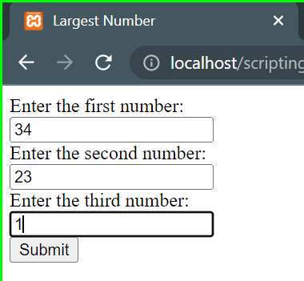 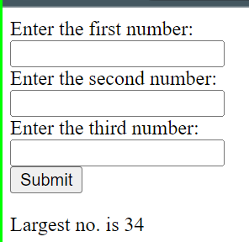

**Write a PHP program to swap two numbers.**

<html>

<body>

<form method="POST">

Enter first number:<input type="number" name="num1">

<br><br>

Enter second number:<input type="number" name="num2">

<br>

<input type="submit" name="submit">

</form>

</body>

</html>

<?php

if(isset($_POST["submit"]))

{

$n1=$_POST['num1'];

$n2=$_POST['num2'];

echo "first no. and second before swapping is $n1 and $n2 <br>";

$temp=0;

$temp=$n1;

$n1=$n2;

$n2=$temp;

echo "first no. and second after swapping is $n1 and $n2 <br>";

}

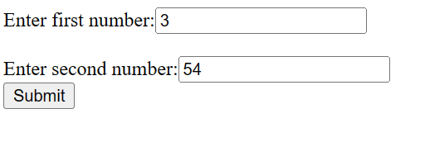 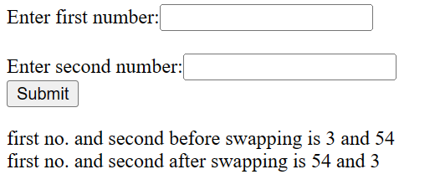

**Write a PHP program to create a table in MySQL.**

<?php

$conn=mysqli_connect("localhost","root","","bca6");

if(!$conn)

{

die("connection failed".mysqli_connect_error());

}

else

echo "connection successfully <br>";

$sql="CREATE TABLE student(Name VARCHAR(10),rollno INT(10) PRIMARY KEY)";

if(mysqli_query($conn,$sql))

{

echo "Table create ";

}

else

echo"Table not create ".mysqli_error($conn);

mysqli_close($conn);

?>

**Write a PHP program to insert record into a table using Mysqli.**

<?php

$conn=mysqli_connect("localhost","root","","bca6");

if(!$conn)

{

echo "Connection failed".mysqli_connect_error();

}

else

echo "connection successfully <br>";

if(isset($_POST["log"]))

{

$name1=$_POST["name1"];

$rollno1=$_POST["rollno1"];

$sql="insert into student(Name,rollno) values('$name1', '$rollno1')";

if(mysqli_query($conn,$sql))

{ echo "data inserted"; }

else

{ echo "data not inserted"; }

}

mysqli_close($conn);

?>

<html>

<body>

<form method="POST">

<label for="name">Name

<input type="text" name="name1" required><br>

</label>

<label for="rollno1">Rollno

<input type="number" name="rollno1" required><br>

</label>

<input type="Submit" name="log" value="Login">

</form>

</body>

</html>