**Q1 - Akshay scored 45, 67, 98 and 70 marks in 4 subjects. Write a java code to calculate his Average marks and percentage using Command line Arguments.**

Ans. //program to implement average and percentage import java.util.*;

class avg{

public static void main(String[] args)

{

System.out.println("NAME :PREETI\t\tROLL NO:48”);

double sum=0;

for(int i=0;i<args.length;i++) sum+=Double.parseDouble(args[i]);

int l=args.length;

System.out.println("AVERAGE : "+(sum/l)+"\nPERCENTAGE IS :

"+(sum/(l*100))*100);

}

}

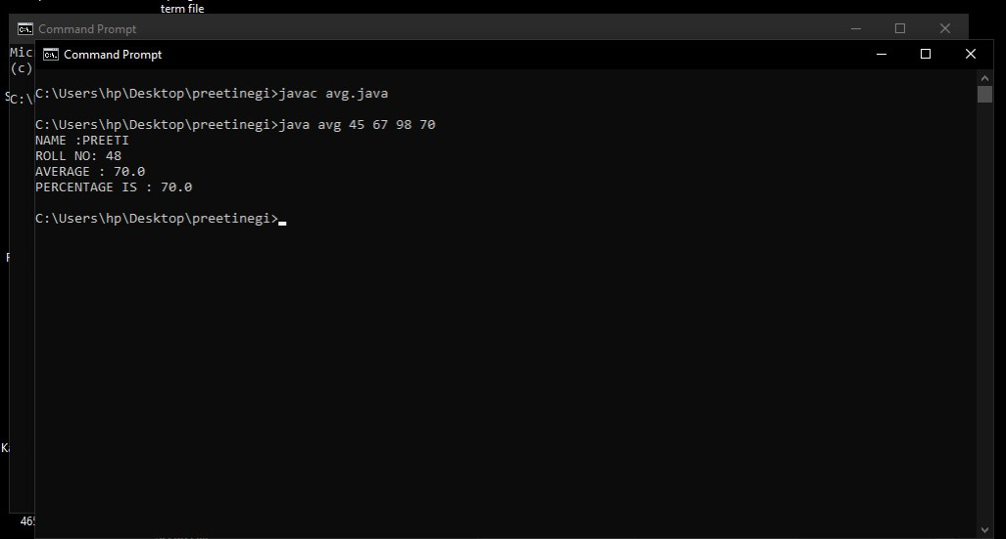**OUTPUT**

**Q2. Akshay wants to calculate the area of Square, Rectangle and Circle. Create three different methods having same name calculateArea(). Take input from command line.**

**Ans.** //java program to implement method overloading import java.util.*;

import java.io.*; public class area {

public static double calculateArea(double side)

{

return (side*side*side);

}

public static double calculateArea(double length, double breadth) { return length * breadth;

}

public static double calculateArea(double base, double height, String shape) { if (shape.equalsIgnoreCase("triangle")) {

return 0.5 * base * height;

} else {

return 0;

}

}

public static void main(String[] args)throws IOException, InterruptedException

{

System.out.println("NAME :PREETII\t\tROLL NO:48”);

Scanner sc=new Scanner(System.in); int ch=0;

while(ch!=4)

{

System.out.println("Enter the number to choose one of the following\n1.To calculate Area of square\n2.To calculate area of rectangle\n3.To calculate area of triangle\n4.Exit\n\nEnter the choice>");

ch=sc.nextInt();

switch(ch){

/ /area of square

case 1:

System.out.println("Enter the side length");

System.out.println("Area of square is "+calculateArea(sc.nextDouble()));

break;

//area of rectangle

case 2:

System.out.println("Enter the \n<length><bredth>");

System.out.println("Area of rectangle: " +

calculateArea(sc.nextDouble(),sc.nextDouble()));

break;

//area of triangle

case 3:

System.out.println("Enter the\n<base> <height>");

System.out.println("Area of triangle: " + calculateArea(sc.nextDouble(),sc.nextDouble(), "triangle"));

break;

//to exit

case 4:break;

default : System.out.println("WRONG CHOICE\n Please Make correct choice from the menu");}

}}}

OUTP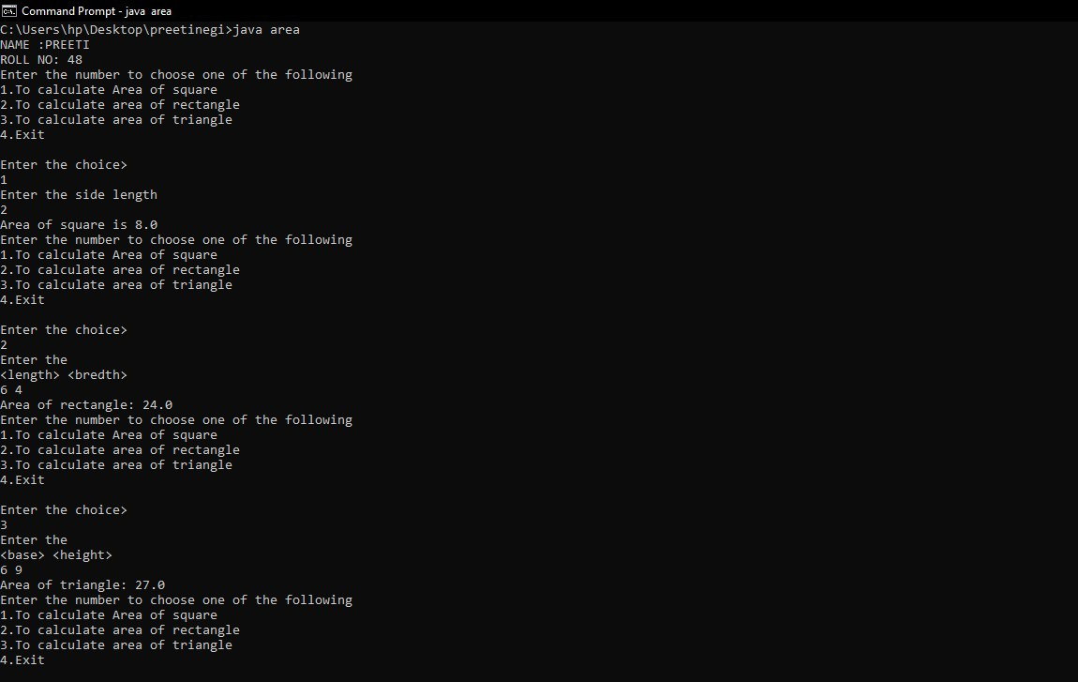UT

**Q3 - Write a JAVA program to compute the sum of even digits in a 5 digit number.**

**Ans.**

import java.util.*; class Evendigit

{

public static void main(String[] args)

{

System.out.println("NAME :PREETII\t\tROLL NO:48”);

Scanner sc=new Scanner(System.in); System.out.println("Enter the numbers"); int num=sc.nextInt();

int sum=0; while(num!=0)

{

if(num%2==0)

sum+=num%10;

num/=10;

}

System.out.println("Sum of digits is "+sum);

}

}

**OUTPUT:**

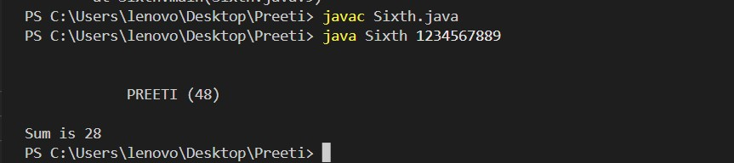

**Q4.Create a Class Student having data members roll no and name and methods are getData() and display().**

**Ans**. //to illustrate class and objects import java.util.*;

class student

{

int roll; String name;

public void getData(String name, int roll)

{

this.name=name; this.roll=roll;

}

public void setData()

{

System.out.println("NAME : "+name); System.out.println("Roll : "+roll);

}

}

class Test

{

public static void main(String[] args)

{

System.out.println("NAME :PREETII\t\tROLL NO:48”);

student st=new student();

Scanner sc=new Scanner(System.in); System.out.println("Enter the NAME and ROLL no"); st.getData(sc.next(),sc.nextInt());

st.setData();

}

}

OUTPUT:

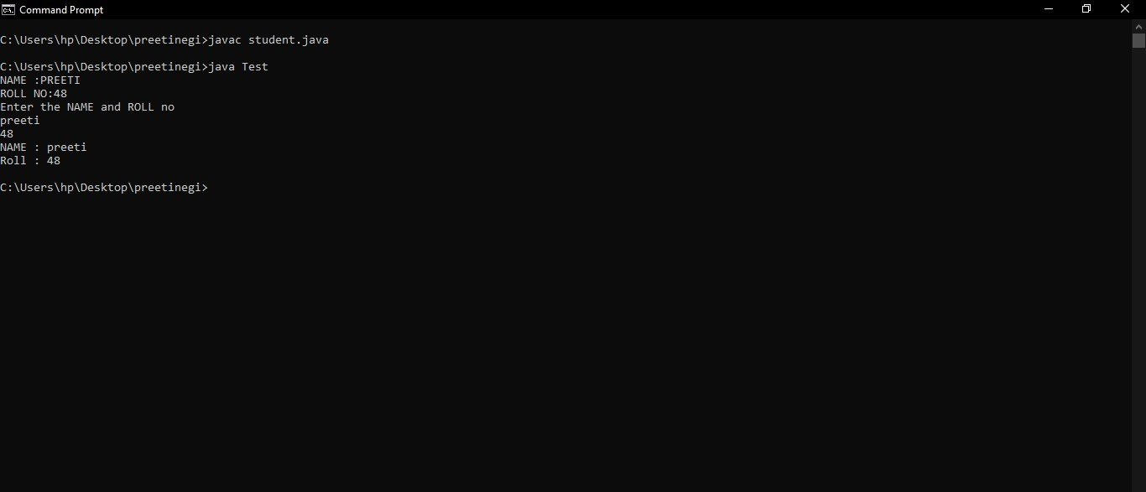

**Q5 - Create a Class Student having data members roll no and name and parametrized constructor.**

**Ans.** //perametrised constructor program import java.util.*;

class student

{

int roll;

String name;

student(String name,int roll){

this.name=name;

this.roll=roll;

}

public void show()

{

System.out.println("NAME : "+name); System.out.println("Roll : "+roll);

}

}

class Test

{

public static void main(String[] args)

{

System.out.println("NAME :PREETII\t\tROLL NO:48”);

Scanner sc=new Scanner(System.in); System.out.println("Enter the NAME and ROLL no"); student st=new student(sc.next(),sc.nextInt()); System.out.println("Enter the NAME and ROLL no"); student st2=new student(sc.next(),sc.nextInt()); st.show();

st2.show();

}

}

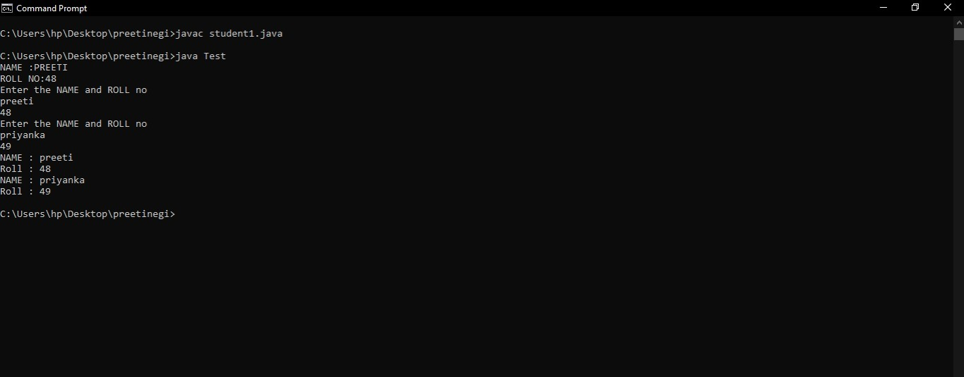OUTPUT:

**Q6.Create a Class “Person” and declare the following variable name (string) and save it in a file called “Person.java”. Create a Class called Employee that will inherit the Person Class , the other data members of Employee Class are AnnualSalary (double), YearOfJoininging (int) and MobileNumber (long).**

**Your Class Should have the necessary constructors and the getter and the setter methods. Do create Class Test having main method to fully check your class definition.**

**Ans.** // INHERITANCE

class Person {

private String name;

public Person(String name) { this.name = name;

}

public String getName() { return name;

}

public void setName(String name) { this.name = name;

}

}

class Employee extends Person {

private double annualSalary; private int yearOfJoining; private long mobileNumber;

public Employee(String name, double annualSalary, int yearOfJoining, long mobileNumber) {

super(name);

this.annualSalary = annualSalary; this.yearOfJoining = yearOfJoining; this.mobileNumber = mobileNumber;

}

public double getAnnualSalary() { return annualSalary;

}

public void setAnnualSalary(double annualSalary) { this.annualSalary = annualSalary;

}

public int getYearOfJoining() { return yearOfJoining;

}

public void setYearOfJoining(int yearOfJoining) { this.yearOfJoining = yearOfJoining;

}

public long getMobileNumber() { return mobileNumber;

}

public void setMobileNumber(long mobileNumber) { this.mobileNumber = mobileNumber;

}

}

class Test {

public static void main(String[] args) {

Employee employee = new Employee("PREETII", 100000.0, 2021, 9123456720);

System.out.println("NAME :PREETII\t\tROLL NO: 48");

System.out.println("Name: " + employee.getName()); System.out.println("Annual Salary: " + employee.getAnnualSalary()); System.out.println("Year of Joining: " + employee.getYearOfJoining()); System.out.println("Mobile Number: " + employee.getMobileNumber());

employee.setAnnualSalary(60000.0); employee.setYearOfJoining(2021); employee.setMobileNumber(9876543210L);

System.out.println("Updated Annual Salary: " + employee.getAnnualSalary());

System.out.println("Updated Year of Joining: " + employee.getYearOfJoining());

System.out.println("Updated Mobile Number: " + employee.getMobileNumber());

}

}

OUTPUT:

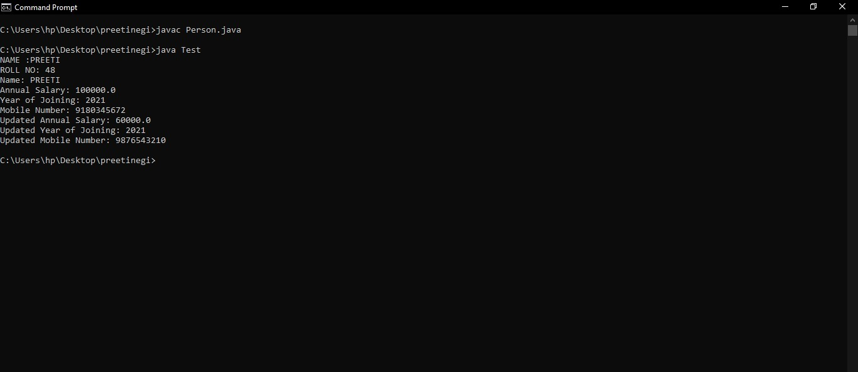

**Q7 - Create a class named as “Animal” which has methods eat() and sleep(). Create a child class of animal named as “Bird” and override the parent class methods such that define a new method named as fly() in the same class.**

**Create an instance of Animal Class and invoke eat() and sleep(). Create an instance of Bird Class and invoke eat(), sleep() and fly().**

**Ans.** //

class Animal

{

public void eat()

{

System.out.println("The animal is eating");

}

public void sleep()

{

System.out.println("The animal is sleeping");

}

}

class Bird extends Animal {

public void eat()

{

System.out.println("The bird is eating");

}

public void sleep()

{

System.out.println("The bird is sleeping");

}

public void fly()

{

System.out.println("The bird is flying");

}

}

class Test {

public static void main(String[] args)

{

System.out.println("NAME : PREETII\t\tROLL NO :48");

Animal animal = new Animal();

animal.eat();

animal.sleep();

Bird bird = new Bird();

bird.eat();

bird.sleep();

bird.fly();

}

}

OUTPUT:

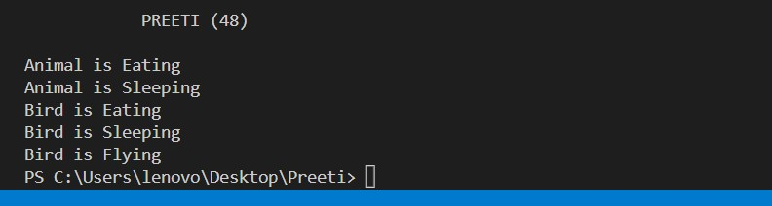

**Q8. Write a JAVA program to calculate the cyclic sum of 5 digits number.**

**Ans.** //program for cyclic sum import java.util.Scanner; class CySum {

public static void main(String[] args) {

System.our.println(“NAME : PREETII\t\tROLL NO :48”);

Scanner scanner = new Scanner(System.in);

System.out.print("Enter a 5-digit number: "); int number = scanner.nextInt();

int sum = 0;

int currentDigit = number % 10; int nextDigit = 0;

for (int i = 0; i < 5; i++) {

int divisor = (int) Math.pow(10, i); nextDigit = (number / divisor) % 10; sum += currentDigit + nextDigit; currentDigit = nextDigit;

}

System.out.println("The cyclic sum of " + number + " is " + sum);

}

}

OUTPUT:

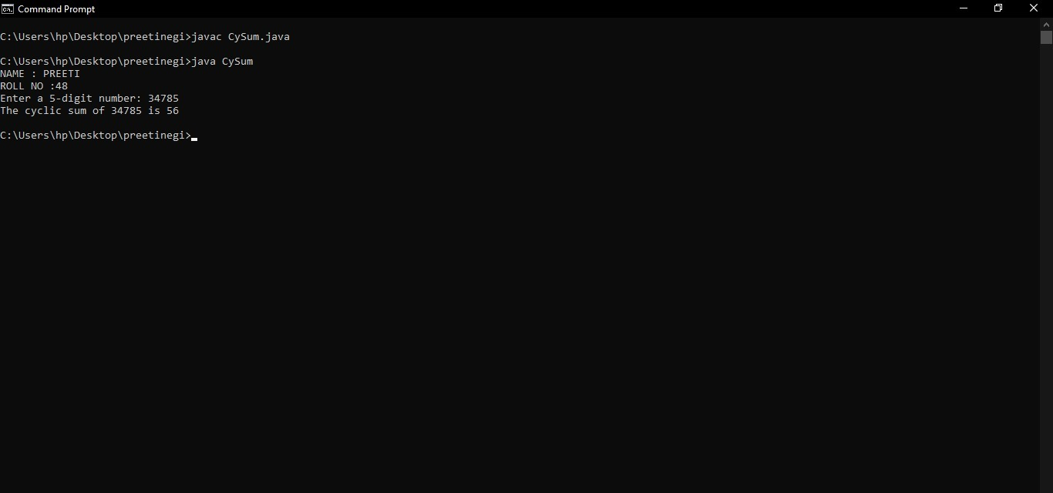

**Q9 - Create PIN using three given input numbers. Secure Assets Private Ltd", a small company that deals with digital lockers which can be locked and unlocked using PINs (password). You have been asked to work on the module that is expected to generate password using three input numbers.**

**Assumption: The three given input numbers will always consist of three digit**

**i.e. each of them will be in range >=100 and <=999. 100<=input1<=999**

**100=Input2<-999**

**Look=lnput3<-999**

**Below are the rules for generating the PIN -**

* **The PIN should be made up of 4 digits**
* **The unit (ones) position of the PIN should be the tens position of the three input numbers.**
* **The hundreds position of the PIN should be the least of the hundred position of the three input numbers.**
* **The tens position of the PIN should be the least of the tens position of the three input numbers.**
* **The hundred position of the PIN should be the least of the hundreds position of the three input numbers.**
* **The thousand position of the PIN should be the maximum of all the digits in the three input numbers.**

**Ans.** //Pin generation program import java.util.*;

class pin

{

static private int pin,min,max,mul=1,i,j=0,savemax; static private int[] arr=new int[4];

static int pin_gen()

{

while(j<=3)

{

min=arr[0]%10; max=0; for(i=0;i<3;i++)

{

if(arr[i]%10<min)

min=arr[i]%10; if(j==1 && arr[i]%10>max)

{

max=arr[i]%10; if(max!=0)

{

savemax=max;

}

}

arr[i]/=10;

}

max=savemax; if(j<3)

pin=(mul*min)+pin;

else

pin=(mul*max)+pin;

mul*=10;

j++;

}

return pin;

}

public static void main(String[] args)

{

}

}

System.out.println("NAME :PREETII\t\tROLL NO:48”);

Scanner sc= new Scanner(System.in); System.out.println("Enter the numbers"); for(int i=0;i<3;i++)

arr[i]=sc.nextInt(); System.out.println(pin_gen());

OUTPUT: