A Minor Project

Report on

“**Turnep**”

Submitted in Partial Fulfillment of the Requirements for the Degree of Software engineering

Under Pokhara University.

Submitted by:  
**Aashish Neupane(15701)**

**Krishesh Shrestha(15715)**

**Bikal Bahadur Rokaya(15709)**

Under the Supervision of:

(**Er. Mandira Bhattrai**)

………………….

Date:  
(19th Dec,2018)



**Department of Software Engineering**

**NEPAL COLLEGE OF INFORMATION TECHNOLOGY**

Balkumari, Lalitpur, Nepal

ACKNOWLEDGEMENT

This project would not have been possible without the joint efforts of many individuals. It has been a pleasure for us to acknowledge the assistance and contributions that were very important and supportive throughout the project. We would like to extend our sincere thanks to all of them. We owe special thanks to a number of people who has devoted much of their time and expertise without which it would have been very difficult for us to complete our project entitled “Turnep”.

We are highly indebted to our Project Supervisor Er. Mandira Bhattrai, Head of Department of IT Engineering for his valuable guidance throughout the project development period and for providing technical support with suggestions which helped our project to grow and foster to a certain level we didn’t think of reaching in such a short period.

Last, but not the least, we would like to thank our teachers and colleagues who have been knowingly or unknowingly the part of this project and lent support and views during the entire development time.

We feel obliged in submitting this project as part of our curriculum.

Although, there may be still many who are unacknowledged in this humble vote of thanks, there are none who remain unappreciated.

Aashish Neupane

Krishesh Shrestha

Bikal B. Rokaya

Nepal College of Information Technology,

Balkumari, Lalitpur, Nepal

**Abstract**

*This project* ***Turnep*** *is an android application which tracks about different crimes rate and notifies user about them. User can post their missing person’s details with a photograph. User may also check for the status updated by the admin. This system is proposed to help agencies like CBI, CID and other bureau’s to speed up their investigation process and get help from the society about the crime details quickly and to proceed with the investigation. With the collaboration of both agencies and society, this application will track the record of crime ratio in the society.*

*With Turnep, user will get the update with the various news, missing peoples and crime reports whole over Nepal. Also, Turnep will have a built-in Smart Recommendation Algorithm to suggest and recommend the users about the Missing People nearby. Keeping track of Missing people updates is easy with the Activity Feed*

*We use ANDROID STUDIO (android SDK) for coding where we used XML for Frontend and java for Backend. We used Firebase as our database and authentication. Photoshop was used for design our logo and GITHUB was used to manage our code smoothly.*

Keywords: Turnep, Android, project, android SDK, XML, Java, Photoshop, Github

Table of Contents

1. Introduction 1

1.1 Problem Statement 1

1.2 Project Objectives 2

1.3 Significance of the study 2

1.5 Project scope and Limitations 3

2. LITERATURE REVIEW 4

2.1 REVIEW 4

2.2 ANDROID 5

2.3 SOLUTIONS OFFERED TO THE EXISTING DEFICIENCIES 5

2.4 GOOGLE FIREBASE 6

3. TEAM MEMBERS AND DIVIDED ROLES 7

4. METHODOLOGY 8

4.1 SOFTWARE DEVELOPMENT LIFECYCLE 8

4.1.1 Analysis Phase 9

4.1.2 Design Phase 9

4.1.3 Coding Phase 9

4.1.4 Testing Phase 9

4.1.5 Managing Increment 9

4.2 PROS OF INCREMENTAL MODEL 12

4.3 WHY DID WE CHOOSE INCREMENTAL MODEL? 12

4.4 TOOLS TO BE USED 12

4.5 TECHNOLOGIES TO BE USED 13

5. Tasks done so far 13

6. Proposed Performance Analysis Methodology and Validation Scheme 14

7. Proposed Deliverables/Output 14

8. Project Task and Time Schedule 15

9. CONCLUSION AND FUTURE EXTENSIONS 17

10. REFERENCES 17

List of Figures

Figure 1 Incremental Model 8

Figure 2 Gantt chart for First Increment 16

Figure 3 Gantt chart for Second Increment 16

Figure 4 Gantt chart for Third Increment 16

Figure 5 Home Page 18

Figure 6 Register Page 19

Figure 7 Login page 19

Figure 9 Share 20

Figure 10 About And FAQ 20

Figure 11 News 21

Figure 12 News Details 21

Figure 13 Profile 22

Figure 14 Missing People 22

Figure 15 Missing People Details 23

Figure 16 Navigation bar 23

Figure 17 Contact Us 24

# Introduction

Introduction 21st century is the century of technological advancement where computer or mobile phones has become part of the life for accessing almost any kind of information. Technology has become part of every man and woman in this era. As the increasing use of technology and advancement in the technology, nowadays everyone wants to complete their tasks using digital devices. Along with many people now uses virtual platform to be connected, share and get genuine information. Social media is what most applied to day to day life of every person.

Even though the advancement of this much technology, there lacks some sorts of services that every people are unable to use and benefit. Hence, our project would provide a people the platform for a people. This system will provide two beneficiaries i.e. the first benefit will be to the user by providing a platform to view news and crimes around them, and second the police officers and respective persons working on different cases.

Users can view the news and missing peoples list in the applications’ homepage and missing people section. Authorized person can view the reports of crimes and missing people to use information on their work in progress case reports. This App allows user to file complaints or missing reports and keep a track of it. There are 2 categories that a user can file; Crime Report and Missing Report. The App also allows other user who doesn’t want to register but can check the crimes and missing persons' list at his or any other area

## Problem Statement

The manual crime reporting system is quite complicated for recording information and is delayed too.

There are lots of limitations of manual system which are listed below:-

* It is time consuming.
* It is quite laborious.
* The records can be error prone.

Thus to overcome this limitations the proper digital system to report crimes and missing persons is needed. To use the application the user does not have to remember or understand anything. The user can use the application easily.

## Project Objectives

The main aim and objectives of this project is to provide platform for the people to file reports for crimes around them and missing person reports whenever needed.

The goal of this project is to save users time for reporting crimes by reaching into police stations. Its objective is to maintain missing persons information well maintained and keep all information regarding reporters and about whom it is reported.

The following are the measure objective of this project:-

* To design an electronic crime reporting application.
* To develop the application through which we can reduce the human efforts.
* To record the information's such as missing person details, crime details, reporters details etc.

## Significance of the study

Researcher has developed the police application in Nepal through which people can call ton toll free emergency number in Nepal. Unfortunately the reports have to be filed manually by visiting the police stations in their respective region. This practice effect the retrieval of the information and staff is unable to maintain the inventory properly.

This system will provide two beneficiaries i.e. the first benefit will be to the user by providing a platform to view news and crimes around them., and second the police officers and respective persons working on different cases. Users can view the the news and missing peoples list in the applications’ homepage and missing people section. Authorized person can view the reports of crimes and missing people to use information on their work in progress case reports. The probability of error should be minimal. Information retrieval should be precise and effective

## Project scope and Limitations

This section describes about the requirements of the project. The project should be developed in such a way that it meets all its objectives. The application should be built such a way that it should suits for all the types crimes and accessible through any police station by admins in near future.

The main scopes of the project are: -

* Provide information of the crimes happening around us.
* A perfect platform to connect between the reporters and the Polices.
* In development of this application, there shall be space for future modifications.

Even though our system has lots of features to serve users, it also has limitations that users could feel limited.

* This system can only be used when there is internet.
* Will not be able to make the required updates and change at the right time.

# LITERATURE REVIEW

This section includes the literature review of web-based navigation and connecting portal service

## REVIEW

With the improving devices and technology, reporting crimes and filing the missing person’s reports remotely is service people are expecting. Even though some services might seem overwhelming and some might seem insufficient, there will always be some areas for improvement. Hence our project is looking forward to define all the possible services so that there is an application through which people can get every service required in general term. Existing Solution Police Application by Nepal government provides the feature to call to toll free number through which people can report instant crimes [1]. There’s also some application which provides features like viewing news and sharing in different platform.

Pros: Police application provides feature to call to toll free number to file a report. Different news application provides news reading features. News can be shared with peoples in different platforms.

CONS: Peoples need to file an official report by visiting a nearby police station. There no any missing person finder application services. News is mostly local only.

## ANDROID

Android is a mobile operating system developed by Google. It is based on a modified version of the Linux kernel and other open source software, and is designed primarily or touchscreen mobile devices such as smartphones and tablets. In addition, Google has further developed Android TV for televisions, Android Auto for cars and Wear OS for wrist watches, each with a specialized user interface. Variants of Android are also used on game consoles, digital cameras, PCs and other electronics. The UI of android is written in Java, while its core and kernels are written in C and C++. Android 9.0 “Pie” is the current version of Android, which was released in August 2018.

## SOLUTIONS OFFERED TO THE EXISTING DEFICIENCIES

Our application provides features to call emergency number 100 to file report. Emergency message support feature is provided. News can be shared with users in different platform. Missing persons can be reported in our application. Peoples without user account can also view missing peoples list.

## GOOGLE FIREBASE

Firebase is a mobile and web application development platform developed by Firebase, Inc. in 2011, then acquired by Google in 2014. As of October 2018, the Firebase platform has 18 products which are used by 1.5 million apps. We used firebase for backend implementation.

The following table provides the details of the products provided by Firebase

|  |  |  |
| --- | --- | --- |
| **SN** | **Product** | **Function** |
| 1. | Firebase Authentication | This feature allows developers to easily register the users of their computer program and then validate whenever they try to login to their app. Firebase now supports validation via Phone, Email, Google, Facebook, Twitter, etc. |
| 2. | Firebase Realtime Database | The real-time database feature of Firebase allows developers to write the code to develop apps such that they can easily modify to database in the real time, instantly. |
| 3. | Cloud Storage for Firebase | Cloud Storage feature of Firebase allows developers to store various resources and files needed for their applications in the storage provided by Firebase itself. These resources could be images of users, various files needed to be accessed by users, etc. |
| 4. | Cloud Functions for Firebase | This feature allows developers to run backend code without managing the servers. The Firebase functions are single purpose JavaScript functions which are run in secure Node.js runtime environment. |
| 5. | Firebase Cloud Messaging | Firebase Cloud Messaging provides a reliable connection between server and client devices, which allows developers to deliver and receive messages and notifications. |

Table 1 : Various features provided by Google Firebase

# TEAM MEMBERS AND DIVIDED ROLES

|  |  |  |
| --- | --- | --- |
| Name | Roles | Responsibilities |
| Krishesh  Shrestha | Project Manager | * Review and approve all project deliverables (Initiation Plan, Detailed Plan, Testing etc.) * Day to Day responsibility to keep project on track for the successful delivery of Turnep * Manage project level risks and issues on an ongoing basis and take responsibility for a project change management |
| System/ UI Designer And Developer | * Develop User-friendly Interface and work through design revisions * Test System Interfaces * Define and execute development requirement |
| Bikal B  Rokaya | System Developer | * Define and execute development requirement |
| End User Documentation | * Participate in testing * Develop Documentation |
| Aashish  Neupane | Database Administrator | * Develop, maintain and implement policies and procedures necessary to ensure the security and integrity of the corporate database |
| Security and Authorizations | * Create and maintain system security( Authentication, User profiles, Assignment of user to profiles) |

Table 2 : Team Members and Divided Roles

# METHODOLOGY

We have planned to work following these methodologies for the application of knowledge, skills, tools and techniques to a broad range of activities in order to meet the requirements of our project, Turnep. This section presents detailed information about the software development process, project approach and the tool that we used for our project.

## SOFTWARE DEVELOPMENT LIFECYCLE

The framework that we planned to incorporate for developing this project is Incremental model. This model combines linear sequential model with the iterative prototype model. New functionalities will be added as each increment is developed. The phases of the linear sequential model are: Analysis, Design, Coding and Testing. The software repeatedly passes through these phase in iteration and an increment is delivered with progressive changes.

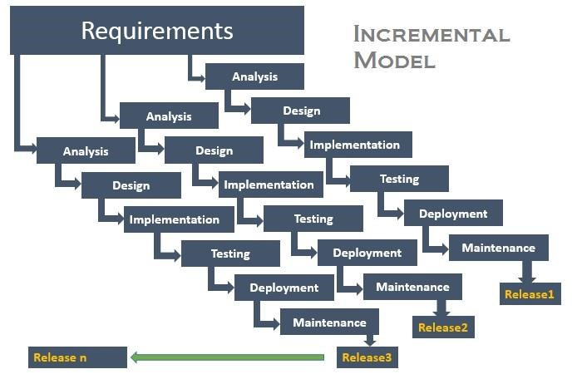

Figure 1 Incremental Model

### Analysis Phase

In this phase, analysis was performed in order to find out the requirements of the system. The outcome of this phase would be a SRS which is an acronym for “System Requirement Specifications”.

### Design Phase

In this phase the SRS would be translated into the system’s design. Context Diagram, DFD, ER – Diagram, Use Case Diagram and Class Diagram will be developed.

### Coding Phase

In this phase, coding would be done according to the design and a working system is achieved/ developed by the end of this process.

### Testing Phase

In this phase, the system would be tested. With each testing a list of changes to the system developed, is suggested and the changes will be applied to the software and the software would be delivered as a successive increment until a satisfying system is achieved.

### Managing Increment

Each stage of incremental model adds some functionality to the product and passes it on to the next stage. The first increment (generally known as a core product) was used for a detailed evaluation. This process resulted in creation of a plan for the next increment. The iteration process, which includes the delivery of the increments to the user, continues until the software is completely developed, i.e. iteratively enhance the requirements until the final software is implemented.

* **INCREMENT 1: Develop Full-fledged Web and Android Application**

In this phase we focused on analysis and design of our system with the help of the objectives of our project. This helped us to figure out every aspects of the project and take them into consideration. A full-fledged web and android application was developed in this phase. We developed an initial project plan to help us in our future increments. The system architecture which is an essential part was developed during this initial iteration. The artifacts to be produced in this phase are:

* + Actors and Use cases
  + Project Boundary
  + System Modules (Web Application and Android App Modules)
  + Initial System Architecture
  + Feasibility Study
  + Risk Assessment
  + Domain model
  + ER Diagram
  + Context Diagram
  + Data Flow Diagram
  + Software Architecture Document
  + Cost and Schedule Estimates
  + Activity Diagram

In this phase we worked on integrating API to our system as we have to create a three-tier architecture for our system. REST API is mostly used in cases where client doesn’t need to do much effort and most of the tasks are defined within server itself. Rather than developing a system from the scratch we will use Android AsynHTTPClients like LoopJ and Volley for the two-way communication between Android and the Web Interface. The modules created during this increments are:

* + Sign up
  + Login
  + News
  + Missing people
  + Navigation Activity
* **INCREMENT 2: Recommendation and Collaborative Filtering Algorithm Integration**

In this phase we worked on validating the system architecture with our back end. Some conclusions from the previous iteration were helpful in the further development of the system. Here, in this phase we seek to develop a platform that seek to predict the “rating” or “preference” that a user would give to an item, specifically the event. Recommendation Systems typically produce a list of recommendation in one of two ways- through Collaborative and Content-based filtering or the personality-based approach. We seek to build a model from a user’s past behavior as well as similar decisions made by other users. However, due to time-constraint and insufficient resources, we couldn’t implement Recommendation Algorithm in this version.

* **INCREMENT 3: Turnep Assistant Development and System Deployment**

In this phase, we worked on finalizing our deployment of the Android system for the initial part then we’ll go through the entire system deployment which brings many challenges to the system. We’ll also made few changes to our system architecture as per the need. We had to make few other changes to our artifacts. Also, we developed a Chatbot interface that will make human interaction with the app users possible through an interactive chat platform in order to initiate an automated service or process.

The artifacts to be produced in this phase are:

* + Class Diagram
  + Integrated System module

## PROS OF INCREMENTAL MODEL

* Generates working software quickly and early during the software life cycle.
* More flexible – less costly to change scope and requirements.
* Easier to test and debug during a smaller iteration.
* Easier to manage risk because risky pieces are identified and handled during its iteration.
* Each iteration is an easily managed milestone.
* Handling functionality during iteration process

## WHY DID WE CHOOSE INCREMENTAL MODEL?

* The requirements of the complete system were clearly defined and understood.
* Major requirements were defined (however, some details could evolve with time)
* Various backend APIs needed to be integrated and implemented.

## TOOLS TO BE USED

The tools used for documentation, designing and developing UI/UX, testing are listed below in table

|  |  |
| --- | --- |
| TOOLS | PURPOSE |
| Android Studio | Official IDE for Android App Development |
| Advanced REST Client: Extension of Google Chrome | Check APU Request |
| Natural Language Toolkit (NLTK) | Natural Language Processing |
| GitHub | Manage Source Code |
| Adobe Photoshop CS6 | Designing UI/UX |

Table 3 : Tools to be used

## TECHNOLOGIES TO BE USED

* REST API, for requesting systems to access and manipulate textual representations of Web resources using a uniform and predefined set of stateless operations
* XML and Java in Android, for extensive frontend and backend application development
* JSON to transmit data objects consisting of attribute–value pairs

# Tasks done so far

* Login form

The user can login through their Email id and password if they have already registered. Using Firebase system. [2]

* Registration form

The user can register themselves as donor through this registration form. Using Firebase system.[2]

* Read news around user

The user can read the news. We used the api of news.org.[3]

* Emergency call and Message button

The application has a feature through which user can call and message to 100 in case of emergency.

* Missing People Page

The application has a feature through which user can view missing peoples list.

* About and FAQ

The application has a feature through which user can view about the application and also has FAQs in the same page.

* Share Application

The application has a feature through which user can share application with friends.

# SYSTEM DESIGN AND UML MODELS

Designing according to the requirement specification, we have made an attempt to make sure that the system design actually confirms the user requirements of the system.

## ARCHITECTURE SKELETON

The System Architecture of our project “Turnep” is a Three-Tier Architecture System which includes a Presentation Tier, an Application Tier and Data Tier. The Architecture Skeleton of the project is shown in the figure below:

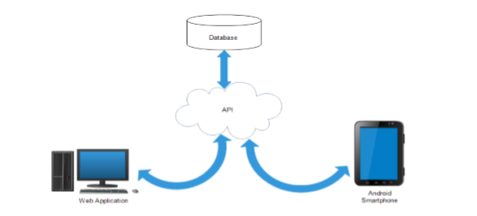

* **Presentation Tier:** It is user friendly GUI through which users are allowed to interact with our system. Sign in/ Sign up pages restrict unauthorized users to use the application and GUI for display for the News, Missing People and Crime Report.
* **Application Tier:** It consists of logical operations and data access in the project application users command processing, making enquiry of the events, make decision for the network group. With Android background services and Asynchronous Tasks, the application notifies users for the upcoming Events. Use of APIs such as newsapi.org [3] and other material Design libraries are included in Application Tier of the project.
* **Data Tier:** It is our Database where information are stored and retrieved upon user and system request. Data tier of the project also includes other third party databases which are accessed with the call of provided API function calls**.**

## USE CASE DIAGRAM

A use case diagram at its simplest is a representation of a user's interaction with the system that shows the relationship between the user and the different use cases in which the user is involved. The actors for our system are: User, System and APIs. The simplified and graphical representation of what our system must actually do is represented below:

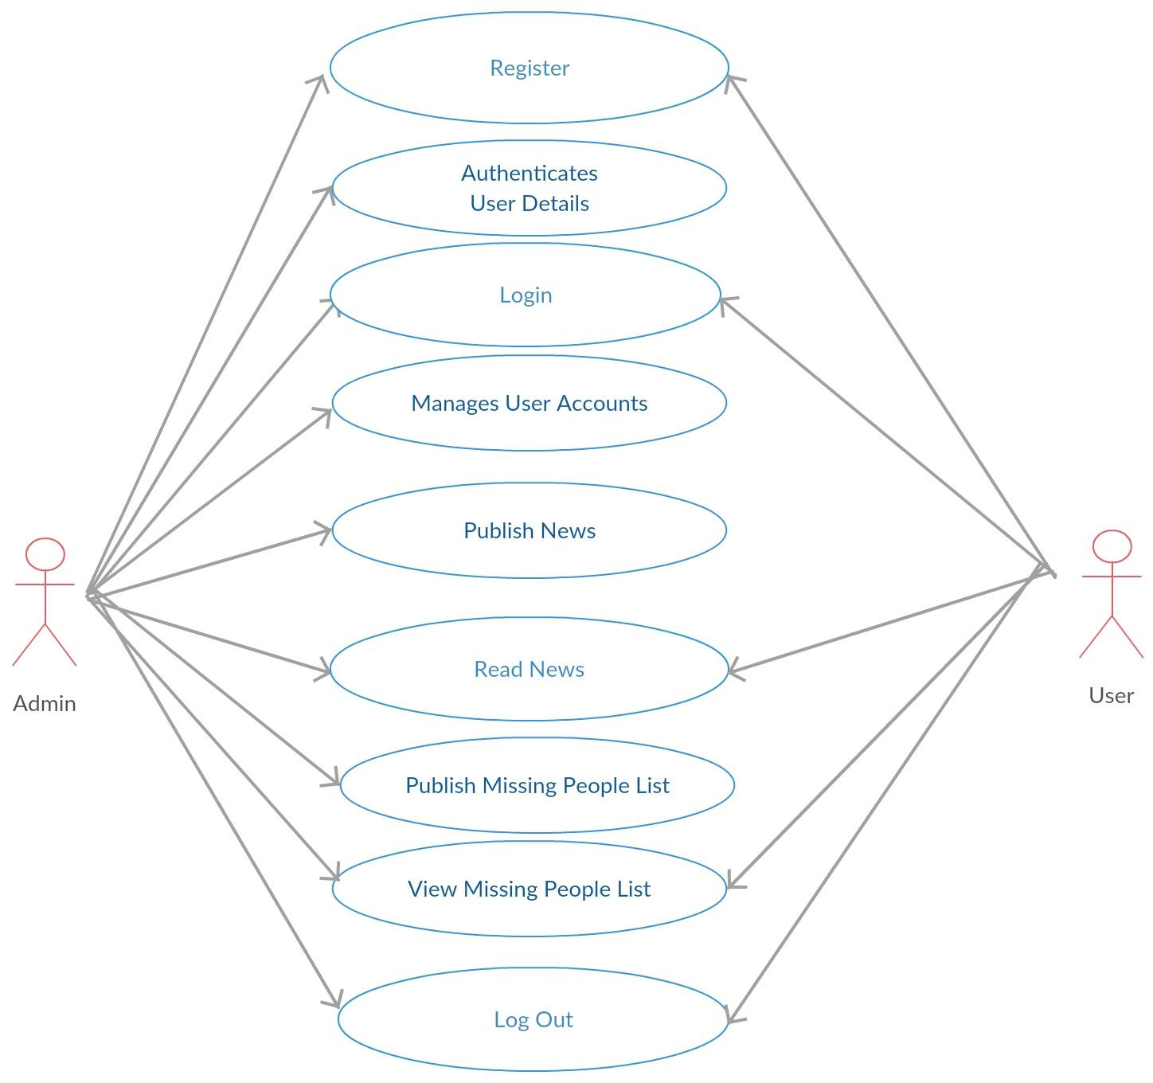

# Proposed Performance Analysis Methodology and Validation Scheme

Process

* Crime and other news on homepage

This function allows the users to view and read news on homepage.

* User Profile Registration

This allows the people to register as a donor.

* Online Crime Report

This allows to report the crimes and missing persons case online.

* Share Application an Support

This allows user it share this application aiming

friends and Support feature links to website for further support.

* emergency Call and Message button

The emergency call and Message button on the navigation tool bar provide a feature through which user can attempt emergency calls.

# Proposed Deliverables/Output

The main deliverables of the projects are as follows:

• Requirement Specification

¬ Use-Case Model

• Analysis Model will be used to show that all the requirements of the system has been analyzed.

• Design specification will be used to specify the design.

• Implementation model

¬ Code and System

• Documentation and Manual

# Project Task and Time Schedule

The project schedule has been designed as per requirements and constraints involved. This project is scheduled to be completed in about two months. Requirement analysis have been given more emphasis. Research and database management is to be done first and well documented. Debugging and Testing is to be done prior to the completion of the project.

|  |  |  |  |  |
| --- | --- | --- | --- | --- |
| Task | First increment period | Second Increment period | Third increment period | APPROX Duration (in days) |
| Requirement analysis and Specification. | 5 | 6 | 4 | 14 |
| Analysis of the System | 7 | 7 | 6 | 18 |
| System design | 5 | 9 | 16 | 26 |
| Develop System | 11 | 9 | 17 | 35 |
| Testing and Debugging | 8 | 62 | 11 | 23 |
| Overall System Test | 6 | 5 | 8 | 13 |
| Develop Documentation | 21 | 14 | 25 | 60 |

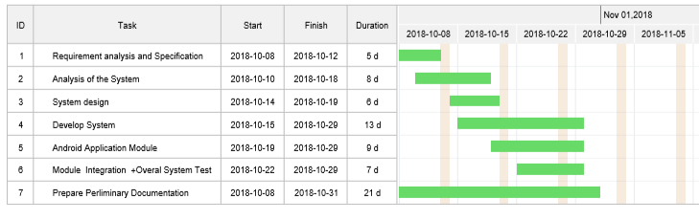

Figure 2 Gantt chart for First Increment

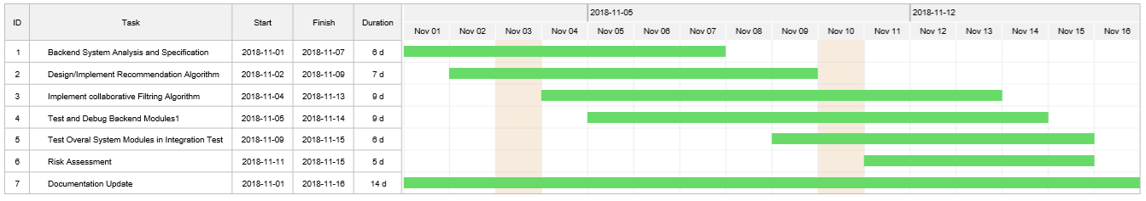

Figure 3 Gantt chart for Second Increment

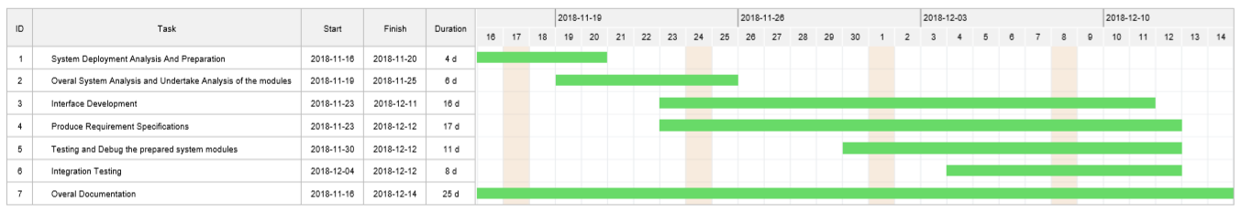

Figure 4 Gantt chart for Third Increment

# CONCLUSION AND FUTURE EXTENSIONS

The TURNEP app is now at the initial phase with its beta version having most of the basic functionalities discussed before. All the modules have been working after integrating and are ready for the demo. As the features adding up the level of complexity has been increasing as well. However it is not complete with the ideas we have put through and might need more improvisation in the coming days as well. This makes us think about the future extensions that we are going to implement in this application. Some of the extensions we have planned of are:

* Hybrid Recommender Systems (Content-based and Collaborative-based) for intelligent recommendation of the events.
* Event Rating and Feedback to the event organizers via the application.
* Online registration (RSVP) for the events. Digital Wallet Integration system for the paid events
* TURNEP can offer personalized schedule integration.

# REFERENCES

[1]" ”Review To The Nepal Police app”[online].Available https://nepalpolice.gov.np/index.php/mobile-app-privacy-policy [ Accessed 4-Dec-2018]

[2]" “Firebase : working with database”[Online]. Available

https://firebase.google.com/docs [ Accessed 28-nov-2018]

[3]" “News Api –Terms of use”[Online].Available

https://newsapi.org [Accessed 21-Nov-2018]

**APPENDIX**

SYSTEM SNAPSHOT

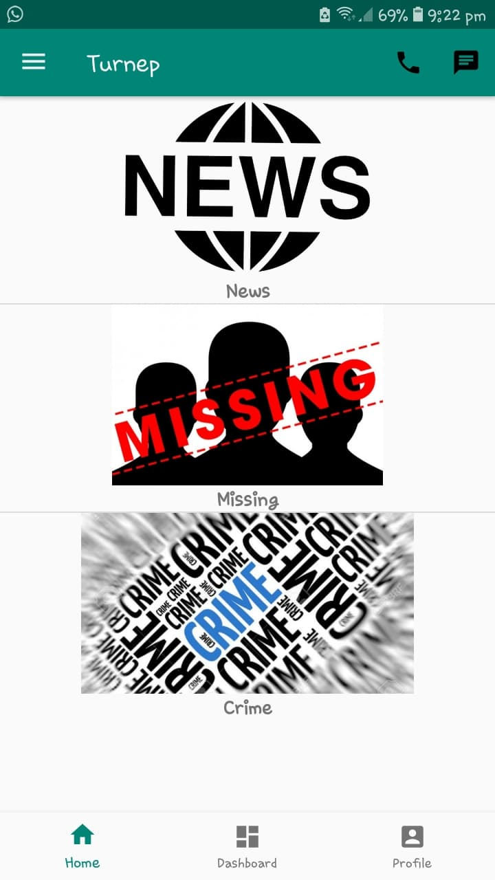

Figure 5 Home Page

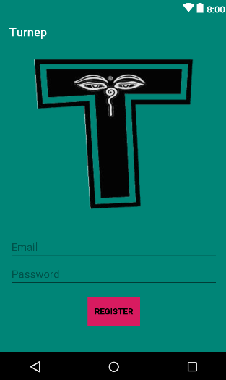

Figure 6 Register Page

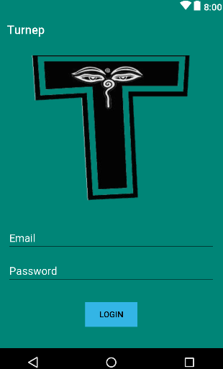

Figure 7 Login page

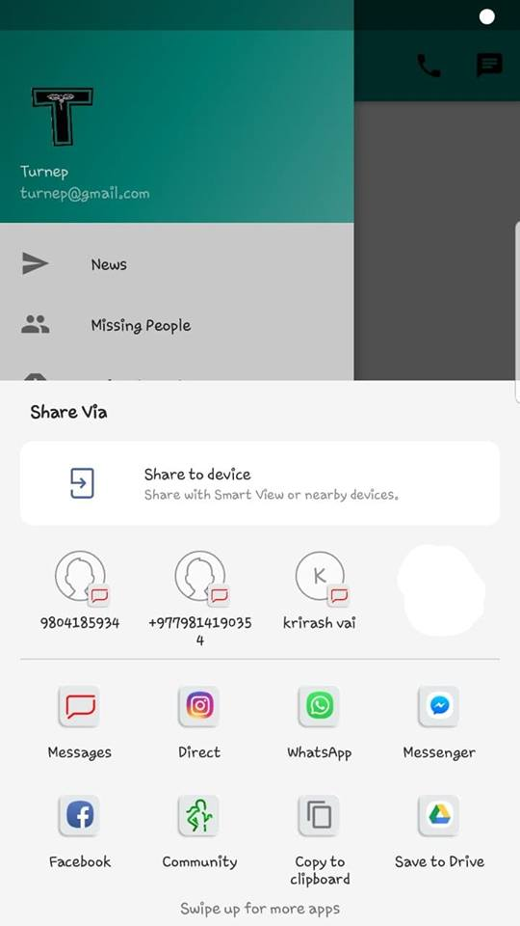

Figure 9 Share

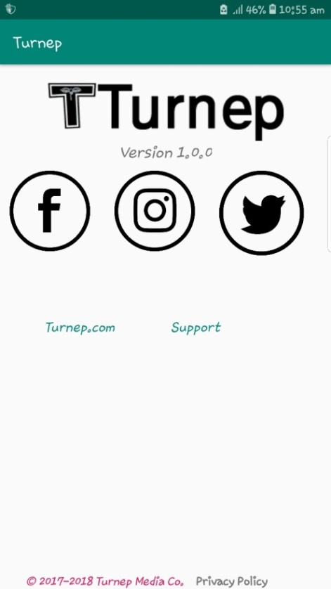

Figure 10 About And FAQ



Figure 11 News



Figure 12 News Details

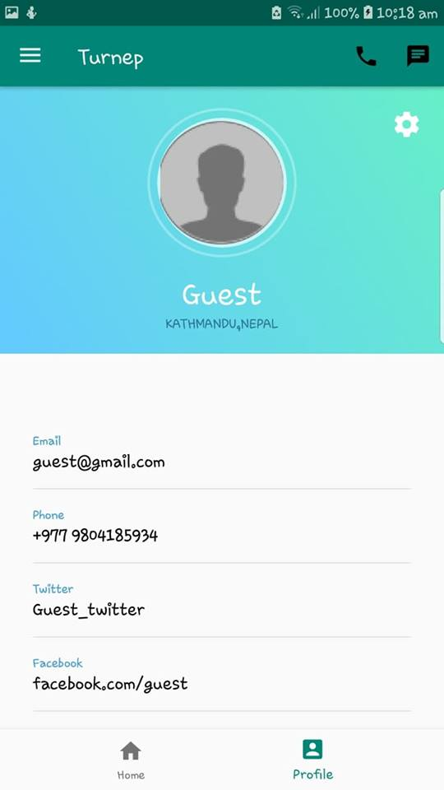

Figure 13 Profile

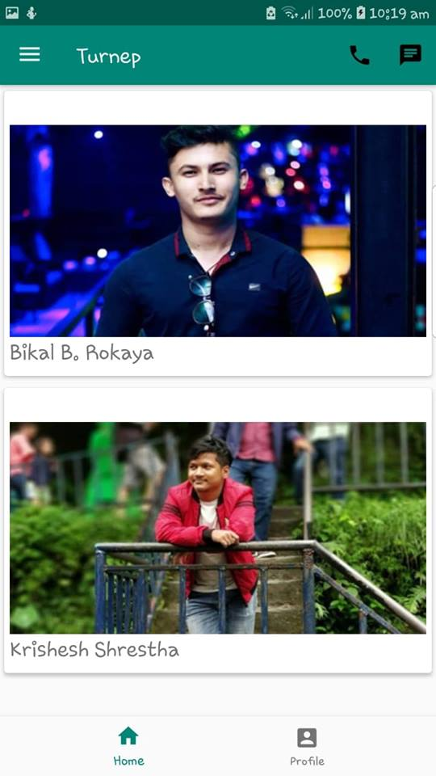

Figure 14 Missing People

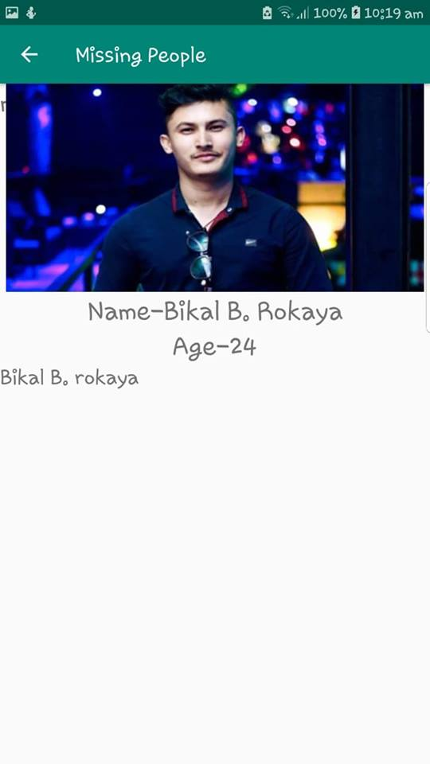

Figure 15 Missing People Details

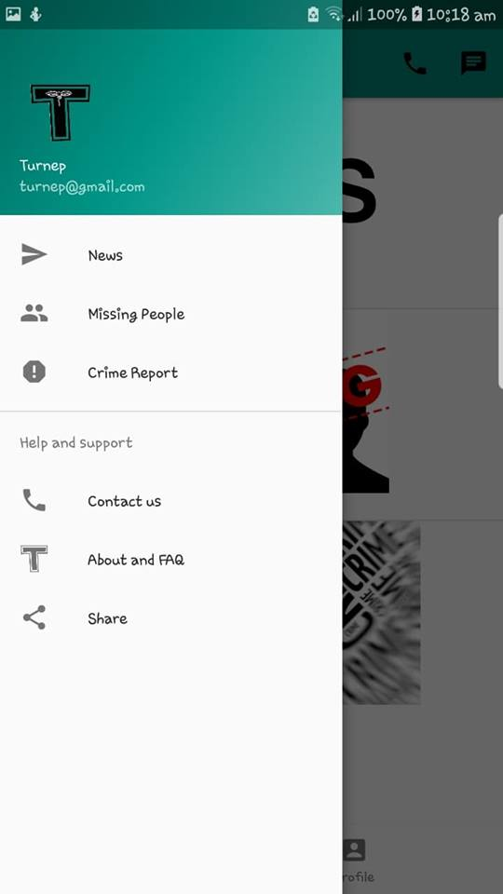

Figure 16 Navigation bar

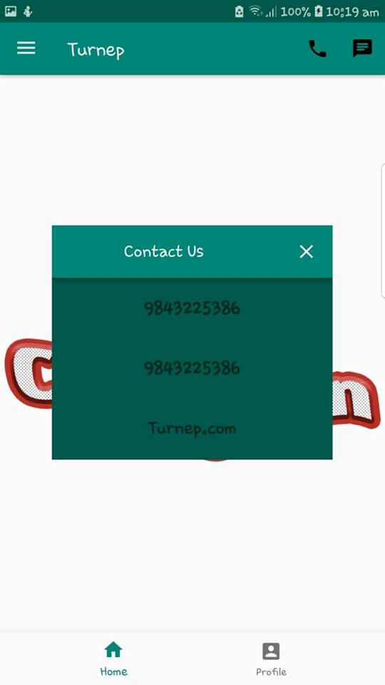

Figure 17 Contact Us