1.THE DATA WAS CLEANED BY REMOVING CELLS WITH BLANK VALUES USING FIND ALL OPTION. ALL THE CELLS WERE SELECTED AND DELETED. AROUND 1000+ CELLS WERE REMOVED.

2. PROFIT=GROSS-BUDGET. IT WAS SORTED AND THEN A SCATTER GRAPH WAS PLOTTED WHICH SHOWED THE OUTLIER VALUES.

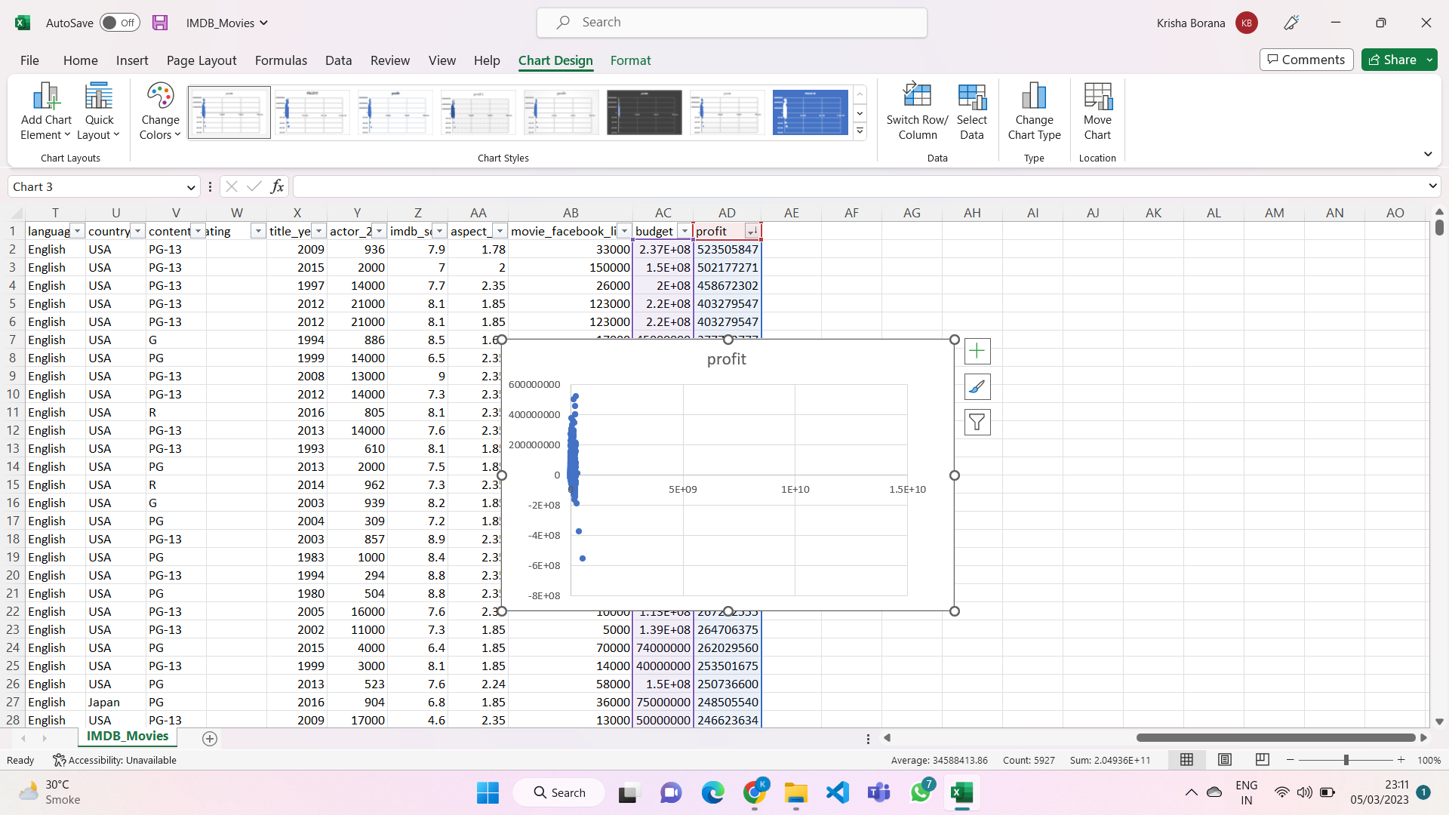

3.top 25 top IMDB SCORES.

NOT IN ENGLISH LANGUAGE

