# CSC/ECE 570 Section 001

# Spring 2021

# Homework #5

**Keywords:** Media Access, Data Link Layer Switching

Name 1: __________________________Student ID 1: _______________________

Name 2: __________________________Student ID 2: _______________________

## Instructions

* You can do this homework in groups of two (at most). Only one submission per group.
* The total number of points is 40.
* You must answer all questions for full credit.
* Use only this paper for your answers, in the space provided.
* The due date is as posted on the web page (please submit your answers through Moodle).

# Questions: Answer the following questions. Justify your answers and be as precise as possible. Do not make unnecessary assumptions.

[1] [4 points] Six stations, A through F, communicate using the MACA protocol. Is it possible for two transmissions to take place simultaneously? Explain your answer.

Ans - Yes. Since they are in a straight line and that each station can reach only its nearest neighbors, A can send to B while E is sending to F.

[2] [4 points] Two CSMA/CD stations are each trying to transmit long (multiframe) files. After each frame is sent, they contend for the channel, using the binary exponential backoff algorithm. What is the probability that the contention ends on round *k*, and what is the mean number of rounds per contention period?

Ans - Number the acquisition attempts starting at 1. Attempt *i* is distributed among 2*i* − 1 slots. Thus, the probability of a collision on attempt *i* is 2−(*i* − 1). The probability that the first k − 1 attempts will fail, followed by a success on round k is

* Pk = (1 − 2−(k −1)) ∏i=1k-1 2−(i −1)

which can be simplified to

* Pk = (1 − 2−(k −1)) 2−(k −1) (k −2)/2

The expected number of rounds is then just ΣkPk .

[3] [4 points] Ethernet frames must be at least 64 bytes long to ensure that the transmitter is still going in the event of a collision at the far end of the cable. Fast Ethernet has the same 64-byte minimum frame size but can get the bits out ten times faster. How is it possible to maintain the same minimum frame size?

Ans - The only difference in the fast Ethernet is that it reduces the bit time from “100” nanoseconds to “10” nanoseconds; because the fast Ethernet can exhibit the output ten times faster than the Ethernet and it reduces the maximum length of the cable by a factor of “10”. Thus, it meets the maximum wire delay as “1/10” (one-tenth) in fast Ethernet which is as long as in Ethernet. This advantage makes possible for the fast Ethernet to copy “10Mbps” classic Ethernet with maximum wire delay by a factor of “10”. Hence, the fast Ethernet also uses the same “64 byte” minimum frame size during the transmission.

The maximum wire delay in fast Ethernet is 1/10 as long as in Ethernet.

[4] [4 points] Suppose that an 11-Mbps 802.11b LAN is transmitting 64-byte frames back-to-back over a radio channel with a bit error rate of 10−5. How many frames per second will be damaged on average?

Ans – A frame contains 512 bits. The bit error rate p = 10-5. The probability of all 512 of them surviving correctly is (1-p)512, which is about 0.99489305939. The fraction damaged is thus about 5.1 * 10-5. The number of frames/sec is 11 × 106 /512 or about 21,484. Multiplying these two numbers together, we get about 1 damaged frame per second.

[5] [4 points] An 802.16 network has a channel width of 30 MHz. How many bits/sec can be sent to a subscriber station?

Ans -

[6] [4 points] In the following figure, we see that a Bluetooth device can be in two piconets at the same time. Is there any reason why one device cannot be the master in both of them at the same time?

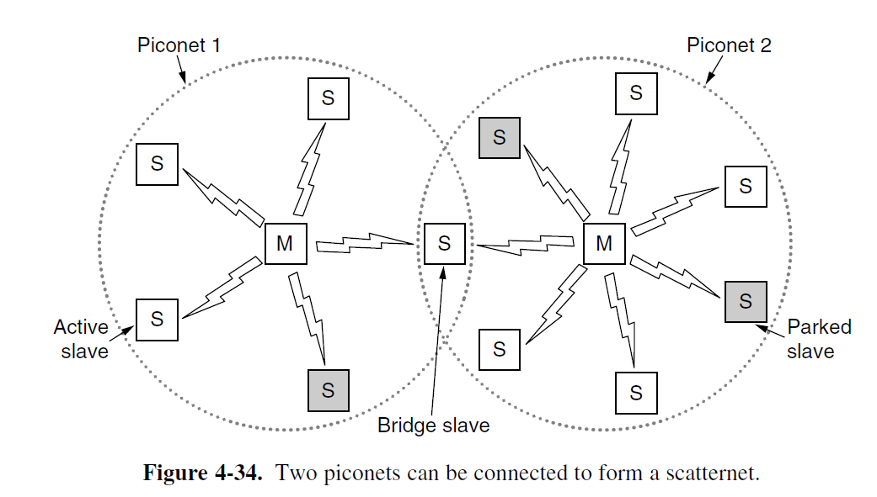

Ans - It is impossible for a device to be master in two piconets at the same time. Allowing this would create two problems.

First, only 3 address bits are available in the header, while as many as seven slaves could be in each piconet. Thus, there would be no way to uniquely address each slave.

Second, the access code at the start of the frame is derived from the master’s identity. This is how slaves tell which message belongs to which piconet. If two overlapping piconets used the same access code, there would be no way to tell which frame belonged to which piconet. In effect, the two piconets would be merged into one big piconet instead of two separate ones.

[7] [4 points] Suppose that there are 10 RFID tags around an RFID reader. What is the best value of Q? How likely is it that one tag responds with no collision in a given slot?

Ans - We want to maximize the probability that one (and only one) tag responds in a given slot. The best tag probability for 10 tags is 1/10. This occurs when the reader sets Q equal to 10 slots. The probability that one tag responds is roughly 40%.

[8] [4 points] A switch designed for use with fast Ethernet has a backplane that can move 10 Gbps. How many frames/sec can it handle in the worst case?

Ans - The worst case is an endless stream of 64-byte (512-bit) frames. If the backplane can handle 109 bps, the number of frames it can handle is 109 /512. This is 1,953,125 frames/sec.

[9] [4 points] Consider the extended LAN connected using bridges B1 and B2 in the following figure (b). Suppose the hash tables in the two bridges are empty. List all ports on which a packet will be forwarded for the following sequence of data transmissions:

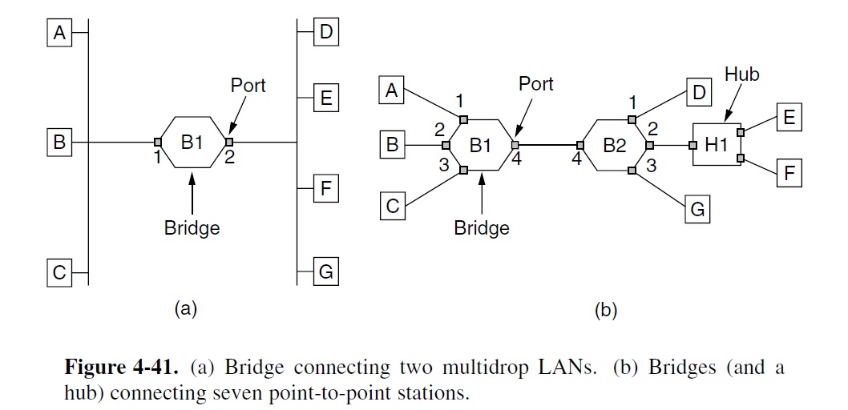

(a) A sends a packet to E.

(b) E sends a packet to F.

(c) F sends a packet to E.

(d) G sends a packet to E.

(e) D sends a packet to A.

(f) B sends a packet to F.

Ans –

(a) B1 will forward this packet on ports 2, 3, and 4. B2 will forward it on 1, 2 and 3.

(b) B2 will forward this packet on ports 1, 3, and 4. B1 will forward it on 1, 2 and 3.

(c) B2 will not forward this packet on any of its ports, and B1 will not see it.

(d) B2 will forward this packet on port 2. B1 will not see it.

(e) B2 will forward this packet on port 4 and B1 will forward it on port 1.

(f) B1 will forward this packet on ports 1, 3 and 4. B2 will forward it on port 2.

[10] [4 points] It is mentioned in Section 4.8.3 that some bridges may not even be present in the spanning tree. Outline a scenario where a bridge may not be present in the spanning tree.

Ans - A bridge that does not have any station directly connected to any of its ports and is part of a loop is a candidate for not being a part of the spanning tree bridges. This can happen if the shortest paths to the root for all bridges connected to this bridge does not include this bridge.

One scenario may be that there are 7 bridges. We can think of them as being in a hexagon with one in the middle. There are connections along the perimeter, and all are connected to the center bridge. The center bridge may be left out of the spanning tree to prevent a loop.