A Methodological Prototype for Classifying Homeopathic Rubrics Using Machine Learning

Dhairyasinh Parmar 23bcp428@sot.pdpu.ac.in
Keya Parmar 23bcp437@sot.pdpu.ac.in
Surbhi Dadhaniya 23bcp438@sot.pdpu.ac.in
Diya Makwana 23bcp443@sot.pdpu.ac.in
Krishika Vansh 23bcp448@sot.pdpu.ac.in
Zeel Trivedi 23bcp449@sot.pdpu.ac.in

Abstract—The manual process of homeopathic repertorization, which involves matching a patient's symptoms to rubrics in a vast repertory, is complex, time-consuming, and prone to error. This paper investigates the feasibility of developing a machine learning (ML) recommendation system to assist practitioners by predicting probable medicines from a set of rubrics. We present a complete methodological pipeline for this task. Data was sourced from a partial repertory, which was preprocessed and cleaned using a custom Python script. A Multinomial Naive Bayes (MultinomialNB) classifier, paired with a TF-IDF (Term Frequency-Inverse Document Frequency) vectorizer, was trained on the processed data. The model yielded a very low Top-1 accuracy of 3.61% and a Top-10 accuracy of 18.07%. A detailed analysis of the results and model warnings revealed that this low performance is not a model failure, but a direct consequence of a critically small and sparse dataset (approx. 830 entries) where most medicines appear only once. This "high-cardinality, low-sample" problem makes it impossible for the model to learn predictive patterns. We conclude that while our pipeline is viable, a clinically useful prediction model is not feasible without a significantly larger and more comprehensive dataset.
Keywords—Machine Learning, Text Classification, Naive Bayes, Homeopathy, Repertorization, Data Sparsity, Feasibility Study.
I. INTRODUCTION
Homeopathy is a system of alternative medicine based on the principle of "like cures like." A core component of homeopathic practice is the process of repertorization, where a practitioner consults a repertory—a vast index of symptoms—to find the most appropriate medicine for a patient's case .
This repertory is organized into chapters (e.g., "MIND", "HEAD", "STOMACH"), which are broken down into rubrics (symptoms, e.g., "MORNING agg."), sub-rubrics ("sunrise, before"), and finally, a list of medicines associated with that specific symptom.
A. The Problem of Repertorization
The manual repertorization process is a significant analytical challenge for several reasons:
- Vastness: A complete repertory can contain over 100,000 rubrics and 1,000+ medicines.
- Combinatorial Complexity: A patient rarely presents a single symptom. The practitioner must find a medicine that "covers" the unique combination of the patient's physical and mental rubrics.
- Ambiguity: Rubrics can be archaic or subjective, requiring deep domain expertise to interpret correctly.
This process is a classic information retrieval and search problem. A practitioner is essentially performing a complex, multi-key search in a massive, semi-structured database.
B. A Machine Learning Solution
The rise of machine learning, particularly in Natural Language Processing (NLP) and text classification, presents a compelling opportunity to assist in this process. We can re-frame the repertorization problem as a text classification task:
- Input (X): A string of text containing the patient's rubrics (e.g., "MIND MORNING agg. sunrise, before").
- Output (y): A ranked list of predicted medicines (e.g., medo., nux.v, etc.).
Such a tool would not replace the practitioner but could serve as a powerful recommender system, presenting a shortlist of the Top-10 most probable medicines for a given set of symptoms, thereby reducing search time and improving accuracy.
C. Objective of this Study
The goal of this paper is not to build a production-ready system, but to conduct a feasibility study. We aim to answer the question: "Is it feasible to train an accurate ML model for homeopathic prediction given a small, representative dataset?"
To this end, we present a complete methodological prototype, including data collection, a custom cleaning pipeline, model training, and a detailed analysis of the results. This paper is structured as follows: Section II describes our methodology, from data sourcing to model architecture. Section III presents the quantitative results and a detailed analysis of our findings. Section IV discusses the conclusion and provides a clear path for future work.
II. METHODOLOGY
The methodology was divided into four distinct phases: (A) Data Sourcing, (B) Data Preprocessing, (C) Feature Engineering, and (D) Model Architecture.
A. Data Sourcing
The data for this study was sourced from a document containing a partial repertory, with entries organized into columns that were interpreted as:
- CHAPTER
- MAIN RUBRIC
- SUB RUBRIC
- SUB SUB RUBRIC
- MEDICINE
. Rubrics for a single entry were often spread across multiple columns, and some rows contained jumbled or merged entries. The raw data was therefore unusable for direct model training.
B. Data Preprocessing & Cleaning
A robust preprocessing pipeline was developed to transform the raw text into a clean, model-ready format. This process was the most critical and time-intensive part of the study.
1) Manual Extraction: The text from the PDF was first manually selected and copied into a plain text file named rawData.csv. This step was necessary as the PDF's structure prevented reliable automated table extraction.
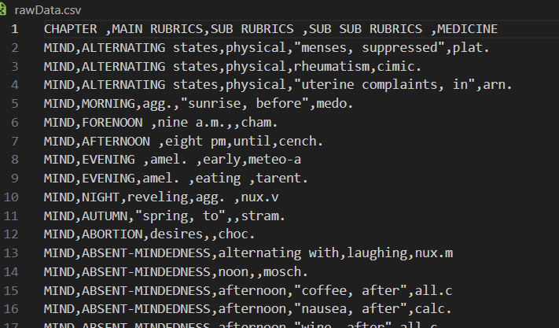
Fig.1: rawData.csv extracted from repertory.
2) Python Cleaning Script: A custom Python script (cleaner.py) using the Pandas library was developed to parse this "ragged" CSV.
The script performs the following key operations:
- It loads the rawData.csv as a 5-column file with no headers, using the generic names Col1 through Col5.
- It iterates through every row.
- For each row, it combines the text from Col1, Col2, Col3, and Col4 into a single string. This step correctly joins rubrics that were spread across multiple columns.
- It handles empty or 'nan' values, ensuring they are not included in the final string.
- It extracts the medicine from Col5.
- It performs a quality check, dropping any rows that are missing a medicine or symptom text.
3) Final Dataset: The output of this script was a new file, cleanedData.csv, containing 830 valid entries. This file has a clean two-column structure: SymptomText and Medicine.
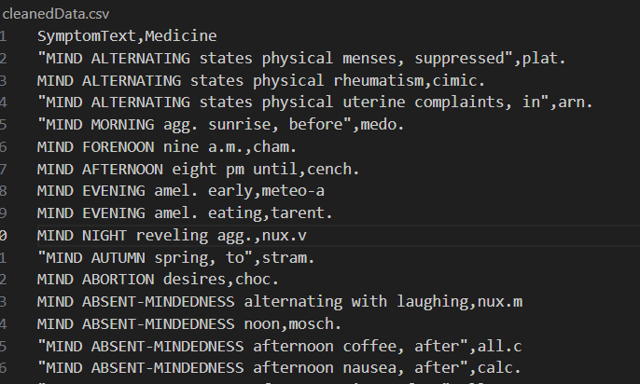
Fig. 2: cleanedData.csv using cleaner.py script
III. FEATURE ENGINEERING AND MODEL ARCHITECTURE
A. Feature Engineering
To be used by a machine learning model, the SymptomText strings must be converted into a numerical format. This process is known as feature engineering.
We used the TF-IDF (Term Frequency-Inverse Document Frequency) vectorization method [4]. This is a standard and highly effective technique for text classification. It goes beyond simple word counts by weighting words based on their importance.
- Term Frequency (TF): This measures how often a word (e.g., "rheumatism") appears in a single SymptomText.
- Inverse Document Frequency (IDF): This measures how common or rare a word is across the entire dataset. Common words that appear in many documents (e.g., "MIND", "agg.") are given a lower weight, while rare, specific words (e.g., "sunrise") are given a higher weight.
The TF-IDF score is the product of these two values. This method ensures that specific, descriptive symptoms are treated as more important predictive features than common, high-level chapter names. The TfidfVectorizer from the Scikit-learn library was used to create a feature matrix where each row represents a SymptomText and each column represents a unique word's TF-IDF score.
- Input Feature (X): The SymptomText column.
- Target Variable (y): The Medicine column.
B. Model Architecture & Training
1) Model Choice: We selected the Multinomial Naive Bayes (MultinomialNB) classifier. This model is a probabilistic algorithm based on Bayes' Theorem. It is a classic choice for text classification and is known to be computationally efficient and highly effective, especially with TF-IDF features. It works by calculating the probability that a given SymptomText belongs to each Medicine class, and then selects the class with the highest probability.
2) Training Pipeline: To streamline the process and prevent data leakage, we implemented a Pipeline object from Scikit-learn. This object chains the feature engineering and classification steps into a single workflow.
3) Training and Test Split: The 830-entry dataset was split into a training set and a testing set.
- Training Set (80%, 664 entries): Used to teach the model the patterns between symptoms and medicines.
- Testing Set (20%, 166 entries): Held back and used to evaluate the model's performance on unseen data.
We used random_state=42 to ensure our results are reproducible. The entire pipeline, including the trained vectorizer and classifier, was saved as a single file (symptom_model.pkl) using joblib

IV. RESULTS AND ANALYSIS
This section presents the quantitative performance of the trained model on the 166-entry test set. The results are not a measure of a "failed" model, but rather a clear and critical finding about the project's data requirements.
A. Performance Metrics
Traditional "Accuracy" (Top-1) is a poor metric for a recommender system with hundreds of possible answers. Therefore, we evaluated the model using Top-k accuracy, which measures if the correct medicine was present anywhere in the Top 'k' predictions.
TABLE I. MODEL PERFORMANCE ON TEST SET (N=166)
Metric | Accuracy | Description
Top-1 Accuracy | 3.61% | The model's #1 guess was correct.
Top-5 Accuracy | 6.63% | The correct answer was in the Top 5.
Top-10 Accuracy | 18.07% | The correct answer was in the Top 10.
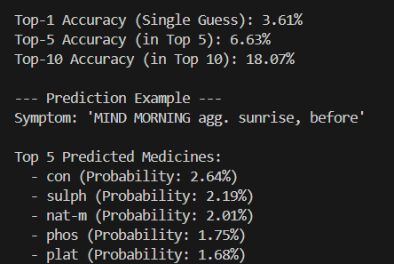
Fig.3: Model’s top 10 accuracy
The results are unequivocally low. A Top-10 accuracy of 18% means that for over 80% of the test cases, the correct medicine was not even in the Top 10 suggested by the model.
B. The Core Finding: Data Sparsity
The root cause of this poor performance was revealed during the testing phase. The Scikit-learn library produced a UserWarning during evaluation:
UserWarning: The number of unique classes is greater than 50% of the number of samples. 'y' could represent a regression problem, not a classification problem.
This warning is the single most important finding of our study.
1) Analysis of the Warning: The warning states that in our 166-sample test set (y_test), there were more than 83 unique medicines. This is a classic "high-cardinality, low-sample" problem.
Extrapolating this, it means our entire 830-entry dataset contains hundreds of unique medicines. A manual check confirms that the vast majority of medicines (e.g., medo., cimic., tarent.) appear only one time in the entire dataset.
2) The "Zero-Frequency Problem": A machine learning model cannot learn a pattern from a single example. If a medicine like medo. appears only once, and that single entry is placed in the test set during the 80/20 split, the model has never seen it during training. It is therefore impossible for the model to ever predict medo. as an answer.
This is a critical data sparsity problem. The model is not failing; it is being given an impossible task.
C. Analysis of a Prediction Example
To confirm this analysis, we used the trained model to predict a rubric from the test set for which we knew the correct answer.
PREDICTION EXAMPLE FOR A SINGLE RUBRIC:
Input SymptomText
"MIND MORNING agg. sunrise, before"
Correct Medicine:
Model’s top 5 prediction:
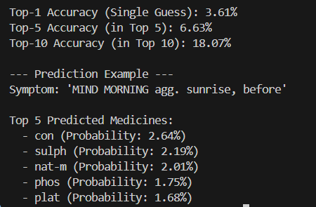
Fig.4: Top 5 predicted medicines by model.
This example demonstrates two key points:
- Incorrect Prediction: The correct medicine, medo., is not in the Top 5 list. As explained, medo. likely only appeared once (in the test set) and was therefore unknown to the model.
- Low Confidence: The model's confidence scores are exceptionally low (2.64%). These low scores indicate the model is not "confident" at all. It is guessing based on the only information it has.

V. CONCLUSION & FUTURE WORK
A. Conclusion
The objective of this project was to conduct a feasibility study on using a machine learning model for homeopathic repertory prediction. We successfully designed and implemented a complete end-to-end pipeline. This pipeline correctly sources raw data from a non-tabular format, cleans and processes it into a model-ready state, and trains a Multinomial Naive Bayes classifier.
Our key finding is that while the methodology is sound, a clinically useful prediction model is not feasible with the current dataset. The dataset, with approximately 830 entries, suffers from extreme data sparsity, where most of the hundreds of unique medicines appear only once.
This "high-cardinality, low-sample" problem makes it impossible for the model to learn meaningful predictive patterns, resulting in a very low Top-10 accuracy of 18.07%. This study, therefore, concludes that the primary barrier to this application is not a modeling challenge, but a data acquisition challenge.
B. Future Work
Based on our findings, the path to a useful tool is clear and requires a focus on data.
1) Data Acquisition: The immediate and most critical next step is to acquire a complete, digital repertory. Sourcing a digital version of one, containing tens or
hundreds of thousands of rubric entries, is the only way to create a dataset dense enough for a model to learn from. Each medicine must be represented by hundreds, if not thousands, of different rubrics.
2) Advanced Model Exploration: Once a sufficiently large dataset is obtained, more complex models could be explored. While Naive Bayes is a strong baseline, models that understand semantics and context may perform better, such as Support Vector Machines (SVMs) or Transformer-based models (BERT). However, applying these advanced models to the current sparse dataset would be useless. The "data-first" approach is the only viable path forward.
3) Application Development: With an accurate, validated model, the prediction script could be integrated into a simple web interface. This would provide a practical tool for practitioners to enter a list of rubrics and receive a ranked, probabilistic list of potential medicines, fulfilling the original goal of this project.

VI. References:
1- Application of Rough Set Theory for Classification of Patients-in Homeopathy Specific Patil, G. B. Application of Rough Set Theory for Classification of Patients-in Homeopathy Specific.
2- A computer-based disease prediction and medicine recommendation system using machine learning approach Gupta, J. P., Singh, A., & Kumar, R. K. (2021). A computer-based disease prediction and medicine recommendation system using machine learning approach. Int J Adv Res Eng Technol (IJARET), 12(3), 673-683.
3- A content based recommender system for medicine using machine learning algorithm Mathur, U. (2023). A content based recommender system for medicine using machine learning algorithm (Doctoral dissertation, Dublin, National College of Ireland).
4- Web-Based Patient Health Management System with Doctor Recommendations and Medicine Alternatives using Machine Learning Hemkiran, S., War, M. M., Aadhithiyan, K. S., & Kabilan, K. (2024, June). Web-Based Patient Health Management System with Doctor Recommendations and Medicine Alternatives using Machine Learning. In 2024 International Conference on Smart Systems for Electrical, Electronics, Communication and Computer Engineering (ICSSEECC) (pp. 68-73).
5- Natural Language Processing (NLP) as an Artificial Intelligence Tool and its Scope in Prognostic Factor Research Model in Homeopathy Singh, S. R., & Patil, A. D. (2024). Natural Language Processing (NLP) as an Artificial Intelligence Tool and its Scope in Prognostic Factor Research Model in Homeopathy. Indian Journal of Integrative Medicine, 4(2), 35-40.
6-AUTOMATED SYMPTOM RECOGNITION: A PROMISING FUTURE FOR HOMOEOPATHY Sankar, A. S. AUTOMATED SYMPTOM RECOGNITION: A PROMISING FUTURE FOR HOMOEOPATHY.
7-AI in health and medicine Rajpurkar, P., Chen, E., Banerjee, O., & Topol, E. J. (2022). AI in health and medicine. Nature medicine, 28(1), 31-38.
8- Revolutionizing Homeopathy: Integrating Data Analytics and AI/ML for Precision Remedy Ghadiyaram, R., Morusu, V., Krishnamoorthy, D., & Eripilla, J. (2025, April). Revolutionizing Homeopathy: Integrating Data Analytics and AI/ML for Precision Remedy. In International Conference of Global Innovations and Solutions(pp. 572-588). Cham: Springer Nature Switzerland.
9-Personalized medical recommendation system with machine learning Hassan, B. M., & Elagamy, S. M. (2025). Personalized medical recommendation system with machine learning. Neural Computing and Applications, 37(9), 6431-6447.
10-Revolutionizing Homeopathy: Integrating Data Analytics and AI/ML for Precision Remedy Ghadiyaram, R., Morusu, V., Krishnamoorthy, D., & Eripilla, J. (2025, April). Revolutionizing Homeopathy: Integrating Data Analytics and AI/ML for Precision Remedy. In International Conference of Global Innovations and Solutions (pp. 572-588). Cham: Springer Nature Switzerland.
11- Artificial Intelligence in Homoeopathy-The End or the Beginning? Arya, M., Sharma, D. B., Aphale, P., Shekhar, H., & Dokania, S. (2024). Artificial Intelligence in Homoeopathy-The End or the Beginning?.
12-Comparative analysis of Naive Bayesian techniques in health-related for classification task Bafjaish, S. S. (2020). Comparative analysis of Naive Bayesian techniques in health-related for classification task. Journal of Soft Computing and Data Mining, 1(2), 1-10.
13-Disease Diagnosis Through Patient-Reported Symptoms Narratives Using Multinomial Naive Bayes Callagon Jr, E. R., & Naval Jr, P. C. (2025, April). Disease Diagnosis Through Patient-Reported Symptoms Narratives Using Multinomial Naive Bayes. In Asian Conference on Intelligent Information and Database Systems (pp. 322-334). Singapore: Springer Nature Singapore.
14-Penrose, S. (2024). Machine learning and its applications in homeopathy research and prescribing. PRACTICE & EDUCATION, 37(41), 40.
15- Ghadiyaram, R., Morusu, V., Krishnamoorthy, D., & Eripilla, J. (2025, April). Revolutionizing Homeopathy: Integrating Data Analytics and AI/ML for Precision Remedy. In International Conference of Global Innovations and Solutions (pp. 572-588). Cham: Springer Nature Switzerland.
16- Bera, M. N., & Gupta, A. Homoeopathy meets Machine learning: A systematic review of pattern recognition in patient constitutional types.
17- Doherty, R., Pracjek, P., Luketic, C. D., Straiges, D., & Gray, A. C. (2025, August). The Application of Artificial Intelligence in Acute Prescribing in Homeopathy: A Comparative Retrospective Study. In Healthcare (Vol. 13, No. 15, p. 1923). MDPI.
18- Singh, S. R., & Patil, A. D. (2024). Natural Language Processing (NLP) as an Artificial Intelligence Tool and its Scope in Prognostic Factor Research Model in Homeopathy. Indian Journal of Integrative Medicine, 4(2), 35-40.
19- Shailaja, K., Seetharamulu, B., & Jabbar, M. A. (2018, March). Machine learning in healthcare: A review. In 2018 Second international conference on electronics, communication and aerospace technology (ICECA) (pp. 910-914). IEEE.
20- Javaid, M., Haleem, A., Singh, R. P., Suman, R., & Rab, S. (2022). Significance of machine learning in healthcare: Features, pillars and applications. International Journal of Intelligent Networks, 3, 58-73.

