Synopsis

Project Title

Prediction of Congestion in Campus Wi-Fi Networks using Machine Learning

Project ID: PY-GT-45
Problem ID: 25
Student Name: Krish Bajaj
University Roll Number: 2028747
Section: G

Student Name: Sparsh Jain
University Roll Number: 2028863
Section: G

Student Name: Srijan Parashar
University Roll Number: 2028865
Section: G

Repohttps://github.com/Krishisgone/PBL-AI-ML.

Problem Description
Campus Wi-Fi congestion has become a common issue due to the growing number of connected devices and the increased use of online learning resources, video meetings, digital classrooms, cloud platforms, and mobile applications. When too many users access the same network resources, the performance of the Wi-Fi network degrades and users experience high latency, packet loss, low throughput, and unstable connectivity.
This project aims to design and develop an end-to-end machine learning classification system that can analyze network performance data and predict whether the campus Wi-Fi is congested or not. The system uses a suitable dataset containing numerical features such as the number of connected devices, network latency, packet loss rate, bandwidth usage, and access point load. Before model building, the data is cleaned, normalized, and transformed to improve quality and consistency. Exploratory Data Analysis is then performed to understand feature distributions, detect anomalies, identify congestion periods, and study relationships among network parameters. Correlation analysis and feature selection techniques such as PCA, forward selection, and backward selection are applied to identify the most relevant features. Finally, classification models are trained and evaluated using standard performance metrics so that the best model can support better network monitoring, congestion control, and decision-making.

Steps of Implementation
This project follows a structured machine learning pipeline for campus Wi-Fi congestion prediction. Each phase of implementation is explained below:

Data Collection
A suitable campus Wi-Fi dataset is selected for congestion prediction. In this project, the dataset contains numerical network performance features such as the number of connected devices, latency, packet loss rate, bandwidth usage, and access point load.
These attributes are useful for classifying the network state into congested and non-congested classes.

Data Preprocessing
The dataset is cleaned before model training. Missing values are handled, inconsistent or duplicate records are removed, and numerical features are scaled using preprocessing techniques from scikit-learn such as MinMaxScaler and StandardScaler. This improves data quality and ensures that feature values are in a comparable range.

Exploratory Data Analysis
EDA is performed to understand the structure and behavior of the data. Statistical summaries, histograms, box plots, scatter plots, and correlation heatmaps are used to study the distribution of network metrics, detect anomalies, identify possible congestion periods, and understand how features influence one another.

Feature Selection
Relevant input variables are selected to improve classification performance and reduce redundancy. Methods such as PCA, forward selection, and backward selection are considered so that the most informative network attributes are retained for model development.

Model Selection
Classification algorithms suitable for binary prediction are chosen. Beginner-friendly and effective models such as Logistic Regression, Decision Tree Classifier, Random Forest Classifier, K-Nearest Neighbours, and Support Vector Machine can be used for learning congestion patterns from historical network data.

Training and Validation
The dataset is divided into training and testing subsets, commonly in an 80:20 ratio. Models are trained on the training data and validated on unseen test data to check whether they generalize well and predict Wi-Fi congestion reliably.

Evaluation
After training, the models are evaluated using standard classification metrics such as accuracy, precision, recall, F1-score, confusion matrix, ROC curve, and optionally AUC score. These measures help compare different models and identify the most effective classifier.

Final Model
The model that demonstrates the best overall performance is selected as the final model.
This model can be used to support proactive monitoring of campus Wi-Fi usage and help network administrators make better decisions for congestion management.

Machine Learning Pipeline Architecture
The following graphical flowchart summarizes the complete workflow used in the proposed project.
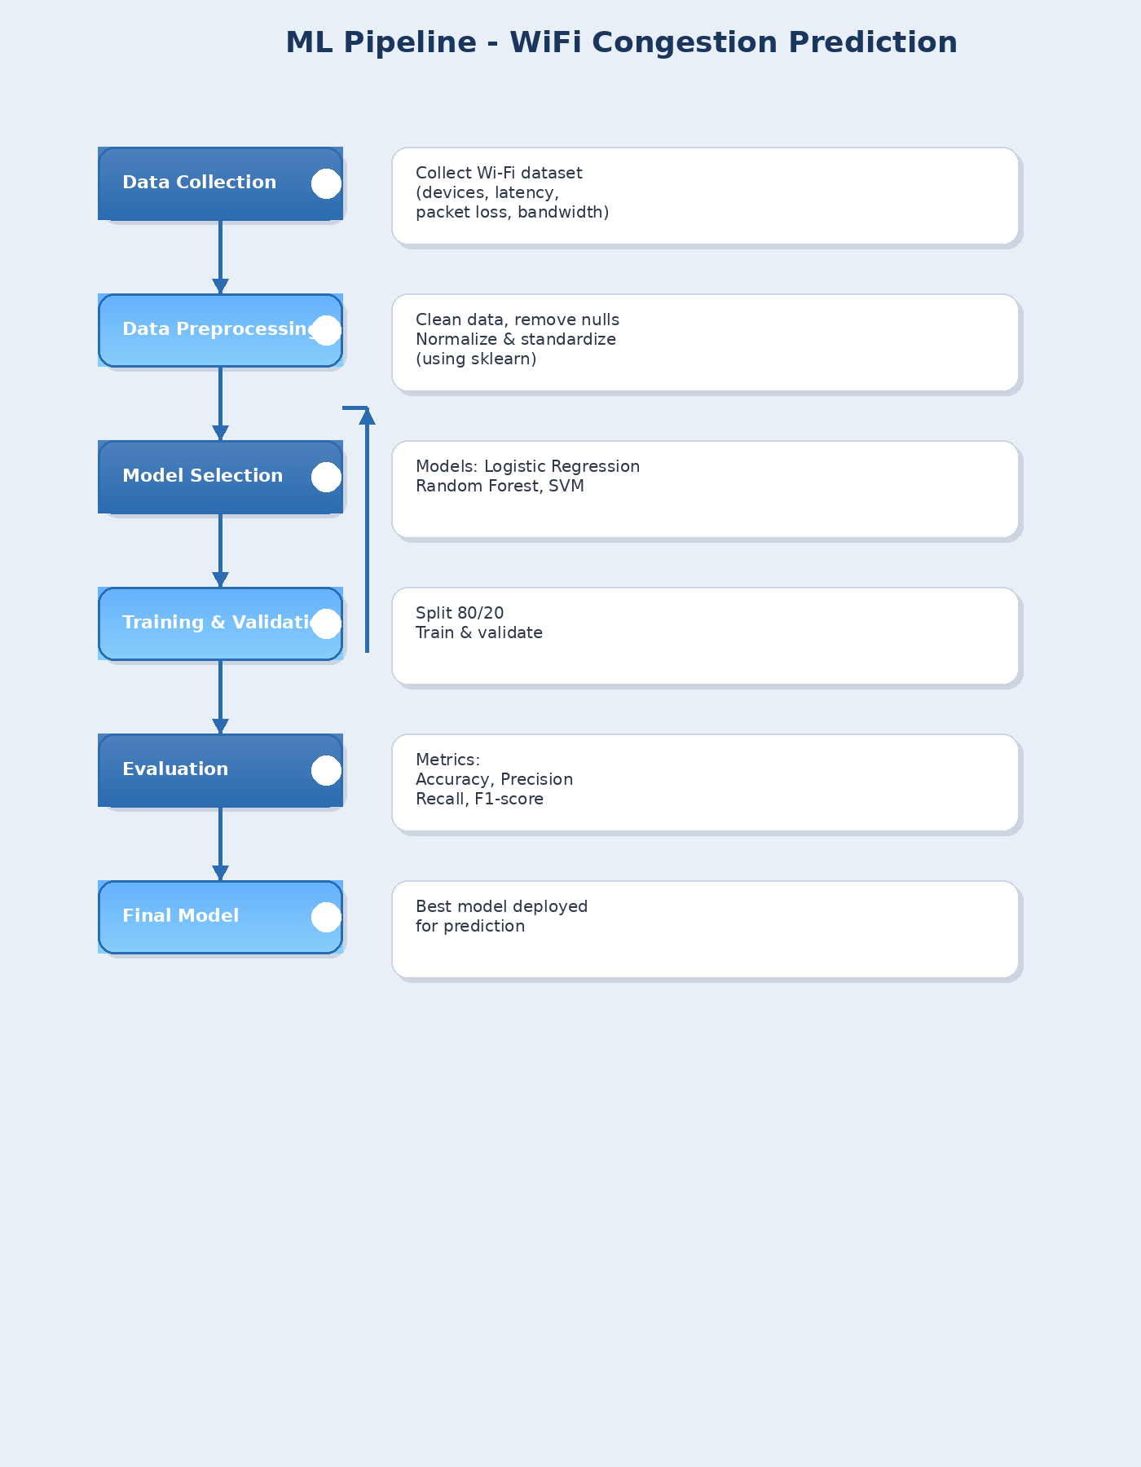

Expected Modules / Libraries to be Used
The following Python libraries and important scikit-learn modules are proposed for use in this project:

NumPy
Used for numerical operations, matrix handling, and efficient processing of arrays.

Pandas
Used for reading the dataset from CSV files and for organizing, cleaning, filtering, and analyzing tabular network data.

Matplotlib
Used for plotting graphs such as histograms, scatter plots, box plots, and model comparison charts.

Seaborn
Used for advanced data visualization, especially for correlation heatmaps and confusion matrix heatmaps.

Scikit-learn (sklearn)
The main machine learning library used for preprocessing, feature selection, model training, testing, and evaluation.

Pandas
Used for reading the dataset from CSV files and for organizing, cleaning, filtering, and analyzing tabular network data.

Matplotlib
Used for plotting graphs such as histograms, scatter plots, box plots, and model comparison charts.

Seaborn
Used for advanced data visualization, especially for correlation heatmaps and confusion matrix heatmaps.

Scikit-learn (sklearn)
The main machine learning library used for preprocessing, feature selection, model training, testing, and evaluation.

Important Modules from Scikit-learn
  - train_test_split: Divides the dataset into training and testing sets.

  - StandardScaler: Standardizes numerical features to zero mean and unit variance.

  - MinMaxScaler: Normalizes values into a fixed range such as 0 to 1.

  - PCA: Reduces dimensionality and helps select compact feature combinations.

  - LogisticRegression: Implements a logistic regression classifier for binary classification.

  - DecisionTreeClassifier: Builds a decision tree model for classification.

  - RandomForestClassifier: Creates an ensemble classifier using multiple decision trees.

  - KNeighborsClassifier: Implements the K-Nearest Neighbours classifier.

  - SVC: Implements the Support Vector Machine classifier.

  - accuracy_score: Calculates overall model accuracy.

  - precision_score: Computes prediction precision.

  - recall_score: Measures model recall.

  - f1_score: Calculates the harmonic mean of precision and recall.

  - confusion_matrix: Generates the confusion matrix for classification results
.
  - roc_curve and roc_auc_score: Used to draw the ROC curve and measure class-separation ability.

Expected Evaluation Metrics and Plots to be Used
The following evaluation measures and plots are proposed for comparing machine learning models used for Wi-Fi congestion prediction:

Accuracy
Measures the proportion of correctly classified records out of the total predictions.

Precision
Shows how many of the records predicted as congested are actually congested.

Recall
Measures how many actual congestion cases are correctly identified by the model.

F1-score
Provides a balanced measure by combining precision and recall.

Confusion Matrix
Displays true positives, true negatives, false positives, and false negatives in a structured form.

ROC Curve
Shows the classification performance across different threshold values.

AUC Score (optional but recommended)
Indicates how well the classifier separates congested and non-congested classes.

Plots to be Used
  - Confusion Matrix Heatmap
  - ROC Curve Plot
  - Model Comparison Bar Graph using Accuracy and F1-score
  - Correlation Heatmap
  - Histogram and Box Plot for network features
  - Scatter Plot for studying relationships between network parameters

Required Topics from the Subject

Strings
Used for handling column names, labels, file paths, class names, and output messages.

Pointers
Although pointers are mainly a C programming concept, their study helps in understanding memory handling and efficient data management.

Files
Essential for reading and writing data because the network dataset is generally stored in CSV format and loaded into Python for analysis.

Arrays
Used to store multiple numerical values of the same type and are important for model input and processing.

Functions
Used to divide the program into smaller reusable blocks for preprocessing, training, prediction, and evaluation.

Conditional Statements
Help in making decisions in the program, such as checking missing values, selecting the best model, or assigning congestion labels.

Platform Required
The project can be implemented using the following platforms:
  - Jupyter Notebook: Ideal for writing and executing Python code step by step in a beginner-friendly environment.
  - Google Colab: Useful for running notebooks online without local installation.
  - Visual Studio Code: Suitable for project development, file management, and writing Python scripts.

Books and Link Sources
  - Scikit-learn Documentation - https://scikit-learn.org
  - Pandas Documentation - https://pandas.pydata.org
  - NumPy Documentation - https://numpy.org
  - Matplotlib Documentation - https://matplotlib.org
  - Hands-On Machine Learning with Scikit-Learn, Keras, and TensorFlow by Aurelien Geron

Dataset https://github.com/Krishisgone/PBL-AI-ML.

