Orion: An AI-Assisted, Microservices-Based Online Recruitment Portal with Semantic Matching and Skill-Gap Analysis

Duggisetty Laasya Priya
Team Lead
Dept. of Computer Science Engineering
K L (Deemed to be) University 2420030002@klh.edu.in
Bhanu Prakash
Team Member
Dept. of Computer Science Engineering
K L (Deemed to be) University 2420030209@klh.edu.in
Krishita Myneni
Team Member
Dept. of Computer Science Engineering
K L (Deemed to be) University 2420030443@klh.edu.in
Abstract — Online recruitment platforms struggle to connect candidates and employers efficiently as job listings and applications grow: keyword search can miss relevant profiles that describe equivalent skills in different words, manual screening is time-consuming, and candidates receive little explanation of their suitability. This paper presents Orion, an AI-assisted, microservices-based online recruitment portal that supports candidate profiles, job discovery, applications, status tracking, notifications, recruiter dashboards, and applicant screening. The system combines a React frontend, Java 21 and Spring Boot microservices behind a Spring Cloud API Gateway, Neon PostgreSQL for live application data, and a FastAPI service that provides semantic and keyword-based analysis, skill-gap identification, and applicant ranking. Text is encoded with BAAI/bge-small-en-v1.5 (384 dimensions), with 37,554 candidate embeddings and 6,011 job embeddings recorded. A Logistic Regression matching classifier trained on 41,308 candidate–job pairs (17,649 positive and 23,659 negative) and evaluated on 8,262 test samples achieved 71% accuracy and a 0.70 F1-score, and a separate recruiter screening model recorded 0.8238 accuracy and a 0.7924 F1-score. An example analysis produced a 74.39% match score with 50% skill coverage. The JTH dataset is used only for training and evaluation; live analysis uses candidate and job records retrieved from Neon PostgreSQL. Orion keeps recruiters responsible for final hiring decisions.
Keywords — recruitment portal, semantic matching, skill-gap analysis, sentence embeddings, applicant screening, microservices, Spring Boot, FastAPI

I. INTRODUCTION
Online recruitment has made job discovery and application submission more accessible, but effective matching remains difficult. A candidate may have the right underlying experience even when a profile does not use the exact words of a job description, while recruiters who review many applications by hand face delays in shortlisting. Candidates, in turn, receive little explanation of why they match a role or which required skills are missing. Industry systems for talent search, recommendation, and job discovery address parts of this problem [1]–[3].
This paper presents Orion, an AI-assisted online recruitment portal that combines the core recruitment workflow with semantic matching, skill-gap feedback, and applicant screening in one application. Orion follows a microservices architecture: authentication, candidate profiles, job management, applications, matching, skill-gap analysis, screening, and notifications are separate services that communicate through REST interfaces and an API Gateway. Orion was developed as a project for the course SOA Programming and Microservices (24SDCS03). The main contributions are: (1) an end-to-end recruitment platform built from independently organized services; (2) semantic, context-based candidate–job matching alongside keyword-based analysis; (3) skill-gap analysis that classifies skills as strong, partial, or missing and suggests learning directions; (4) AI-assisted applicant ranking with a manual-screening path that preserves recruiter oversight; and (5) a strict separation between the JTH dataset, used only for training and evaluation, and the live Neon PostgreSQL data used during analysis.
The rest of this paper is organized as follows. Section II reviews related work and the research gap. Section III describes the system architecture, AI components, and experimental setup. Section IV reports the results, functional checks, and screenshots. Section V discusses the findings and limitations, and Section VI concludes the paper and outlines future scope.
II. RELATED WORK
A. Industry Talent Search and Recommendation
LinkedIn Talent Solutions provides recruitment and talent-search tools relevant to candidate discovery and recruiter workflows [1]. However, this general industry resource does not report experimental results that can be directly compared with Orion’s evaluation. Orion extends the recruitment workflow by integrating candidate–job matching with skill-gap analysis and recruiter screening.
Jobindex provides an online recruitment platform [2], while Indeed provides job-search and recruitment services [3].
B. Semantic Similarity and Ranking
Ajjam and Al-Raweshidy [4] present an AI-driven semantic similarity-based job matching framework that captures contextual relationships between candidate profiles and job descriptions, addressing the limitations of keyword-based recruitment. Their work is closely related to Orion’s semantic matching feature. A machine learning-based resume ranking system [5] uses cosine similarity to compare resumes with job descriptions and a K-Nearest Neighbors algorithm to rank candidates, helping reduce the effort involved in manually evaluating applicants. In contrast, Orion integrates context-based semantic matching, skill-gap analysis, and AI-assisted, manual, or combined screening within a microservices-based recruitment workflow.
C. Research Gap
Existing solutions often emphasize one or more functions, such as candidate search, job recommendation, ranking, or recruiter feedback, rather than combining an end-to-end recruitment workflow with semantic matching, interpretable skill-gap feedback, applicant screening, and manual recruiter control in one modular application. Orion is designed to fill this gap.
III. METHODOLOGY
A. System Architecture
Orion consists of a React frontend, a Spring Cloud API Gateway, eight Spring Boot microservices, a Neon PostgreSQL database, and a FastAPI AI service (Fig. 1). The frontend sends requests to the gateway, which routes them to the relevant service. For AI analysis, the backend obtains candidate and job details from Neon PostgreSQL and passes the relevant profile and job information to the FastAPI service, which returns matching and skill-gap results through the backend to the frontend. Table I lists the components and ports used in the project configuration.
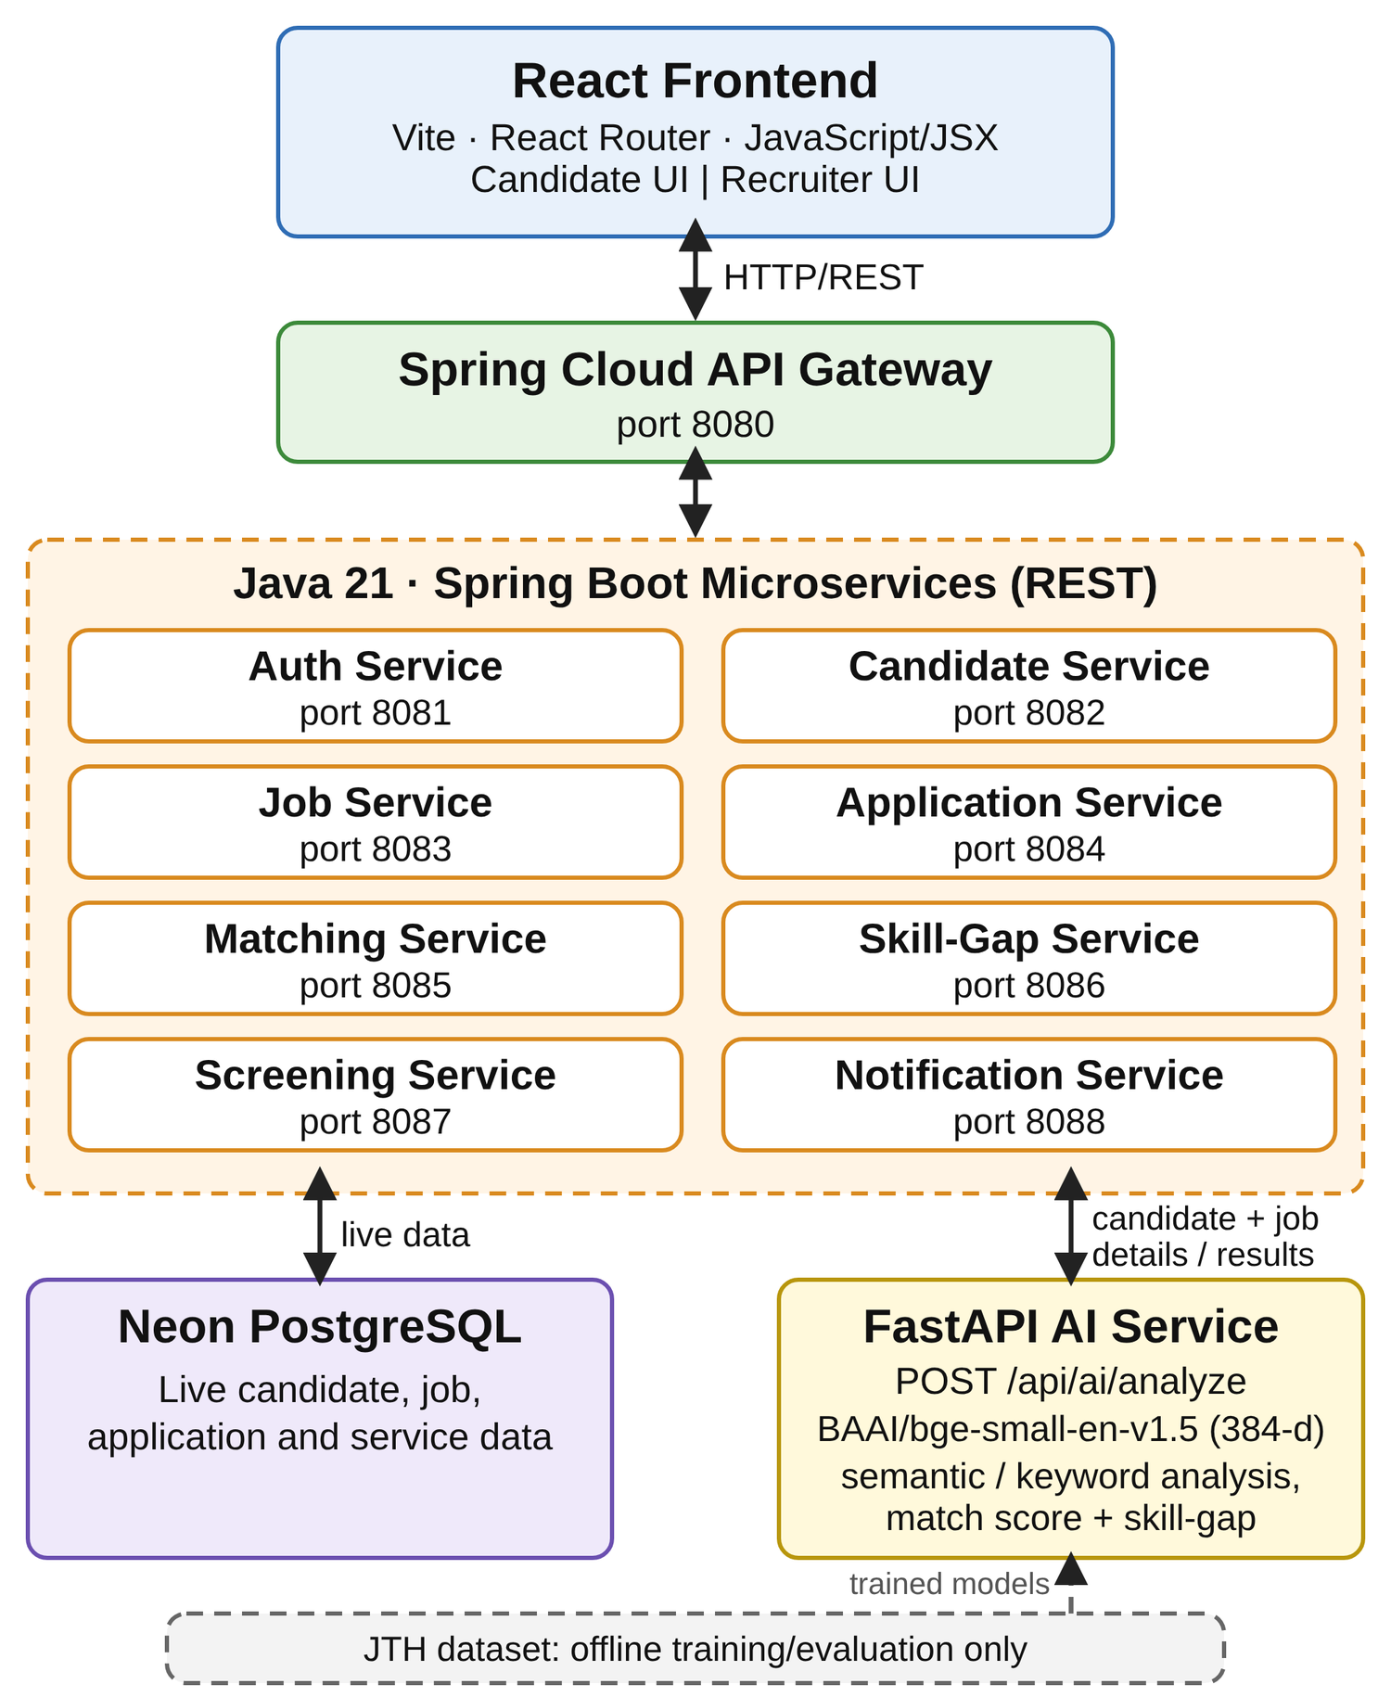
Fig. 1. Architecture of Orion. Live candidate, job, and application data come from Neon PostgreSQL; the JTH dataset is used only offline for model training and evaluation.
TABLE I
Orion Services and Responsibilities
Component | Port / Tech. | Responsibility
API Gateway | 8080 | Routes frontend requests to backend services
Auth Service | 8081 | Registration, login, password handling, authentication
Candidate Service | 8082 | Candidate profile data
Job Service | 8083 | Recruiter jobs and job requirements
Application Service | 8084 | Applications and application status
Matching Service | 8085 | Coordinates candidate–job matching requests
Skill-Gap Service | 8086 | Coordinates skill-gap analysis
Screening Service | 8087 | Applicant screening, ranking, recruiter review data
Notification Service | 8088 | Candidate notifications for application and status events
AI Service | FastAPI | Semantic/keyword analysis and skill-gap output
Database | Neon PostgreSQL | Live candidate, job, application, and service data

B. Frontend and Backend
The frontend is a React application built with Vite, JavaScript/JSX, CSS, and React Router. The candidate interface supports registration and login, profile maintenance, job browsing, applying for jobs, application status, AI match analysis with skill-gap feedback, and notifications. The recruiter interface supports job management, applicant review, and the selection of AI-based, manual, or combined screening workflows. Recruiters can choose context-based (semantic) or keyword-based analysis for AI screening. Detailed screening functionality is described in Section III-F.
The backend uses Java 21 and Spring Boot [8] services on ports 8081–8088 behind Spring Cloud Gateway on port 8080, built with Maven 3.9.12. Services communicate through REST interfaces, and Neon PostgreSQL stores live candidate, job, application, and service data. The Notification Service creates candidate notifications when an application is submitted and when a recruiter updates an application status.
C. AI Service Integration
The AI service is implemented with FastAPI [9] and exposes POST /api/ai/analyze. Its request contains candidate information and job information that the Orion backend retrieves from Neon PostgreSQL, and its response includes a match score and skill-gap details. Both semantic (context-based) and keyword-based analysis modes are supported. The live data flow is: Neon PostgreSQL candidate/job records → Orion backend → FastAPI AI analysis → match and skill-gap results → React UI.
D. AI Components
1) Semantic matching
Candidate and job text are encoded as 384-dimensional embeddings with BAAI/bge-small-en-v1.5 [7], used through the sentence-transformers library [6]. The project records 37,554 candidate embeddings and 6,011 job embeddings. These representations allow profiles and job descriptions to be compared by meaning even when their wording differs.
2) Matching classifier
A Logistic Regression classifier (scikit-learn) was trained on 41,308 candidate–job pairs, of which 17,649 are positive and 23,659 negative, and evaluated on 8,262 test samples. Its results are reported in Section IV.
3) Skill-gap analysis
The skill-gap component compares a candidate’s profile skills and experience with the job’s required and preferred skills. Its output categorizes skills as strong/present, partial, or missing, reports skill coverage, and provides learning suggestions. The exact result depends on the candidate and job data passed into the analysis.
4) Recruiter screening model
A separate screening model supports AI-assisted applicant ranking. Its recorded evaluation metrics are reported in Section IV.
E. Dataset Separation
The JTH dataset [10] is reserved for model training and evaluation. It is not the source of live candidates or jobs during normal Orion use: live analysis uses only records retrieved from Neon PostgreSQL through the Orion backend. This separation is a core architectural rule of the project.
F. Application Workflows
A candidate registers or logs in, maintains a profile, browses jobs and requirements, applies, views the application state, requests AI match and skill-gap analysis for relevant jobs, and receives notifications on applying and on status updates. A recruiter logs in, creates or manages jobs, selects a job and reviews its applicants, selects a screening workflow—AI screening, manual screening, or combined AI and manual screening. For AI-based screening, the recruiter selects context-based (semantic) or keyword-based analysis. The recruiter can review ranked applicants and update application status, score, and feedback. Each application-status change generates a candidate notification.
G. Experimental Setup
Model training used an NVIDIA RTX 4050 Laptop GPU with 6 GB VRAM and CUDA enabled. The AI stack uses Python 3.13, FastAPI, PyTorch, Transformers, sentence-transformers, scikit-learn, pandas, and joblib. The frontend uses React, Vite, and React Router with Node.js and npm; development used Visual Studio Code and Git.
IV. RESULTS
A. Data and Model Statistics
Table II summarizes the recorded embedding and training-data statistics. The matching classifier’s positive and negative training pairs sum to the 41,308 total.
TABLE II
Recorded Embedding and Dataset Statistics
Item | Value
Embedding model | BAAI/bge-small-en-v1.5
Embedding dimensions | 384
Candidate embeddings | 37,554
Job embeddings | 6,011
Training pairs (matching classifier) | 41,308
Positive pairs | 17,649
Negative pairs | 23,659
Test samples | 8,262

B. Model Performance
Table III reports the recorded evaluation metrics. The matching classifier achieved 71% accuracy and a 0.70 F1-score on the recorded test set. The separate recruiter screening model recorded 0.8238 accuracy, 0.7976 precision, 0.7873 recall, a 0.7924 F1-score, and a 0.898 ROC-AUC. Because the screening model’s training data and evaluation protocol are not documented in the available project material, these metrics should be interpreted cautiously and should not be treated as evidence of superior performance over the matching classifier.

TABLE III
Recorded Evaluation Results
Model | Acc. | Prec. | Rec. | F1 | ROC-AUC
Matching classifier (Logistic Regression) | 71% | — | — | 0.70 | —
Recruiter screening model | 0.8238 | 0.7976 | 0.7873 | 0.7924 | 0.898
“—” indicates a value not recorded in the project material.
C. Example Analysis
A sample matching result recorded in the project review shows a match score of 74.39% with 50% skill coverage, including examples of strong, partial, and missing skills. These are reported training and evaluation results and should not be read as a guarantee of performance on every live recruitment dataset.
D. Functional Checks
The following end-to-end checks were recorded during development: a candidate applies to a job and an application record is created; a notification is created when a candidate applies; recruiter status updates generate candidate notifications that are delivered to the candidate; the recruiter can review remaining applicants and perform manual screening; and the AI analysis endpoint returns match-score and skill-gap details for candidate/job inputs.
E. Application Screenshots
Figs. 2–5 show the implemented interface, captured from a local development build. The scores visible in the screenshots belong to the captured sessions and are illustrative; they are separate from the documented example analysis and evaluation metrics above.
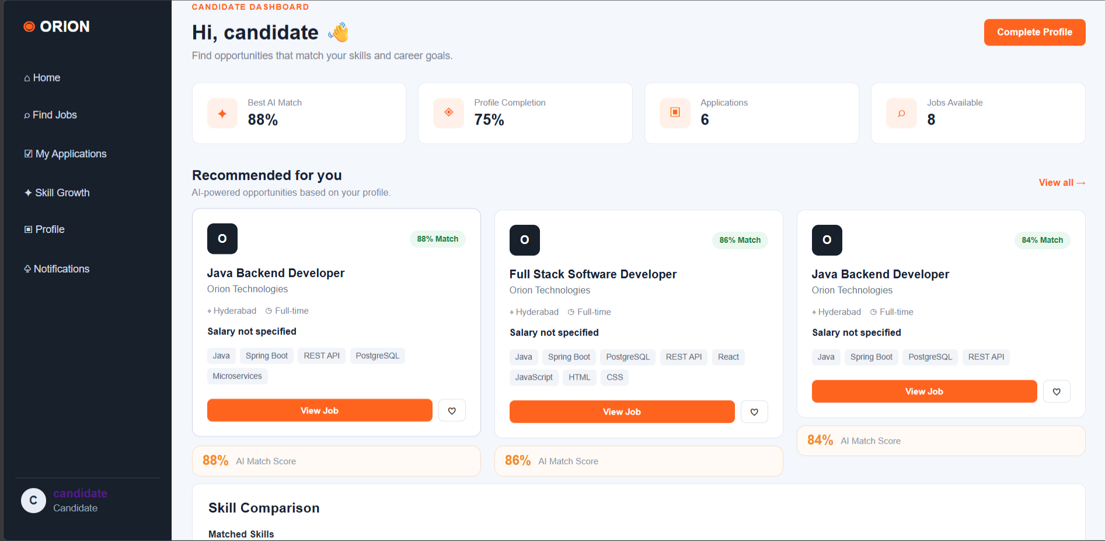
Fig. 2. Candidate dashboard and job discovery: AI match scores for recommended jobs, applications, and job requirements.
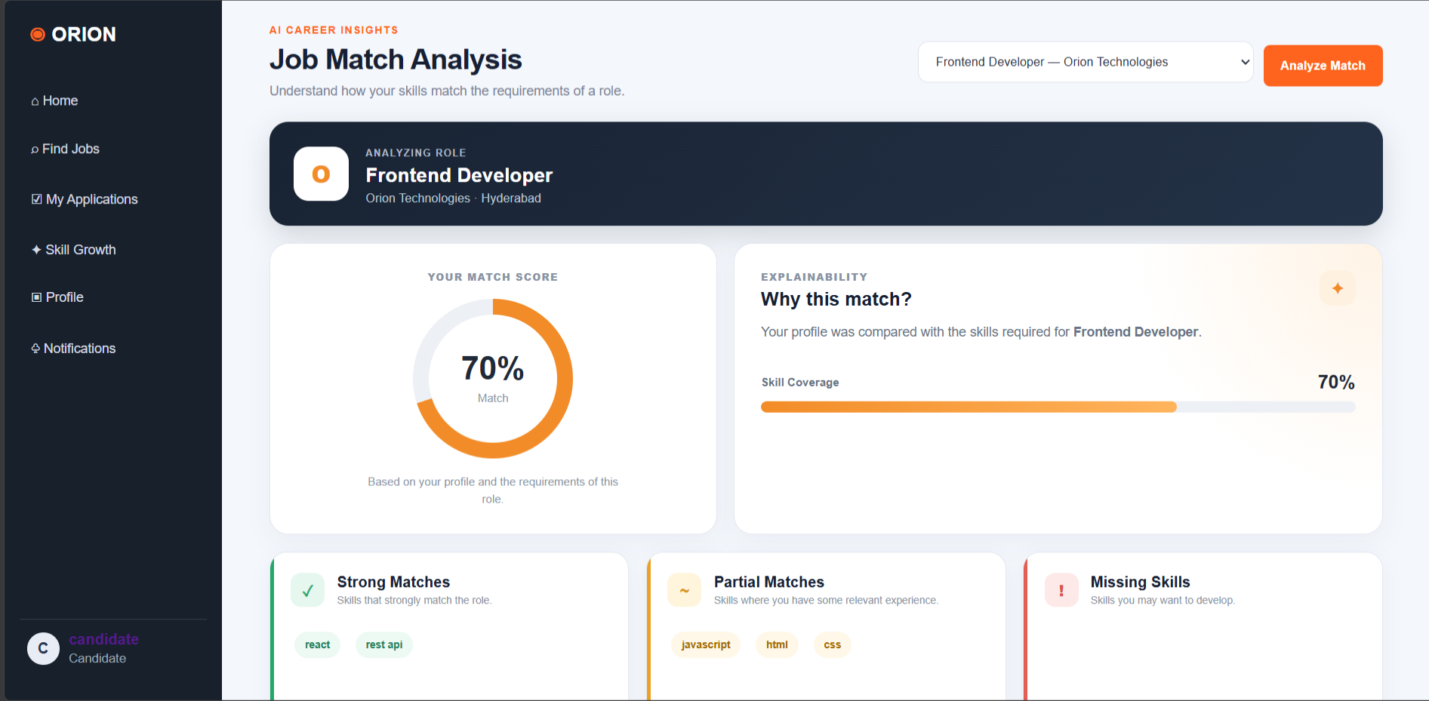
Fig. 3. AI match analysis and skill-gap results: match score, skill coverage, and strong, partial, and missing skills for the selected job.
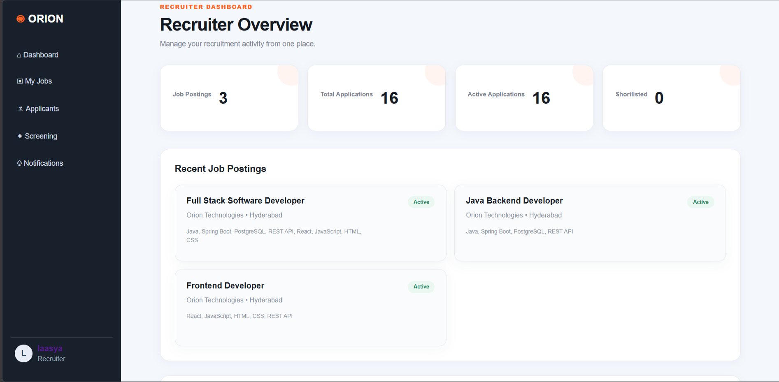
Fig. 4. Recruiter dashboard: job postings, applications, and recent job listings.
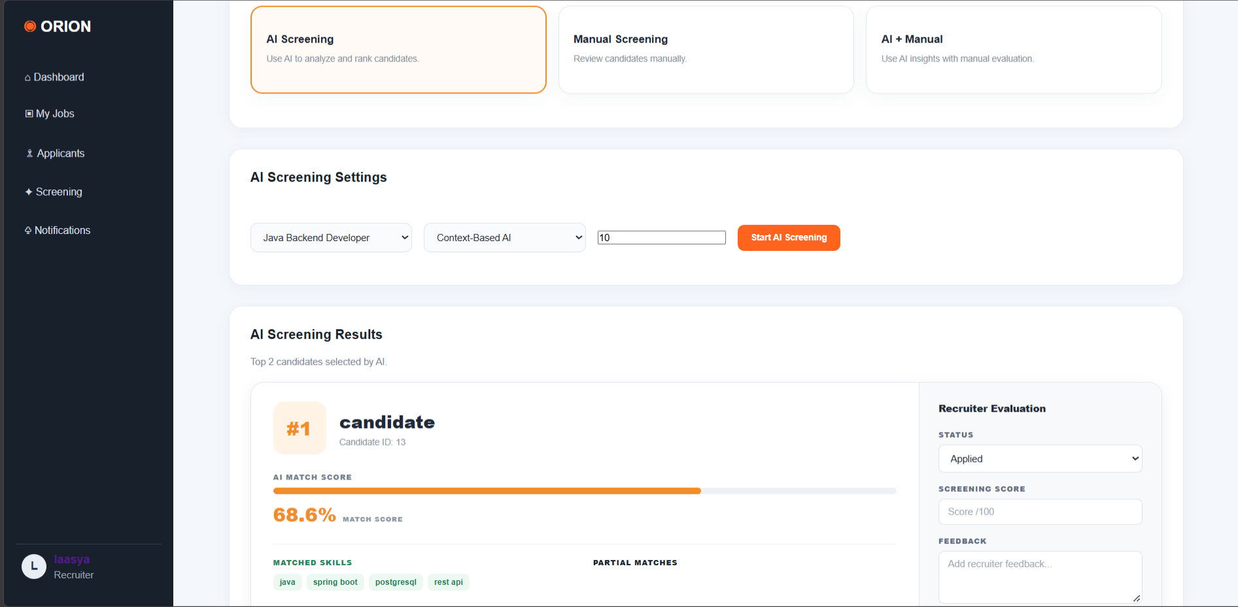
Fig. 5. Recruiter screening: AI, manual, or combined screening modes; context-based AI settings; ranked results with matched skills; and a recruiter evaluation panel for status, score, and feedback. Each status change triggers a candidate notification.
V. DISCUSSION
The two models perform different tasks and are not directly comparable because the recruiter screening model’s training data and evaluation protocol are undocumented (see Section IV-B).
Compared with the related work in Section II, Orion’s distinguishing contribution is architectural and functional rather than a reported accuracy gain: it integrates semantic matching, interpretable skill-gap feedback, two screening modes, manual review, and notifications in one modular application. No quantitative comparison with [1]–[5] is made because comparable metrics are not part of the project material. Keeping the JTH dataset out of the live path means the evaluation data and the operational data remain distinct, so the reported metrics describe model quality on the training/evaluation data rather than on live Orion records.
A. Limitations and Responsible Use
Reported metrics are evaluation results on the project’s datasets; performance may differ on new or biased real-world data. Precision, recall, and ROC-AUC were not recorded for the matching classifier, and no latency, load, or scalability measurements were recorded. Semantic similarity and skill extraction depend on the quality and consistency of profile skills and job requirements. AI scores should assist rather than automatically determine hiring outcomes, and recruiters should review candidates fairly. The project describes the implemented design and tested workflows but does not claim that cloud deployment is complete. Before production use, the system would need stronger monitoring, privacy controls, a security review, and bias evaluation.
VI. CONCLUSION
Orion brings together job discovery, applications, recruiter screening, and notifications in a modular recruitment portal, meeting the project’s objective of an end-to-end platform built from independent services. Semantic matching compares candidate profiles with job descriptions beyond exact keyword overlap, and skill-gap analysis gives clearer feedback on present, partial, and missing skills. Recruiters can choose semantic or keyword-based screening and retain the option of manual review. The implementation combines React, Java 21 and Spring Boot microservices, an API Gateway, Neon PostgreSQL, and a FastAPI AI service, with the JTH dataset used only for training and evaluation. The project demonstrates an AI-assisted recruitment workflow that keeps final decisions with human recruiters.
Future work includes: deploying the frontend, API Gateway, backend services, and AI service to cloud hosting; improving the matching and screening models with larger, diverse, and carefully validated datasets; adding recruiter feedback loops and ongoing model-performance monitoring; expanding skill-development recommendations with curated learning resources; improving observability, automated integration tests, access control, and production security; and evaluating fairness and explainability across candidate groups before any real-world hiring use.
ACKNOWLEDGMENT
The authors thank their guide, Venkateshwari Ketineni, Assistant Professor, Department of CSE, for her support, encouragement, and guidance, and Dr. P. Venkateshwar, Head of the Department of Computer Science Engineering, for providing the facilities needed to complete this work. They also thank the teaching and non-teaching staff, their families, friends, and classmates. This work was carried out as a project for SOA Programming and Microservices (24SDCS03) at K L (Deemed to be) University, academic year 2026–2027.
REFERENCES
[1] LinkedIn Talent Solutions, “LinkedIn Talent Solutions.” [Online]. Available: https://business.linkedin.com/talent-solutions[Accessed: Aug. 29, 2026].
[2] Jobindex, “Jobindex.” [Online]. Available: https://www.jobindex.dk/. [Accessed: Aug. 29, 2026].
[3] Indeed, “Indeed.” [Online]. Available: https://www.indeed.com/. [Accessed: Aug. 29, 2026].
[4] M.-H. Ajjam and H. S. Al-Raweshidy, “AI-driven semantic similarity-based job matching framework for recruitment systems,” Information Sciences, vol. 724, Art. no. 122728, 2026, doi: 10.1016/j.ins.2025.122728.
[5] T. K., U. V., S. M. Kadiwal, and S. Revanna, “Design and development of machine learning based resume ranking system,” Global Transitions Proceedings, vol. 3, no. 2, pp. 371–375, Nov. 2022, doi: 10.1016/j.gltp.2021.10.002.
[6] Sentence Transformers, “SentenceTransformers Documentation.” [Online]. Available: https://www.sbert.net/. [Accessed: Aug. 30, 2026].
[7] BAAI, “bge-small-en-v1.5,” Hugging Face. [Online]. Available: https://huggingface.co/BAAI/bge-small-en-v1.5. [Accessed: Aug. 31, 2026].
[8] Spring, “Spring Boot.” [Online]. Available: https://spring.io/projects/spring-boot. [Accessed: Aug. 31, 2026].
[9] FastAPI, “FastAPI Documentation.” [Online]. Available: https://fastapi.tiangolo.com/. [Accessed: Aug. 31, 2026].
[10] Aunsiels, “JTH Dataset,” GitHub repository. [Online]. Available: https://github.com/Aunsiels/JTH. [Accessed: Aug. 31, 2026].

