ORION
AI-Assisted Microservices-Based Online Recruitment Portal
A Mini Project Report Submitted in the partial fulfillment of the requirements for the award of the degree of

BACHELOR OF TECHNOLOGY

In
DEPARTMENT OF COMPUTER SCIENCE ENGINEERING
By
Laasya Priya – 2420030002 (Team Lead)
Bhanu Prakash – 2420030209
Krishita – 2420030443

Under the Esteemed Guidance of

Venkateshwari Ketineni
Assistant Professor, Department of CSE





K L (Deemed to be) University
DEPARTMENT OF COMPUTER SCIENCE ENGINEERING

DECLARATION

The Mini Project Report entitled “ORION: AI-Assisted Microservices-Based Online Recruitment Portal” is a record of Bonafide work of Laasya Priya – 2420030002, Bhanu Prakash – 2420030209, Krishita – 2420030443 submitted in partial fulfillment for the award of B. Tech in Computer Science and Engineering to the K L University. The results embodied in this report have not been copied from any other departments/University/Institute.

Laasya Priya – 2420030002
Bhanu Prakash – 2420030209
Krishita – 2420030443

K L (Deemed to be) University
DEPARTMENT OF COMPUTER SCIENCE ENGINEERING
CERTIFICATE

This is to certify that the mini project based report entitled “ORION: AI-Assisted Microservices-Based Online Recruitment Portal” is a bonafide work done and submitted by Laasya Priya – 2420030002, Bhanu Prakash – 2420030209, Krishita – 2420030443 in partial fulfillment of the requirements for the award of the degree of BACHELOR OF TECHNOLOGY in Department of Computer Science Engineering, K L (Deemed to be University), during the academic year 2026-2027.

Signature of the Course Co-ordinator Signature of HOD

ACKNOWLEDGEMENT

The success in this project would not have been possible but for the timely help and guidance rendered by many people. Our wish to express my sincere thanks to all those who has assisted us in one way or the other for the completion of my project.

Our greatest appreciation to my guide, Venkateshwari Ketineni, Assistant Professor, Department of Computer Science which cannot be expressed in words for her tremendous support, encouragement and guidance for this project.

We express our gratitude to Dr. P. Venkateshwar Sir (CSE), Head of the Department of Computer Science Engineering for providing us with adequate facilities, ways and means by which we are able to complete this project-based Lab.

We thank all the members of teaching and non-teaching staff members, and also who have assisted me directly or indirectly for successful completion of this project. Finally, I sincerely thank my parents, friends and classmates for their kind help and cooperation during my work.

Laasya Priya – 2420030002
Bhanu Prakash – 2420030209
Krishita Myneni – 2420030443

TABLE OF CONTENTS

S.No. | Contents | Page no.
1. | Abstract | 6
2. | Introduction | 7
3. | Literature survey | 8
4. | Problem Statement and Objectives | 10
5. | Hardware and Software requirements | 11
6. | Implementation | 12
7. | Results & Discussion | 16
8. | Conclusion & Future Scope | 20
9. | References | 21
- ABSTRACT
Recruitment platforms connect candidates with employment and internship opportunities, but the growing volume of job listings and applications makes it difficult to identify suitable matches efficiently. Keyword-based search can miss relevant profiles when similar skills are described using different terms, recruiters spend considerable time reviewing applications, and candidates often receive limited explanation of their suitability or the skills they need to improve. Orion is an AI-assisted, microservices-based online recruitment portal designed to address these challenges. It supports candidate profiles, job discovery, applications, application tracking, notifications, recruiter dashboards, and applicant screening. Its AI workflow provides context-based semantic matching, keyword-based analysis, skill-gap identification, and applicant ranking. The system uses React for the frontend, Java 21 and Spring Boot for backend microservices, Neon PostgreSQL for live application data, and FastAPI to expose AI analysis. Semantic embeddings are generated with BAAI/bge-small-en-v1.5 (384 dimensions), and a matching classifier was trained and evaluated on the JTH dataset, which is used for training and evaluation only; live analysis uses records retrieved from Neon PostgreSQL. Orion aims to make recruitment more relevant and explainable while keeping recruiters responsible for final decisions.
Team Name: Orion
Team Members:
- Laasya Priya, Team Lead (Roll No. 2420030002)
- Bhanu Prakash, Team Member (Roll No. 2420030209)
- Krishita Myneni, Team Member (Roll No. 2420030443)
- INTRODUCTION
Online recruitment has made job discovery and application submission more accessible, but effective matching remains challenging. A candidate may have the right underlying experience even when their profile does not use the exact words in a job description. On the recruiter side, manually checking many applications can delay shortlisting. Orion combines the core recruitment workflow with AI assistance so that matching, skill-gap feedback, and screening are available within one application. The project was developed for the course SOA Programming and Microservices (24SDCS03) in the academic year 2026–2027.
The project follows a microservices architecture. Authentication, candidate profiles, job management, applications, matching, skill-gap analysis, screening, and notifications are separated into services that communicate through REST interfaces and an API Gateway. This modular design makes each capability easier to maintain and allows individual services to be scaled or enhanced independently.
Key Features and Novelty:
- Semantic AI matching: compares candidate profiles and job descriptions by contextual relevance, not only exact words.
- Skill-gap analysis: identifies skills represented strongly, partially, or not at all in relation to a job’s requirements.
- Explainable results: displays match scores and skill information to make the output easier to interpret.
- Two screening modes: recruiters can choose context/semantic-based analysis or keyword-based analysis.
- AI-assisted applicant ranking with manual screening: supports prioritization without removing recruiter oversight.
- Integrated microservices: combines recruitment workflows and AI capabilities behind an API Gateway.
The rest of this report is organized as follows: Section 3 reviews related work and the research gap; Section 4 states the problem and objectives; Section 5 lists the hardware and software used; Section 6 describes the implementation, including the architecture, AI components, and workflows; Section 7 presents the results, testing, and limitations; Section 8 concludes the report and outlines future scope; and Section 9 lists the references.
- LITERATURE SURVEY
The following existing systems, studies, and technologies were reviewed to understand current approaches to candidate retrieval, job recommendation, semantic matching, and service-based application development. The source URLs are listed in the References section.
1. LinkedIn Talent Search and Recommendation (2018) [1]. This work focuses on candidate retrieval, ranking, and recommendations for recruiting. It demonstrates the value of retrieving and ranking relevant candidate profiles. The project review identifies that it offers no explicit job-specific skill-gap analysis. Orion builds on the idea of ranking applicants for recruiters and adds skill-gap feedback alongside matching.
2. Jobindex Human-in-the-Loop Recommendation (2026) [2]. This work studies AI recommendations combined with recruiter feedback. It highlights the benefit of combining automated recommendations with human review and feedback. The reviewed material identifies a gap in combining such feedback with explainable skill-gap analysis. Orion keeps recruiters in control through manual screening and displays explainable match and skill information.
3. Indeed Job Recommender (2019) [3]. This work covers offline evaluation and online job recommendation. It shows how personalized relevance can support job discovery for candidates. Its focus is job recommendation rather than the full candidate-side and recruiter-side workflow. Orion covers both sides, including applications, status tracking, notifications, and recruiter screening.
4. AI-driven Semantic Similarity-Based Job Matching Framework (2025) [4]
This research by Ajjam and Al-Raweshidy focuses on improving job–candidate matching using AI and semantic similarity. It addresses the limitations of keyword-based recruitment by capturing contextual relationships between candidate profiles and job descriptions. The framework explores real-time recruitment matching and aims to improve relevance, transparency, and fairness. It is closely related to Orion’s semantic matching feature, while Orion additionally integrates skill-gap analysis and recruiter screening into its microservices workflow
5. Design and Development of Machine Learning-Based Resume Ranking System (2022) [5]
This research explores automated resume screening and candidate ranking to reduce the effort required to manually evaluate large numbers of applicants. It uses cosine similarity to compare resumes with job descriptions and a K-Nearest Neighbors (KNN) algorithm to rank candidates. The study demonstrates how machine learning can help recruiters identify potentially suitable applicants more efficiently. Unlike this approach, Orion combines contextual semantic matching, skill-gap analysis, and both AI-assisted and manual screening options.
.
Research Gap:
The project materials identify that existing solutions often emphasize one or more functions—candidate search, job recommendation, ranking, or recruiter feedback—rather than combining an end-to-end recruitment workflow with semantic matching, interpretable skill-gap feedback, applicant screening, and manual recruiter control in one modular application. Orion is designed to fill this gap.
- PROBLEM STATEMENT AND OBJECTIVES
Problem Statement: How can AI make recruitment more relevant, efficient, and understandable for both candidates and recruiters?
Problem Description: Growing numbers of job listings and applications, together with keyword-based search and manual screening, make it hard for candidates to find suitable roles and for recruiters to shortlist efficiently, while candidates receive little explanation of their match or missing skills.
Objectives:
Project purpose: the project addresses four related challenges.
- Increasing job and internship listings make it difficult for candidates to find opportunities aligned with their skills.
- Keyword-based recruitment can overlook relevant profiles when equivalent skills use different terminology.
- Manual recruiter screening is time-consuming when application volumes are high.
- Candidates may not understand why they match a role or which required skills are missing.
To address these challenges, the objectives of the project are to:
- Build an end-to-end recruitment platform using independently organized backend services.
- Support candidate profiles, recruiter job creation, job discovery, applications, status tracking, and notifications.
- Provide semantic/context-based candidate-job matching alongside keyword-based analysis.
- Identify strong/present, partial, and missing skills and produce relevant learning suggestions.
- Rank applicants to support recruiter screening while retaining a manual review path.
- Use Neon PostgreSQL as the live source of candidate, job, and application data.
- Keep the JTH dataset separate from live application data and use it only for AI training and evaluation.
- HARDWARE AND SOFTWARE REQUIREMENTS
Hardware Requirements:
- NVIDIA RTX 4050 Laptop GPU with 6 GB VRAM, CUDA enabled (hardware noted for model training).
Software Requirements:
- Frontend: React, Vite, JavaScript/JSX, CSS, React Router
- Backend: Java 21, Spring Boot, Spring Cloud Gateway, REST APIs
- Database: Neon PostgreSQL
- AI API: Python 3.13, FastAPI
- AI / NLP: PyTorch, Transformers, sentence-transformers, BAAI/bge-small-en-v1.5, scikit-learn
- Model/data tools: JTH dataset (training and evaluation only), pandas, joblib
- Development tools: Visual Studio Code, Git, Maven 3.9.12, Node.js and npm
- IMPLEMENTATION
- Frontend: React application (Vite, JavaScript/JSX, CSS, React Router) with candidate and recruiter interfaces.
- Backend: Java 21 and Spring Boot microservices behind a Spring Cloud API Gateway, with Neon PostgreSQL as the live data store.
- API Integration: FastAPI AI service exposing POST /api/ai/analyze, called with candidate and job details retrieved through the Orion backend.
System Architecture
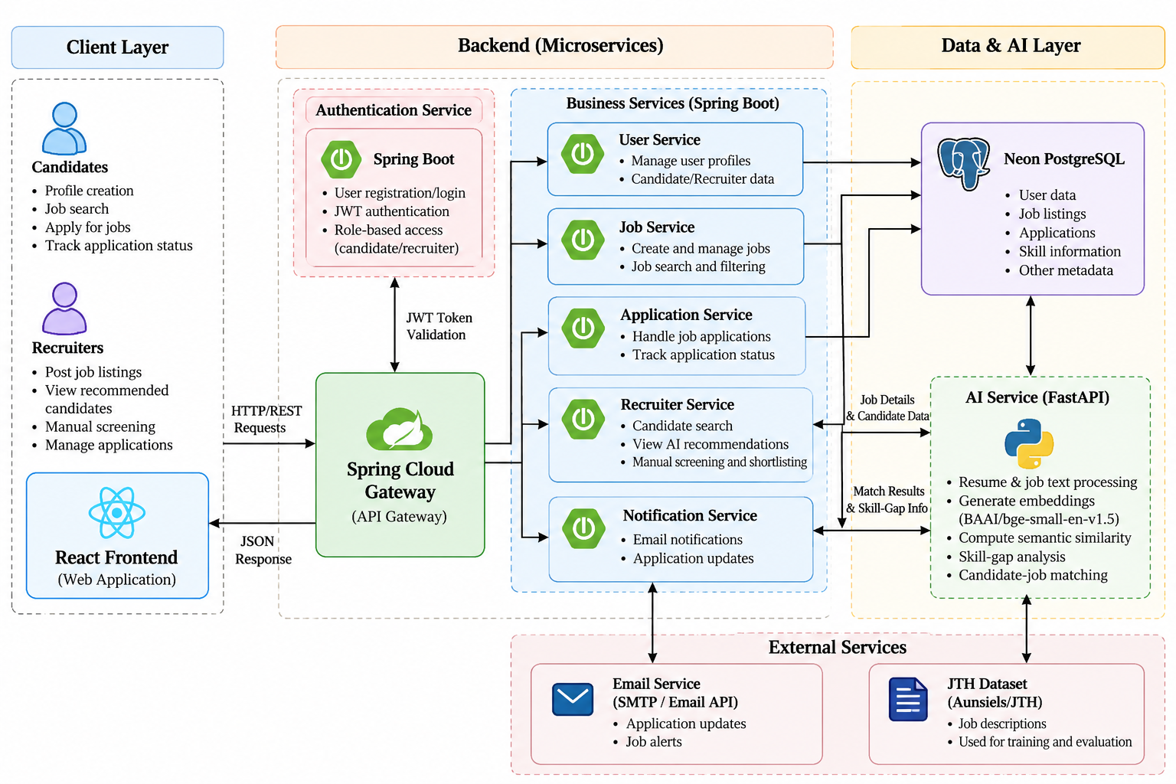
The React frontend sends requests to the Spring Cloud API Gateway. The gateway routes requests to the relevant Spring Boot service. For AI analysis, the backend obtains the candidate and job details from Neon PostgreSQL and passes the relevant profile and job information to the FastAPI AI service. The AI service returns matching and skill-gap results, which are returned to the frontend through the backend workflow. Table 1 lists the components and ports used in the project configuration.
Table 1. Orion services and responsibilities
Component | Port / Technology | Responsibility
API Gateway | 8080 | Routes frontend requests to backend services.
Auth Service | 8081 | Registration, login, password handling and authentication.
Candidate Service | 8082 | Candidate profile data.
Job Service | 8083 | Recruiter jobs and job requirements.
Application Service | 8084 | Applications and application status.
Matching Service | 8085 | Coordinates candidate-job matching requests.
Skill-Gap Service | 8086 | Coordinates skill-gap analysis.
Screening Service | 8087 | Applicant screening, ranking and recruiter review data.
Notification Service | 8088 | Candidate notifications for application and status events.
AI Service | FastAPI | Semantic/keyword analysis and skill-gap output.
Database | Neon PostgreSQL | Live candidate, job, application and service data.

1. Frontend (React, Vite, JavaScript/JSX, CSS)
- React and React Router: build the user interface and page routing; Vite is the project’s build tool.
- Candidate interface: registration and login, profile maintenance, job browsing and job requirements, applying for jobs, application status, AI match analysis with skill-gap feedback, and notifications.
- Recruiter interface: login, creating and managing the logged-in recruiter’s jobs, viewing applicants for a selected job, choosing semantic or keyword-based screening, reviewing ranked applicants, manual screening, and updating status, score and feedback.
- Communication: the frontend communicates with backend services through the API Gateway and does not use the training dataset directly.
2. Backend (Java 21, Spring Boot, Spring Cloud Gateway)
- Microservices: authentication, candidate, job, application, matching, skill-gap, screening and notification services run as separate Spring Boot services (ports 8081–8088), as listed in Table 1.
- API Gateway: Spring Cloud Gateway on port 8080 routes frontend requests to the relevant service; services communicate through REST interfaces.
- Data layer: Neon PostgreSQL stores live candidate, job, application and service data.
- Notifications: the Notification Service creates candidate notifications when an application is submitted and when a recruiter updates an application status.
- Build tool: Maven 3.9.12.
3. API Integration (FastAPI AI Service)
- Endpoint: the FastAPI service exposes POST /api/ai/analyze.
- Request: contains candidate information and job information, which the backend retrieves from Neon PostgreSQL.
- Response: includes a match score and skill-gap details.
- Analysis modes: the integration supports semantic/context-based and keyword-based analysis.
- Data flow: Neon PostgreSQL candidate/job records → Orion backend → FastAPI AI analysis → match and skill-gap results → React UI.
4. AI Components and Dataset
Semantic matching. The semantic component uses BAAI/bge-small-en-v1.5 to encode candidate and job text as 384-dimensional embeddings. The project review records 37,554 candidate embeddings and 6,011 job embeddings. These representations support comparison of profile and job-description meaning even when wording differs.
Matching classifier. A Logistic Regression classifier was trained on 41,308 candidate-job pairs (17,649 positive and 23,659 negative examples) and evaluated on 8,262 test samples. Its results are reported in Section 7.
Skill-gap analysis. The skill-gap component compares the candidate’s profile skills and experience with the job’s required and preferred skills. Its output categorizes skills as strong/present, partial, or missing, reports skill coverage, and provides learning suggestions. The exact result depends on the candidate and job data passed into the analysis.
Recruiter screening model. A separate screening model supports applicant ranking for recruiters; its recorded evaluation metrics are reported in Section 7.
Dataset separation rule. The JTH dataset (https://github.com/Aunsiels/JTH) is reserved for model training and evaluation. It is not the source of live candidates or jobs during normal Orion use. The operational flow is: Neon PostgreSQL candidate/job records → Orion backend → FastAPI AI analysis → match and skill-gap results → React UI. This separation is a core architecture rule for the project.
5. Application Workflows
Candidate workflow:
- Register or log in and maintain a candidate profile.
- Browse job listings and view job requirements.
- Apply for a suitable job and see the application state.
- View AI match analysis and skill-gap feedback for relevant opportunities.
- Receive notifications when applying and when a recruiter updates the application status.
Recruiter workflow:
- Log in and create or manage jobs belonging to the logged-in recruiter.
- Select a job and review its applicants.
- Choose context/semantic-based AI screening or keyword-based screening.
- Review ranked applicants and use manual screening where required.
- Update applicant status, score, and feedback; status changes generate candidate notifications.
- RESULTS & DISCUSSION
The project’s reported results demonstrate a working semantic matching pipeline and a separate screening model. Table 2 summarizes the recorded evaluation metrics (— indicates a value not recorded in the project review material).
Table 2. Recorded evaluation results
Model | Accuracy | Precision | Recall | F1-score | ROC-AUC
Matching classifier (Logistic Regression) | 71% | — | — | 0.70 | —
Recruiter screening model | 0.8238 | 0.7976 | 0.7873 | 0.7924 | 0.898

The matching classifier was trained on 41,308 pairs and tested on 8,262 samples. A sample matching result in the review presentation is a match score of 74.39% with 50% skill coverage, including examples of strong, partial, and missing skills. These are the reported training/evaluation results and should not be interpreted as a guarantee of performance on every live recruitment dataset.
Functional Checks
The following end-to-end checks were recorded during development:
- A candidate applies to a job and an application record is created.
- A notification is created when a candidate applies.
- Recruiter application-status updates generate candidate notifications, which are delivered to the candidate.
- The recruiter can review remaining applicants and perform manual screening.
- The AI analysis endpoint returns match-score and skill-gap details for candidate/job inputs.
Application Screenshots
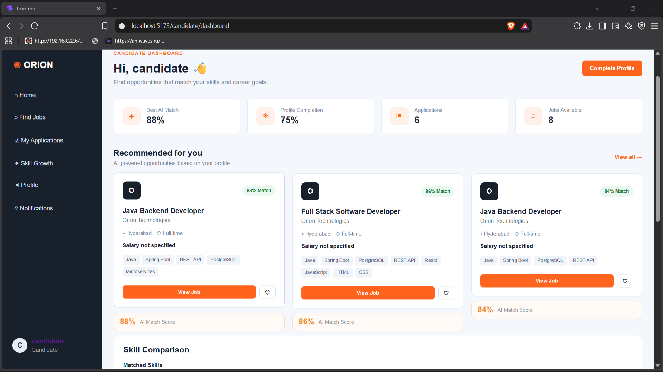Figure 1. Candidate dashboard and job discovery
Candidates browse job listings, view requirements and apply, then track the state of each application.
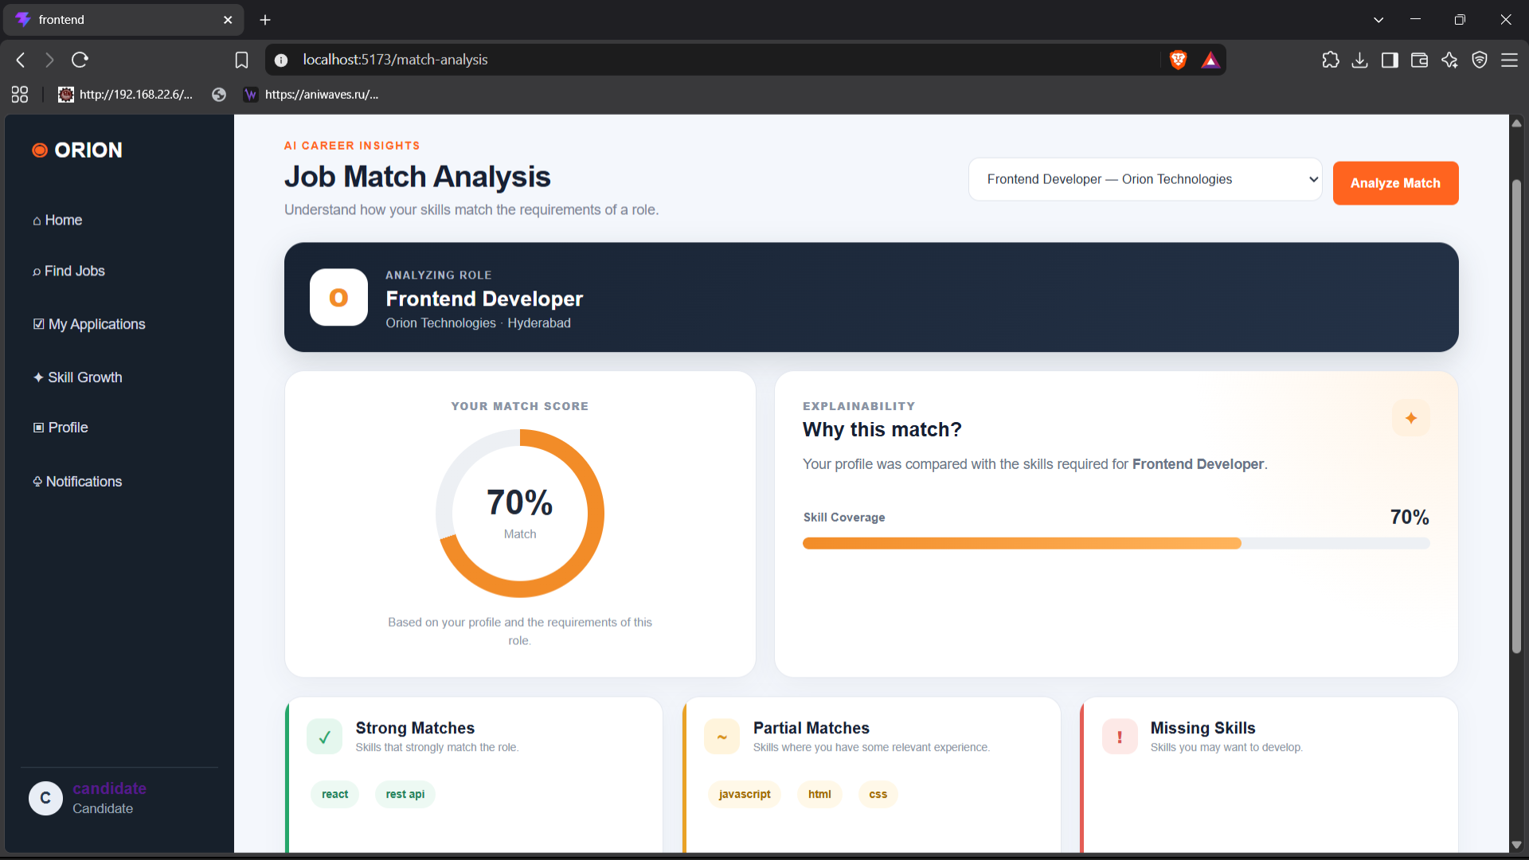Figure 2. AI match analysis and skill-gap results
The match score and the strong, partial and missing skills are shown with learning suggestions for the selected job.
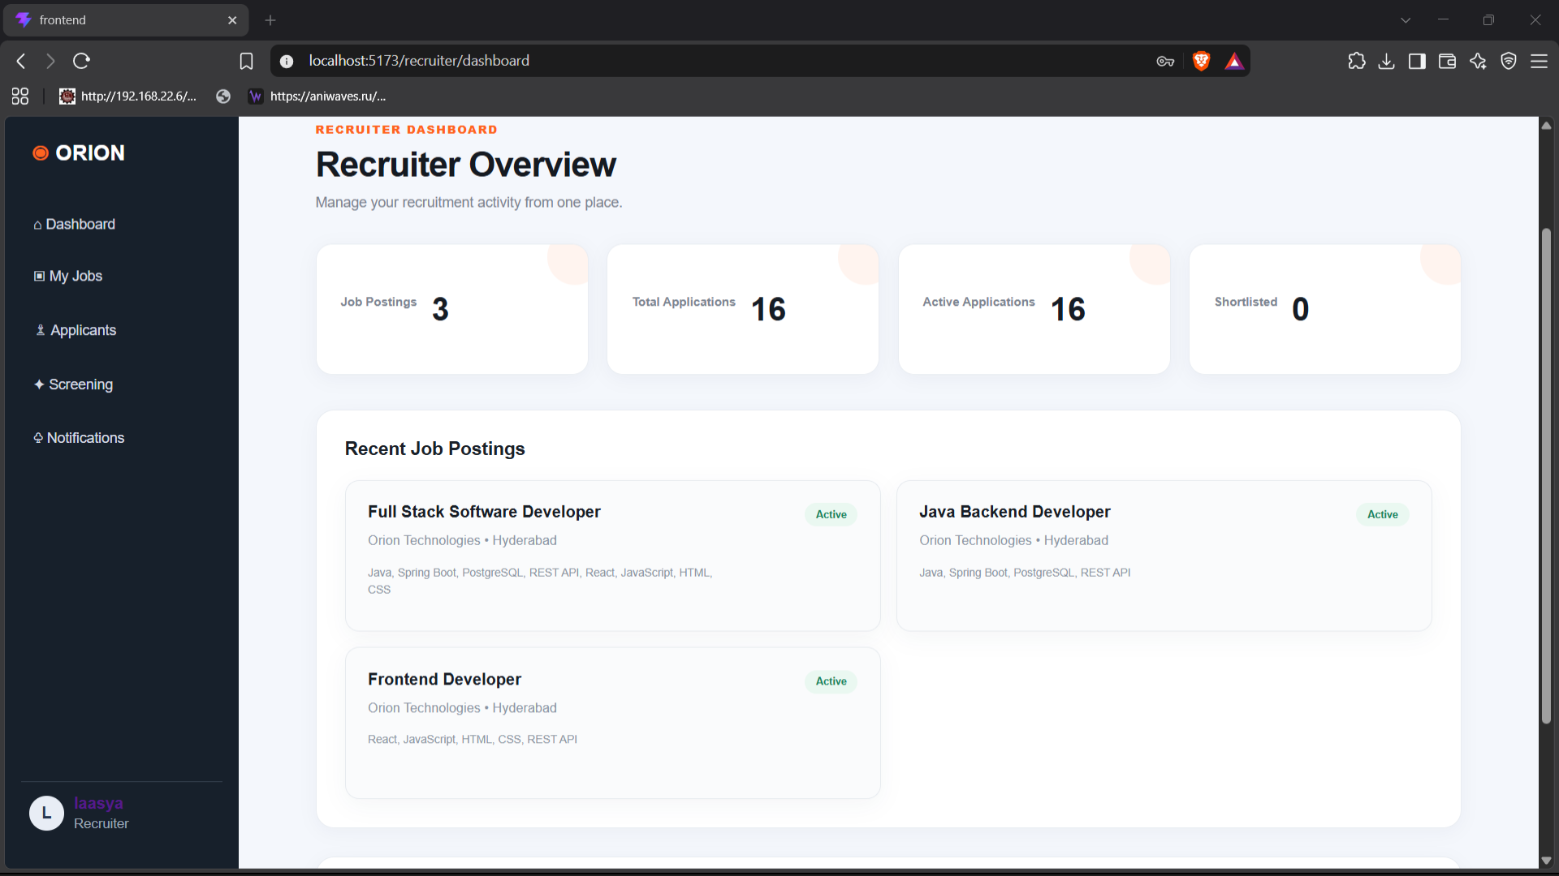
Figure 3. Recruiter dashboard and applicant screening
Recruiters select a job, choose semantic or keyword-based screening, and review the ranked applicants.
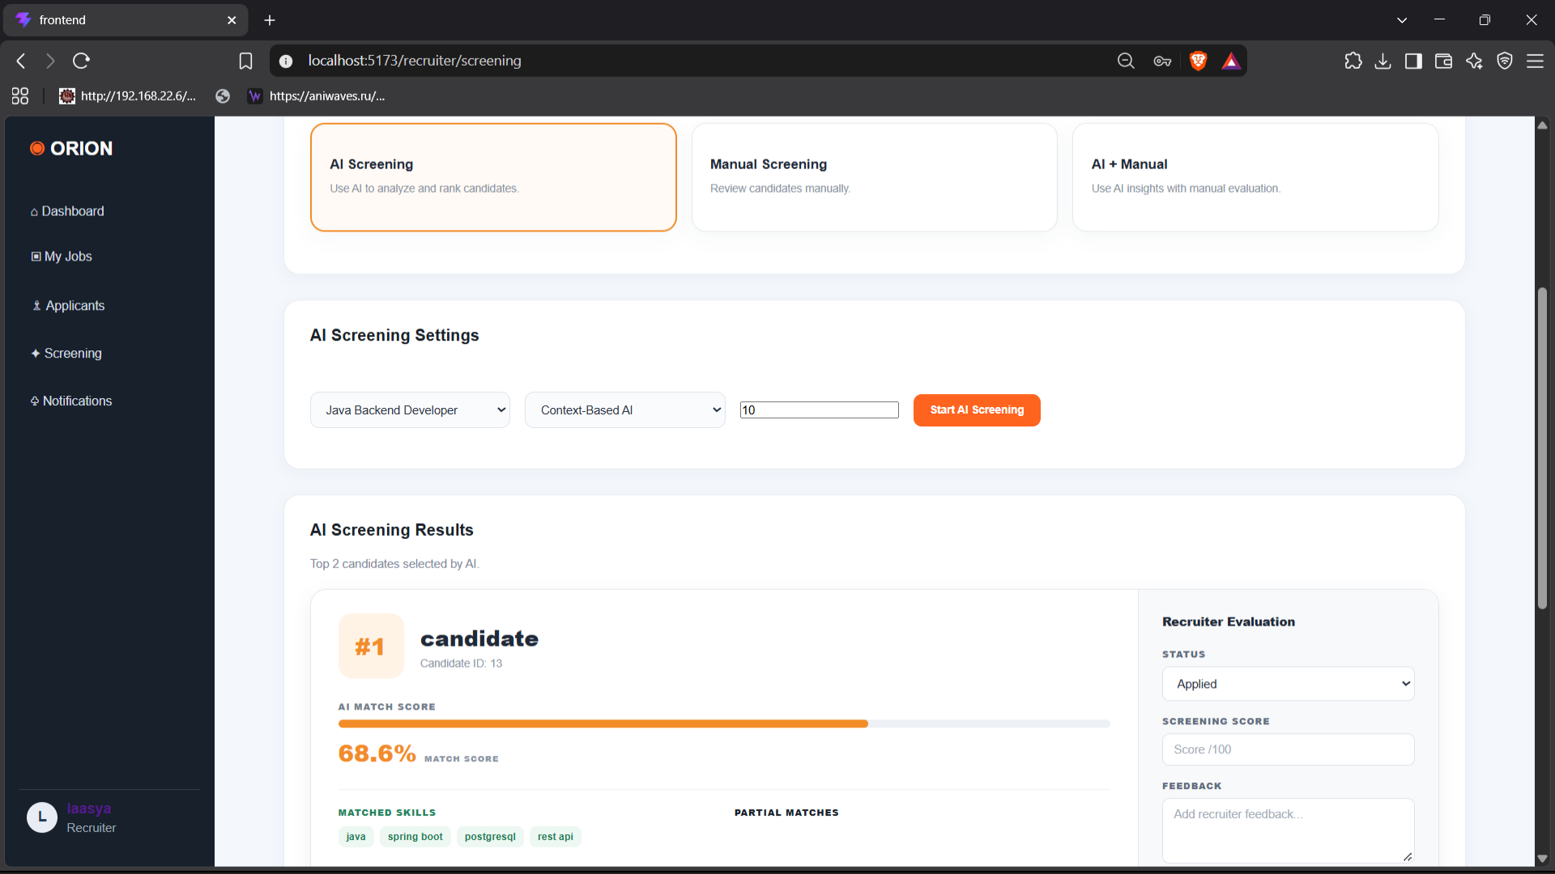Figure 4. Manual screening, status update, and notifications
Recruiters can choose AI-based screening, manual screening, or a combination of both, with AI screening supporting context-based or keyword-based analysis. Recruiters can manually update applicant status, score, and feedback, and each status change triggers a notification to the candidate.
Limitations and Responsible Use
- Reported metrics are evaluation results on the project’s datasets; performance may differ on new or biased real-world data.
- Semantic similarity and skill extraction depend on the quality and consistency of profile skills and job requirements.
- AI scores should assist rather than automatically determine hiring outcomes; recruiters should review candidates fairly.
- The project describes the implemented design and tested workflows but does not claim that cloud deployment is complete.
- Before production use, the system would need stronger monitoring, privacy controls, security review, and bias evaluation.
- CONCLUSION & FUTURE SCOPE
Orion brings together job discovery, applications, recruiter screening, and notifications in a modular recruitment portal, meeting the project’s objectives of an end-to-end platform built from independent services. Semantic matching helps compare candidate profiles with job descriptions beyond exact keyword overlap, while skill-gap analysis provides clearer feedback on present, partial, and missing skills. Recruiters can choose semantic/context-based or keyword-based screening and retain the option of manual review. The implementation combines React, Spring Boot microservices, Neon PostgreSQL, and a FastAPI AI service. The JTH dataset remains separate from live application data and is used only for training and evaluation. The project demonstrates an end-to-end AI-assisted recruitment workflow while keeping final decisions with human recruiters.
Future Scope:
- Deploy the frontend, API Gateway, backend services, and AI service to cloud hosting.
- Improve matching and screening models with larger, diverse, and carefully validated datasets.
- Add recruiter feedback loops and ongoing model-performance monitoring.
- Expand skill-development recommendations with curated learning resources.
- Improve observability, automated integration tests, access control, and production security.
- Evaluate fairness and explainability across different candidate groups before any real-world hiring use.
- REFERENCES

- LinkedIn Talent Solutions. https://business.linkedin.com/talent-solutions
- Jobindex. https://www.jobindex.dk/
- Indeed. https://www.indeed.com/
- AI-Based Job Matching. https://doi.org/10.1016/j.ins.2025.122728
- ML-Based Resume Ranking. https://doi.org/10.1016/j.gltp.2021.10.002
- Sentence Transformers. https://www.sbert.net/
- BGE Model. https://huggingface.co/BAAI/bge-small-en-v1.5
- Spring Boot. https://spring.io/projects/spring-boot
- FastAPI. https://fastapi.tiangolo.com/
- JTH Dataset. https://github.com/Aunsiels/JTH

