1.Create A new component which have news title(should print as h2), news detail(<p>), published date, source create this component using sling model.

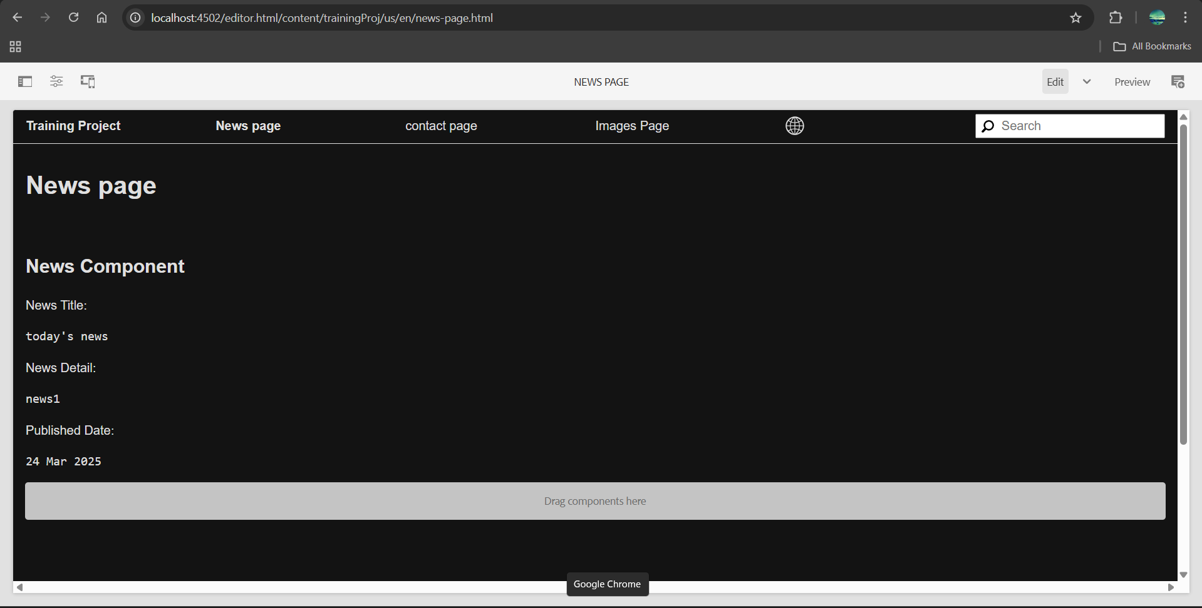

2.Create multi field component(multiple news) using sling model fields: title of new and source of news

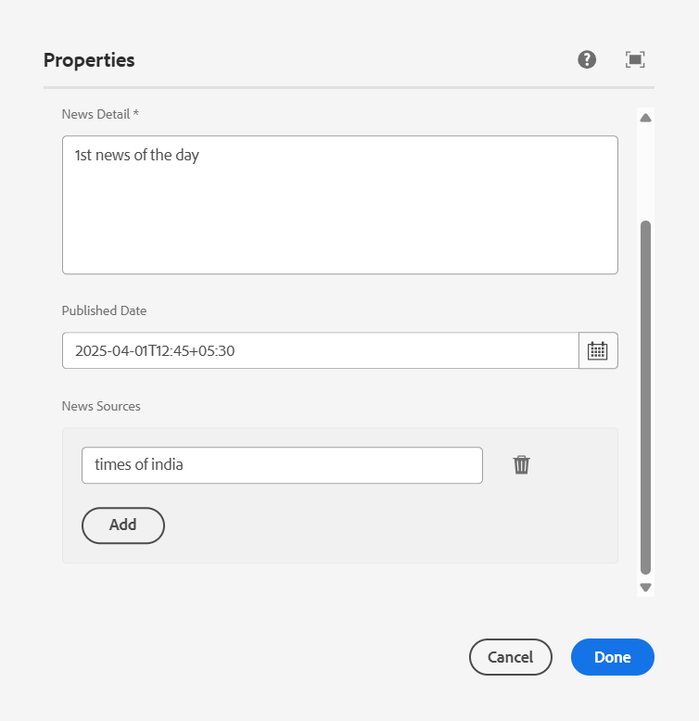

3.Create clientlibs for news component and

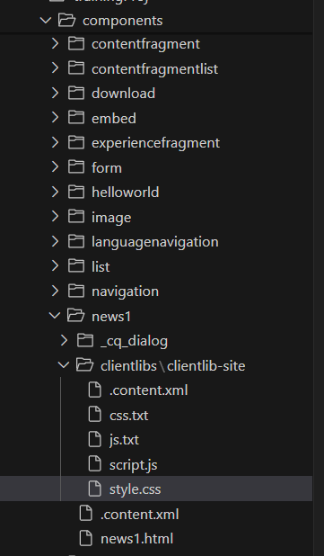

4.Apply Green colour to the heading(h2) and yellow colour to news detail(<p) and date should be black in colour.

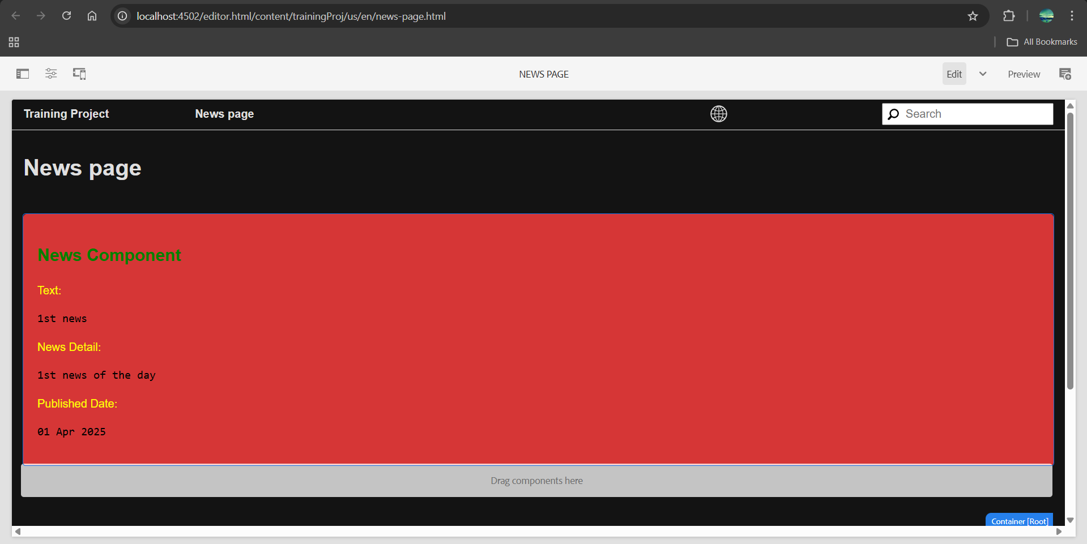

5.Add Component style to add custom style name (cop-news-component)in news component

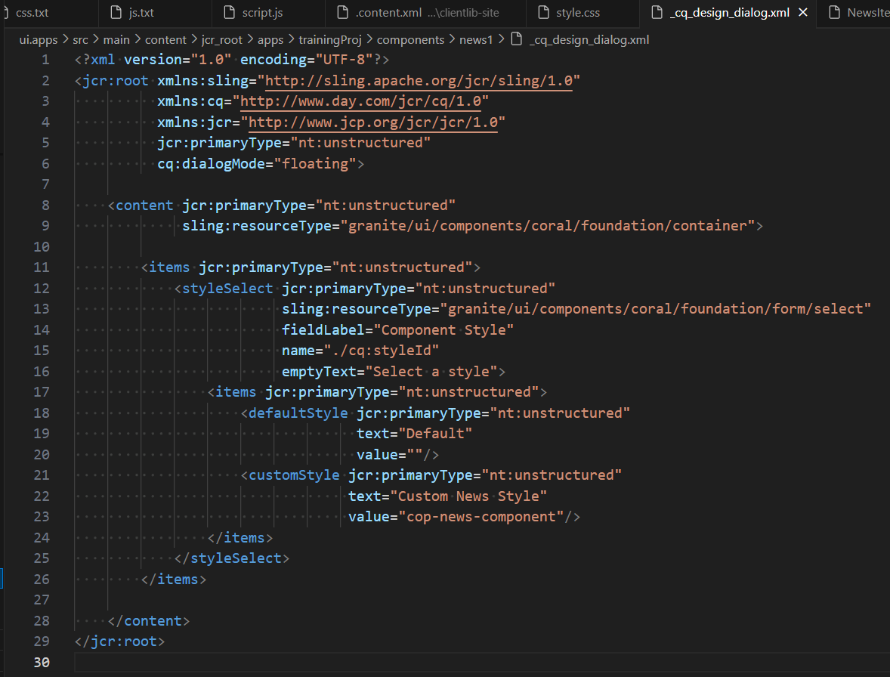 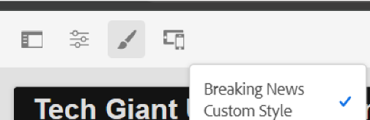

6. Create a base page component and add new file as metadata so that it can print og:title, og:description and og:image link that file in base page.html

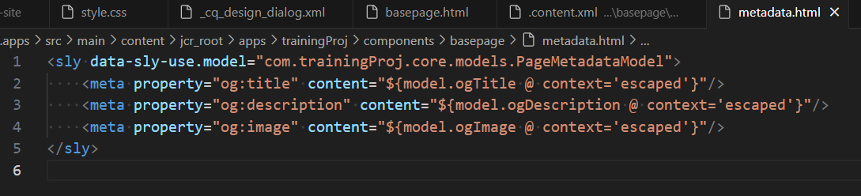

7.Create custom page properties saying Global properties and 3 fields should be there as og:title, og :description and og:image path

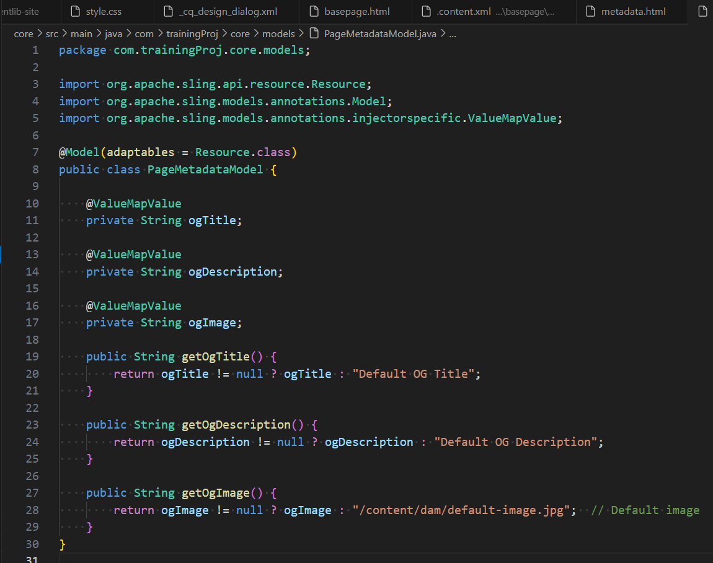

8. What is extraclientlib add it this multi field component

An extraclientlib in Adobe Experience Manager (AEM) is a way to include additional client libraries (CSS/JS) to be used in your components. These client libraries are typically referenced to enhance the functionality or appearance of a component, such as adding custom styles or JavaScript.

When you use extraclientlib, it allows you to associate specific client libraries with your components in a modular manner.