1. Create News room page component using base page component

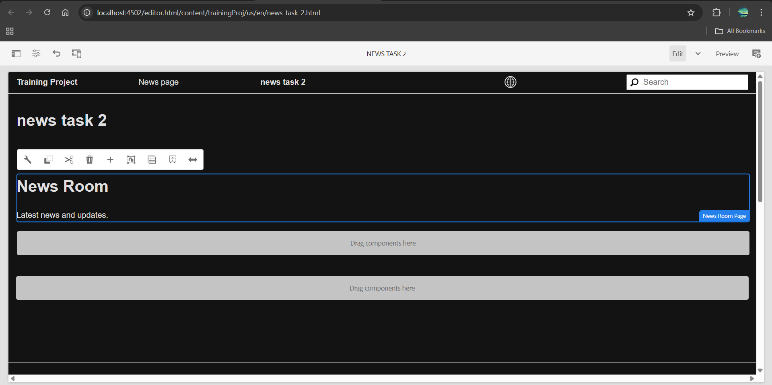

1. Create custom page property as NEWS configurations where I can author the default news image. Read More CTA for News Article

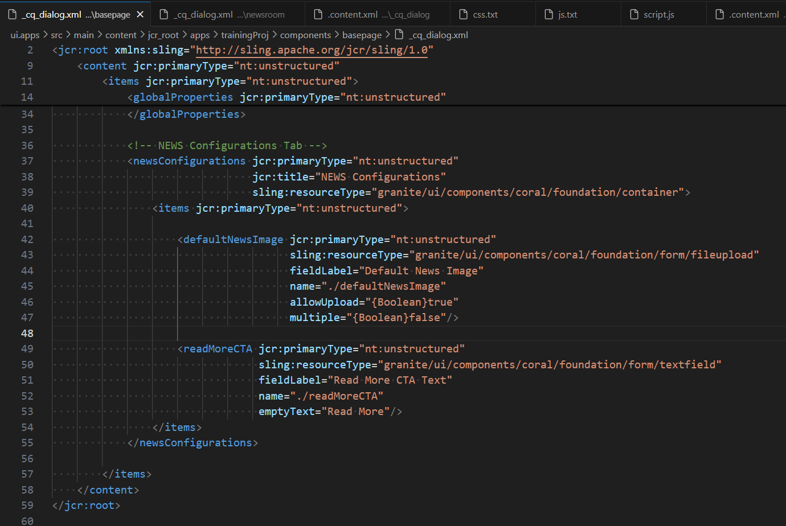

1. Create News room template type by using news room page component

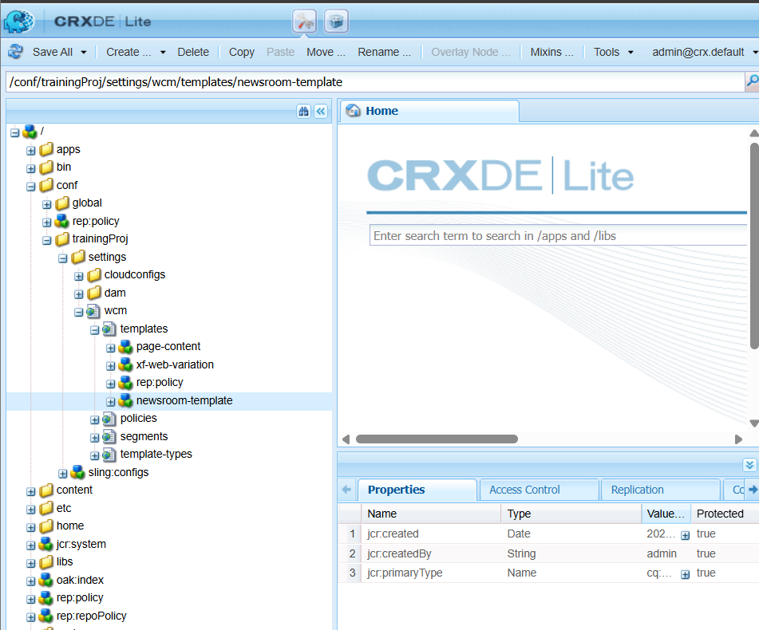

1. Apply the styling to news/ hello world component from ui.frontend folder

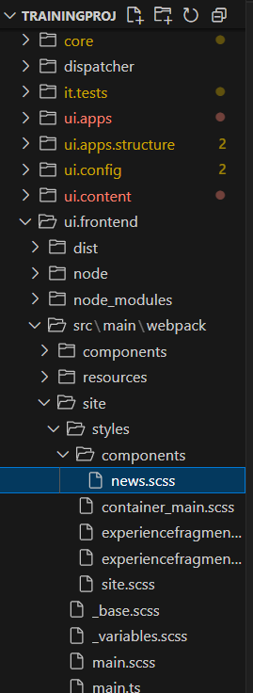 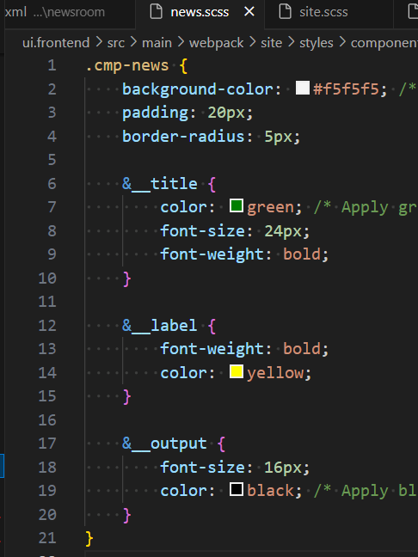

1. Additionally you can create custom style to apply above styling to hello world or news component.
2. <cq:style jcr:primaryType="nt:unstructured"
3. sling:resourceType="granite/ui/components/coral/foundation/select"
4. fieldLabel="Choose a Style"
5. name="./cq:style">
6. <items jcr:primaryType="nt:unstructured">
7. <default jcr:primaryType="nt:unstructured"
8. text="Default"
9. value="default"/>
10. <highlighted jcr:primaryType="nt:unstructured"
11. text="Highlighted News"
12. value="highlighted"/>
13. <bordered jcr:primaryType="nt:unstructured"
14. text="Bordered News"
15. value="bordered"/>
16. </items>
17. </cq:style>