**Create 5 news article pages under /content/us/en/news**

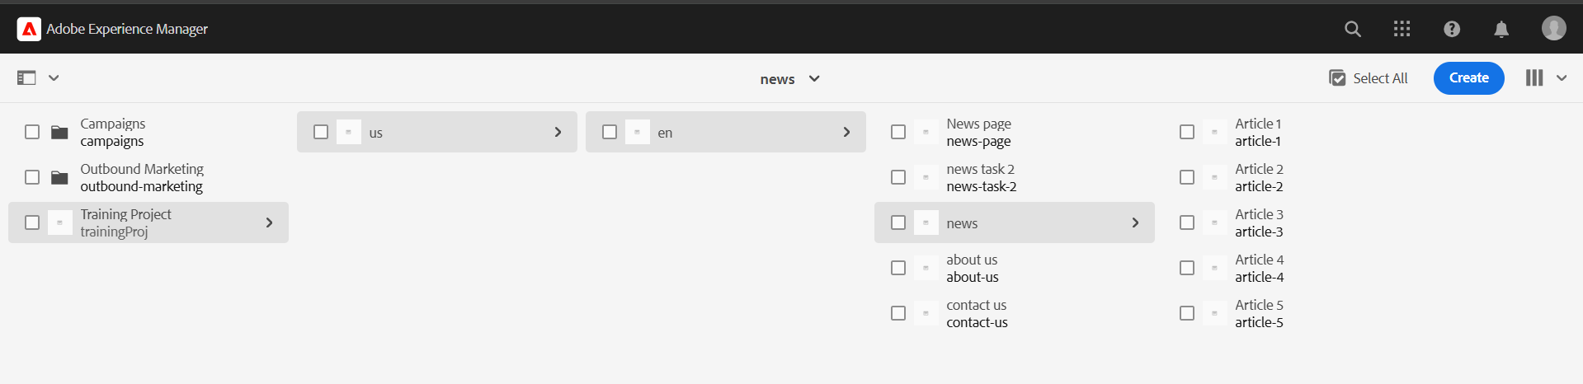

**All should be unique , Use News component which we had created previously to provide the title, news detail and published date.**

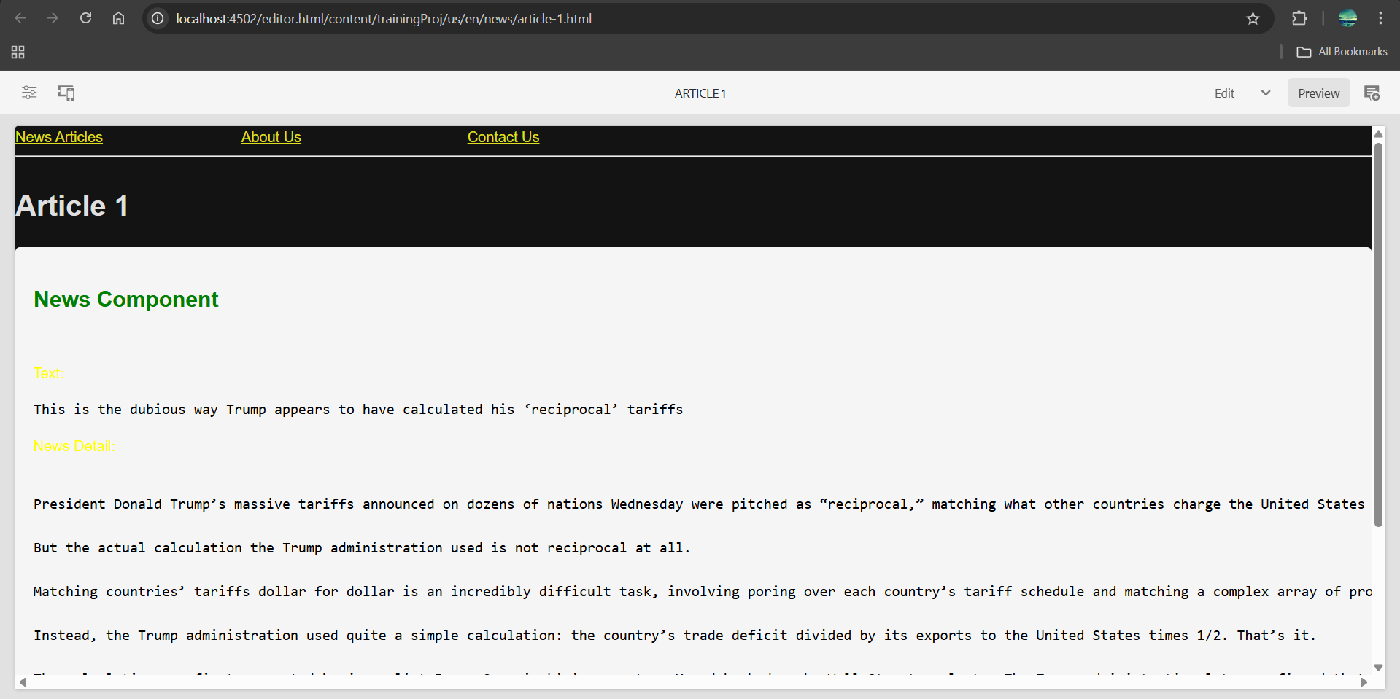

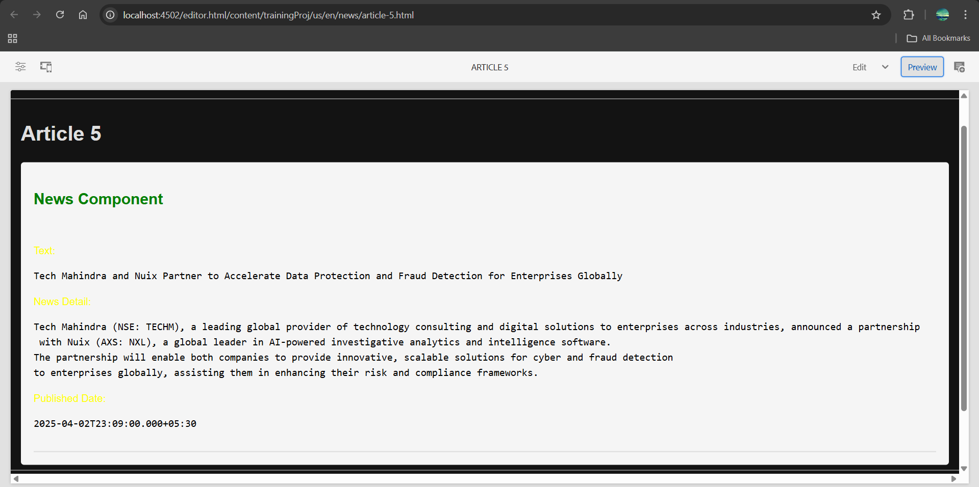

**Header Experience fragment for header**

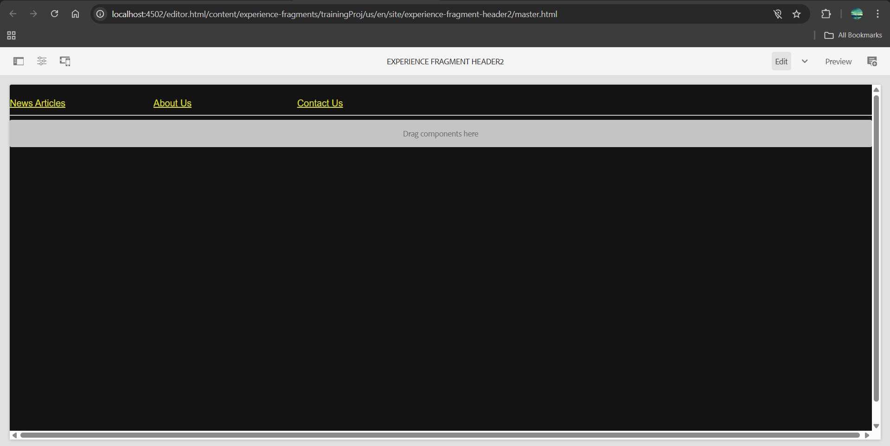

**News page with these news pages as menu**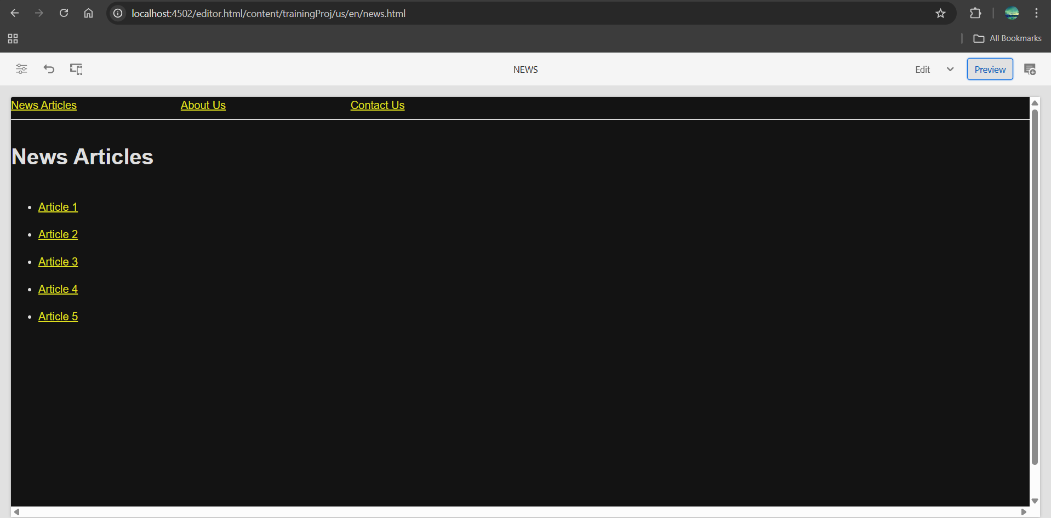

**Contact Us and About Us pages**

create contact us page and about me page (you can use teaser or image, text, title components to provide some details about journalist on about me page and on contact us page it should be some contact related details it can have their mobile number office address or email address). Social media section-you can use list component for this to provide some social media account references.

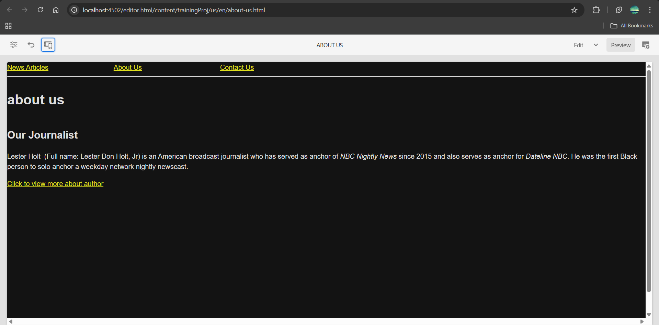

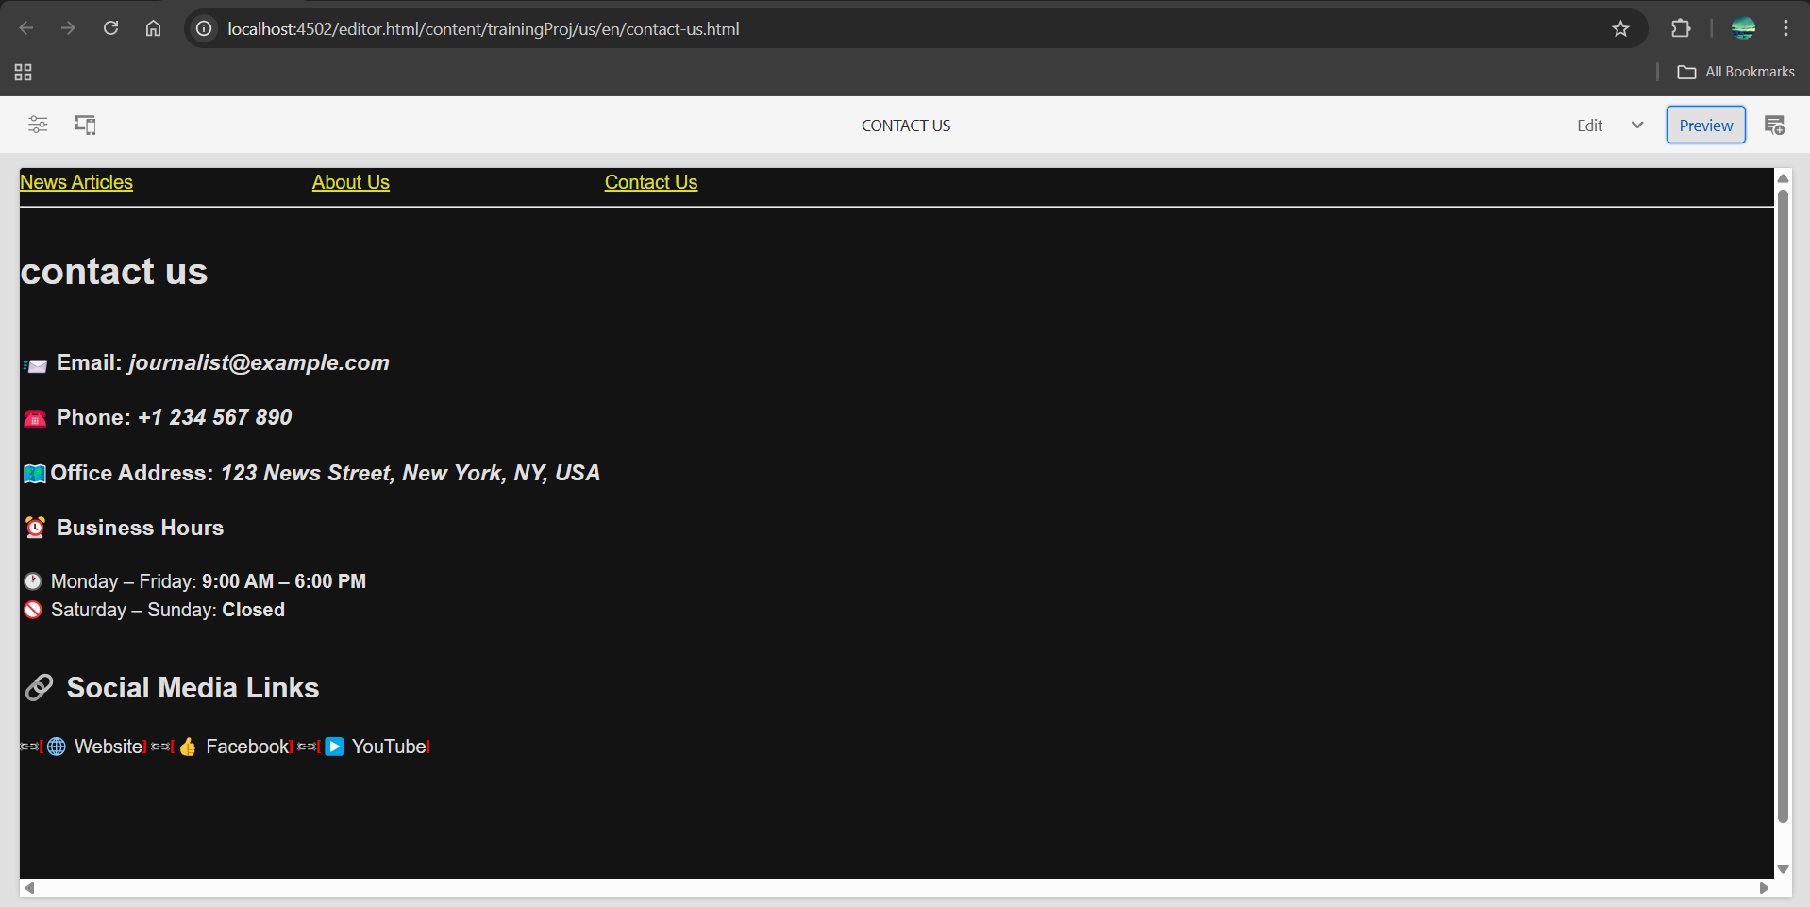

**Footer Experience Fragment**

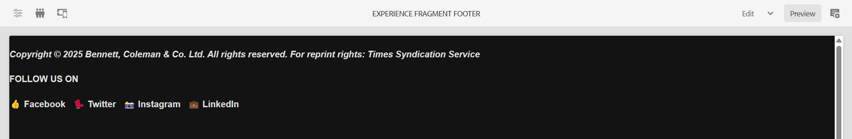

**Create a custom service to print hello world and call this service from news component sling model and print this value in logs as well.**

**NewsModel.java**

package com.trainingProj.core.models;

import com.trainingProj.core.services.HelloWorldService;

import org.apache.sling.api.resource.Resource;

import org.apache.sling.models.annotations.DefaultInjectionStrategy;

import org.apache.sling.models.annotations.Model;

import org.apache.sling.models.annotations.injectorspecific.Self;

import org.apache.sling.models.annotations.injectorspecific.OSGiService;

import org.slf4j.Logger;

import org.slf4j.LoggerFactory;

import javax.annotation.PostConstruct;

@Model(adaptables = Resource.class, defaultInjectionStrategy = DefaultInjectionStrategy.OPTIONAL)

public class NewsComponentModel {

private static final Logger LOG = LoggerFactory.getLogger(NewsComponentModel.class);

@Self

private Resource currentResource;

@OSGiService

private HelloWorldService helloWorldService;

private String serviceMessage;

@PostConstruct

protected void init() {

if (helloWorldService != null) {

serviceMessage = helloWorldService.getMessage();

LOG.info("Service Message: {}", serviceMessage);

} else {

LOG.warn("HelloWorldService is not available");

}

}

public String getServiceMessage() {

return serviceMessage;

}

}

**INFO [com.example.core.models.NewsComponentModel] Service Message: Hello World from Custom OSGi Service!**