1.Create Custom Workflow (my custom workflow)

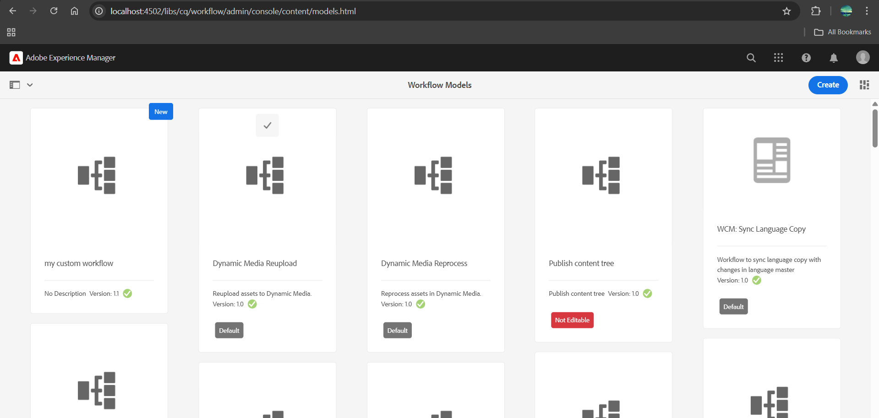

2.Create custom workflow process and print the page title in logs and run this workflow in page so that it can give some metadata in logs

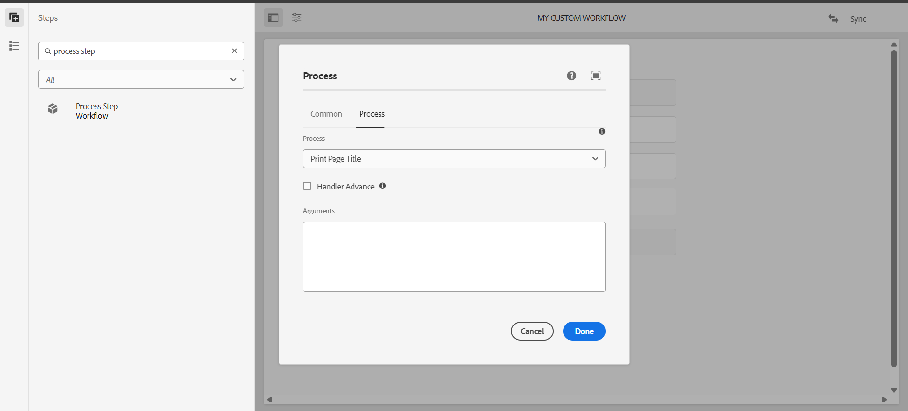

⚙️ Workflow triggered for path: /content/us/en/news/article-1

📄 Page Title: Article 1

🔍 Metadata - executedBy: admin

3.Create Event handler in aem and print the resource path in logs.

Event Handler Class

package com.trainingProj.core.listeners;

import org.osgi.service.component.annotations.Component;

import org.osgi.service.component.propertytypes.ServiceDescription;

import org.osgi.framework.Constants;

import org.apache.sling.api.resource.ResourceResolverFactory;

import org.apache.sling.api.resource.ResourceResolver;

import org.apache.sling.jcr.api.SlingRepository;

import javax.jcr.RepositoryException;

import javax.jcr.observation.Event;

import javax.jcr.observation.EventListener;

import javax.jcr.observation.ObservationManager;

import javax.jcr.Session;

import javax.jcr.Node;

import org.osgi.service.component.annotations.Reference;

import javax.annotation.Activated;

@Component(

service = EventListener.class,

immediate = true,

property = {

Constants.SERVICE_DESCRIPTION + "=Custom Page Event Listener"

}

)

public class PageEventHandler implements EventListener {

@Reference

private SlingRepository repository;

private Session session;

@Activated

public void activate() {

try {

session = repository.loginService("datawrite", null);

ObservationManager observationManager = session.getWorkspace().getObservationManager();

observationManager.addEventListener(

this, // EventListener

Event.NODE_ADDED | Event.NODE_REMOVED | Event.PROPERTY_CHANGED,

"/content", // Path to listen to

true, // isDeep?

null, // UUIDs filter

null, // NodeTypes filter

false // NoLocal

);

} catch (RepositoryException e) {

e.printStackTrace();

}

}

@Override

public void onEvent(javax.jcr.observation.EventIterator events) {

while (events.hasNext()) {

Event event = events.nextEvent();

try {

String path = event.getPath();

System.out.println("📌 AEM Event Triggered at Path: " + path);

} catch (RepositoryException e) {

e.printStackTrace();

}}}}

In logs:

AEM Event Triggered at Path: /content/us/en/news/article-1/jcr:content

4.create sling job to print hello world message in logs

Sling job consumer class

package com.example.core.jobs;

import org.apache.sling.event.jobs.Job;

import org.apache.sling.event.jobs.consumer.JobConsumer;

import org.osgi.service.component.annotations.Component;

@Component(

service = JobConsumer.class,

immediate = true,

property = {

JobConsumer.PROPERTY_TOPICS + "=com/example/helloworld"

})

public class HelloWorldJobConsumer implements JobConsumer {

@Override

public JobResult process(Job job) {

// Print to AEM logs

System.out.println("✅ Sling Job Triggered - Hello World!");

return JobResult.OK;

}}

5. Create one schedular to print the yellow world in logs in every 5 mins through custom configuration using cron expression.

Scheduler class

package com.trainingProj.core.schedulers;

import org.osgi.service.component.annotations.Component;

import org.osgi.service.metatype.annotations.Designate;

import org.osgi.service.component.annotations.Activate;

import org.osgi.service.component.annotations.Modified;

import org.osgi.framework.Constants;

import org.osgi.service.metatype.annotations.ObjectClassDefinition;

import org.osgi.service.metatype.annotations.AttributeDefinition;

import org.slf4j.Logger;

import org.slf4j.LoggerFactory;

import java.util.concurrent.atomic.AtomicBoolean;

import org.apache.sling.commons.scheduler.ScheduleOptions;

import org.apache.sling.commons.scheduler.Scheduler;

@Component(

service = Runnable.class,

immediate = true,

configurationPid = "com.example.core.schedulers.YellowWorldScheduler"

)

@Designate(ocd = YellowWorldScheduler.Config.class)

public class YellowWorldScheduler implements Runnable {

private static final Logger LOG = LoggerFactory.getLogger(YellowWorldScheduler.class);

@ObjectClassDefinition(name = "💛 Yellow World Scheduler Config")

public @interface Config {

@AttributeDefinition(name = "Cron Expression", description = "Cron expression for scheduling the task")

String scheduler_expression() default "0 0/5 * * * ?";

}

@org.osgi.service.component.annotations.Reference

private Scheduler scheduler;

private final AtomicBoolean isScheduled = new AtomicBoolean(false);

@Activate

@Modified

protected void activate(Config config) {

String expression = config.scheduler_expression();

ScheduleOptions scheduleOptions = scheduler.EXPR(expression);

scheduleOptions.name("YellowWorldSchedulerJob");

scheduleOptions.canRunConcurrently(false);

if (isScheduled.compareAndSet(false, true)) {

scheduler.schedule(this, scheduleOptions);

LOG.info("✅ YellowWorld Scheduler Registered with cron: {}", expression);

} }

@Override

public void run() {

LOG.info("💛 Yellow World");

}}

6. Create 3 users and add them in a group(Dev author create this new group)

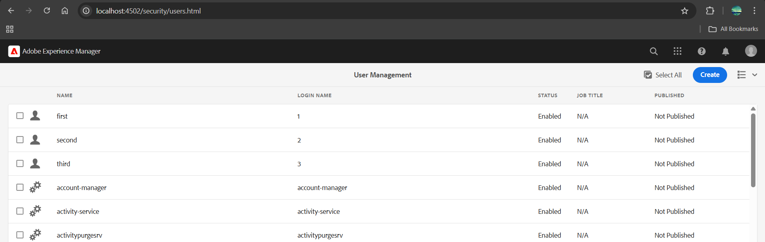

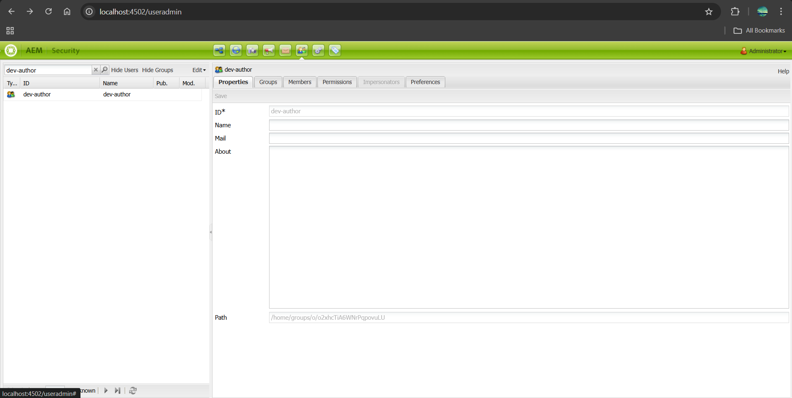

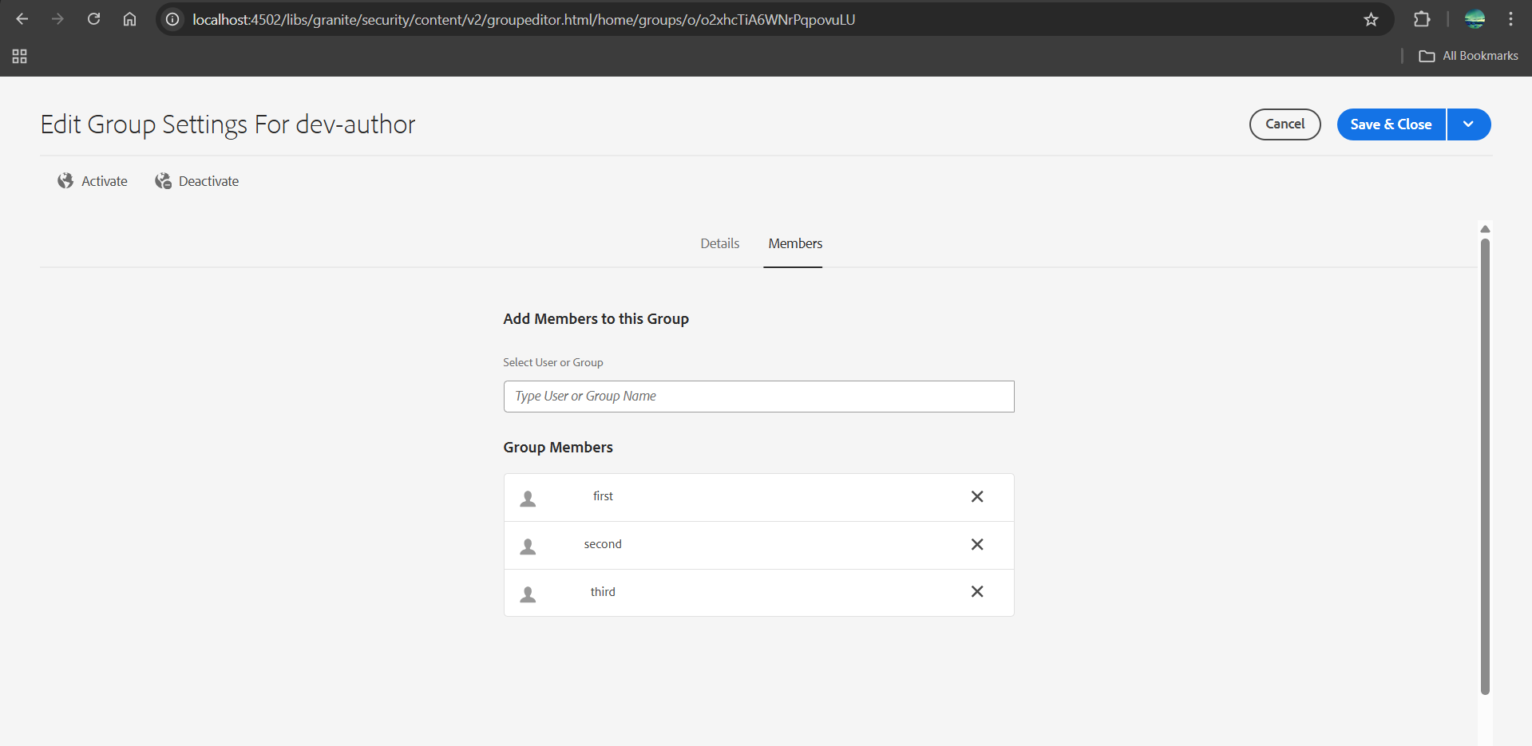

give permission to read only for /content/dam folder only and they should have replication access as well.

