PRODUCT AND TECHNICAL REPORT
Compass
An inspectable AI coding workbench for project change, review, and delivery
EXECUTIVE SUMMARY
Compass combines a governed LangGraph agent with a local terminal UI and an authenticated web workbench. It helps developers move from project understanding to reviewed changes and GitHub delivery while keeping context, approvals, and run activity visible.
Prepared from the current Compass implementation
25 July 2026

1. Product overview
Compass is a coding assistant designed as a workbench rather than a chat box. It provides a structured route from a developer request to project context, an execution plan, approved tool actions, patch review, and a publishable GitHub outcome.
- Local-first terminal workflow for developers working directly in a checked-out repository.
- Authenticated browser workspace for isolated uploads and GitHub imports.
- Explicit controls for context, interaction mode, patches, approvals, activity, and publishing.
- One agent workflow shared across interfaces, with different safety boundaries for local and hosted execution.
PRODUCT POSITION
Compass differentiates itself through clarity and control: it makes powerful agent behavior understandable without exposing raw internal reasoning or hiding project-changing operations.

2. System architecture
The terminal UI operates on a local repository. The web workbench talks to FastAPI, which owns authentication, sessions, isolated workspaces, runs, patches and GitHub connections. Both use the LangGraph agent workflow.
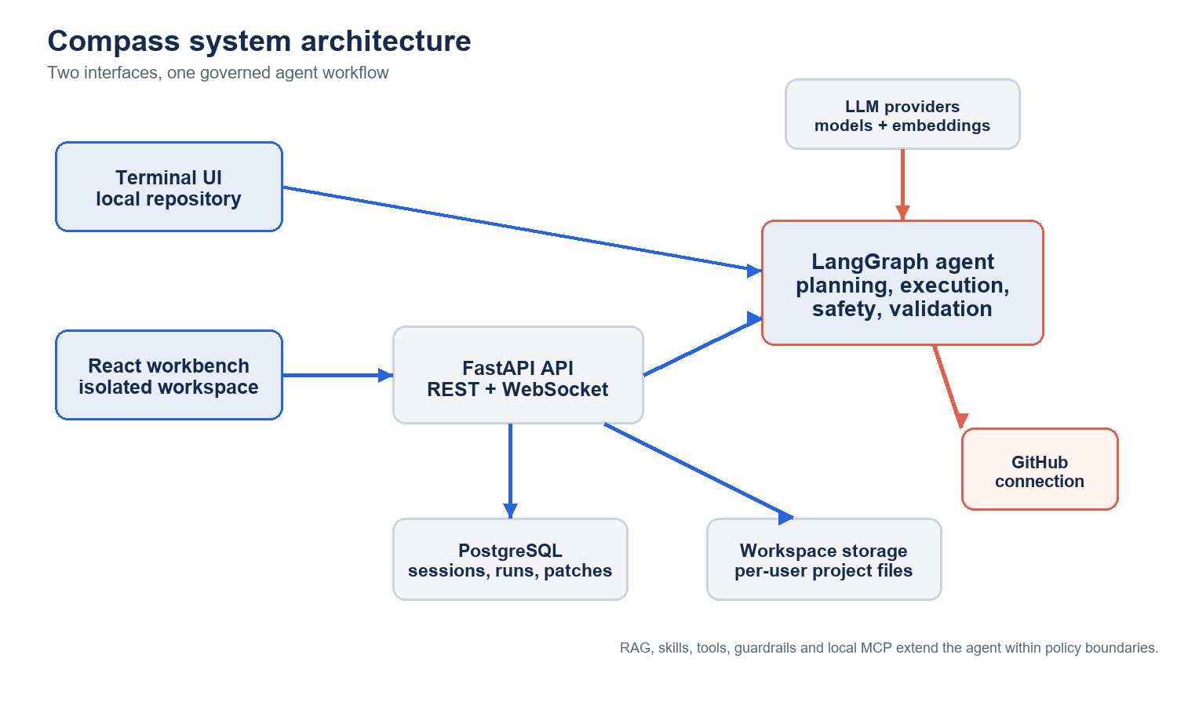
Figure 1. Compass joins local and web experiences through one governed agent workflow.

3. Feature set
Capability | What it enables | Surface
Project workbench | Files, editor, changes, preview, agent and activity views share one responsive workspace state. | Web
Agent execution | Ask, Edit, Plan and Goal modes route work through planning, tools, guardrails, recovery and evaluation. | TUI + web
Context intelligence | File search, semantic retrieval/RAG, pinned files, session history, skills and task state. | Agent + workbench
Review and recovery | Patch counts, diff review, accept/reject, undo, run stages, failure details and loop recovery. | TUI + web
GitHub delivery | Separate repository connection, import, branch creation, commits and draft pull requests. | Web + TUI helpers
Local integrations | Local MCP configuration, custom tools, skills, shell execution and repository configuration. | TUI only

4. Technology stack
Layer | Primary technologies | Role
Frontend | React 19, TypeScript, Vite, Tailwind CSS, Base UI, CodeMirror, WebContainers | Responsive workbench, editor, diff, preview and accessible controls.
Backend | FastAPI, Pydantic, SQLAlchemy, Alembic, Uvicorn | Authenticated REST/WebSocket API and product services.
Agent | LangGraph, LangChain, provider adapters | Planning, models, tools, recovery and persistent routing.
Persistence | PostgreSQL, psycopg, LangGraph Postgres checkpointing | Users, sessions, messages, runs, patches, workspaces and resumable state.
Intelligence | RAG indexing, chunking, retrieval, embeddings | Relevant project evidence and semantic source search.
Safety + operations | NeMo Guardrails, JWT, OAuth, encryption, logging, rate limiting | Input/output policy, identity, credentials and operational visibility.
Delivery | GitHub OAuth/PAT, Docker Compose, Nginx | Repository integration and deployable packaging.

5. Workflow graph and modes
The graph keeps project-changing activity visible. It checks the request, builds context, plans when required, evaluates each side effect against policy, records tool activity, and validates the result before completion.
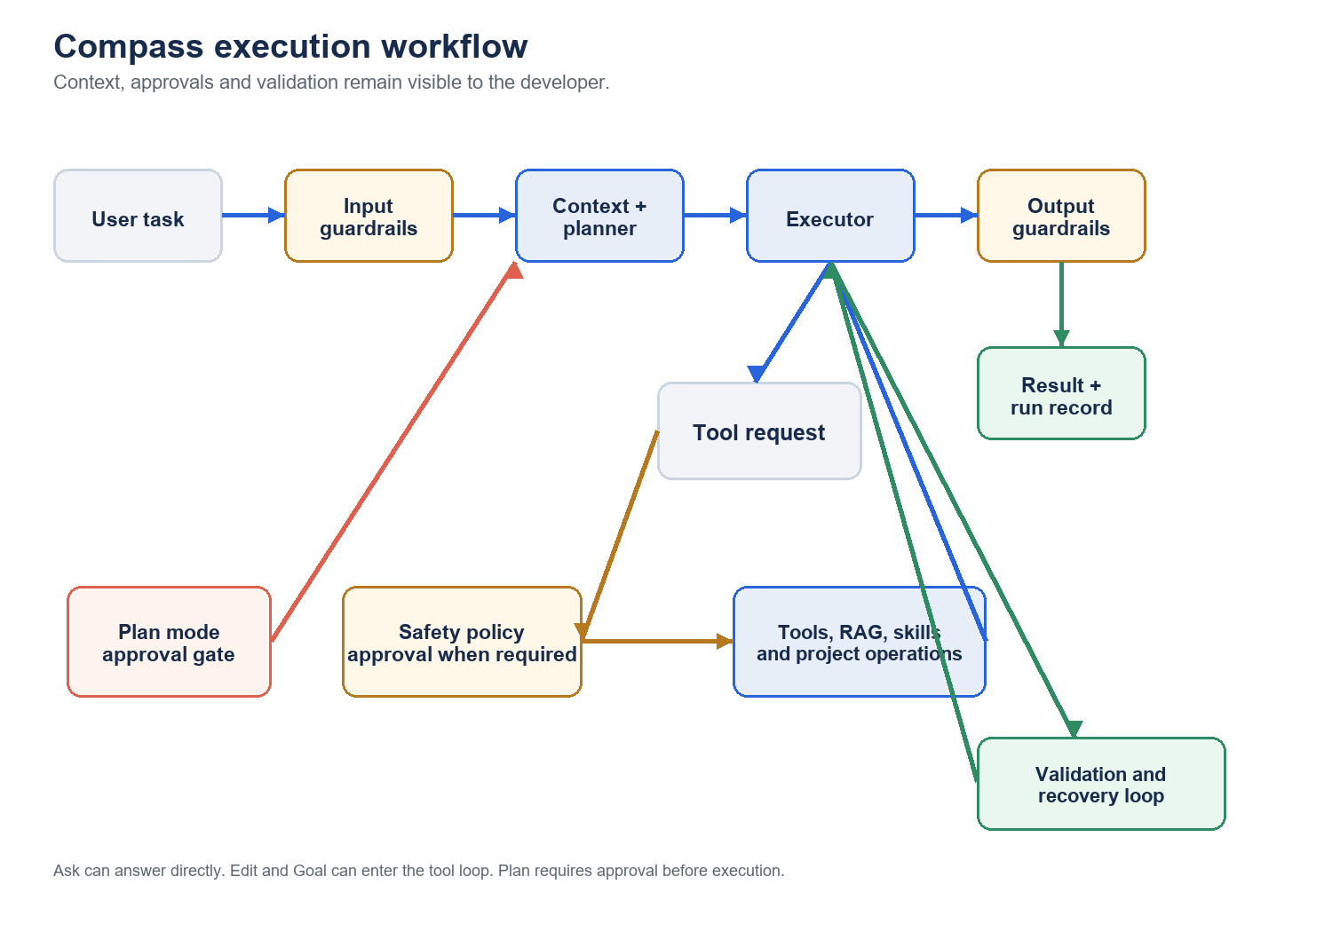
Figure 2. Main execution path and approval-controlled tool loop.
Mode | Intent | Control model
Ask | Understand code, explain behavior or research. | Read-oriented and can answer directly.
Edit | Make bounded project changes. | Risky actions follow approval policy.
Plan | Produce a reviewable plan before acting. | Explicit plan approval gate.
Goal | Pursue a larger outcome with validation and recovery. | Multi-step progress; risky actions remain governed.

6. Problems Compass solves
Developer problem | Compass response | Value
Large codebases are hard to orient. | Trees, search, RAG retrieval, pinned context and history surface relevant evidence. | Faster understanding with traceable context.
Chat-only agents obscure execution. | Run rails, activity, tools, affected files and approvals make work visible. | Higher trust and easier intervention.
Review is often bolted on late. | Patches, real diff statistics, review controls, bulk actions and undo are central. | Safer changes and clearer ownership.
Delivery requires repetitive handoffs. | Repository import, branch, commit and pull request steps live in one flow. | Shorter path from task to reviewed delivery.
Hosted agents can expose local risk. | Per-user workspaces, ownership checks, path validation, shell and MCP restrictions. | A safer boundary for web development.

7. Safety and operating model
- Read/search operations can proceed under the default policy; local writes, edits and shell commands are classified as risky.
- Approvals offer Yes, No, Always and Skip decisions.
- Hosted mode removes shell execution and rejects browser-configured command MCP servers.
- Web workspaces are ownership-checked and reject absolute paths or traversal.
- GitHub access is separate from identity login; stored provider credentials are encrypted by the backend.
IMPORTANT
AI-generated changes still require engineering review. The intended loop is: inspect context -> approve relevant side effects -> review the patch -> validate -> publish through a pull request.

8. Future improvements
These recommendations are proposed improvements, not claims about shipped capability.
Horizon | Recommendation | Expected outcome
Near term | Unify TUI slash-command metadata and handlers; add regression coverage for routing and safety decisions. | Lower maintenance cost and more reliable local operations.
Near term | Automate UI coverage for auth, command palette, review, GitHub states and responsive layouts. | Protect the completed workbench from regressions.
Next | Expand GitHub conflict, permission, retry and repository-selection recovery states. | Clearer production delivery.
Next | Add observability for stage latency, tool reliability, approvals and patch outcomes. | Evidence-based quality and cost improvements.
Later | Introduce reusable team/workflow templates after core contracts stabilize. | Composable automation without diluting the workbench.
Later | Formalize policy administration, retention controls, audit export and enterprise identity. | Stronger deployment governance.

9. Evaluation criteria
- Task success: correct and reviewable outcomes.
- Control quality: understandable context, tools, changes and approvals.
- Safety: effective workspace, credential and hosted-boundary enforcement.
- Delivery quality: reliable branch, commit and pull-request recovery paths.
- Experience quality: accessible, responsive and readable desktop/mobile operation.

10. Conclusion
Compass is positioned as a controlled AI development environment. Its strongest product decision is combining automation with inspectable context, approval-aware actions, first-class patch review and an intentional route to GitHub delivery. Future work should strengthen reliability, observability and deployment governance while preserving that control model.

