
PROJECT REPORT
On
UNICORN STARTUP ANALYSIS
Exploratory Data Analysis Using Python
In
Software Tools for Artificial Intelligence and Machine Learning

BACHELOR OF TECHNOLOGY
IN
Artificial Intelligence and Machine Learning
SUBMITTED BY
Harshit – 25070123053

Khush Chauhan - 25070123062

Krishiv Sharma - 25070123065

Kshitij Dalvi - 25070123066

Batch: ENTC A-3
SYMBIOSIS INSTITUTE OF TECHNOLOGY, PUNE – 412115
(A Constituent of Symbiosis International (Deemed University))
2025-26

1. Abstract 1
2. Introduction 1
3. Background and Dataset Description 1
3.1 Dataset Overview 1
3.2 Derived Columns 1
4. Methodology 1
4.1 Data Inspection 1
4.2 Data Cleaning — Custom Currency Parsing 1
4.3 Univariate Analysis 1
4.4 Bivariate Analysis 1
4.5 Outlier Detection — IQR Method 1
5. Data Visualizations 1
5.1 Bar Plot — Top 10 Industries by Number of Unicorns 1
5.2 Bar Plot — Top 10 Countries by Number of Unicorns 1
5.3 Line Plot — Unicorn Growth Over Time 1
5.4 Scatter Plot — Funding vs. Valuation 1
5.5 Box Plot — Valuation Distribution by Industry 1
5.6 Histogram — Time to Unicorn Status 1
5.7 Correlation Heatmap 1
5.8 Top 15 Investors Analysis 1
5.9 Outlier Detection — Box Plots 1
5.10 Donut Chart — Geographic Distribution by Continent 1
5.11 Dendrogram — Hierarchical Clustering of Industries 1
5.12 Bubble Plot — Valuation vs. Year Founded 1
5.13 Violin Plot — Time to Unicorn by Continent 1
5.14 K-Means Clustering 1
6. Results and Discussion 1
6.1 Industry Landscape 1
6.2 Geographic Concentration 1
6.3 Temporal Trends 1
6.4 Funding and Valuation Dynamics 1
6.5 Speed of Value Creation 1
7. Applications and Use Cases 1
8. Conclusion 1
9. References 1

ACKNOWLEDGEMENT
We would like to express our sincere gratitude to our EDA course instructor, Snehal Bhosle ma’am, for her invaluable guidance, continuous support, and constructive feedback throughout the development of this Exploratory Data Analysis project on Unicorn Startups. Her insights into data analysis methodologies, Python programming, and visualization techniques greatly enriched the quality and depth of this report.
We are grateful to the administration of Symbiosis Institute of Technology, Pune, for providing the computational resources, software tools, and academic environment that made this project possible. Access to Python libraries such as Pandas, Matplotlib, Seaborn, and Scikit-learn was instrumental in carrying out our analysis of global unicorn startup data.
We extend our heartfelt thanks to our parents and friends for their constant encouragement and moral support throughout this project. Their belief in our work motivated us to explore complex patterns in the dataset, from funding dynamics and geographic distributions to temporal trends in unicorn growth across industries.
Finally, we acknowledge the publicly available Unicorn Companies dataset and the various academic references, research articles, and online resources that provided the contextual foundation for our analysis. This project would not have been possible without these contributions from the broader data science and startup research community.

1. Abstract
This project report presents an in-depth Exploratory Data Analysis (EDA) of the global unicorn startup ecosystem using Python. The dataset comprises 1,074 privately-held companies valued at over $1 billion — commonly referred to as 'unicorn' companies. By leveraging powerful Python libraries including Pandas, NumPy, Matplotlib, Seaborn, and Plotly, this study uncovers meaningful patterns in industry distribution, geographic spread, investor activity, funding behavior, and valuation trends.
The analysis proceeds through a structured pipeline: raw data inspection and cleaning, basic statistical computations, univariate and bivariate analysis, data filtering, outlier detection via the IQR method, and comprehensive visualizations including bar plots, line charts, scatter plots, box plots, histograms, correlation heatmaps, and choropleth maps.

💡 Key Finding: Fintech is the dominant industry (20.86%), the United States accounts for 52.33% of all unicorns, 2021 saw a historic surge of 414 new unicorns, and Sequoia Capital is the most active investor with 101 portfolio companies.

2. Introduction
The term 'unicorn' was coined by venture capitalist Aileen Lee in 2013 to describe privately held startup companies valued at over $1 billion. Since then, the unicorn club has expanded dramatically, reflecting unprecedented growth in global entrepreneurship, technological innovation, and venture capital investment. As of the dataset's scope, 1,074 such companies exist worldwide, spanning industries from financial technology to artificial intelligence, across six continents.
This project undertakes a systematic Python-based Exploratory Data Analysis (EDA) of the unicorn dataset to answer fundamental questions: Which industries produce the most unicorns? Which countries dominate the ecosystem? How has the rate of unicorn creation changed over time? What is the relationship between funding raised and company valuation? And how quickly do modern startups achieve the $1B milestone compared to their predecessors?

3. Background and Dataset Description

3.1 Dataset Overview
The dataset used in this project is Unicorn_Companies.csv — a publicly available dataset of global unicorn startups. It contains 1,074 rows and 10 columns. The dataset was loaded into a Pandas DataFrame.

Column | Description | Data Type | Notes
Company | Name of the unicorn company | object | No missing values
Valuation | Company valuation (e.g., $180B) | object | Requires cleaning
Date Joined | Date the company entered unicorn club | object | Converted to datetime
Industry | Business industry/sector | object | 16 unique categories
City | Headquarters city | object | 16 missing values
Country/Region | Headquarters country | object | No missing values
Continent | Headquarters continent | object | 6 continents
Year Founded | Year the company was founded | int64 | Range: 1919–2021
Funding | Total funding raised | object | Requires cleaning
Select Investors | Key investors | object | Comma-separated list

3.2 Derived Columns
Two important derived columns were engineered from the raw data to enable time-based analysis:
- Year Joined: Extracted from the 'Date Joined' column after converting it to datetime format. This represents the year the company achieved unicorn status.
- Years to Unicorn: Calculated as (Year Joined − Year Founded). This measures how many years it took each company to reach a $1B valuation from its founding date.

4. Methodology

4.1 Data Inspection
The first phase involved thoroughly inspecting the raw dataset using built-in Pandas functions. The dataset has 1,074 entries with 10 features. Only 'Year Founded' is numeric; all other columns are stored as objects (strings). There are 16 missing city values, which were filled using the column mode.

4.2 Data Cleaning — Custom Currency Parsing
The Valuation and Funding columns are stored as strings with currency symbols and suffixes (e.g., '$180B', '$500M'). A custom Python function was developed to convert these into numeric values. The function handles B (billions), M (millions), and K (thousands) suffixes, and gracefully returns NaN for any unparseable values.

Metric | Valuation | Funding | Notable Company
Maximum | $180,000,000,000 | $14,000,000,000 | Bytedance / JUUL Labs
Minimum | $1,000,000,000 | $0 | 150+ companies / Otto Bock HealthCare
Mean | $3,455,307,262.57 | $557,269,303.20 | Average across 1,074 unicorns

4.3 Univariate Analysis
Univariate analysis examines each column independently to understand its distribution and frequency patterns. The value_counts() function was central to this phase.

Industry | Count | Percentage
Fintech | 224 | 20.86%
Internet Software & Services | 205 | 19.09%
E-commerce & Direct-to-Consumer | 111 | 10.34%
Health | 74 | 6.89%
Artificial Intelligence | 73 | 6.80%
Supply Chain, Logistics & Delivery | 57 | 5.31%
Cybersecurity | 50 | 4.66%

4.4 Bivariate Analysis
pd.crosstab() was used to examine simultaneous relationships between two variables. Three cross-tabulations were performed: Industry vs Valuation, Country vs Valuation, and Country vs Funding. Fintech dominates across all valuation tiers, confirming its position as the sector producing both the most numerous and highest-value companies.

4.5 Outlier Detection — IQR Method
The Interquartile Range (IQR) method was used to detect statistical outliers. Any observation falling below Q1 − 1.5×IQR or above Q3 + 1.5×IQR is classified as an outlier. The method was applied to Valuation, Funding, and Year Founded.

Column | Outlier Count | Nature | Notable Examples
Valuation | 102 | Right-skewed | Bytedance ($180B), SpaceX ($100B)
Funding | 54 | Right-skewed | JUUL Labs ($14B)
Year Founded | 58 | Both tails | Pre-1995 firms & post-2020 startups

5. Data Visualizations
This section presents all charts and graphs generated from the unicorn dataset. Each visualization uncovers a specific dimension of the startup ecosystem.

5.1 Bar Plot — Top 10 Industries by Number of Unicorns
The horizontal bar chart below compares the top 10 industries by unicorn count, using the Seaborn viridis palette. Fintech leads with 224 companies, closely followed by Internet Software & Services (205).
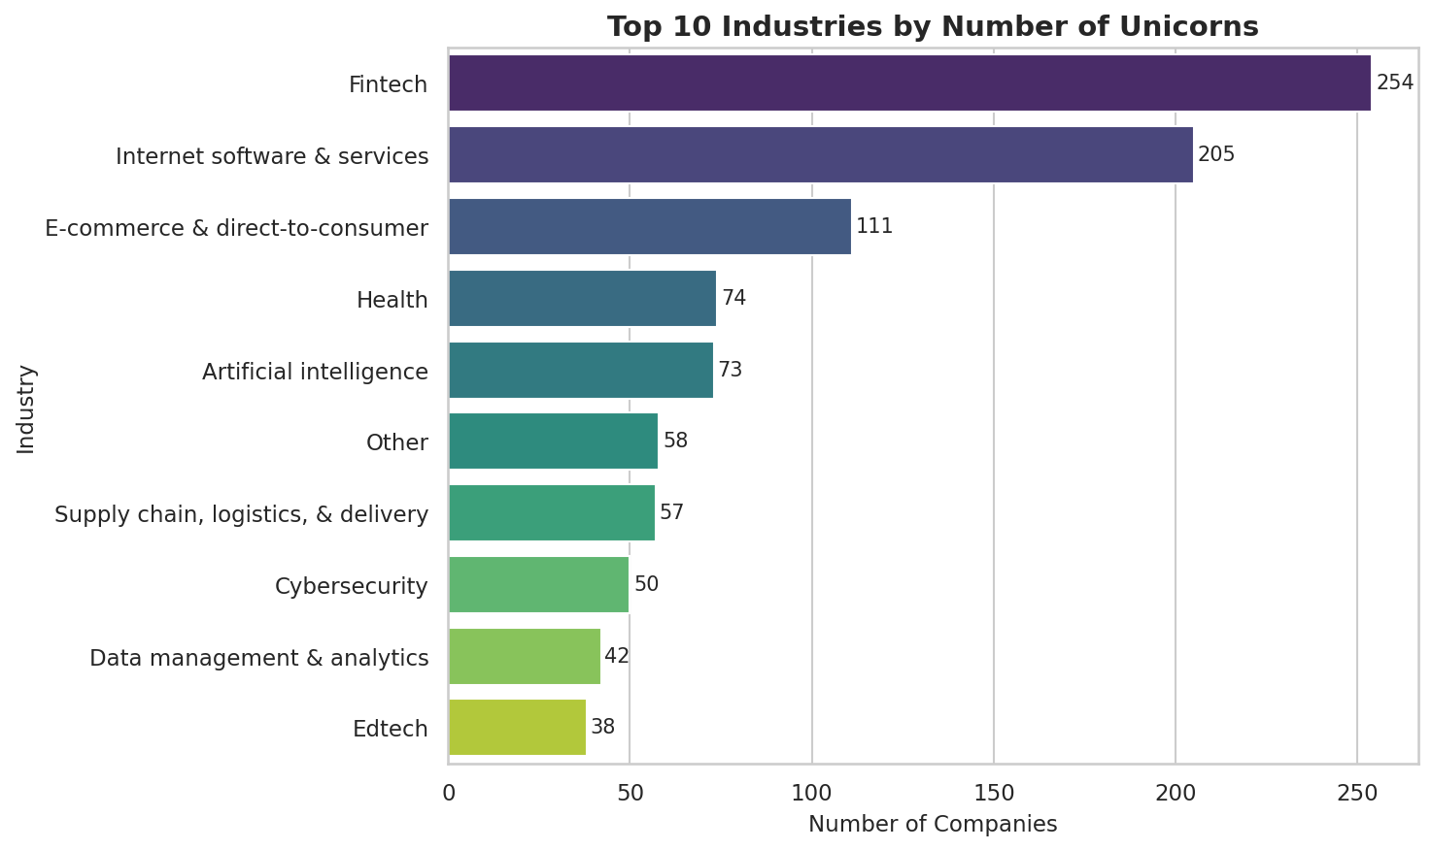
Figure 1: Top 10 Industries by Number of Unicorn Companies
💡 Key Finding: Fintech (224) and Internet Software & Services (205) together account for nearly 40% of all global unicorns, driven by large addressable markets and asset-light, technology-enabled business models.

5.2 Bar Plot — Top 10 Countries by Number of Unicorns
The country-level bar chart uses the magma palette to highlight geographic concentration. The USA dominates with 562 unicorns (52.33%), followed distantly by China (173, 16.11%) and India (65, 6.05%).
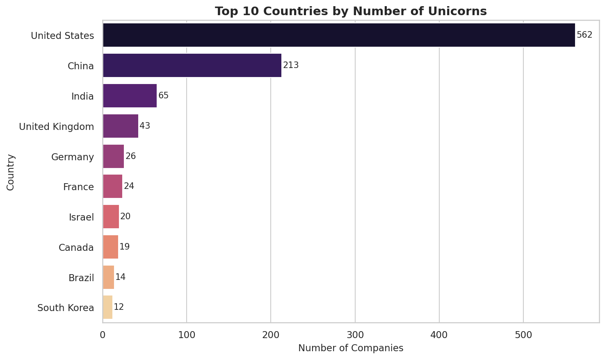
Figure 2: Top 10 Countries by Number of Unicorn Companies
💡 Key Finding: The top 3 countries collectively account for approximately 74.5% of all global unicorns, indicating extreme geographic concentration of startup wealth and venture activity.

5.3 Line Plot — Unicorn Growth Over Time
The line plot tracks the number of companies joining the unicorn club per year. The groupby('Year Joined') aggregation reveals a dramatic exponential growth trend, particularly from 2015 onwards.
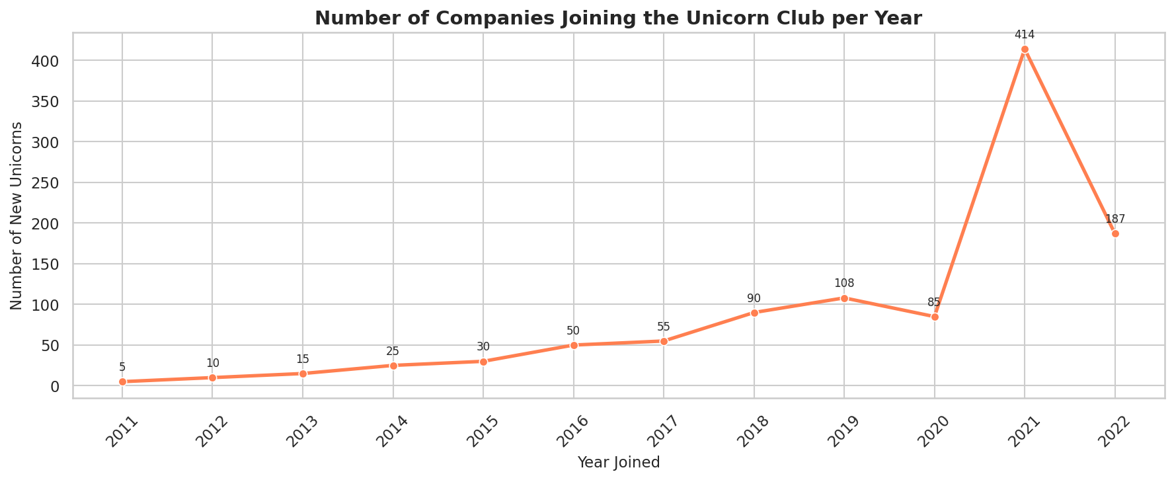
Figure 3: Number of Companies Joining the Unicorn Club per Year
💡 Key Finding: 2021 witnessed a historic all-time high of 414 new unicorn companies — nearly double any previous year. This surge reflects post-pandemic digital acceleration, record-low interest rates, and the maturation of technology ecosystems in emerging markets.

5.4 Scatter Plot — Funding vs. Valuation
A logarithmic scale was applied to both axes to handle the extreme range of values caused by outliers like Bytedance ($180B valuation) and JUUL Labs ($14B funding). The scatter reveals a moderate positive correlation between funding raised and current valuation.
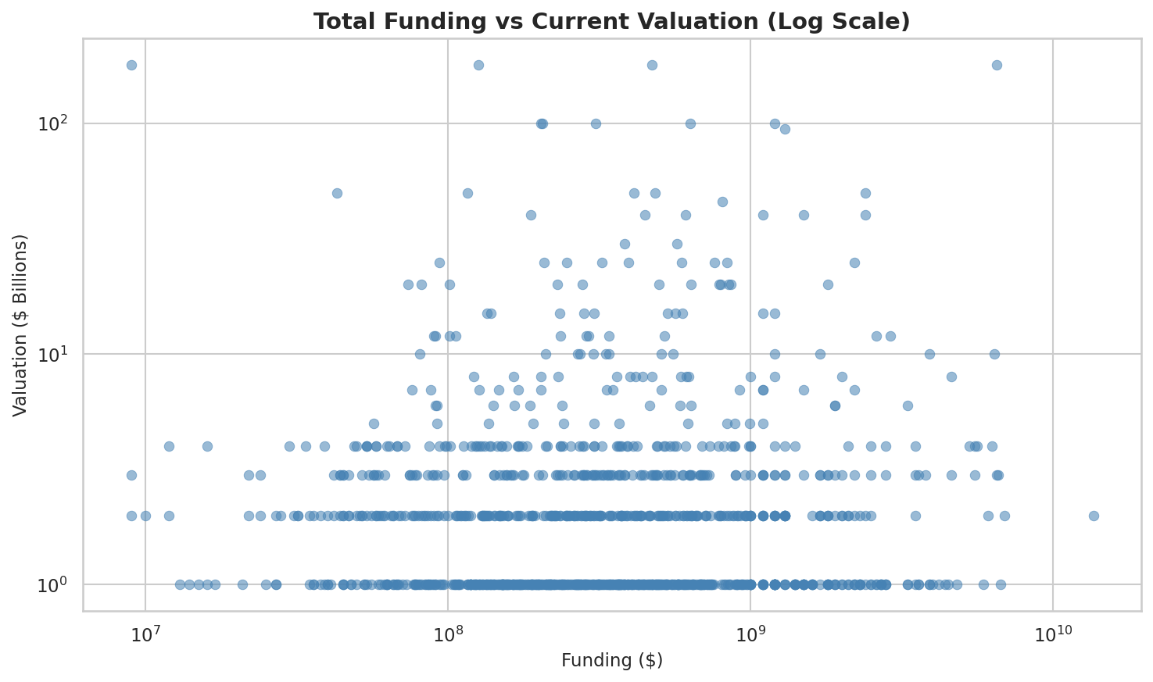
Figure 4: Total Funding vs. Current Valuation (Log Scale)
💡 Key Finding: A moderate positive correlation (r = +0.38) exists between funding and valuation. However, several high-valuation unicorns achieved outsized valuations with relatively modest capital, suggesting market size, network effects, and competitive positioning are equally important drivers.

5.5 Box Plot — Valuation Distribution by Industry
The box plot visualizes the statistical distribution of valuations across the top 5 industries. Log scale is used to handle the heavy right skew. The box spans Q1 to Q3, the median is shown inside the box, and individual outliers are plotted beyond the whiskers.
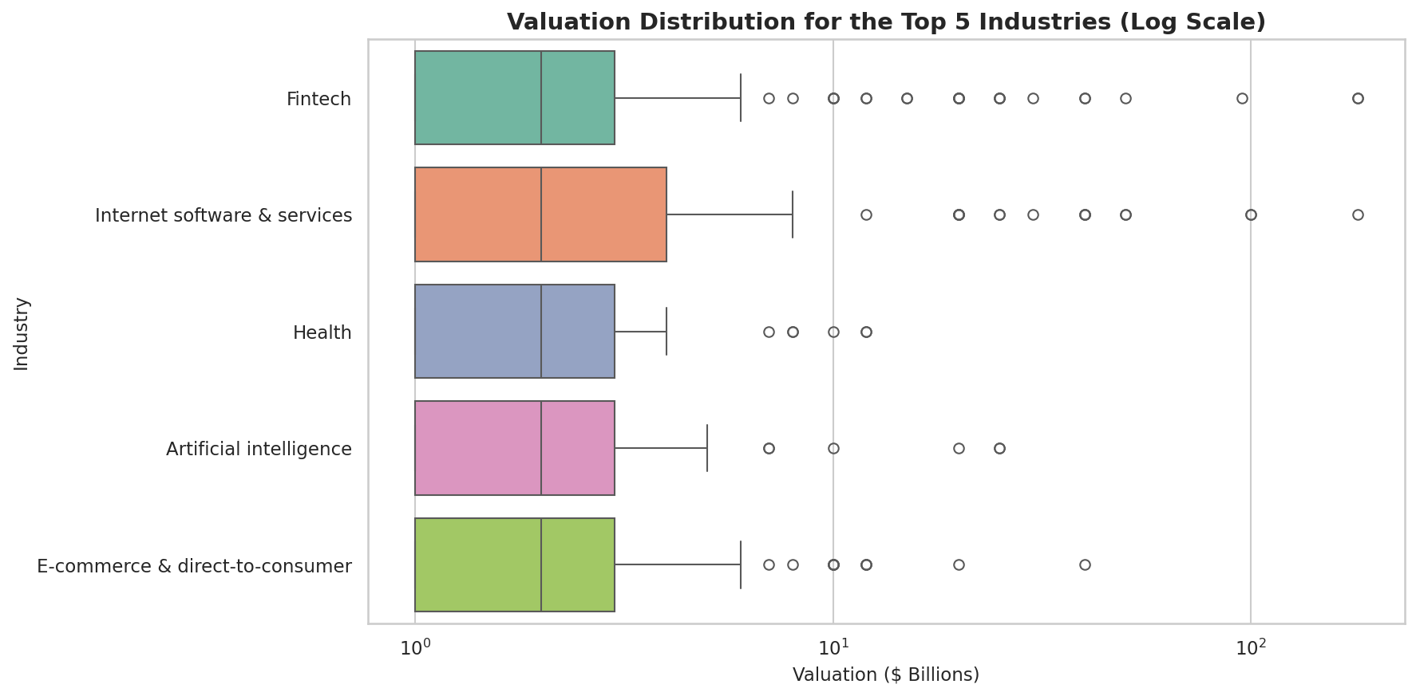
Figure 5: Valuation Distribution for the Top 5 Industries (Log Scale)

5.6 Histogram — Time to Unicorn Status
The histogram with KDE overlay visualizes how long it takes companies to achieve $1B valuation from founding. The distribution peaks around 5–10 years, with a pronounced right tail of older companies.
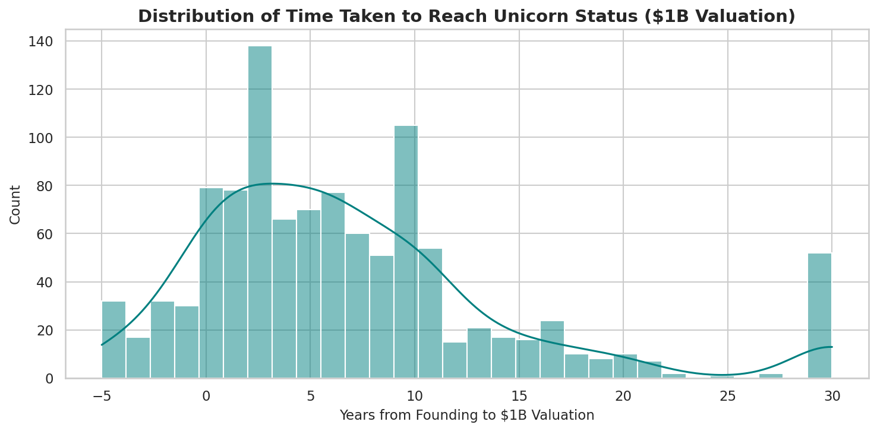
Figure 6: Distribution of Time Taken to Reach Unicorn Status ($1B Valuation)
💡 Key Finding: The majority of unicorns achieve $1B valuation within 5 to 10 years of founding. The strong negative correlation (r = −0.70) between founding year and years to unicorn shows modern startups reach this milestone far faster than predecessors.

5.7 Correlation Heatmap
The Pearson correlation matrix was computed for all four numeric columns — Valuation, Funding, Year Founded, and Years to Unicorn — and visualized using the coolwarm colormap. Red indicates positive correlation, blue indicates negative.
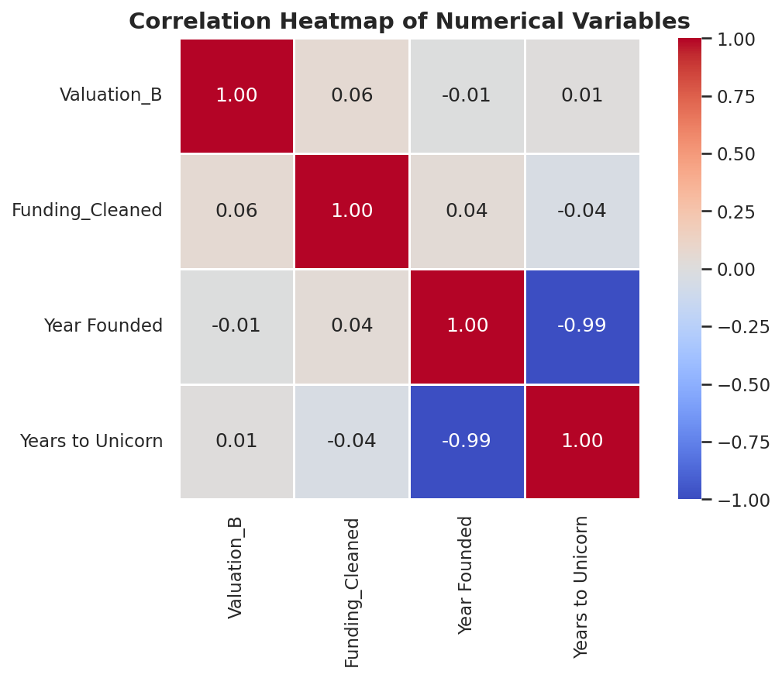
Figure 7: Correlation Heatmap of Numerical Variables

Variable Pair | Correlation | Interpretation
Valuation ↔ Funding | +0.38 | Moderate positive: more funding somewhat predicts higher valuation
Year Founded ↔ Years to Unicorn | −0.70 | Strong negative: newer companies reach $1B much faster
Valuation ↔ Year Founded | −0.05 | Negligible: founding year has little impact on ultimate valuation
Valuation ↔ Years to Unicorn | +0.02 | Negligible: speed to $1B does not predict final valuation
Funding ↔ Year Founded | −0.08 | Negligible: funding amounts are similar across eras

5.8 Top 15 Investors Analysis
Investor data was stored as comma-separated strings. The str.split(',') method was used to tokenize and .explode() to expand into individual rows, enabling accurate per-investor frequency counts.
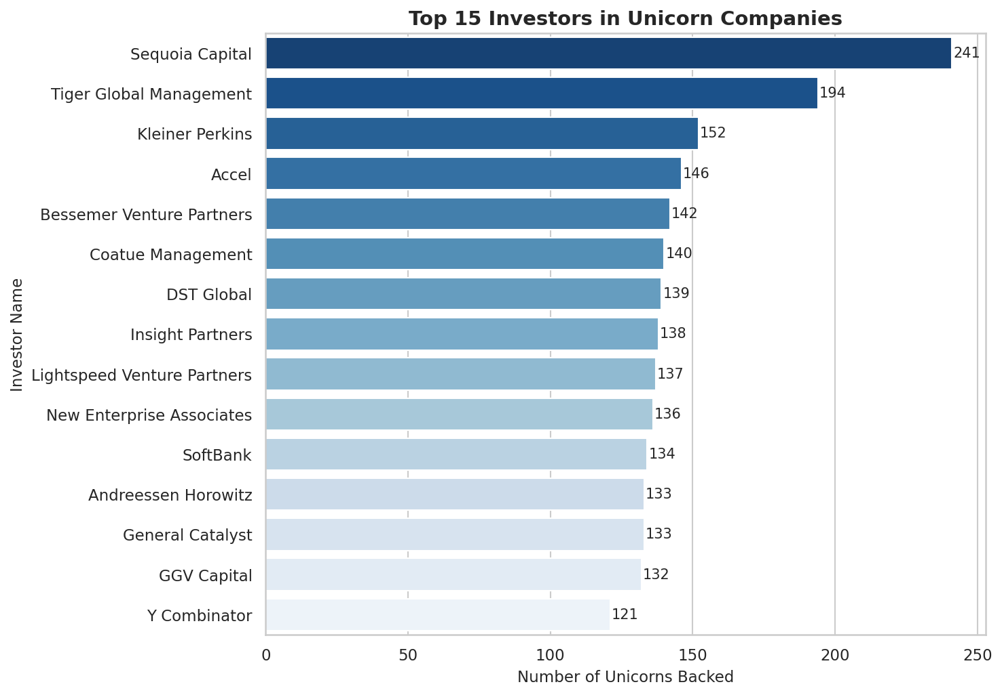
Figure 8: Top 15 Investors in Unicorn Companies
💡 Key Finding: Sequoia Capital leads all investors with 101 unicorn companies backed. A small group of elite venture funds is responsible for a disproportionate share of the world's most valuable private startups — consistent with the power-law distribution in venture capital returns.

5.9 Outlier Detection — Box Plots
Three side-by-side box plots visualize the outlier landscape across Valuation, Funding, and Year Founded. The IQR method was applied to identify the boundaries, with all points beyond the whiskers classified as statistical outliers.
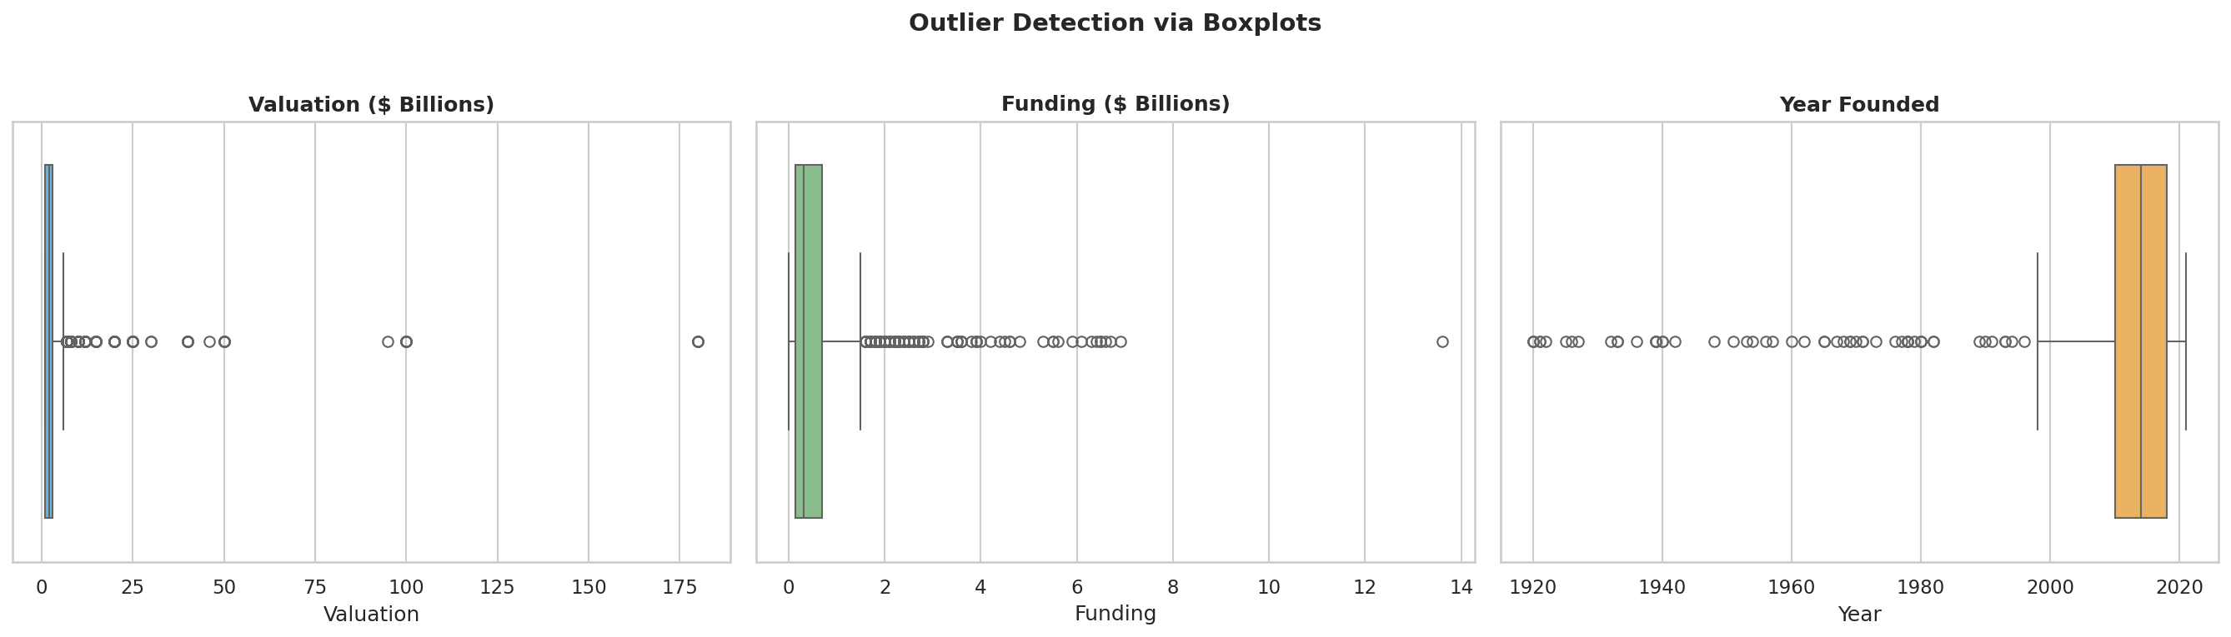
Figure 9: Boxplots Showing Outlier Detection Across Three Numeric Columns

5.10 Donut Chart — Geographic Distribution by Continent
The donut chart provides a quick high-level overview of the proportion of unicorns across continents. North America dominates, followed by Asia and Europe.
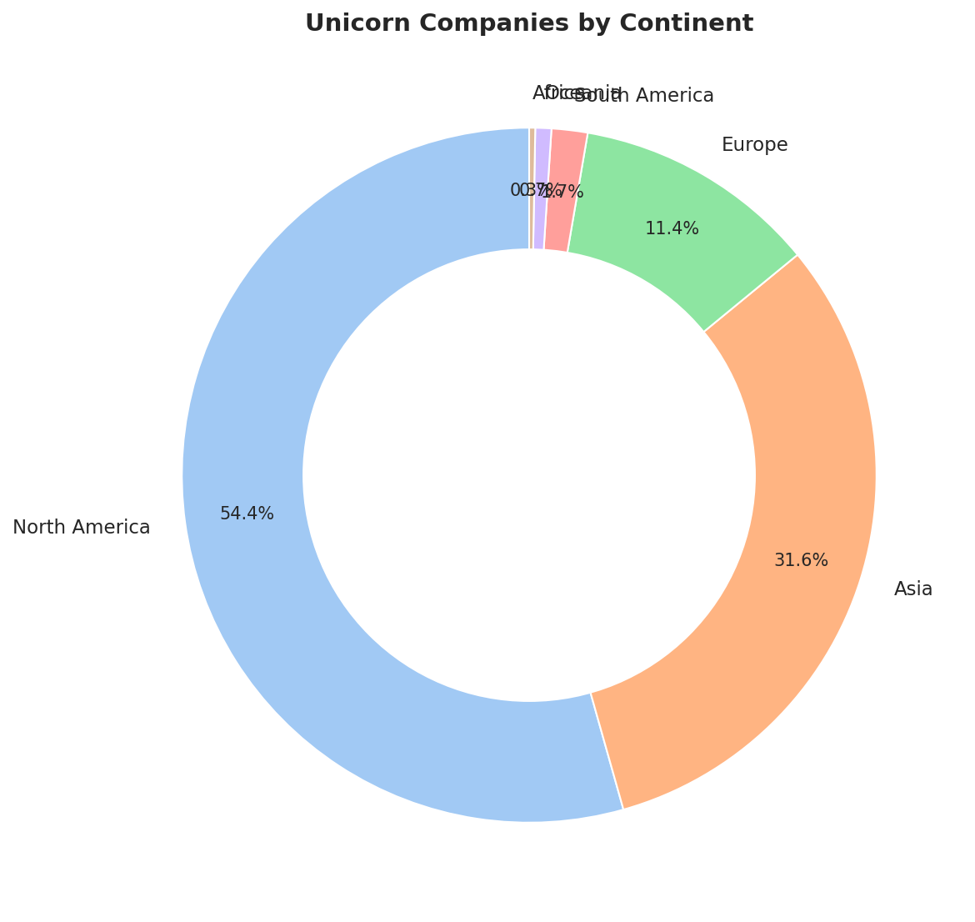
Figure 10: Unicorn Companies by Continent (Donut Chart)
💡 Key Finding: North America accounts for 54.84% of all unicorns. Africa (0.28%) and South America (1.96%) remain significantly underrepresented, highlighting persistent inequalities in global venture capital access.

5.11 Dendrogram — Hierarchical Clustering of Industries
Using Ward's linkage method, industries were clustered by their average valuation and funding characteristics. The dendrogram reveals which sectors are most similar in financial profile and which are distinct.
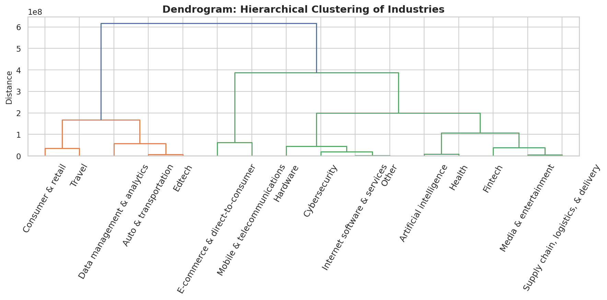
Figure 11: Dendrogram — Hierarchical Clustering of Industries by Avg. Valuation & Funding

5.12 Bubble Plot — Valuation vs. Year Founded
Each bubble represents a unicorn company. The X-axis shows the founding year, the Y-axis shows current valuation, and the bubble size is proportional to total funding raised. This reveals the relationship between company age, valuation, and capital efficiency.
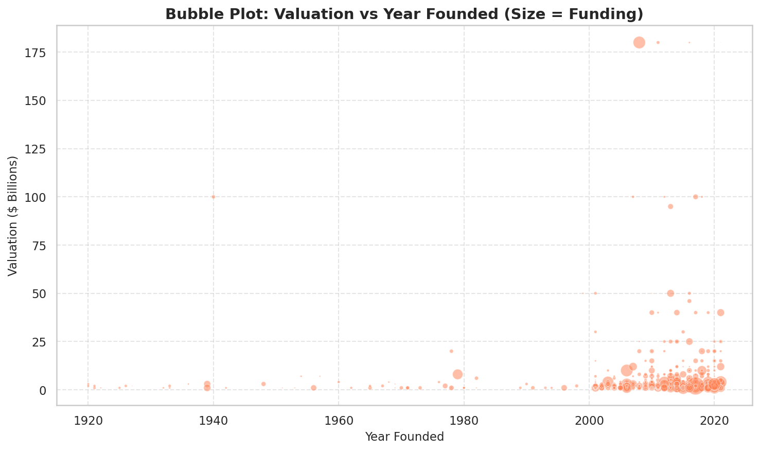
Figure 12: Bubble Plot — Valuation vs. Year Founded (Bubble Size = Funding)

5.13 Violin Plot — Time to Unicorn by Continent
The violin plot combines a box plot with a kernel density estimate to show the full distribution of 'Years to Unicorn' across each continent. The inner quartile lines provide additional statistical context.
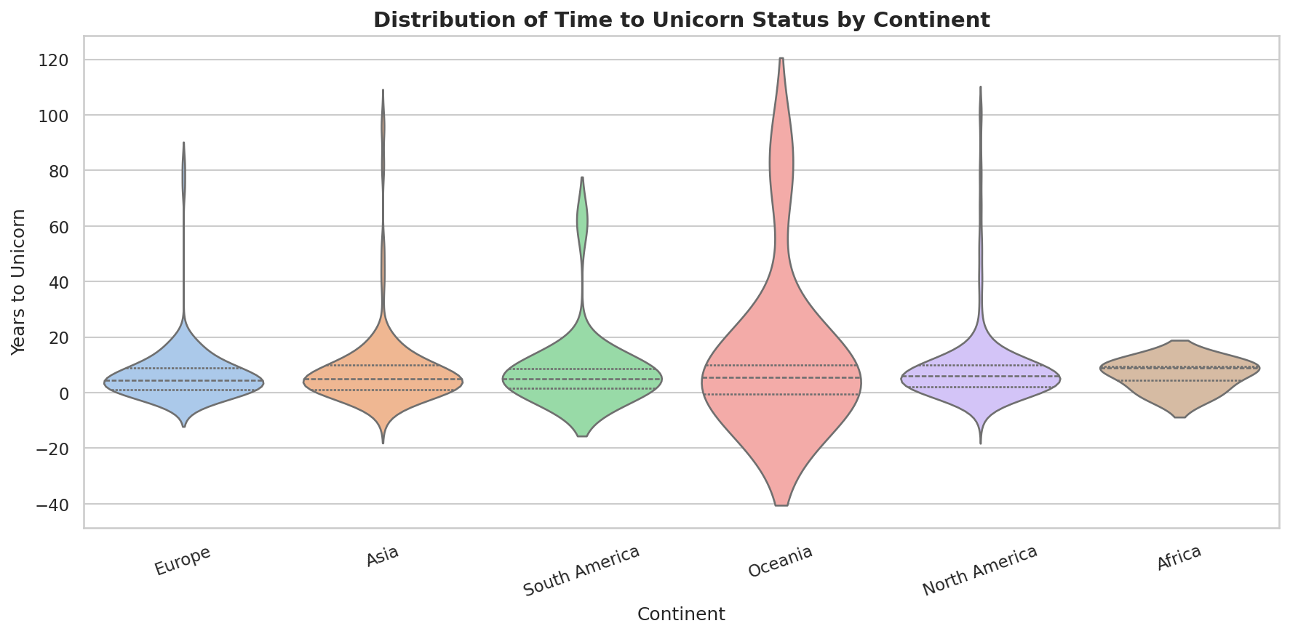
Figure 13: Distribution of Time to Unicorn Status by Continent (Violin Plot)

5.14 K-Means Clustering
K-Means clustering (k=3) was applied to the three numerical variables — Valuation, Funding, and Years to Unicorn — after standardization using StandardScaler. The resulting clusters are visualized in a scatter plot colored by cluster assignment.
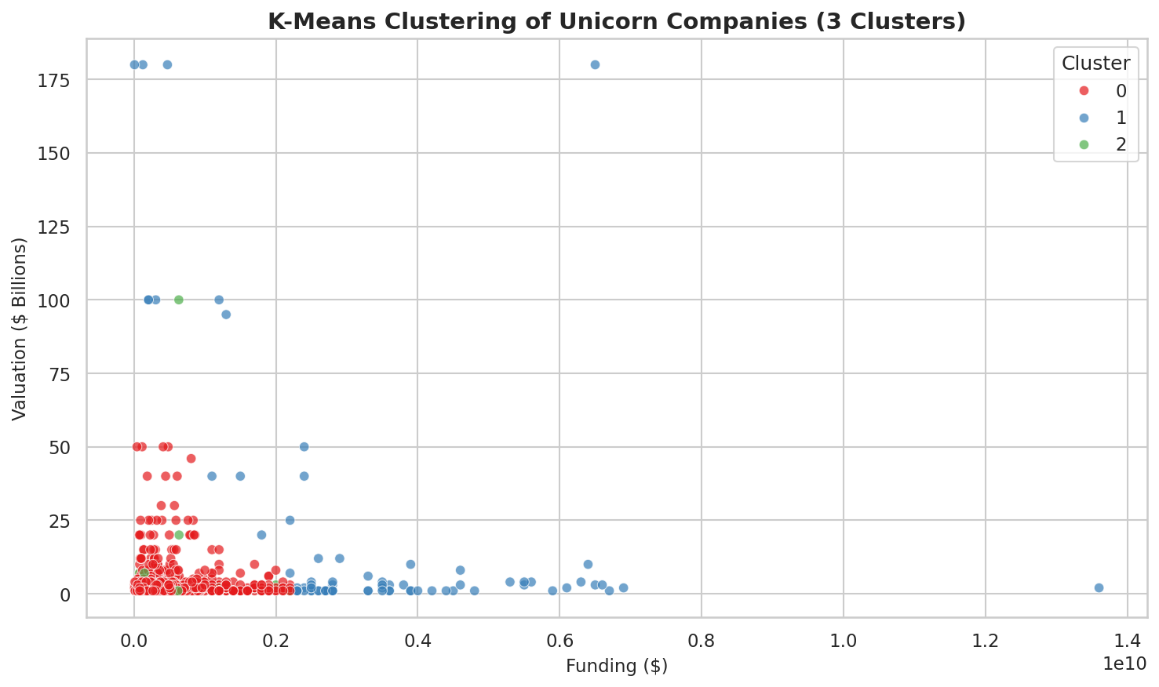
Figure 14: K-Means Clustering of Unicorn Companies (3 Clusters)

6. Results and Discussion

6.1 Industry Landscape
Fintech emerges as the definitive dominant industry with 224 companies (20.86%), followed by Internet Software & Services at 205 (19.09%). Together these two sectors account for nearly 40% of all unicorns. This dominance is explained by the combination of large addressable markets, asset-light business models, strong network effects, and the transformative impact of technology on traditional financial services. E-commerce ranks third (10.34%), reflecting the sustained growth of digital retail globally.

6.2 Geographic Concentration
The unicorn ecosystem is strikingly concentrated. North America accounts for 54.84% of all unicorns, with the United States alone contributing 52.33% (562 companies). Asia is the second-largest region at 28.86%, powered primarily by China (173), India (65), and Israel (20). Europe contributes 13.31%, led by the United Kingdom, Germany, and France. Africa (0.28%) and South America (1.96%) remain significantly underrepresented, highlighting persistent inequalities in global venture capital access.

6.3 Temporal Trends
The year 2021 represents a watershed moment in unicorn creation with 414 new companies achieving the $1B milestone — more than double the next highest year. This explosive growth was driven by multiple converging factors: unprecedented venture capital deployment fueled by low interest rates, pandemic-accelerated digital adoption, and increased availability of private market liquidity through SPACs and alternative funding vehicles.

6.4 Funding and Valuation Dynamics
The moderate positive correlation (r = +0.38) between funding and valuation reveals that while capital access does help companies grow to higher valuations, the relationship is far from deterministic. Bytedance (valued at $180B) achieved this milestone with $8B in funding — a remarkably efficient capital deployment. Conversely, some companies have raised over $5B in funding while remaining at relatively modest valuations, suggesting that investor capital alone cannot substitute for genuine market traction, unit economics, or competitive moats.

6.5 Speed of Value Creation
The most statistically significant finding in the dataset is the strong negative correlation (r = −0.70) between Year Founded and Years to Unicorn. Companies founded in the 2010s typically reach unicorn status in 5–8 years, whereas companies founded before 2000 often required 15–20+ years. This acceleration reflects the compounding effects of improved technology stacks, more mature global venture networks, and the lessons accumulated by the startup community over generations of founders.

7. Applications and Use Cases
The findings from this analysis have practical implications across multiple domains:
- Investment Intelligence: Venture capital firms can use this analysis to benchmark portfolio performance, identify underinvested industries, and time investment cycles by tracking annual unicorn creation trends.
- Startup Benchmarking: Aspiring founders can identify which industries are most likely to produce unicorns, understand typical funding requirements, and benchmark their growth timelines against historical patterns.
- Economic Policy: Governments and economic development agencies can use the geographic analysis to identify gaps in startup ecosystems and design targeted incentive programs.
- Research Methodology: The data cleaning techniques and visualization approaches demonstrated here serve as a practical template for EDA in finance and economics research.
- Corporate Strategy: Corporations considering acquisitions or competitive assessments can use the industry distribution and growth trend data to understand where the most dynamic innovation is occurring.

8. Conclusion
This project successfully demonstrated a comprehensive Exploratory Data Analysis of the global unicorn startup ecosystem using Python. Through a systematic analytical pipeline — spanning data inspection, cleaning, basic statistics, univariate and bivariate analysis, filtering, outlier detection, and rich visualizations — a complete picture of the unicorn landscape was assembled from a dataset of 1,074 companies.
The analysis yielded six major findings:
- Fintech dominance: With 20.86% of all unicorns, Fintech is the undisputed leader across all valuation tiers, driven by large addressable markets and technology-enabled disruption of traditional financial services.
- US concentration: The United States holds 52.33% of all unicorns, reflecting its unparalleled venture capital ecosystem, risk culture, talent concentration, and technology infrastructure.
- 2021 unicorn explosion: A historic surge of 414 unicorns in 2021 marks a potential structural shift in the pace of startup value creation globally.
- Funding–valuation relationship: A moderate positive correlation (r = +0.38) shows that funding helps but does not guarantee high valuations. Business model quality and market size are equally important.
- Accelerating time to unicorn: The strong negative correlation (r = −0.70) between founding year and years to unicorn shows modern startups achieve $1B valuations significantly faster than predecessors.
- Elite investor concentration: Sequoia Capital (101 unicorns), Tiger Global, and Accel dominate unicorn investment, confirming that a small group of top-tier funds has disproportionate influence.

9. References
- Pandas Documentation. pandas.pydata.org — Official reference for all DataFrame operations used in this project.
- Seaborn Documentation. seaborn.pydata.org — Reference for barplot, lineplot, scatterplot, boxplot, histplot, and heatmap functions.
- Plotly Express Documentation. plotly.com/python/plotly-express/ — Reference for choropleth map creation.
- NumPy Documentation. numpy.org — Reference for NaN handling and array operations.
- Unicorn Companies Dataset. Kaggle / CB Insights — Source dataset of 1,074 global unicorn companies.
- McKinsey Global Institute. (2022). The State of AI in 2022. Report on technology sector growth trends.
- CB Insights. (2022). State of Venture 2021. Annual global venture capital report.
- Lee, A. (2013). Welcome to the Unicorn Club. TechCrunch. Original publication coining the unicorn terminology.

