

School Of Future Tech

Case Study Report

On

FarmEquip

By

Krishiv Amitsinh Solanki
150096725072

Introduction to the Case Study

The modernization of agriculture is heavily dependent on the adoption of advanced machinery. From automated harvesters to precision seeders, technology has the potential to drastically increase yield and efficiency. However, the economic barrier to entry for such equipment remains prohibitively high for small to medium-scale farmers.
This case study focuses on FarmEquip, a web-based agricultural equipment leasing platform. The project aims to democratize access to high-end farming machinery by enabling a "Farming as a Service" (FaaS) model. Instead of capital-intensive ownership, farmers can rent equipment on a need-basis, thereby optimizing costs and operational efficiency.
The report details the design, development, and implementation of a responsive front-end solution that facilitates this leasing process, highlighting the technical decisions made to ensure accessibility across devices commonly used in rural environments (mobile phones and tablets).

Problem Statement / Case Background

Background
Traditional farming in many regions suffers from low productivity due to a lack of mechanization. While machinery exists, the cost of ownership includes not just the purchase price, but also maintenance, storage, and depreciation. For seasonal crops, a specific machine might only be needed for two weeks a year, making full ownership economically inefficient.

Problem Statement
Farmers lack a centralized, transparent, and easy-to-use platform to locate and rent agricultural equipment. Current solutions often rely on informal local networks, which are unreliable and lack standardized pricing. There is a need for a digital solution that:
- Provides a catalog of available machinery with detailed specifications.
- Offers transparent pricing based on usage duration.
- Is accessible on low-end devices via a responsive web interface.
- Allows for checking availability to plan farming activities in advance.

Case Study Design

The FarmEquip system is designed as a modular client-side web application. The design philosophy prioritizes Responsiveness and Maintainability.

Architecture Overview
The application follows a Multi-Page Application (MPA) architecture where each core function resides in a distinct HTML file, supported by specific CSS and JavaScript files. This separation of concerns ensures that the code remains clean and debugging is localized to specific features.
- Data Handling: Due to the client-side nature of this prototype, data handling (pricing logic, equipment details) is managed via DOM manipulation and URL parameters to simulate dynamic content loading without a heavy backend.
- User Flow: The user enters via a Landing Page, browses the Catalog, selects Equipment for Details, checks Availability, and finally calculates costs via the Pricing module.

Methods & Algorithms / Technology Applied

To build a lightweight and universally accessible platform, the following technologies were applied:

Technologies
- HTML5: Used for semantic markup to ensure the structure is meaningful and accessible
- CSS3: Used extensively for layout management. CSS Grid handles the catalog displays, while Flexbox manages navigation bars and alignment. CSS Variables (Custom Properties) are used for consistent theming.
- Vanilla JavaScript: Chosen over heavy frameworks (like React or Angular) to minimize load times and complexity. Key algorithms handle:
  - URL Parameter Parsing: To pass equipment IDs between the Catalog and Details pages.
  - Dynamic Pricing Algorithm: Calculates total cost = (Base Rate × Days) + Seasonal Multiplier.
  - DOM Manipulation: Injecting HTML content dynamically based on user interaction.

Implementation Details and Features

The project is structured into five main functional modules. The file structure is organized to promote modularity:

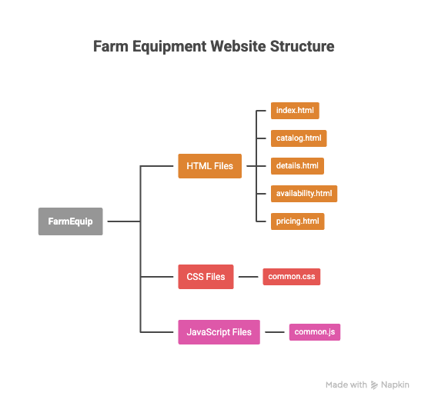
Module Breakdown

Landing Page (Index)
Serves as the entry point. It features a hero section describing the value proposition and quick links to the catalog. It implements a responsive navigation bar found across all pages.

Equipment Catalog
Displays machinery in a responsive grid. Each card contains an image, title, and a "View Details" button. JavaScript event listeners attach to these buttons to generate dynamic links.

Detailed Specifications
This page parses the URL query parameters on load. Using a JavaScript object dictionary acting as a database, it populates the page with the specific data (Engine power, Capacity, Fuel type) corresponding to the requested equipment ID.

Availability Checker
An interactive form where users select a piece of equipment and a date range. Simple logic validates that the end date is after the start date and simulates an availability check (returning specific dates as "Booked" or "Available").

Dynamic Pricing Calculator

A core feature for transparency. The user selects an equipment type and duration. The JavaScript logic calculates the estimated cost instantly, updating the DOM without a page reload.

Results and Conclusion

Findings
The implementation of FarmEquip demonstrates that a robust, user-friendly platform can be built using standard web technologies without heavy dependencies.
  - Performance: By using Vanilla JavaScript, the application loads near-instantly, which is critical for rural areas with poor internet connectivity.
  - Usability: The responsive design ensures that farmers using low-cost smartphones have the same access to information as those on desktop computers.
  - Modularity: The separation of CSS and JS files per page allows for easy maintenance and future scaling (e.g., adding a backend API).

Conclusion
FarmEquip successfully addresses the problem of information asymmetry in agricultural leasing. By providing a digital catalog, transparent pricing, and availability checking, it empowers farmers to make better operational decisions. The project serves as a foundational prototype that can be expanded with real-time database integration, user authentication, and payment gateway processing in the future.

References

  - Project Repository: https://github.com/Krishiv200719/FarmEquip
  - MDN Web Docs: Documentation for HTML5, CSS Grid, and JavaScript ES6 features.
  - W3C Standards: Guidelines for Web Accessibility Initiative (WAI) used in semantic markup.

