

Krish mahajan
Jr. Scientist,Mos&t,
9055721797,
krishmahajan334@gmail.com

Date:07-03-2025

To Whomsoever It May Concern

This is to certify that the drafted project, namely AquaSense-X, is the intellectual property of Mr. Krish Mahajan. Additionally, the images of the 3D render associated with this project are subject to copyright protection.
Any unauthorized use, reproduction, or distribution of the project or its visual representations without explicit permission from the owner is strictly prohibited.

Regards,
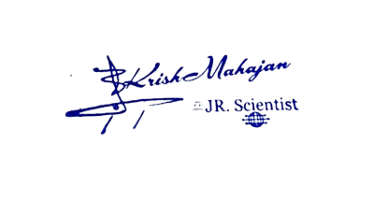
Krish mahajan,

