
Sri Lanka Institute of Information Technology

SE3090 – Software Engineering Frameworks
Year 3, Semester 1- 2026

Practical Answer Submission

Lab Test 11

Student ID | IT24103866
Student Name | Obesekara S.O.K.D
Campus/ Center name | Malabe
Specialization | Artificial Intelligence
Batch No | WE.AI.02

GitHub Repo: https://github.com/Krishmal2004/SEF_Lab11.git
Live URL: CampusEats Dashboard

Backend URL: https://sef-lab11-83ir.onrender.com/

Task 01

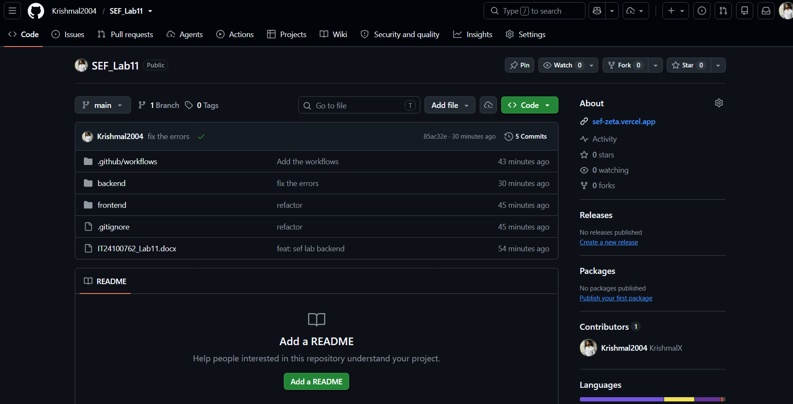

Task 2

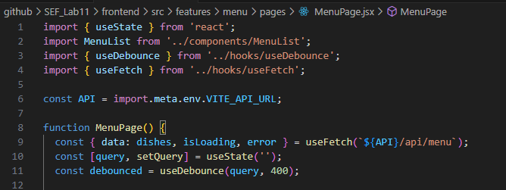

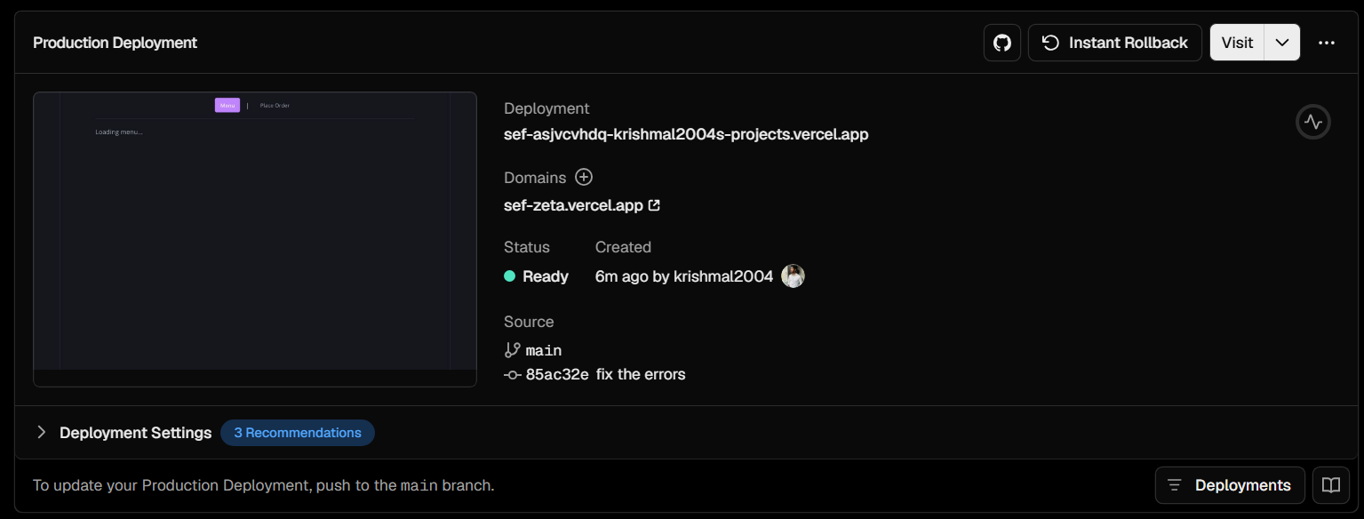

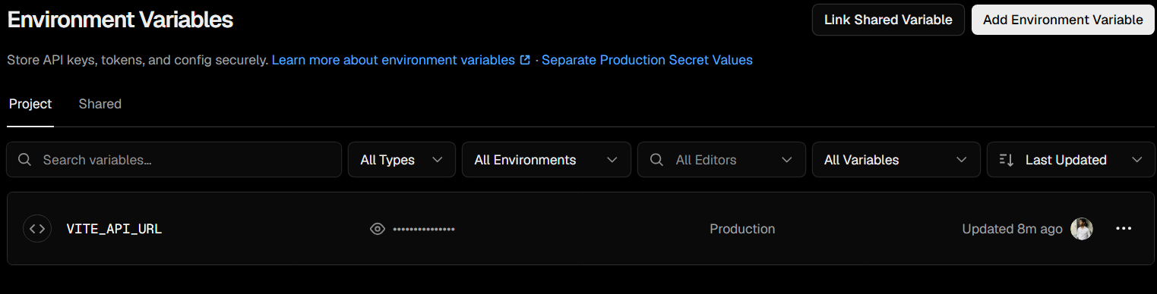

Task 3

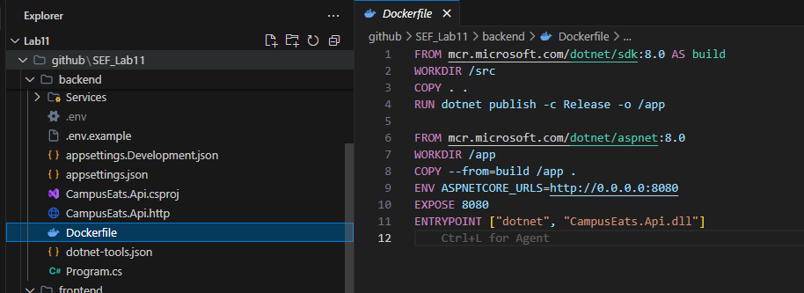

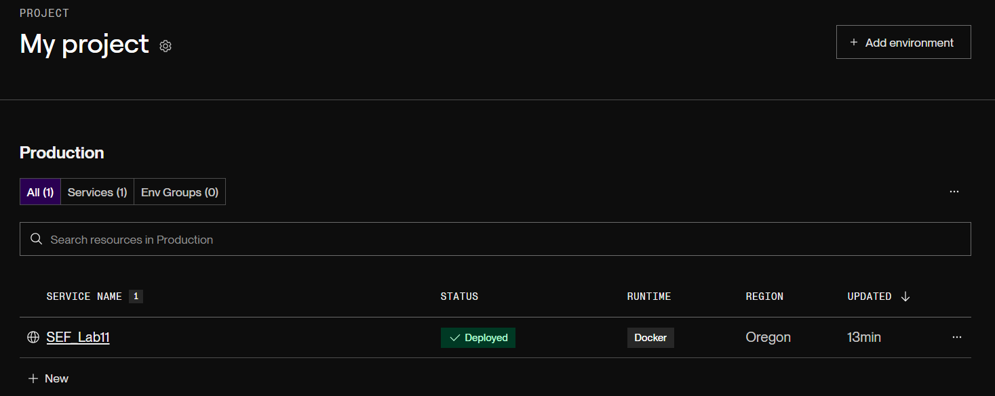

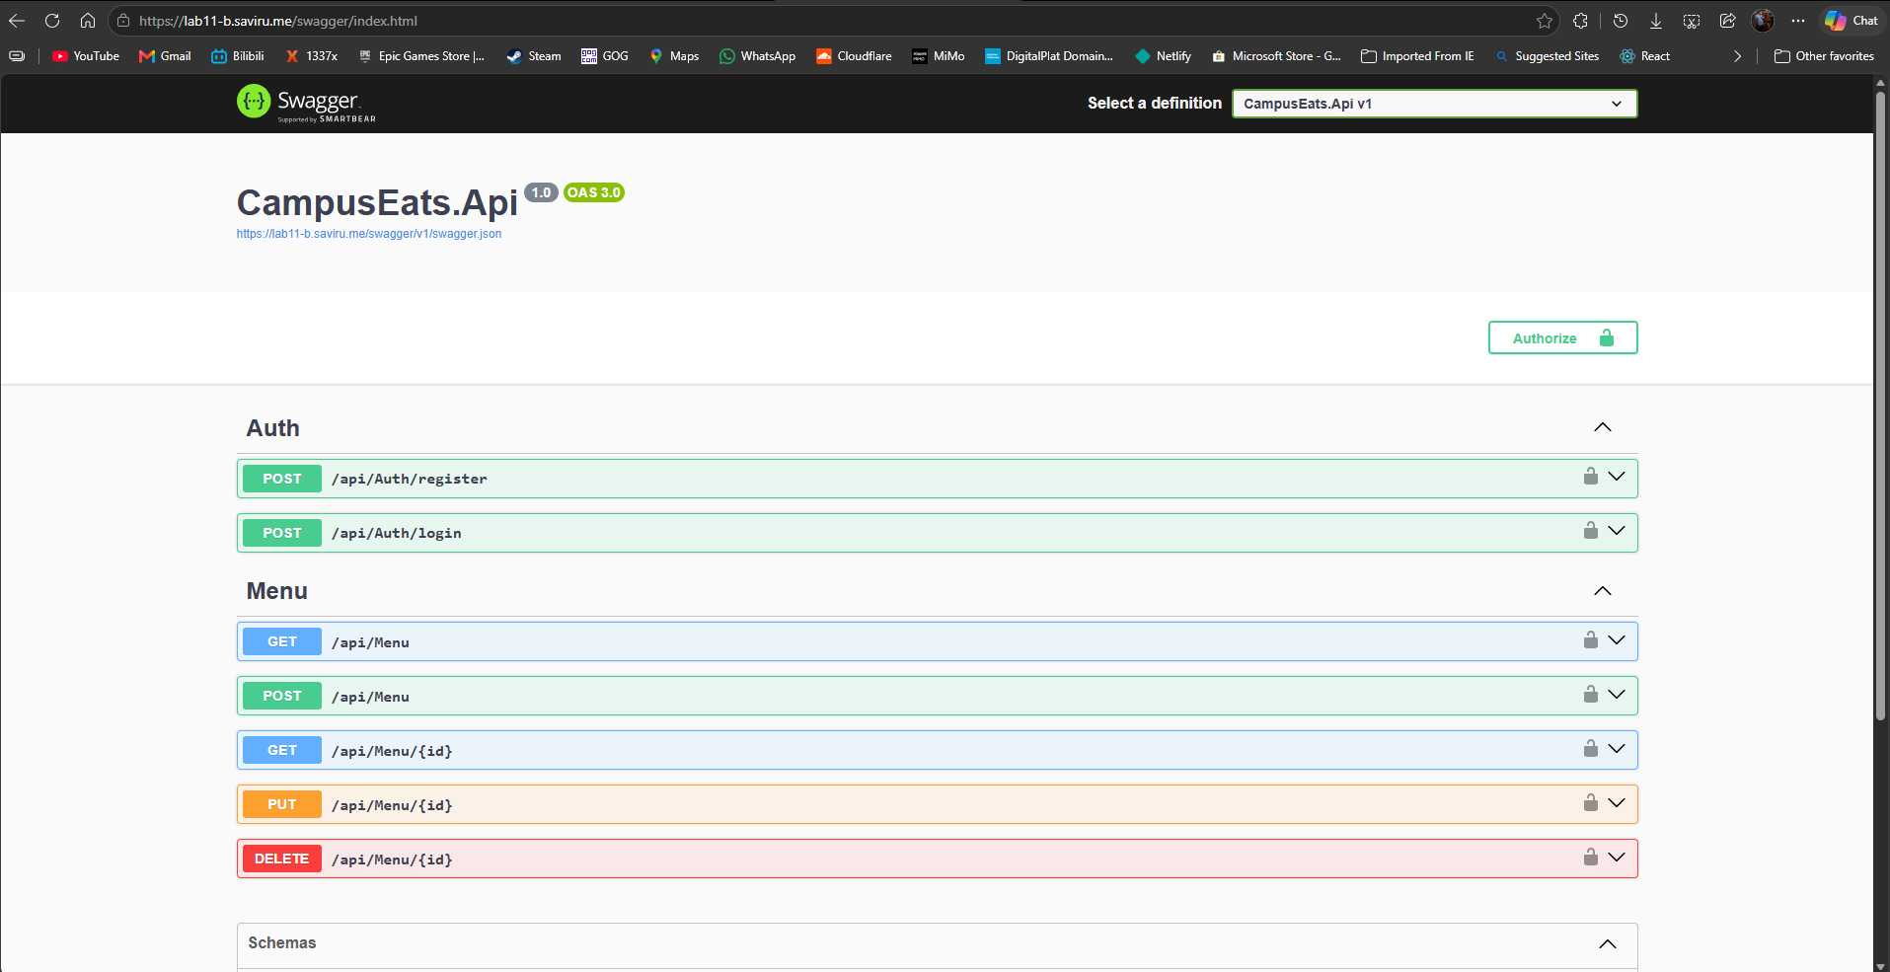

Task 4

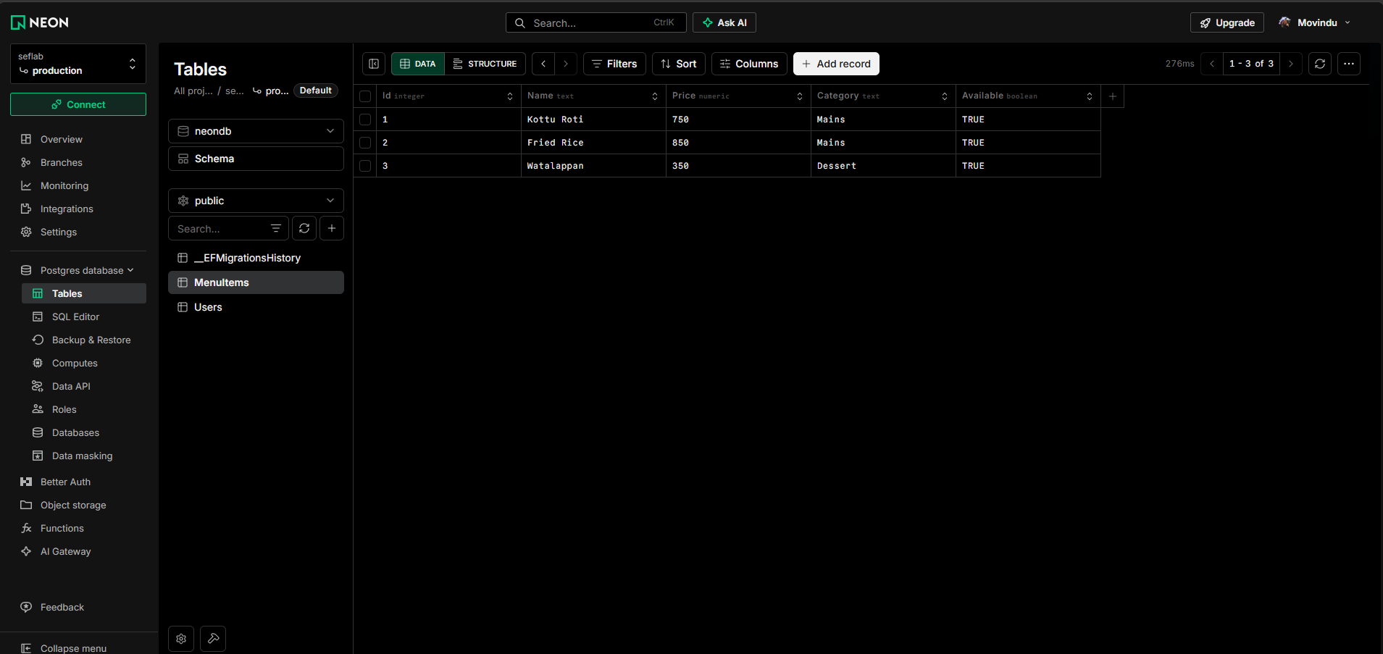

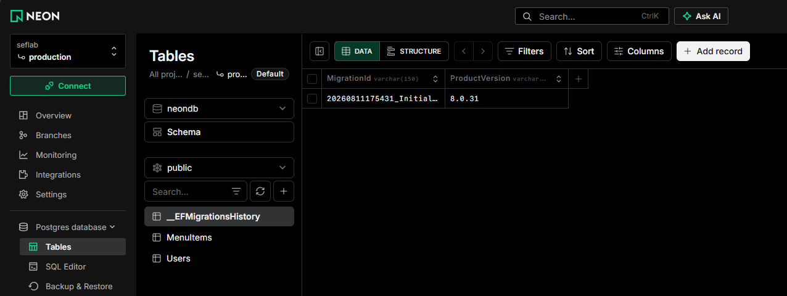

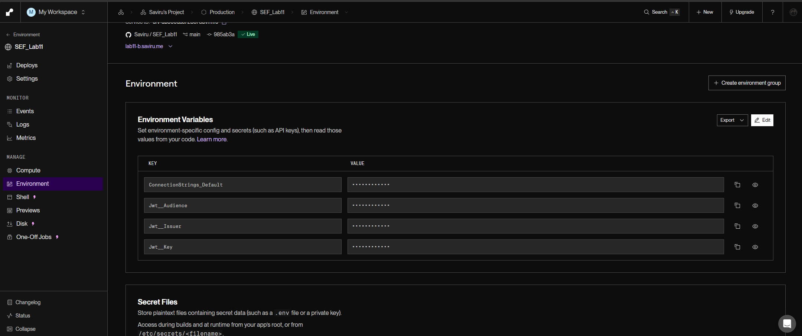

Task 5

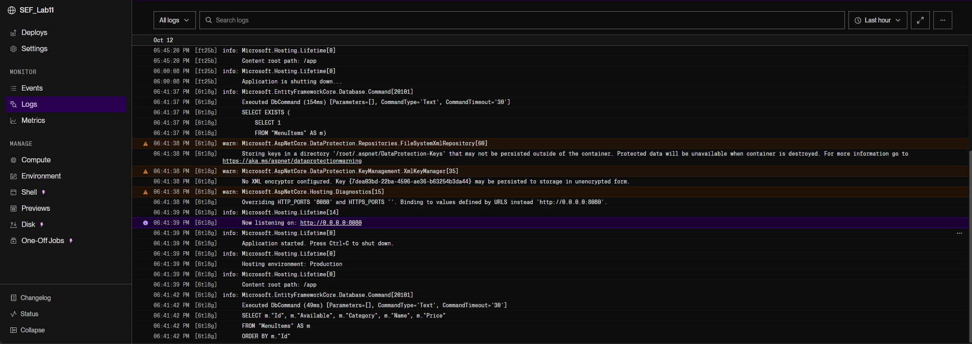

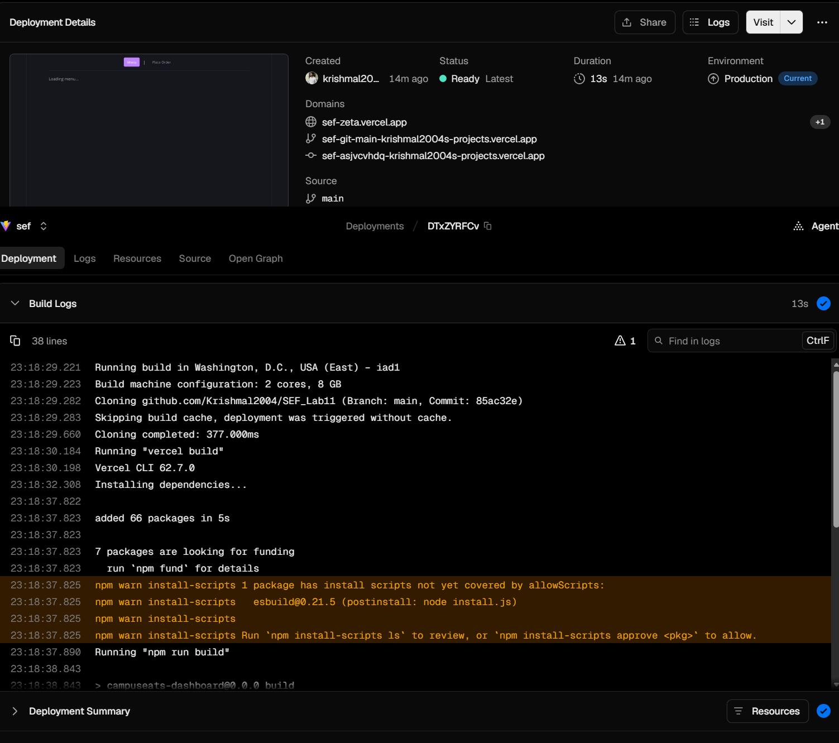

Task 6

Part A

Tier | Platform | Reason
Frontend | Vercel | This is a lightweight and simple UI written in react. Vercel provides enough resources with its free tier and compatible GitHub integration.
Backend API | Render | The backend is dockerized and also written in .NET. Render gives enough resources for with minimal configuration and GitHub integration.
Database | Neon | NeonDB is simple and fast compared to supabase and other pSQL databases. Also as this project is not a complicated one it can be easily connected to that for free.

Part B

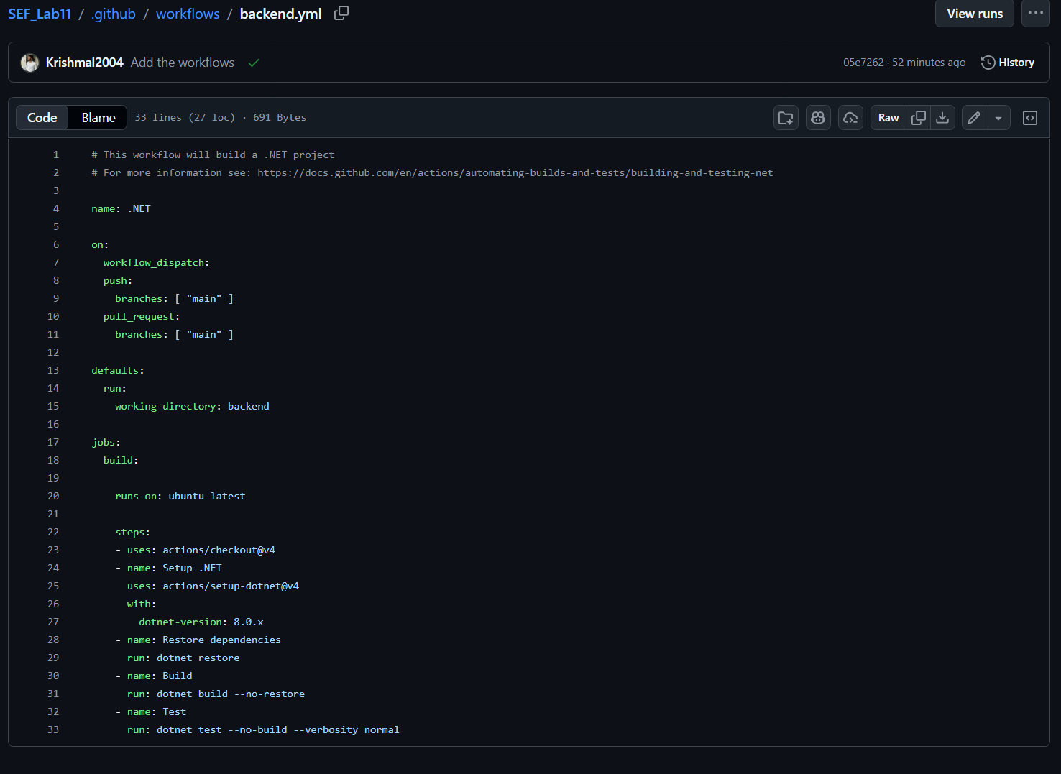

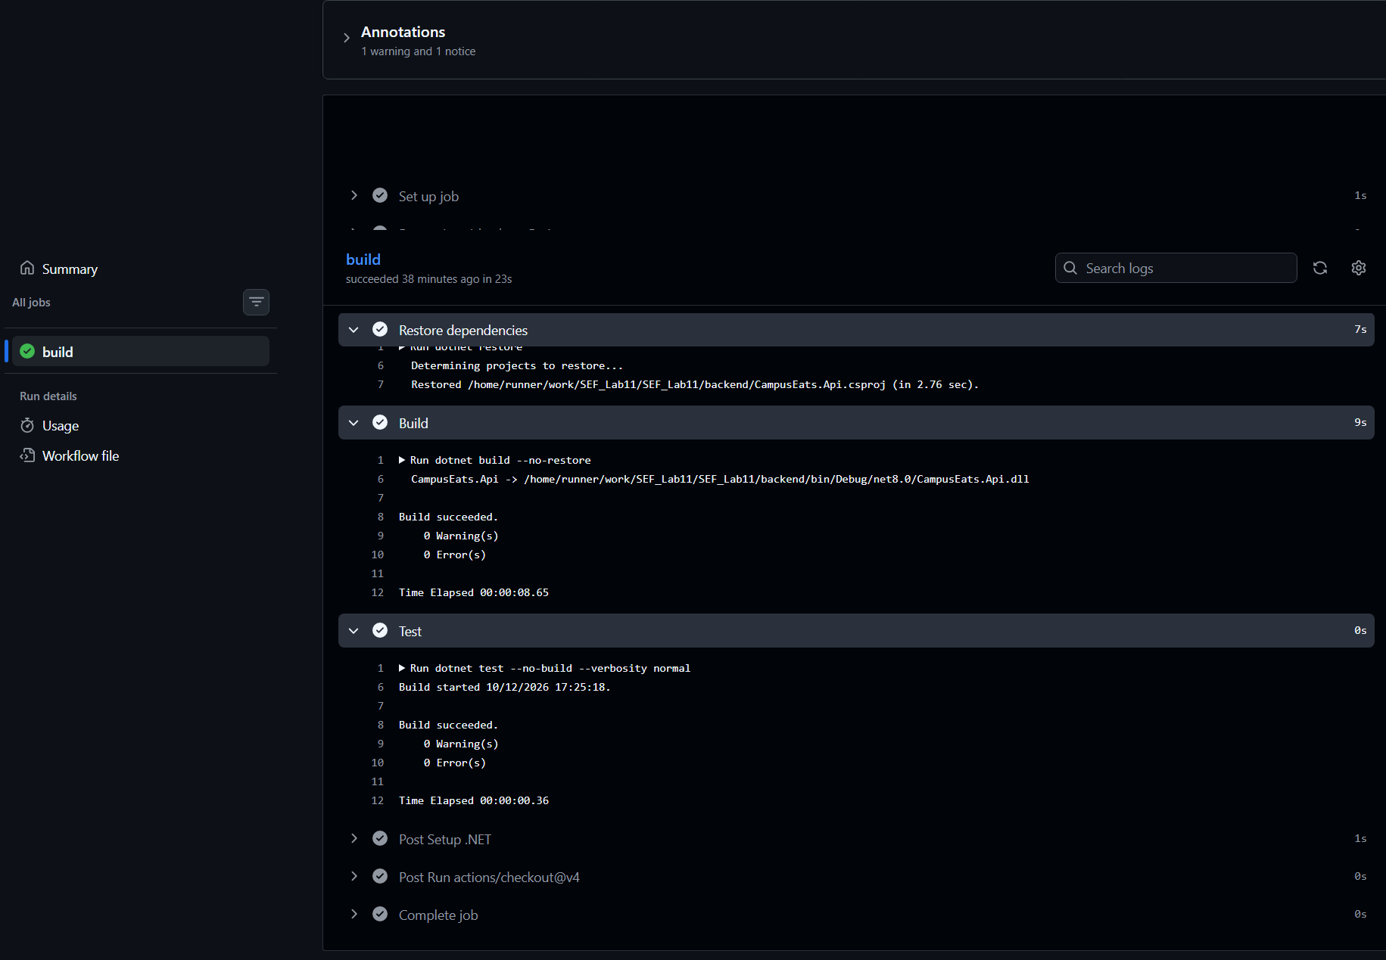

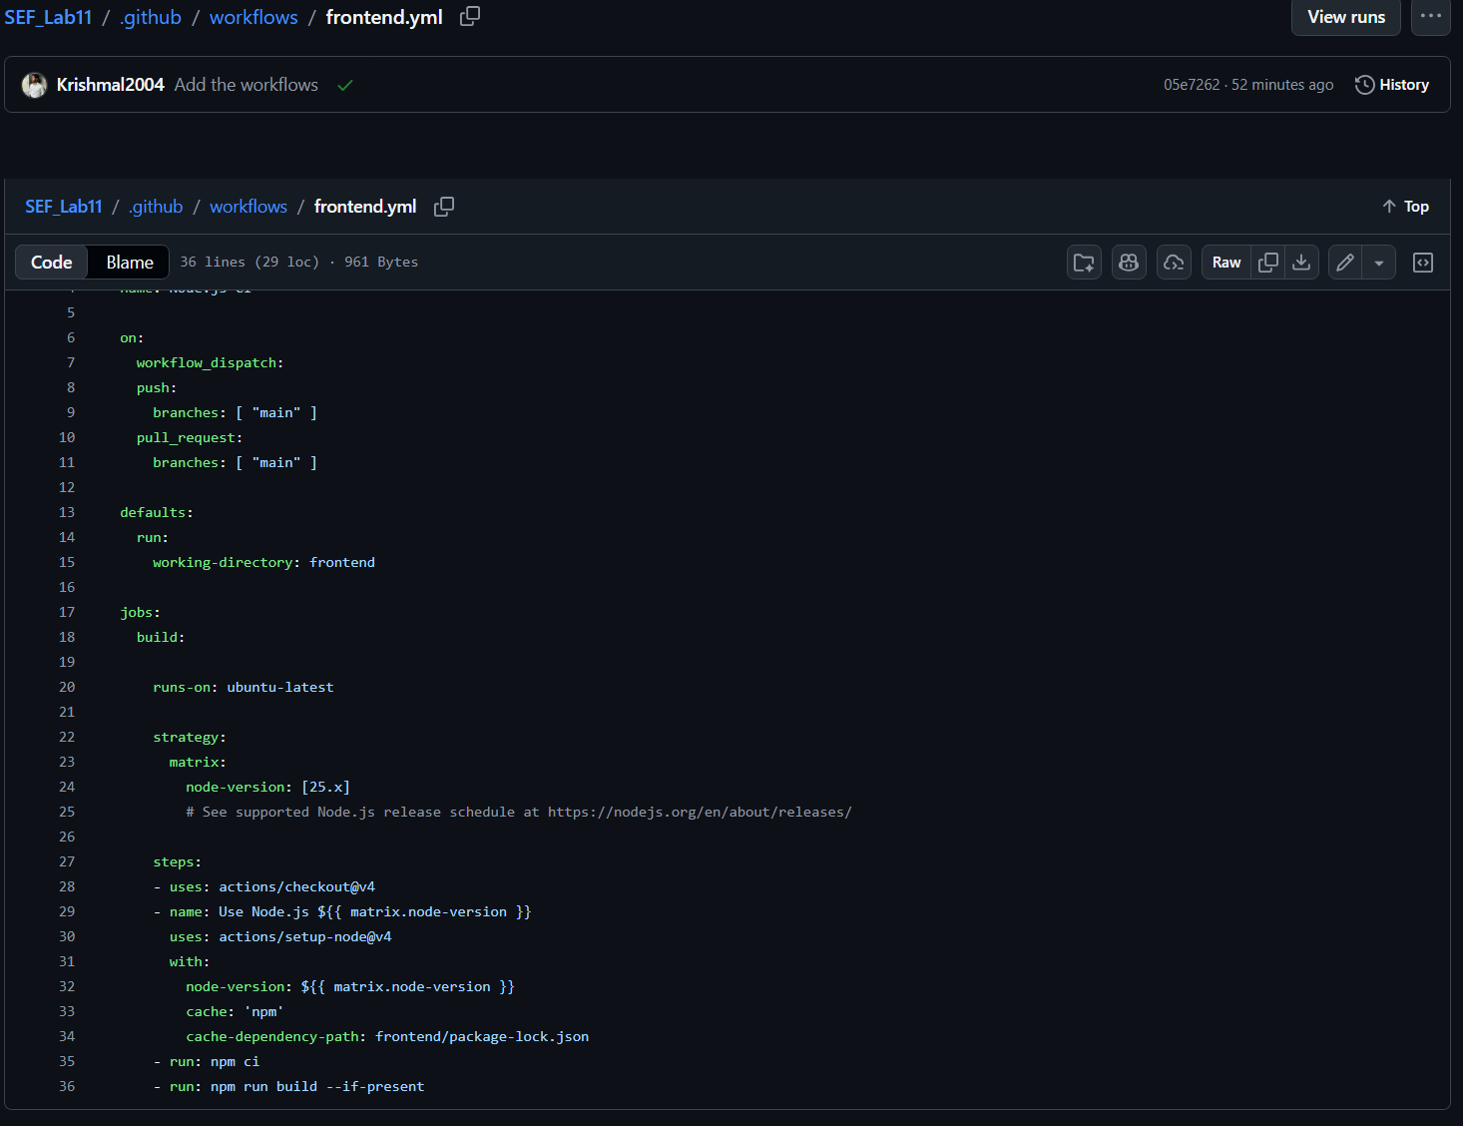

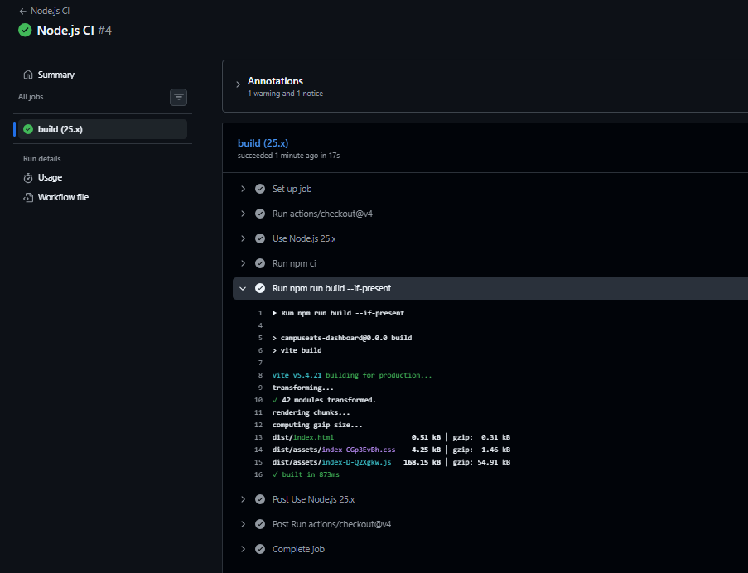

These screenshots reflect how I automated the CI to automatically test both backend and frontend on each push or PR. Then when it comes to Vercel and Render. Also, the backend url, JWT key and the neon connection string are kept out of version control, adhering to Twelve-Factor app principles. Cloud logs and monitoring dashboards provided instant visibility into HTTP traffic, build statuses, and runtime errors. These GitHub CI workflows, hosted platforms and their secret managements solve "it works on my machine" issues by standardizing build and runtime environments across all tiers.

Quick Test

- Q1: (b) unite development and operations with automation to deliver faster and more reliably
- Q2: (c) a frontend/static host such as Vercel or Netlify
- Q3: (c) in environment variables configured on the hosting platform
- Q4: (b) observe the running app's logs, metrics, and errors
- Q5: (a) automatically releasing builds to an environment after checks pass
- Q6:
  - Security: Prevents hardcoding secrets (database passwords, API keys) into source control.
  - Environment Portability: Enables the exact same codebase to run in development, testing, and production simply by changing variable values without code modifications.
- Q7: Build command: npm run build. Production output folder: dist/.
- Q8:
  - Check that the backend CORS policy allow-list contains the exact deployed frontend origin (protocol, domain, no trailing slash).
  - Check that the frontend VITE_API_URL environment variable points to the correct HTTPS backend URL (and that the backend is awake and responding).

