Name: Krishnmohan Mishra MSc CS Sem 1

Cyber Security and Digital Forensics

Practical 2: Vulnerability Scanning using Nikto in Kali Linux

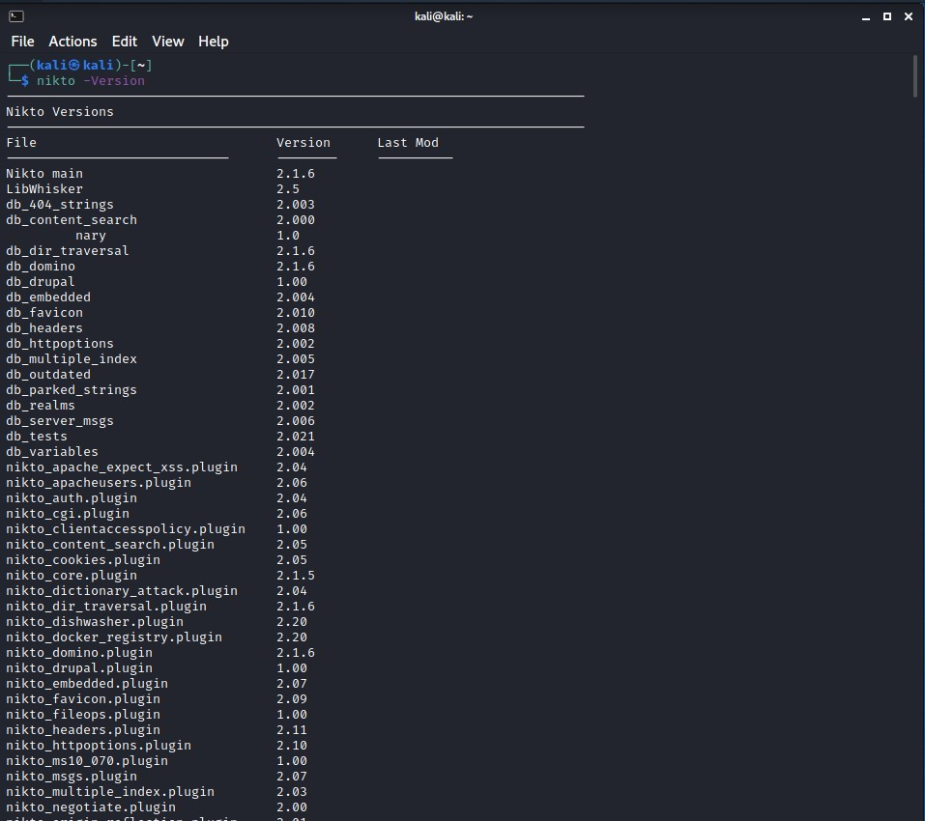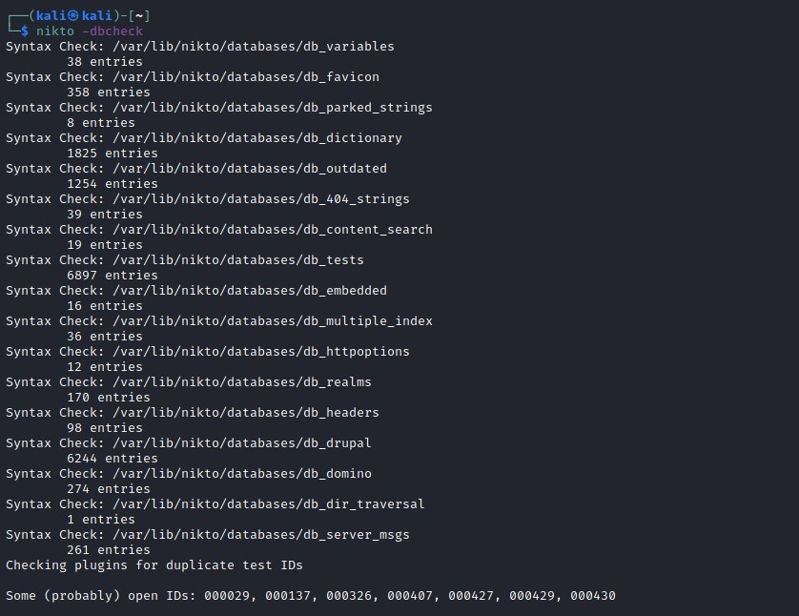

Name:Krishnmohan Mishra MSc CS Sem 1

